Supplementary Information for

Modulation of western U.S. compound precipitation and temperature extremes by compounding MJO and ENSO interaction
Jiabao Wang*¹, Michael J. DeFlorio¹, Alexander Gershunov¹, Kristen Guirguis¹, Luca Delle Monache¹, F. Martin Ralph¹
¹ Center for Western Weather and Water Extremes, Scripps Institution of Oceanography, University of California, San Diego, La Jolla, California

*Correspondence to: Jiabao Wang (jiw093@ucsd.edu)

Including:
Supplementary Fig. 1.
Supplementary Fig. 2.
Supplementary Fig. 3.
Supplementary Fig. 4.
Supplementary Fig. 5.
Supplementary Fig. 6.
Supplementary Fig. 7.

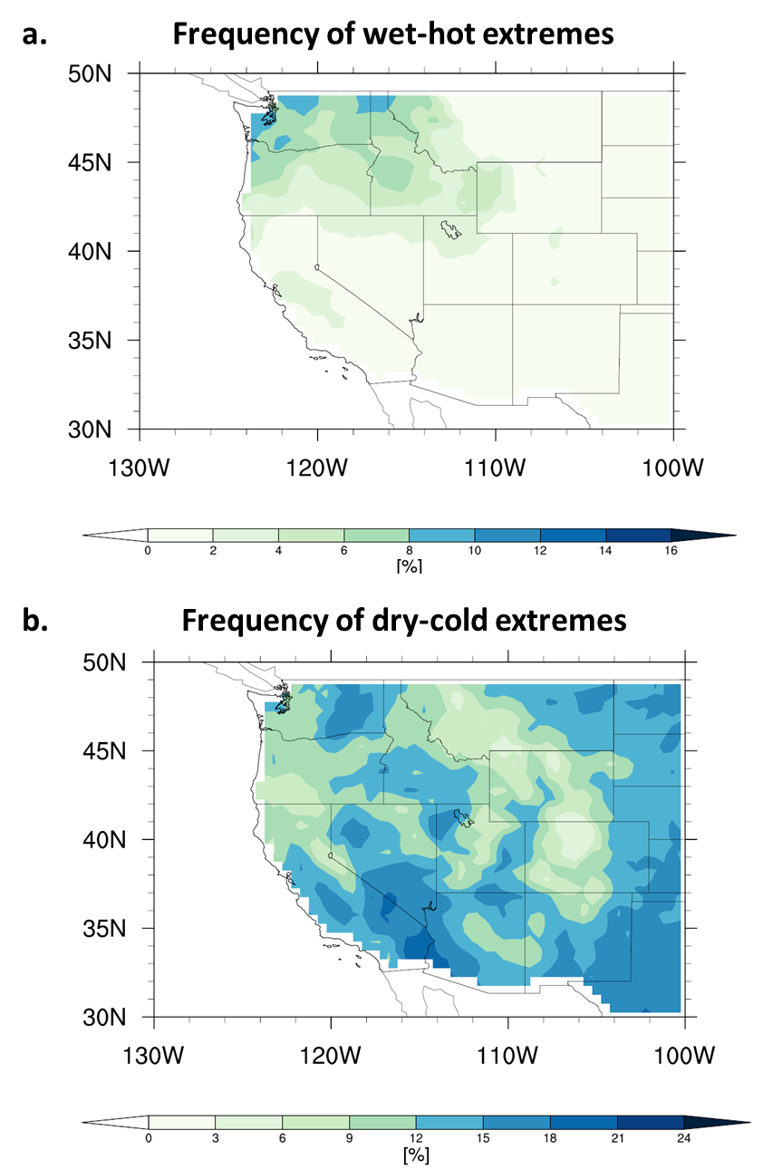
Supplementary Fig. 1. Climatological frequency of compound wet-hot and dry-cold extremes over the western U.S..
Same as Fig. 1, except for wet-hot (>75th percentile precipitation and >75th percentile maximum temperature) extremes and dry-cold (<25th percentile precipitation and <25th percentile maximum temperature) extremes.

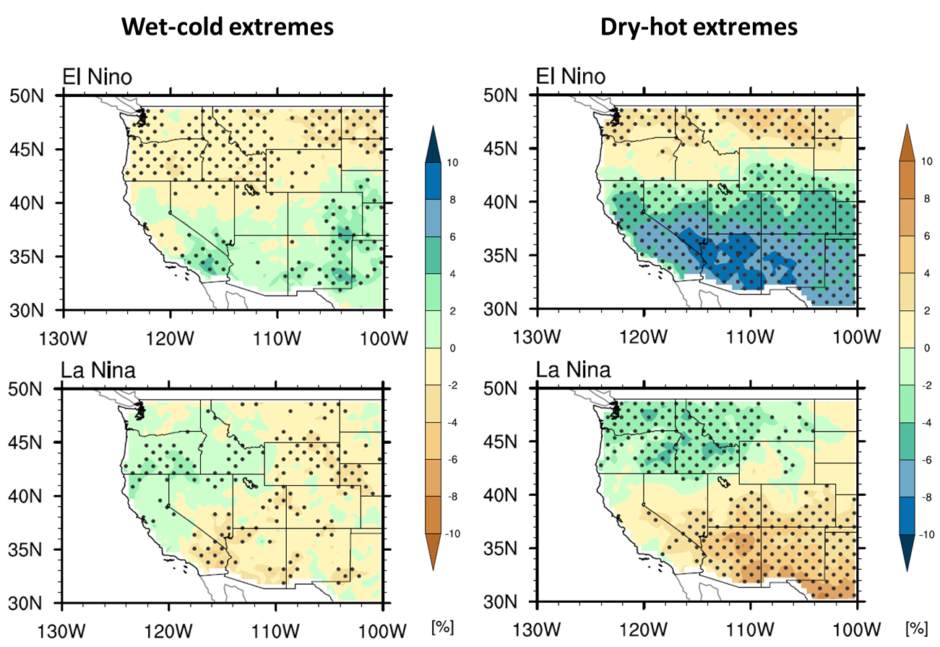
Supplementary Fig. 2. Changes in wet-cold and dry-hot extreme frequency in response to ENSO only.
Same as Fig. 2, except for seasonal changes in wet-cold and dry-hot extremes impacted by ENSO only.

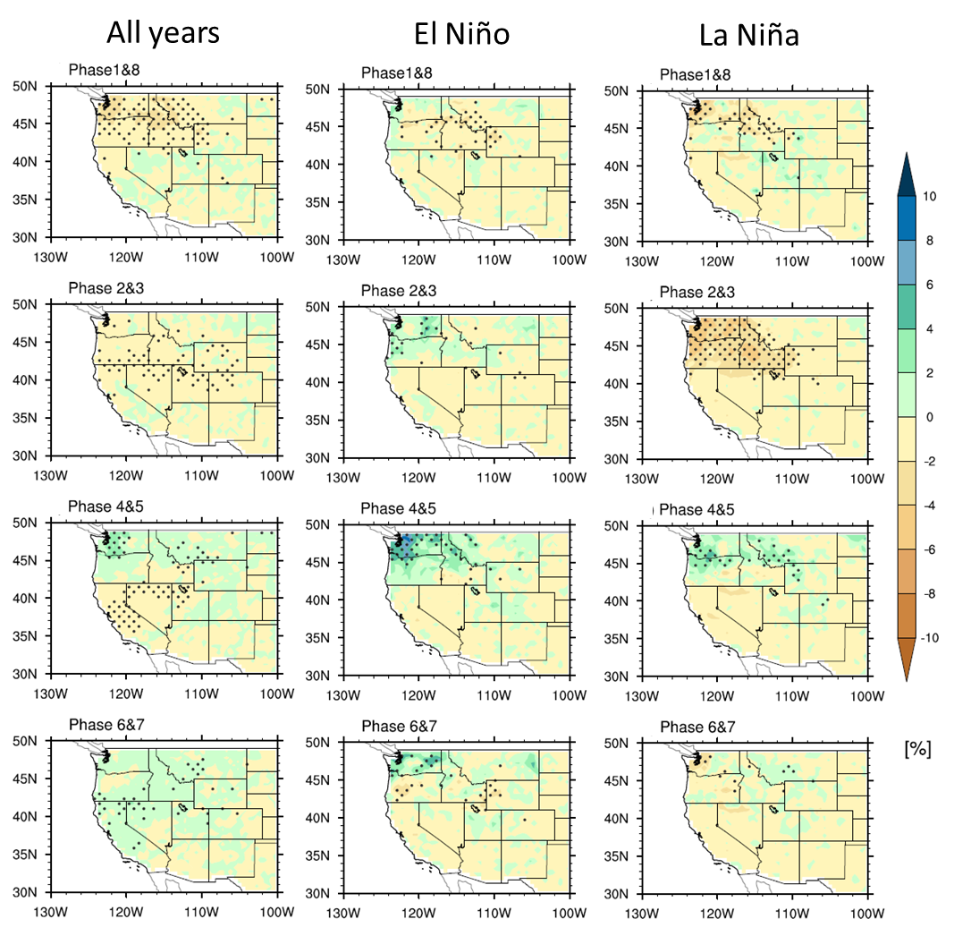
Supplementary Fig. 3. Changes in wet-hot extreme frequency in response to MJO and ENSO.
Same as Fig. 2, except for wet-hot extremes.

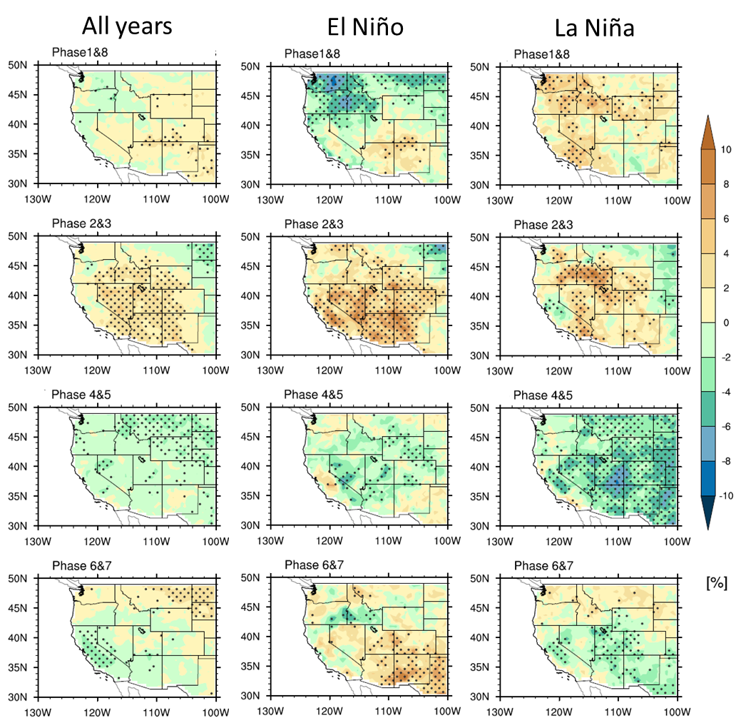
Supplementary Fig. 4. Changes in dry-cold extreme frequency in response to MJO and ENSO.
Same as Fig. 2, except for dry-cold extremes.

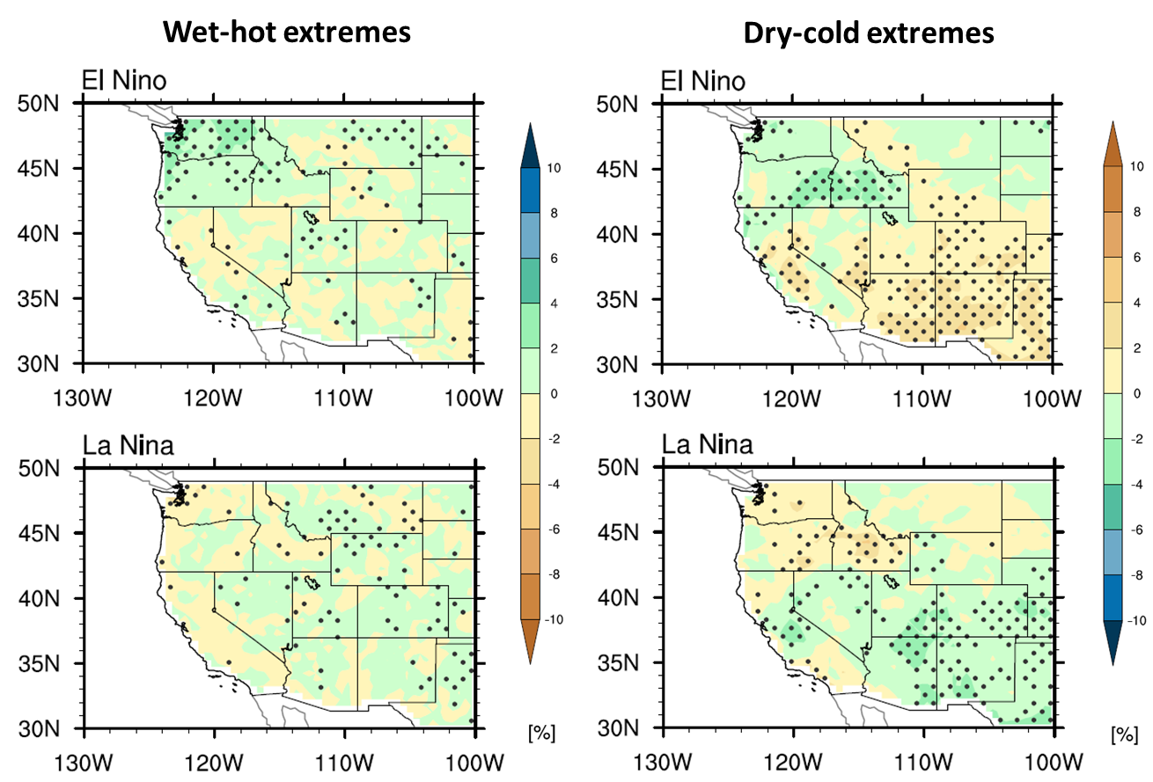
Supplementary Fig. 5. Changes in wet-hot and dry-cold extreme frequency in response to ENSO only.
Same as Supplementary Fig. 2, except for seasonal changes in wet-hot and dry-cold extremes impacted by ENSO only.

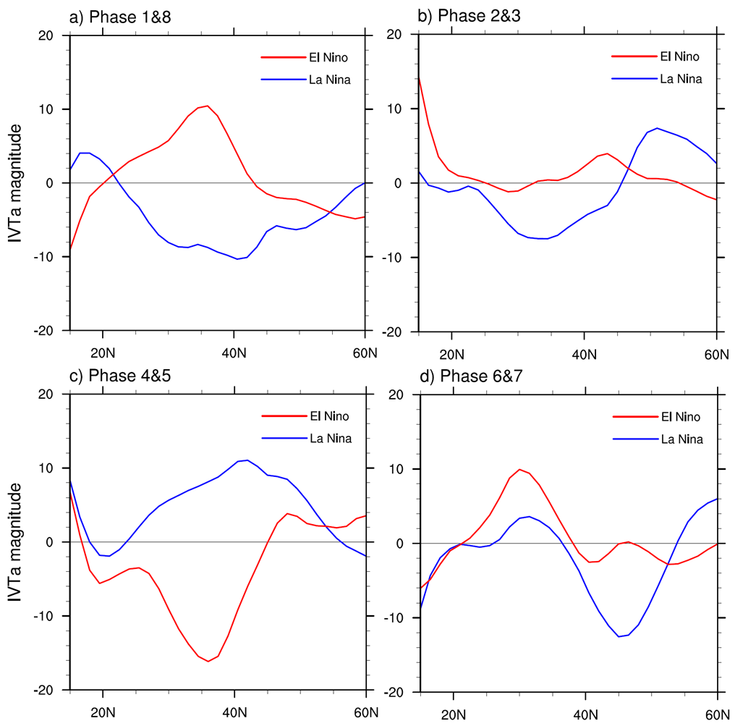
Supplementary Fig. 6. ENSO impacts on MJO-related response in IVT magnitude over the North Pacific
North Pacific averaged (220-240 °E) anomalies of IVT magnitude between the two ENSO phases for different MJO phase combinations. The unit of IVT magnitude is kg m⁻¹ s⁻¹.

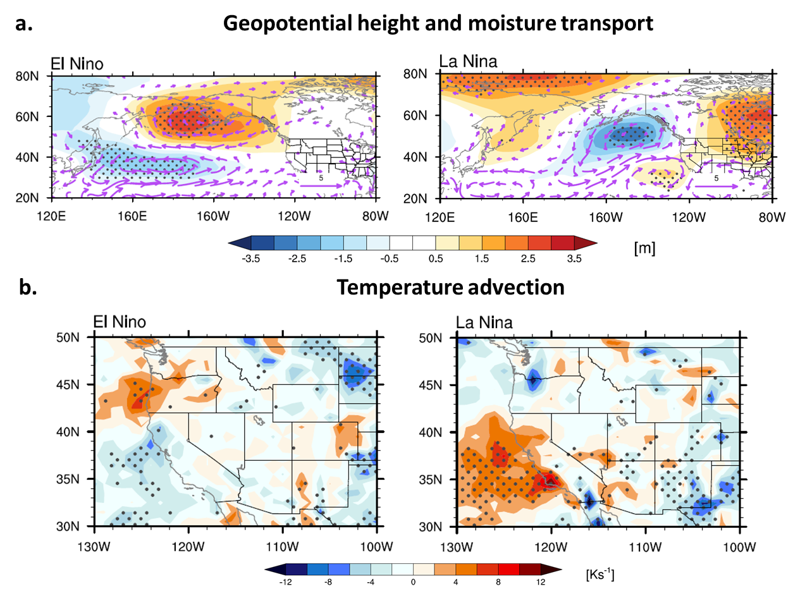
Supplementary Fig. 7. Changes in large-scale circulations, moisture transport, and temperature advection in response to ENSO impacts.
Same as Figs. 3 and 4, except for seasonal changes in large-scale circulations, moisture transport, and temperature advection (shading: 10⁷ K s⁻¹) impacted by ENSO only.

