Supporting information

Microwave-induced high dispersion anchoring of MOFs on SiC surfaces: Built-in electric field dominated process

Zongliang Kouª, Kai Liuª, Zhenyu Zhaoª, Hong Liª, Xin Gao^{a,b,}*
ªSchool of Chemical Engineering and Technology, National Engineering Research Center of Distillation Technology, Collaborative Innovation Center of Chemical Science and Engineering (Tianjin), Tianjin University, Tianjin 300072, China
^{b} Haihe Laboratory of Sustainable Chemical Transformations, Tianjin 300192, China

- Experimental section
1.1. Materials
SiC (200 meads, 99.9%), N, N-dimethylformamide (DMF, 99.9%), succinic anhydride (99%), 2-aminoterephthalic acid (98%), and 3-aminopropyltriethoxysilane were purchased from Aladdin (Shanghai, China). Acetic acid (99.8%), chlorobenzene (99.5%), Europium nitrate (hexahydrate) (Eu, 99.9%) and cyclohexene (99%) were purchased from Shanghai McLean Biochemical Technology Co., Ltd. (Shanghai, China). Acetone (AR) and anhydrous ethanol (AR) were purchased from Lianlong Bohua Pharmaceutical Chemicals Co. (Tianjin, China). Zirconium tetrachloride (98%) was purchased from Shanghai Myriad Biochemical Technology Co. (Shanghai, China). Dichloromethane (AR) was purchased from Comio Chemical Reagents (Tianjin, China). Chlorosulfonic acid (99%) was purchased from Shanghai Shengding Biotechnology Co. (Shanghai, China). Terbium nitrate hexahydrate (Tb) (99.99 %) was purchased from Jiuding Chemical Shanghai Technology Co., Ltd. (Shanghai, China). 1,3,5-Benzenetricarboxylic acid was purchased from Bide Pharmaceutical Technology Co., Ltd. (Shanghai, China). The SiC was calcined in a muffle furnace (SX-G12123, Tianjin Zhonghuan Electric Furnace Co., Ltd., China) at 800°C for 12 h before use. Fluorescein was purchased from Xiensi Biochemical Technology Co., Ltd. (Tianjin, China). Except for SiC, other pharmaceutical products were used as received. Carboxylated silicon carbide were prepared according to the previously reported method ^{1, 2, 3}.
1.2. Preparation of Europium/Terbium@SiC (Eu/Tb-MOF@SiC) Nanothermometers.
Similar to the method for preparing UIO-66-NH₂@SiC. Europium nitrate (443.97 mg), trimellitic acid (210.14 mg) and terbium nitrate (8.92 mg) were added to 50 mL DMF containing SiC under ultrasonic irradiation. After the solution was mixed uniformly, it was transferred to a tetrafluoro autoclave. Subsequently, it was heated in a microwave reactor (XH-800SE, Beijing Xianghu Technology Development Co., Ltd., China) for 40 min (120 °C, heating rate: 10 °C/min) (the reactor is shown in Fig. S1(a)). After the reaction, the product was centrifuged and washed three times each with DMF and ethanol. Finally, the product was dried in a vacuum drying oven at 80 °C for 12 h.
1.3. Preparation of NDI-MOF
The particles of Zr-MOF were prepared by using a microwave reactor according to the reported in the literature ⁴. First, we accurately weigh DMF (30 mL), ZrOCl₂.8H₂O (112.7 mg), and naphthalenediimide (BINDI) (171.3 mg) into a 50 mL polytetrafluoroethylene reactor. Subsequently, 20 mL of formic acid was added to the system, and a homogeneous suspension was obtained under ultrasonic irradiation (KQ-250E, Kunshan Ultrasound Instrument Co., Ltd. China). The above suspension was placed in a microwave reactor (XH-800SE, Beijing Xianghu Technology Development Co., Ltd., China). The microwave reactor was operated at 120°C (2.45 GHz, 1000 w) for 2.5 h to obtain rod-shaped crystals. After the synthesis, the resulting product was separated by centrifugation and washed twice using DMF and twice using acetone, then vacuum-dried at 80 °C for 24 h to give the pristine Zr-MOF.
1.4. "Hot spot" temperature measurement.
The hot spot temperature was measured according to the method previously reported by our group⁵ (the setup is shown in Fig. S1(b)).

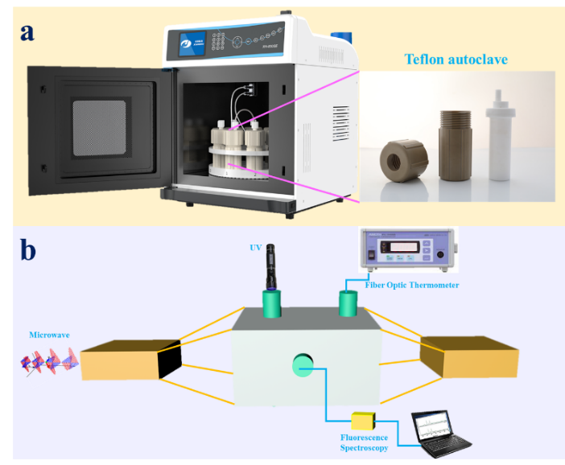
Fig. S1 Equipment diagram of microwave reactor and tetrafluoro autoclave (a), "Hot spot" temperature measurement device diagram (b).
1.5. Preparation of sulfonic acid functionalized UIO-66-NHSO₃H@SiC ^{6, 7, 8}
The synthesized UIO-66-NH₂@SiC (1 g) was suspended in CHCl₂ (30 mL). The mixed solution was continuously stirred in a three-necked flask with stirring. A mixed solution of DMF (10 mL) dissolved with 0.5 g of chlorosulfonic acid was added dropwise to the suspension of UIO-66-NH₂@SiC with a constant pressure dropping funnel within 30 min, and kept at 25 °C for 12 h. The product obtained after centrifugation was washed with CHCl₂ and dried under reduced pressure at 60°C to obtain an active UiO-66-NHSO₃H catalyst.
1.6. Evaluation of catalytic effect
4.68 g of cyclohexene and 10.26 g of acetic acid were weighed, and the mixed solution was transferred to a reaction kettle with tetrafluoroethylene. Then weigh 0.75 g of the catalyst UIO-66-NHSO₃H@SiC with active groups obtained in 2.4 into the reaction kettle. The mixed solution was placed in a microwave reactor (XH-800SE, Beijing Xianghu Technology Development Co., Ltd., China) and reacted at 100 °C for 3 h. After the reaction, the mixed solution was centrifuged, and the upper layer solution was taken and analyzed by gas chromatography (Trace 1300, Thermo Scientific, USA). The isolated catalyst was repeatedly washed with acetone and ethanol, and dried in a vacuum oven at 60°C.
2. Numerical simulation
2.1. Model simplifications
Although some differences exist between simulations and actual experiments, simulations can still reveal some physical phenomena and help us better understand the temperature rise inside the solution. To reduce the computational difficulty and save simulation time, we have made some assumptions about the model to simplify the computational process:
1. The temperature of the air at the hot air inlet of the blast oven is always consistent with the temperature of the air inside the oven during the calculation, and the air domain inside the oven is treated in accordance with the isothermal domain.
2. The initial temperature of the solution and air inside the hydrothermal reactor is uniform, which is 293K.
3. The initial temperature of the air in the microwave reactor is kept uniform at 293K.
4. The dielectric constant and dielectric loss of sic particles are constant.
5. The diameter of sic particles is 2.4mm, and the particle spacing is 0.25mm, arranged in a 3×3 stacking manner.
6. Neglect the PTFE plastic bracket inside the microwave reactor and the metal tray bracket inside the blast oven.
7. The microwave input frequency is fixed at 2.45GHz.
8. The oven and microwave chamber shells are adiabatic.
2.2. Physical model
The drawing module provided by COMSOL Multiphysics (V6.0) was used to accurately model the equipment used for conventional heating and microwave heating. As shown in Fig. S2, the main structure of the blast oven used for conventional heating is a 400mm x 400mm x 400mm aluminum square cavity structure, with a 120mm x 120mm hot air inlet located on the back side of the cavity. The conventional hydrothermal reactor is placed in the cavity center at a height of 20 mm from the cavity bottom. The detailed specifications of the hydrothermal reactor are shown in Fig. S3. During the simulation calculations, the solvent volume was determined based on the liquid level height at the actual reactors. In order to save calculation time, transient heating was calculated only for the first 2 min of conventional oven heating.
As shown in Fig. S4, the microwave reactor used for microwave heating is a 350 mm × 350 mm × 350 mm aluminum square cavity structure with an aluminum BJ26 rectangular waveguide (86.4 mm × 43.2 mm × 100 mm) connected to the side. The microwave, with an input power of 400W, is transmitted to the inside of the cavity through the waveguide to heat the microwave hydrothermal reactor located in the center of the cavity at a height of 20mm from the bottom of the cavity. Fig. S5 shows the detailed dimensions of the microwave hydrothermal reactor. The solvent volume in the model is determined according to the amount of solvent added to the actual reaction.
Since the simulation is only to observe the heating of the solution and SiC particles in the hydrothermal reactor during microwave heating, the transient simulation time of microwave heating is set to 60 s to complete the calculation quickly and obtain more obvious changes in temperature rise.

Fig. S2 Dimensions of the blast oven

Fig. S3 Dimensions of conventional hydrothermal reactor.

Fig. S4 Dimensions of the microwave reactor.

Fig. S5 Dimensions of the microwave hydrothermal reactor.

Fig. S6 The size and spacing of sic particles.

2.3. Definition of material properties
The microwave cavity, waveguide, and oven housing are all aluminum. The shell of the conventional hydrothermal reactor is 304 L stainless steel, while the shell of the microwave hydrothermal reactor consists of polytetrafluoroethylene (PTFE). In the actual reaction, the solution is defined as DMF in the modeling due to the addition of other components is almost negligible compared to N, N-Dimethylformamide (DMF). The dielectric properties of DMF were comprehensively measured using a dielectric network analyzer (Keysight, ENA 85033C). Moreover, as some of the physical properties data of DMF and SiC are absent from the database supplied with COMSOL Multiphysics (V6.0), data on the density, thermal conductivity, constant pressure heat capacity, kinetic viscosity, and conductivity of DMF were obtained by using Aspen Plus (V11.0) calculations. The dielectric data and conductivity of the sic used in the simulations are actual measured values, and the rest of the data of the sic are from the database built into Comsol Multiphysics (V6.0). The partial summary of the physical properties data required for the simulations is shown in Table 1.
TableS1 Material physical properties
Material | $$ε'$$ | $$ε''$$ | $$μ$$ | $σ(S/m$) | $ρ($kg/m³) | $k($W/(m$∙$K)) | $Cp($J/(kg$∙$K))
SiC ^{9, 10, 11} | 4.5 | 0.12 | 1 | $$σ_{sic}$$ | 3310 | $$k_{sic}$$ | $$Cp_{sic}$$
DMF | $$ε'_{DMF}$$ | $$ε''_{DMF}$$ | 1 | $$σ_{DMF}$$ | $$ρ_{DMF}$$ | $$k_{DMF}$$ | $$Cp_{DMF}$$
Air | 1 | 0 | 1 | 0 | $$ρ_{Air}$$ | $$k_{Air}$$ | $$Cp_{Air}$$
Aluminum | 1 | 0 | 1 | 3.774$×{10}^{7}$ | 2700 | 238 | 900
PTFE | 2.55 | 0 | 1 | 0 | $$ρ_{PTFE}$$ | $$k_{PTFE}$$ | $$Cp_{PTFE}$$
304L stainless Steel | - | - | 1 | - | $$ρ_{304L}$$ | $$k_{304L}$$ | $$Cp_{304L}$$

$$ε'_{DMF}\text{=21.96+2.46}×\text{1}{\text{0}}^{\text{15}}⋅T^{\text{-5.709}} \\ ε''_{DMF}\text{=20.03-0.0462}⋅T \\ σ_{sic}=\frac{1}{\exp{(}-\text{1.433037}×10^{-8}T^{3}\text{+5.315569}×10^{-5}T^{2}\text{-6.632958}×10^{-2}T\text{+22.14811})} \\ k_{sic}=\text{191.9216-0.326178}4⋅T+2.739462×10^{-4}T^{2}-7.70926×10^{-8}T^{3} \\ Cp_{sic}=24.94×(20.559+0.06458⋅T-5.\text{2988}×10^{-5}T^{2}\text{+1.6958}×10^{-8}T^{3}\text{-0.782}×10^{6}T^{-2}) \\ σ_{DMF}\text{=3.288}×10^{-6}⋅\text{T-8.9}×10^{-4} \\ ρ_{DMF}\text{=1216.26416-1.02405}⋅\text{T+7.8681}×10^{-4}T^{2}\text{-1.37379}×10^{-6}T^{3} \\ k_{DMF}=\text{0.26-2.55}×10^{-4}⋅\text{T+6.50118}×10^{-21}⋅T^{2} \\ Cp_{DMF}=\text{1134.80495+1.26194}⋅\text{T+5.16}×10^{-3}⋅T^{2}$$
$$ρ_{Air},k_{Air},Cp_{Air} were built-in material library \\ ρ_{PTFE},k_{PTFE},Cp_{PTFE} were built-in material library \\ ρ_{304L},k_{304L},Cp_{304L} were built-in material library$$
Where $ε'$, $ε''$, $μ$and $σ$ are the dielectric constant, dielectric loss, relative permeability, and electrical conductivity of the material, respectively.
2.4. Governing equations
The simulation of the microwave heating process involves the coupling of multiple physical fields, including electromagnetic field and temperature field. The distribution of the electric field in the microwave reactor cavity was calculated by Maxwell's wave equation¹².
$∇×{μ_{r}}^{-1}×\left(∇×E\right)-k_{0}^{2}\left(ε_{0}ε_{r}-jσ/ω_{0}\right)E=0$ (1)
$k_{0}=ω\sqrt{ε_{0}μ_{0}}$ (2)
Where E is the electric field strength, $ε_{0}$ is the permittivity of vacuum (8.854$×$10¹² F/m), $μ_{r}$ is the relative permeability, k₀ represents the wave number, and $ω_{0}$ represents the angular frequency. For non-magnetic material, the main parameter which describes the level of heat generation inside a microwave absorbent material is the complex permittivity ($ε_{r})$ as represented in equation (3)¹³.
$ε_{r}=ε'-ε''j$ (3)
The real part $ε'$ and imaginary part $ε''$ of the complex permittivity represent the ability of a material to store electrical energy and to convert electrical energy into heat, respectively¹⁴. Generally, the dielectric loss angle tangent is used to characterize the ability of a material to convert absorbed microwave energy into thermal energy, and the expression of $\tan{δ}$ was shown in Equation (4).
$\tan{δ}=\frac{ε''}{ε'}$ (4)
The electromagnetic power loss Q_{MW} of wave absorbing material can be obtained by equation (5).
$Q_{MW}=πfε_{0}ε''{\left|E\right|}^{2}V_{m}$ (5)
Where $V_{m}$ is the volume of material. Combining Equation (5), the temperature distribution in the microwave reactor can be calculated by Equation (6).
$ρCp\frac{∂T}{∂t}+ρCpu⋅∇T=∇⋅(k∇T)+Q_{MW}$ (6)
Where $u$ is represents the velocity vector, which can be obtained by combining the continuity equation (7) and the momentum equation (8).
$\frac{∂ρ}{∂t}+∇⋅(ρu)=0$ (7)$ρ\frac{∂u}{∂t}+ρu⋅∇u=-∇p+∇⋅\left[μ\left(∇u+{\left(∇u\right)}^{T}\right)-\frac{2}{3}μ\left(∇⋅u\right)\right]+F$ (8)
Where $μ$, P, and F are dynamic viscosity, pressure, and volume force vector, respectively.
2.5. Boundary conditions
The shell of the microwave chamber and the blast oven are considered thermally insulated without transferring heat to the outside, and their boundary equation is described by equation (9).
$-n⋅q=0$ (9)

The microwave reactor cavity shell is an ideal electrical conductor, which can be described by equation (10).
$n×E=0$ (10)
The hydrothermal reactor in the microwave reactor transfers heat to the surrounding air through radiation.
$-n⋅q=εσ\left(T_{amb}^{4}-T^{4}\right)$ (11)
where ε is the surface emissivity, σ is the Stefan-Boltzmann constant (a predefined physical constant), and Tamb is the ambient temperature.
The hydrothermal reactor in the blast oven undergoes forced convection heat transfer with the surrounding flowing air. The heat transfer coefficient h follows the cylindrical winding mode of external forced convection, and the expression was given in Equation (14).
$-n∙q=q_{0}$ (12)
$q_{0}=h\left(Text-T\right)$ (13)
$h=\frac{k}{D}\left(0.3+\frac{0.62{Re}_{D}^{1/2}{{Pr}^{1/3}}}{{\left(1+{\left(\frac{0.4}{Pr}\right)}^{2/3}\right)}^{1/4}}{\left(1+{\left(\frac{{Re}_{D}}{282000}\right)}^{5/8}\right)}^{4/5}\right)$ (14)
2.6. Mesh generation
The grid division dramatically impacts the accuracy of the calculation results. Based on extensive literature ^{11, 15, 16}, at least 12 cells per wavelength length are required to obtain mesh-independent results for microwave radiation at 2.45 GHz. According to the mesh independence study, the mesh size used in this paper was defined as
$m_{meshsize}≤\frac{c}{8f\sqrt{ε'}}$ (15)
Where $m_{meshsize}$ is the size of the unit mesh cell, f is microwave frequency (2.45GHz), C is the speed of light in a vacuum, and is the material's dielectric constant. The schematic diagram of the mesh division is shown in Figure 6.

Fig. S7 The schematic diagram of the mesh division

2.7. Solver
For solving the heating problem in microwave fields, the generalized minimum residual method (GMRES) was used to solve the wave equations in microwave fields. In contrast, the direct iterative method (PARDISO) is used to solve heat conduction and radiation. A Hewlett-Packard workstation with two Intel Xeon CPUs (X5687 @3.60GHz) and 96 GB of RAM was used to solve the above model.
3. Supplementary figures
Fig. S8 X-ray diffraction pattern of samples

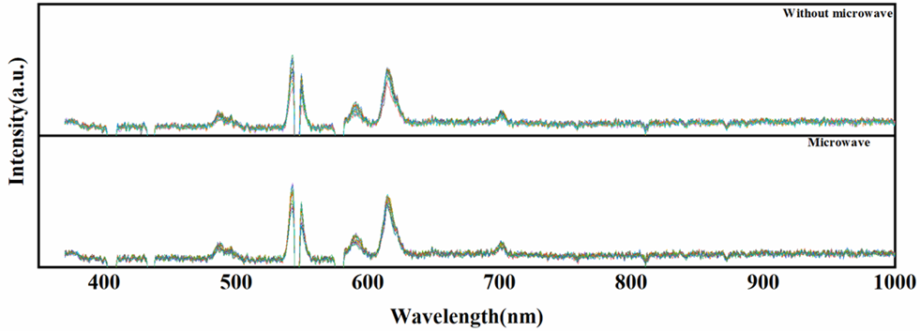
Fig. S9 Fluorescence Spectrogram.

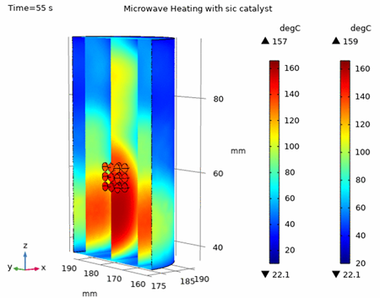
Fig. S10 Simulation diagram of temperature change between SiC particles and solvent
Fig. 11 EPR spectrum of NDI^{‧-} in MOF system

References
1. Gou K, et al. Carboxyl-functionalized mesoporous silica nanoparticles for the controlled delivery of poorly water-soluble non-steroidal anti-inflammatory drugs. Acta Biomater 134, 576-592 (2021).

2. Zhu QY, et al. Speciation analysis of chromium by carboxylic group functionalized mesoporous silica with inductively coupled plasma mass spectrometry. Talanta 195, 173-180 (2019).

3. Zhang C, et al. Selective Immobilization of Highly Valent Radionuclides by Carboxyl Functionalized Mesoporous Silica Microspheres: Batch, XPS, and EXAFS Analyses. ACS Sustainable Chemistry & Engineering 6, 15644-15652 (2018).

4. Radha G, Roy S, Chakraborty C, Aggarwal H. Electrochromic and photochromic behaviour in a single metal-organic framework containing a redox-active linker. Chem Commun (Camb) 58, 4024-4027 (2022).

5. Zhao Z, et al. Watching Microwave-Induced Microscopic Hot Spots via the Thermosensitive Fluorescence of Europium/Terbium Mixed-Metal Organic Complexes. Angew Chem Int Ed Engl 61, e202114340 (2022).

6. Zhao X-N, et al. A highly efficient and recyclable cobalt ferrite chitosan sulfonic acid magnetic nanoparticle for one-pot, four-component synthesis of 2H-indazolo[2,1-b]phthalazine-triones. RSC Adv 4, 51089-51097 (2014).

7. Homaee M, Hamadi H, Nobakht V, Javaherian M, Salahshournia B. Ultrasound-assisted synthesis of UiO-66-NHSO3H via post-synthetic modification as a heterogeneous Brønsted acid catalyst. Polyhedron 165, 152-161 (2019).

8. Kassaee MZ, Masrouri H, Movahedi F. Sulfamic acid-functionalized magnetic Fe3O4 nanoparticles as an efficient and reusable catalyst for one-pot synthesis of α-amino nitriles in water. Applied Catalysis A: General 395, 28-33 (2011).

9. Ghorbel I, Ganster P, Moulin N, Meunier C, Bruchon J. Experimental and numerical thermal analysis for direct microwave heating of silicon carbide. J Am Ceram Soc 104, 302-312 (2021).

10. Tamang S, Aravindan S. 3D numerical modelling of microwave heating of SiC susceptor. Appl Therm Eng 162, (2019).

11. Yu S, et al. Three-dimensional simulation of a novel microwave-assisted heating device for methyl ricinoleate pyrolysis. Appl Therm Eng 153, 341-351 (2019).

12. Ye J, Zhang C, Zhu H. A Temperature-Control System for Continuous-Flow Microwave Heating Using a Magnetron as Microwave Source. Ieee Access 8, 44391-44399 (2020).

13. Gao X, Liu X, Yan P, Li X, Li H. Numerical analysis and optimization of the microwave inductive heating performance of water film. Int J Heat Mass Tran 139, 17-30 (2019).

14. Zhang Y, Zhao Z, Li H, Li X, Gao X. Numerical modeling and optimal design of microwave-heating falling film evaporation. Chem Eng Sci 240, 116681 (2021).

15. Liao Y, et al. A Phase-Shifting Method for Improving the Heating Uniformity of Microwave Processing Materials. Materials (Basel) 9, (2016).

16. Zhu H, et al. A rotary radiation structure for microwave heating uniformity improvement. Appl Therm Eng 141, 648-658 (2018).

