S1. Metabolite quantification and quality assessment
¹H-MRS data were pre-processed using the FID Appliance (FID-A) pipeline (www.github.com/CIC-methods/FID-A) running in MATLAB 9.2.0 (The Mathworks Inc., Natick, Massachusetts, USA). FID-A runs several steps, namely weighted receiver coil combination; removal of motion corrupted averages; frequency and phase drift correction; and spectral registration to align ON and OFF sub-spectra [1], in addition to creating the files needed for further analysis with LCModel [2] (Stephen Provencher Inc., Oakville, Canada). GABA+ and glutamate were then quantified from the difference spectrum [3] using LCModel version 6.3-1L (http://s-provencher.com/lcmodel.shtml). The basis set used for quantification of the difference spectrum was simulated using FID-A software and high-density matrix simulations [4] with 201 x 201 x 201 spatial positions and included GABA+, Glutamate, Glutamine, N-Acetylaspartate, N-Acetylaspartilglutamate and Glutathione. Metabolite coupling constants used were based on the study by Govindaraju et al [5], except for GABA which value was based in updated estimation from Kreis & Bolliger [6]. The unsuppressed water signal was used to obtain water-scaled metabolite values and perform eddy-current correction.
The ¹H-MRS voxel was coregistered to the SPGR anatomical scan (see Supplementary Figure 1) using the standalone coregistration routine from Gannet 3.0 (http://www.gabamrs.com) running in MATLAB 9.2.0 (The Mathworks Inc., Natick, Massachusetts, USA) which then runs the Statistical Parametric Mapping 12 (SPM12) (https://www.fil.ion.ucl.ac.uk/spm/software/spm12) segmentation tool to extract the proportion of grey matter (pGM), white matter (pWM) and cerebrospinal fluid (pCSF) within the voxel (see Supplementary Figure 3). These tissue proportion values were then used to correct the water-scaled metabolite values for partial volume effects and different amounts of ‘visible’ water in each tissue type. Each individual metabolite was corrected using the following calculation:

Met_{corr} = Met_{LCModel} x ((43300 x pGM + 35880 x pWM + 55556 x pCSF)/35880) / (1/(1-pCSF))

where Met_{corr} is the corrected value, Met_{LCModel} is the initial LCModel output, 43300, 35880, and 55556 are the water concentrations in millimolar for GM, WM and CSF, respectively. The division by 35880 in the first fraction corrects for the LCModel initial analysis assumption of a pure WM voxel (further details in the LCModel manual, http://s-provencher.com/lcmodel.shtml). This results in the final equation:

Met_{corr} = Met_{LCModel} x ((1.207 x pGM + pWM + 1.548 x CSF) / (1/(1-pCSF))

All metabolite values are reported in institutional units.
Spectra (see Supplementary Figure 2) were visually inspected for data and fitting quality. Briefly, spectra were inspected for artifacts (subtraction artifacts, ghosts), baseline irregularities and residuals. Two participants (both with ASPD+P) were excluded from further analysis due to noisy spectra and/or poor fitting quality.
Measures of spectra data quality for the final sample were: standard deviation of the Cramer-Rao lower bounds (%CRLB) between 3% and 8% for glutamate and between 3% and 5% for GABA+; signal-to-noise ratios between 20 and 31, and full width at half maximum between 0.038 ppm and 0.096 ppm.

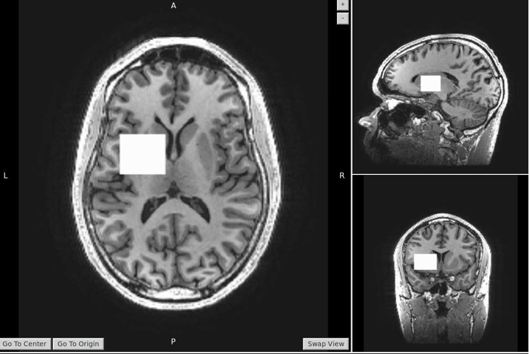
S
A

P
A

S
R
L
R
L

I
P

Supplementary Figure 1. Anatomical placement of the ¹H-MRS voxel. A, anterior; P, posterior; L, left; R, right; S, superior, I, inferior

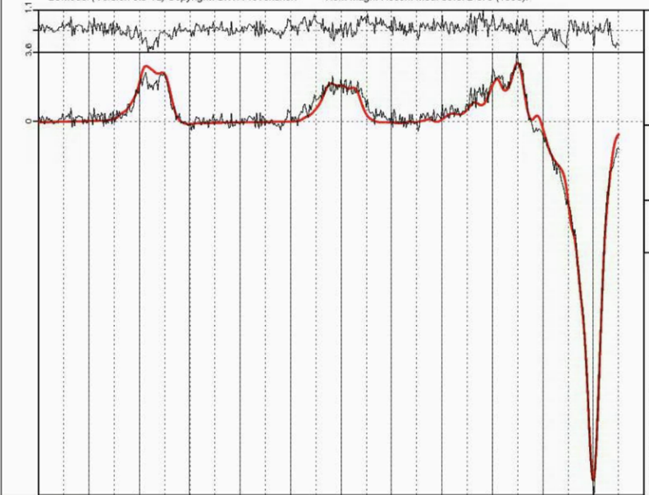
Supplementary Figure 2. Example of magnetic resonance spectroscopy spectra in the ¹H-MRS voxel.
X axis represents the peak amplitude, and the y-axis represents the chemical shift in parts per million (p.p.m.). Abbreviations: γ-aminobutyric acid + macromolecules, GABA+; glutamate + glutamine, Glx; N-acetyl-aspartate, NAA.

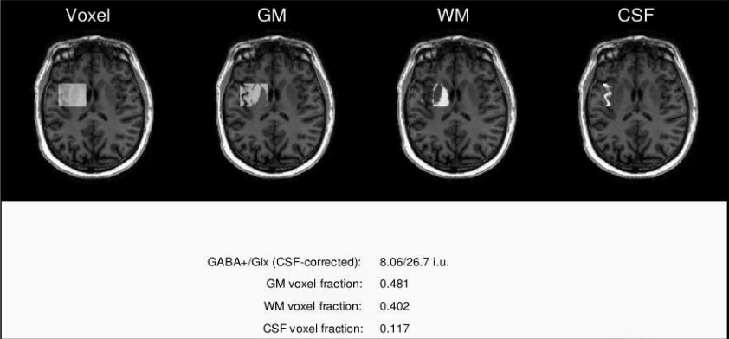
Supplementary Figure 3. Example of output from segmentation step. Abbreviations: GM, grey matter; WM, white matter; CSF, cerebrospinal fluid; i.u, institutional units.

 | Group |  |  |  | Group Comparisons*
Demographic/  Clinical Characteristic | NO  (n =21) | All ASPD  (n= 30) | ASPD-P  (n= 15) | ASPD+P  (n= 19) | NO vs All ASPD | ASPD-P vs ASPD+P
Any drug | 4 (19%) | 16 (53.3%) | 8 (50%) | 8 (57.1%) | 0.019 | 0.73
Cannabis | 4 (19%) | 11 (36.6%) | 5 (31.2%) | 6 (42.8%) | 0.2214 | 0.706
Cocaine | 2 (9.5%) | 9 (30%) | 4 (25%) | 5 (35.7%) | 0.0977 | 0.694
Opioid | 0 (0%) | 3 (10%) | 1 (6.2%) | 2 (14.2%) | 0.2588 | 0.586
Benzodiazepine | 0 (0%) | 3 (10%) | 1 (6.2%) | 2 (14.2%) | 0.2588 | 0.586
Amphetamine | 1 (4.7%) | 0 (0%) | 0 (0%) | 0 (0%) | 0.4118 | n/a
Other hallucinogenic | 1 (4.1%) | 0 (0%) | 0 (0%) | 0 (0%) | 0.4118 | n/a

Supplementary Table 1. Positive illicit drug tests. *p value for Fisher’s exact test provided in each case.

1 Simpson R, Devenyi GA, Jezzard P, Hennessy TJ, Near J. Advanced processing and simulation of MRS data using the FID appliance (FID‐A)—an open source, MATLAB‐based toolkit. Magnetic resonance in medicine. 2017;77(1):23-33.
2 Provencher SW. Automatic quantitation of localized in vivo 1H spectra with LCModel. NMR in Biomedicine. 2001;14(4):260-64.
3 van Veenendaal TM, Backes WH, van Bussel FC, Edden RA, Puts NA, Aldenkamp AP, et al. Glutamate quantification by PRESS or MEGA-PRESS: Validation, repeatability, and concordance. Magnetic resonance imaging. 2018;48:107-14.
4 Zhang Y, An L, Shen J. Fast computation of full density matrix of multispin systems for spatially localized in vivo magnetic resonance spectroscopy. Medical physics. 2017;44(8):4169-78.
5 Govindaraju V, Young K, Maudsley AA. Proton NMR chemical shifts and coupling constants for brain metabolites. NMR in Biomedicine: An International Journal Devoted to the Development and Application of Magnetic Resonance In Vivo. 2000;13(3):129-53.
6 Kreis R, Bolliger CS. The need for updates of spin system parameters, illustrated for the case of γ‐aminobutyric acid. NMR in Biomedicine. 2012;25(12):1401-03.

