Supporting Information
Increase of anthropogenic NOx emissions stimulate the productivity on global ocean deserts
Qibin Lao¹, Hongliang Li², Jinpei Yan³, Peng Huang^{1, 4, 5}, Guangzhe Jin^{1, 4, 5}, Guirong He¹, Chunqing Chen¹, Qingmei Zhu^{1, 4, 5}, Fajin Chen^{1, 4, 5}*
¹ College of Ocean and Meteorology, Guangdong Ocean University, Zhanjiang, China
² Key Laboratory of Marine Ecosystem Dynamics, Second Institute of Oceanography, Ministry of Natural Resources, Hangzhou, China
³ Key Laboratory of Global Change and Marine Atmospheric Chemistry, Ministry of Natural Resources, Xiamen, China,
⁴ Key Laboratory of Climate, Resources and Environment in Continental Shelf Sea and Deep Sea of Department of Education of Guangdong Province, Guangdong Ocean University, Zhanjiang, China
⁵ Key Laboratory of Ocean Circulation and Wave Studies, Institute of Oceanology, Chinese Academy of Sciences, Qingdao, China
* Corresponding author: fjchen@gdou.edu.cn (Fajin Chen)

Index
Texts
Text S1. Nitrate production pathways
Text S2. Reaction mechanism of nitrogen oxides on ozone production and removal
Text S3. The Bayesian isotope mixing model
Figures
Figure S1. The annual-average of global tropospheric NO₂ for 2006-2021.
Figure S2. Air mass backward trajectory and NO3- concentrations for each sample collected along the Arctic (a), Indian Ocean-SCS, and Northwestern Pacific Ocean (b) cruises.
Figure S3. Distribution of SO₄²⁻ concentrations during the Indian Ocean-SCS and northwestern Pacific Ocean cruise.
Figure S4. The correlation between NO₃⁻ and nss-SO₄²⁻ in the East China and South Asian marginal sea.
Figure S5. Variations of the annual and monthly-mean ozone for globally different latitude from 1979-2022.
Figure S6. The variations of monthly day length in the southern and northern hemisphere.
Figure S7. Global distribution of averaged aerosol optical depth from 2006 to 2021.
Figure S8. Division of global marine areas in this study.
Tables
Table S1: Concentration and isotopic composition of atmospheric nitrate along the Indian Ocean-SCS, northwest Pacific and Arctic cruises
Table S2: Proportional contribution of potential nitrate sources in global different oceans
Table S3: Stations information and meteorological parameters during the sampling periods.
Table S4: The values of δ¹⁵N-NO₃⁻ for the potential nitrate sources.

Text S1. Nitrate production pathways
There are several pathways for NO_{x} oxidation to NO₃⁻, vary with day length, chemistry, and location^{1,2}. During the day, NO₂ in the atmosphere can be oxidized by an OH radical to form HNO₃ (R1). During the night, the reaction R1 halts, and NO₂ is further oxidized by O₃ to form NO₃ (R2). Then, NO₃ can react with NO₂ to form N₂O₅ (R3) that is easily hydrolysed to generate HNO₃ (R4), or NO₃ reacts with hydrocarbons (HC) or DMS to form HNO₃ (R5). In addition, NO₂ can also react with reactive halogens (such as BrO) in some regions where halogens are elevated to form HNO₃ (R6-R7)^{3,4}.
NO₂ + OH + M → HNO₃ + M (R1)
NO₂ + O₃ → NO₃ + O₂ (R2)
NO₃ + NO₂ + M → N₂O₅ + M (R3)
N₂O₅ (g) + H₂O (l) → 2HNO₃ (R4)
NO₃ + HC or DMS → HNO₃ + products (R5)
NO₂ + BrO → BrNO₂ (R6)
BrNO₂ + H₂O → HNO₃ + HOBr (R7)
During the day-time, NO_{x} is usually oxidised by hydroxyl radicals (OH) to generate NO₃⁻. In contrast, O₃ oxidises NO_{x} to generate nitrate radicals (NO₃⁻) at night-time⁵. At night, NO₃⁻ can further react with hydrocarbons (HC) or dimethyl sulphide (DMS) to form N₂O₅, followed by hydrolysis to generate HNO₃⁶. In addition, NO_{x} can be oxidised by reactive halogens (e.g. BrO) in regions with higher halogen contents⁴. Usually, the NO₃⁻ produced via the OH pathway is characterised by negative δ¹⁸O-NO₃⁻ because one-third of oxygen atoms in formed NO₃⁻ comes from OH, which characterises negative δ¹⁸O (−15 to 0‰)⁷. NO₃⁻ formed via the O₃ pathway has higher δ¹⁸O because five-sixth of the oxygen atoms in two formed NO₃⁻ come from O₃ (90–120‰)⁸. In addition, NO₃⁻ formed via BrO, DMS, or HC has the highest δ¹⁸O since these processes originate from the terminal oxygen atom of O₃⁵.
Text S2. Reaction mechanism of nitrogen oxides on ozone production and removal
The hydroxyl radical (OH) is a strong oxidant that can react rapidly with most gas phase chemistry, resulting in their removal on a relatively short timescale during daytime. The primary production of OH is the photoproduct of ozone by ultraviolet (UV) sunlight with short wavelengths (λ<330 nm) in the presence of water vapor⁹:
O₃ + hv → O(¹D) + O₂ (R8)
O(¹D) + H₂O → 2OH (R9)
In the troposphere, peroxy radical plays a crucial role in the production and removal of ozone, which mainly depends on the availability of NO_{x}¹⁰. In the cleaner regions with low-NO_{x} atmosphere, the main loss processes for peroxy radicals HO₂ (hydroperoxyl, products of most OH-oxidation reactions) and RO₂ (organic peroxy, mainly composed of CH₃O₂ in clean air) are their recombination (R10 and R11) and reaction with ozone (R12). These processes result in net photochemical ozone destruction.
HO₂ + HO₂ → H₂O₂ + O₂ (R10)
CH₃O₂ + HO₂ → CH₃OOH + O₂ (R11)
HO₂ + O₃ → OH +2O₂ (R12)
In the polluted regions with NO_{x}-rich atmosphere, the secondary OH production is primarily controlled by NO_{x}^{5,6}, which can compete with reactions R10-R12, resulting in ozone generation via photolysis (λ<430 nm) of the NO₂ product.
HO₂ + NO → OH + NO₂ (R13)
NO₂ + hv → NO + O(³P) (R14)
O(³P) + O₂(+M) → O₃ (+M) (R15)
The balance between O₃ removal and O₃ generation is of major importance to the tropospheric O₃ budget, which has been widely discussed from a theoretical standpoint⁹⁻¹¹. Globally, tropospheric NO_{x} in the northern hemisphere is remarkably higher than that in the southern hemisphere, which may lead to the dominance of reactions R10-R12 in the southern hemisphere, whereas the dominance of reactions R13-R15 in the northern hemisphere.
Text S3. The Bayesian isotope mixing model
The formulation of nitrate-mixture measurements on isotopes (j) with source contributors (k) on the Bayesian isotope mixing model is as follows:
X_{ij} = $\sum_{k=1}^{k}{P_{k}\left(S_{jk}+c_{jk}\right)+ε_{ij}}$ (1)
S_{jk} ~ N (μ_{jk}, ω²_{jk}) (2)
c_{jk} ~ N (λ_{jk}, τ²_{jk}) (3)
ε_{jk} ~ N (0, σ²_{j}) (4)
where X_{ij} is the J-vector of δ¹⁵N-NO₃⁻ values for mixture i, which denotes the isotope measurement in mixture i for isotope j; s_{ik} is the J-vector of δ¹⁵N-NO₃⁻ sources values for mixture i on source k; P_{k} is the proportional contribution of potential nitrate sources; c_{jk} iss the fractionation factor for mixture i on nitrate source k, ε_{jk} is the residual error of the additional unquantified change between the aerosol samples.

Figure S1. The annual-average of global tropospheric NO₂ (×10¹⁴ molec cm⁻²; 0.25 latitude ×0.25 longitude) for 2006-2021.
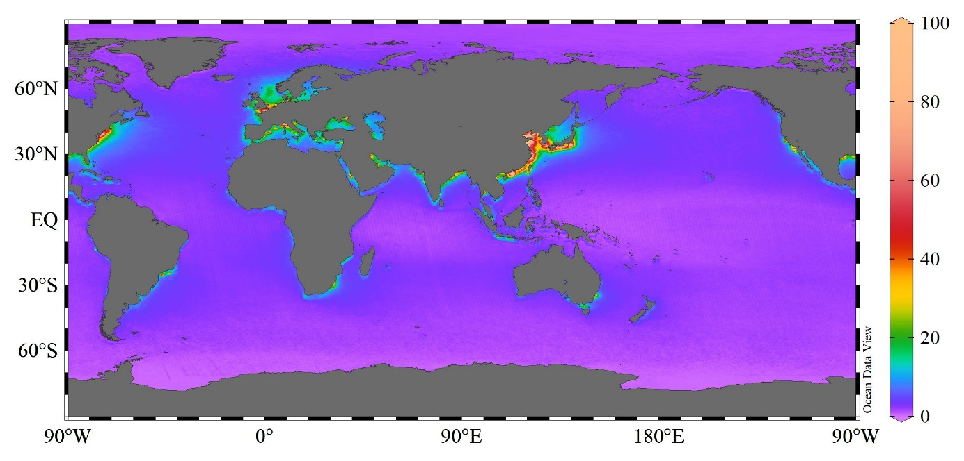
Note: The Ozone Monitoring Instrument (OMI) NO₂ data are available from the Aura Validation data Center (AVDC) on the National Aeronautics and Space Administration (NASA) (https://airquality.gsfc.nasa.gov/no2).

Figure S2. Air mass backward trajectory and NO₃⁻ concentrations for each sample collected along the Arctic (a), Indian Ocean-SCS, and Northwestern Pacific Ocean (b) cruises. Circles represent the geographic location where the aerosol sample was collected (endtime), and the different circle colours reflect NO₃⁻ concentrations.
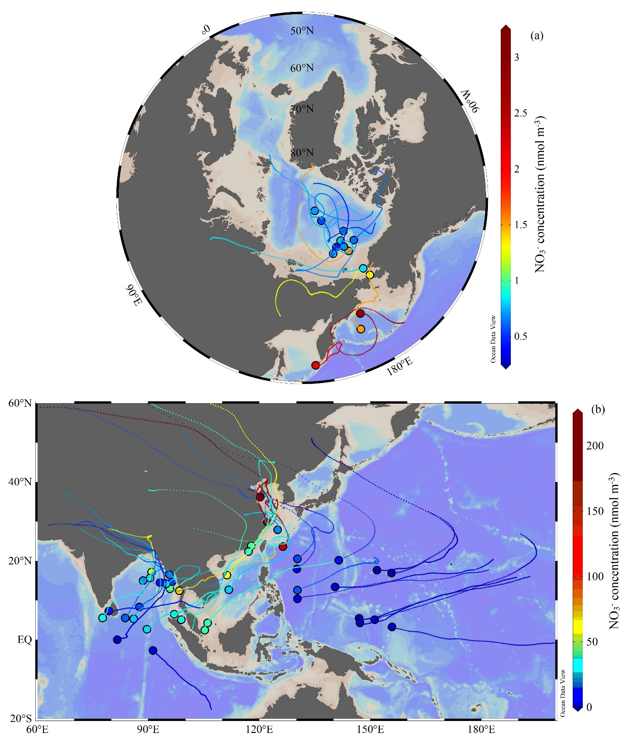

Figure S3. Distribution of SO₄²⁻ concentrations during the Indian Ocean-SCS and northwestern Pacific Ocean cruise.
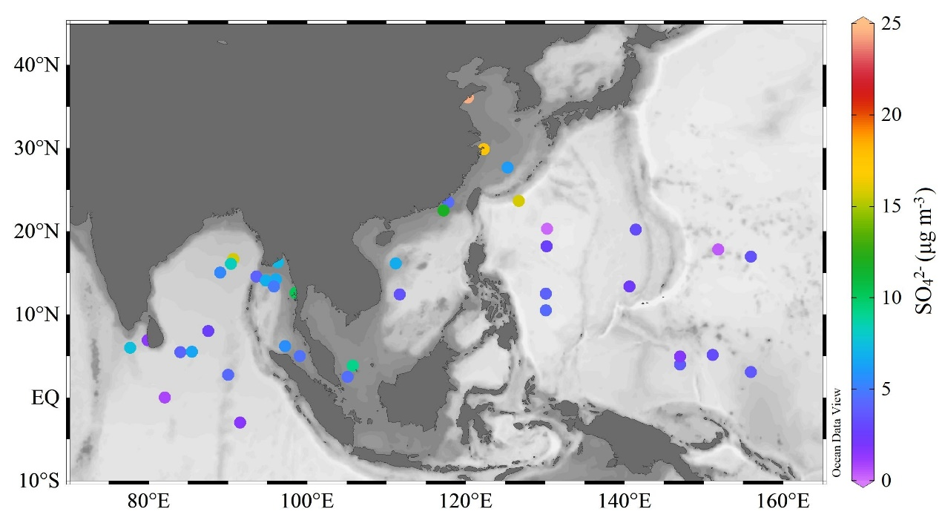

Figure S4. The correlation between NO₃⁻ and nss-SO₄²⁻ in the East China (a) and South Asian marginal sea (b).

Figure S5. Variations of the annual and monthly-mean ozone (Dobson Unit, DU) for globally different latitude from 1979-2022. The figure and data were obtained from National Aeronautics and Space Administration Ozone Watch (NASA Ozone Watch, https://ozonewatch.gsfc.nasa.gov/).
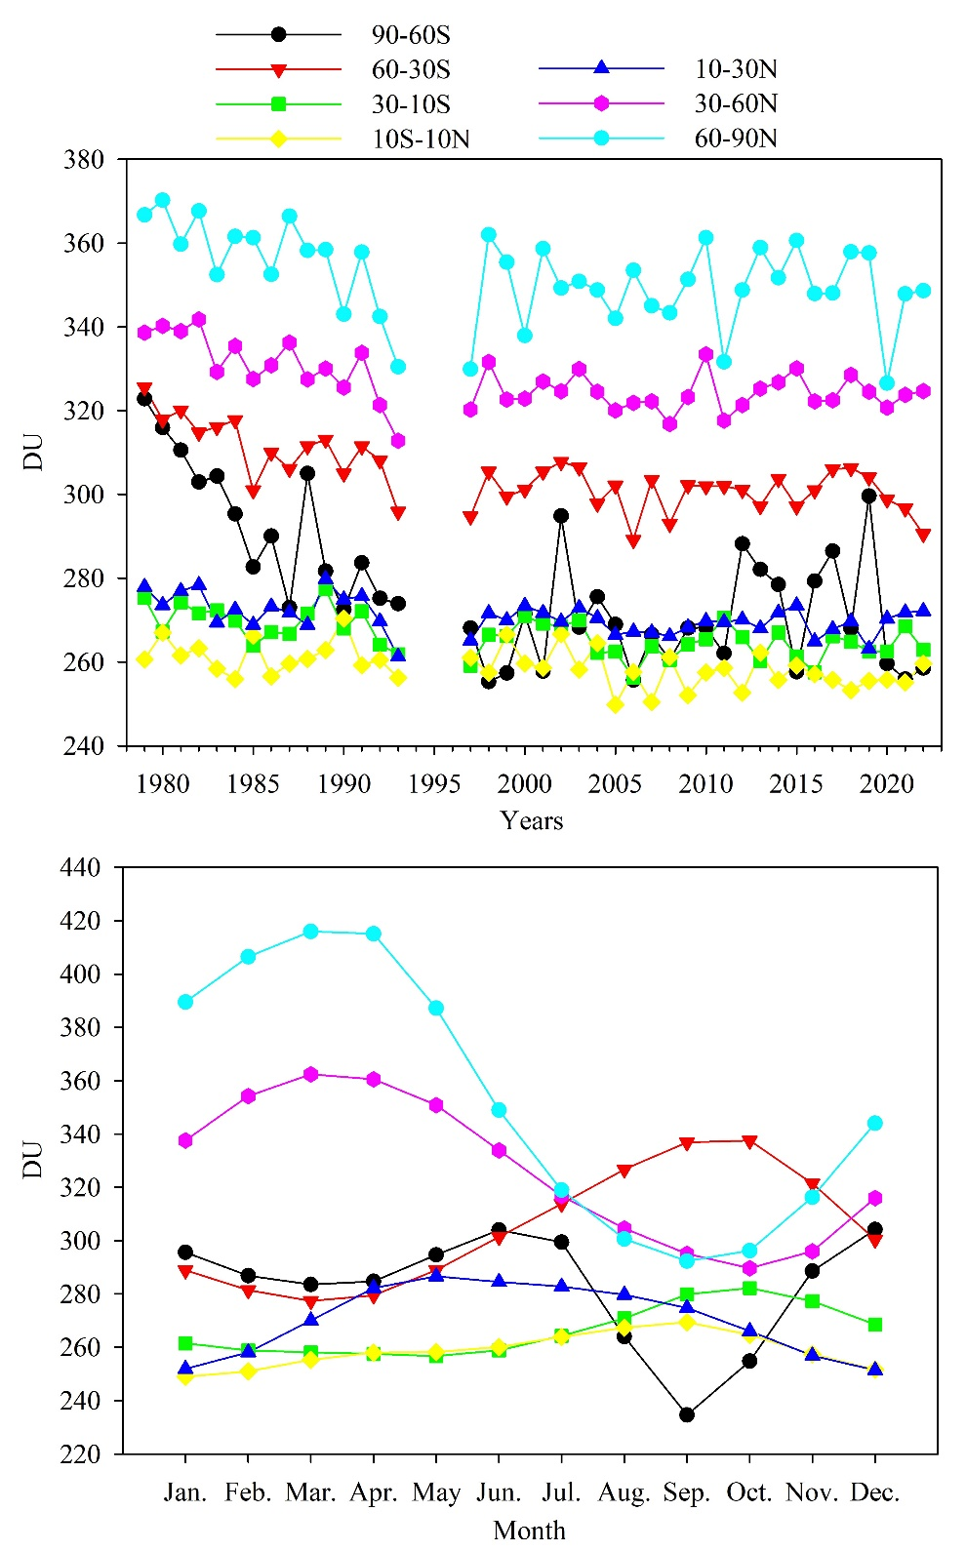

Figure S6. The variations of monthly day length in the southern and northern hemisphere.
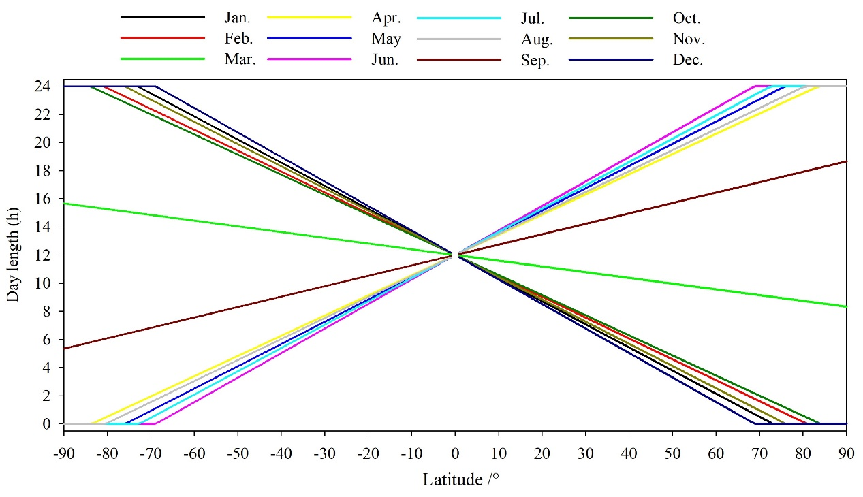

Figure S7. Global distribution of averaged aerosol optical depth (AOD, unitless) from 2006 to 2021.
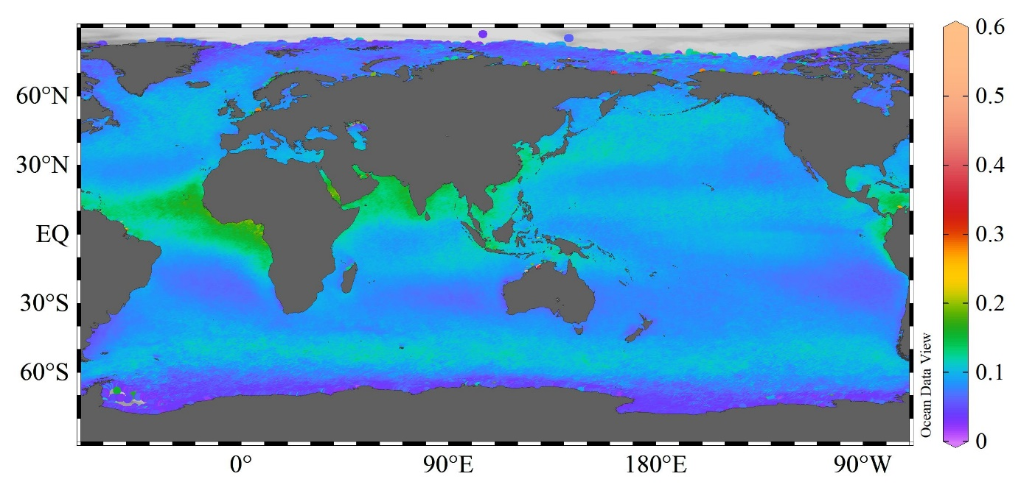
Note: The merged AOD data at 865 nm over a footprint of 4×4 km from January 2006 to December 2021 were obtained from the GloColour (https://hermes.acri.fr/).

Figure S8. Division of global marine areas in this study. NWP: Northwestern Pacific; NP: Northern Pacific; EP: Eastern Pacific.
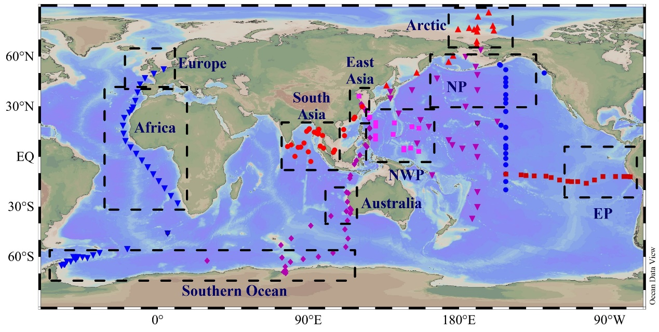

Table S1. Concentration and isotopic composition of atmospheric nitrate along the Indian Ocean-SCS, northwest Pacific and Arctic cruises
Stations | Latitude and longitude  Start | Latitude and longitude  End | NO₃⁻  (nmol m⁻³) | δ¹⁵N-NO₃⁻ (‰) | δ¹⁸O-NO₃⁻ (‰)
Y1 | 29°57′09.80″N 122°11′01.58″E | 23°33′18.62″N 117°46′48.51″E | 47.90 | 5.2 | 68.0
Y2 | 23°30′36.36″N 117°45′07.60″E | 17°53′30.65″N111°59′42.87″E | 62.09 | -1.1 | 67.0
Y3 | 16°09′58.71″N 111°09′57.32″E | 3°52′08.31″N 105°45′38.24″E | 39.78 | -2.7 | 74.8
Y4 | 3°51′06.22″N 105°44′40.52″E | 6°10′59.95″N97°20′46.90″E | 35.38 | 0.9 | 70.9
Y5 | 6°11′10.21″N 97°10′47.68″E | 2°47′37.37″N 89°59′49.01″E | 29.58 | 1.5 | 66.4
Y6 | 2°45′32.23″E 89°59′36.91″E | 2°59′51.99″S 91°30′17.17″E | 3.95 | -0.2 | 63.7
Y7 | 2°59′45.46″S 91°30′21.33″E | 00°00′25.93″N 82°00′56.6″E | 3.44 | 0.1 | 64.3
Y8 | 00°00′29.73″N 82°01′03.91″E | 6°56′27.80″N 79°50′41.09″E | 8.92 | 1.9 | 62.6
Y9 | 06°56′27.18″N 79°50′40.62″E | 05°29′30.97″N 83°59′01.04″E | 17.63 | 2.3 | 72.1
Y10 | 05°28′08.26″N 83°57′57.10″E | 06°56′28.42″N 79°50′40.88″E | 39.84 | 4.3 | 65.1
Y11 | 06°00′27.13″N 77°38′01.76″E | 05°30′21.35″N 87°28′55.90″E | 27.92 | 2.9 | 73.5
Y12 | 05°33′24.97″N 85°27′29.70″E | 08°00′08.93″N 87°28′55.90″E | 17.15 | 10.3 | 78.4
Y13 | 08°00′08.93″N 87°28′55.90″E | 15°00′14.34″N 88°58′07.88″E | 22.62 | 6.4 | 76.4
Y14 | 15°04′12.32″N 89°00′21.22″E | 16°41′51.15″N 90°40′49.18″E | 57.41 | 1.9 | 79.7
Y15 | 16°41′43.72″N 90°40′27.01″E | 16°19′08.67″N 93°02′22.34″E | 23.33 | 2.7 | 70.3
Y16 | 16°19′08.67″N 96°18′05.01″E | 14°15′00.40″N 93°02′22.34″E | 13.72 | 5.5 | 73.0
Y17 | 14°14′32.57″N 96°01′46.45″E | 16°05′58.41″N 90°18′13.15″E | 39.62 | 5.0 | 75.3
Y18 | 16°06′13.75″N 90°20′18.35″E | 15°06′41.87″N 93°37′26.02″E | 8.22 | 2.4 | 66.3
Y19 | 14°34′13.37″N 93°33′39.04″E | 14°07′31.84″N 94°44′45.83″E | 37.09 | 4.6 | 68.7
Y20 | 14°06′49.66″N 94°45′26.03″E | 13°24′21.62″N 95°46′26.41″E | 50.03 | 5.3 | 64.2
Y21 | 13°24′01.43″N 95°46′02.67″E | 12°32′10.83″N 98°32′24.01″E | 65.17 | 6.1 | 68.2
Y22 | 12°36′55.94″N 98°28′45.75″E | 5°02′36.52″N 99°02′15.52″E | 34.99 | 1.7 | 64.8
Y24 | 5°00′20.23″N 99°03′57.41″E | 2°29′32.79″N 105°03′04.74″E | 41.53 | 3.5 | 60.2
Y25 | 2°31′20.73″N 105°03′53.14″E | 12°24′10.73″N 111°39′43.99″E | 28.96 | 3.2 | 66.5
Y26 | 12°25′32.99″N 111°40′30.98″E | 22°29′35.48″N 117°07′50.15″E | 33.85 | -0.3 | 66.7
Y27 | 22°31′06.68″N 117°09′08.53″E | 29°55′13.86″N 122°14′29.45″E | 161.13 | 6.3 | 70.1
W01 | 29°54′12.51″N 122°13′36.74″E | 23°40′47.48″N 126°38′29.79″E | 155.10 | 3.2 | 91.8
W02 | 23°39′05.68″N 126°39′31.60″E | 12°31′56.40″N 130°06′07.08″E | 15.18 | -3.3 | 86.1
W03 | 12°30′04.00″N 130°06′05.27″E | 10°29′51.08″N 130°06′10.05″E | 2.32 | 0.7 | 79.9
W04 | 10°31′02.00″N 130°04′36.00″E | 18°14′20.66″N 130°11′79.01″E | 3.34 | -1.0 | 78.0
W05 | 18°14′15.25″N 130°11′21.36″E | 13°22′32.84″N 140°32′20.01″E | 3.56 | -0.2 | 79.0
W06 | 13°22′05.50″N 140°38′38.85″E | 04°00′13.25″N 146°59′58.14″E | 2.28 | -1.6 | 78.2
W07 | 04°00′48.25″N 146°59′16.28″E | 04°58′33.73″N 146°59′09.36″E | 1.69 | -3.7 | 62.0
W08 | 04°58′35.06″N 146°59′10.12″E | 05°10′07.84″N 151°07′3.48″E | 2.65 | -1.0 | 82.1
W09 | 05°08′09.81″N 151°06′30.08″E | 03°04′26.99″N 155°56′27.28″E | 2.61 | -7.4 | 75.7
W10 | 03°06′55.34″N 155°56′52.31″E | 17°00′02.49″N 156°00′15.73″E | 3.22 | -4.7 | 84.8
W11 | 16°58′40.99″N 155°57′39.57″E | 17°48′30.81″N 151°51′08.45″E | 3.04 | -0.9 | 79.4
W12 | 17°49′29.66″N 151°50′28.68″E | 20°13′43.72″N 141°27′24.02″E | 9.22 | -4.3 | 90.0
W13 | 20°13′42.66″N 141°26′26.25″E | 20°15′36.41″N 130°15′04.82″N | 14.83 | -1.4 | 88.6
W14 | 20°19′35.72″N 130°15′10.41″E | 27°40′17.68″N 125°15′06.11″E | 24.64 | -2.1 | 86.8
W15 | 27°40′51.75″N 125°14′42.40″E | 36°06′12.04″N 120°15′14.69″E | 216.96 | 7.5 | 85.4
AA1 | 42°19.21′N 136°44.79′E  136 | 49°56.81′N 154°43.77′E | 2.21 | -1.2 | 66.1
AA2 | 49°56.81′N 154°43.77′E | 56°26.23′N 173°48.90′E | 1.41 | -3.2 | 66.6
AA3 | 56°26.23′N 173°48.90′E | 66°40.57′N 169°20.24′W | 1.27 | -2.9 | 63.7
AA4 | 66°40.57′N 169°20.24′W | 75°57.93′N 179°32.50′E | 0.79 | 0.3 | 65.4
AA5 | 75°57.93′N 179°32.50′E | 74°39.10′N 169°06.84′W | 1.52 | 2.7 | 67.1
AA6 | 74°39.10′N 169°06.84′W | 77°00.25′N 168°55.92′W | 0.76 | 0.5 | 61.9
AA7 | 77°00.25′N 168°55.92′W | 75°10.36′N 159°08.36′W | 0.59 | -1.0 | 58.9
AA8 | 75°10.36′N 159°08.36′W | 78°01.55′N 159°47.08′W | 0.61 | 0.2 | 55.7
AA9 | 78°01.55′N 159°47.08′W | 83°30.21′N 168°39.61′W | 0.55 | 0.9 | 53.4
AA10 | 83°30.21′N 168°39.61′W | 85°57.72′N 162°16.30′W | 0.71 | 1.4 | 53.3
AA16 | 77°27.06′N 176°45.75′W | 76°42.00′N 173°55.62′W | 0.50 | -4.2 | 60.4
AA17 | 76°42.00′N 173°55.62′W | 75°52.72′N 170°59.35′W | 0.71 | -3.8 | 64.4
AA18 | 75°52.72′N 170°59.35′W | 68°39.37′N 169°18.58′W | 0.82 | -4.2 | 67.0
AA19 | 68°39.37′N 169°18.58′W | 60°06.52′N 176°34.22′E | 3.04 | -3.1 | 78.6
Note: stations in Y are the Indian Ocean-SCS cruise; stations in W are the northwest Pacific Ocean cruise; stations in AA are the Arctic cruise.

Table S2. Proportional contribution of potential nitrate sources in global different oceans
Regions | Oceanic emissions | Snowpack emissions | Biomass burning | coal combustion | Vehicle emission | Lightning
Africa | 16±13% | 5±4% | 19±6% | 23±12% | 17±14% | 20±14%
Arctic | 17±13% |  | 28±15% | 31±17% | 25±17%
Australia | 17±7% | 6±3% | 19±12% | 21±20% | 18±17% | 20±12%
East Asia | 9±3% |  | 20±14% | 41±34% | 18±8% | 19±9%
Eastern Pacific | 31±13% |  | 17±11% | 13±8% | 18±15% | 21±17%
Europe | 14±9% |  | 28±19% | 37±14% | 20±14%
Northern Pacific | 31±25% |  | 20±18% | 34±14% | 15±12%
South Asia | 5±3% |  | 22±17% | 46±18% | 9±5% | 17±12%
Southern Ocean | 32±17% | 43±17% | 25±12%
Northwestern Pacific | 20±17% |  | 21±18% | 19±13% | 22±8% | 19±15%

Table S3. Stations information and meteorological parameters during the sampling periods.
Stations | Time  Start | Time  End | Flow (m³/min) | Latitude and longitude  Start | Latitude and longitude  End | T (℃) | P (hPa) | Wind speed (m/s) | Wind direction
Y1 | 2019.11.24 | 2019.11.27 | 1.32 | 29°57′09.80″N 122°11′01.58″E | 23°33′18.62″N 117°46′48.51″E | 22.5 | 1021.8 | 2.8 | NW
Y2 | 2019.11.27 | 2019.12.1 | 1.32 | 23°30′36.36″N 117°45′07.60″E | 17°53′30.65″N111°59′42.87″E | 22.0 | 1021.5 | 4.7 | N
Y3 | 2019.12.02 | 2019.12.05 | 1.27 | 16°09′58.71″N 111°09′57.32″E | 3°52′08.31″N 105°45′38.24″E | 21.5 | 1019.1 | 9.0 | NE
Y4 | 2019.12.05 | 2019.12.09 | 1.33 | 3°51′06.22″N 105°44′40.52″E | 6°10′59.95″N97°20′46.90″E | 28.0 | 1014.4 | 1.7 | NE
Y5 | 2019.12.09 | 2019.12.14 | 1.33 | 6°11′10.21″N 97°10′47.68″E | 2°47′37.37″N 89°59′49.01″E | 37.0 | 1014.2 | 1.0 | NE
Y6 | 2019.12.14 | 2019.12.20 | 1.34 | 2°45′32.23″E 89°59′36.91″E | 2°59′51.99″S 91°30′17.17″E | 29.4 | 1012.8 | 4.4 | S
Y7 | 2019.12.20 | 2019.12.28 | 1.34 | 2°59′45.46″S 91°30′21.33″E | 00°00′25.93″N 82°00′56.6″E | 27.0 | 1012.4 | 3.1 | SE
Y8 | 2019.12.28 | 2020.1.3 | 1.34 | 00°00′29.73″N 82°01′03.91″E | 6°56′27.80″N 79°50′41.09″E | 26.2 | 1012.9 | 0.8 | SE
Y9 | 2020.1.5 | 2020.1.10 | 1.33 | 06°56′27.18″N 79°50′40.62″E | 05°29′30.97″N 83°59′01.04″E | 28.0 | 1014.1 | 1.9 | SW
Y10 | 2020.1.10 | 2020.1.17 | 1.34 | 05°28′08.26″N 83°57′57.10″E | 06°56′28.42″N 79°50′40.88″E | 26.9 | 1013.0 | 5.8 | NE
Y11 | 2020.1.20 | 2020.1.25 | 1.33 | 06°00′27.13″N 77°38′01.76″E | 05°30′21.35″N 87°28′55.90″E | 25.5 | 1013.5 | 4.1 | W
Y12 | 2020.1.25 | 2020.1.31 | 1.33 | 05°33′24.97″N 85°27′29.70″E | 08°00′08.93″N 87°28′55.90″E | 25.5 | 1013.5 | 4.4 | N
Y13 | 2020.1.31 | 2020.2.7 | 1.33 | 08°00′08.93″N 87°28′55.90″E | 15°00′14.34″N 88°58′07.88″E | 26.2 | 1013.1 | 1.0 | NE
Y14 | 2020.2.7 | 2020.2.10 | 1.33 | 15°04′12.32″N 89°00′21.22″E | 16°41′51.15″N 90°40′49.18″E | 27.2 | 1018.1 | 2.6 | N
Y15 | 2020.2.10 | 2020.2.12 | 1.33 | 16°41′43.72″N 90°40′27.01″E | 16°19′08.67″N 93°02′22.34″E | 22.8 | 1016.9 | 2.4 | NE
Y16 | 2020.2.15 | 2020.2.17 | 1.34 | 16°19′08.67″N 96°18′05.01″E | 14°15′00.40″N 93°02′22.34″E | 26.1 | 1014.0 | 1.0 | NE
Y17 | 2020.2.17 | 2020.2.19 | 1.33 | 14°14′32.57″N 96°01′46.45″E | 16°05′58.41″N 90°18′13.15″E | 26.3 | 1013.9 | 2.6 | N
Y18 | 20202.20 | 2020.2.21 | 1.33 | 16°06′13.75″N 90°20′18.35″E | 15°06′41.87″N 93°37′26.02″E | 26.7 | 1019.0 | 4.7 | E
Y19 | 2020.2.21 | 2020.2.22 | 1.05 | 14°34′13.37″N 93°33′39.04″E | 14°07′31.84″N 94°44′45.83″E | 23.8 | 1018.1 | 8.7 | NW
Y20 | 2020.2.22 | 2020.2.23 | 1.06 | 14°06′49.66″N 94°45′26.03″E | 13°24′21.62″N 95°46′26.41″E | 30.6 | 1015.8 | 8.1 | NE
Y21 | 2020.2.23 | 2020.2.25 | 1.05 | 13°24′01.43″N 95°46′02.67″E | 12°32′10.83″N 98°32′24.01″E | 28.1 | 1016.3 | 1.0 | NE
Y22 | 2020.2.27 | 2020.2.29 | 1.05 | 12°36′55.94″N 98°28′45.75″E | 5°02′36.52″N 99°02′15.52″E | 33.4 | 1012.0 | 2.3 | NW
Y24 | 2020.2.29 | 2020.3.2 | 1.05 | 5°00′20.23″N 99°03′57.41″E | 2°29′32.79″N 105°03′04.74″E | 31.7 | 1009.7 | 4.2 | SE
Y25 | 2020.3.2 | 2020.3.5 | 1.06 | 2°31′20.73″N 105°03′53.14″E | 12°24′10.73″N 111°39′43.99″E | 30.8 | 1010.0 | 5.7 | N
Y26 | 2020.3.5 | 2020.3.8 | 1.05 | 12°25′32.99″N 111°40′30.98″E | 22°29′35.48″N 117°07′50.15″E | 30.2 | 1012.8 | 5.0 | N
Y27 | 2020.3.8 | 2020.3.11 | 1.05 | 22°31′06.68″N 117°09′08.53″E | 29°55′13.86″N 122°14′29.45″E | 26.3 | 1014.9 | 9.6 | NW
W01 | 2020.12.11 | 2020.12.13 | 1.05 | 29°54′12.51″N 122°13′36.74″E | 23°40′47.48″N 126°38′29.79″E | 13.1 | 1019.9 | 3.3 | NW
W02 | 2020.12.13 | 2020.12.17 | 1.05 | 23°39′05.68″N 126°39′31.60″E | 12°31′56.40″N 130°06′07.08″E | 28.1 | 1016.3 | 3.0 | SE
W03 | 2020.12.17 | 2020.12.20 | 1.05 | 12°30′04.00″N 130°06′05.27″E | 10°29′51.08″N 130°06′10.05″E | 31.1 | 1008.4 | 4.5 | W
W04 | 2020.12.20 | 2020.12.26 | 1.05 | 10°31′02.00″N 130°04′36.00″E | 18°14′20.66″N 130°11′79.01″E | 30.0 | 1011.1 | 3.6 | NE
W05 | 2020.12.26 | 2020.12.29 | 1.05 | 18°14′15.25″N 130°11′21.36″E | 13°22′32.84″N 140°32′20.01″E | 29.9 | 1016.2 | 3.9 | W
W06 | 2020.12.30 | 2021.01.03 | 1.05 | 13°22′05.50″N 140°38′38.85″E | 04°00′13.25″N 146°59′58.14″E | 32.6 | 1011.7 | 4.8 | E
W07 | 2021.01.03 | 2021.01.08 | 1.05 | 04°00′48.25″N 146°59′16.28″E | 04°58′33.73″N 146°59′09.36″E | 27.8 | 1010.0 | 4.3 | SW
W08 | 2021.01.08 | 2021.01.14 | 1.05 | 04°58′35.06″N 146°59′10.12″E | 05°10′07.84″N 151°07′3.48″E | 30.1 | 1009.8 | 5.2 | NE
W09 | 2021.01.14 | 2021.01.18 | 1.05 | 05°08′09.81″N 151°06′30.08″E | 03°04′26.99″N 155°56′27.28″E | 33.2 | 1007.1 | 4.1 | NW
W10 | 2021.01.18 | 2021.01.24 | 1.05 | 03°06′55.34″N 155°56′52.31″E | 17°00′02.49″N 156°00′15.73″E | 30.8 | 1008.5 | 9.3 | NE
W11 | 2021.01.25 | 2021.01.29 | 1.05 | 16°58′40.99″N 155°57′39.57″E | 17°48′30.81″N 151°51′08.45″E | 33.3 | 1010.5 | 2.2 | W
W12 | 2021.01.29 | 2021.02.01 | 1.05 | 17°49′29.66″N 151°50′28.68″E | 20°13′43.72″N 141°27′24.02″E | 30.2 | 1010.8 | 3.4 | NW
W13 | 2021.02.01 | 2021.02.03 | 1.05 | 20°13′42.66″N 141°26′26.25″E | 20°15′36.41″N 130°15′04.82″N | 26.9 | 1018.5 | 11.5 | E
W14 | 2021.02.04 | 2021.02.06 | 1.05 | 20°19′35.72″N 130°15′10.41″E | 27°40′17.68″N 125°15′06.11″E | 26.3 | 1018.5 | 10.6 | NE
W15 | 2021.02.06 | 2021.02.08 | 1.05 | 27°40′51.75″N 125°14′42.40″E | 36°06′12.04″N 120°15′14.69″E | 18.3 | 1019.6 | 6.9 | N
AA1 | 2020.07.15 | 2020.07.21 | 0.17 | 42°19.21′N 136°44.79′E  136 | 49°56.81′N 154°43.77′E | 21.5 | 1007 | - | -
AA2 | 2020.07.21 | 2020.07.24 | 0.10 | 49°56.81′N 154°43.77′E | 56°26.23′N 173°48.90′E | 13.7 | 1012 | - | -
AA3 | 2020.07.24 | 2020.07.27 | 0.10 | 56°26.23′N 173°48.90′E | 66°40.57′N 169°20.24′W | 11.1 | 1005 | - | -
AA4 | 2020.07.27 | 2020.07.30 | 0.10 | 66°40.57′N 169°20.24′W | 75°57.93′N 179°32.50′E | 4.0 | 994 | - | -
AA5 | 2020.07.30 | 2020.08.02 | 0.10 | 75°57.93′N 179°32.50′E | 74°39.10′N 169°06.84′W | 4.4 | 994 | - | -
AA6 | 2020.08.02 | 2020.08.05 | 0.10 | 74°39.10′N 169°06.84′W | 77°00.25′N 168°55.92′W | 4.1 | 1010 | - | -
AA7 | 2020.08.05 | 2020.08.08 | 0.10 | 77°00.25′N 168°55.92′W | 75°10.36′N 159°08.36′W | 1.6 | 1001 | - | -
AA8 | 2020.08.08 | 2020.08.11 | 0.10 | 75°10.36′N 159°08.36′W | 78°01.55′N 159°47.08′W | 3.9 | 1003 | - | -
AA9 | 2020.08.11 | 2020.08.14 | 0.10 | 78°01.55′N 159°47.08′W | 83°30.21′N 168°39.61′W | 3.4 | 1004 | - | -
AA10 | 2020.08.14 | 2020.08.17 | 0.10 | 83°30.21′N 168°39.61′W | 85°57.72′N 162°16.30′W | 5.3 | 1014 | - | -
AA16 | 2020.09.03 | 2020.09.06 | 0.10 | 77°27.06′N 176°45.75′W | 76°42.00′N 173°55.62′W | 2.0 | 1022 | - | -
AA17 | 2020.09.06 | 2020.09.09 | 0.10 | 76°42.00′N 173°55.62′W | 75°52.72′N 170°59.35′W | 3.2 | 1024 | - | -
AA18 | 2020.09.09 | 2020.09.12 | 0.10 | 75°52.72′N 170°59.35′W | 68°39.37′N 169°18.58′W | 6.4 | 1006 | - | -
AA19 | 2020.09.12 | 2020.09.15 | 0.10 | 68°39.37′N 169°18.58′W | 60°06.52′N 176°34.22′E | 12.6 | 1006 | - | -
Note: stations in Y are the Indian Ocean-SCS cruise; stations in W are the northwest Pacific Ocean cruise; stations in AA are the Arctic cruise.

Table S4. The values of δ¹⁵N-NO₃⁻ for the potential nitrate sources.
Sources | δ¹⁵N-NO₃⁻ | Reference
Oceanic sources | -15.4‰ | This study
Snowpack emissions | -54‰ | ^{12,13}
Fossil fuel combustion | 6—13‰ (9.6±2.9‰) | ¹⁴
Biomass combustion | -7.2—12.0‰ (1.0±4.1‰) | ¹⁵
Vehicle emission | -2‰—-13‰  (-7.0±4.7‰) | ^{14,16}

References
- Kamezaki, K. et al. Tracing the sources and formation pathways of atmospheric particulate nitrate over the Pacific Ocean using stable isotopes. Atmos. Environ. 209, 152-166 (2019).
- Luo, L. et al. Quantifying the formation pathways of nitrate in size-segregated aerosols during winter haze pollution. Gondwana Res. 115, 71-80 (2023).
- Carter, T. T. S., Joyce, E. E., & Hastings, M. G. Quantifying Nitrate Formation Pathways in the Equatorial Pacific Atmosphere from the GEOTRACES Peru-Tahiti Transect. ACS Earth Space Chem. 5, 2638-2651 (2021).
- Joyce, E. E., Balint, S. J., & Hastings, M. G. Isotopic evidence that alkyl nitrates are important to aerosol nitrate formation in the Equatorial Pacific. Geophys. Res. Lett. 49, e2022GL099960 (2022).
- Shi, G. et al. Using stable isotopes to distinguish atmospheric nitrate production and its contribution to the surface ocean across hemispheres. Earth Planet. Sci. Lett. 564, 116914 (2021).
- Alexander, B. et al. Quantifying atmospheric nitrate formation pathways based on a global model of the oxygen isotopic composition (Δ17O) of atmospheric nitrate. Atmos. Chem. Phys. 9, 5043-5056 (2009).
- Vicars, W. C., & Savarino, J. Quantitative constraints on the ¹⁷O-excess (Δ¹⁷O) signature of surface ozone: Ambient measurements from 50N to 50S using the nitrite-coated filter technique. Geochim. Cosmochim. Ac. 135, 270-287 (2014).
- Krankowsky, D. et al. Measurement of heavy isotope enrichment in tropospheric ozone. Geophys. Res. Lett. 22, 1713-1716 (1995).
- Lelieveld, J., Gromov, S., Pozzer, A., & Taraborrelli, D. Global tropospheric hydroxyl distribution, budget and reactivity. Atmos. Chem. Phys. 16, 12477-12493 (2016).
- Carpenter, L. J. et al. A study of peroxy radicals and ozone photochemistry at coastal sites in the northern and southern hemispheres. J. Geophys. Res.-Atmos. 102, 25417-25427 (1997).
- Lu, X. et al. Surface and tropospheric ozone trends in the Southern Hemisphere since 1990: possible linkages to poleward expansion of the Hadley circulation. Sci. Bull. 64, 400-409 (2019).
- Blunier, T., Floch, G. L., Jacobi, H. W., & Quansah, E. Isotopic view on nitrate loss in Antarctic surface snow. Geophys. Res. Lett. 32, L13501 (2005).
- Morin, S. et al. Tracing the origin and fate of NOx in the Arctic atmosphere using stable isotopes in nitrate. Science 322, 730-732 (2008).
- Heaton, T. H. E. ¹⁵N/¹⁴N ratios of NO_{x} from vehicle engines and coal-fired power stations. Tellus B 42, 304-307 (1990).
- Fibiger, D. L., & Hastings, M. G. First measurements of the nitrogen isotopic composition of NO x from biomass burning. Environ. Sci. technol. 50, 11569-11574 (2016).
- Hoering, T. The isotopic composition of the ammonia and the nitrate ion in rain. Geochim. Cosmochim. Ac. 12, 97-102 (1957).

