Supplementary Material to:
Papan et al., Teaching medical microbiology during the COVID-19 pandemic: perceptions of medical undergraduates and the effects of online learning

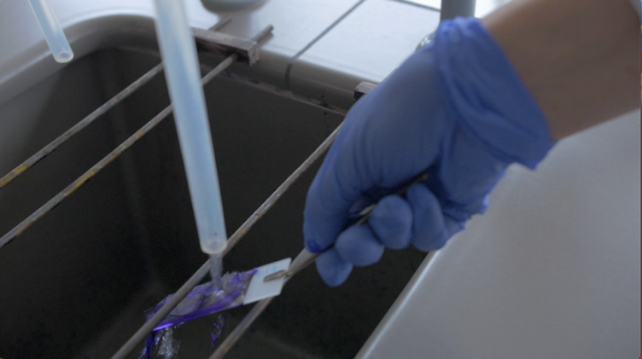
Figure 1. Video still of Gram staining.
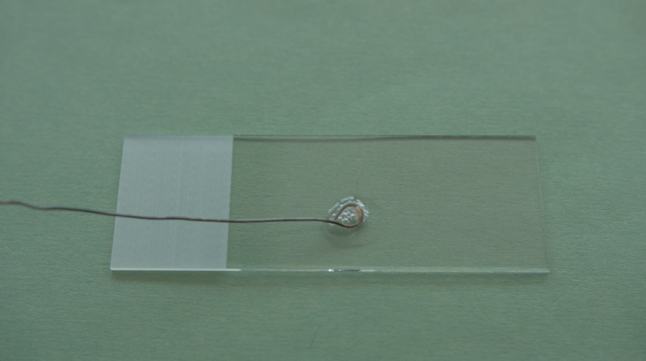
Figure 2. Video still of catalase test.
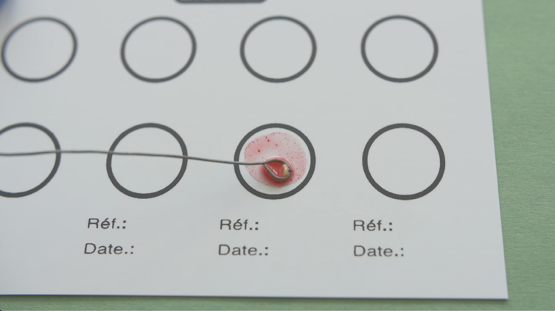
Figure 3. Video still of coagulase test.
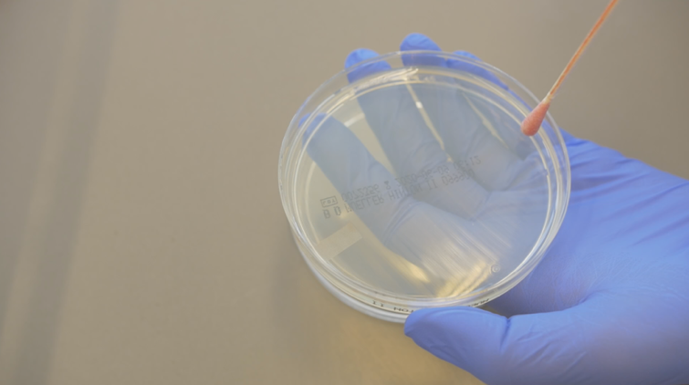
Figure 4. Video still of spread plating

