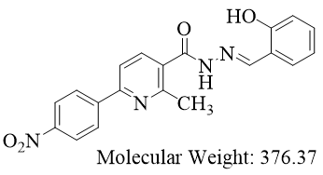
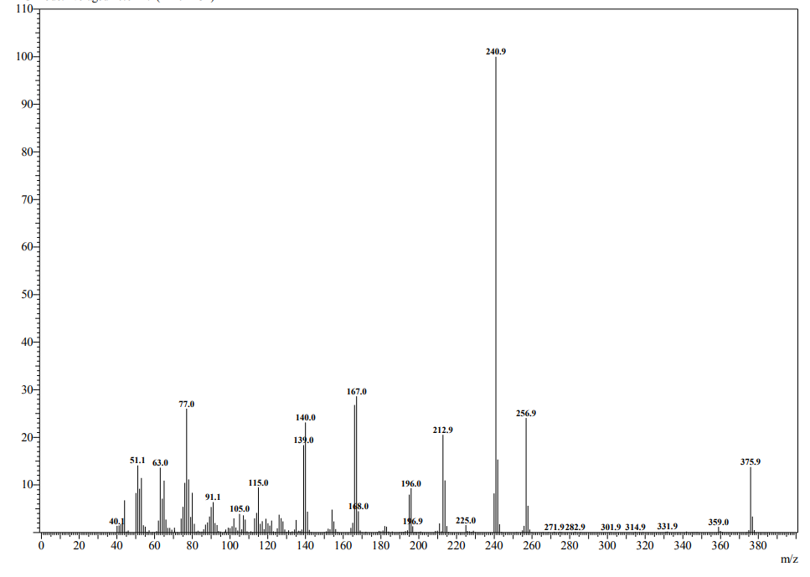
Figure 1. Mass spectrum of 1e (Ligand)

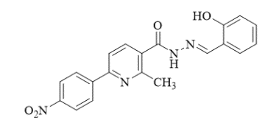
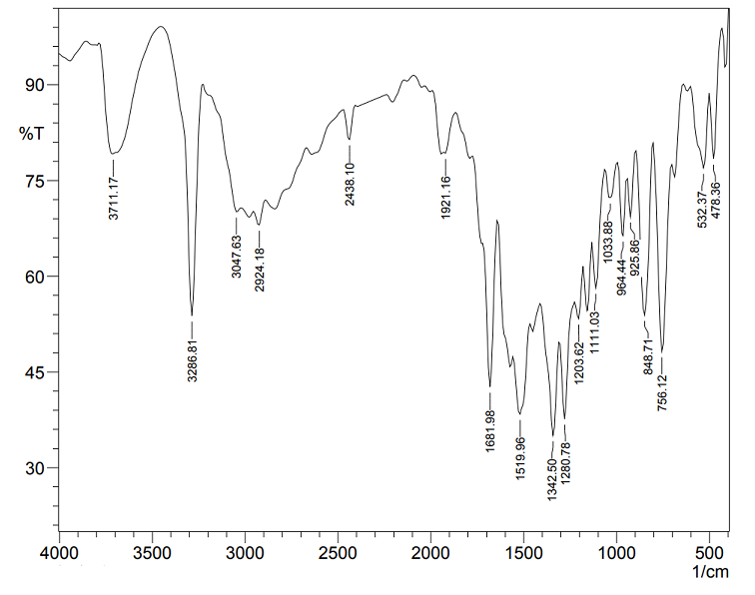
Figure 2. IR spectrum (KBr) of 1e (Ligand)

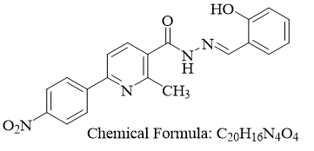
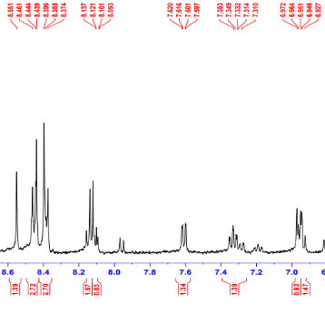
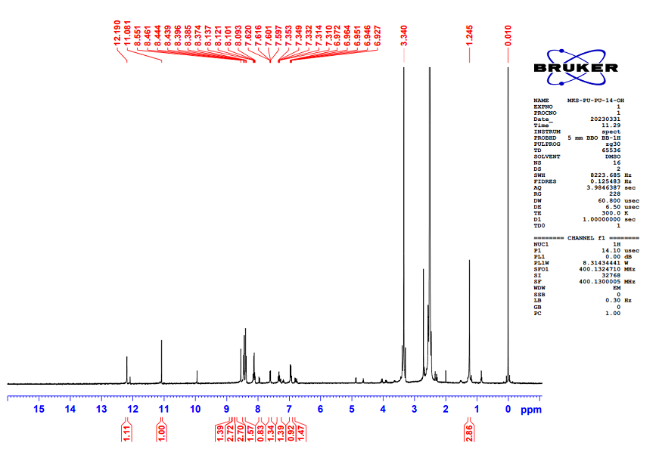
Figure 3. ¹H NMR spectrum (400 MHz, DMSO-d₆) of 1e (Ligand)

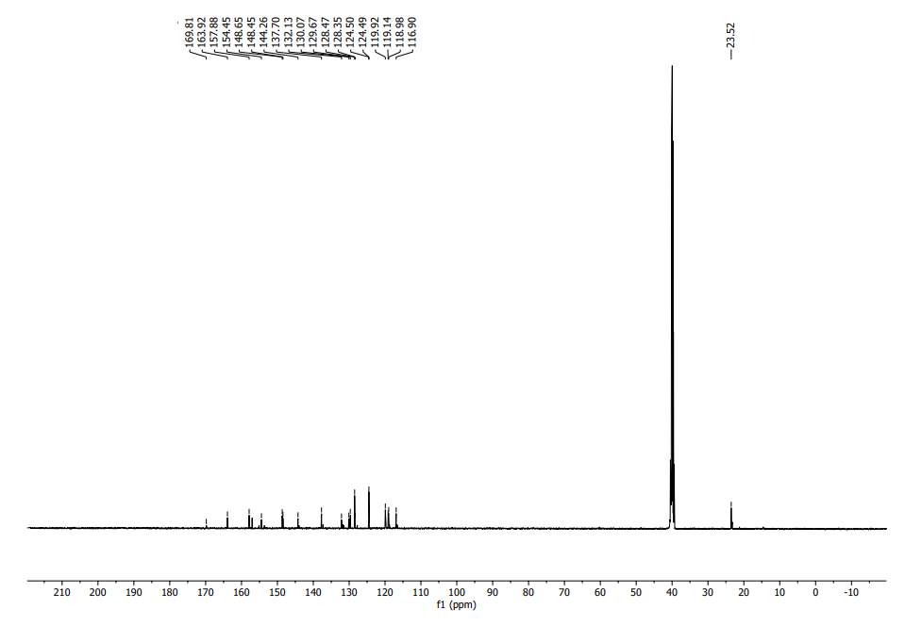
Figure 4. ¹³C NMR spectrum (126 MHz, DMSO-d₆) of 1e (Ligand)
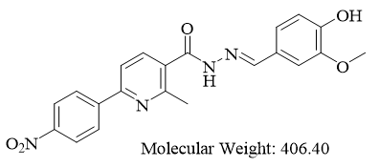
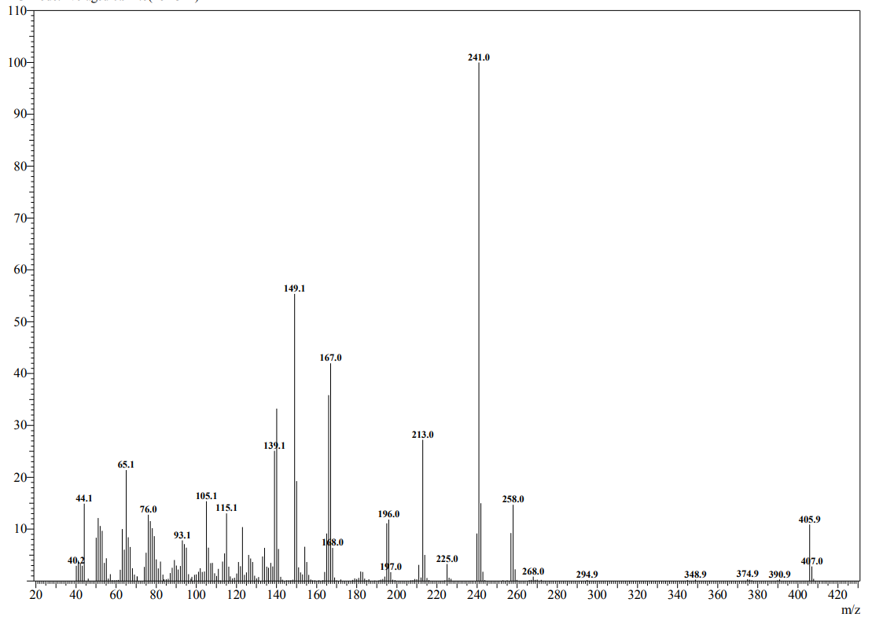
Figure 5. Mass spectrum of compound 1f

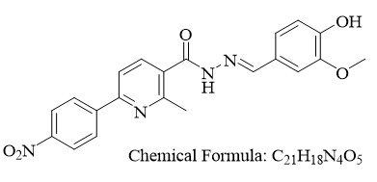
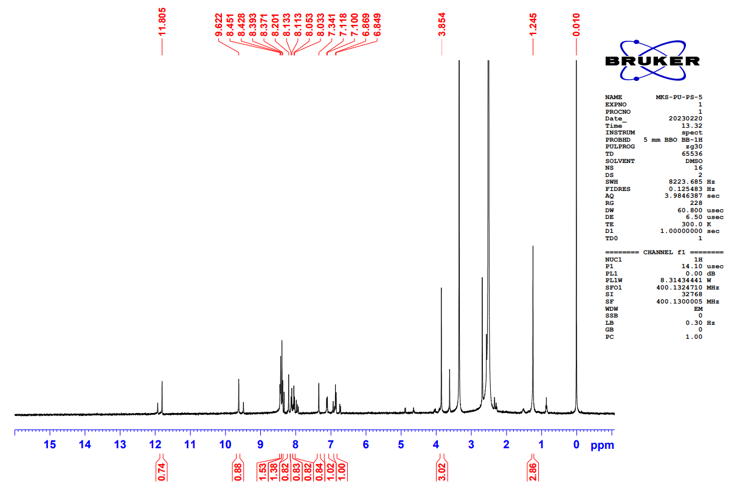
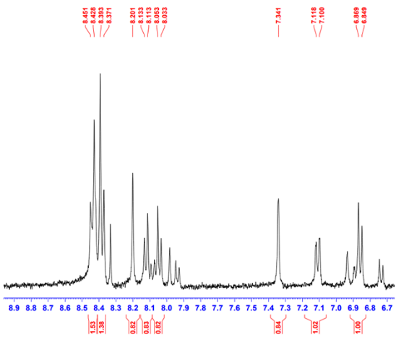
Figure 6. ¹H NMR spectrum (400 MHz, DMSO-d₆) of 1f

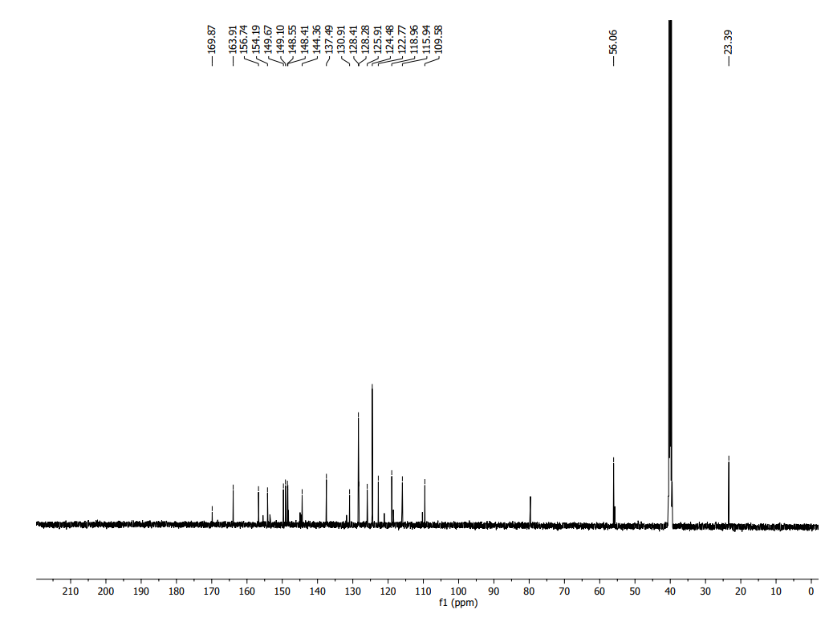
Figure 7. ¹³C NMR spectrum (126 MHz, DMSO-d₆) of 1f
Figure. 8 IR spectrum (KBr) of 1f
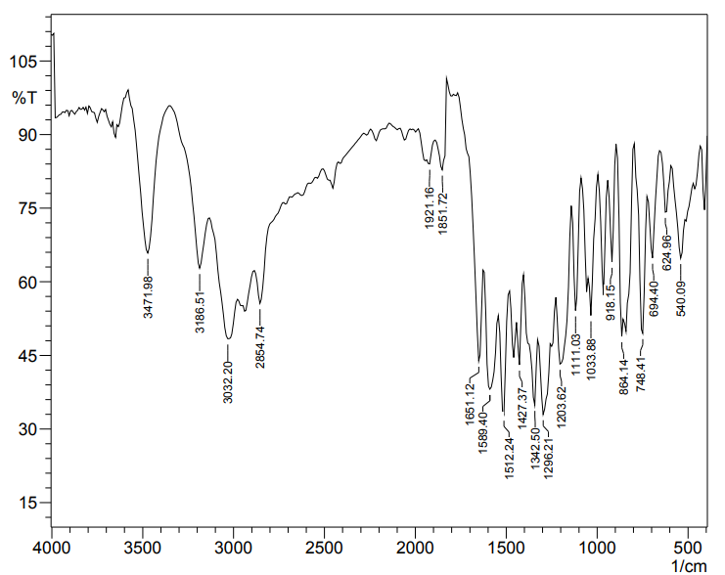

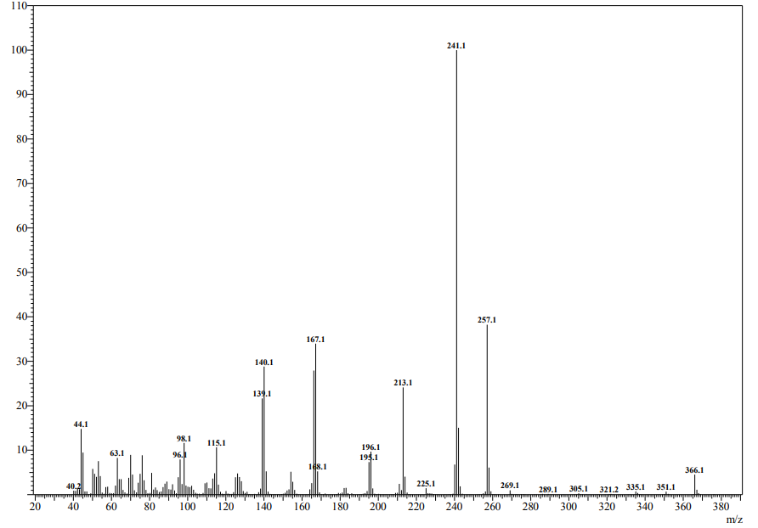
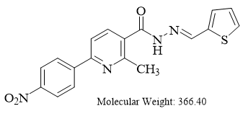
Figure 9. Mass spectrum of compound 1g

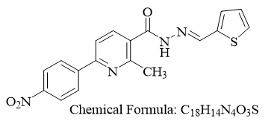
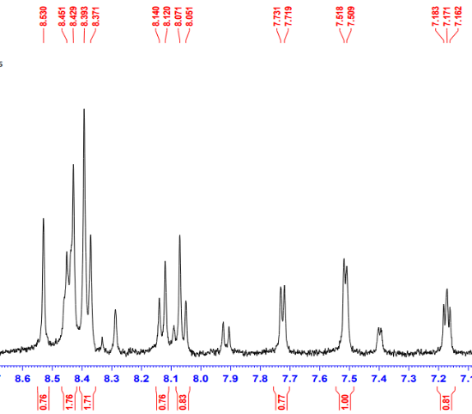
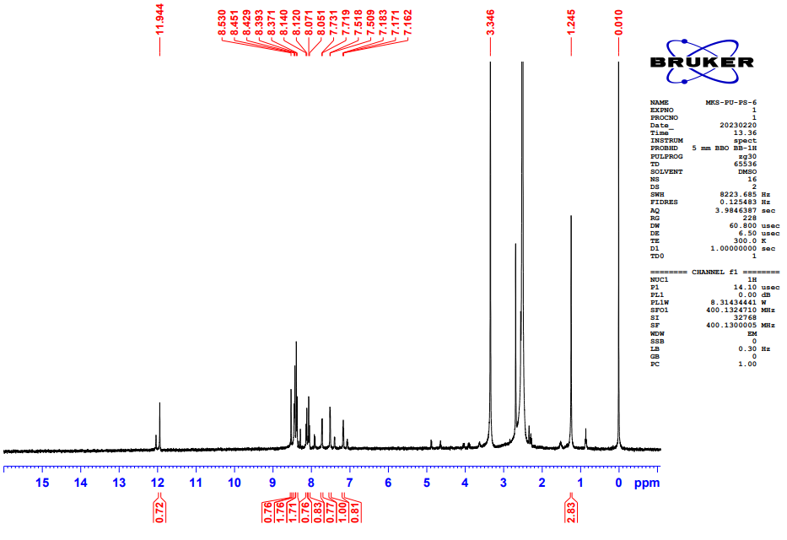
Figure 10. ¹H NMR spectrum (400 MHz, DMSO-d₆) of 1g
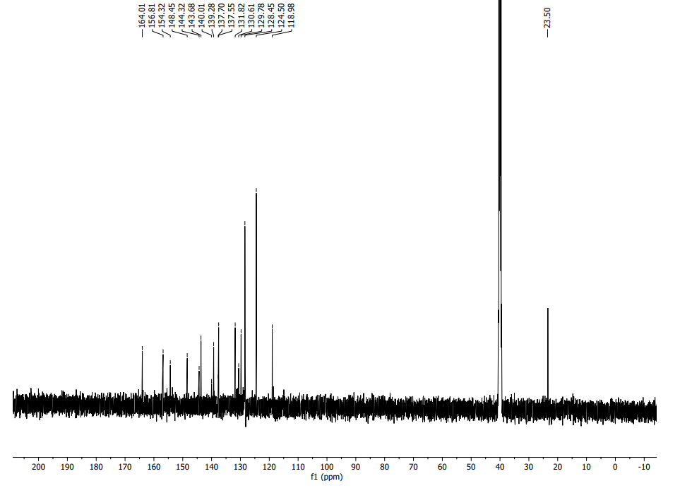
Figure 11. ¹³C NMR spectrum (126 MHz, DMSO-d₆) of 1g

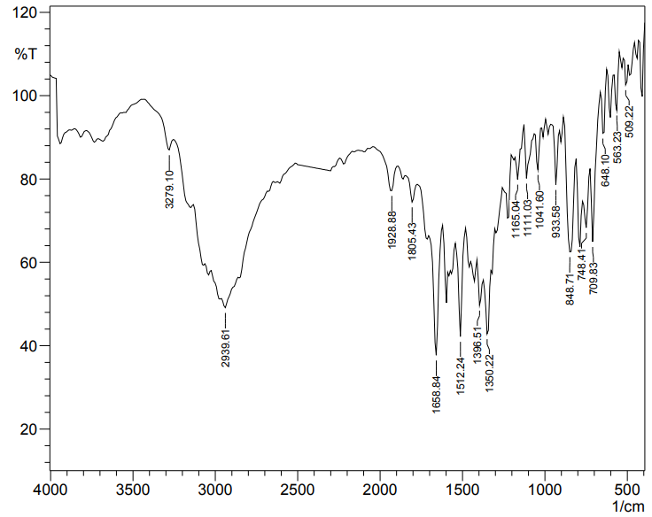
Figure 12. IR spectrum (KBr) of 1g

Figure 13. Mass spectrum of compound 1h
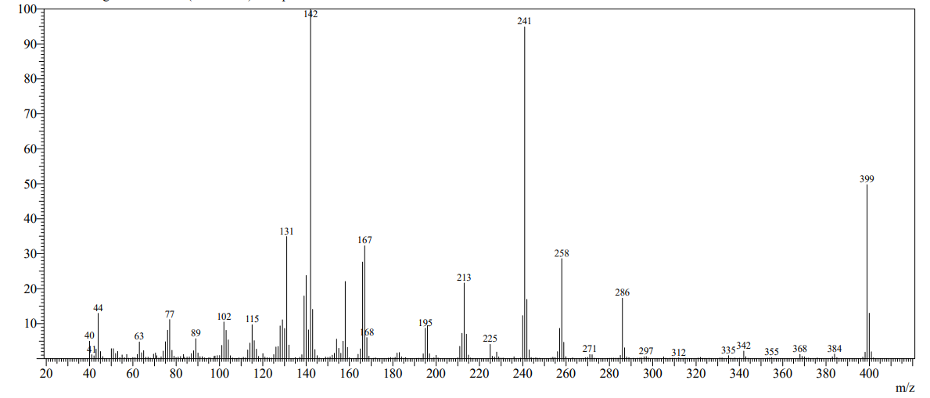
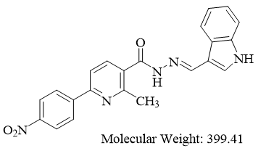
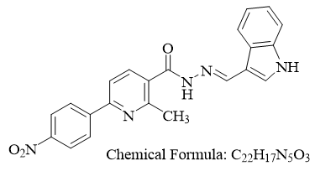
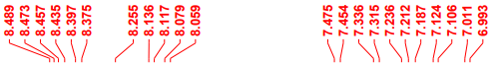
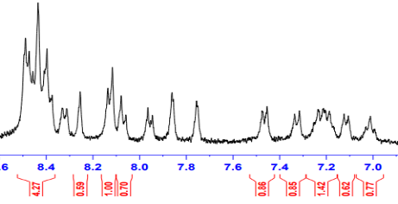
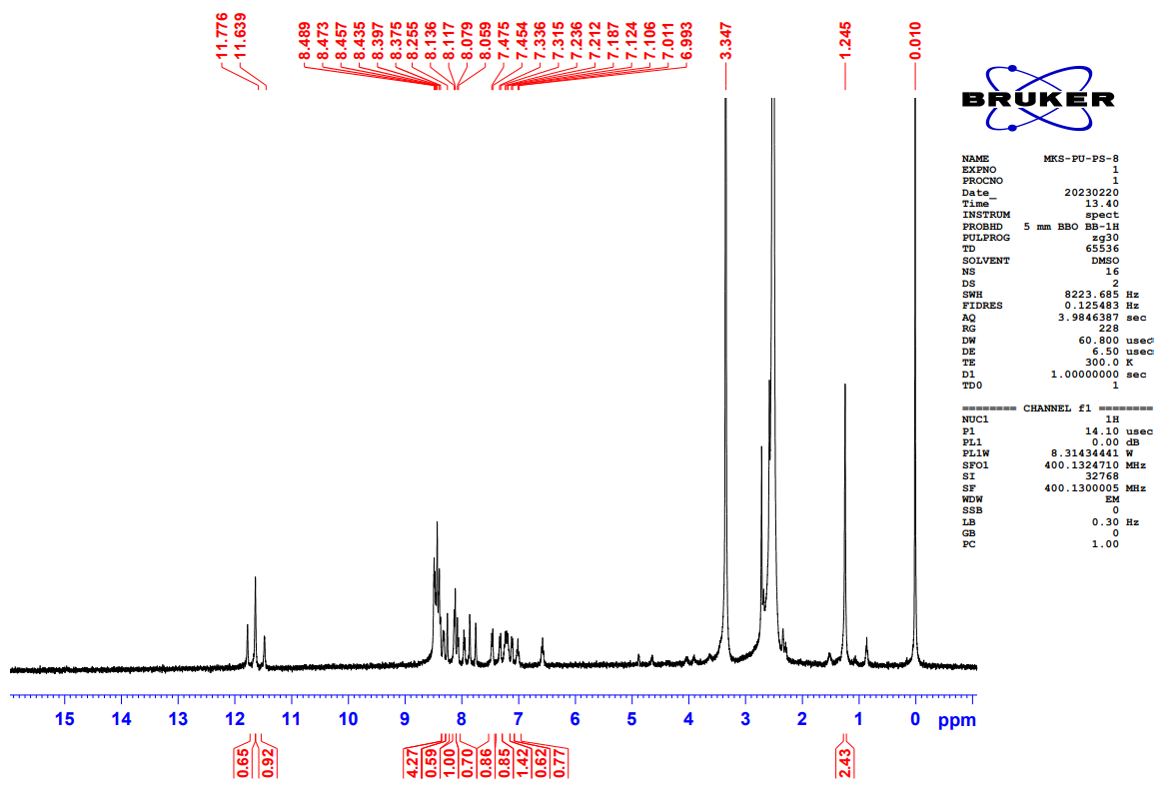
Figure 14. ¹H NMR spectrum (400 MHz, DMSO-d₆) of 1h

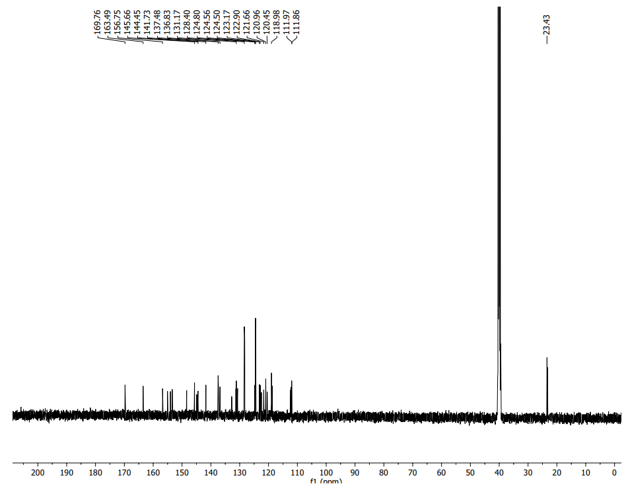
Figure 15. ¹³C NMR spectrum (126 MHz, DMSO-d₆) of 1h
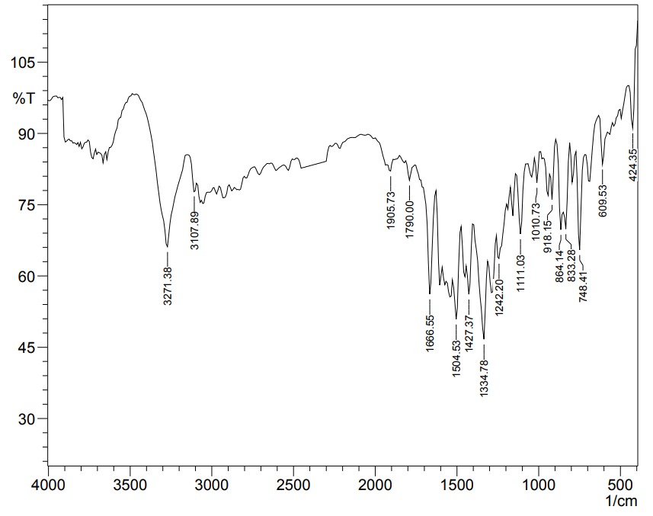
Figure 16. IR spectrum of 1h

Figure 17. Mass spectrum of compound Pd-complex

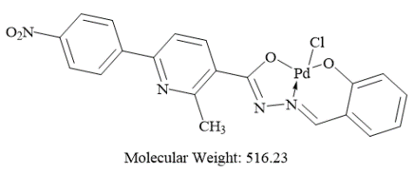
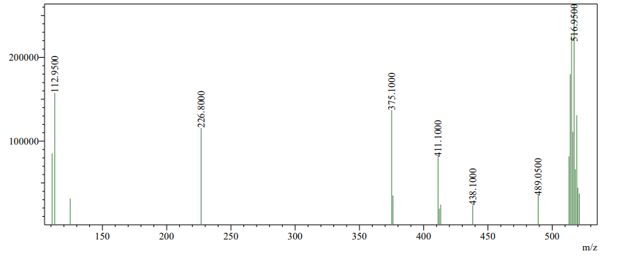

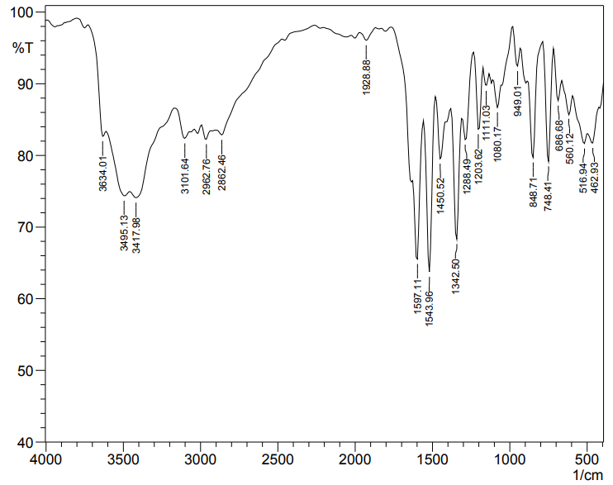
Figure 18. IR spectrum (KBr) of Pd-complex

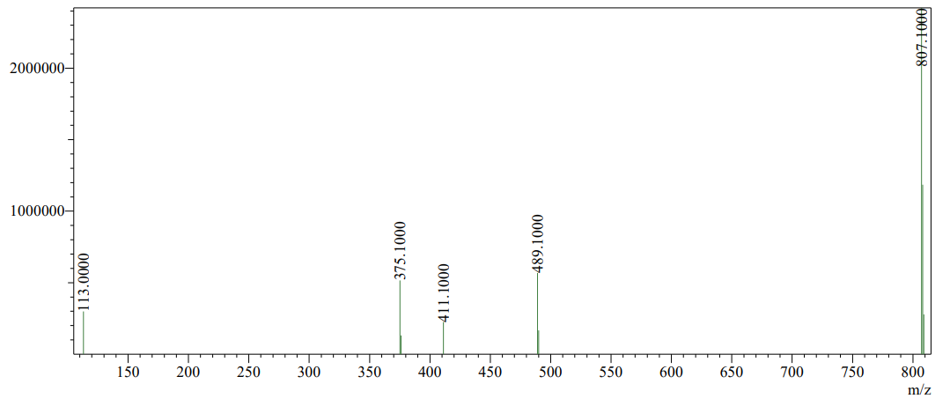
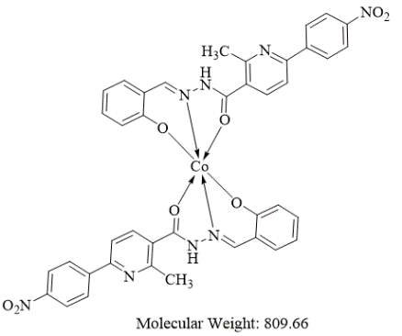
Figure 19. Mass spectrum of compound Co-complex

Figure 20. IR spectrum (KBr) of Co-complex
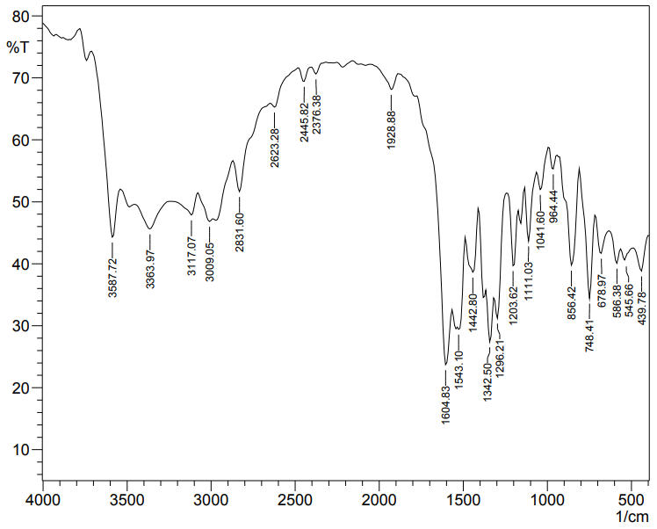

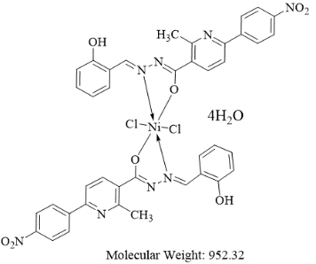
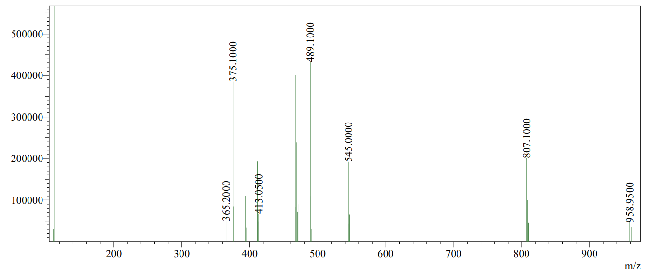
Figure 21. Mass spectrum of compound Ni-complex

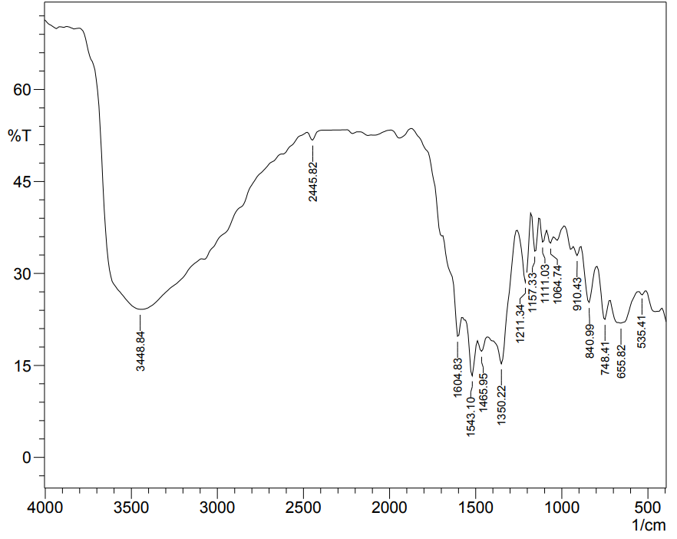
Figure 22. IR spectrum (KBR) of Ni-complex

Figure 23. TGA Pd-COMPLEX
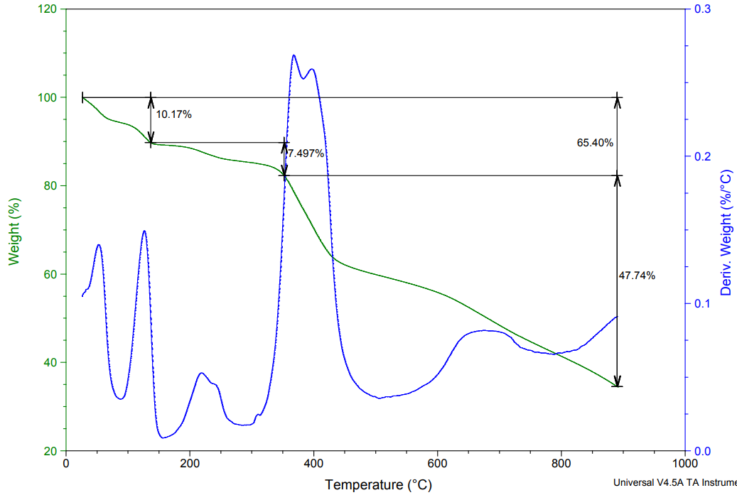

According to graph shown in Figure 23.
We got 65.40% degradation range of 0⁰C-900⁰C temperature.
Now, molecular weight of complex = 516.9 gm/mol
If Molecular weight of 100 % complex is 516.9 gm/mol
Then molecular weight of 65.40% complex =?
= $65.4 X \frac{516.9}{100}$
= 338.05 gm/mol
Therefore, calculated molecular weight of 65.40% the complex is 338.05gm/mol

Temperature range: 0ºC-200ºC
As shown in Figure 23, First weight loss found 10.17 %
10.17 % of 338.05 gm/mol
= $338.05 X \frac{10.17}{100}$
= 34.37 gm/mol ≅ 35.5 (molecular weight of one chorine atom)
Therefore, 34.37 gm/mol shows loss of one chlorine atom.

Temperature range: 200ºC-400ºC
As shown in Figure 23, Second weight loss found 7.497%
7.497 % of 338.05 gm/mol
= $338.05 X \frac{7.497}{100}$
= 25.44 gm/mol ≅ 30 (molecular weight of - NO)
Therefore, 25.34 gm/mol shows loss of -NO from NO₂ group

Temperature range: 400ºC-900ºC
As shown in Figure 23, Third weight loss found 47.74%
47.74 % of 338.05 gm/mol
= $161.38 X \frac{47.74}{100}$
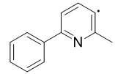
= 161.38 gm/mol ≅ 169 (molecular weight of )
Therefore, 161.38 gm/mol shows loss of (C₁₂H₁₀N•) ligand.

Above 900ºC residue of PdO

Figure 24. TGA Ni-COMPLEX
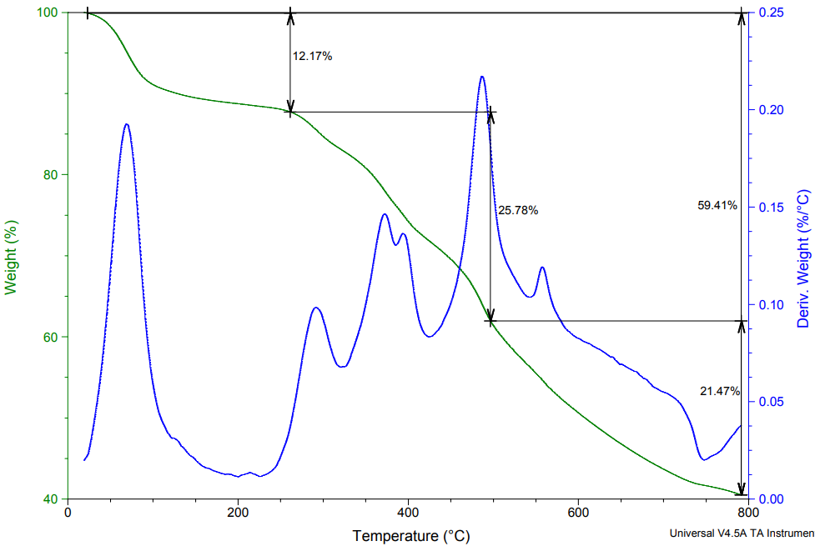
According to graph shown in Figure 24,
We got 59.41% degradation range of 0ºC-900ºC temperature.
Now, molecular weight of complex = 956.41 gm/mol
If Molecular weight of 100 % complex is 956.41 gm/mol
Then molecular weight of 59.41% complex =?
= $59.41 X \frac{956.41}{100}$
= 568.2 gm/mol
Therefore, calculated molecular weight of 59.41% the complex is 568.2 gm/mol

Temperature range: 0ºC-250ºC
As shown in Figure 24, First weight loss found 12.17%
12.17 % of 568.2 gm/mol
= $568.2 X \frac{12.17}{100}$
= 69.14 gm/mol ≅ 71 (molecular weight of 2 chlorine atoms)
Therefore, 69.14 gm/mol shows loss of 2-chlorine atom.

Temperature range: 250ºC-500ºC
As shown in Figure 24, Second weight loss found 25.78%
25.78 % of 568.2 gm/mol
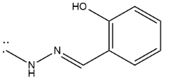
= $568.2 X \frac{25.78}{100}$
= 146.48 gm/mol ≅ 148.06 (molecular weight )

Therefore, 146.48 gm/mol shows loss of (C₈H₈N₂O^{2•)} ligand.

Temperature range: 500ºC-800ºC
As shown in Figure 24, Third weight loss found 21.47%
21.47% of 568.2 gm/mol
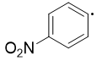
= $568.2 X \frac{21.47}{100}$
= 121.99gm/mol ≅ 122.02 (molecular weight of )
Therefor, 121.99 gm/mol shows loss of (C₆H₄NO₂•) ligand.

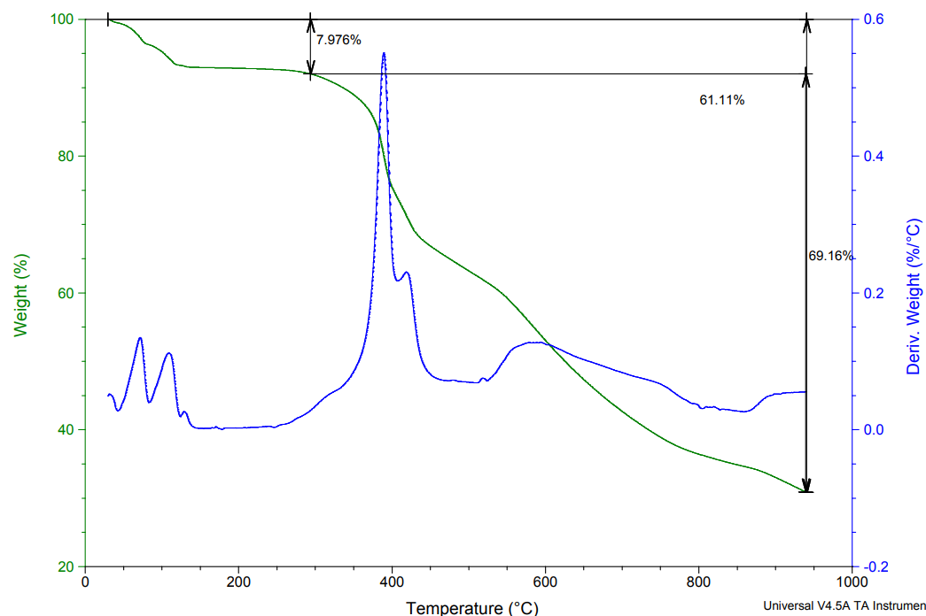
Figure 25. TGA Co-complex

According to graph shown in Figure 25,
We got 59.41% degradation range of 0ºC-900ºC temperature.
Now, molecular weight of complex = 807.65 gm/mol
If Molecular weight of 100% complex is 807.65 gm/mol
Then molecular weight of 69.16% complex =?
= $69.16 X \frac{807.65}{100}$
= 558.57 gm/mol
Therefore, calculated molecular weight of 69.16% the complex is 558.57 gm/mol

Temperature range: 0ºC-300ºC
As shown in Figure 25, First weight loss found 7.976%
7.976 % of 558.57 gm/mol
= $558.57 X \frac{7.976}{100}$
= 44.55 gm/mol ≅ 45.99 (molecular weight of 1 –NO₂ atom)
Therefore, 44.55 gm/mol shows loss of one –NO₂ atom.

Temperature range: 300ºC-900ºC
As shown in Figure 25, second weight loss found 61.11%
61.11 % of 558.57 gm/mol
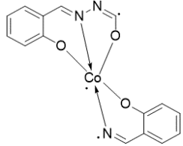
= $558.57 X \frac{61.11}{100}$
= 341.34 gm/mol ≅ 339.20 (molecular weight of )

Therefore, 341.34 gm/mol shows loss of (C₁₅H₁₀CoN₃O₃^{3•}) ligand.

Photocatalytic activity:
Stock solution: weight 100 mg of Remazol Brilliant Blue R (RBBR) dye and dissolved in ultra-pure water and further diluted up to 100 ml. so final concentration of dye solution was 1000 ppm.
Standard solution: Standard 50, 100, 150, 200 ppm prepared from 1000 ppm stock solution.
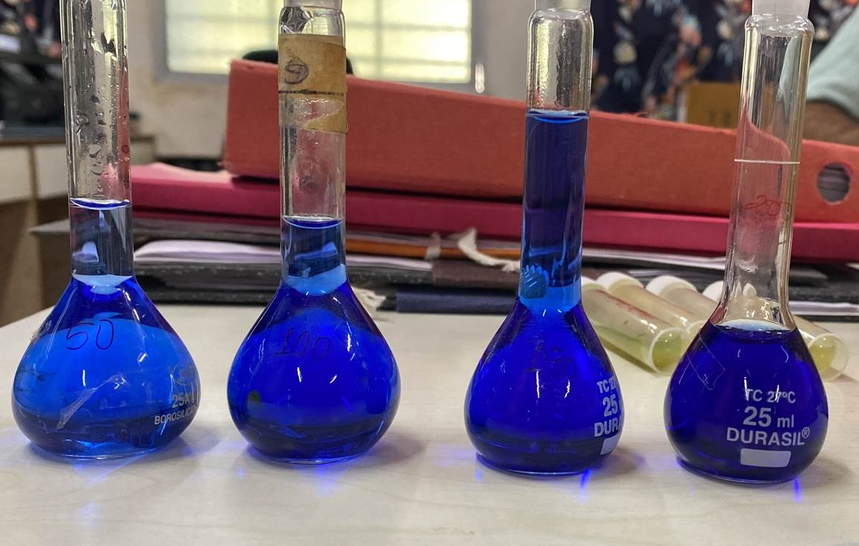
Standard solution of 50-200 ppm RBBR

Photo-catalytic dye degradation was performed spectrophotometrically on visible light irradiation using Co, Ni and Pd complexes on RBBR dyes. It is well known that RBBR dyes are adsorbed and degraded simultaneously by the catalyst in an aqueous solution.
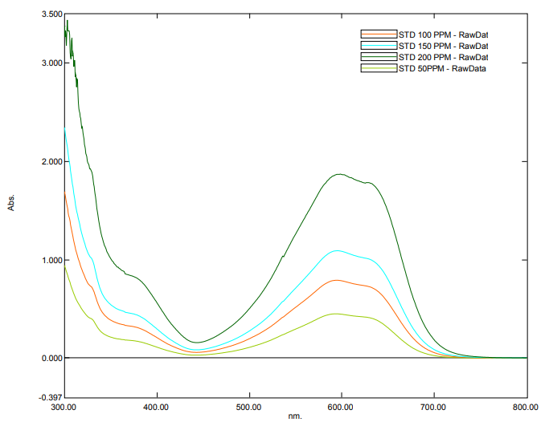
Absorbance spectra of Standard solution of 50-200 ppm

The photo catalytic efficiency (%) is calculate using the formula:
% Degradation = $\frac{\left(A_{0}- A_{F}\right) × 100}{A_{0}}$
where A₀ and A_{F} are the initial (at 0h) and final (at 4h) concentration of the dye
the absorbance of RBBR was determined by a UV-vis spectrophotometer at the absorption wavelength of 595 nm

Calculation for Co-complex:
- Co 50 ppm = $\frac{\left(A_{0}- A_{F}\right) × 100}{A_{0}}$ 2 . Co 100 ppm = $\frac{\left(A_{0}- A_{F}\right) × 100}{A_{0}}$
= $\frac{\left(1.091- 0.582\right) × 100}{1.091}$ = $\frac{\left(1.233- 0.637\right) × 100}{1.233}$
= 46.65 % = 48.33 %

- Co 150 ppm = $\frac{\left(A_{0}- A_{F}\right) × 100}{A_{0}}$ 4. Co 200 ppm = $\frac{\left(A_{0}- A_{F}\right) × 100}{A_{0}}$
= $\frac{\left(2.045- 0.576\right) × 100}{2.045}$ = $\frac{\left(1.779- 0.281\right) × 100}{1.779}$
= 71.83 % = 84.20 %

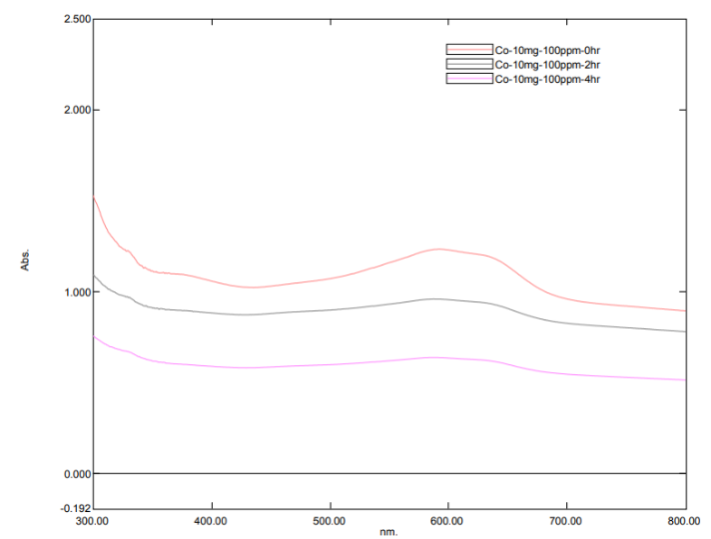
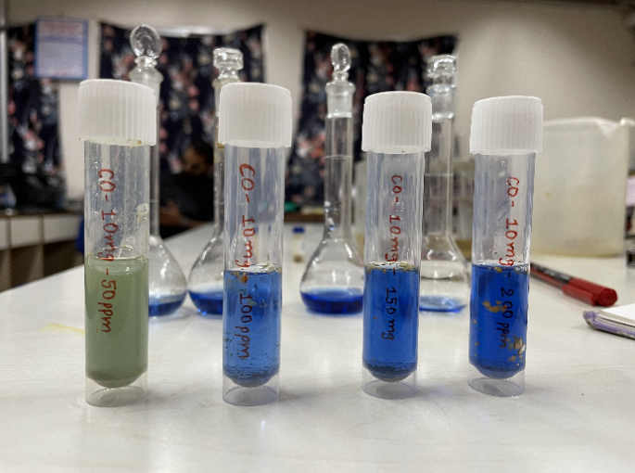
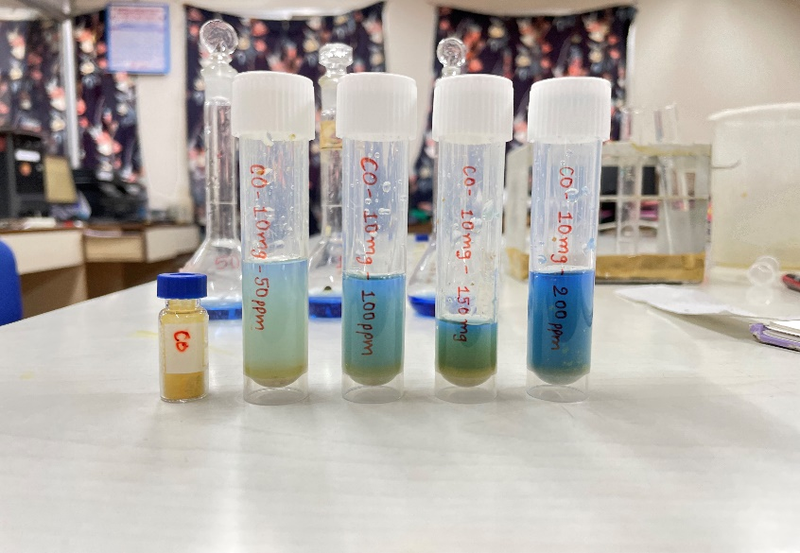
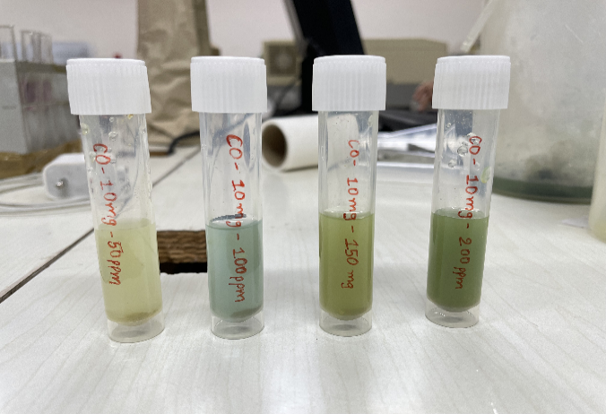
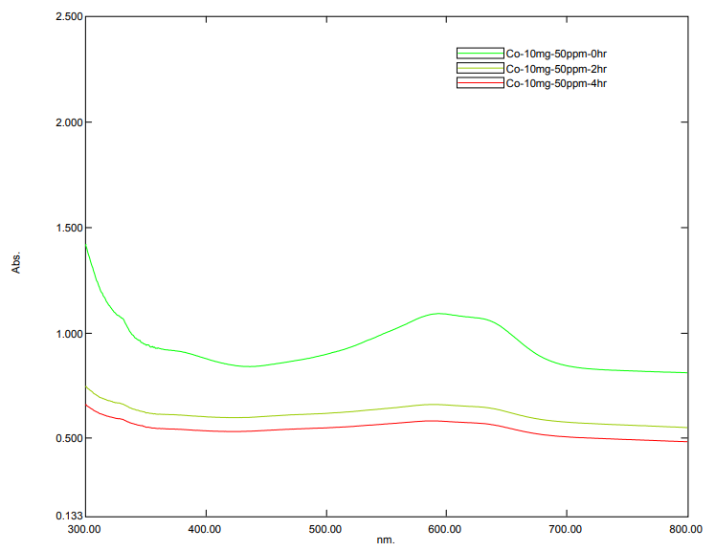
Graph: Photodegradation of RBBR dye

Solution of RBBR dye 50, 100, 150, 200 ppm with Co-complex
at 0h at 2h at 4h
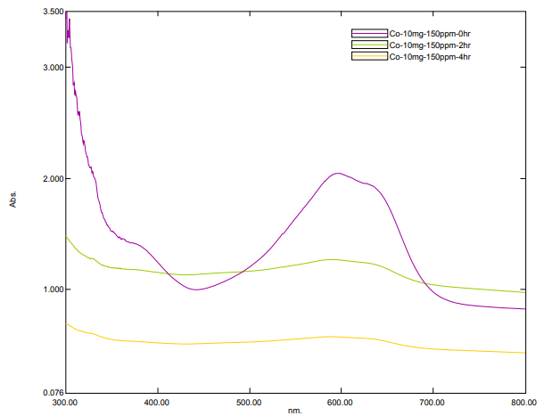
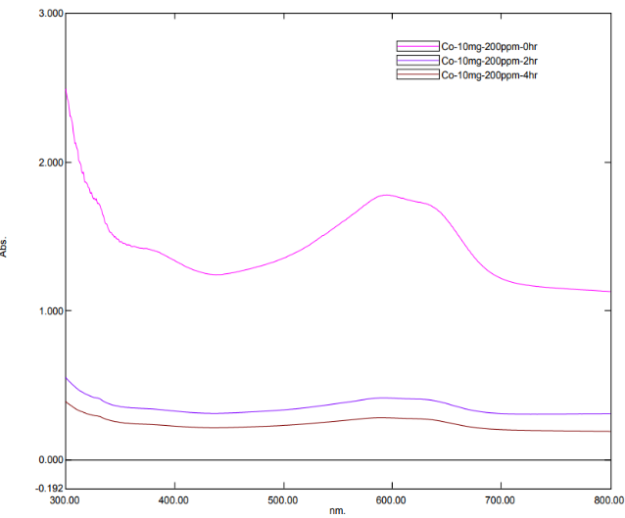
RBBR 50 ppm solution with 10mg Co-complex RBBR 100 ppm solution with 10mg Co-complex
RBBR 150 ppm solution with 10mg Co-complex RBBR 200 ppm solution with 10mg Co-complex
Calculation for Ni-complex:
- Ni 50 ppm = $\frac{\left(A_{0}- A_{F}\right) × 100}{A_{0}}$ 2 Ni 100 ppm = $\frac{\left(A_{0}- A_{F}\right) × 100}{A_{0}}$
= $\frac{\left(0.576- 0.530\right) × 100}{0.576}$ = $\frac{\left(1.101- 1.041\right) × 100}{1.101}$
= 4.51 % = 5.40 %

- Ni 150 ppm = $\frac{\left(A_{0}- A_{F}\right) × 100}{A_{0}}$ 4 Ni 200 ppm = $\frac{\left(A_{0}- A_{F}\right) × 100}{A_{0}}$
= $\frac{\left(1.872- 1.691\right) × 100}{1.872}$ = $\frac{\left(0.789- 0.707\right) × 100}{0.789}$
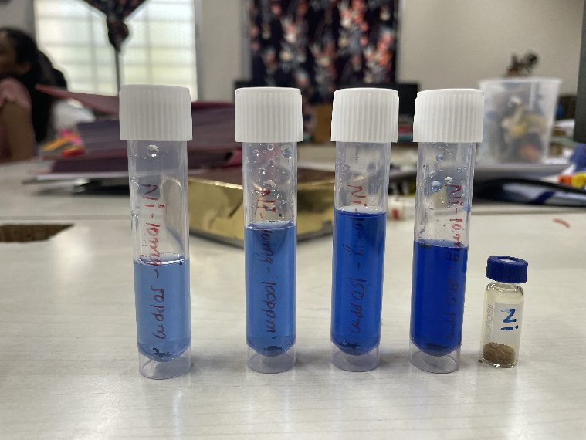
= 9.66 % = 10.39 %
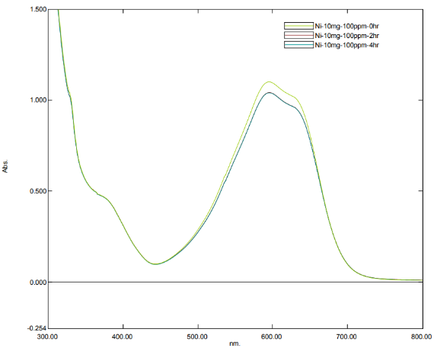
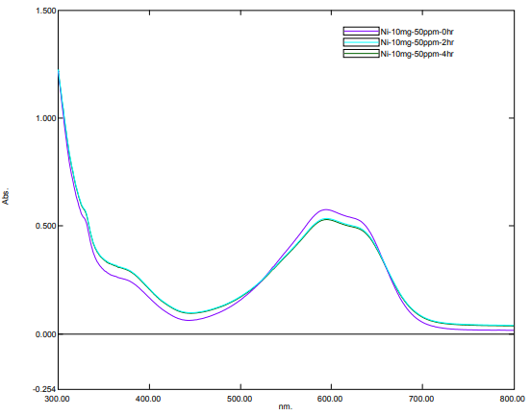
Solution of RBBR dye 50, 100, 150, 200 ppm with Ni-complex
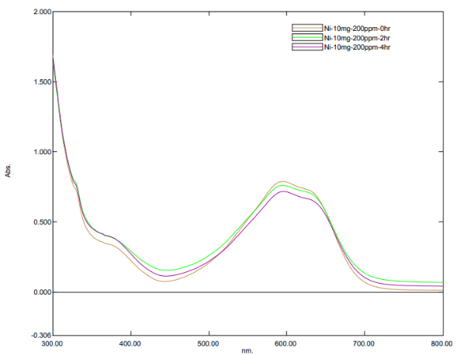
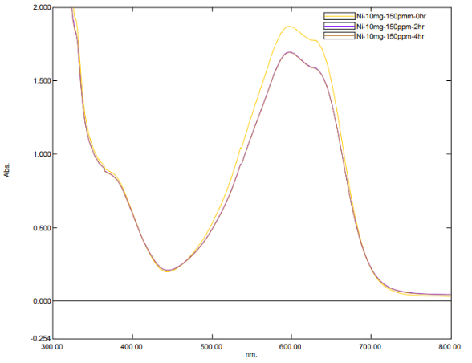
RBBR 50 ppm solution with 10mg Ni-complex RBBR 100 ppm solution with 10mg Ni-complex
RBBR 150 ppm solution with 10mg Ni-complex RBBR 200 ppm solution with 10mg Ni-complex
Calculation for Pd-complex:
- Pd 50 ppm = $\frac{\left(A_{0}- A_{F}\right) × 100}{A_{0}}$ 2 Pd 100 ppm =$\frac{\left(A_{0}- A_{F}\right) × 100}{A_{0}}$
= $\frac{\left(1.868- 1.799\right) × 100}{1.868}$ = $\frac{\left(0.787- 0.757\right) × 100}{0.787}$
= 3.69 % = 3.80 %

- Pd 150 ppm = $\frac{\left(A_{0}- A_{F}\right) × 100}{A_{0}}$ 4 Pd 200 ppm = $\frac{\left(A_{0}- A_{F}\right) × 100}{A_{0}}$
= $\frac{\left(0.437- 0.419\right) × 100}{0.437}$ = $\frac{\left(1.105- 1.020\right) × 100}{1.105}$
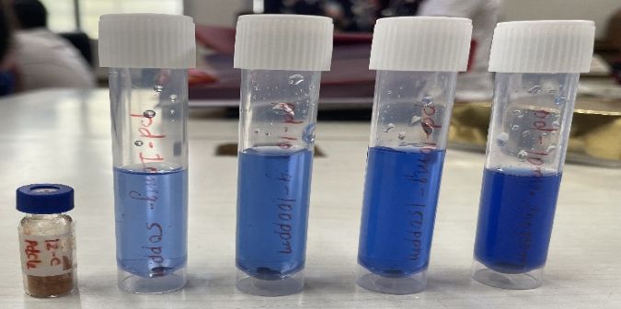
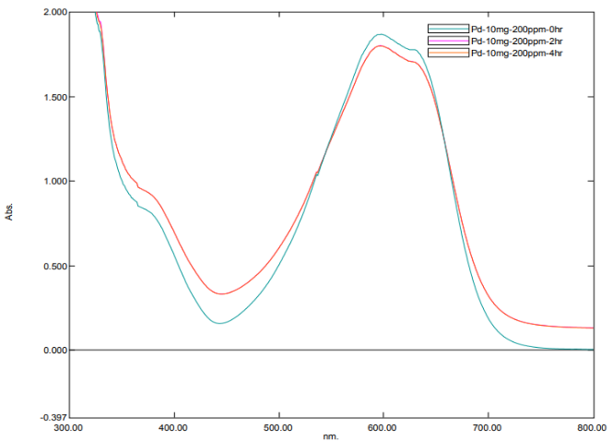
= 4.10 % = 7.69 %
Solution of RBBR dye 50, 100, 150, 200 ppm with Pd-complex
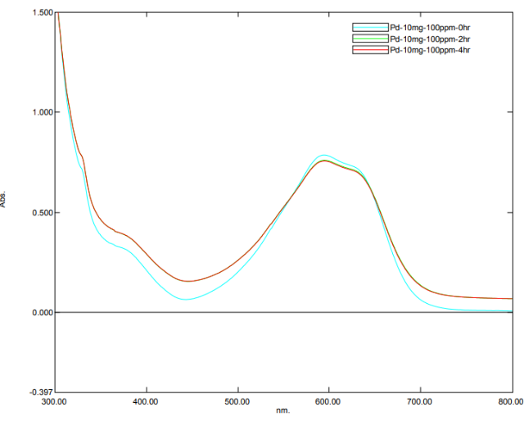
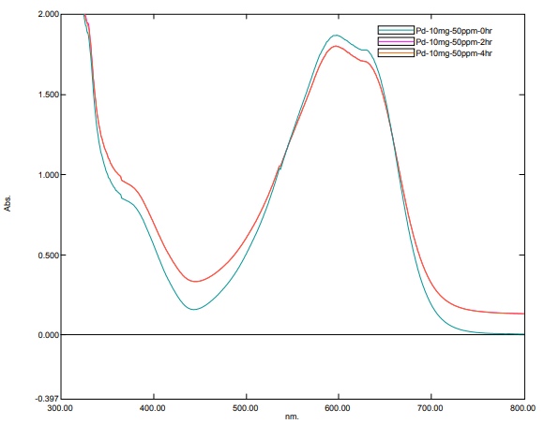
RBBR 50 ppm solution with 10mg pd-complex RBBR 100 ppm solution with 10mg Pd-complex

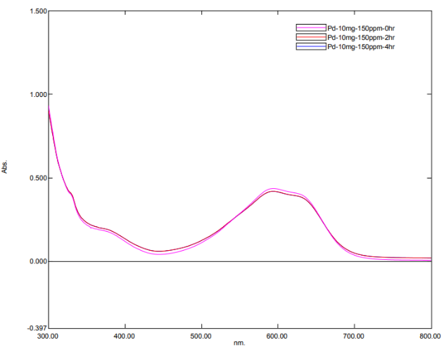
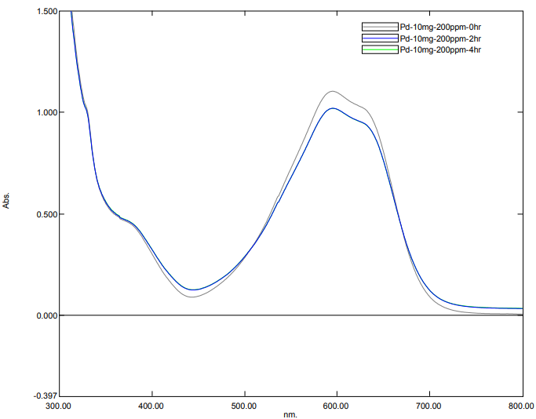
RBBR 150 ppm solution with 10mg pd-complex RBBR 200 ppm solution with 10mg pd-complex

