Supplementary Materials
- Supplementary Figures
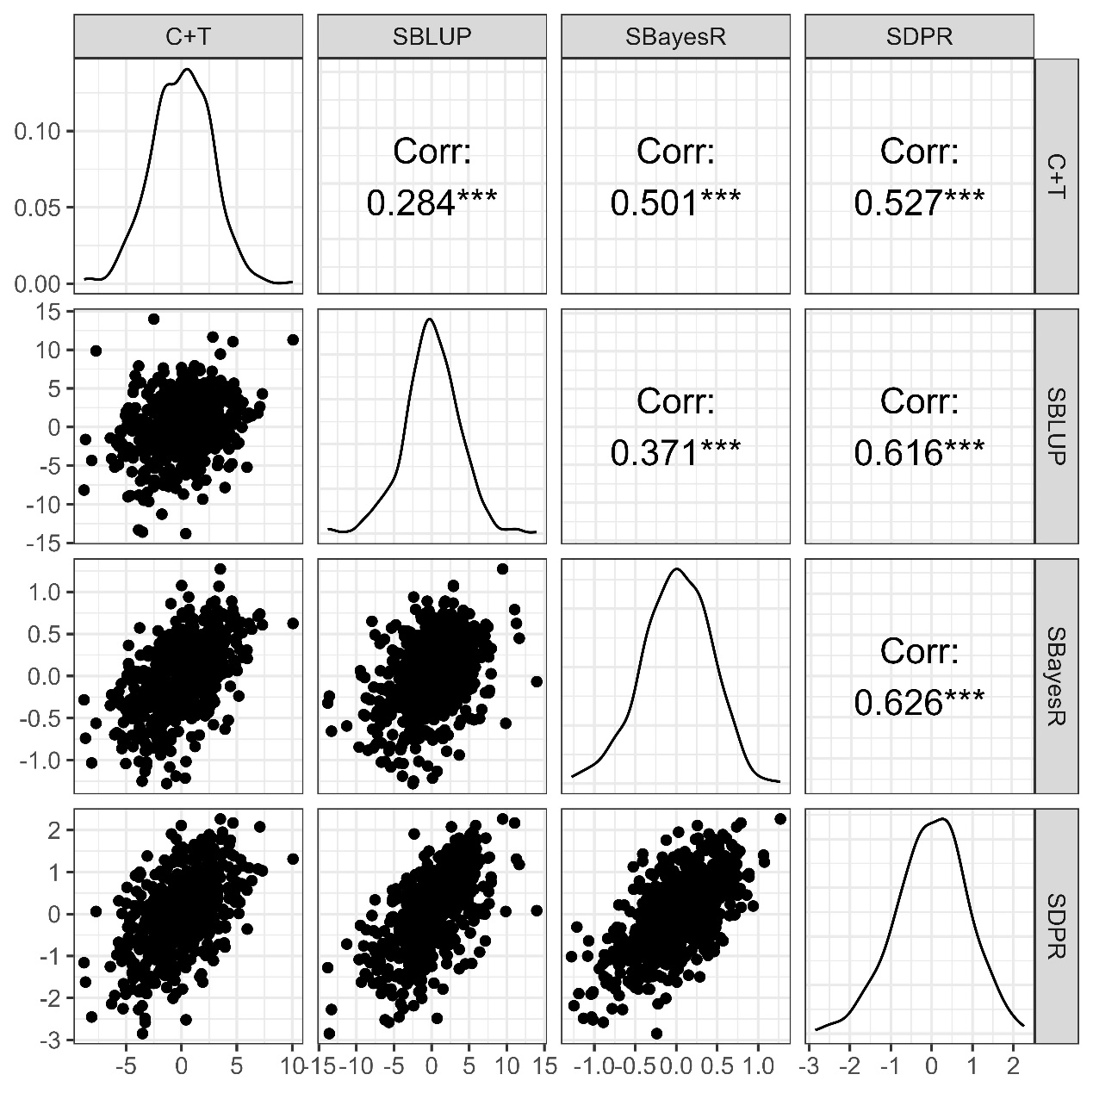
Supplementary Figure S1. Correlations among PRS obtained from C+T, SBayesR, SBLUP and SDPR.
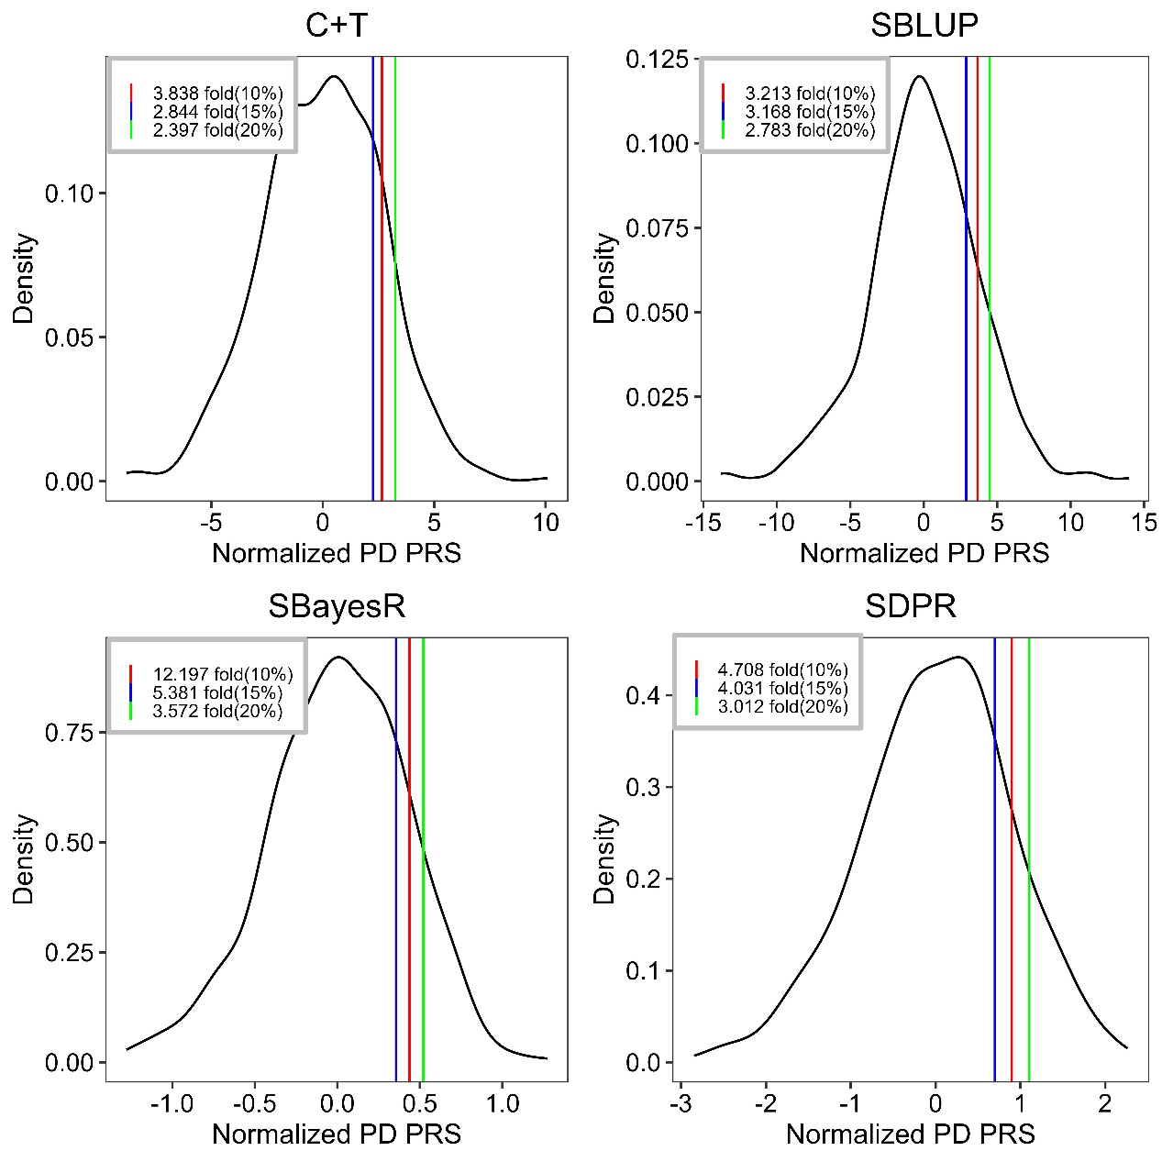
Supplementary Figure S2. Individuals in the top 10%, 15%, and 20% of PRS have several folds greater odds of Parkinson’s disease as compared to the rest of the study cohort. PRS methods include C+T, SBLUP, SBayesR, and SDPR.

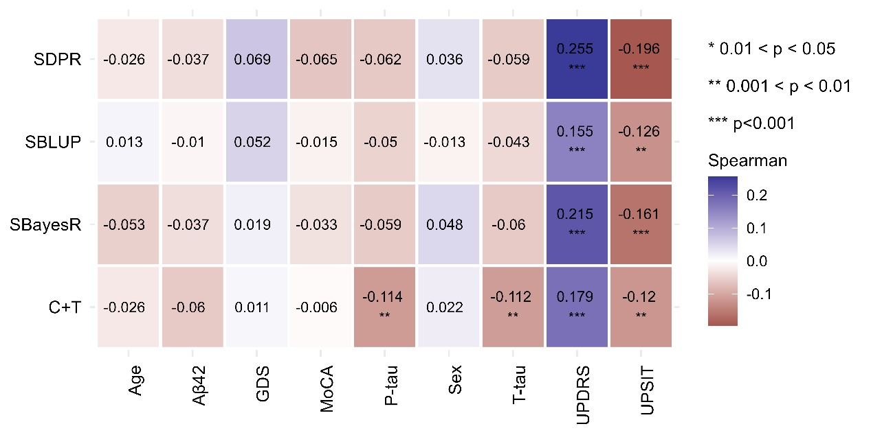
Supplementary Figure S3. Spearman’s correlation coefficients (ρ) between PRS and other risk factors. PRS methods include C+T, SBayesR, SBLUP, and SDPR.

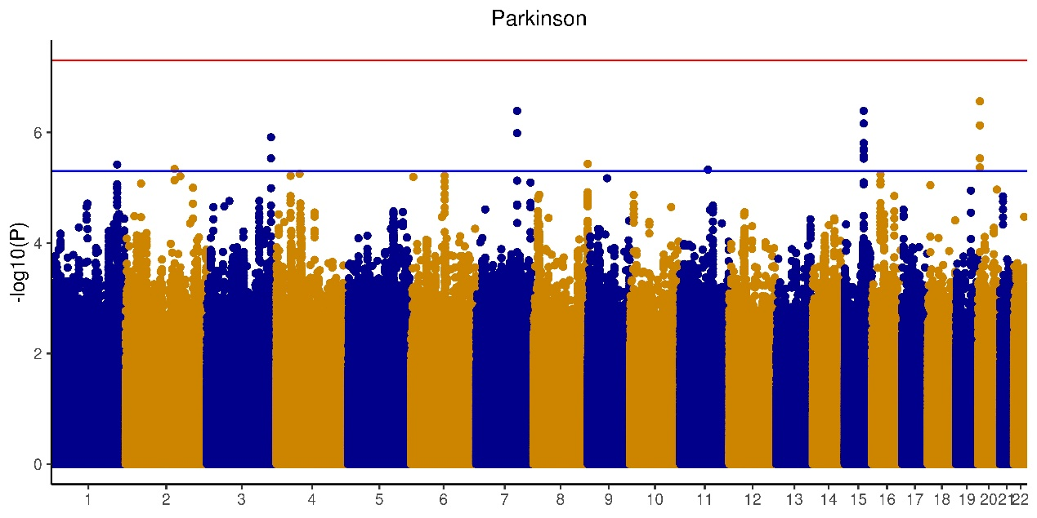
Supplementary Figure S4. Manhattan plot for Parkinson’s disease in PPMI based on additive model for Genome-wide association analysis.

- Supplementary Tables
Supplementary Table S1. Baseline demographic and clinical characteristics of participants.
 | Cases  (n=427) | Controls  (n=169)
Demographic characteristics
Age, years ª | 61.89(9.49) | 61.40(11.04)
Sex ^{b} | 266(62.30%) | 107(63.31%)
Clinical assessments ª
MDS-UPDRS motor score ^{c} | 20.65(8.94) | 1.31(2.31)
UPSIT ^{d} | 22.44(8.11) | 33.93(5.04)
Montreal Cognitive Assessment (MoCA) | 27.00(2.58) | 28.23(1.11)
Geriatric Depression Scale (GDS) | 5.33(1.49) | 5.19(1.38)
CSF marker, pg/mL ª
Amyloid β1-42 (Aβ₄₂) | 936.73(402.04) | 1070.234(493.89)
Total tau (T-tau) | 174.49(59.55) | 198.66(78.83)
Phosphorylated tau (P-tau) | 14.81(5.56) | 17.59(8.48)
a. For age, clinical assessments and CSF biomarkers, mean (standard deviation) is reported.
b. For sex, the number of males and its percentage are reported.
c. MDS-UPDRS=Movement Disorder Society Unified Parkinson’s Disease Rating Scale.
d. UPSIT=University of Pennsylvania Smell Inventory Test.

Supplementary Table S2. Average effects for each predictor and the percentage of variability in the outcome that each predictor explains.
Parameter | C+T |  | SBLUP |  | SBayesR |  | SDPR
Parameter | Beta | Percentage | Beta | Percentage | Beta | Percentage | Beta | Percentage
Scenario I: PRS+ Age+ Sex
PRS | 0.99 | 80.58 | 1.27 | 89.65 | 1.56 | 81.51 | 1.76 | 86.06
Age | 0.16 | 12.96 | 0.10 | 7.12 | 0.20 | 10.54 | 0.17 | 8.07
Sex | -0.08 | 6.46 | -0.05 | 3.22 | -0.15 | 7.95 | -0.12 | 5.87
Scenario II: PRS+ Age+ Sex+ UPSIT+ MoCA+ GDS
PRS | 1.00 | 10.70 | 1.44 | 14.67 | 1.74 | 16.93 | 1.86 | 18.11
Age | -0.80 | 8.50 | -0.83 | 8.43 | -0.72 | 7.04 | -0.86 | 8.38
Sex | -0.47 | 4.98 | -0.38 | 3.87 | -0.49 | 4.74 | -0.46 | 4.43
UPSIT | -5.44 | 57.97 | -5.47 | 55.73 | -5.50 | 53.61 | -5.44 | 52.93
MoCA | -1.64 | 17.47 | -1.70 | 17.27 | -1.78 | 17.38 | -1.64 | 15.98
GDS | -0.04 | 0.40 | -3.69×10⁻³ | 0.04 | 0.03 | 0.30 | -0.02 | 0.17
Scenario III: PRS+ Age+ Sex+ UPSIT+ MoCA+ GDS+ P-tau+ T-tau+ Aβ₄₂
PRS | 1.02 | 5.99 | 1.43 | 8.11 | 1.76 | 10.31 | 1.89 | 10.34
Age | -0.67 | 3.92 | -0.74 | 4.17 | -0.58 | 3.39 | -0.75 | 4.11
Sex | -0.47 | 2.75 | -0.37 | 2.07 | -0.52 | 3.04 | -0.47 | 2.57
UPSIT | -5.34 | 31.47 | -5.37 | 30.40 | -5.38 | 31.59 | -5.36 | 29.36
MoCA | -1.76 | 10.39 | -1.84 | 10.40 | -1.85 | 10.89 | -1.74 | 9.54
GDS | -0.03 | 0.18 | 6.91×10⁻³ | 0.04 | 0.05 | 0.32 | -1.08×10⁻³ | 5.91×10⁻³
Aβ₄₂ | -0.51 | 3.00 | -0.60 | 3.39 | -0.50 | 2.94 | -0.52 | 2.84
T-tau | 3.26 | 19.23 | 3.39 | 19.22 | 2.92 | 17.14 | 3.46 | 18.96
P-tau | -3.92 | 23.07 | -3.92 | 22.21 | -3.47 | 20.39 | -4.07 | 22.27
Abbreviations: UPSIT, University of Pennsylvania Smell Inventory Test; MoCA, Montreal Cognitive Assessment; GDS, Geriatric Depression Scale; Aβ₄₂, amyloid β₁₋₄₂; P-tau, phosphorylated tau; T-tau, total tau.

Supplementary Table S3. Relative excess risk due to interaction (RERI) and the attributable proportion (AP) between PRS and other risk factors.
Risk factor | C+T |  | SBLUP |  | SBayesR |  | SDPR
Risk factor | AP (95%CI) | RERI | AP (95%CI) | RERI | AP (95%CI) | RERI | AP (95%CI) | RERI
MoCA | -0.16  (-0.57-0.26) | -0.17 | 0.22  (-0.34-0.79) | 0.11 | -0.59  (-1.23-0.04) | -64.63 | -0.06  (-1.52-1.41) | -0.05
UPSIT | -0.15  (-0.29--0.01) | -0.20 | -0.125  (-0.23--0.02) | -0.15 | -0.32  (-0.58--0.06) | -3.26 | -0.26  (-0.47--0.04) | -0.85
UPDRS | 0.03  (-0.15-0.22) | 0.08 | 0.03  (-0.13-0.19) | 0.08 | 0.46  (0.31-0.61) | 7.13 | 0.23  (-0.25-0.71) | 0.80
GDS | 0.03  (-2.05×10⁻³-0.06) | 0.03 | 0.03  (-0.003-0.053) | 0.03 | -0.03  (-0.42-0.36) | -0.21 | 0.06  (-0.11-0.22) | 0.13
Aβ42 | -1.63×10⁻⁴  (-4.45×10⁻⁴-1.19×10⁻⁴) | -2.03×10⁻⁴ | -2.51×10⁻⁵  (-2.25×10⁻⁴-1.75×10⁻⁴) | -2.81×10⁻⁵ | -7.44×10⁻⁴  (-2.04×10⁻³-5.47×10⁻⁴) | -4.75×10⁻³ | -8.08×10⁻⁵  (-8.45×10⁻⁴-6.84×10⁻⁴) | -1.64×10⁻⁴
P-tau | -3.49×10⁻³  (-0.02-0.02) | -3.75×10⁻³ | 6.37×10⁻⁴  (-0.02-0.02) | 6.53×10⁻⁴ | -0.03  (-0.10-0.04) | -0.13 | -0.02  (-0.08-0.04) | -0.04
T-tau | -3.38×10⁻⁴  (-2.17×10⁻³-1.49×10⁻³) | -3.85×10⁻⁴ | 1.18×10⁻⁴  (-1.39×10⁻³-1.63×10⁻³) | 1.26×10⁻⁴ | -4.19×10⁻³  (-0.01-3.13×10⁻³) | -0.02 | -2.38×10⁻³  (-7.50×10⁻³-2.75×10⁻³) | -5.49×10⁻³
Age | 3.27×10⁻³  (6.29×10⁻⁵-6.48×10⁻³) | 3.23×10⁻⁴ | 3.48×10⁻³  (1.05×10⁻⁴-6.86×10⁻³) | 3.00×10⁻³ | -2.58×10⁻³  (-0.05-0.05) | -0.03 | -8.22×10⁻³  (-0.04-0.02) | -0.04
Sex | 0.158  (0.03-0.29) * | 0.21 | 0.11  (6.97×10⁻³-0.21) * | 0.14 | 0.77  (0.54-1.01) * | 7.97 | 0.37  (0.01-0.72) | 1.12
*: indicates significance. Abbreviations: UPSIT, University of Pennsylvania Smell Inventory Test; MoCA, Montreal Cognitive Assessment; GDS, Geriatric Depression Scale; Aβ42, amyloid β1-42; P-tau, phosphorylated tau; T-tau, total tau.
Supplementary Table S4. Multiplicative interaction terms (betas and p-values) for interaction between PRS and the other risk factors. PRS methods include C+T, SBLUP, SBayesR and SDPR.
Risk factor | C+T |  | SBLUP |  | SBayesR |  | SDPR
Risk factor | Beta | SE | Beta | SE | Beta | SE | Beta | SE
MoCA | -8.34×10⁻³ | 0.02 | 0.02 | 0.02 | -0.12 | 0.17 | 0.02 | 0.08
UPSIT | -0.01 | 8.89×10⁻³ | -8.96×10⁻³ | 6.27×10⁻³ | -0.02 | 0.06 | -0.02 | 0.03
UPDRS | 0.06* | 0.03 | 0.04 * | 0.02 | -2.30×10⁻³ | 0.24 | 0.17 * | 0.09
GDS | 0.02 | 0.02 | 0.02 | 0.02 | -0.08 | 0.17 | 0.03 | 0.08
Aβ42 | -4.13×10⁻⁵ | 7.78×10⁻⁵ | 4.67×10⁻⁵ | 5.97×10⁻⁵ | -1.93×10⁻⁴ | 5.23×10⁻⁴ | 1.96×10⁻⁴ | 2.65×10⁻⁴
P-tau | 3.28×10⁻³ | 5.03×10⁻³ | 4.78×10⁻³ | 4.29×10⁻³ | 0.02 | 0.03 | 0.01 | 0.02
T-tau | 2.46×10⁻⁴ | 5.01×10⁻⁴ | 4.42×10⁻⁴ | 4.09×10⁻⁴ | 1.04×10⁻⁴ | 3.00×10⁻³ | 3.38×10⁻⁴ | 1.68×10⁻³
Age | 3.49×10⁻³ | 3.64×10⁻³ | 5.25×10⁻³ | 2.69×10⁻³ | -9.57×10⁻³ | 0.02 | -0.01 | 0.01
Sex | 0.17 * | 0.07 | 0.11 * | 0.06 | 1.46 * | 0.49 | 0.45 | 0.25
*: indicates significance. Abbreviations: UPSIT, University of Pennsylvania Smell Inventory Test; MoCA, Montreal Cognitive Assessment; GDS, Geriatric Depression Scale; Aβ42, amyloid β1-42; P-tau, phosphorylated tau; T-tau, total tau.

Supplementary Table S5. The prior distributions of random effects under different methods.
Methods | LD matrix modeling | Effect Size Distribution | Effect size modeling assumption
C+T | Clumping | NA | Sparse
SBayesR | Shrinkage estimator of LD matrix | $$β_{j}∼π_{1}N\left(0,{{10}^{-2}σ}_{a}^{2}\right)+π_{2}N\left(0,{{10}^{-3}σ}_{a}^{2}\right)+π_{3}N\left(0,{{10}^{-4}σ}_{a}^{2}\right)+\left(1-π_{1}-π_{2}-π_{3}\right)δ_{0},σ_{a}^{2}∼χ^{-2}(v,S_{a}^{2})$$ | Sparse
SBLUP | Banded LD matrix | $$β_{j}∼N\left(0,σ_{a}^{2}\right)$$ | Polygenic
SDPR | Block diagonal LD matrix+ index sorting | $$β_{j}∼\sum_{k=1}^{+∞}{π_{k}N\left(0,σ_{k}^{2}\right),}σ_{k}^{2}∼G, G∼DP(H,λ)$$ | Polygenic

Supplementary Methods
A polygenic risk score (PRS) uses genomic information alone to assess an individual’s genetic susceptibility to a particular medical condition. It is calculated as a weighted average of the presence or absence of multiple genomic variants without the consideration of other factors. The main difference among different PRS methods lie in their modeling assumptions. We considered the four widely used PRS calculation methods in our research (i.e., C+T, SBayesR, SBLUP and SDPR), primarily because they have covered the commonly assumed genetic architectures, including oligogenic, polygenic and omnigenic architecture(1, 2). Supplementary Table S5 summarizes the four models and their key characteristics. Below we have presented the technical details of the four methods.

Clumping and thresholding(C+T)
Clumping and thresholding (C+T)(3) is a commonly used PRS calculation method in genetic studies. C+T utilizes three hyperparameters: the squared correlation threshold (r²), the window size (w_{c}) for clumping, and the p-value threshold (p_{T}). To be specific, C+T first performs clumping by using informed linkage disequilibrium (LD) to remove redundancy included effects and retain the SNPs most associated with the phenotype/disease. Then it selects all SNPs that are significant at a certain p-value threshold. A strict p-value threshold must be chosen to strike a balance between removing informative variants and introducing excessive noise in the score. Even though C+T does not have explicit assumptions, it implicitly assumes an oligogenic model, where certain independent SNPs have a non-zero effect on the target phenotype/disease. For our analysis, we selected SNPs using the p-value thresholds of 5 × 10⁻⁸, 1 × 10⁻⁶, 1 × 10⁻⁴, 0.001, 0.01, 0.05, 0.1, 0.2, 0.5, and 1.0, as suggested by Yang et al.(4), where p-value of 1 means that all SNPs are included for clumping. We set the LD threshold to be r²=0.1 within the window size of 250 kb. We used the PLINK v1.9 software and selected the p-value threshold that achieves the highest AUC as the best PRS.

SBayesR
SBayesR(5) models the outcome as $y=Xβ+ε$, where $X$ is the genotypes, $β$ is multiple regression coefficients, and $ε_{i}∼N(0,σ_{ε}^{2})$. The prior of the effect size $β_{j}$ is assumed to follow a four-component normal mixture distribution $β_{j}∼\sum_{i}^{4}{π_{i}N(0,γ_{i}σ_{β}^{2})}$, where $γ={\left(γ_{1},γ_{2},γ_{3},γ_{4}\right)}^{'}=(0,0.01,0.1,1)'$. With $γ_{1}=0$, SBayesR can have SNPs with the effect size being exactly zero, introducing sparsity into the model. Therefore, SBayesR implicitly assumes an oligogenic model with a small fraction expected to have substantial effects. The posterior of the parameters is obtained via Gibbs sampling(6). In our analysis, GCTB is the software we used to perform SBayesR analysis, and interpolated map positions for the CEU, YRI, and ASN populations generated from the HapMap 2 Project were downloaded from https://github.com/joepickrell/1000-genomes-genetic-maps, which is necessary for implementing the LD matrix shrinkage estimator(5). We employed the default $C=4$ as proposed by Lloyd-Jones et al(5) and set the weights for the four prior normal distributions of genetic effects to be 0.95, 0.02, 0.02, and 0.01 (i.e.,$π=\left(π_{1},π_{2}, π_{3}, π_{4}\right)=(0.95, 0.02, 0.02, 0.01))$, which indicates the majority of the SNPs are expected to have an effect size of 0. We constructed the shrunk LD matrix, which employs the shrinkage estimator for the LD correlation matrix initially proposed by Wen and Stephens(7). The effective population size was set to be 11,400. The sample size of the genetic map reference was 183, and the hard threshold on the shrinkage value was set to 10⁻⁵, all following the default settings. In addition, the MCMC chain also followed the default setting, which was run for 10,000 iterations, with 2,000 burn-in iterations.

SBLUP
SBLUP(8) models the outcomes as $y=Xβ+Wu+e$, where $y$is an $n×1$ vector of phenotypes, $X$ is an $n×p$ matrix of covariates, $β$ is a $p×1$ vector of covariate effects, $W$is a standardized genotype matrix, $u$ is the vector of SNP effects and $e\sim N(0,σ_{e}^{2}I)$. SBLUP assumes that all SNPs contribute equally to the genomic variance, with each SNP effect following a normal distribution with common variance. It incorporates summary data and a reference panel into the model and approximates the covariance matrix of genotypes in the training data as $E\left(W^{T}W\right)=V^{T}V*\left(\frac{n_{t}}{n_{r}}\right)=B,$ where $V$ represents the standardized genotypes derived from a reference panel, $n_{t}$ is the sample sizes for the training samples and $n_{r}$ is the number of the reference samples.
SBLUP achieves a balance between traditional least squares estimation and estimation based on prior information. It approximates the best linear unbiased prediction through a transformation to the LSE $E\left(W^{T}y\right)=diag\left(B\right)\hat{β}$, where $\hat{β}$ is the LSE for SNP effects, which are obtained through a regression analysis using the summary statistics available. In our analysis, we used the GCTA software (v.1.94.1) and specified LD window size to be 1000 for the ease of computation(8). The heritability was estimated from GCTA-GREML.

SDPR
SDPR(9) models the phenotypes using the same model as SBayesR, SDPR relies on adaptive modeling with normal mixture distributions and the likelihood function is modified as $\hat{β}|β∼N(Rβ,\frac{R}{N})$, where $R$ is the reference LD matrix. SDPR also assumes that the effect size of SNPs follows a normal distribution with mean 0 and variance $σ_{β}^{2}$. In contrast to other methods, it uses a Bayesian non-parametric model and presents the Dirichlet process as an infinite Gaussian mixture model: $β_{j}∼\sum_{k=1}^{+∞}{π_{k}N\left(0,σ_{k}^{2}\right),}σ_{k}^{2}∼G, G∼DP(H,λ)$. SDPR does not set parameters for the distribution of SNP effect sizes and instead apply an infinite number of normal distributions as priors. Specifically, SDPR first takes the data as input and incorporates the marginal coefficients and true effect sizes into the model. Then, it constructs a block diagonal LD matrix with the Bayes shrinkage estimator, which enables the Gibbs sampler to effectively perform posterior estimation, achieving parallelization and robustness through MCMC algorithm. The SDPR software can be downloaded from http://github.com/eldronzhou/SDPR, and we set the MCMC iteration number to be 500 and the other parameters to default(9).

Finally, the PRS for each method was calculated using the PLINK v1.9 software, where effect sizes estimated for each SNP across the genome were added up.

References
1. Boyle EA, Li YI, Pritchard JK. An Expanded View of Complex Traits: From Polygenic to Omnigenic. Cell. 2017;169(7):1177-86.
2. Badano JL, Katsanis N. Beyond Mendel: an evolving view of human genetic disease transmission. Nat Rev Genet. 2002;3(10):779-89.
3. Privé F, Vilhjálmsson BJ, Aschard H, Blum MGB. Making the Most of Clumping and Thresholding for Polygenic Scores. American journal of human genetics. 2019;105(6):1213-21.
4. Yang S, Zhou X. Accurate and Scalable Construction of Polygenic Scores in Large Biobank Data Sets. American journal of human genetics. 2020;106(5):679-93.
5. Lloyd-Jones LR, Zeng J, Sidorenko J, Yengo L, Moser G, Kemper KE, et al. Improved polygenic prediction by Bayesian multiple regression on summary statistics. Nat Commun. 2019;10(1):5086.
6. Kemper KE, Reich CM, Bowman PJ, Vander Jagt CJ, Chamberlain AJ, Mason BA, et al. Improved precision of QTL mapping using a nonlinear Bayesian method in a multi-breed population leads to greater accuracy of across-breed genomic predictions. Genet Sel Evol. 2015;47(1):29.
7. Wen X, Stephens M. Using Linear Predictors To Impute Allele Frequencies from Summary or Pooled Genotype Data. Ann Appl Stat. 2010;4(3):1158-82.
8. Robinson MR, Kleinman A, Graff M, Vinkhuyzen AAE, Couper D, Miller MB, et al. Genetic evidence of assortative mating in humans. Nature Human Behaviour. 2017;1(1).
9. Zhou G, Zhao H. A fast and robust Bayesian nonparametric method for prediction of complex traits using summary statistics. PLoS Genet. 2021;17(7):e1009697.

