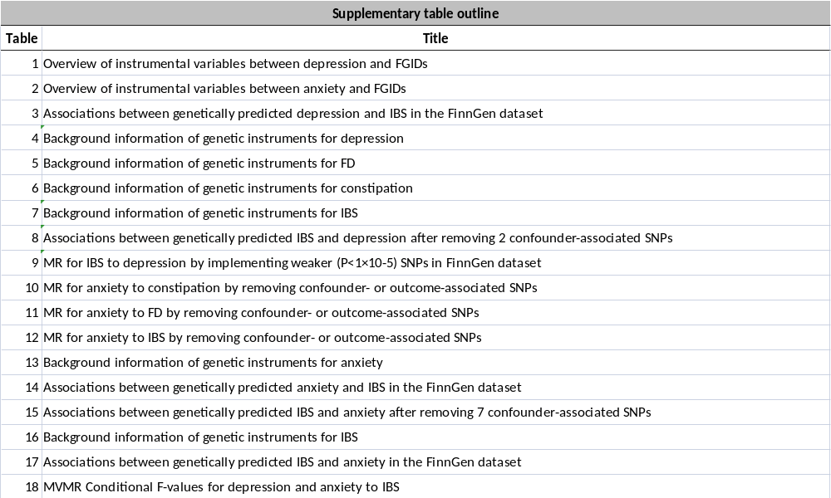

Supplementary Table 1
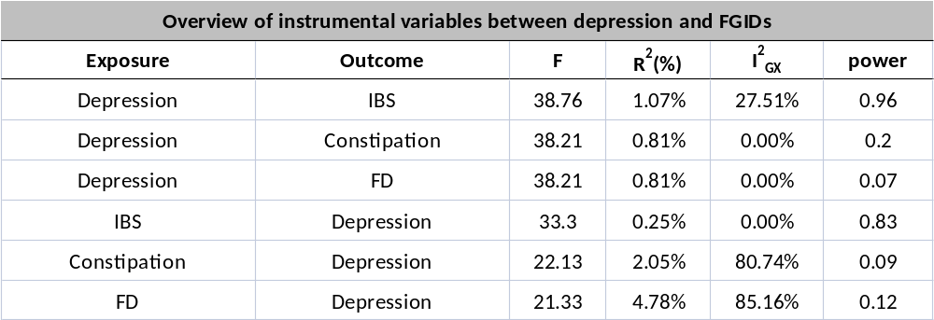

Supplementary Table 2
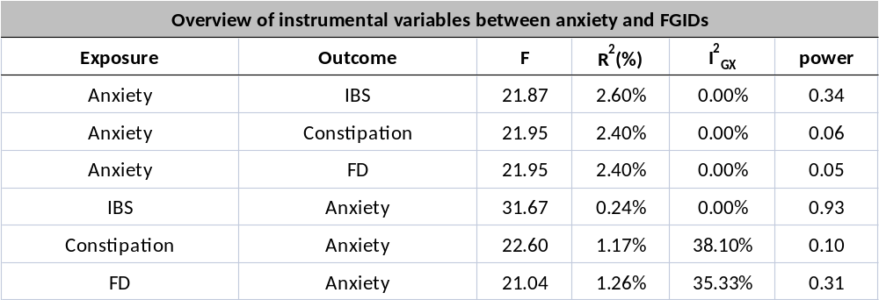

Supplementary Table 3
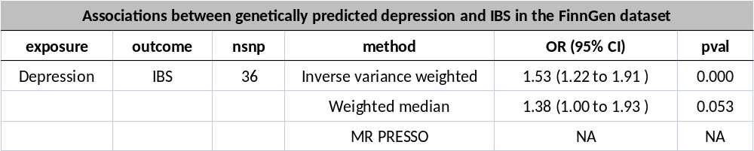

Supplementary Table 4
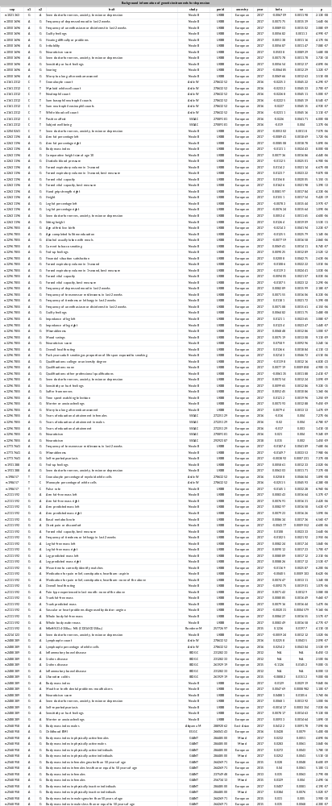
Supplementary Table 5
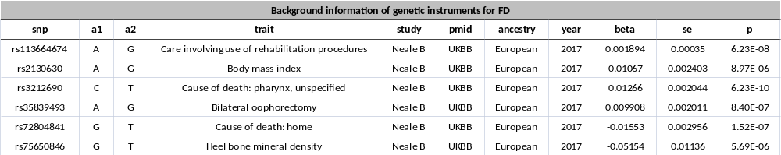

Supplementary Table 6
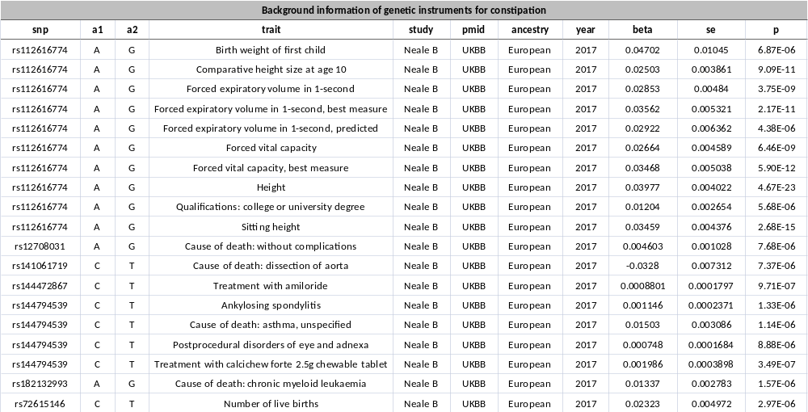

Supplementary Table 7
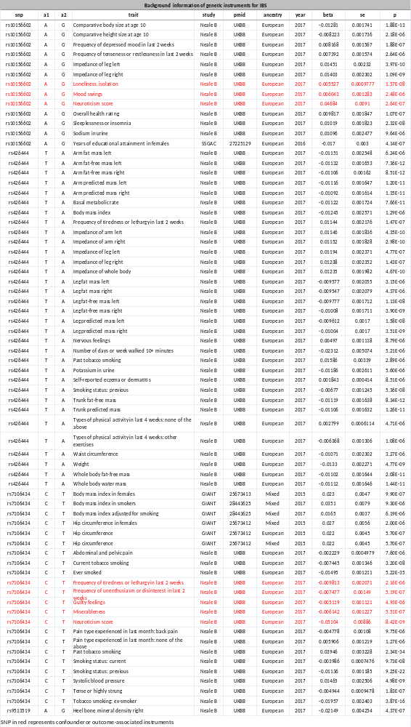
Supplementary Table 8
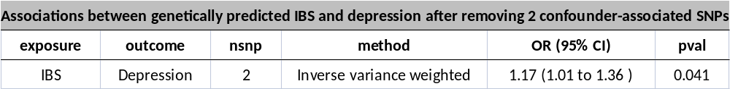

Supplementary Table 9
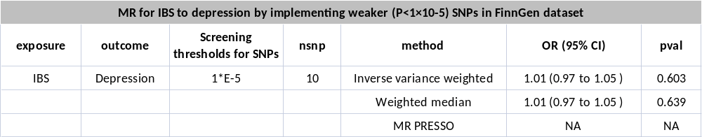

Supplementary Table 10
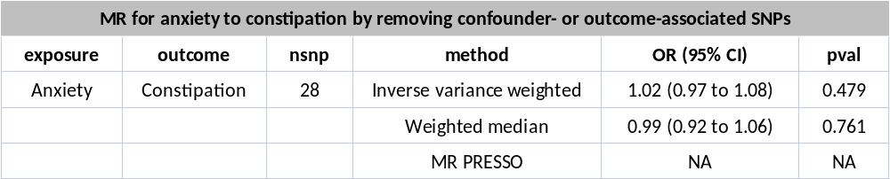

Supplementary Table 11
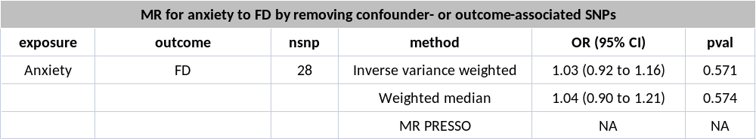

Supplementary Table 12
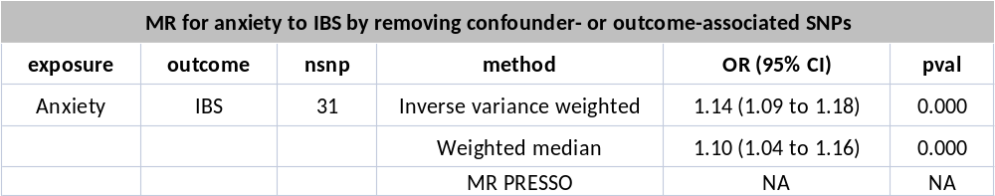

Supplementary Table 13
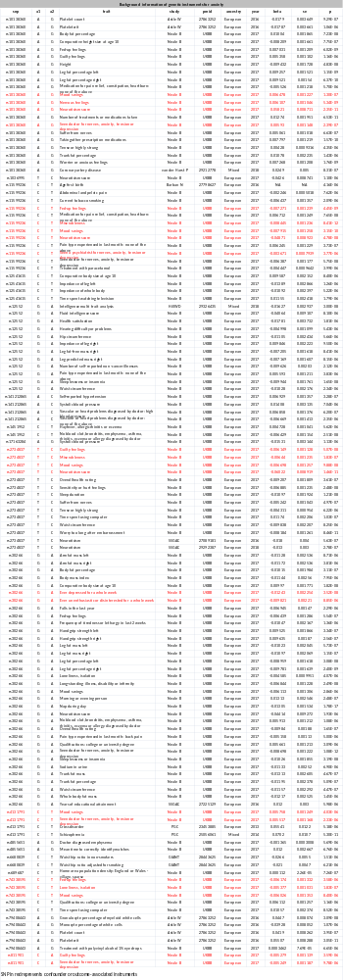
Supplementary Table 14
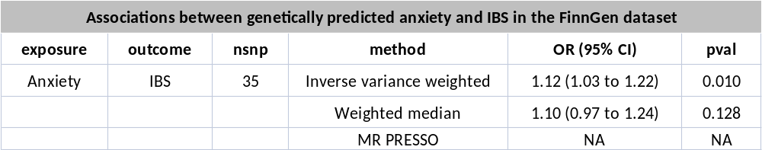

Supplementary Table 15
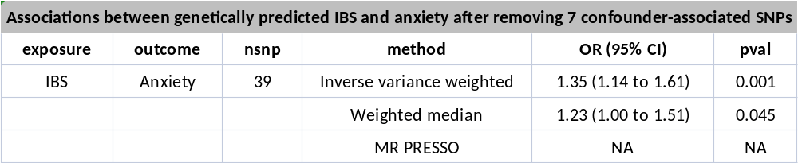

Supplementary Table 16
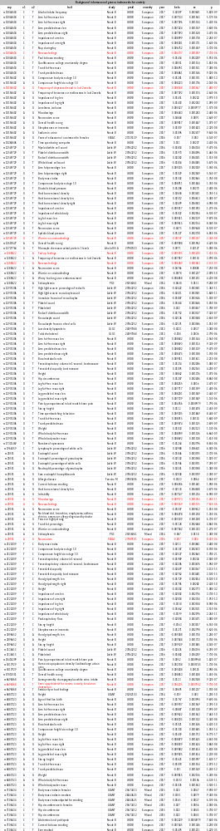
Supplementary Table 17
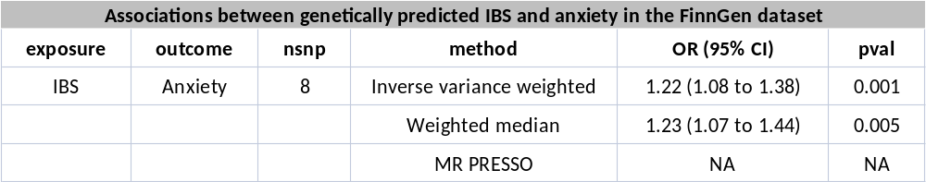

Supplementary Table 18
