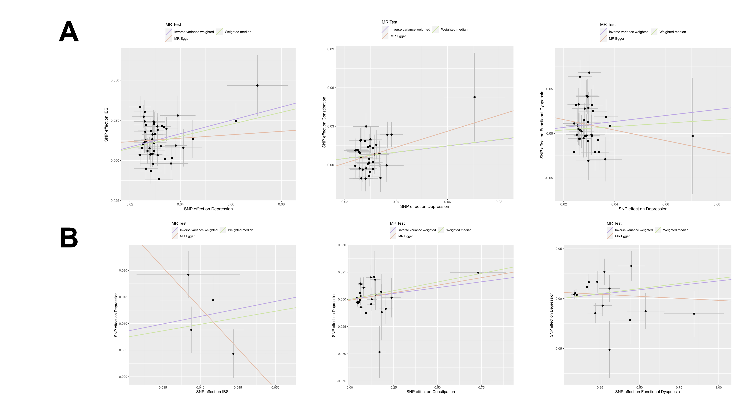
Supplementary Figure 1, Scatter plot of MR analyses. Part A indicates MR analysis of Depression to FGIDS, and part B indicates MR analysis of FGIDS to Depression.
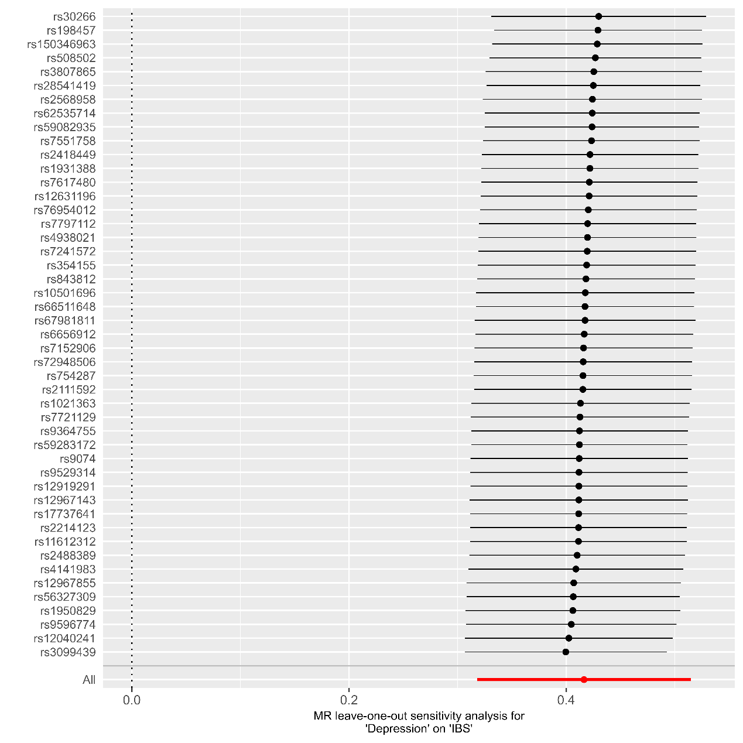

Supplementary Figure 2, MR Leave-one-out sensitivity analysis for Depression to IBS

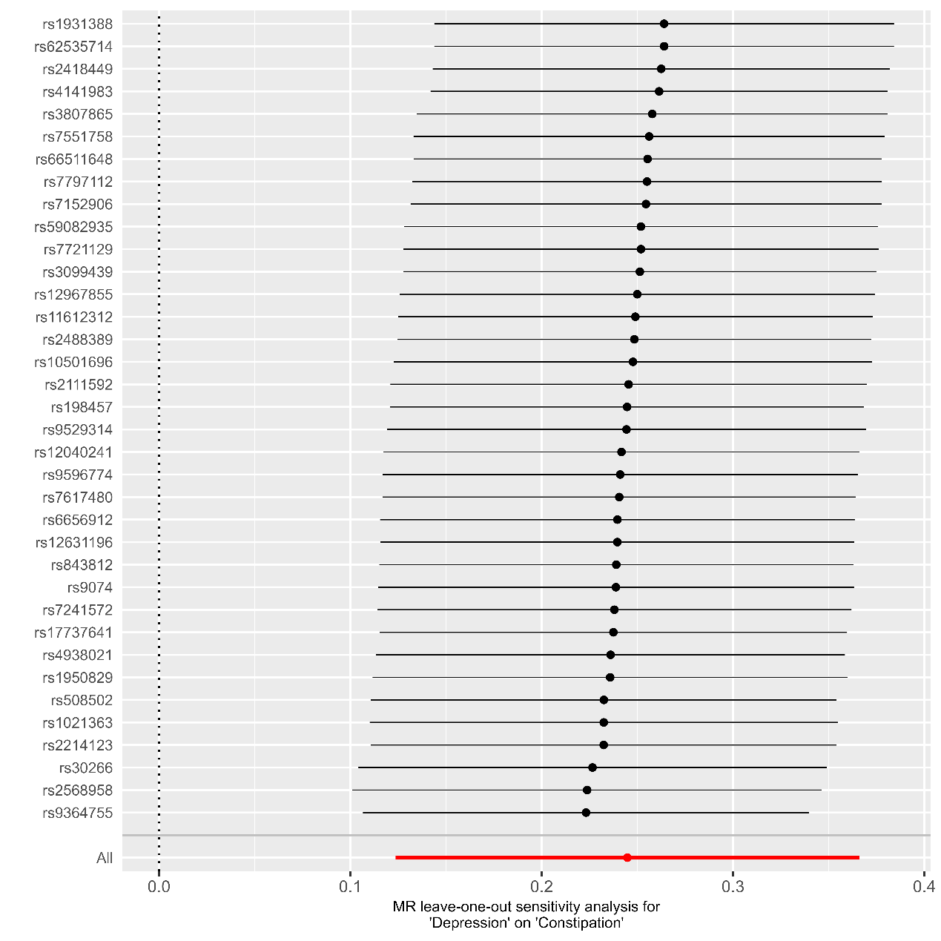

Supplementary Figure 3, MR Leave-one-out sensitivity analysis for Depression to Constipation

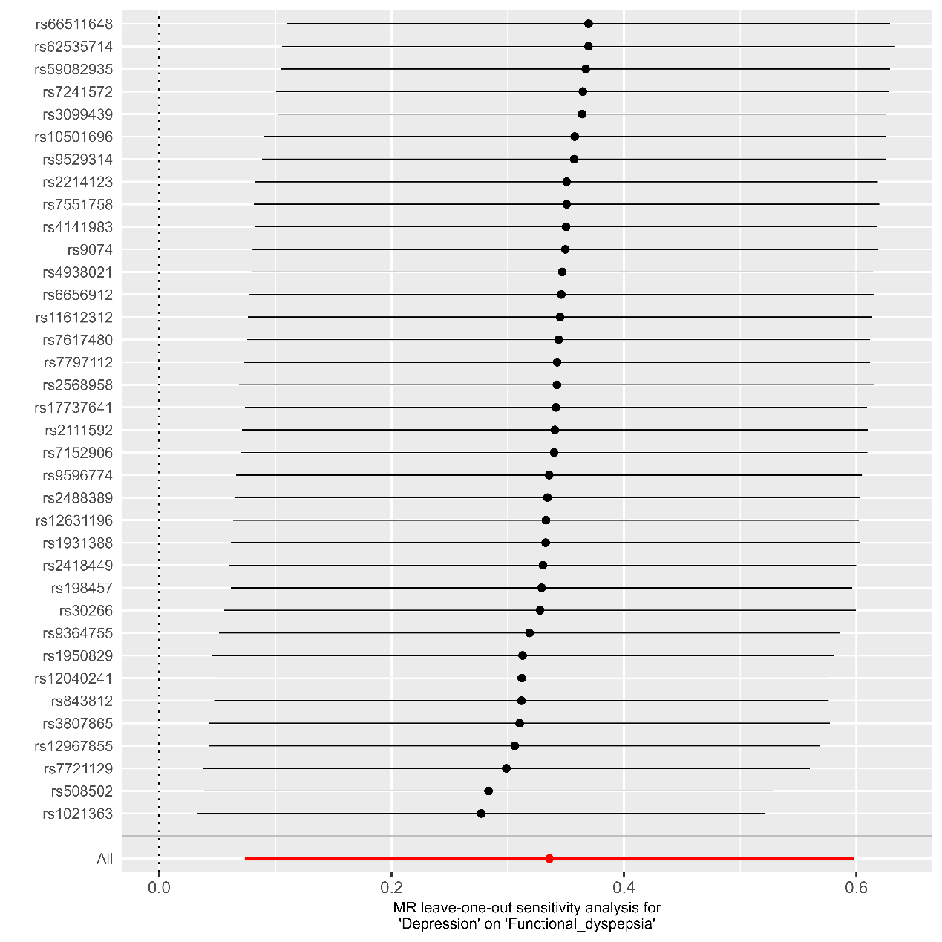

Supplementary Figure 4, MR Leave-one-out sensitivity analysis for Depression to Functional dyspepsia

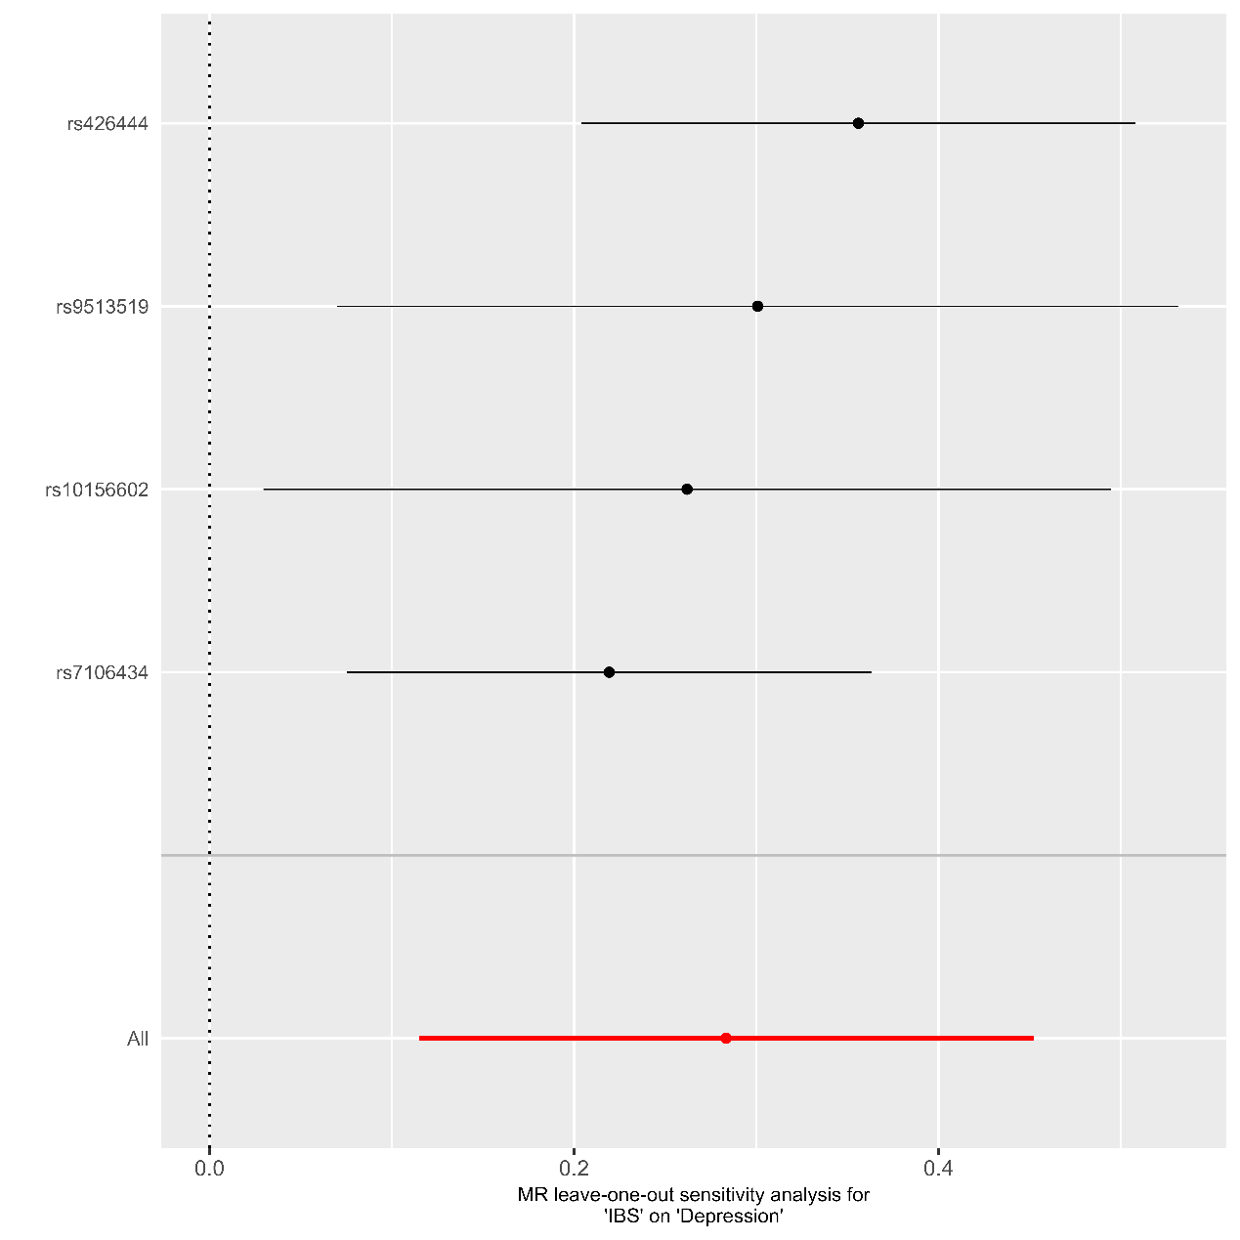

Supplementary Figure 5, MR Leave-one-out sensitivity analysis for IBS to Depression

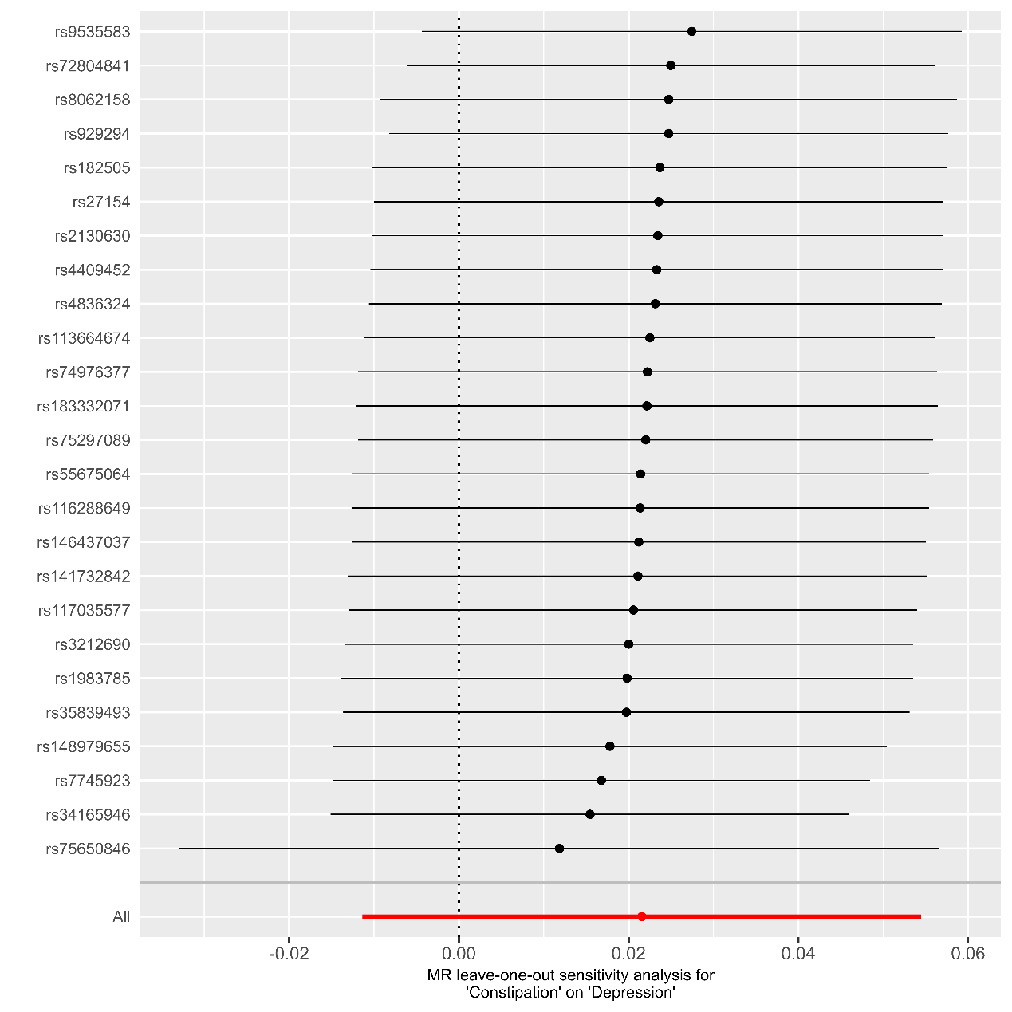

Supplementary Figure 6, MR Leave-one-out sensitivity analysis for Constipation to Depression

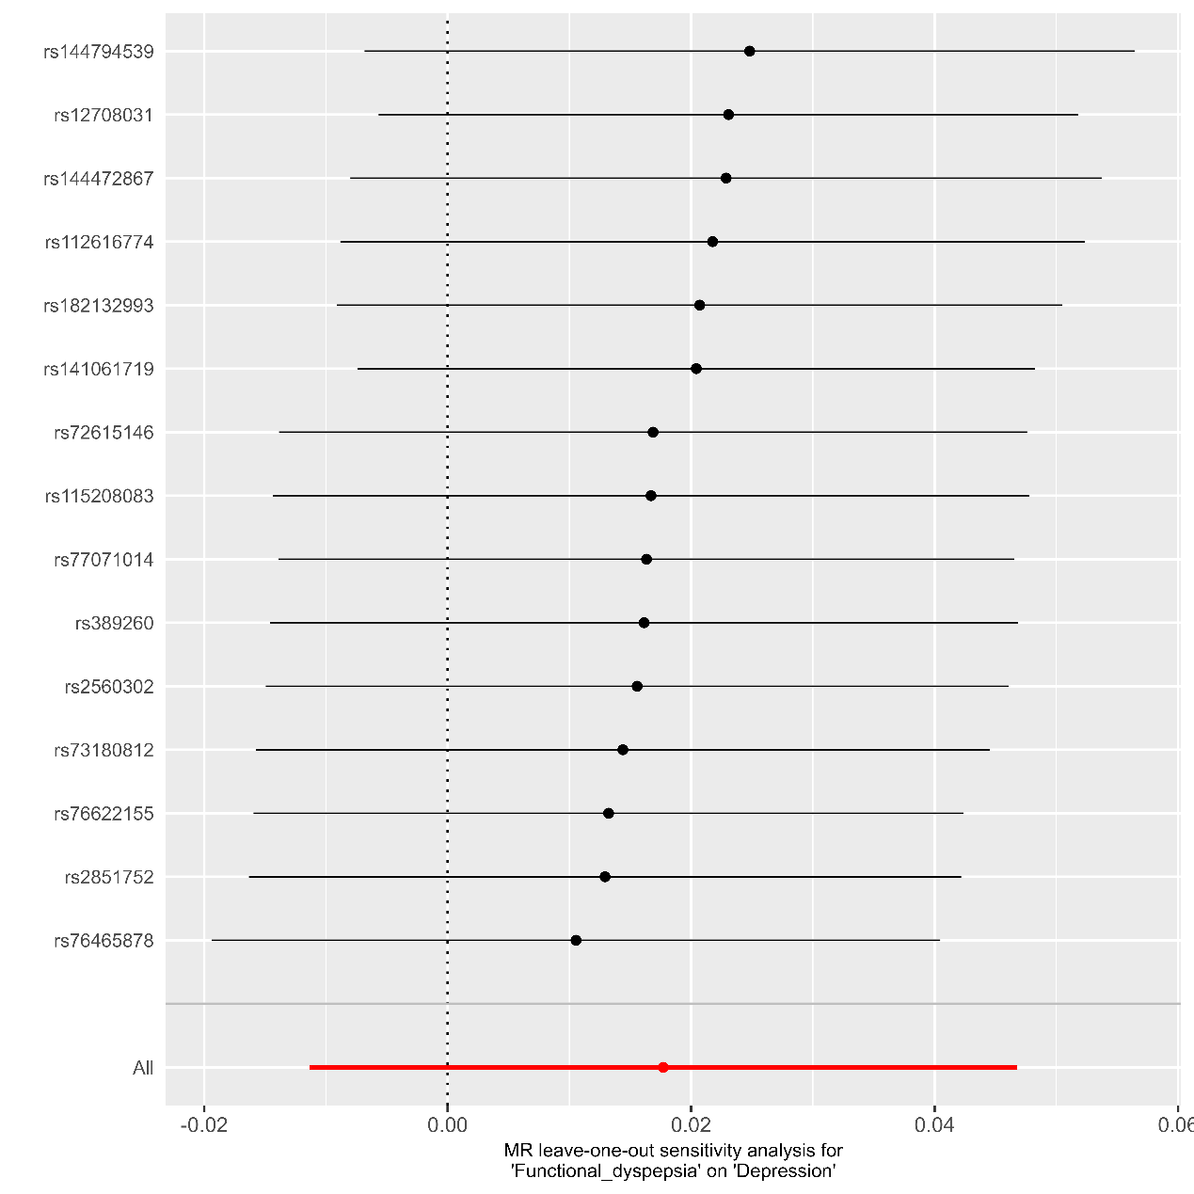

Supplementary Figure 7, MR Leave-one-out sensitivity analysis for Functional dyspepsia to Depression

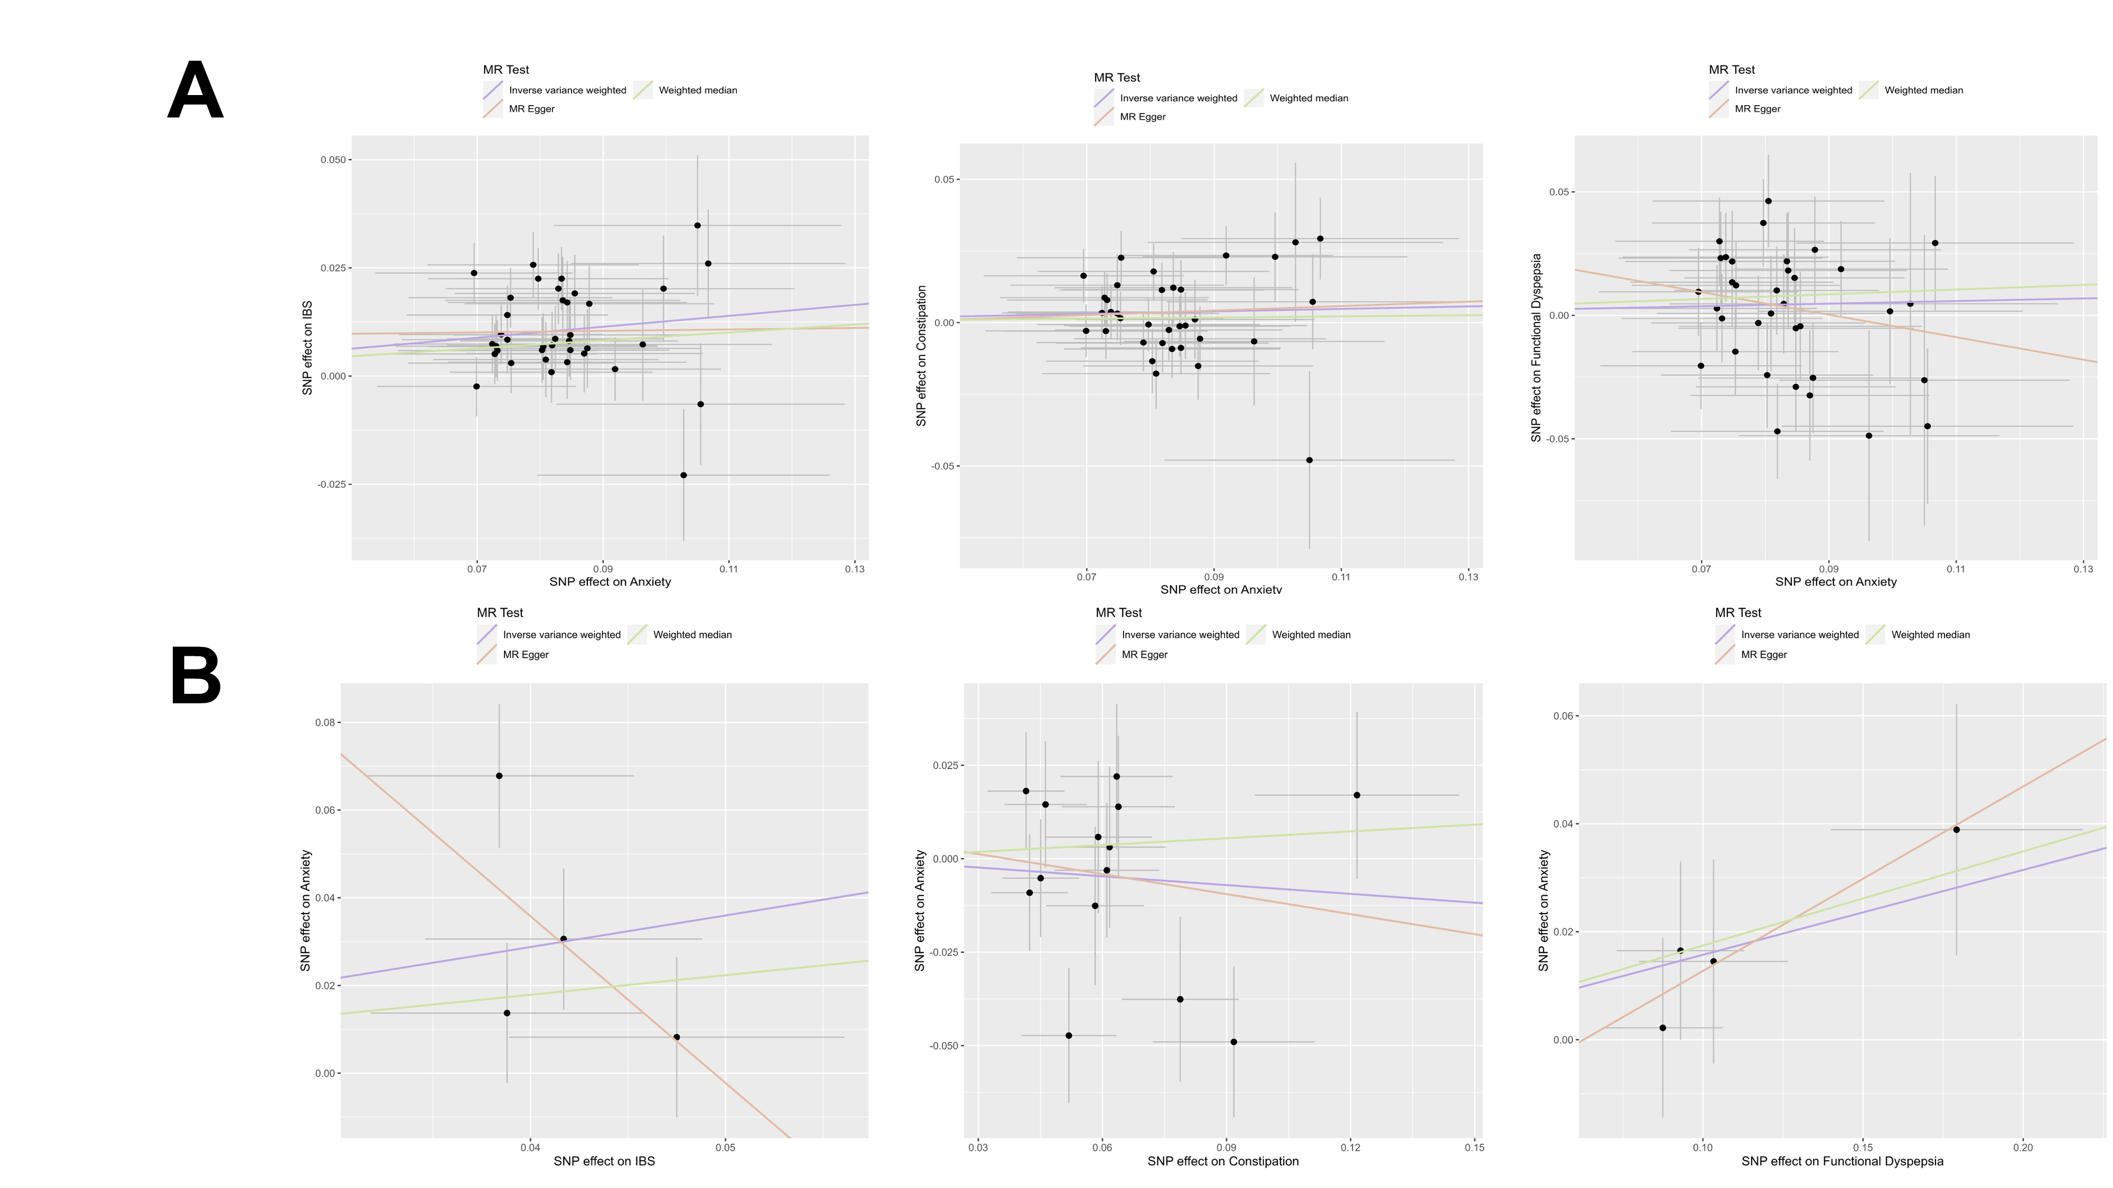

Supplementary Figure 8, Scatter plot of MR analyses. Part A indicates MR analysis of Anxiety to FGIDS, and part B indicates MR analysis of FGIDS to Anxiety.

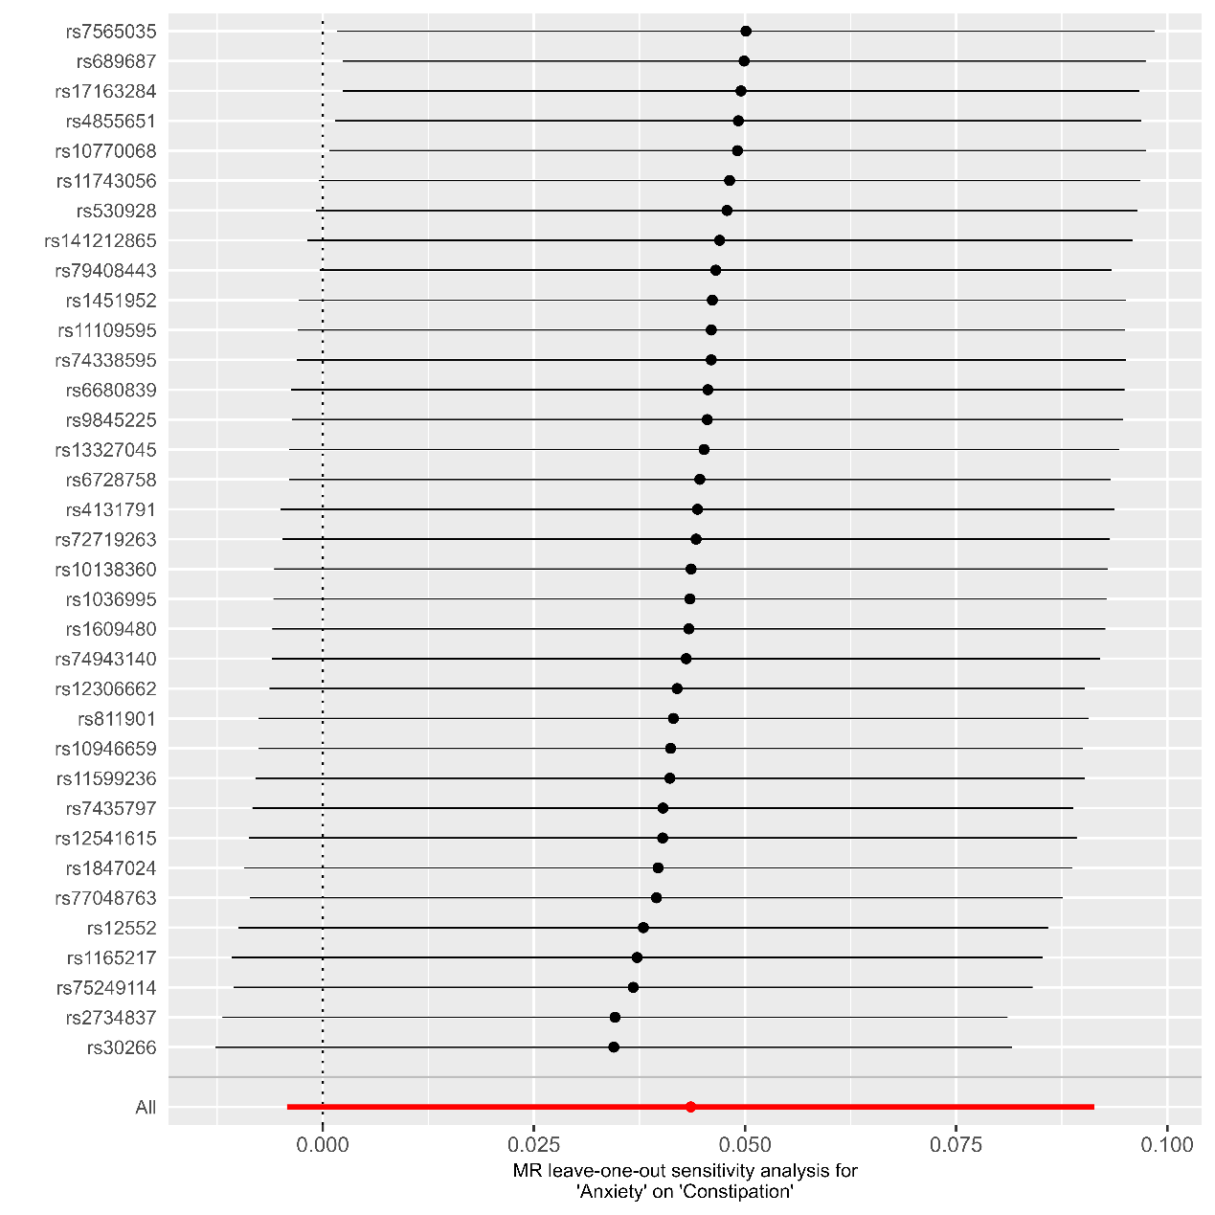

Supplementary Figure 9, MR Leave-one-out sensitivity analysis for Anxiety to Constipation

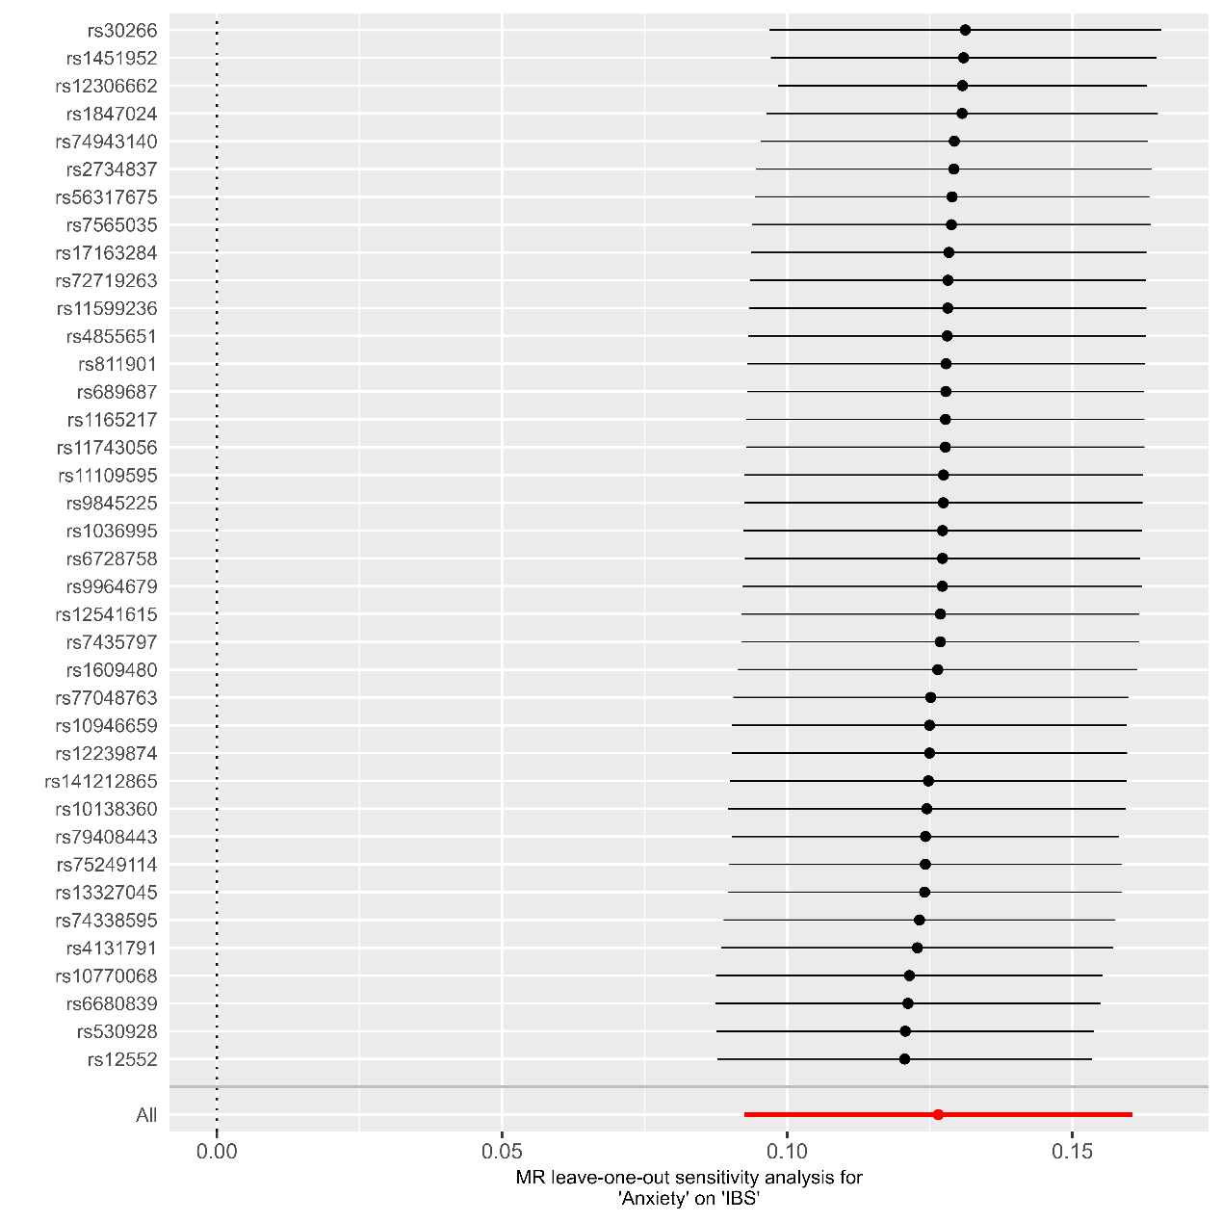

Supplementary Figure 10, MR Leave-one-out sensitivity analysis for Anxiety to IBS
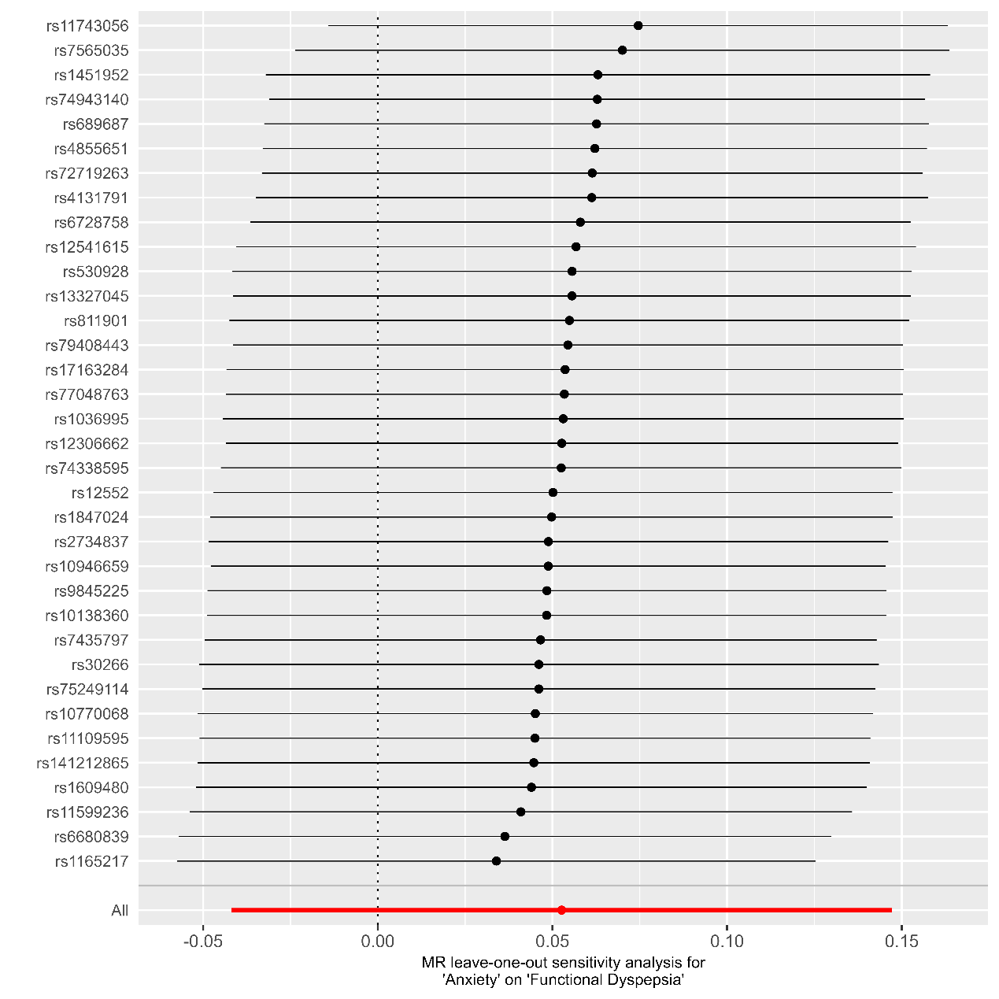

Supplementary Figure 11, MR Leave-one-out sensitivity analysis for Anxiety to Functional Dyspepsia
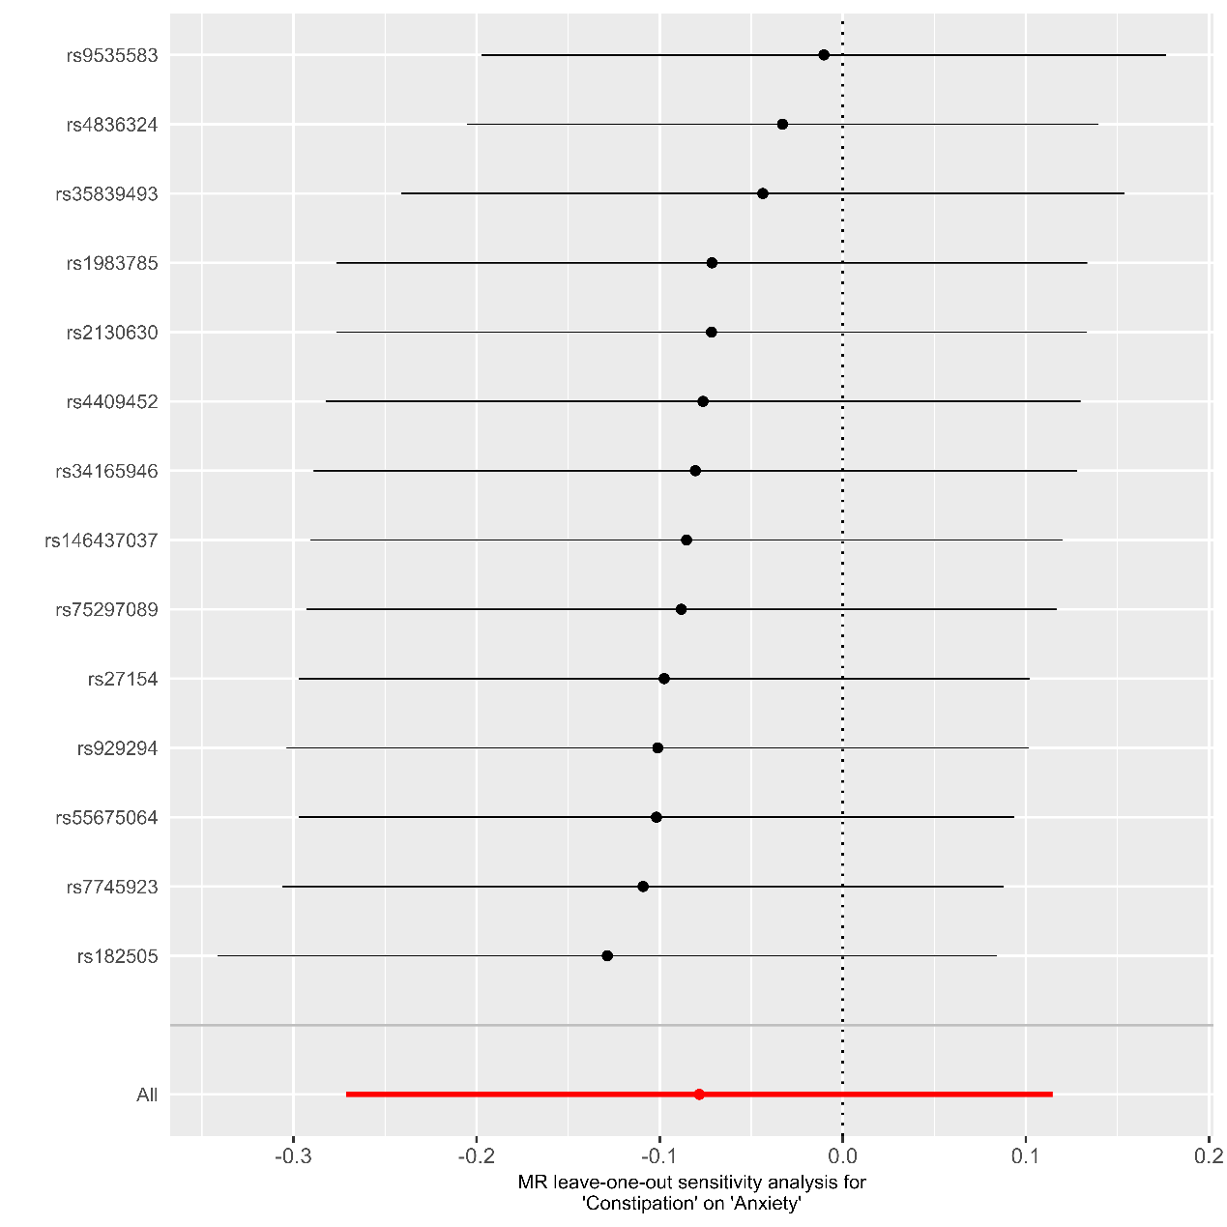

Supplementary Figure 12, MR Leave-one-out sensitivity analysis for Constipation to Anxiety
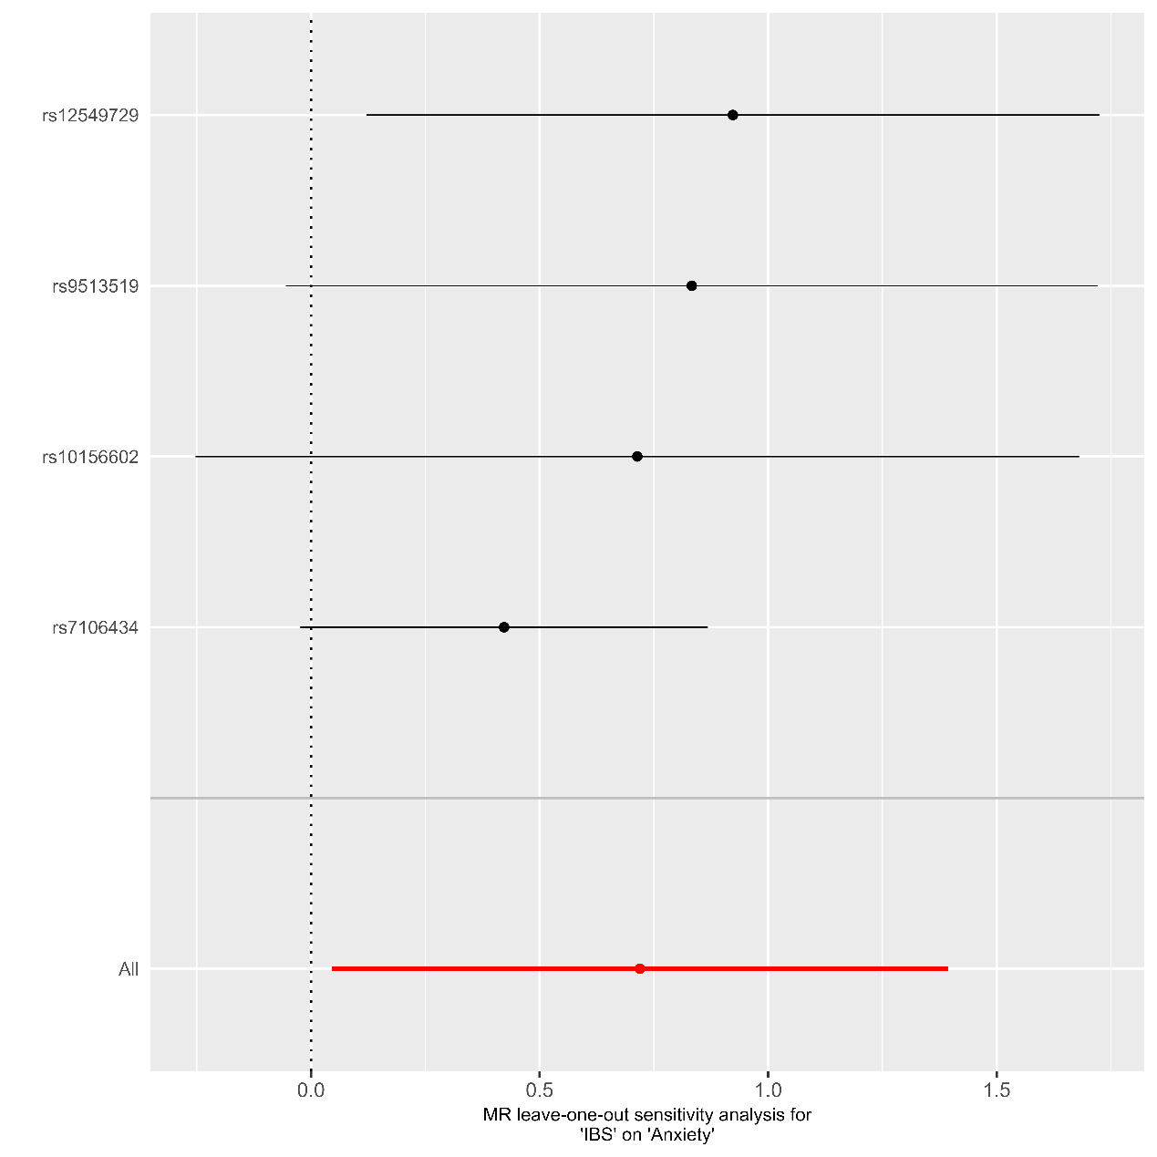

Supplementary Figure 13, MR Leave-one-out sensitivity analysis for IBS to Anxiety
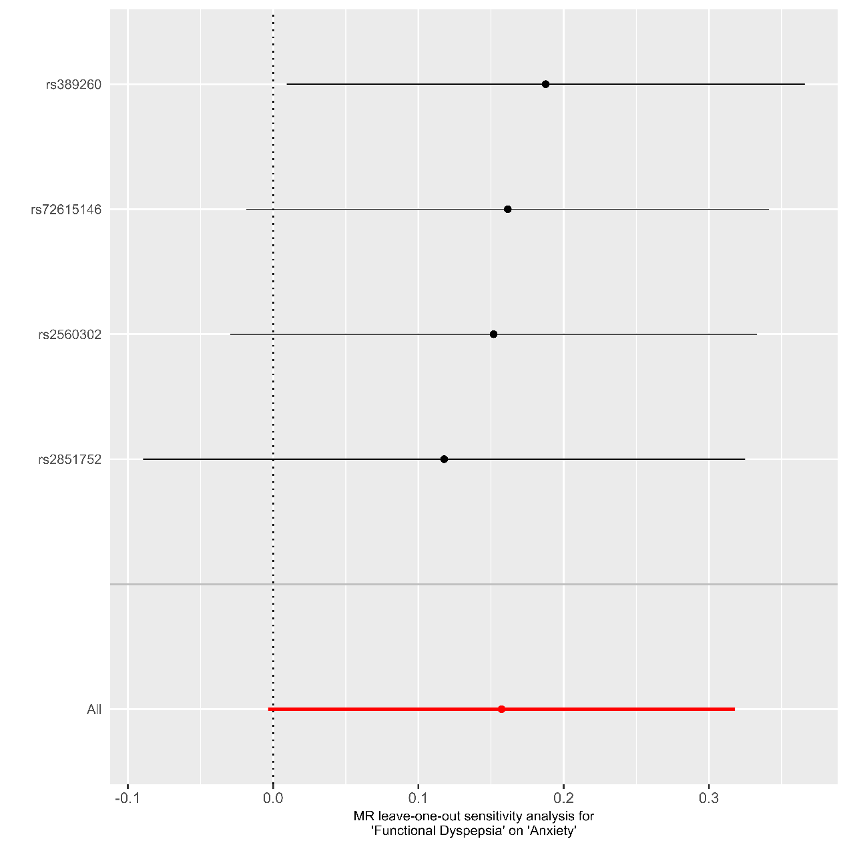

Supplementary Figure 14, MR Leave-one-out sensitivity analysis for FD to Anxiety

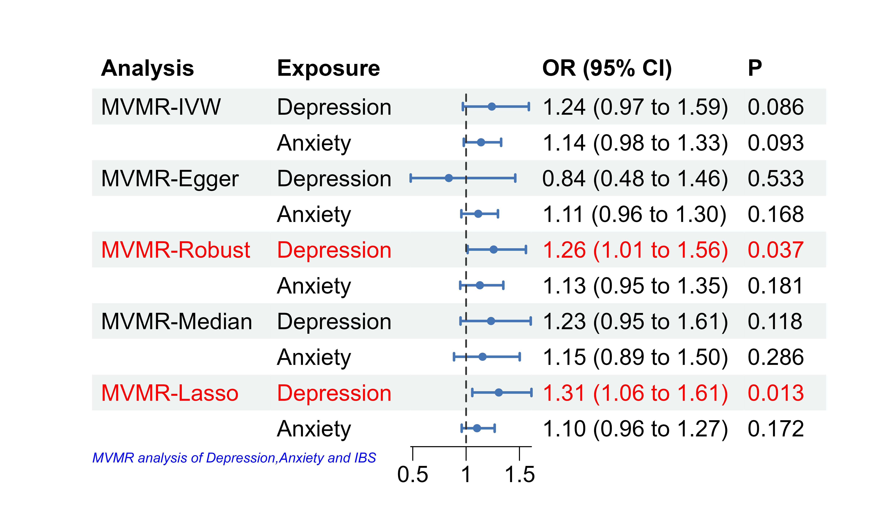
Supplementary Figure 15. Forest plot of multivariable MR estimates of depression and anxiety as exposures and risk of UKB-IBS as outcome. Data are displayed as odds ratio (OR) and 95% confidence interval (CI) per log (OR) increase in genetically predicted Depression and Anxiety. MVMR: multivariable Mendelian randomization; IVW: inverse-variance weighted method

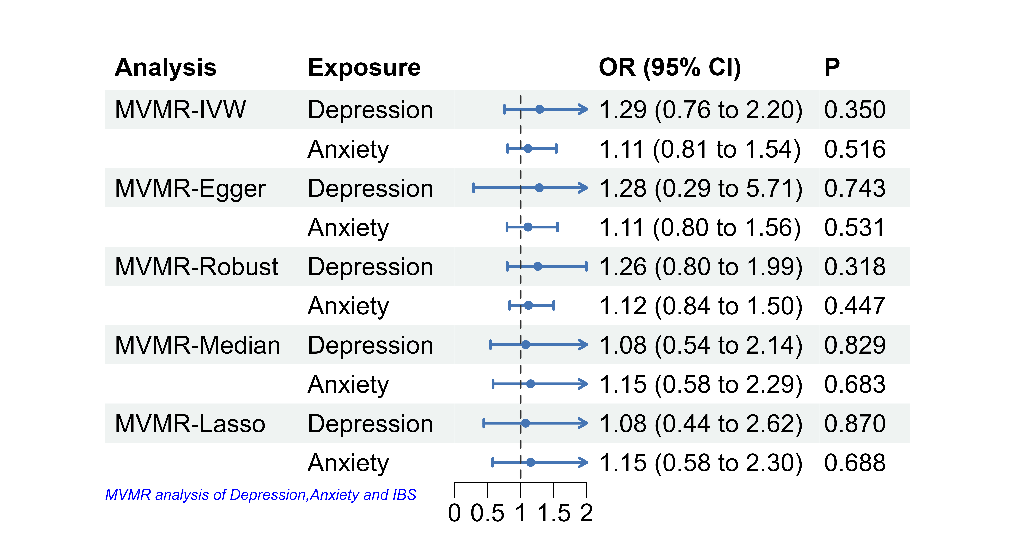
Supplementary Figure 16, Forest plot of multivariable MR estimates of depression and anxiety as exposures and risk of FinnGen-IBS as outcome. Data are displayed as odds ratio (OR) and 95% confidence interval (CI) per log (OR) increase in genetically predicted Depression and Anxiety. MVMR: multivariable Mendelian randomization; IVW: inverse-variance weighted method

