Supplementary Information
(SI)

ApcE plays an important role in light-induced excitation energy dissipation in the Synechocystis PCC6803 phycobilisomes

Gonfa Tesfaye Assefa, Joshua L. Botha, Bertus van Heerden, Farooq Kyeyune, Tjaart P.J. Krüger, and Michal Gwizdala

Fig. S1

A  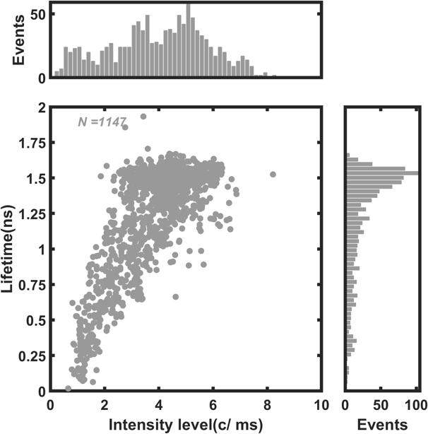 | B  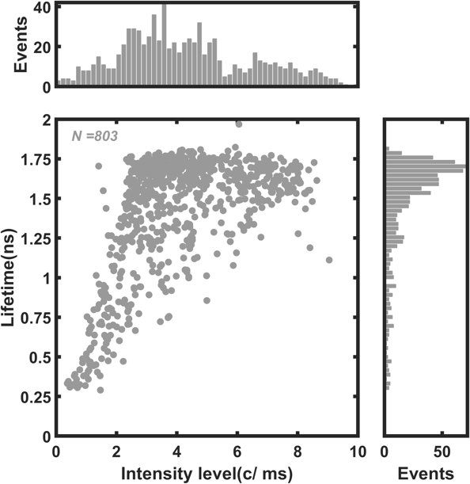
Fig. S1. Correlation between the non-normalised fluorescence intensities and lifetimes for A) 129 ApcE-C190S-PB and B) 87 WT-PB complexes at 1648 mW cm⁻² illumination. N denotes the number of states.

Fig. S2

A  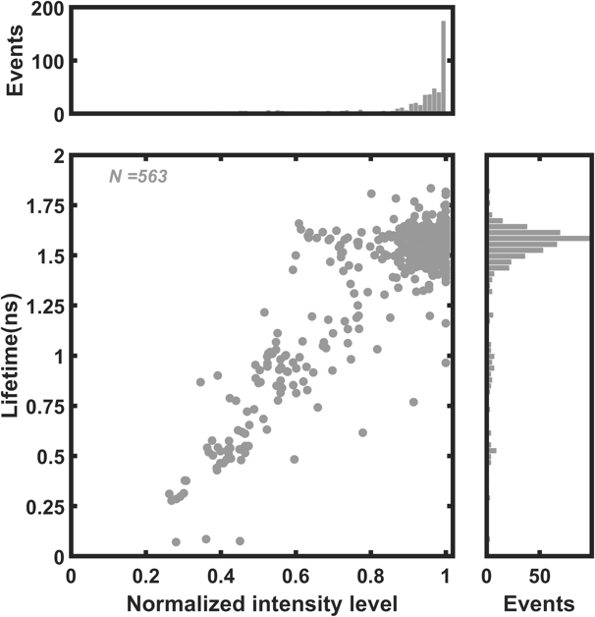 | B  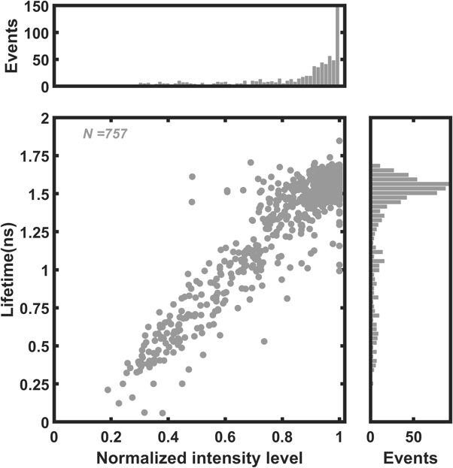
C  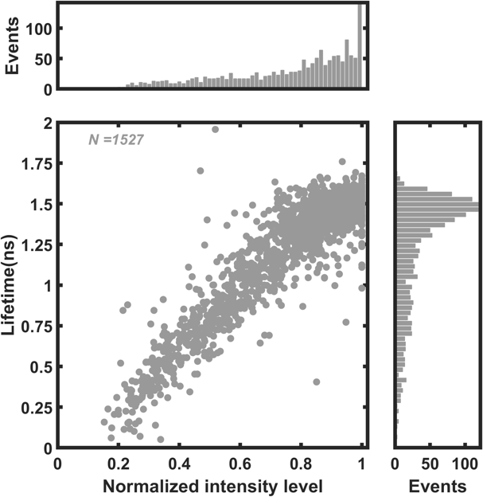 | D  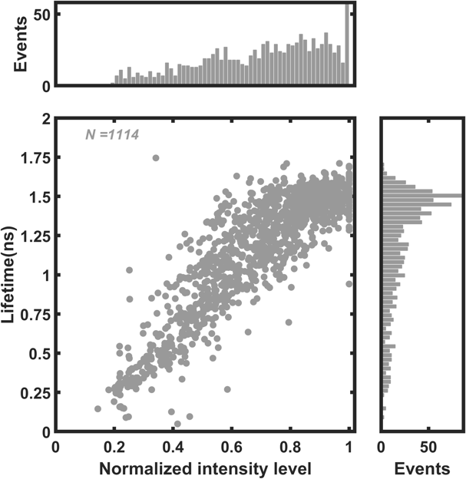
Fig. S2. Correlation between the normalised fluorescence intensities and lifetimes for ApcE-C190S-PB complexes at A) 400, B) 896, C) 2448, and D) 4096 mW cm⁻² illumination. N denotes the number of states.

Fig. S3

A  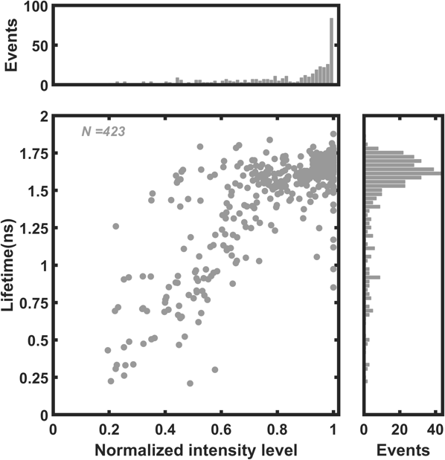 | B  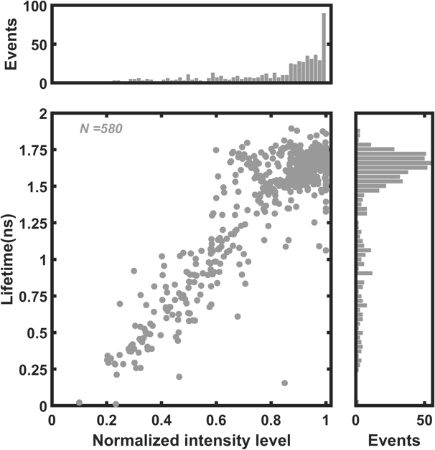
C  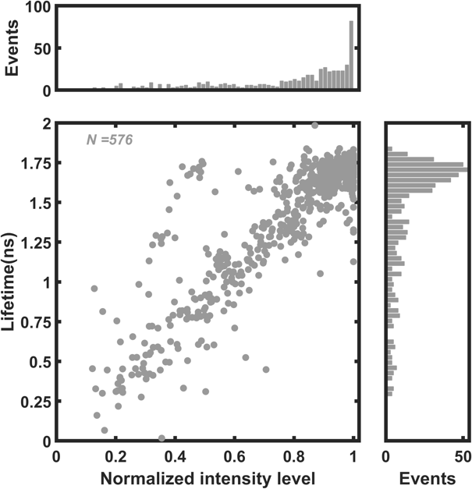 | D  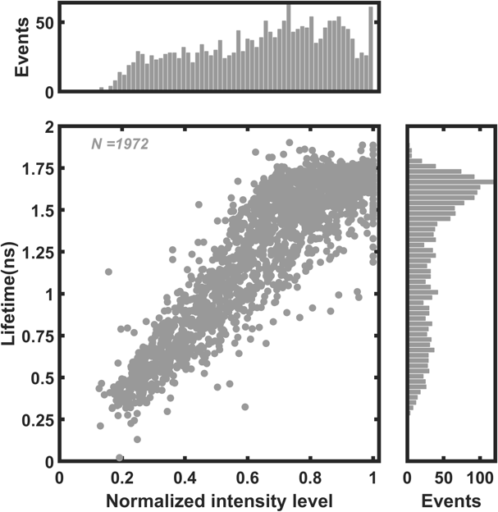
E  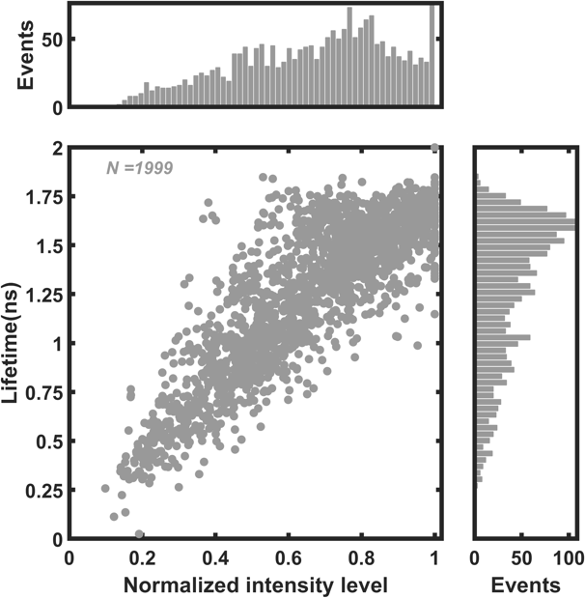 | Fig. S3. Correlation between the normalised fluorescence intensities and lifetimes for WT-PB complexes at A) 272, B) 496, C) 800, D) 2480, and E) 4128 mW cm⁻² illumination. m denotes the number of complexes after pre-screening. N denotes the number of states.
Fig. S4

A  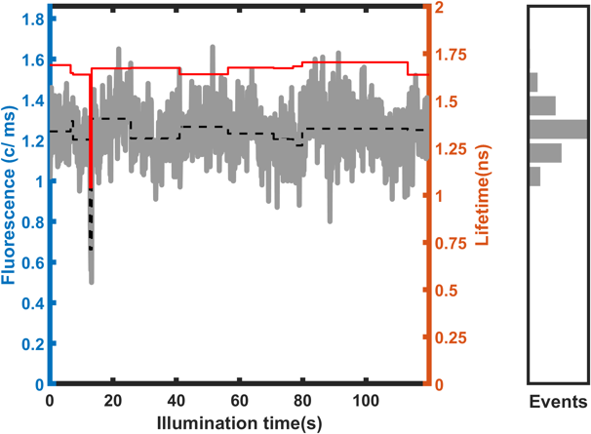 | B  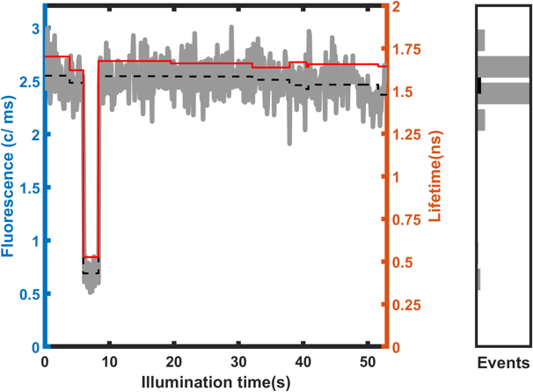
C  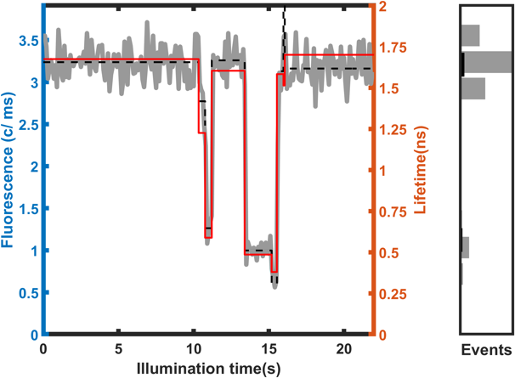 | D  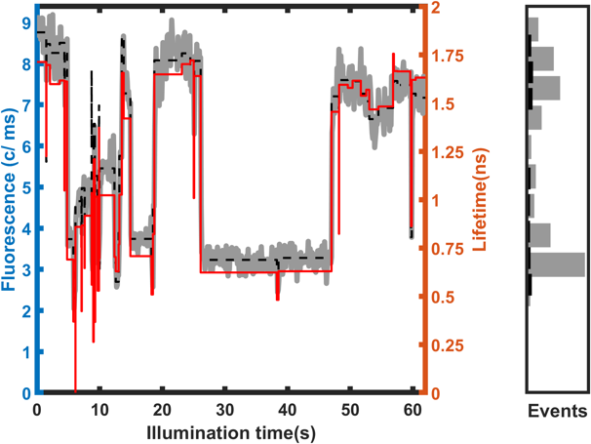
Fig. S4. Examples of emission and lifetime dynamics with increasing excitation rates for WT-PB at A) 496, B) 800, C) 1648, and D) 4128 mW cm⁻² illumination.

Fig. S5

A  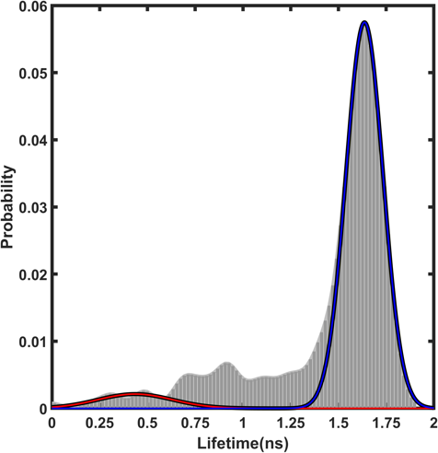 | B  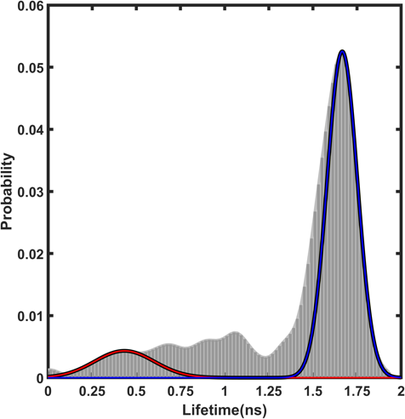
C  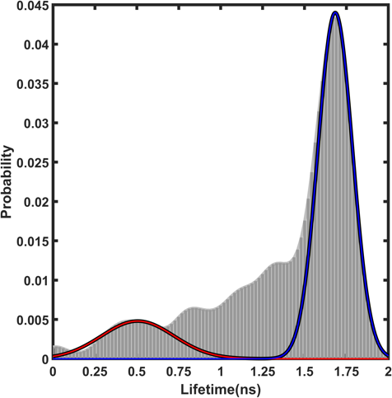 | D  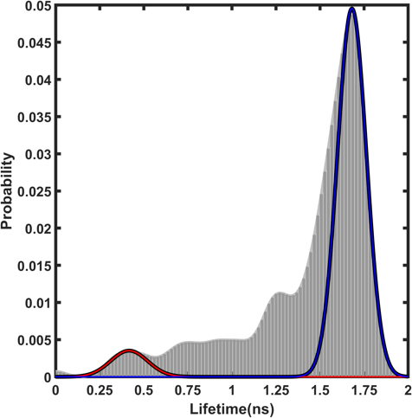
E  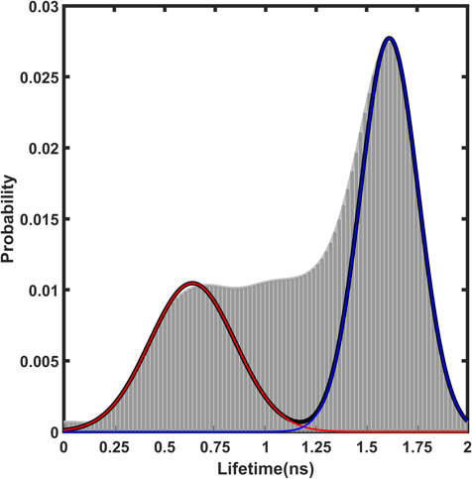 | F  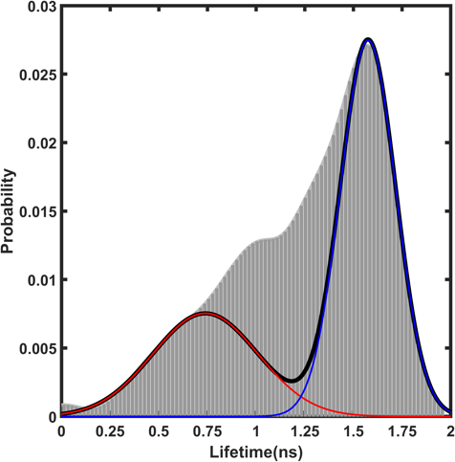
Fig. S5. Fluorescence lifetimes distribution for pre-screened WT-PBs at A) 272, B) 496, C) 800, D) 1648, E) 2480, and F) 4128 mW cm⁻² illumination. To determine the threshold between the bright and dim states for two-state model analysis, each distribution was fitted with two Gaussians (yellow and red). For both fits, half-Gaussians were initially fitted to the outer edges of the distributions and then mirror second halves were added to complete both Gaussians. The saddle point between the Gaussians determined the threshold between bright and dim states.

Fig. S6

A  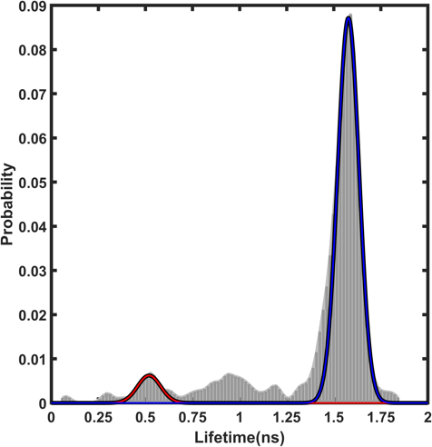 | B  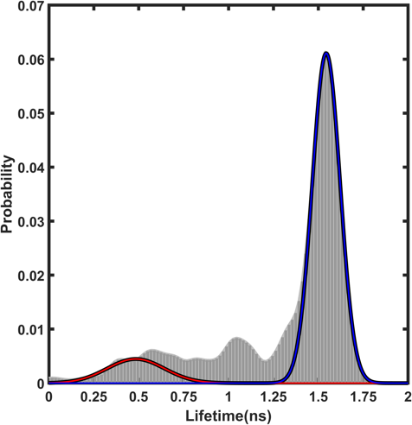
C  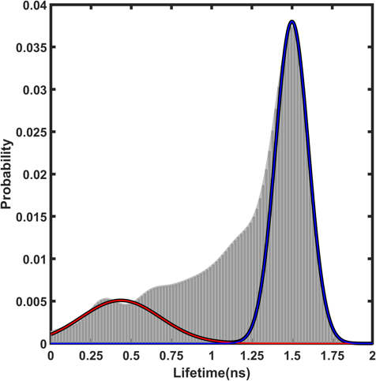 | D  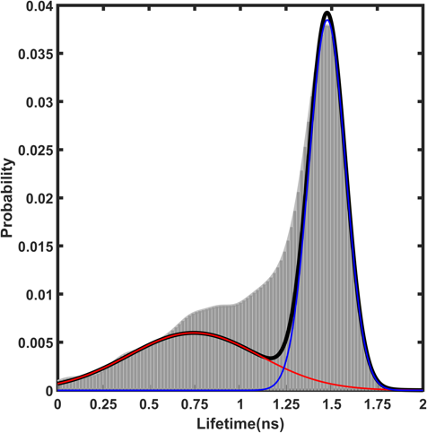
E  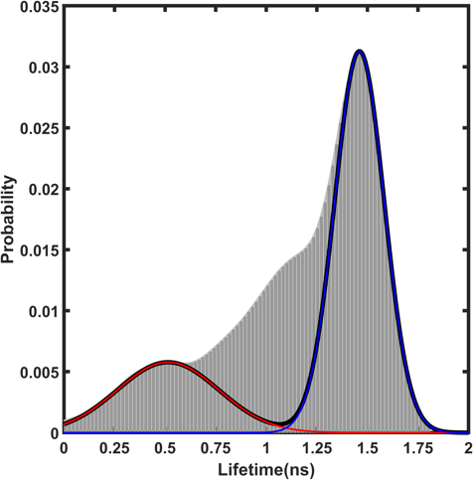 | Fig. S6. Fluorescence lifetimes distribution for pre-screened ApcE-C190S-PB at A) 400, B) 896, C) 1648, D) 2448, and E) 4096 mW cm⁻² illumination. To determine the threshold between the bright and dim states for two-state model analysis, each distribution was fitted with two Gaussians (yellow and red) at the edges of the distributions (fitting like in Fig S5). The saddle point between the Gaussians determined the threshold between bright and dim states.

Fig. S7

A  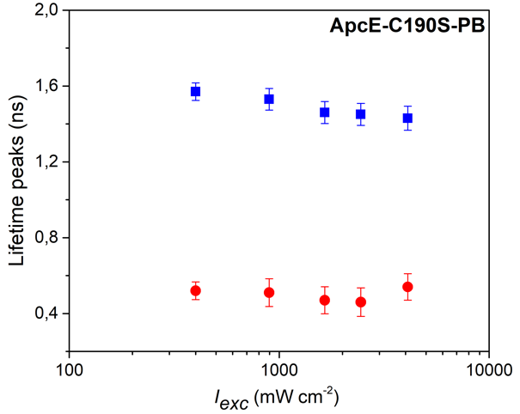 | B  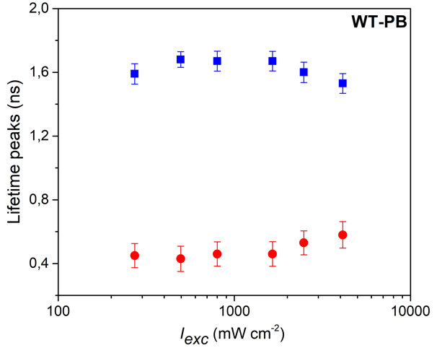
Fig. S7. Peak positions for Gaussians fitted to the distributions of lifetimes for A) ApcE-C190S-PB, and B) WT-PBs as shown in SI Figs S6 and S5, respectively.

Fig. S8

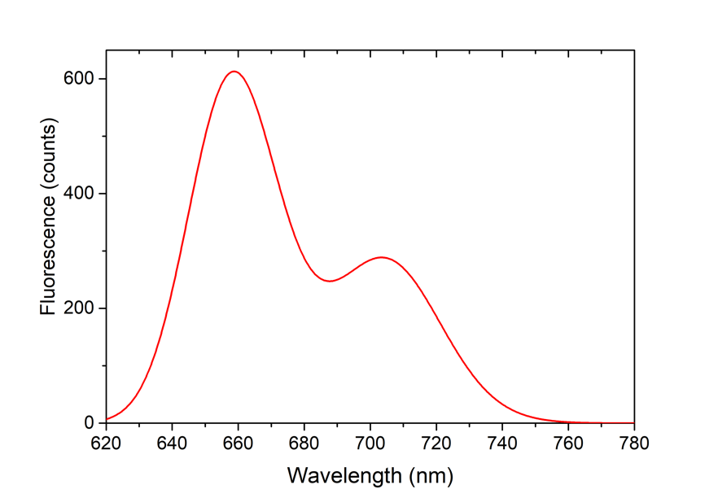
Fig. S8. An example of a spectrum from ApcE-C190S-PB displaying far-red emission. Similar spectra were previously recorded for WT-PB and signify the involvement of charge-transfer states in the light-induced energy quenching mechanism (for more information, see the main text and Krüger et al. 2019 & Wahadoszamen et al. 2020).

Fig. S9

A  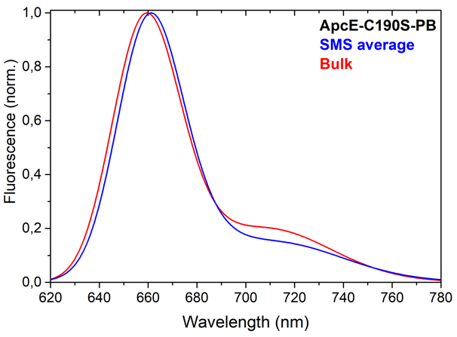 | B  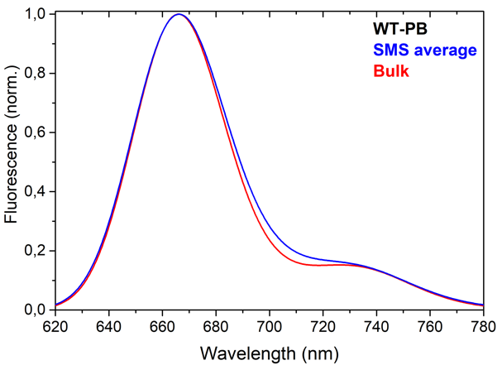
Fig. S9. Comparison between the average of all SMS spectra (of pre-screened complexes; blue) and bulk spectra (red) measured on the same spectroscopic setup for A) ApcE-C190S-PB and B) WT-PBs.

Table S1

Table S1. The total number of complexes measured and selected for analysis for different conditions s (more information in the main text).

Table S2

Table S2. Saddle points for different illumination as obtained from Figs S5 and S6.

Table S3

Table S3. Peak positions and the full width at half maxima (FWHM) for spectra shown in Figs 7 and S9.

