Supplementary file 1: supplementary tables
Guideline of VTE prophylaxis recommended in Nonsurgical Patients (based on Padua model)

Supplementary table 1. Padua Risk Assessment Model for Nonsurgical Patients
Baseline Features | Score
Active Cancer  (*Patients with local or distant metastases and/or chemotherapy or radiation therapy in the last 6 months.) | 3
Previous VTE (excluding superficial vein thrombosis) | 3
Reduced mobility  (Bed rest with bathroom privileges (either due to patient limitation or physician order) for at least 3 days.) | 3
Already known thrombophilic condition  (Carriage of defects of antithrombin, protein C or S, factor V Leiden, G20210A prothrombin mutation, antiphospholipid syndrome.) | 3
Recent (less than or equal to 1 month) trauma and/or surgery | 2
Elderly age (70 years or older) | 1
Heart and/or respiratory failure | 1
Acute myocardial infarction or ischemic stroke | 1
Acute infection and/or rheumatologic disorder | 1
Obesity (BMI 30 kg/m2 or greater) | 1
Ongoing hormonal treatment | 1
Total score

Supplementary table 2. Total Score and VTE Risk Level for non-surgical patients based on Padua model
Total Score | VTE Risk Level | Renal function | Weight | VTE Prophylaxis recommended? | Contraindication
Less than 3 | Low | - | - | Early ambulation  Sequential Compression Device (SCD) | See table 3
3 or more | High | GFR <30 ml/min | < 13۰kg | - Heparin 5000 units SQ TID | See table 3
3 or more | High | GFR <30 ml/min | ≥13۰kg | - Heparin 5000 units SQ BID | See table 3
 |  | GFR>30 ml/min | < 75 Kg | - Enoxaparin 40mg SQ daily | See table 3
 |  | GFR>30 ml/min | ≥75 kg | - Enoxaparin 60 mg SQ daily | See table 3

Supplementary table 3. Contraindication VTE prophylaxis order
Contraindications To Early Ambulation | Acute Myocardial Infarction  Active Bleeding  Increased Intracranial Pressure  Unstable Pelvic Fractures  Other
Contraindications to Mechanical Prophylaxis | Severe Peripheral Arterial Disease  Congestive Heart Failure  Acute Superficial/Deep Vein Thrombosis  Fracture  Other
Contraindications to pharmacological prophylaxis | Active Bleeding  Thrombocytopenia (PLT≤50000)  Hepatic Failure (INR > 2)  Lumbar puncture, epidural, or spinal anesthesia within previous 4 h  Ingestion of Oral Anticoagulants  Acute gastroduodenal bleeding  Heparin-induced thrombocytopenia  Bleeding disorders such as hemophilia  Administration of glycoprotein IIb/IIIa inhibitors  Other

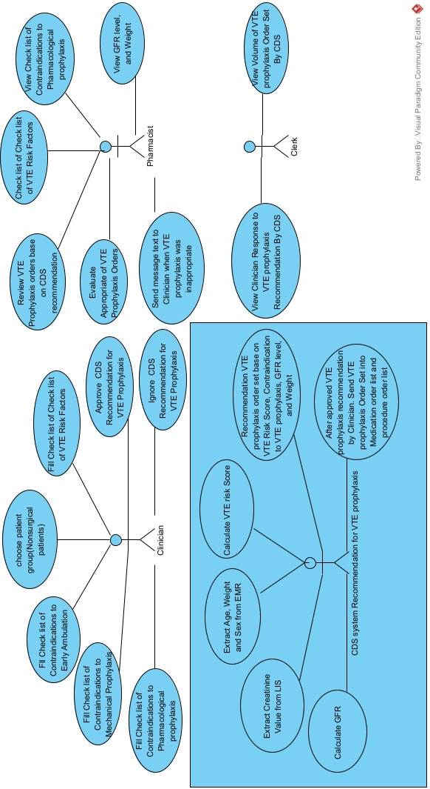
Supplementary File 2: UML diagram (supplementary figures)
Supplementary figure 1. Diagram 1-use case diagram for CDS recommendation to VTE prophylaxis in nonsurgical patients

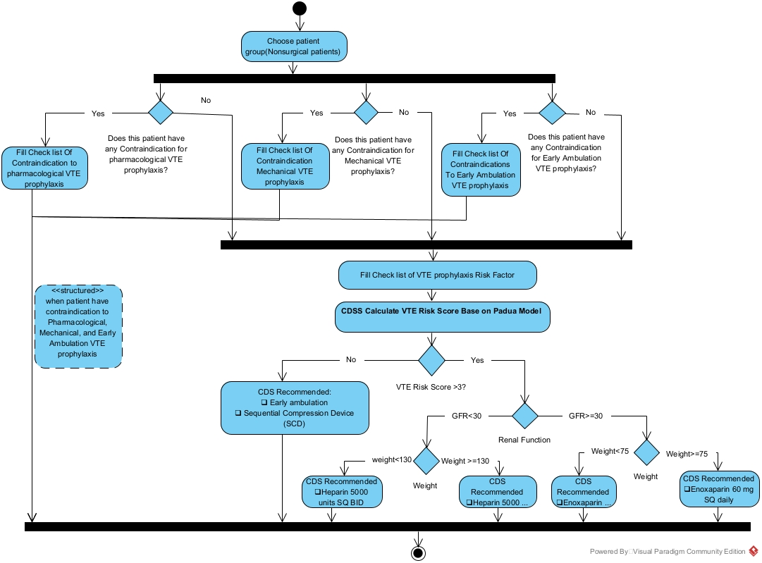

Supplementary figure 2. activity diagram when patient have any contraindication to VTE prophylaxis or Patient not have any continuation to VTE prophylaxis in nonsurgical patients

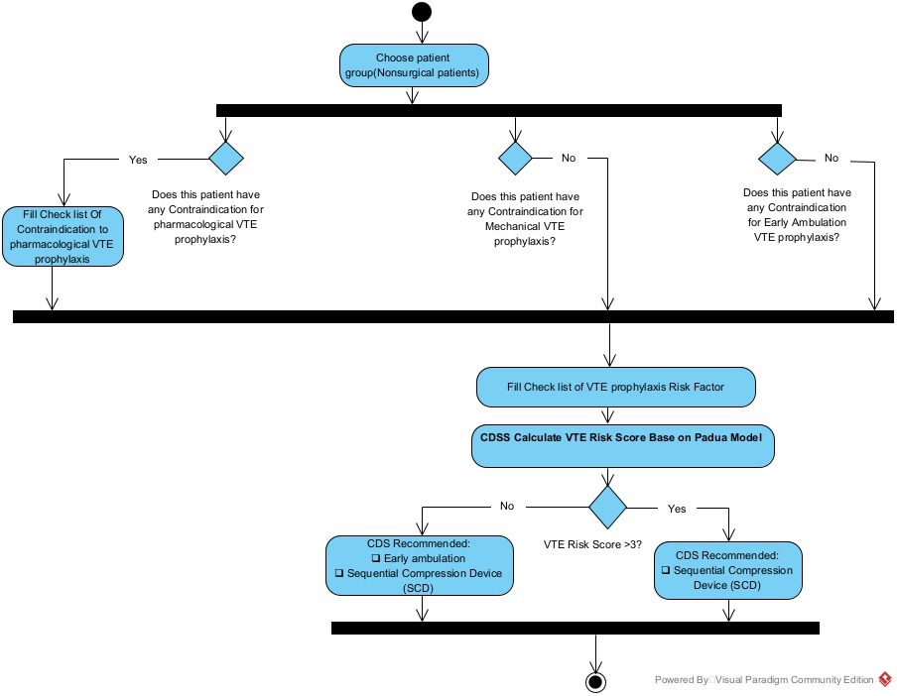

Supplementary figure 3.- activity diagram when the patient only has a contraindication to pharmacological VTE prophylaxis in nonsurgical patients.

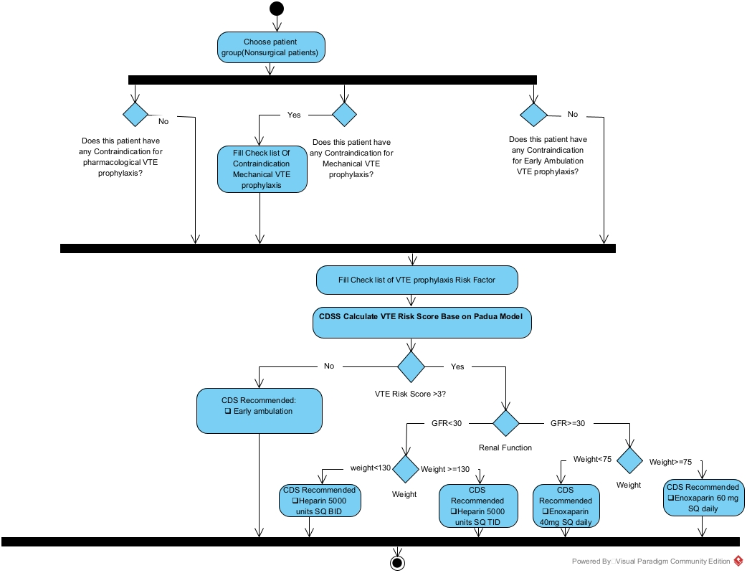
Supplementary figure 4. activity diagram when the patient has only contraindication to Mechanical VTE prophylaxis in nonsurgical patients

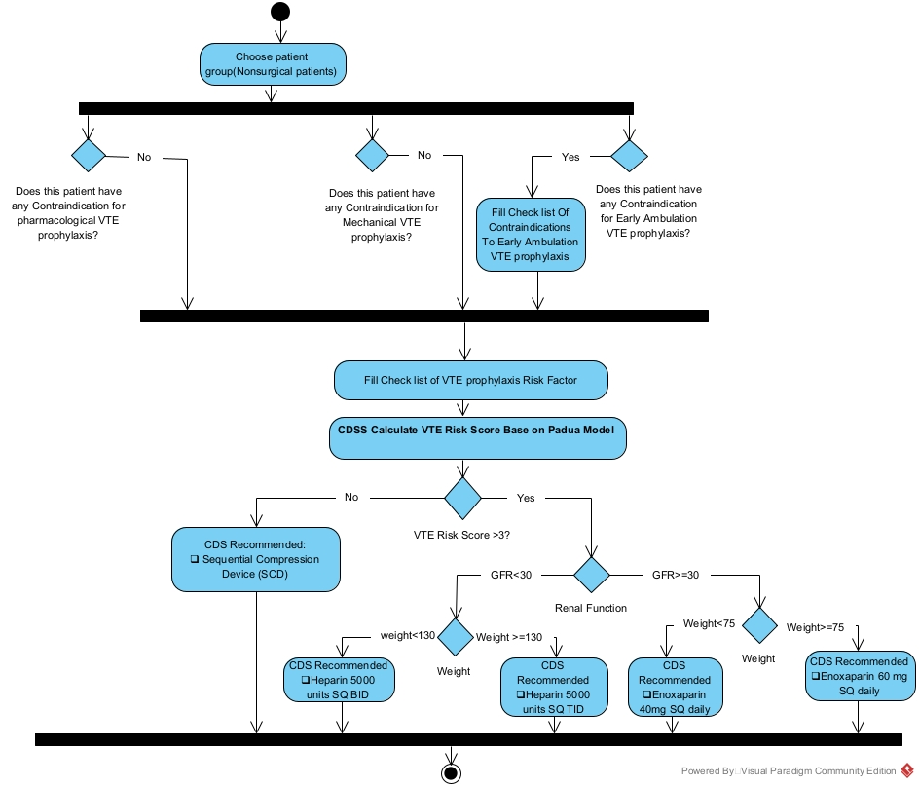
Supplementary figure 5. Activity Diagram When Patient Have only Contraindications To Early Ambulation VTE prophylaxis nonsurgical patient.

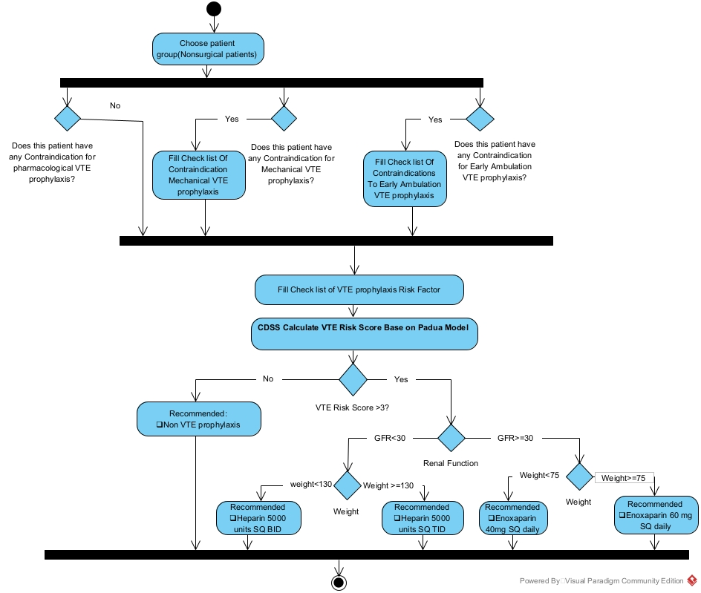
Supplementary figure 6. activity diagram when patient have contraindication to mechanical and early ambulation VTE prophylaxis in nonsurgical patient

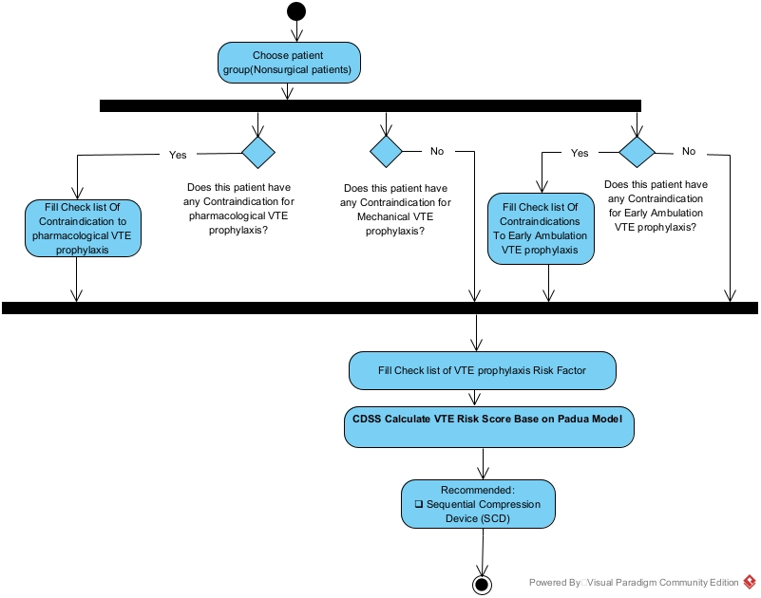
Supplementary figure 7. activity diagram when patient have contraindication to pharmacological and early ambulation VTE prophylaxis in nonsurgical patients

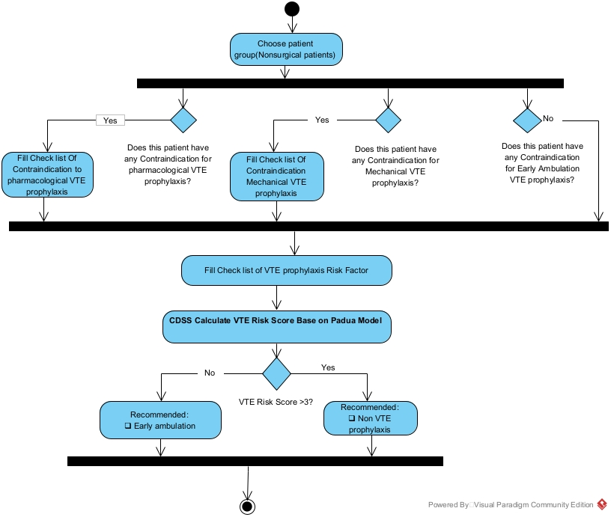
Supplementary figure 8. Activity diagram when patient have contraindication to pharmacological and mechanical VTE prophylaxis in nonsurgical patient

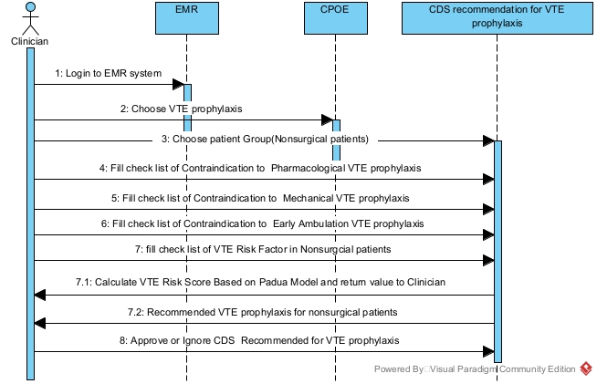
Supplementary figure 9. Sequence diagram for CDS recommendation for VTE prophylaxis in nonsurgical patients

Supplementary file 3: Screen of VTE Prophylaxis CDS system in Nonsurgical Patients

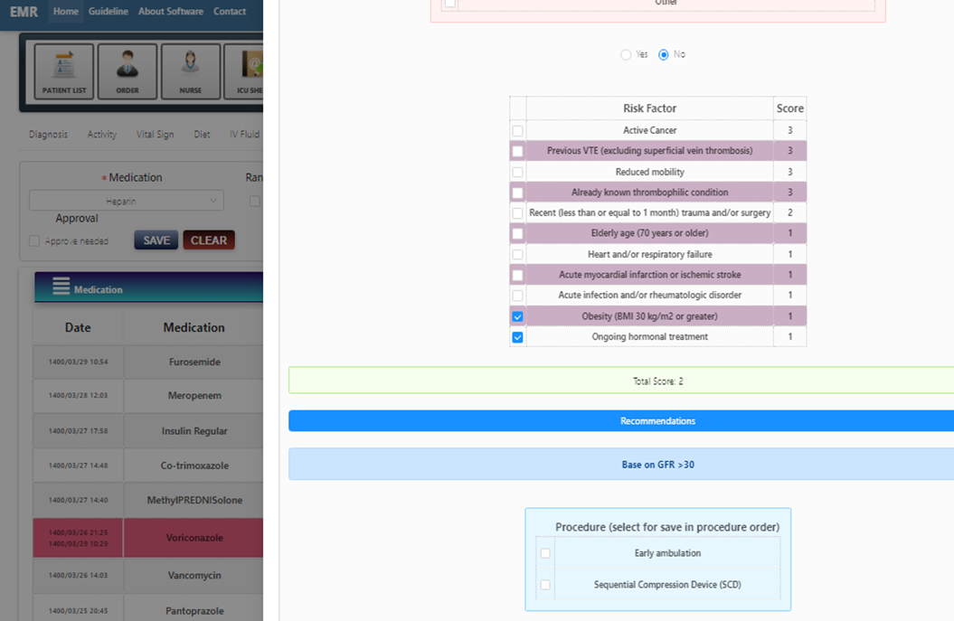
Supplementary figure 10. Screen of VTE Prophylaxis CDS system in Nonsurgical Patients

