Supplementary material

Figure A1. ESBL proportions in our sample before and after computing the propensity score.

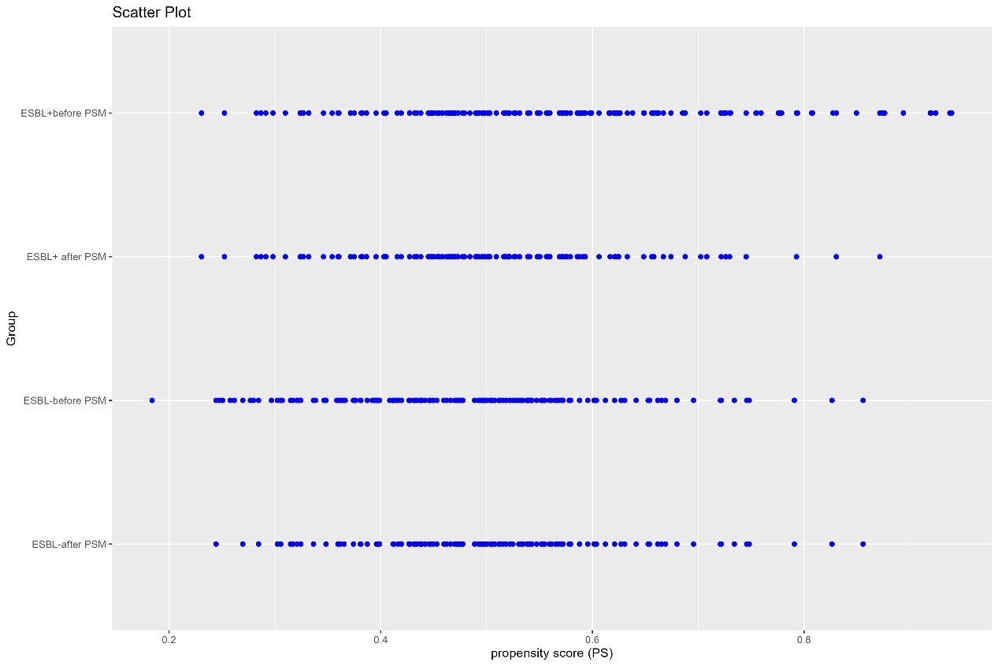

Figure A2. Diagram of the mediation effects (LOS and IEAT) between ESBL and economic costs
ESBL
Economic costs
LOS
IEAT
Mediator 1
Main variable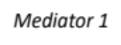2
Outcome
Mediator 2
Direct impact
Indirect impact
Indirect impact

Notes: IEAT: Ineffective empirical antibiotic treatment. LOS= Length of hospital stay. ESBL= Extended Spectrum Beta-Lactamase.

