Supplements
We had to make a few adjustments to make the algorithm usable to measure change.
Table S1. Adjustments necessary to calculate a change in QRISK3 score.
Risk factor | Value at follow-up
Family history of premature coronary heart disease in a first-degree relative* | If yes,  value at baseline is leveled to follow-up value
Antihypertensive medication** | If no,  value at baseline is used as follow-up value
Age | Leveled to baseline
*This factor might not be known at the start of enrolment but does contribute to the patient’s cardiovascular risk.
**If ‘on blood pressure treatment’ is answered ‘yes’, this will raise the QRISK3 score according to the algorithm. In case a patient starts blood pressure treatment due to the intervention, this will be ignored at follow-up.

Table S2. Overview of advice given during the multidisciplinary meetings.
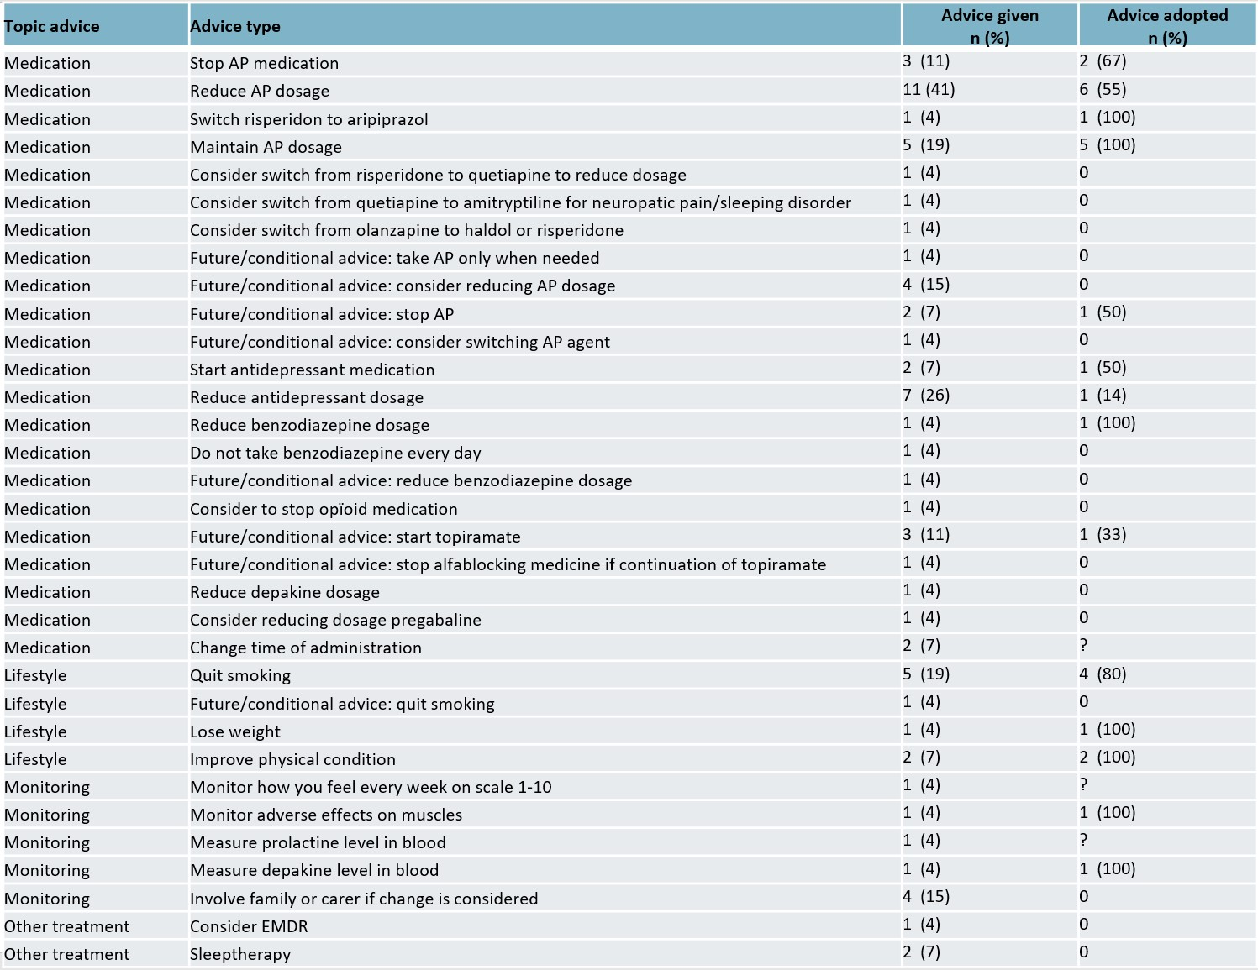
AP, antipsychotic; EMDR, eye movement desensitization and reprocessing.

Table S3. Changes in patient outcome in patients who completed follow-up (n = 18 unless mentioned otherwise).
QRISK3 variable | T0 (SD) | T1 (SD) | T0–T1 (SD)
Mean QRISK3 score | 10.29 (12.55) | 8.96 (11.10) | 1.32 (2.84)
Mean QRISK3 score with TDS | 10.99 (12.78) | 9.47 (11.13) | 1.52 (3.42)
Mean cholesterol ratio | 4.05 (1.32) | 4.10 (1.39) | –0.05 (0.40)
Mean systolic blood pressure | 127.00 (19.43) | 121.33 (14.58) | 5.67 (9.34)
Mean SD of at least two most recent systolic blood pressure readings | 6.83 (6.48) | 6.27 (6.35) | –2.22 (4.52)
Mean BMI | 26.98 (4.84) | 26.83 (4.36) | 0.14 (1.21)
Albumin creatinine ratio | 0.82 (3.28) | 0.31 (0.75) | 0.64 (3.36)
Antihypertensive treatment | 1 | 2 | 1
APs | 18 | 15 | 3
Chronic corticosteroids | 1 | 1 | 0
Chronic kidney disease stage 3–5 | 2 | 0 | 2
Mental health variable (n=21) | T0 | T1 | T0–T1
MHI-5 scores (SD) | 59.52 (17.31) | 61.43 (18.98) | –1.90 (15.04)
Smoking* (n=22) | T0 | T1 | T0–T1
Never | 7 | 7 | 0
Past | 8 | 12 | –4
Light | 4 | 3 | 1
Medium | 3 | 0 | 3
Heavy | 0 | 0 | 0
Adverse effects (n=21) | T0 | T1 | T0–T1
Mean adverse effects (SD) | 22.57 (11.65) | 17.33 (10.30) | 5.24 (5.04)
EQ-5D (n=21) | T0 | T1 | T0–T1
Mean EQ-5D | 0.33 (0.29) | 0.42 (0.28) | –0.09 (0.24)
* Data derived from EMR and questionnaires.
AP, antipsychotic; BMI, body mass index; EQ-5D, generic quality of life; MHI, Mental Health Inventory; SD, standard deviation; TDS, Townsend deprivation score.

Additional analyses on QRISK3
The distribution of the proportional reduction in QRISK3 score, being the difference in QRISK3 score resulting from the intervention as a proportion of what could be achieved (a QRISK3 score with all modifiable risk factors optimized), is shown in Figure S1. For the 18 participants who had a complete follow-up, the risk reduction is presented on the x-axis. The mean improvement was 25.4% (SD=58.7). The proportional changes of three participants are outliers exceeding (–)100%. These participants had a very low maximum achievable improvement. A slight change in cholesterol ratio the wrong way (within the optimum range) or an improvement of systolic blood pressure (lower than what was defined as optimal) caused these outliers.

Figure S1. Distribution of proportional QRISK3 reduction.

