Table 1. Inclusion and exclusion criteria. 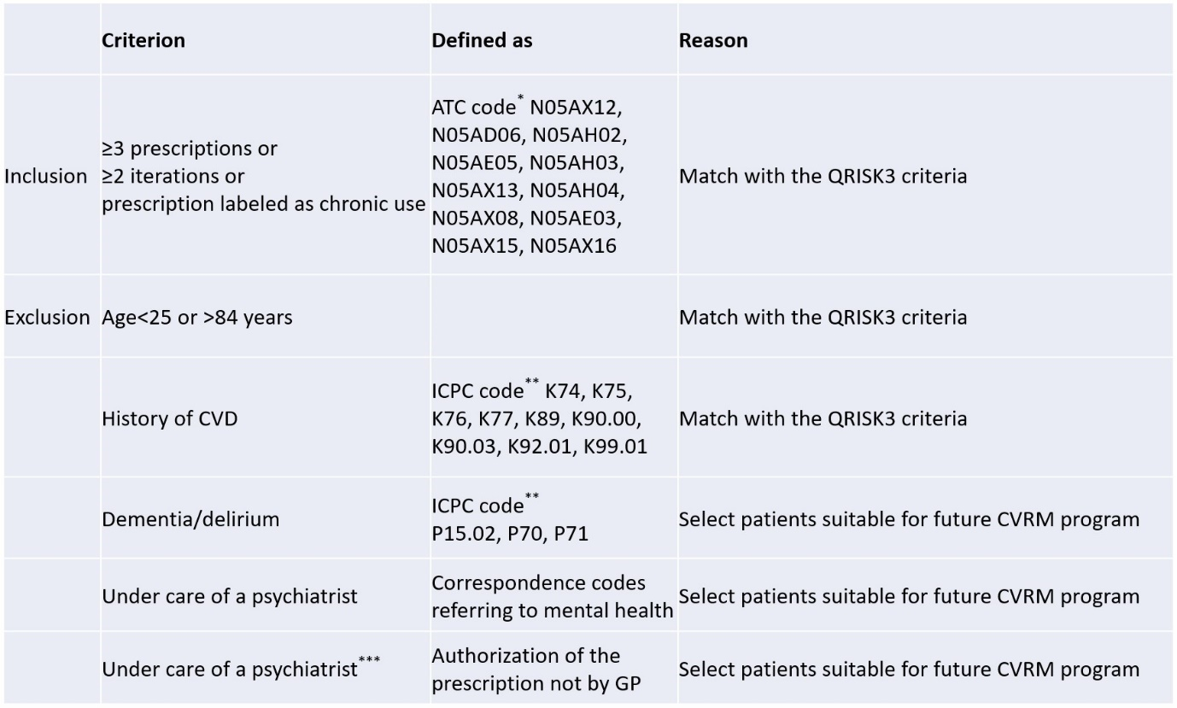
*The prescriptions from the ATC codes²².
**The diagnoses from the ICPC codes²³.
***Changed criterion during inclusion of patients.
ATC, anatomical therapeutic chemical; CVD, cardiovascular disease; GP, general practitioner; ICPC, International Classification of Primary Care.

Table 2. Participant characteristics at baseline (n=28).
Demographic:
Age in years mean (SD) | 49 (11.1)
Female n (%) | 13 (46.4)
Country of birth
The Netherlands n (%) | 24 (85.7)
Morocco n (%) | 2 (7.1)
Other n (%) | 2 (7.1)
Education*
Low n (%) | 7 (22.2)
Middle n (%) | 11 (40.7)
High n (%) | 10 (37.0)
Low socioeconomic status n (%) | 10 (35.7)
Mental health:
Primary psychiatric disorders
Depressive disorder n (%) | 6 (21.4)
Personality disorder n (%) | 5 (17.9)
PTSD n (%) | 4 (14.3)
Autistic spectrum disorder n (%) | 3 (10.7)
Anxiety disorder n (%) | 3 (10.7)
Bipolar disorder n (%) | 2 (7.1)
Psychosis n (%) | 2 (7.1)
Anorexia nervosa n (%) | 1 (3.6)
ADHD n (%) | 1 (3.6)
Insomnia n (%) | 1 (3.6)
AP agent
Quetiapine n (%) | 16 (57.1)
Risperidone n (%) | 7 (25.0)
Aripiprazole n (%) | 3 (10.7)
Olanzapine n (%) | 2 (7.1)
Adverse effects for APs
Not at all | 0
Very little | 0
A little n (%) | 3 (10.7)
Much n (%) | 16 (57.2)
Very much n (%) | 9 (32.1)
MHI-5 score mean (SD) | 56.79 (18.01)
Quality of life:
EQ-5D score mean (SD) | 0.31 (0.28)
CVR:
QRISK3 score mean (SD) | 11.17 (14.51)
QRISK3 score with revised TDS mean (SD) | 11.89 (14.85)
Smoking**
Never n (%) | 8 (28.6)
Past n (%) | 10 (35.7)
Light n (%) | 4 (14.3)
Medium n (%) | 5 (17.9)
Heavy n (%) | 1 (3.6)
Atrial fibrillation n (%) | 1 (3.6)
Migraine n (%) | 3 (10.7)
Chronic kidney disease, stages 3–5 n (%) | 4 (14.3)
Family history of CVD n (%) | 13 (46.4)
Diabetes mellitus type 2 n (%) | 2 (7.1)
Chronic corticosteroids n (%) | 2 (7.1)
Statins n (%) | 1 (3.6)
Antihypertensive medication n (%) | 4 (14.3)
*Definition of grouping according to Central Bureau voor de Statistiek (Statistics Netherlands)²⁸.
**Light smoker <10, moderate 10–19, heavy >19 cigarettes a day.
ADHD, attention deficit hyperactivity disorder; AP, antipsychotic; CVD, cardiovascular disease; CVR, cardiovascular risk; EQ-5D, generic quality of life; MHI, Mental Health Inventory; PTSD, post-traumatic stress disorder; QRISK, person's risk of developing a heart attack or stroke over the next 10 years; SD, standard deviation; TDS, Townsend deprivation score.

Table 3. Lack of or incomplete follow-up.
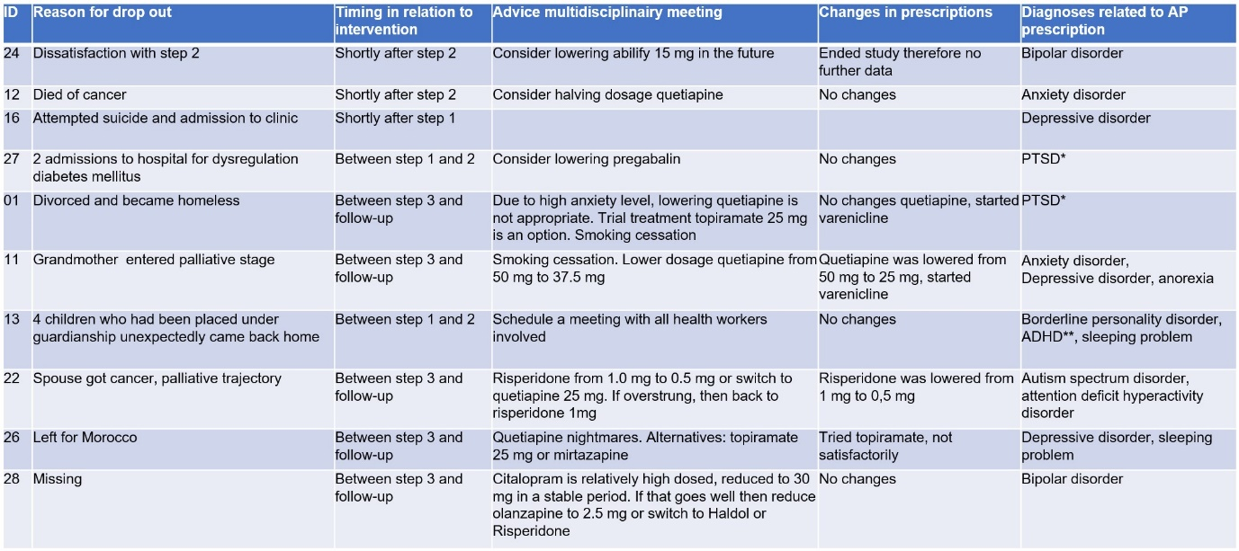
ADHD, attention deficit hyperactivity disorder; AP, antipsychotic; PTSD, post-traumatic stress disorder.

