Electronic Supplementary Material

Toward flexible, stable and sensitive SERS substrate from Ag@ZIF-67 decorated cotton fabric for label-free detection of Phenol-soluble modulin
Jiangtao Xu¹, Wei Gao², Ping Zeng³, Shouxiang Jiang¹*, Songmin Shang¹*

¹ Institute of Textiles and Clothing, The Hong Kong Polytechnic University, Hong Kong, 999077, China
² Department of Applied Physics, The Hong Kong Polytechnic University, Hong Kong, 999077, China
³ Department of Applied Biology and Chemical Technology, The Hong Kong Polytechnic University, Hong Kong, 999077, China

Corresponding authors: Shouxiang Jiang, kinor.j@polyu.edu.hk
Songmin Shang, profshang@126.com

1 FDTD simulation
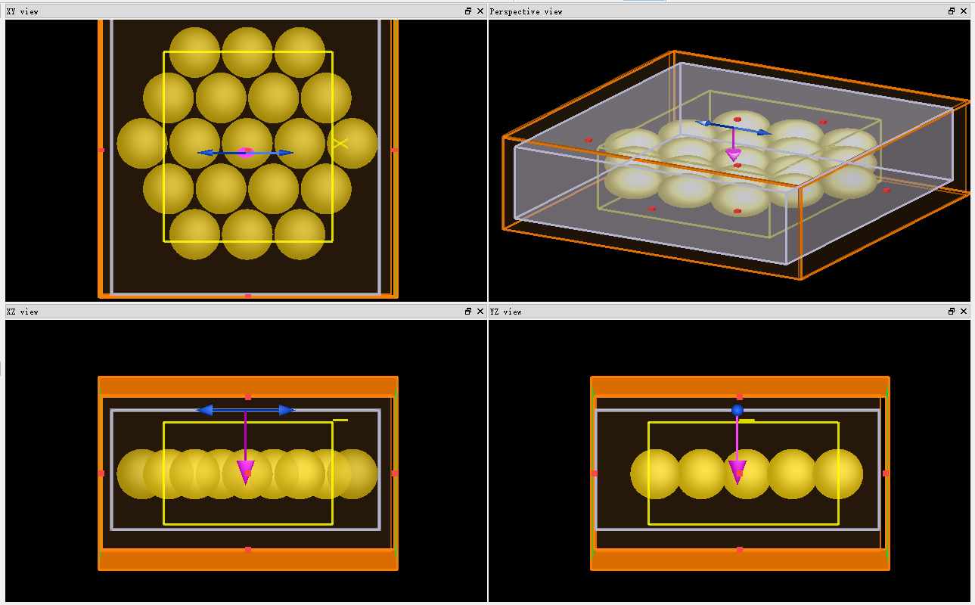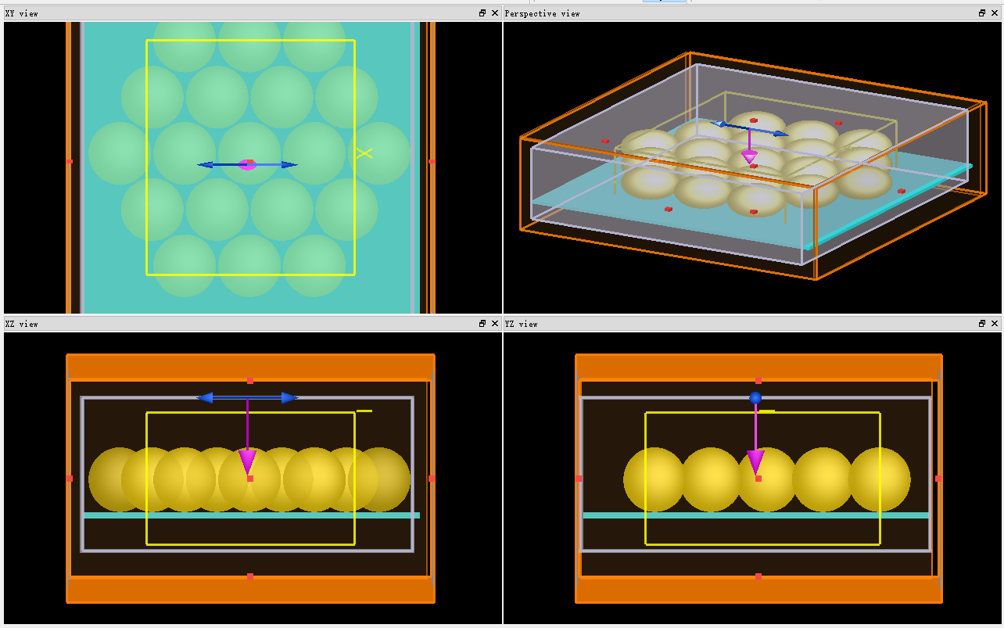
To simulate the electrical field intensity on the surface around Ag nanoparticles and ZIF-67, FDTD was employed. The calculation model of Ag and Ag decorated ZIF-67 was established as shown in the figure. According to the statistical results of Image J from the SEM image, the parameters of size of Ag nanoparticle and mean gap among Ag nanoparticles were obtained, where mean particle size was 20 nm and mean gap was 6 nm. In the simulation, the wavelength of the incident light was set as a plane wave with a fixed wavelength of 532 nm and 785 nm which is matched with the laser used. The incident direction of the light is perpendicular to the X plane.

Figure S1 Optical images of prepared samples. (a) cotton fabric, (b) ZIF-67 coated cotton fabric, (c) Ag coated cotton fabric, (d) C-AZ5, (e) C-AZ30, (f) C-AZ60, (g) C-AZ90

Figure S2 SEM images of prepared samples. (a) and (b) cotton fabric, (c) and (d) ZIF-67 coated cotton fabric, (e) C-AZ5, (f) C-AZ30, (g) C-AZ60, and (h) C-AZ90

Figure S3 Raman spectra of substrate

Figure S4 (a)VB-XPS spectrum of ZIF-67; (b) light absorbance of ZIF-67; (c) Band gap of ZIF-67; and (d) HOMO and LUMO of ZIF-67

