Supplementary Material
Table S1: Parameter Descriptions and Values:
Parameter | Symbol | Value | Description
Epidemiological Parameters
Transmission parameter | $β$ | - | Calculated from R₀
Basic reproduction number | R₀ | 3.0 | Estimated from European data consistent with a doubling time of 3.5 days¹.
Mean Latent Period | $\frac{1}{α}$ | 4.6 days | Estimated at 5.1 day²⁻⁴. The last 0.5 days are incorporated in the infectious periods to capture pre-symptomatic infectivity
Mean Duration of Mild Infection |  | 2.1 days | Incorporates 0.5 days of infectiousness prior to symptoms. In combination with mean duration of severe illness this gives a mean serial interval of 6.75 days⁵.
Mean Duration of Severe Infection Prior to Hospitalisation |  | 4.5 days | Mean onset-to-admission of 4 days⁶. Values in the wider literature range from 1.2 days to 12 days^{2-4,7,8}. Includes 0.5 days of infectiousness prior to symptom onset.
Mean Duration of Hospitalisation for non-critical cases if survive | $\frac{1}{γ_{3,1}}$ | 9 days | Median of values identified in ⁷⁻¹¹
Mean Duration of Hospitalisation for non-critical cases if die | $\frac{1}{γ_{3,0}}$ | 9 days | Median of values identified in ⁷⁻¹¹
Mean Duration in ICU if survive | $\frac{1}{γ_{4,1}}$ | 14.8 days | Mean duration in ICU of 13.3 days from a study across 42 countries¹². Ratio of duration in critical care if die: duration in critical care if survive of 0.75 and 60.1% probability of survival in ICU¹³.
Mean Duration in ICU if die | $\frac{1}{γ_{4,0}}$ | 11.1 days | Mean duration in ICU of 13.3 days from a study across 42 countries¹². Ratio of duration in critical care if die: duration in critical care if survive of 0.75 and 60.1% probability of survival in ICU¹³.
Mean Duration in Recovery after ICU |  | 3.4 days | Working assumption
Mean duration of naturally acquired immunity |  | 365 days | Assumed value based on published data of protection to reinfection. Protection is reported to last at least 8 months ¹⁴⁻¹⁶
Infection fatality ratio (IFR) | $μ(a)$ | - | Age-dependent¹⁷
Hospitalisation rate | $ϕ(a)$ | - | Age-dependent¹⁸ .
Vaccination parameters
Vaccine efficacy against infection | $$υ_{inf}\left(a\right)$$ | 94%; 63% | We assumed infection-blocking efficacy is the same as reported vaccine efficacy against clinical disease. Values were selected to cover the range of approved vaccines efficacies reported to date ^{19,20}
Vaccine efficacy against disease | $$υ_{dis}\left(a\right)$$ | 60% | Estimate based on reported vaccine effectiveness data in the UK which suggests ~86% efficacy against hospitalisation/death compared to ~65% against mild disease for a single dose of the Pfizer vaccine ^{21,22}. The assumed value of 60% generates 98% efficacy against hospitalisation/death for the high efficacy vaccines and 85% for the moderate efficacy vaccine, with both representing two dose schedules.
Vaccine duration of protection | $$1/φ$$ | Lifelong | Assumption. No data currently available but estimates from MERS vaccines suggest durability of at least 1 year²³.
Age-dependent rate of vaccination | $$κ\left(a\right)$$ | - | Population-dependent: set such that number of people vaccinated per day in each age group achieves target coverage by the end of the vaccination period
Mean time to develop vaccine-acquired immunity following second dose | $$1/ω$$ | 7 days | Based on immunogenicity data from Phase II trials in which antibody titres plateau ~7 days post dose 2 ²³⁻²⁷
Vaccine schedule |  | 21 days | 2 doses modelled 21 days apart^{19,20,28,29}. Efficacy follows 2nd dose (so only modelling final dose of any vaccine schedule)
Age-targeting of vaccination |  | Individuals over 15 years old are targeted | Vaccination is targeted prioritising elderly age groups

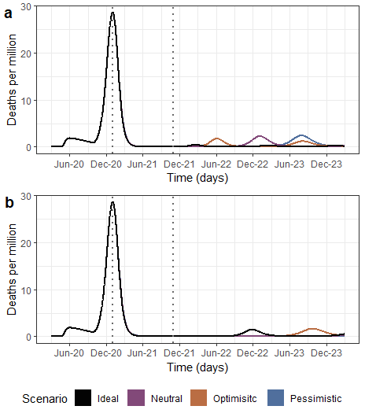
Figure S1 - COVID-19 dynamics for different reproductive number profiles. Profiles were estimated for each vaccine hesitancy scenario in order to achieve herd immunity (R_{eff} =1) and control the pandemic. a) Daily projected deaths per million for a high vaccine efficacy. b) Daily projected deaths per million for a moderate vaccine efficacy. Black line shows an ideal scenario without vaccine hesitancy and 98% of individuals above 15 years old, are vaccinated. Orange shows an optimistic scenario with low vaccine hesitancy, purple shows a neutral scenario and blue line shows a pessimistic scenario with high vaccine hesitancy. In each scenario, vaccination coverage per age group varies according to vaccine hesitancy.

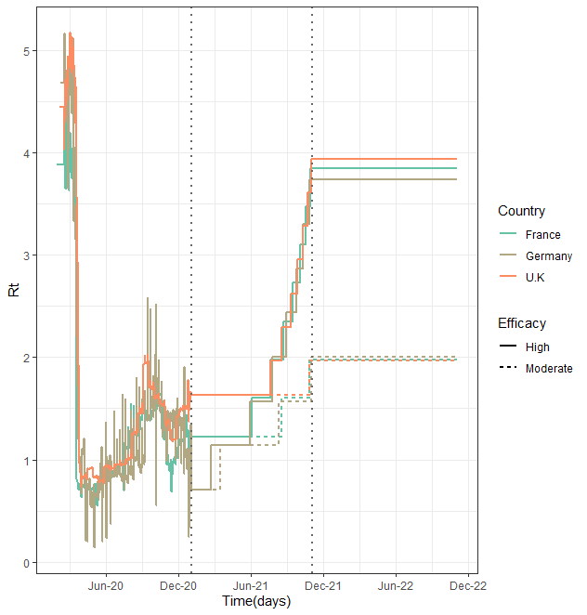
Figure S2 - Reproductive number profile for country specific simulations. Profiles, before vaccination begins, are taken from model fittings to country-specific data (https://mrc-ide.github.io/global-lmic-reports/ ). After vaccination starts, NPIs are lifted based on an ideal vaccination coverage over time. Reproductive number is set to increase in ten steps from the value at the beginning of vaccination to an average initial reproductive number. Continuous lines show profiles for a high efficacy vaccine. Dotted lines show profiles for a moderate efficacy vaccine.
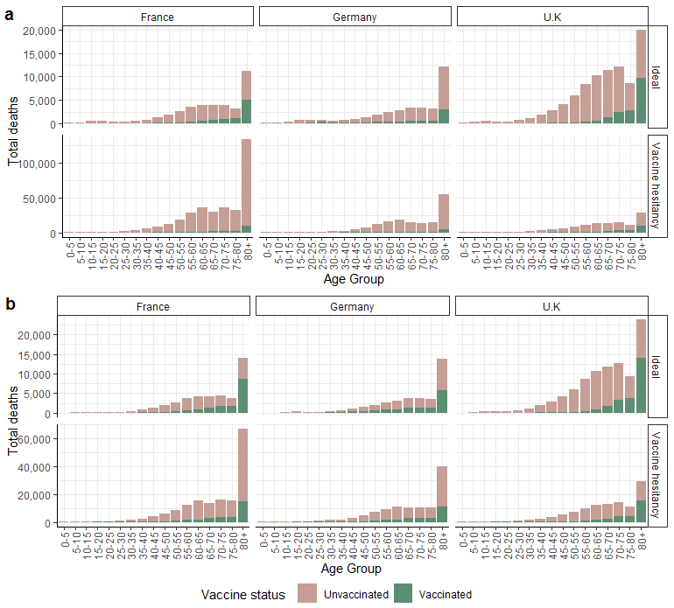
Figure S3 - Projected deaths per age group for each country. a) Total deaths for a vaccine with high efficacy. b) Total deaths for a vaccine for moderate efficacy. Values are shown for the vaccinated and unvaccinated populations. Two scenarios are presented: An ideal scenario, where 98% of the population older than 15 years old is vaccinated, and a vaccine hesitancy scenario, where coverage for people over 15 years old is based on vaccine acceptance in each country. Total deaths are estimated over a two-year period since vaccination starts.

References

1. Walker, P.G.T., et al. The impact of COVID-19 and strategies for mitigation and suppression in low- and middle-income countries. Science 369, 413-422 (2020).
2. Linton, N.M., et al. Incubation Period and Other Epidemiological Characteristics of 2019 Novel Coronavirus Infections with Right Truncation: A Statistical Analysis of Publicly Available Case Data. J Clin Med 9, 538 (2020).
3. Li, Q., et al. Early Transmission Dynamics in Wuhan, China, of Novel Coronavirus–Infected Pneumonia. New England Journal of Medicine 382, 1199-1207 (2020).
4. Lauer, S.A., et al. The Incubation Period of Coronavirus Disease 2019 (COVID-19) From Publicly Reported Confirmed Cases: Estimation and Application. Ann Intern Med 172, 577-582 (2020).
5. Bi, Q., et al. Epidemiology and transmission of COVID-19 in 391 cases and 1286 of their close contacts in Shenzhen, China: a retrospective cohort study. The Lancet Infectious Diseases 20, 911-919 (2020).
6. Docherty, A.B., et al. Features of 20 133 UK patients in hospital with covid-19 using the ISARIC WHO Clinical Characterisation Protocol: prospective observational cohort study. BMJ 369, m1985 (2020).
7. Hawryluk, I., et al. Inference of COVID-19 epidemiological distributions from Brazilian hospital data. J. R. Soc. Interface 17(2020).
8. South African COVID-19 Modelling Consortium X. Estimating cases for COVID-19 in South Africa. Short term Projections June 2020. (2020).
9. Sreevalsan-Nair, J., Vangimalla, R.R. & Ghogale, P.R. Analysis and Estimation of Length of In-Hospital Stay Using Demographic Data of COVID-19 Recovered Patients in Singapore. medRxiv, 2020.2004.2017.20069724 (2020).
10. Haw, N.J.L., Uy, J., Sy, K.T.L. & Abrigo, M.R.M. Epidemiological profile and transmission dynamics of COVID-19 in the Philippines. Epidemiol Infect 148, e204-e204 (2020).
11. Oliveira, E., et al. ICU Outcomes and Survival in Patients with Severe COVID-19 in the Largest Health Care System in Central Florida. medRxiv, 2020.2008.2025.20181909 (2020).
12. Pritchard, M., et al. ISARIC Clinical Data Report 4 October 2020. medRxiv, 2020.2007.2017.20155218 (2020).
13. Intensive Care National Audit And Research Centre (ICNARC). ICNARC report on COVID-19 in criƟcal care:England, Wales and Northern Ireland (2020).
14. Hall, V., et al. Do antibody positive healthcare workers have lower SARS-CoV-2 infection rates than antibody negative healthcare workers? Large multi-centre prospective cohort study (the SIREN study), England: June to November 2020. medRxiv, 2021.2001.2013.21249642 (2021).
15. Dan, J.M., et al. Immunological memory to SARS-CoV-2 assessed for up to 8 months after infection. Science 371, eabf4063 (2021).
16. To, K.K., et al. COVID-19 re-infection by a phylogenetically distinct SARS-coronavirus-2 strain confirmed by whole genome sequencing. Clinical infectious diseases : an official publication of the Infectious Diseases Society of America (2020).
17. Brazeau, N.F., et al. Report 34: COVID-19 Infection Fatality Ratio: Estimates from Seroprevalence. in COVID-19 reports (Imperial College London, 2020).
18. Salje, H., et al. Estimating the burden of SARS-CoV-2 in France. Science 369, 208-211 (2020).
19. Polack, F.P., et al. Safety and Efficacy of the BNT162b2 mRNA Covid-19 Vaccine. New England Journal of Medicine 383, 2603-2615 (2020).
20. Voysey, M., et al. Safety and efficacy of the ChAdOx1 nCoV-19 vaccine (AZD1222) against SARS-CoV-2: an interim analysis of four randomised controlled trials in Brazil, South Africa, and the UK. The Lancet 397, 99-111 (2021).
21. Public Health England. PHE monitoring of the early impact and effectiveness of COVID-19 vaccination in England. 1-15 (Public Health England 2021).
22. Bernal, J.L., et al. Early effectiveness of COVID-19 vaccination with BNT162b2 mRNA vaccine and ChAdOx1 adenovirus vector vaccine on symptomatic disease, hospitalisations and mortality in older adults in England. medRxiv, 2021.2003.2001.21252652 (2021).
23. Folegatti, P.M., et al. Safety and immunogenicity of a candidate Middle East respiratory syndrome coronavirus viral-vectored vaccine: a dose-escalation, open-label, non-randomised, uncontrolled, phase 1 trial. The Lancet Infectious Diseases 20, 816-826 (2020).
24. Jackson, L.A., et al. An mRNA Vaccine against SARS-CoV-2 - Preliminary Report. N Engl J Med 383, 1920-1931 (2020).
25. Zhu, F.C., et al. Safety, tolerability, and immunogenicity of a recombinant adenovirus type-5 vectored COVID-19 vaccine: a dose-escalation, open-label, non-randomised, first-in-human trial. Lancet (London, England) 395, 1845-1854 (2020).
26. Mulligan, M.J., et al. Phase I/II study of COVID-19 RNA vaccine BNT162b1 in adults. Nature 586, 589-593 (2020).
27. Sahin, U., et al. COVID-19 vaccine BNT162b1 elicits human antibody and TH1 T cell responses. Nature 586, 594-599 (2020).
28. Baden, L.R., et al. Efficacy and Safety of the mRNA-1273 SARS-CoV-2 Vaccine. New England Journal of Medicine 384, 403-416 (2020).
29. Logunov, D.Y., et al. Safety and efficacy of an rAd26 and rAd5 vector-based heterologous prime-boost COVID-19 vaccine: an interim analysis of a randomised controlled phase 3 trial in Russia. The Lancet.

