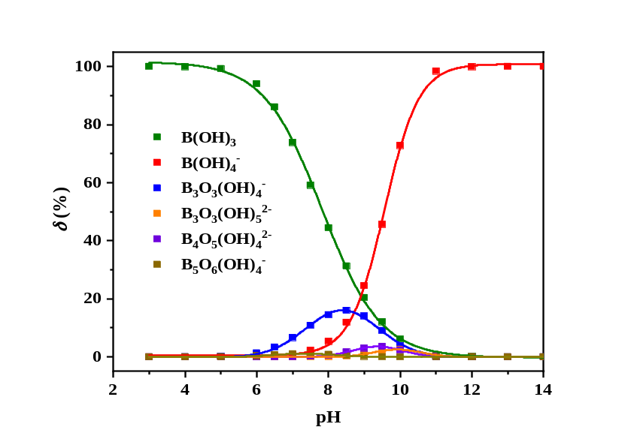
Fig. S1 pH-dependent borate speciation in boric acid solution (Total boron concentration: 0.3 mol·L⁻¹)

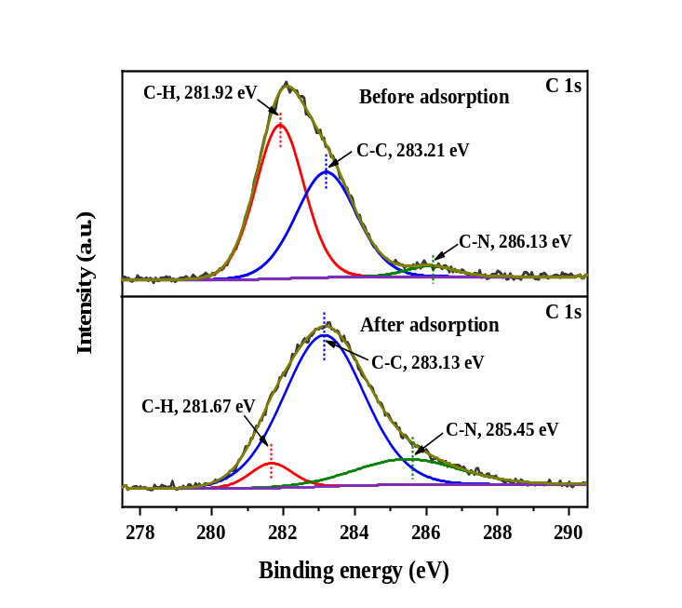
Fig. S2 The C1s XPS spectra of the Fe₃O₄@SiO₂-NH₂ before and after boron adsorption.

Table S1 BET surface areas and pore structure parameters of Fe₃O₄ and Fe₃O₄@SiO₂-NH₂
Sample name | specific surface area  (m²·g⁻¹) | Pore Diameter  (nm) | total pore volume  (cm³·g⁻¹)
Fe₃O₄ | 49.07 | 54.85 | 0.284
Fe₃O₄@SiO₂-NH₂ | 165.17 | 6.57 | 0.330

Table S2 Kinetic parameters of different models for boron adsorption on Fe₃O₄@SiO₂-NH₂
q_{e,exp}(mg·g⁻¹) | Pseudo-first-order kinetic model |  |  | Pseudo-second-order kinetic model
q_{e,exp}(mg·g⁻¹) | q_{e,cal} (mg·g⁻¹) | k₁(h⁻¹) | R² | q_{e,cal} (mg·g⁻¹) | k₂(g·mg⁻¹·h⁻¹) | R²
23.39 | 0.90 | 0.4233 | 0.4045 | 23.53 | 0.7853 | 0.9998

Table S3 Parameters of two isotherm models for boron adsorption on Fe₃O₄@SiO₂-NH₂
T (°C) | Langmuir model |  |  | Freundlich model
T (°C) | q_{m}(mg·g⁻¹) | K_{L} | R² | 1/n | K_{F} | R²
288.15 | 56.54 | 2.33 | 0.988 | 0.6395 | 48.13 | 0.978
298.15 | 51.19 | 2.04 | 0.972 | 0.6181 | 39.85 | 0.980
308.15 | 36.880 | 2.78 | 0.979 | 0.5571 | 31.94 | 0.993
318.15 | 21.44 | 5.23 | 0.967 | 0.4274 | 21.36 | 0.970

