SUPPLEMENTARY:

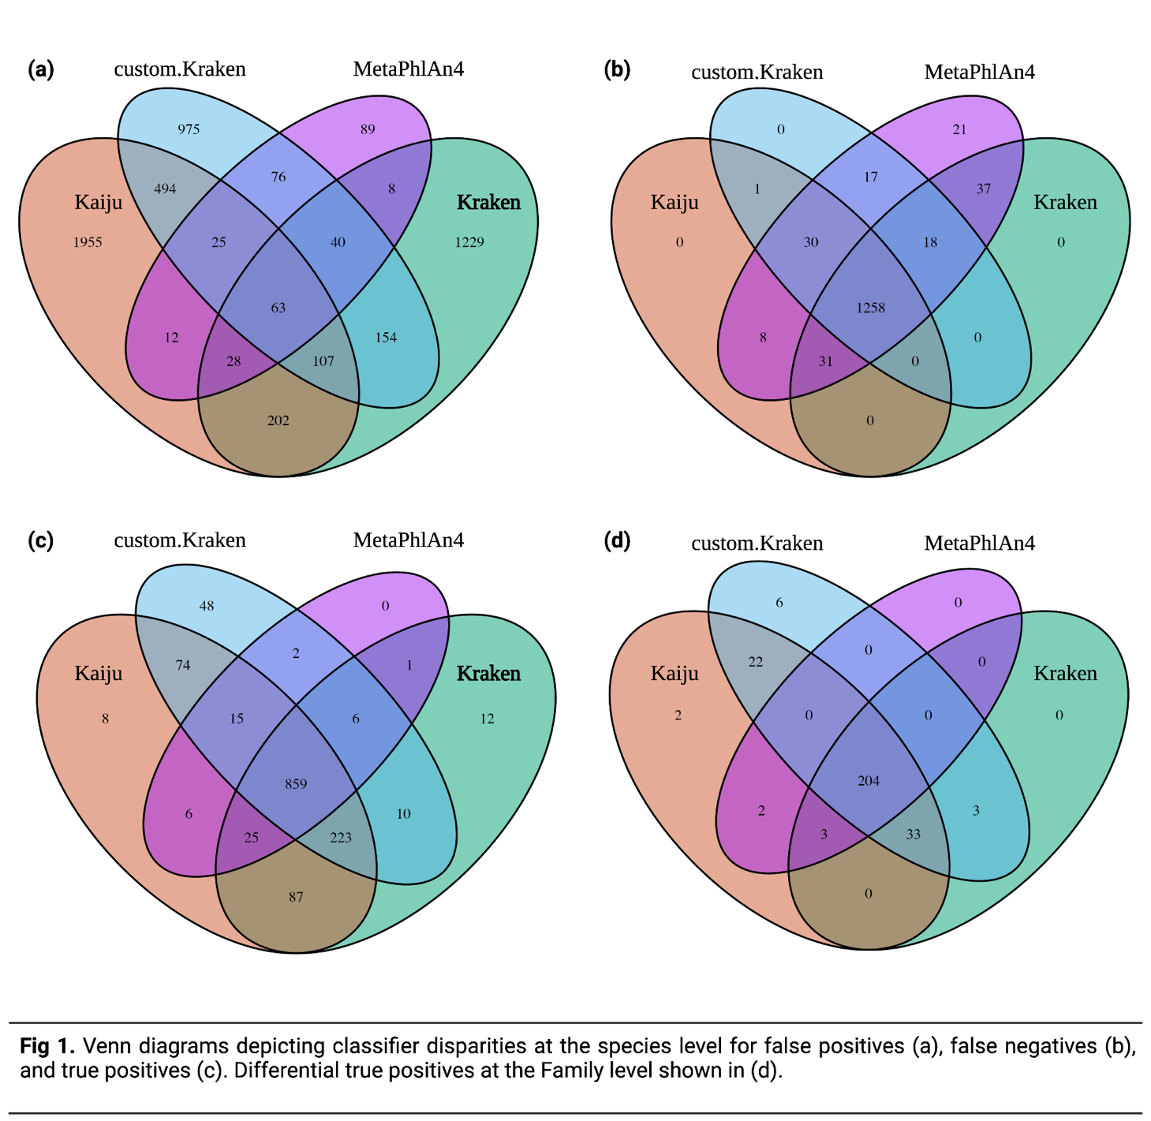
Supplementary figure 1. Venn diagrams depicting classifier disparities at the species level for false positives (a), false negatives (b), and true positives (c). Differential true positives at family level are shown in (d).

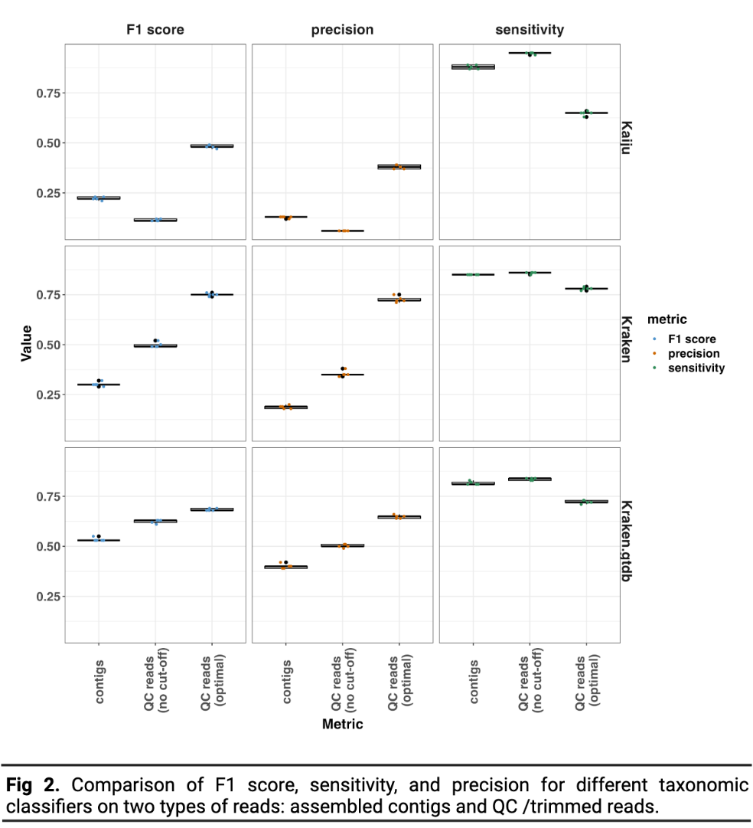
Supplementary figure 2. Comparison of F1 score, sensitivity and precision for different taxonomic classifiers on assembled reads and QC/ trimmed reads

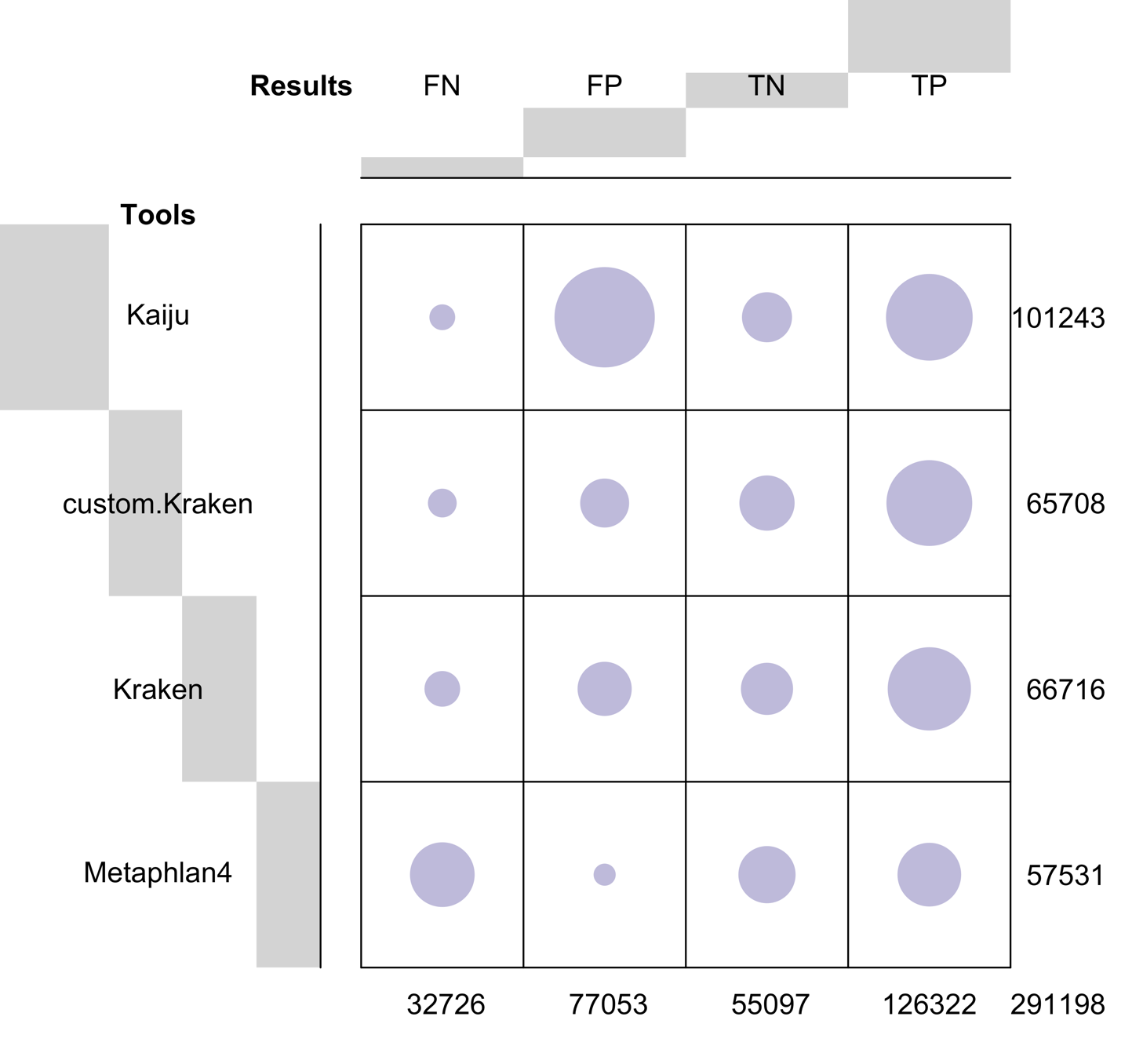
Supplementary figure 3. Balloon Plot Visualization of Classification Outcomes at the Family Level Using Different Tools. The size of each balloon corresponds to the count of observations under specific outcome categories: FN (False Negatives), FP (False Positives), TN (True Negatives), and TP (True Positives). The colour gradient within the balloons indicates the magnitude and direction of deviations between observed and expected classifications. Numbers displayed on the right or bottom of the plot represent cumulative counts across respective categories.

Supplementary figure 4. Heatmap representing consistently misclassified families. This heatmap displays the family level classification that were identified as false positives by the classifier consistently in the 200 instances (across every sample in every run)
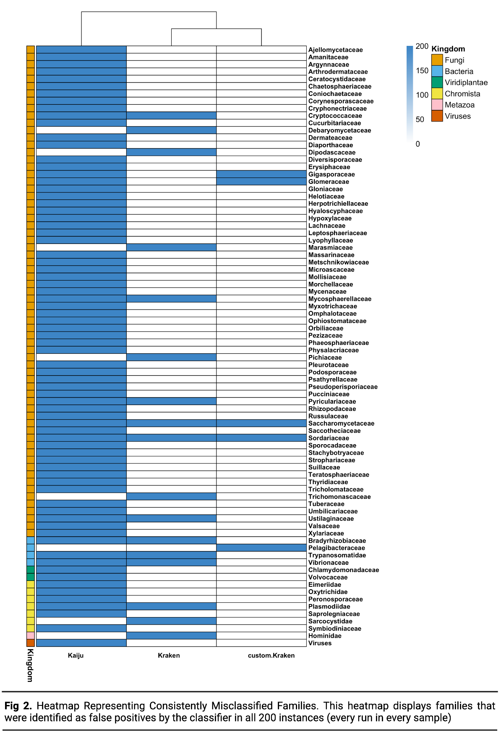

Supplementary figure 5. Heatmap of recurrent false negative families. This heatmap displays the family level classification that were identified as false negatives by the classifier between 50 to 200 on 200 instances.
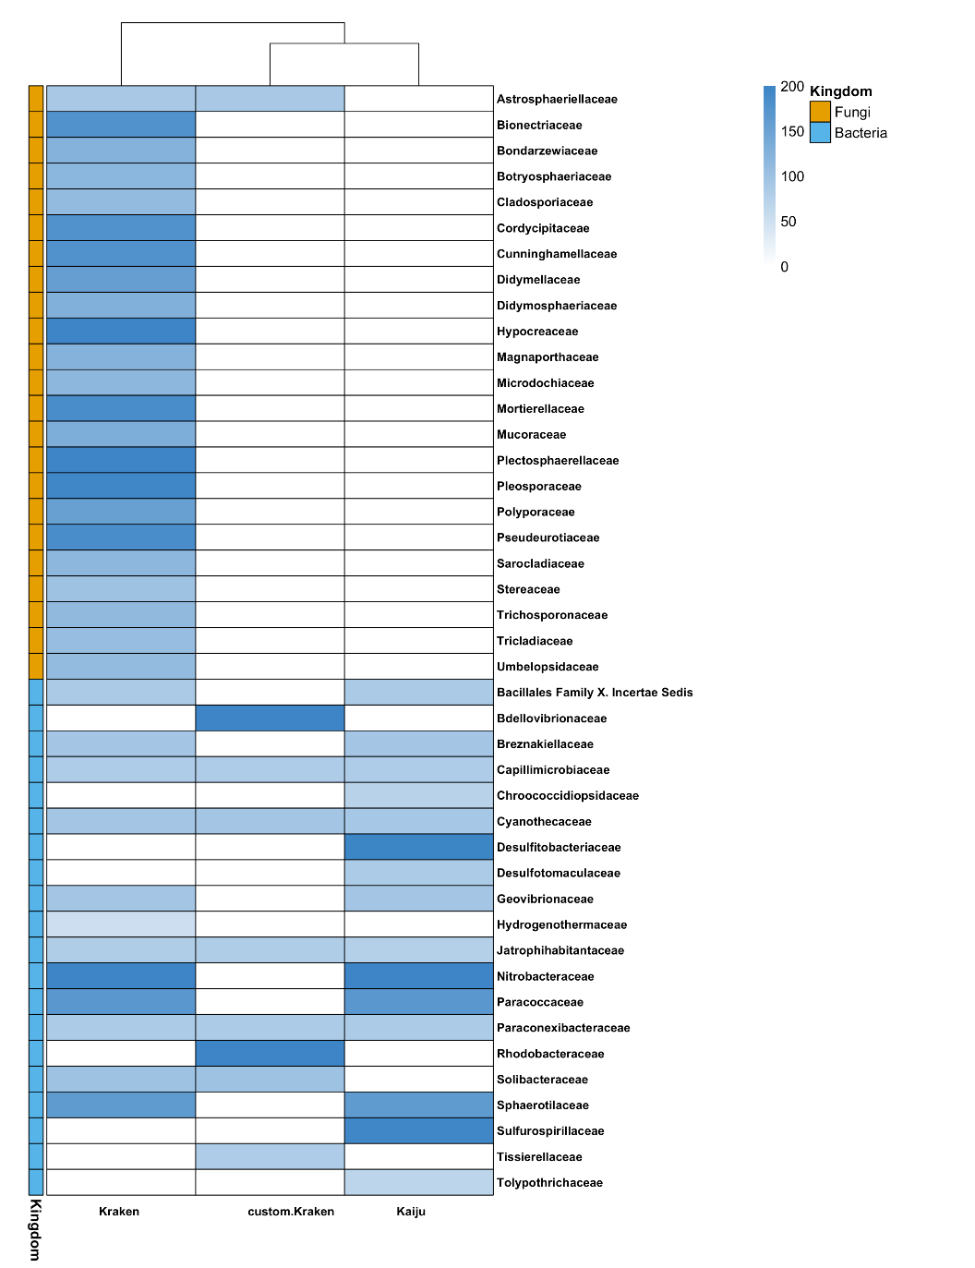

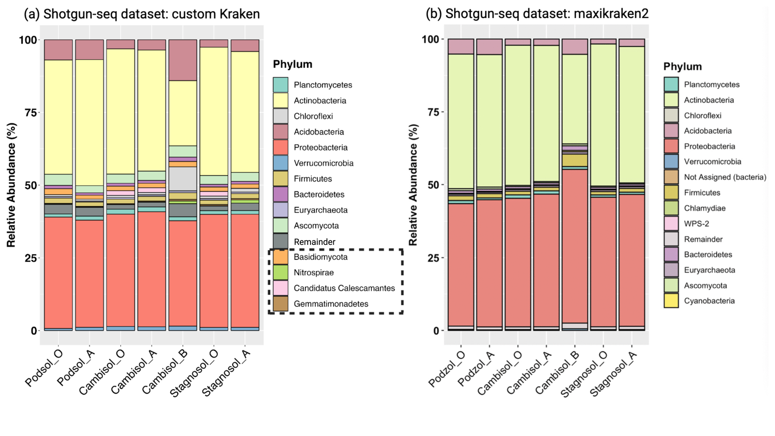
Supplementary figure 6. Taxonomic comparison across Sampling Sites and Soil Horizons at phylum level. (a) Bar plot detailing the microbial composition from the shotgun dataset using custom.Kraken, displaying the older phylum names. (b) Bar plot showcasing the microbial composition as presented in the original study. The top 14 phyla are represented with distinct colours in both plots, while all other phyla are grouped as “Remainder”. A consistent colour palette is maintained across both plots for equivalent phyla. The x-axis illustrates the three distinct sampling sites (Podsol, Cambisol, and Stagnosol), further divided by soil horizons (O, A, and B) within each site. Note: This supplementary figure provides a reference for older phylum nomenclature in comparison to the main text.
Supplementary figure 7. Impact of different classifiers on beta diversity analysis of microbial communities across soil samples. The analysis reveals a significant influence of the chosen classifier on the distribution of microbial communities. Presented are the Bray-Curtis dissimilarity plots at (a) species level (PerMANOVA: 0.85, p < 0.001) and (b) genus level (PerMANOVA: 0.78, p < 0.001).
Supplementary Files
Supplementary Table 2: Comparative Impact of Tools and Abundance Thresholds on F1 Measure: Results from the Dunn Test. Key outcomes from the post-hoc Dunn test underscore the impact of various tools and relative abundance threshold on the F1 measure. Here, Z values represent the standard Z scores, and any p-value below 0.05 was deemed statistically significant.
Supplementary Table 3b: Significant findings from the post-hoc Dunn test: This table highlights the effects of different tools and threshold values on the Euclidean distance, calculated for each sample in every run.
Additional Files
Additional File 1: Species level taxonomic classification of in-silico data: Preliminary, unfiltered results without any relative abundance threshold applied.
Additional File 2: Genus level taxonomic classification of in-silico data: Preliminary, unfiltered results without any relative abundance threshold applied.
Additional File 3: Family level taxonomic classification of in-silico data: Preliminary, unfiltered results without any relative abundance threshold applied.
Additional File 4: Species level taxonomic classification results from assembled contigs, in-silico data: Preliminary, unfiltered results without any relative abundance threshold applied.
Additional File 5: Metadata file for in-silico data.
Additional File 6: Metadata file for real dataset.
Additional File 7: Results of phylum-level taxonomic classification from the real dataset using Custom.Kraken. Relative abundance threshold: not applied.
Additional File 8: Results of species-level taxonomic classification from the real dataset. Relative abundance thresholds applied are 0.001% for Custom.Kraken and Kaiju, and 0.005% for Kraken.
Additional File 9: Results of genus-level taxonomic classification from the real dataset. Relative abundance thresholds applied are 0.001% for Custom.Kraken and Kaiju, and 0.005% for Kraken
Additional File 10: SoilGenomeDB: Comprehensive metadata of soil-specific bacterial, archaeal, and fungal genomes from NCBI

