Supplementary Figures

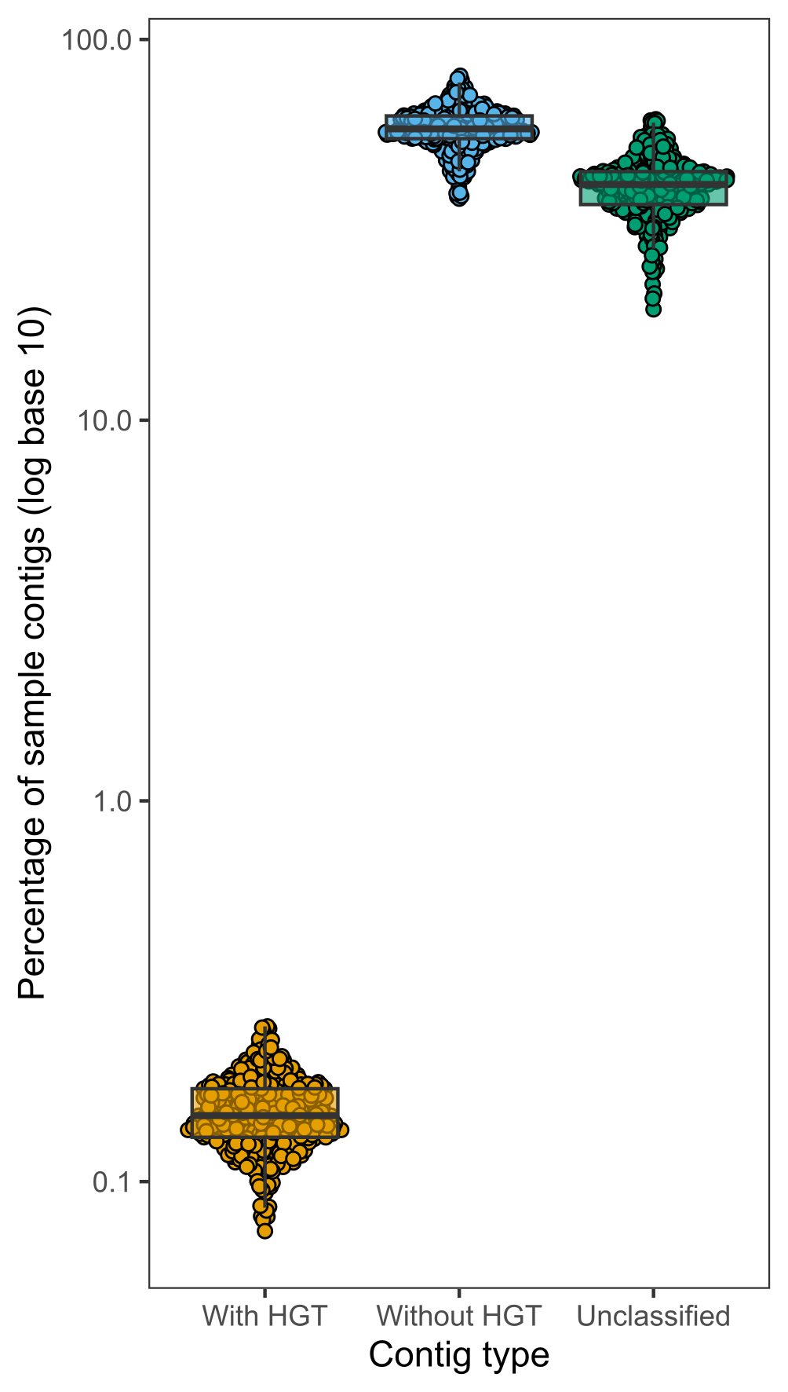
Supplementary Figure 1. Less than one percent of metagenomic contig sequences from healthy individuals and obese adolescents contain evidence of HGT. The percentage of contigs with and without HGT is plotted for each of the 381 microbiome samples from the Gut Bugs Trial (Wilson et al. 2021). HGT, horizontal gene transfer.

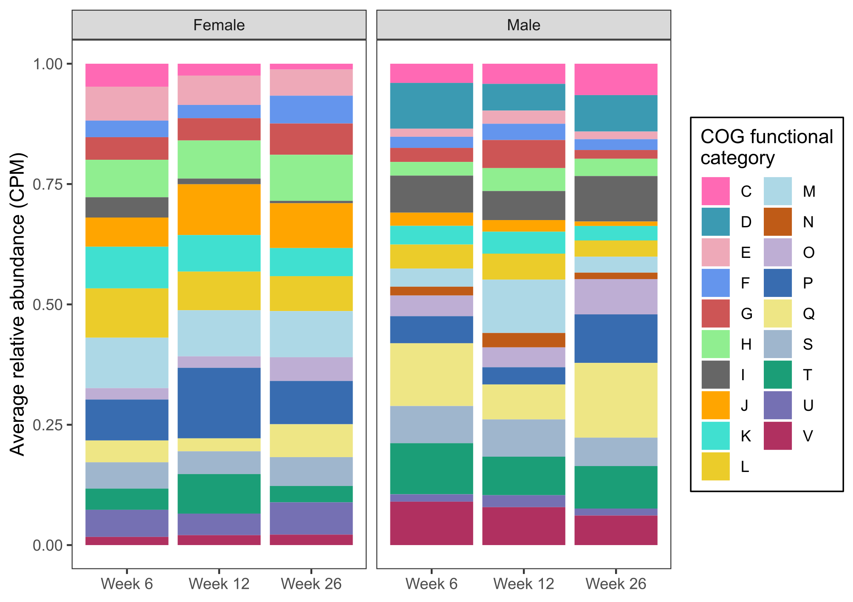
Supplementary Figure 2. Gene functions of engraftment-dependent HTGCs show no differences up to 26 weeks post-intervention. Relative abundances of gene clusters in each COG functional category were compared within each sex at each timepoint (PERMANOVA test). CPM, copies per million reads; COG, clusters of orthologous groups; HTGC, horizontally transferred gene cluster.

