Supplemental Information for

Biodiversity buffers the response of spring leaf unfolding to climate warming
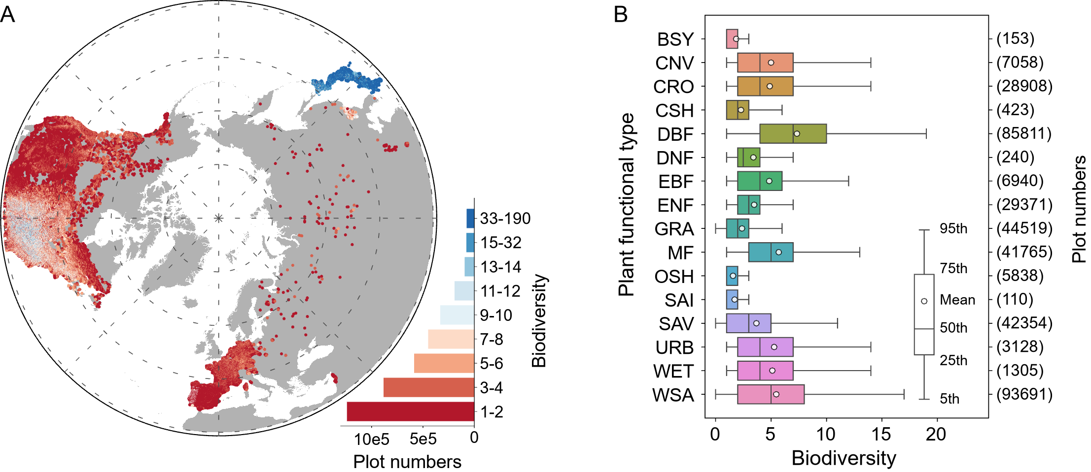

Supplementary Fig. 1 | Distribution of biodiversity and the sensitivity of spring leaf unfolding to warming (S_{T}). A, the binary colors of biodiversity and S_{T}. B, biodiversity of different functional types of vegetation. The full name of the labels in B can be found in Table S5).

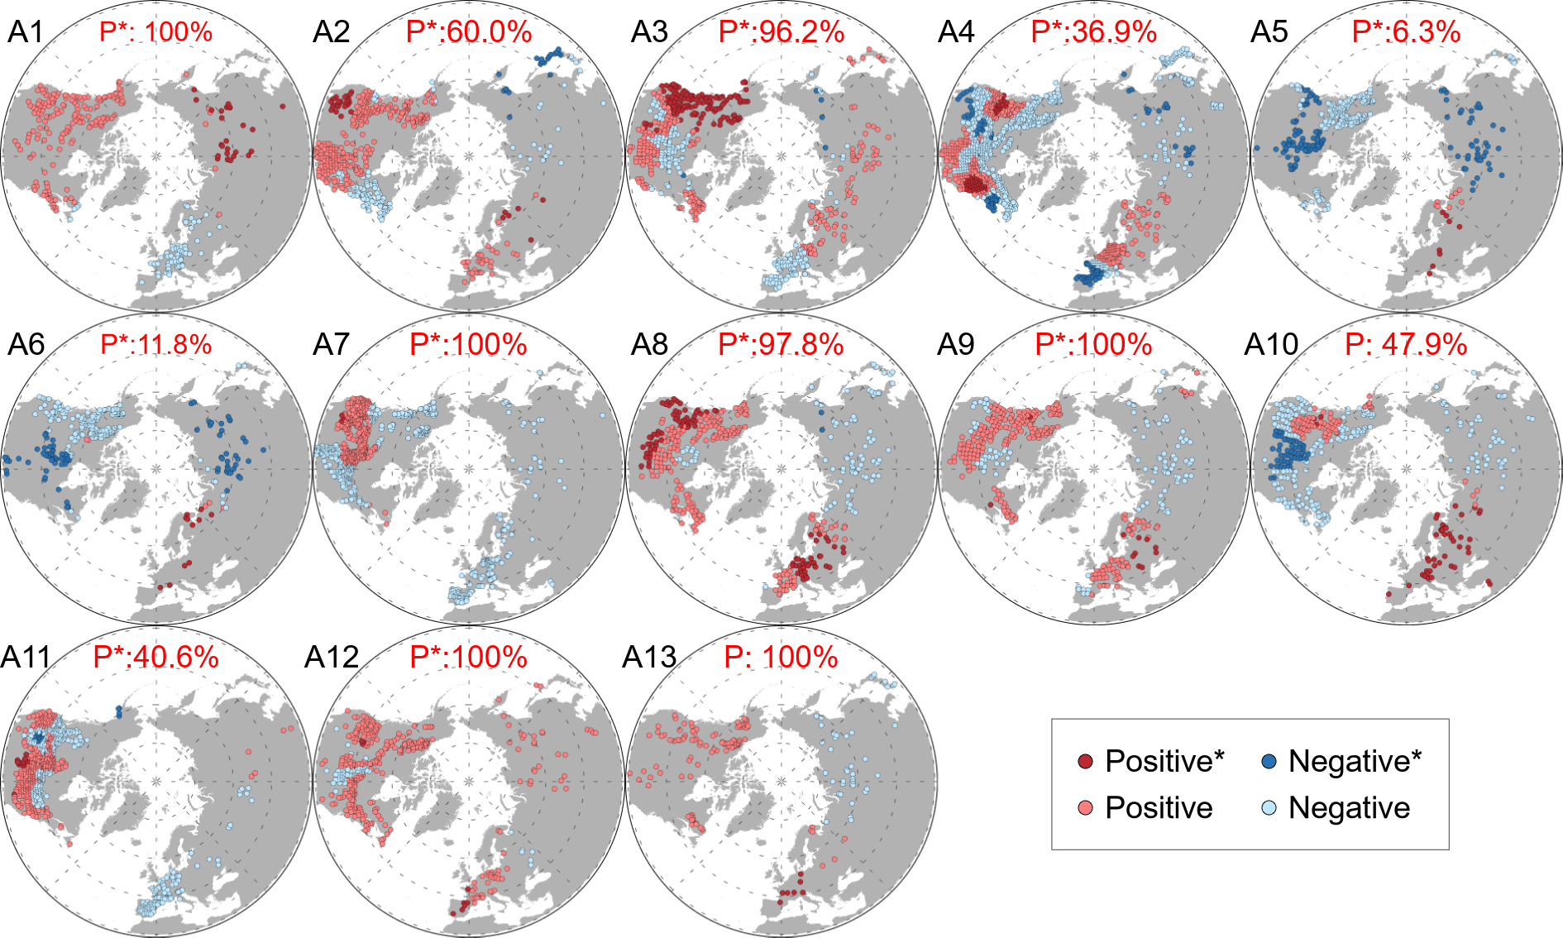

Supplementary Fig. 2 | Impact of biodiversity on the sensitivity of spring leaf unfolding to warming (S_{T}) derived from the data of the Cmip6 models under the ssp126 shared socioeconomic pathways. A1-A13 represent spatial distributions results for the 13 Cmip6 models (Supplementary Table 3), respectively. The numbers in these figures are percentages of significant positive correlations with respect to all significant correlations. P, positive effect; *, P<0.05.

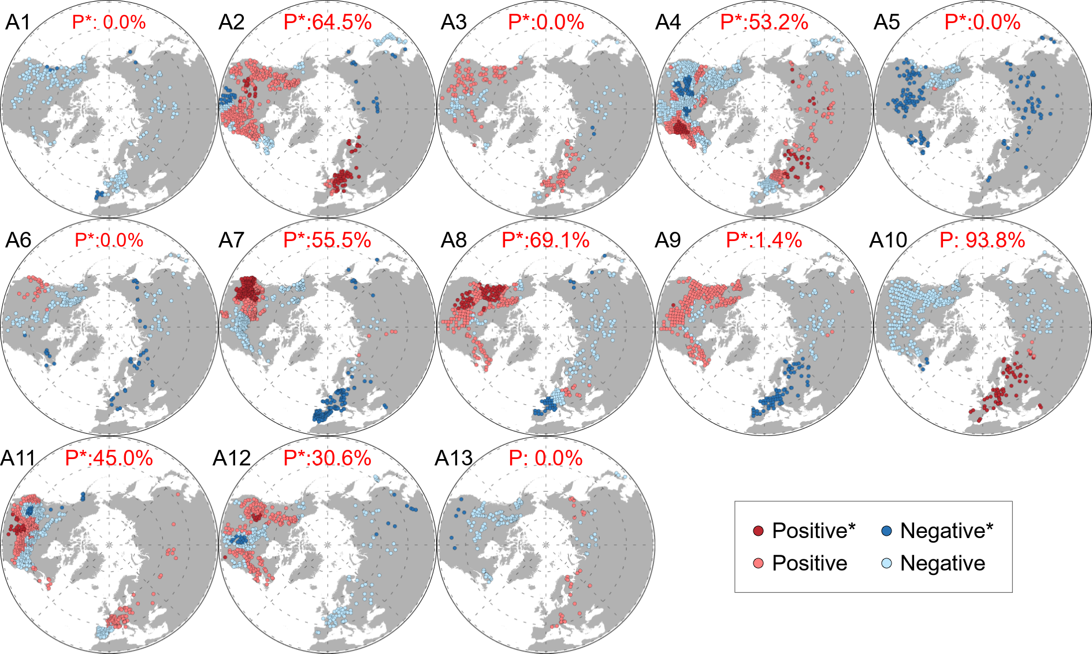

Supplementary Fig. 3 | Impact of biodiversity on the sensitivity of spring leaf unfolding to warming (S_{T}) derived from the data of the Cmip6 models under the ssp245 shared socioeconomic pathways. A1-A13 represent spatial distributions results for the 13 Cmip6 models (Supplementary Table 3), respectively. The numbers in these figures are percentages of significant positive correlations with respect to all significant correlations. P, positive effect; *, P <0.05.
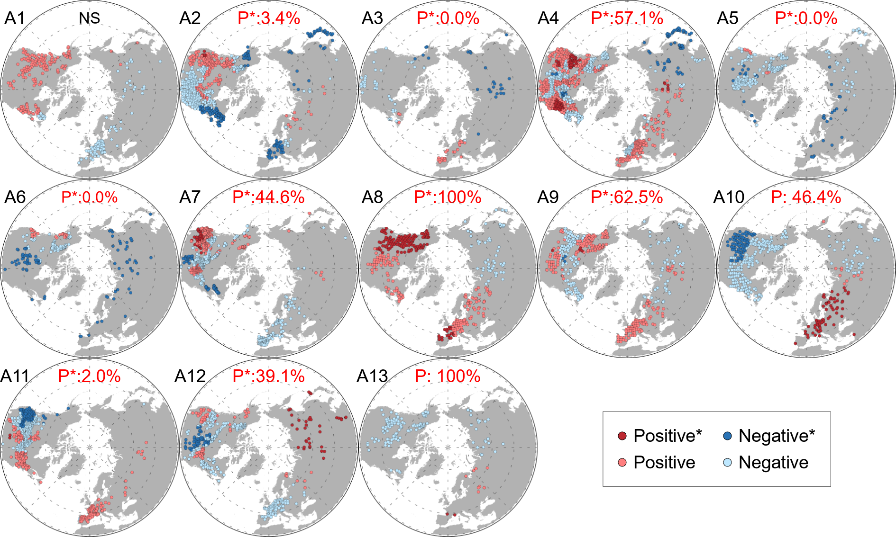

Supplementary Fig. 4 | Impact of biodiversity on the sensitivity of spring leaf unfolding to warming (S_{T}) derived from the data of the Cmip6 models under the ssp585 shared socioeconomic pathways. A1-A13 represent spatial distributions results for the 13 Cmip6 models (Supplementary Table 3), respectively. The numbers in these figures are percentages of significant positive correlations with respect to all significant correlations. P, positive effect; *, P <0.05, NS, not significant.
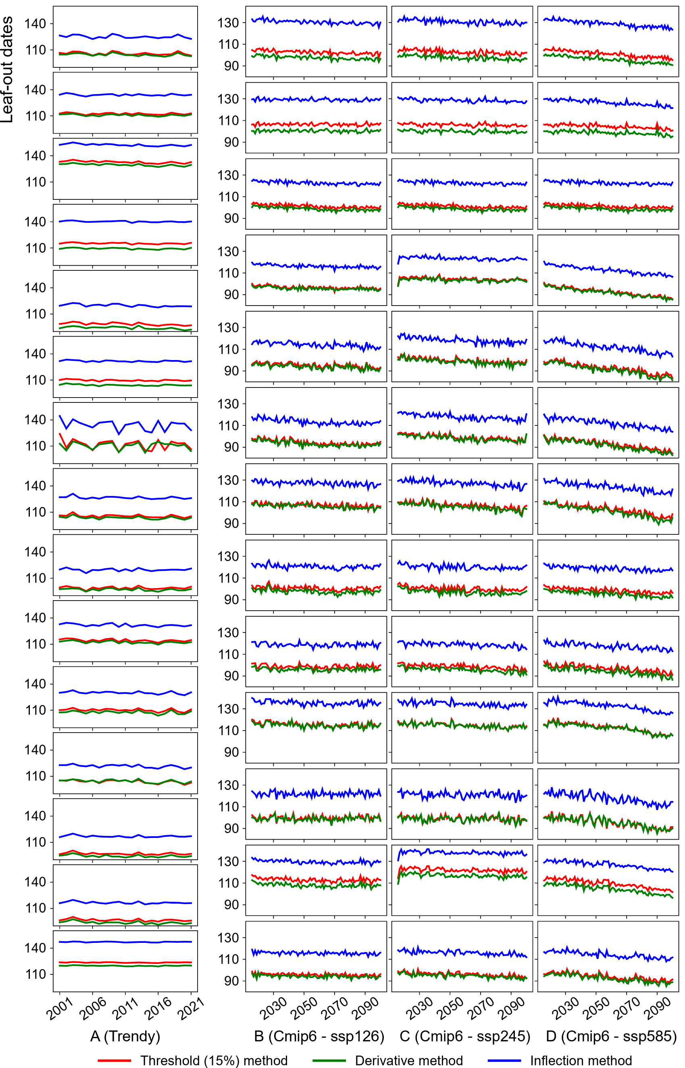

Supplementary Fig. 5 | Comparison of the leaf-out dates extracted by the threshold method, derivative method, and inflection method. A, leaf-out dates of 15 Trendy models for 2001-2021 is shown from top to bottom, corresponding to the names in Table S2 and in the same order. B, C, D, leaf-out dates of 13 Cmip6 models under different shared socioeconomic pathways for 2016-2100 is shown from top to bottom, corresponding to the names in Table S3 and in the same order. The value in A-D represents the global annual average of leaf-out dates.
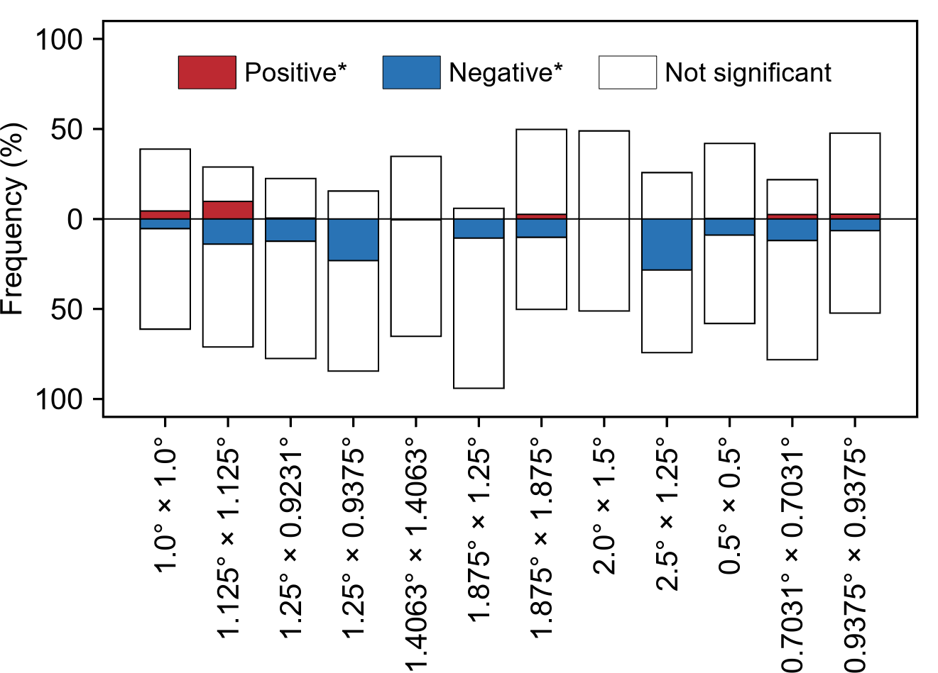

Supplementary Fig. 6 | The impact of biodiversity on the sensitivity of spring leaf unfolding to warming (S_{T}) derived from observed data at different resampling resolutions. The labels on the X-axis represent distinct latitude and longitude resolutions, corresponding to Table S2 and S3. *, P<0.05.

Supplementary Table 1 | Description of environmental variables
# | Variable name | Spatial resolution | Temporal resolution | Time range | Source
1 | Biodiversity | 0.01° | - | - | GFBI¹
2 | Leaf-out dates | 500m | yearly | 2001-2021 | MOD12Q2 v6.1²
3 | 2m temperature | 0.1° | monthly | 2001-2021 | ERA5³
4 | Total precipitation | 0.1° | monthly | 2001-2021 | ERA5³
5 | Solar radiation | 0.1° | monthly | 2001-2021 | ERA5³
6 | Soil temperature | 0.1° | hourly/monthly | 2001-2021 | ERA5³
7 | Soil moisture | 0.1° | monthly | 2001-2021 | ERA5³
8 | Soil total nitrogen | 1km | - | 2021 | SoilGrids⁴
9 | Soil organic carbon | 1km | - | 2021 | SoilGrids⁴
10 | Soil pH | 1km | - | 2021 | SoilGrids⁴
11 | Bulk density | 1km | - | 2021 | SoilGrids⁴
12 | Coarse fragments | 1km | - | 2021 | SoilGrids⁴
13 | Biomes | - | - | 2017 | Ecoregion 2017⁵
14 | Plant functional type | 500m | yearly | 2021 | MCD12Q1 v6.1⁶
15 | Climatic zones | 1km | - | 2020 | Ref. (1)⁷
16 | Forest age | 1km | - | 2021 | Ref. (2)⁸
¹ https://www.gfbinitiative.org/data/
² https://lpdaac.usgs.gov/products/mcd12q1v061/
³ https://doi.org/10.24381/cds.68d2bb30/
⁴ https://files.isric.org/soilgrids/
⁵ https://ecoregions.appspot.com/
⁶ https://doi.org/10.5067/MODIS/MCD12Q1.061/
⁷ https://www.gloh2o.org/koppen/
⁸ https://www.bgc-jena.mpg.de/geodb/projects/FileDetails.php/

Supplementary Table 2 | Description of Trendy models
# | Model name | Spatial resolution | Temporal  resolution | Time range | Source
1 | CABLE-POP | 1°×1° | monthly | 2015-2100 | Ref. (3)¹
2 | CLASSIC | 1°×1° | monthly | 2015-2100 | Ref. (4)¹
3 | CLM5.0 | 1.25°×0.9375° | monthly | 2015-2100 | Ref. (5)¹
4 | DLEM | 0.5°×0.5° | monthly | 2015-2100 | Ref. (6)¹
5 | IBIS | 1°×1° | monthly | 2015-2100 | Ref. (7)¹
6 | ISAM | 0.5°×0.5° | monthly | 2015-2100 | Ref. (8)¹
7 | JSBACH | 1.875°×1.875° | monthly | 2015-2100 | Ref. (9)¹
8 | JULES | 1.875°×1.25° | monthly | 2015-2100 | Ref. (10)¹
9 | LPJ-GUESS | 0.5°×0.5° | monthly | 2015-2100 | Ref. (11)¹
10 | LPX-Bern | 0.5°×0.5° | monthly | 2015-2100 | Ref. (12)¹
11 | OCN | 1°×1° | monthly | 2015-2100 | Ref. (13)¹
12 | ORCHIDEE | 0.5°×0.5° | monthly | 2015-2100 | Ref. (14)¹
13 | VISIT-NIES | 0.5°×0.5° | monthly | 2015-2100 | Ref. (15)¹
14 | VISIT | 0.5°×0.5° | monthly | 2015-2100 | Ref. (16)¹
15 | YIBs | 1°×1° | monthly | 2015-2100 | Ref. (17)¹
¹ https://blogs.exeter.ac.uk/trendy/

Supplementary Table 3 | Description of Cmip6 models
# | Model name | Spatial resolution | Temporal  resolution | Time range | Source
1 | ACCESS-ESM1-5 | 1.875°×1.25° | monthly | 2015-2100 | Ref. (18)¹
2 | BCC-CSM2-MR | 1.125°×1.125° | monthly | 2015-2100 | Ref. (19)¹
3 | CAS-ESM2-0 | 1.4063°×1.4063° | monthly | 2015-2100 | Ref. (20)¹
4 | CESM2-WACCM | 1.25°×0.9375° | monthly | 2015-2100 | Ref. (21)¹
5 | CMCC-CM2-SR5 | 1.25°×0.9375° | monthly | 2015-2100 | Ref. (22)¹
6 | CMCC-ESM2 | 1.25°×0.9375° | monthly | 2015-2100 | Ref. (23)¹
7 | EC-Earth3-Veg | 0.7031°×0.7031° | monthly | 2015-2100 | Ref. (24)¹
8 | INM-CM4-8 | 2.0°×1.5° | monthly | 2015-2100 | Ref. (25)¹
9 | INM-CM5-0 | 2.0°×1.5° | monthly | 2015-2100 | Ref. (26)¹
10 | IPSL-CM6A-LR | 2.5°×1.25° | monthly | 2015-2100 | Ref. (27)¹
11 | MPIESM1-2-HR | 0.9375°×0.9375° | monthly | 2015-2100 | Ref. (28)¹
12 | NorESM2-MM | 1.25°×0.9231° | 3-hourly | 2015-2100 | Ref. (29)¹
13 | TaiESM1 | 1.25°×0.9375° | monthly | 2015-2100 | Ref. (30)¹
¹ https://esgf-node.llnl.gov/projects/cmip6/

Supplementary Table 4 | The selected climate types from the Resolve Ecoregions 2017 dataset
Value | Biomes type | Abbreviation
4 | Temperate Broadleaf & Mixed Forest | TBMF
5 | Temperate Conifer Forests | TCF
6 | Boreal Forests/Taiga | BFT
7 | Tropical & Subtropical Grasslands, Savannas & Shrublands | TSG
8 | Temperate Grasslands, Savannas & Shrublands | TGSS
11 | Tundra | TUN
12 | Mediterranean Forests, Woodlands & Scrub | MFWS
13 | Deserts & Xeric Shrublands | DXS

Supplementary Table 5 | The selected plant functional types from MCD12Q1 v6.1 dataset
Value | Plant functional type | Abbreviation
1 | Evergreen Needleleaf Forests | ENF
2 | Evergreen Broadleaf Forests | EBF
3 | Deciduous Needleleaf Forests | DNF
4 | Deciduous Broadleaf Forests | DBF
5 | Mixed Forests | MF
6 | Closed Shrublands | CSH
7 | Open Shrublands | OSH
8 | Woody Savannas | WSA
9 | Savannas | SAV
10 | Grasslands | GRA
11 | Permanent Wetlands | WET
12 | Croplands | CRO
13 | Urban and Built-up Lands | URB
14 | Cropland/Natural Vegetation Mosaics | CNV
16 | Barren | BSY

Supplementary Table 6 | The selected climatic zones from the Köppen-Geiger climate classification system
Value | Climatic zone | Description
7 | BSK | Arid, steppe, cold
8 | CSA | Temperate, dry summer, hot summer
9 | CSB | Temperate, dry summer, warm summer
14 | CFA | Temperate, no dry season, hot summer
15 | CFB | Temperate, no dry season, warm summer
18 | DSB | Cold, dry summer, warm summer
19 | DSC | Cold, dry summer, cold summer
21 | DWA | Cold, dry winter, hot summer
22 | DWB | Cold, dry winter, warm summer
25 | DFA | Cold, no dry season, hot summer
26 | DFB | Cold, no dry season, warm summer
27 | DFC | Cold, no dry season, cold summer

Supplementary References
1. Dinerstein, E. et al. An Ecoregion-Based Approach to Protecting Half the Terrestrial Realm. BioScience 67, 534–545 (2017).
2. Besnard, S. et al. Mapping global forest age from forest inventories, biomass and climate data. Earth Syst. Sci. Data 13, 4881–4896 (2021).
3. Haverd, V. et al. A new version of the CABLE land surface model (Subversion revision r4601) incorporating land use and land cover change, woody vegetation demography, and a novel optimisation-based approach to plant coordination of photosynthesis. Geosci. Model Dev. 11, 2995–3026 (2018).
4. Melton, J. R. et al. CLASSIC v1.0: the open-source community successor to the Canadian Land Surface Scheme (CLASS) and the Canadian Terrestrial Ecosystem Model (CTEM) – Part 1: Model framework and site-level performance. Geosci. Model Dev. 13, 2825–2850 (2020).
5. Lawrence, D. M. et al. The Community Land Model Version 5: Description of New Features, Benchmarking, and Impact of Forcing Uncertainty. J. Adv. Model. Earth Syst. 11, 4245–4287 (2019).
6. Tian, H. et al. North American terrestrial CO2 uptake largely offset by CH4 and N2O emissions: toward a full accounting of the greenhouse gas budget. Clim. Change 129, 413–426 (2015).
7. Yuan, W. et al. Multiyear precipitation reduction strongly decreases carbon uptake over northern China. J. Geophys. Res. Biogeosciences 119, 881–896 (2014).
8. Meiyappan, P., Jain, A. K. & House, J. I. Increased influence of nitrogen limitation on CO2 emissions from future land use and land use change. Glob. Biogeochem. Cycles 29, 1524–1548 (2015).
9. Reick, C. H. et al. JSBACH 3 - The land component of the MPI Earth System Model: documentation of version 3.2. (2021) doi:10.17617/2.3279802.
10. Clark, D. B. et al. The Joint UK Land Environment Simulator (JULES), model description – Part 2: Carbon fluxes and vegetation dynamics. Geosci. Model Dev. 4, 701–722 (2011).
11. Smith, B. et al. Implications of incorporating N cycling and N limitations on primary production in an individual-based dynamic vegetation model. Biogeosciences 11, 2027–2054 (2014).
12. Lienert, S. & Joos, F. A Bayesian ensemble data assimilation to constrain model parameters and land-use carbon emissions. Biogeosciences 15, 2909–2930 (2018).
13. Zaehle, S. & Friend, A. D. Carbon and nitrogen cycle dynamics in the O-CN land surface model: 1. Model description, site-scale evaluation, and sensitivity to parameter estimates. Glob. Biogeochem. Cycles 24, (2010).
14. Krinner, G. et al. A dynamic global vegetation model for studies of the coupled atmosphere-biosphere system. Glob. Biogeochem. Cycles 19, (2005).
15. Niwa. Long-term global CO₂ fluxes estimated by NICAM-based Inverse Simulation for Monitoring CO₂ (NISMON-CO₂). (2020) doi:10.17595/20201127.001.
16. Kato, E., Kinoshita, T., Ito, A., Kawamiya, M. & Yamagata, Y. Evaluation of spatially explicit emission scenario of land-use change and biomass burning using a process-based biogeochemical model. J. Land Use Sci. 8, 104–122 (2013).
17. Yue, X. & Unger, N. The Yale Interactive terrestrial Biosphere model version 1.0: description, evaluation and implementation into NASA GISS ModelE2. Geosci. Model Dev. 8, 2399–2417 (2015).
18. Ziehn, T. et al. CSIRO ACCESS-ESM1.5 model output prepared for CMIP6 ScenarioMIP. (2019) doi:10.22033/ESGF/CMIP6.2291.
19. Xin, X. et al. BCC BCC-CSM2MR model output prepared for CMIP6 ScenarioMIP. (2019) doi:10.22033/ESGF/CMIP6.1732.
20. Chinese Academy of Sciences (CAS). CAS CAS-ESM2.0 model output prepared for CMIP6 ScenarioMIP. (2020) doi:10.22033/ESGF/CMIP6.1957.
21. Danabasoglu, G. NCAR CESM2-WACCM model output prepared for CMIP6 ScenarioMIP. (2019) doi:10.22033/ESGF/CMIP6.10026.
22. Lovato, T. & Peano, D. CMCC CMCC-CM2-SR5 model output prepared for CMIP6 ScenarioMIP. (2020) doi:10.22033/ESGF/CMIP6.1365.
23. Lovato, T., Peano, D. & Butenschön, M. CMCC CMCC-ESM2 model output prepared for CMIP6 ScenarioMIP. (2021) doi:10.22033/ESGF/CMIP6.13168.
24. EC-Earth Consortium (EC-Earth). EC-Earth-Consortium EC-Earth3-Veg model output prepared for CMIP6 ScenarioMIP. (2019) doi:10.22033/ESGF/CMIP6.727.
25. Volodin, E. et al. INM INM-CM4-8 model output prepared for CMIP6 ScenarioMIP. (2019) doi:10.22033/ESGF/CMIP6.12321.
26. Volodin, E. et al. INM INM-CM5-0 model output prepared for CMIP6 ScenarioMIP. (2019) doi:10.22033/ESGF/CMIP6.12322.
27. Boucher, O. et al. IPSL IPSL-CM6A-LR model output prepared for CMIP6 ScenarioMIP. (2019) doi:10.22033/ESGF/CMIP6.1532.
28. Schupfner, M. et al. DKRZ MPI-ESM1.2-HR model output prepared for CMIP6 ScenarioMIP. (2019) doi:10.22033/ESGF/CMIP6.2450.
29. Bentsen, M. et al. NCC NorESM2-MM model output prepared for CMIP6 ScenarioMIP. (2019) doi:10.22033/ESGF/CMIP6.608.
30. Lee, W.-L. & Liang, H.-C. AS-RCEC TaiESM1.0 model output prepared for CMIP6 ScenarioMIP. (2020) doi:10.22033/ESGF/CMIP6.9688.

