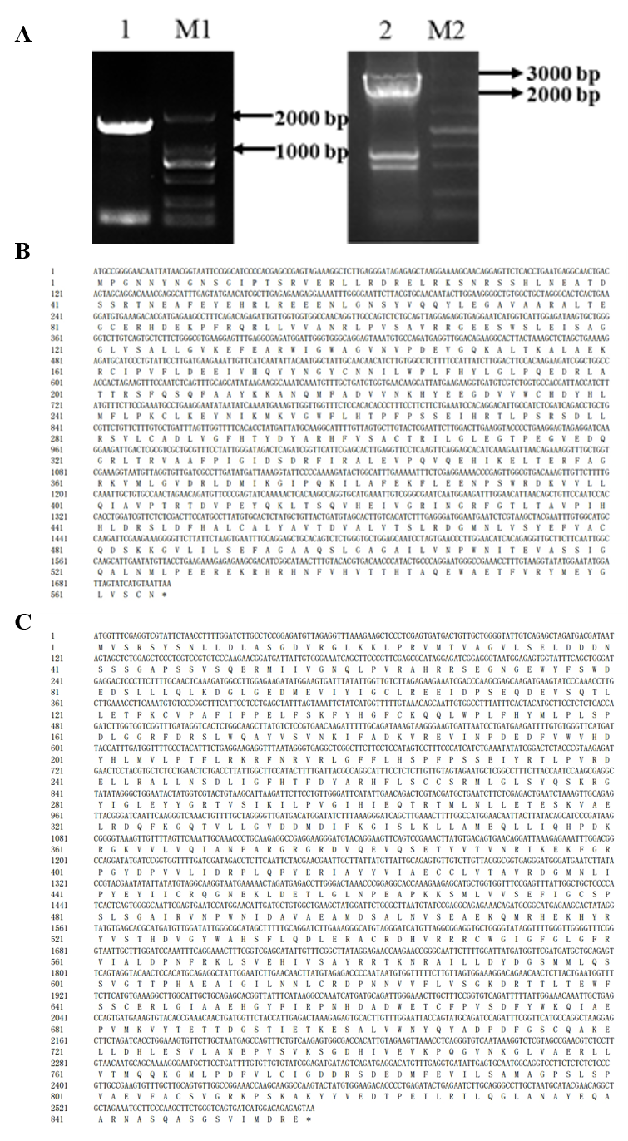
Supplementary Fig. 2 Cloning of full-length of PoTPS1 and PoTPS5 cDNAs. (A) PCR amplification products of PoTPS1 and PoTPS5 genes. 1: PCR amplification products of PoTPS1; M1. DL2000 Maker. 2: PCR amplification products of PoTPS5; M2. DL5000 Maker. (B) Nucleotide sequence and deduced amino acid sequence of PoTPS1. C, Nucleotide sequence and deduced amino acid sequence of PoTPS5.

