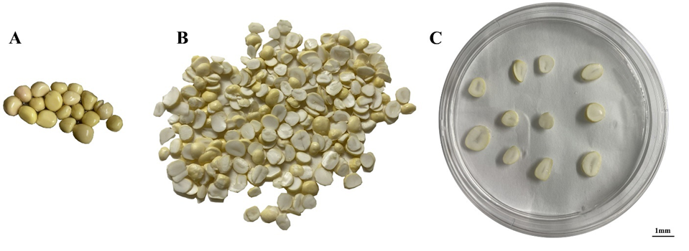
Supplementary Fig. 1 The material and method for abiotic stress treatments of P. ostii seeds on the medium. (A) Seeds of P. ostii. (B) Seeds flakes. (C) Seeds treated on 1/2 MS medium. Scale bar, 1 cm.

