N-cadherin crosstalk with integrin weakens the molecular clutch in response to surface viscosity
Eva Barcelona-Estaje¹, Aleixandre Rodrigo-Navarro¹, Paul Genever², Matthew J Dalby¹, Pere Roca-Cusachs^{3,4*}, Marco Cantini^{1*}, Manuel Salmeron-Sanchez^{1*}

¹Centre for the Cellular Microenvironment, Advanced Research Centre, Glasgow, UK
²Department of Biology, University of York, York, UK
³Institute for Bioengineering of Catalonia (IBEC), the Barcelona Institute of Technology (BIST), Barcelona, Spain
⁴University of Barcelona, Barcelona, Spain

*corresponding authors:

proca@ibecbarcelona.eu,

Marco.Cantini@glasgow.ac.uk,

Manuel.Salmeron-Sanchez@glasgow.ac.uk

Supplementary information

Supplementary Fig.1: hMSCs area with different concentrations of RGD
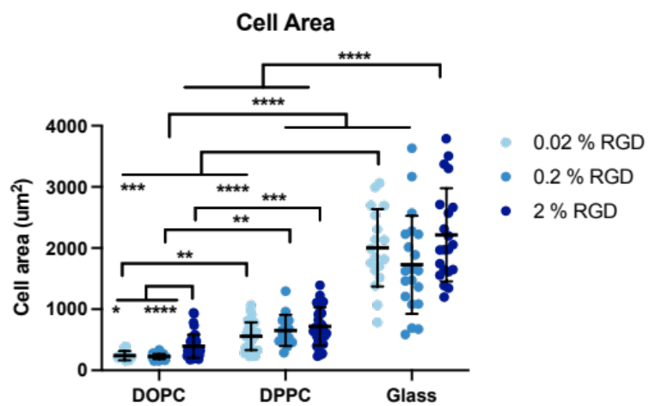
Supplementary Figure 1: hMSCs area on SLBs and glass surfaces functionalized with different concentrations of RGD (in DOPC samples from left to right n=10, 36 and 40, in DPPC samples 34, 15 and 31, and Glass samples 18, 20 and 21). *P ≤ 0.05, **P ≤ 0.01, ***P ≤ 0.001, ****P ≤ 0.0001.

Supplementary Fig.2: SLBs functionalized with FITC-RGD and Cy3-HAVDI
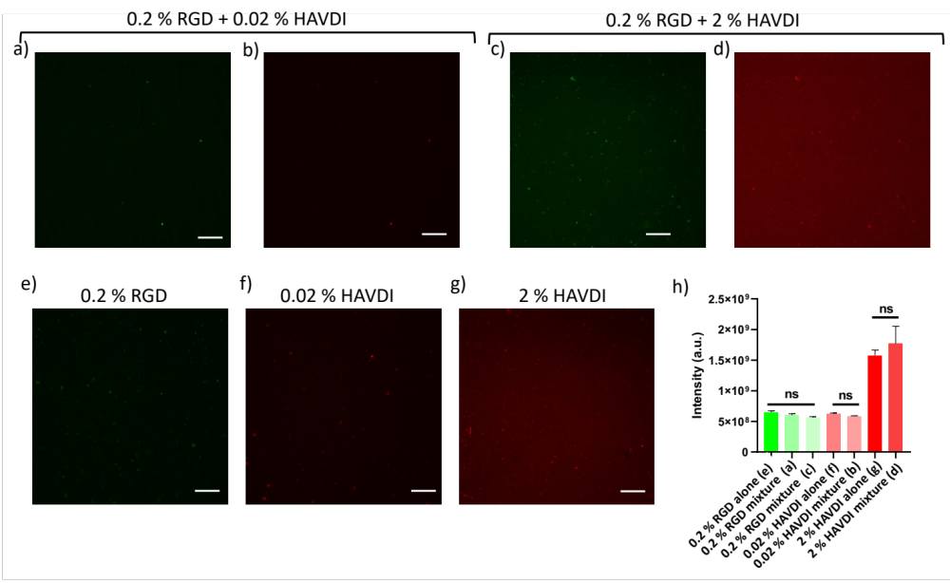
Supplementary Figure 2: Fluorescence imaging of the functionalization of DOPC SLBs with FITC-RGD (green) and Cy-3-HAVDI (red). a,b) FITC-RGD (a) and Cy3-HAVDI (b) images of a bilayer functionalized with 0.2 % RGD and 0.02 % HAVDI. c,d) FITC-RGD (c) and Cy3-HAVDI (d) images of a bilayer functionalized with 0.2 % RGD and 2 % HAVDI. e) FITC-RGD image of a SLB functionalised with 0.2% RGD alone. f,g) Cy3-HAVDI image of a SLB functionalised with 0.02% (f) or 2 % (f) HAVDI alone. Scale bar: 100 μm. Graph h shows the intensity of the ligands in the different bilayers. *P ≤ 0.05, **P ≤ 0.01, ***P ≤ 0.001, ****P ≤ 0.0001.
Supplementary Fig. 3: N-Cadherin adhesion is involved in the changes observer in hMSCs
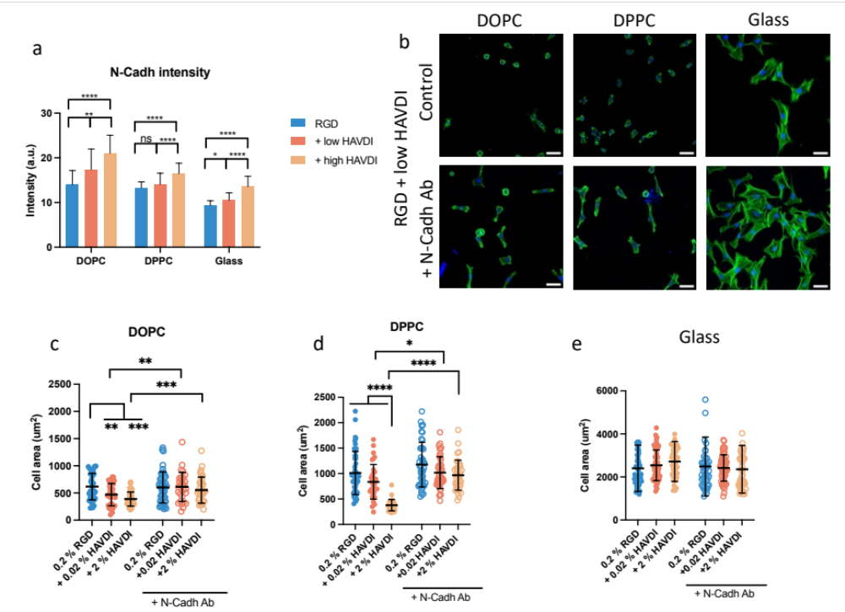

Supplementary Figure 3: a) N-Cadherin intensity measured by immunostaining of hMSCs seeded on surfaces with RGD or RGD plus low or high HAVD after 24 h of cell cultureI. b) Representative images of hMSCs (with or without blocking their N-cadherins) seeded on surfaces with RGD plus low HAVDI stained for actin (green) and DAPI (blue) after 24 h of cell culture (scale bar= 100 um). *P ≤ 0.05, **P ≤ 0.01, ***P ≤ 0.001, ****P ≤ 0.0001.

Supplementary Fig. 4: Cell area and av clustering of hMSCs seeded on surfaces with varying concentrations of RGD and HAVDI
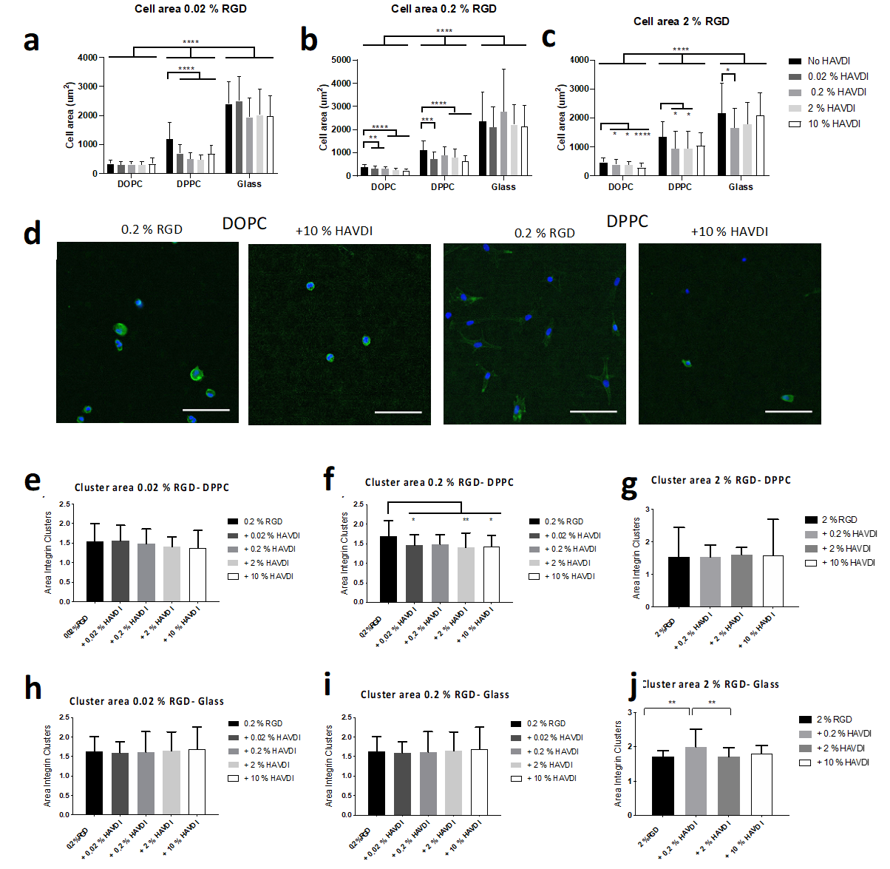
Supplementary Figure 4: a), b) and c) show cell area of hMSCs seeded on surfaces with 0.02 %, 0.2 % and 2 % of RGD respectively and varying concentrations of HAVDI. d) shows representative images of cells on DOPC and DPPC without or with 10 % HAVDI. Scale bar in all the images: 100 μm. Cells are stained for DAPI (blue) and actin (green). Integrin α_{v}clusters formed by hMSCs after 24 h of cell culture on DPPC (e,f,g) and Glass (h,I,j) after 24 h of cell culture. RGD concentration was kept constant (0.02 % for e and h, 0.2 % for f and i and 2 % for g and j) and varying concentrations of HAVDI were added. *P ≤ 0.05, **P ≤ 0.01, ***P ≤ 0.001, ****P ≤ 0.0001.

Supplementary Fig. 5: YAP translocation to the nucleus of hMSCs seeded on surfaces with different concentrations of RGD
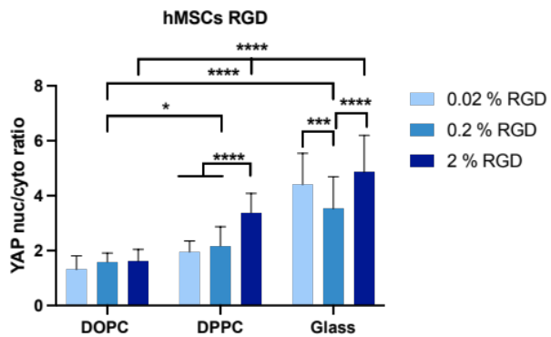
Supplementary Figure 5: YAP translocation to the nucleus of hMSCs seeded con SLBs and glass surfaces with different concentrations of RGD for 24 h (DOPC from left to right n= 31, 30 and 30, DPPC n= 40, 40 and 40, and glass n= 30, 30 and 30). *P ≤ 0.05, **P ≤ 0.01, ***P ≤ 0.001, ****P ≤ 0.0001.

Supplementary Fig. 6: MIIA and vinculin colocalization
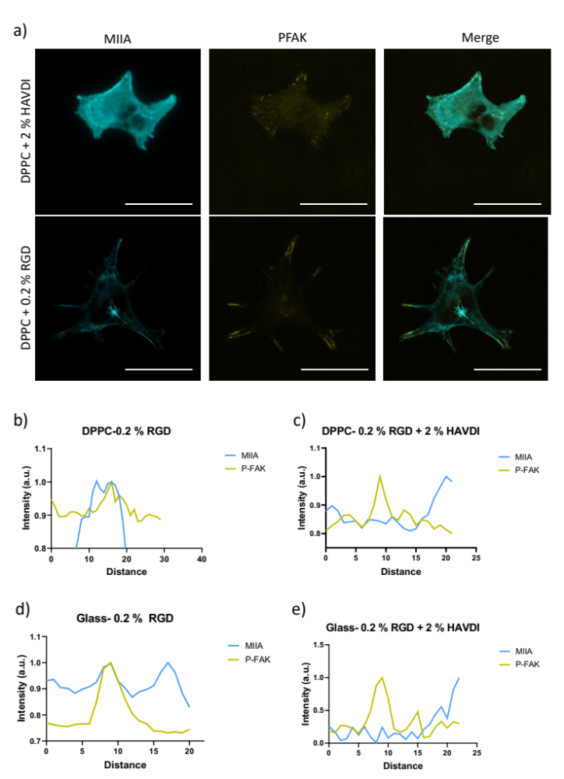
Supplementary Figure 6: Co-localization of MIIA with P-FAK in hMSCs. a) Representative images of hMSCs seeded on DPPC for 24 h stained for MIIA and P-FAK. b, c, d and e are intensity profiles of FA sites of hMSCs stained for MIIA (blue) and P-FAK (yellow). Scale bar= 50 m.

Supplementary Fig. 7: Early hMSCs differentiation markers
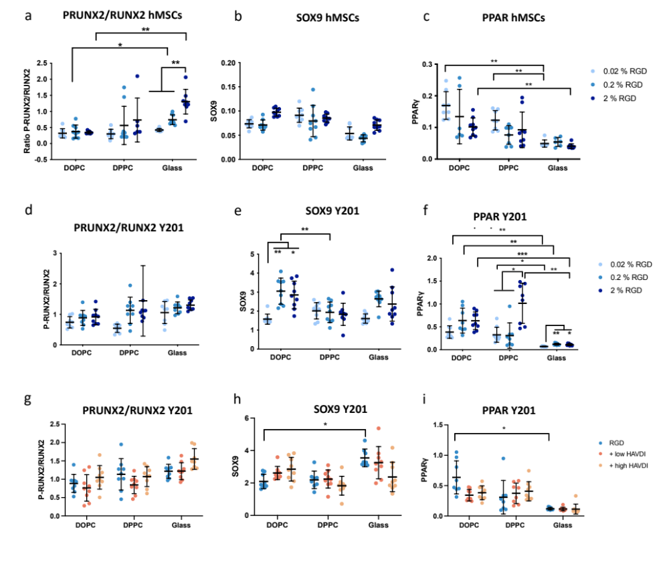
Supplementary Figure 7: Early differentiation hMSCs marker expression measured by ICW for a) osteogenesis (7 days), b) chondrogenesis (5 days) and c) adipogenesis (5 days). *P ≤ 0.05, **P ≤ 0.01, ***P ≤ 0.001, ****P ≤ 0.0001.

Supplementary Fig. 8: Number of FAs of hMSCs
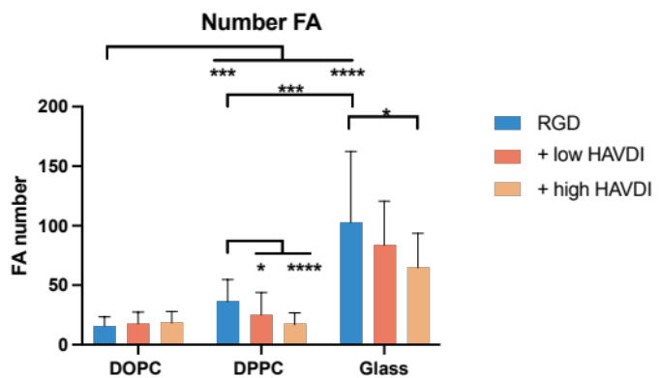
Supplementary Figure 8: Number of FAs of hMSCs seeded on SLBs or glass surfaces functionalized with RGD or RGD plus low or high HAVDI for 24 h measured by vinculin immunostaining. *P ≤ 0.05, **P ≤ 0.01, ***P ≤ 0.001, ****P ≤ 0.0001.

Supplementary Fig. 9: Area, Focal adhesions, YAP and early differentiation of Y201 cells
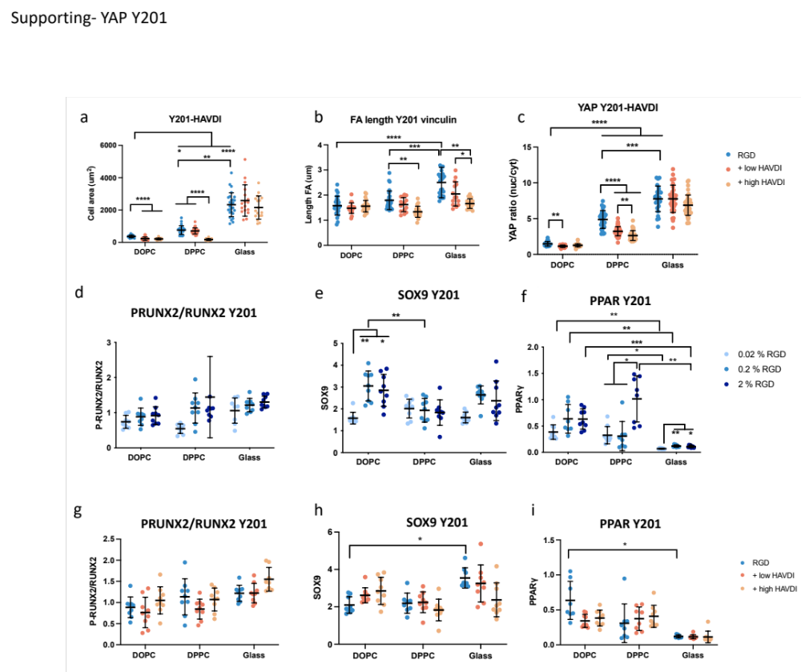
Figure 9: Area (a), focal adhesion length (b) and YAP translocation to the nucleus (c) of Y201 cells seeded on surfaces functionalized with RGD and RGD plus low or high HAVDI after 24 h, 24 h and 3 days respectively. d) and g) show early osteogenic expression of Y201 cells seeded on surfaces functionalized with different concentrations of RGD or RGD plus low or high HAVDI respectively. e) and h) show early chondrogenic expression of Y201 cells seeded on surfaces functionalized with different concentrations of RGD or RGD plus low or high HAVDI respectively. f) and i) show early adipogenic expression of Y201 cells seeded on surfaces functionalized with different concentrations of RGD or RGD plus low or high HAVDI respectively. *P ≤ 0.05, **P ≤ 0.01, ***P ≤ 0.001, ****P ≤ 0.0001.

Supplementary Fig. 10: Jasplakinolide treated Y201 seeded con RGD and RGD plus low or high HAVDI
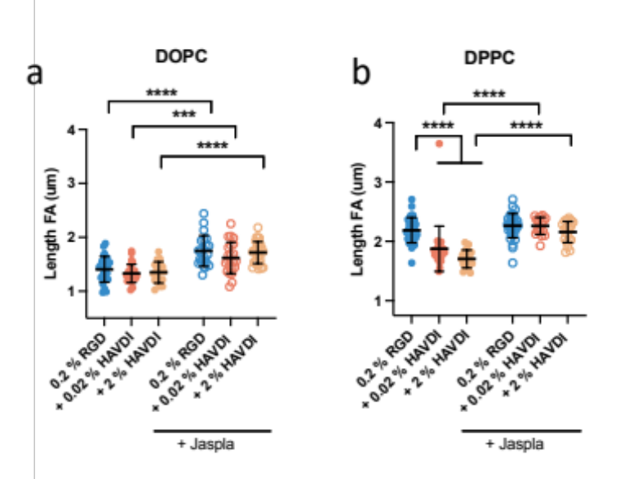
Supplementary Figure 10: FA adhesion size of Y201 cells treated with Jasplakinolide for 1 h, seeded on DOPC (a) and DPPC (b). FA size measured by vinculin staining after 1 day of culture.

Supplementary Fig. 11: SCFS measurements of Y201 and hMSCs seeded on surfaces with different RGD concentrations and hMSCs seeded on surfaces with RGD or RGD plus low and high HAVDI
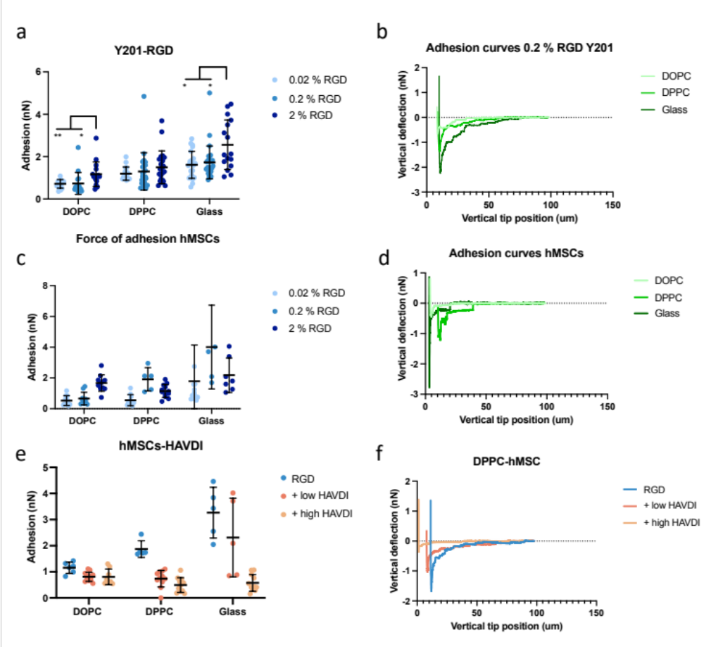
Supplementary Figure 11: a) SCFS values of Y201 cells in contact for 30 seconds with surfaces functionalized with different concentrations of RGD, see b for representative curves. c) SCFS values of hMSCs cells in contact for 30 seconds with surfaces functionalized with different concentrations of RGD, see d for representative curves. e) SCFS values of Y201 cells in contact for 30 seconds with surfaces functionalized with different with RGD or RGD plus low or high HAVDI, see f for representative curves.

