Supplementary Material

Description of the intervention (rhythmic embrocation)

- RE of the back in the morning:
The patient is sitting at the bedside and leaning with his arms on a nightstand or over a pillow; safe sitting has to be achieved in this position as an obligatory prerequisite for this treatment.
During this treatment, only one hand is touching the patient at one time. The treatment can be described as two different movements: in the first movement the hand is moved in circles over one side of the back with the circles going down; the circles are clockwise at the left side of the back and anti-clockwise at the right side of the back; there is a slightly stronger touch when going down above the M. erector spinae to the middle of back (the spine is not touched within these movements); the second movement is a line on one side of the back and then the other going down. Every movement is repeated about 3 times on every side of the back.
- RE of the feet in the evening:
The patient is lying in his bed with a knee roll under his knees (or something similar like a rolled additional bedcover).
During this treatment the two hands of the nurse are touching one foot of the patient, either using both hands for the massage or one hand holding the foot and the other performing massage movements. The treatment can be described in 5 steps, though step 4 is a repetition of step 1. All steps are repeated 3-4 times and then the other foot is treated equally:
- One hand is put into the arch of the foot, the other hand on the bridge. The hand on the arch induces a slight compression when moved towards the toes while the hand on the bridge follows with a lighter touch in the same direction – together gently wrapping the foot.
- One hand lifts the foot slightly while supporting it in the area of the ankle. The other hand gives a slight impulse around the heel.
- Both hands move in circles around the ankle and then over the bridge down to the toes.
- Repetition of I.
- The thenar of the massage therapist touches the ball of the foot of the patient and moves with a slight impulse downwards along the arch to the heel. The other hand supports the bridge.

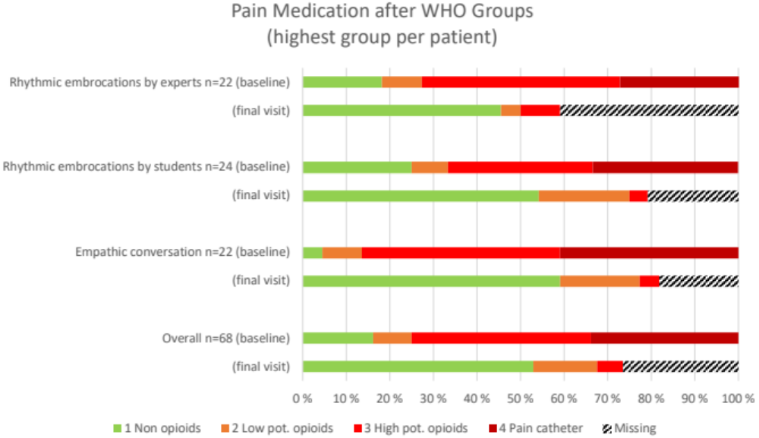

Sedatives per group at baseline and final visit

 | Rhythmic embrocations  by experts  (n=22) | Rhythmic embrocations  by students  (n=24) | Empathic conversation  (n=22) | Overall  (n=68)
Sedatives at baseline | 4 (18.2%) | 3 (12.5%) | 3 (13.6%) | 10 (14.7%)
Sedatives at final Visit | 1 (4.5%) | 2 (8.3%) | 0 (0%) | 3 (4.4%)
Missings final visit | 9 (40.9%) | 5 (20.8%) | 3 (13.6%) | 17 (25.0%)

Heart rate variability data (full data set)

 | RE by experts  (N=22) | RE by students  (N=24) | Empathic conversation  (N=22) | Overall  (N=68)
SDNN Baseline
Median [IQR] | 34.5 [23.9-55.6] | 31.5 [18.1-40.4] | 27.9 [22.8-51.6] | 32.4 [21.9-51.6]
Missing | 8 (36.4%) | 10 (41.7%) | 7 (31.8%) | 25 (36.8%)
SDNN final visit
Median [IQR] | 44.1 [32.6-57.9] | 29.6 [24.7-40.1] | 39.1 [32.0-52.7] | 38.9 [27.9-49.4]
Missing | 8 (36.4%) | 11 (45.8%) | 10 (45.5%) | 29 (42.6%)
SDNN change
Median [IQR] | 9.12 [3.59-12.3] | 5.68 [-0.664-7.50] | 6.64 [-1.49-7.38] | 6.95 [1.81-8.99]
Missing | 10 (45.5%) | 12 (50.0%) | 12 (54.5%) | 34 (50.0%)
RMSSD at Baseline
Median [IQR] | 18.3 [15.0-24.1] | 13.2 [8.12-25.4] | 19.3 [14.1-20.4] | 18.5 [11.9-23.5]
Missing | 8 (36.4%) | 10 (41.7%) | 7 (31.8%) | 25 (36.8%)
RMSSD at final visit
Median [IQR] | 26.7 [20.7-32.2] | 18.6 [12.2-19.8] | 18.6 [15.7-21.7] | 20.4 [13.2-23.2]
Missing | 8 (36.4%) | 11 (45.8%) | 10 (45.5%) | 29 (42.6%)
RMSSD change
Median [IQR] | 7.07 [4.67-11.1] | 1.34 [-5.19-3.60] | 1.94 [-1.17-7.00] | 3.06 [-1.66-8.44]
Missing | 10 (45.5%) | 12 (50.0%) | 12 (54.5%) | 34 (50.0%)
pNN50 at Baseline
Median [IQR] | 1.82 [0.733-5.38] | 0.400 [0.249-6.56] | 1.58 [0.387-3.39] | 1.51 [0.375-5.33]
Missing | 8 (36.4%) | 10 (41.7%) | 7 (31.8%) | 25 (36.8%)
pNN50 at final visit
Median [IQR] | 7.24 [3.26-11.9] | 2.97 [0.556-3.90] | 1.94 [1.13-4.04] | 3.22 [0.999-4.81]
Missing | 8 (36.4%) | 11 (45.8%) | 10 (45.5%) | 29 (42.6%)
pNN50 change
Median [IQR] | 3.90 [1.94-6.69] | 0.200 [-3.57-0.710] | 1.17 [0.161-3.03] | 1.19 [-0.00592-3.53]
Missing | 10 (45.5%) | 12 (50.0%) | 12 (54.5%) | 34 (50.0%)
pNN20 at Baseline
Median [IQR] | 22.6 [16.7-38.8] | 13.4 [3.66-31.5] | 25.0 [14.2-31.1] | 24.2 [8.94-33.1]
Missing | 8 (36.4%) | 10 (41.7%) | 7 (31.8%) | 25 (36.8%)
pNN20 at final visit
Median [IQR] | 38.3 [28.4-51.7] | 12.4 [8.22-20.3] | 21.4 [15.9-30.5] | 22.9 [10.5-36.8]
Missing | 8 (36.4%) | 11 (45.8%) | 10 (45.5%) | 29 (42.6%)
pNN20 change
Median [IQR] | 14.5 [-0.0481-23.0] | 1.46 [-10.1-5.08] | 2.81 [-4.99-13.4] | 3.23 [-4.99-15.6]
Missing | 10 (45.5%) | 12 (50.0%) | 12 (54.5%) | 34 (50.0%)
VLF at Baseline
Median [IQR] | 886 [438-2570] | 823 [315-1410] | 632 [311-2390] | 844 [335-2360]
Missing | 8 (36.4%) | 10 (41.7%) | 7 (31.8%) | 25 (36.8%)
VLF at final visit
Median [IQR] | 1420 [882-2930] | 727 [545-1670] | 1510 [772-2540] | 1090 [657-2350]
Missing | 8 (36.4%) | 11 (45.8%) | 10 (45.5%) | 29 (42.6%)
VLF change
Median [IQR] | 528 [33.1-1270] | 148 [-27.2-299] | 448 [308-667] | 346 [49.0-669]
Missing | 10 (45.5%) | 12 (50.0%) | 12 (54.5%) | 34 (50.0%)
LF at Baseline
Median [IQR] | 275 [111-797] | 134 [66.3-298] | 191 [105-451] | 191 [82.0-491]
Missing | 8 (36.4%) | 10 (41.7%) | 7 (31.8%) | 25 (36.8%)
LF at final visit
Median [IQR] | 347 [163-623] | 231 [101-350] | 257 [136-532] | 284 [128-527]
Missing | 8 (36.4%) | 11 (45.8%) | 10 (45.5%) | 29 (42.6%)
LF change
Median [IQR] | 86.2 [-10.2-140] | 35.3 [-48.1-64.7] | 61.1 [-12.4-185] | 53.0 [-22.8-119]
Missing | 10 (45.5%) | 12 (50.0%) | 12 (54.5%) | 34 (50.0%)
HF at Baseline
Median [IQR] | 144 [93.4-280] | 87.7 [23.9-255] | 90.7 [50.8-182] | 109 [53.0-232]
Missing | 8 (36.4%) | 10 (41.7%) | 7 (31.8%) | 25 (36.8%)
HF at final visit
Median [IQR] | 266 [110-375] | 81.0 [51.4-135] | 128 [63.8-182] | 135 [58.7-211]
Missing | 8 (36.4%) | 11 (45.8%) | 10 (45.5%) | 29 (42.6%)
HF change
Median [IQR] | 101 [25.5-140] | -4.73 [-104-19.1] | 20.6 [-5.24-120] | 21.3 [-19.6-102]
Missing | 10 (45.5%) | 12 (50.0%) | 12 (54.5%) | 34 (50.0%)
LF/HF at Baseline
Median [IQR] | 0.491 [0.164-1.06] | 0.745 [-0.00979-1.12] | 0.912 [0.471-1.11] | 0.770 [0.0868-1.13]
Missing | 8 (36.4%) | 10 (41.7%) | 7 (31.8%) | 25 (36.8%)
LF/HF at final visit
Median [IQR] | 0.339 [-0.186-1.15] | 1.11 [0.640-1.22] | 1.01 [0.719-1.40] | 0.843 [0.327-1.22]
Missing | 8 (36.4%) | 11 (45.8%) | 10 (45.5%) | 29 (42.6%)
LF/HF change
Median [IQR] | -0.0626 [-0.525-0.0969] | 0.113 [-0.0773-0.369] | 0.199 [-0.482-0.378] | 0.0118 [-0.347-0.379]
Missing | 10 (45.5%) | 12 (50.0%) | 12 (54.5%) | 34 (50.0%)

Heart rate variability data (per protocol population)

 | RE by experts  (N=11) | RE by students  (N=8) | Empathic conversation  (N=7) | Overall  (N=26)
SDNN Baseline
Median [IQR] | 33.7 [22.8-53.2] | 31.5 [19.7-42.8] | 26.5 [19.7-39.9] | 30.0 [21.5-50.0]
SDNN final visit
Median [IQR] | 47.2 [32.9-58.2] | 39.4 [24.3-40.6] | 33.0 [26.8-44.3] | 36.4 [29.0-49.4]
SDNN change
Median [IQR] | 8.30 [2.94-10.9] | 5.68 [-0.664-7.50] | 6.55 [-0.116-7.10] | 6.64 [1.81-8.33]
RMSSD at Baseline
Median [IQR] | 16.2 [15.0-23.9] | 16.2 [9.02-27.5] | 15.0 [11.7-20.0] | 15.7 [12.6-24.1]
RMSSD at final visit
Median [IQR] | 30.2 [21.7-32.0] | 19.5 [12.5-20.6] | 20.4 [14.6-21.4] | 20.5 [16.7-29.9]
RMSSD change
Median [IQR] | 5.86 [3.90-9.80] | -0.186 [-5.19-3.60] | 1.50 [-0.905-7.51] | 3.91 [-2.08-8.44]
pNN50 at Baseline
Median [IQR] | 1.51 [0.510-3.95] | 1.42 [0.339-7.78] | 0.980 [0.348-3.65] | 1.42 [0.390-5.03]
pNN50 at final visit
Median [IQR] | 9.48 [3.48-11.9] | 2.98 [0.963-3.66] | 2.18 [1.21-4.60] | 3.63 [1.43-9.49]
pNN50 change
Median [IQR] | 3.40 [1.92-5.64] | 0.159 [-3.57-0.710] | 0.936 [0.114-2.95] | 1.25 [-0.173-4.13]
pNN20 at Baseline
Median [IQR] | 20.4 [16.8-38.4] | 19.7 [3.33-34.0] | 17.2 [8.66-26.3] | 20.0 [11.2-36.2]
pNN20 at final visit
Median [IQR] | 39.6 [30.8-51.4] | 15.5 [9.98-22.0] | 19.9 [14.4-30.1] | 27.2 [13.9-45.7]
pNN20 change
Median [IQR] | 12.0 [-0.574-21.1] | -2.52 [-10.1-5.08] | 2.77 [-3.18-11.5] | 3.62 [-4.99-16.2]
VLF at Baseline
Median [IQR] | 844 [409-2530] | 971 [429-1650] | 414 [311-1630] | 637 [327-2180]
VLF at final visit
Median [IQR] | 1750 [889-2770] | 1090 [618-1690] | 772 [666-2050] | 983 [696-2420]
VLF change
Median [IQR] | 402 [-6.58-935] | 178 [-0.365-317] | 419 [325-561] | 363 [73.8-652]
LF at Baseline
Median [IQR] | 259 [95.8-720] | 122 [65.5-523] | 160 [66.9-290] | 183 [66.3-520]
LF at final visit
Median [IQR] | 307 [169-793] | 297 [104-397] | 137 [128-403] | 274 [127-566]
LF change
Median [IQR] | 76.5 [-13.6-163] | 19.7 [-165-62.9] | 33.1 [-47.0-121] | 38.5 [-26.5-119]
HF at Baseline
Median [IQR] | 111 [94.2-212] | 125 [25.2-237] | 65.1 [42.2-103] | 98.5 [58.4-190]
HF at final visit
Median [IQR] | 308 [131-366] | 114 [56.5-161] | 121 [62.3-179] | 155 [70.0-290]
HF change
Median [IQR] | 103 [14.8-143] | -21.5 [-104-19.1] | 39.9 [-11.7-108] | 30.9 [-33.7-106]
LF/HF at Baseline
Median [IQR] | 0.443 [-0.281-0.866] | 0.745 [0.352-1.10] | 0.912 [0.702-1.01] | 0.667 [0.351-1.07]
LF/HF at final visit
Median [IQR] | 0.0274 [-0.222-1.14] | 1.04 [0.616-1.20] | 0.815 [0.553-1.30] | 0.771 [0.0413-1.19]
LF/HF change
Median [IQR] | -0.0463 [-0.531-0.206] | 0.132 [-0.0773-0.369] | 0.203 [-0.320-0.441] | -0.00429 [-0.347-0.417]

