Supplementary files
Efficient Atrazine Degradation and Toxicity Assessment Using ZnO-Cerium Catalysts: A Path Towards Environmental Remediation

CESAR, P. H. S.^{1*}, CAETANO, A. A.¹, CHAGAS, P. M. B.¹, LOPES, P. A.¹, CARVALHO, I. G. R.^{2,3}
1 – Doctorate researcher of the Chemistry Department (Laboratório de Catálise Ambiental e Novos Materiais) – UFLA, Lavras/MG – Brazil CEP 37200-000
2 – Research advisor of the Chemistry Department (Laboratório de Catálise Ambiental e Novos Materiais) – UFLA, Lavras/MG – Brazil CEP 37200-000

*Corresponding author – pedrocesar.biologia@gmail.com

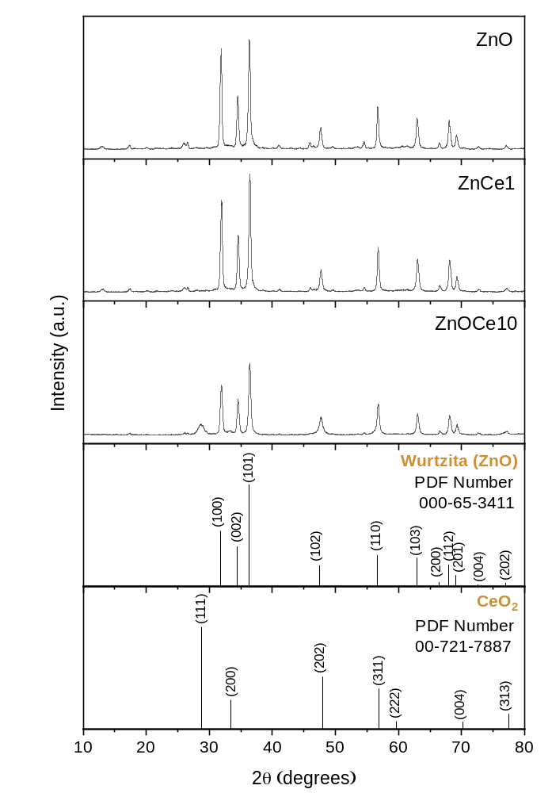

Figure S1 - X-ray diffraction patterns of pure zinc oxide (ZnO) and cerium-doped zinc oxide (ZnOCe1 and ZnOCe10) and reference charts of the wurtzite crystalline phase (ZnO) and cerium dioxide (CeO₂).

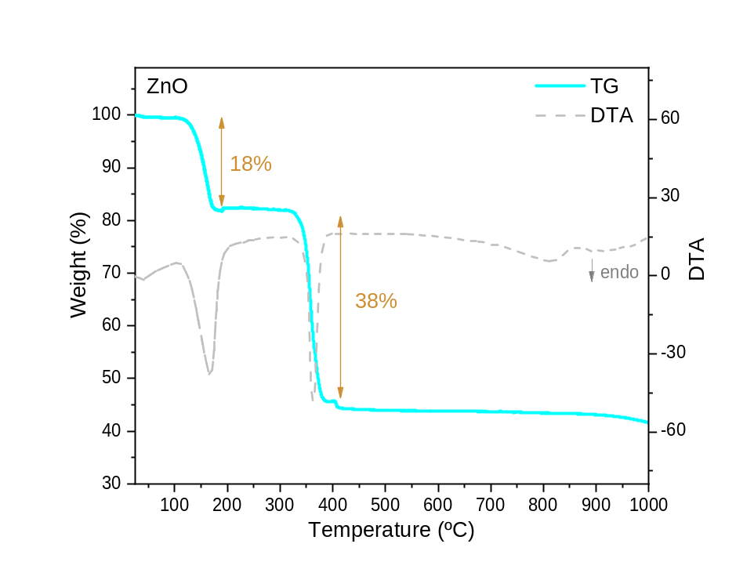

Figure S2 - TGA-DTA curves of the ZnO sample in an oxidizing atmosphere with synthetic air flow (10°C min⁻¹).

