Extended data:
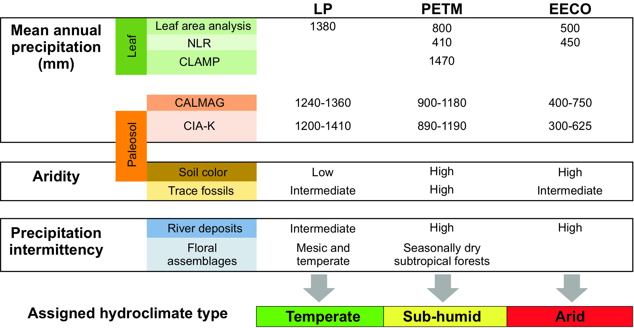
Figure 1. Example of the multi-proxy climate type assignment process. Graphical depiction of the multi-proxy climate assignment process shows how different proxies were integrated in order to describe the climate type of a location and how it changed over time. “LP” stands for Late Paleocene.
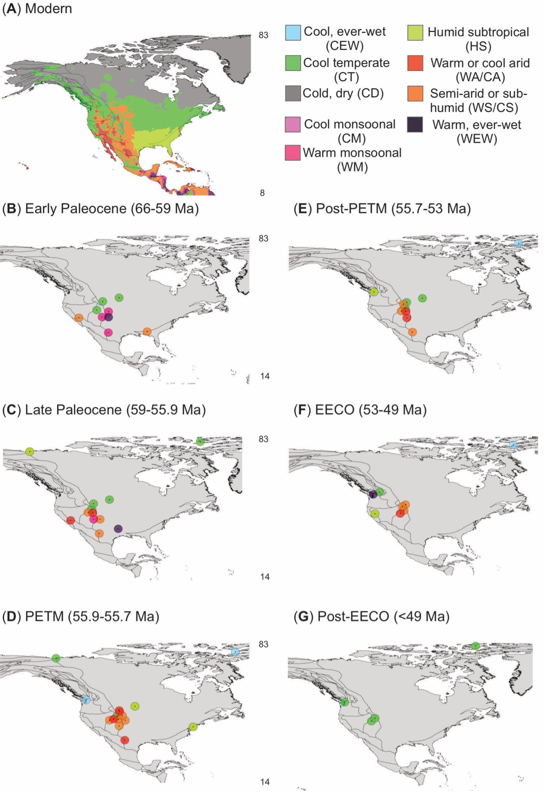
Figure 2. Climate in the modern world (A) and Early Paleogene (B-G). Map has a high-resolution focus on North America to show the spatial complexity of the proxy data. To see high-resolution images of all of the map areas, see the GIS version (Data S2 or S3).

