Graph For Graphical Abstract:
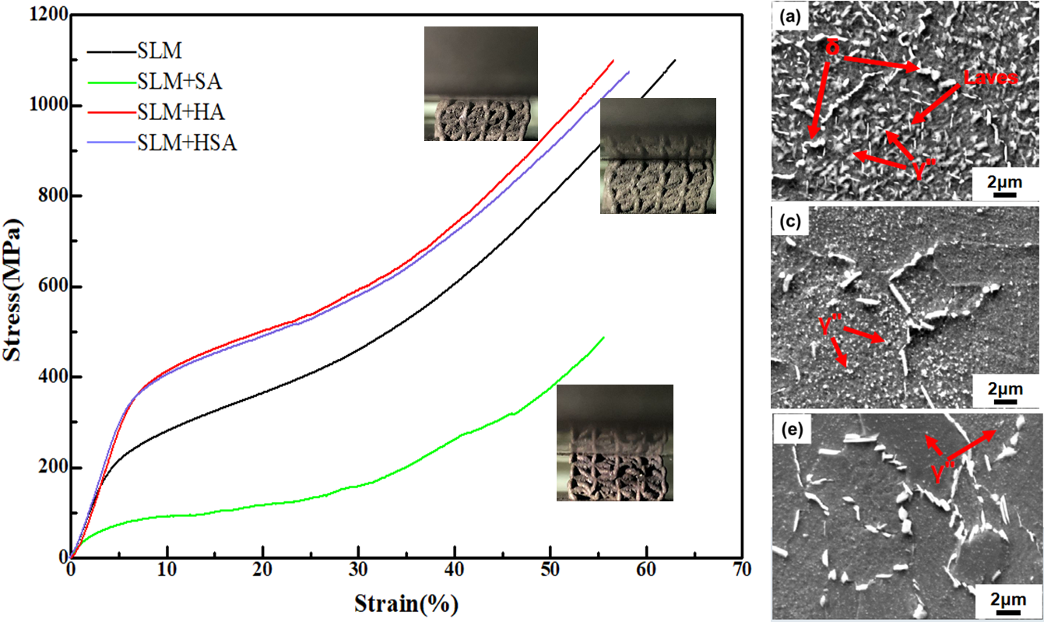

The SLMed porous Inconel718 alloy after homogenizing heat treatment has better mechanical properties due to the precipitation of nano-sized γ" phase.

