Appendix
The constant parameter in equation (1)-(4) are obtained by Yan et al. (2019), and e_{C}=e_{m1}=e_{m2}=0.78, e_{f1}=e_{F}=0.60, a₀=a₁=0.39, b₀=b₁=0.41, a₂=0.40, b₂=0.34, respectively. Thus, equations (1)-(4), the equation (2)-(4) can be written as follows:
$e_{j}=0.78∙C_{m}+0.78∙C_{c}+0.60∙C_{f}-0.624∙C_{f}-0.3198∙C_{c}$ (A1)
$e_{j}=0.78*(C_{m1}+C_{m2})+0.60*C_{f1}-0.3198*C_{m2}-0.6400*C_{f1}$ (A2)
$e_{j}=0.78*(C_{m1}+C_{m2})+0.60*C_{f1}-0.6942*C_{m1}-0.6400*C_{f1}$ (A3)
The data in Table 2 are used to calculated the primary porosity. The calculated results are shown in Fig. A1. Φ_{m} is measured porosity, and Φ_{j} is calculated porosity using equation (A1) - (A3). The maximum error of type C, type B and type D samples are 2.38%, 2.54%, and 2.61, respectively; and the minimum error of type C, type B and type D samples are 0.03%, 0.03% and 0.01%, respectively. The average error of type C, type B and type D samples are 1.14%, 1.11% and 1.47%, respectively. About 50% of samples have errors between measured and calculated primary porosity of less than 1%.
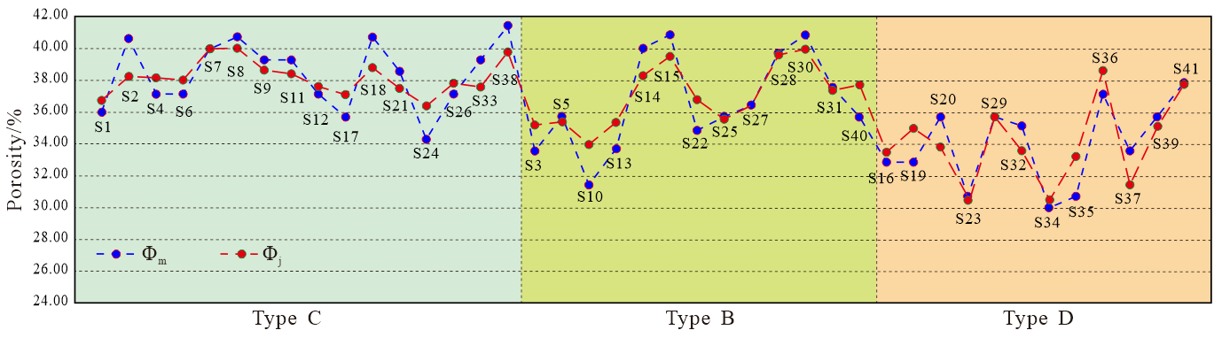
Fig. A1. The measured and calculated primary porosity of 41 sands from modern braided river. Φ_{m} is the measured porosity; Φ_{j} is the calculated porosity.

