SUPPLEMENTARY INFORMATION
Catching Astrocyte Ensembles: Astrocytic Ensembles Control
Cue-motivated Behavior

Includes supplementary figures 1-7 and Table 1: Statistic and Reproducibility.

Fig. S1. mEPSC transmission related to AstroLight-derived ChR2 optostimulation.
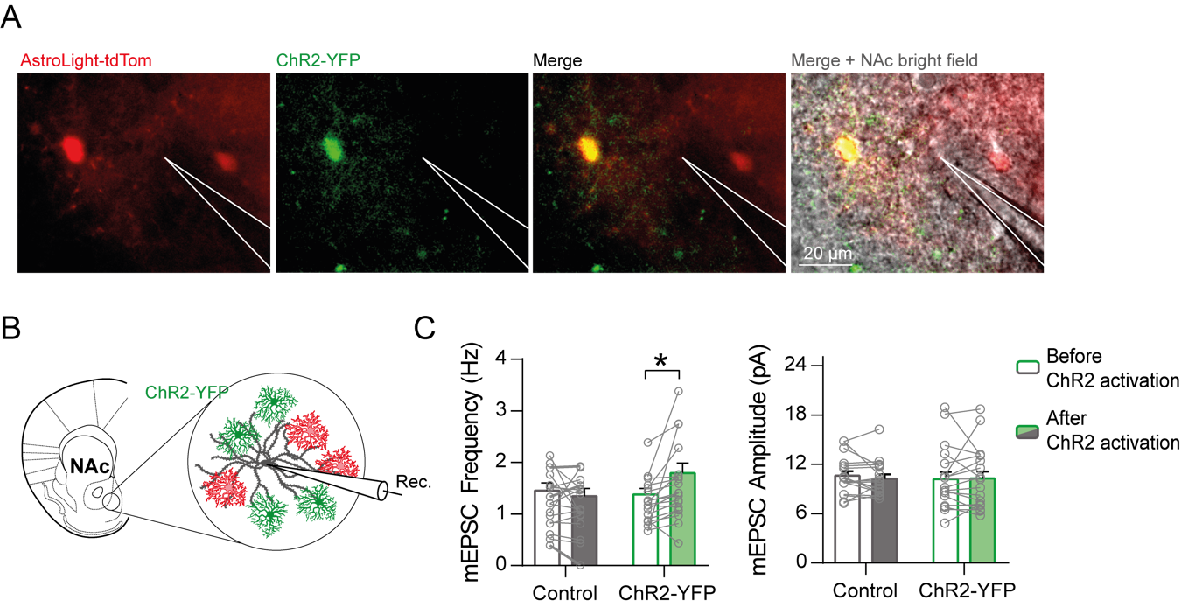
(A) Representative images of a patch-clamp field showing AstroLight-tdTom epifluorescence signal (red), signal of astrocytes expressing ChR2-YFP (green), and merges with and without the NAc tissue in bright field. (B) Scheme showing NAc neuronal patch-clamp recordings in presence of astrocytes expressing AstroLight-derived ChR2-YFP. (C) Quantification of miniature excitatory postsynaptic currents (mEPSC) frequency (Hz) (left) before and after astrocyte-ChR2 optostimulation in Control (grey; before, 1.45 ± 0.15 Hz; after, 1.35 ± 0.15 Hz; p = 0.47; n = 17 cells, 4 mice) and ChR2-YFP (green; before, 1.38 ± 0.11 Hz; after, 1.8 ± 0.2 Hz; p = 0.01; n = 19 cells, 5 mice) conditions, and mEPSC amplitude (pA) (right) before and after astrocyte-ChR2 optostimulation in Control (grey; before, 10.62 ± 0.56 pA; after, 10.25 ± 0.51 pA; p = 0.71; n = 17 cells, 4 mice) and ChR2-YFP (green; before, 10.2 ± 0.86 pA; after, 10.28 ± 0.85 pA; p = 0.88; n = 19 cells, 5 mice) conditions. Two-way ANOVA, Holm-Sidak test for multiple comparisons; *: p < 0.05. All error bars express SEM.

Fig. S2. cytoGCaMPf6 AAV and fiber photometry cannula location.

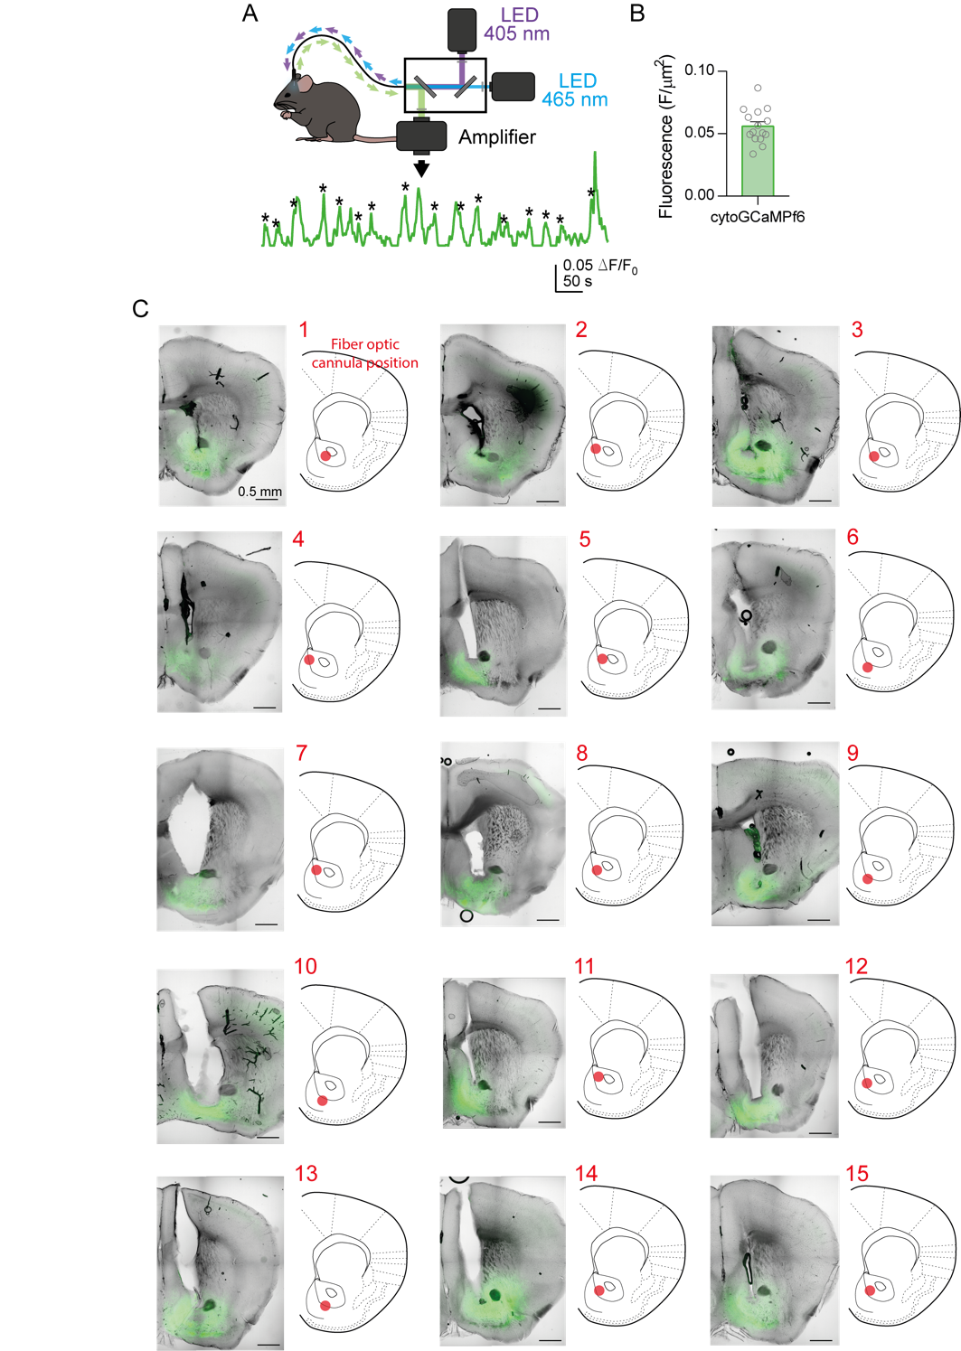
(A) Scheme of the fiber photometry experimental approach, showing Ca²⁺ signaling during training in the operant chamber. Stars indicate Ca²⁺ activity related to reward consumption. (B) Fluorescence (F/µm²) quantified at the injection site (0.056 ± 0.006 F/µm²; n = 15 mice). (C) Representative epifluorescence images and NAc scheme showing fiber cannula position (red dot) in each individual mouse.

Fig. S3. Labeling reward location of AstroLight in reward group mice.

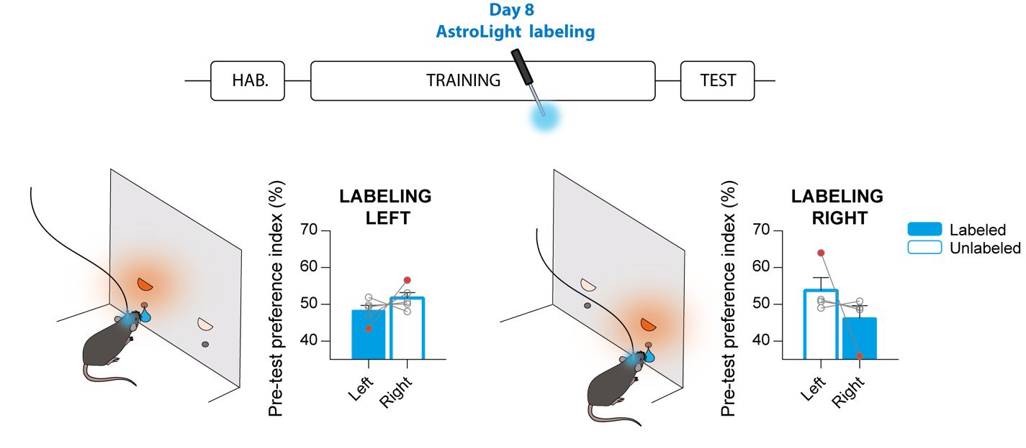
Top, timeline scheme of the behavioral approach indicating labeling day during the training period. Bottom, preference index (%) towards left or right waterholes was quantified during the pre-test period before each training session. Preference was used to balance labeling of reward group mice between both reward locations (Labeling left; n = 4 mice; Labeling right, n = 5 mice). If animals showed a strong preference (red dots; > 55%) towards one location, they were labeled in the opposite waterhole.

Fig. S4. Analysis of YFP/tdTom ratio with respect to fiber photometry cannula location.

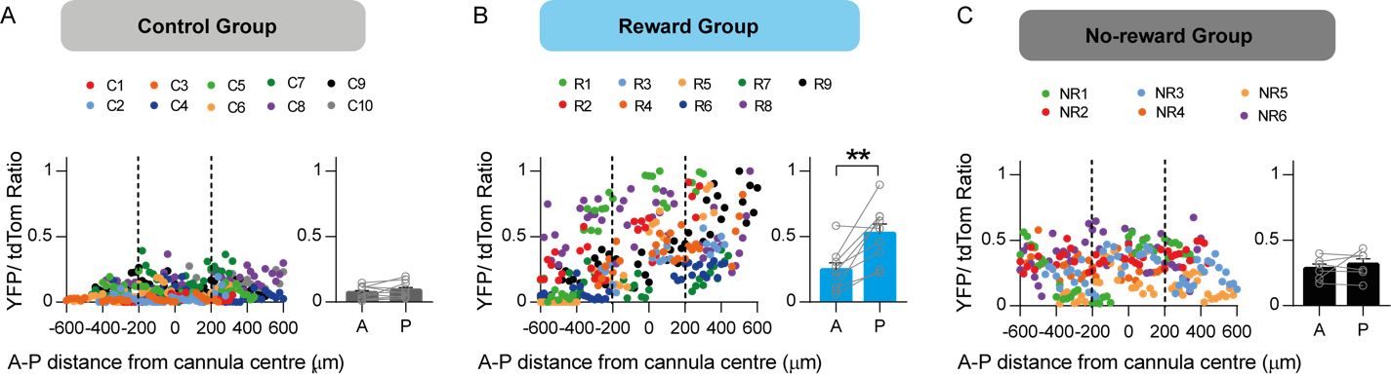
Dispersion plot (left) showing YFP/tdTom ratio in the anterior-posterior (A-P) axis centered to cannula position (0 µm) and average values (right) of the anterior and posterior half of the NAc for (A) control group (anterior, 0.07 ± 0.02; posterior, 0.09 ± 0.02 %; p = 0.25; n = 10 mice), (B) reward group (anterior, 0.25 ± 0.05; posterior, 0.52 ± 0.07 %; p = 0.03; n = 9 mice) and (C) no-reward group (anterior, 0.28 ± 0.04; posterior, 0.32 ± 0.04 %; p = 0.49; n = 6 mice). Each dot shows the YFP/tdTom ratio of an individual 10 µm plane from a specific mouse, separated by different colors. Discontinuous vertical lines indicate limits of the fiber photometry cannula (Ø 400 µm). Note that when aligned to the cannula, the reward group maintained an increased YFP/TdTom ratio in the posterior region of the NAc, demonstrating that ChR2-YFP expression derived from AstroLight labeling is not dependent on cannula position. Two-tailed paired t-test, **: p < 0.01; all error bars express SEM.

Fig. S5. AAV-transfection levels and three-dimensional dispersion maps of AstroLight-tdTom.
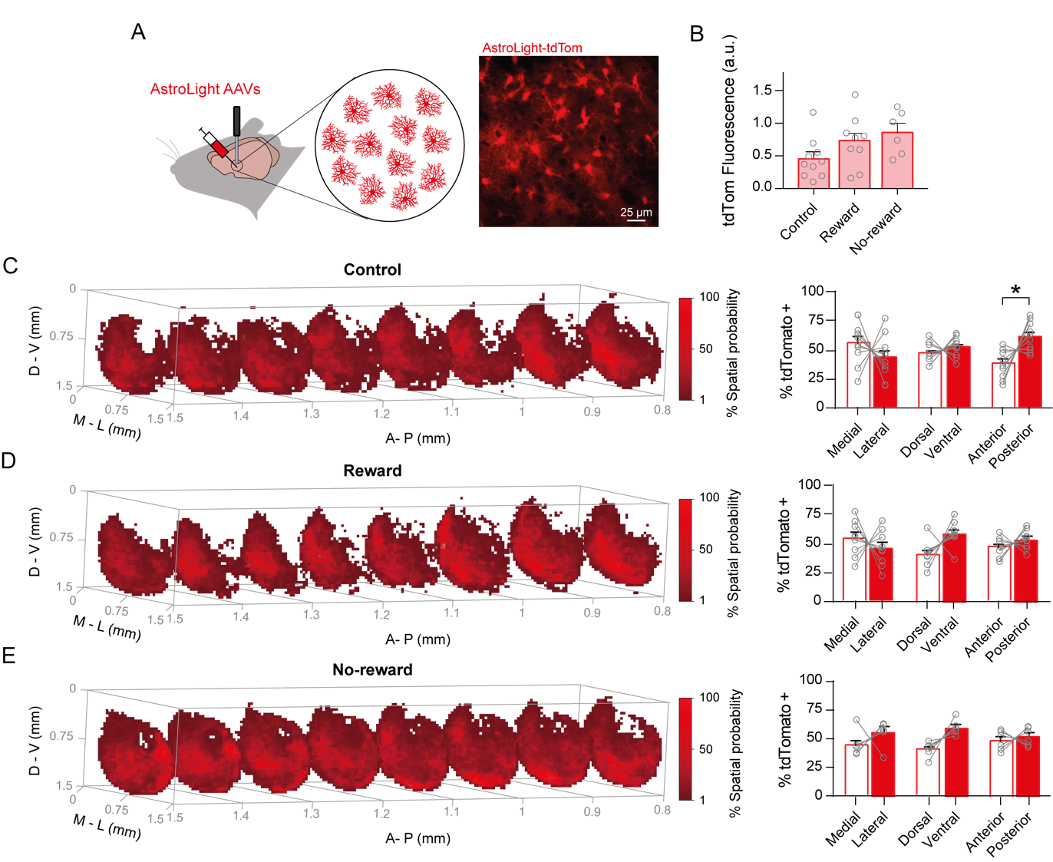
(A) Scheme of the experimental approach (left) showing AstroLight AAV astrocytic transfection and fiber photometry cannula implant in the NAc and representative confocal image (right) of NAc astrocytes expressing AstroLight-tdTom. (B) tdTom fluorescence (a.u.) was quantified at the virus injection site for control group (0.45 ± 0.1 a.u.; 10 mice), reward group (0.72 ± 0.13 a.u.; 9 mice) and no-reward group (0.86 ± 0.14 a.u.; 6 mice). One-way ANOVA (p = 0.08). (C) For the control group, three-dimensional heat map gradient (left) showing the AstroLight-tdTom homogeneous dispersion in the NAc expressed as the tdTom-positive % spatial probability and quantification (right) of the average % tdTom-positive cells across the medial-lateral (M-L; medial, 56.34 ± 5.84 %; lateral, 43.63 ± 5.85 %; p = 0.29), dorsal-ventral (D-V; dorsal, 47.49 ± 2.7 %; ventral, 52.3 ± 2.67 %; p = 0.59) and anterior-posterior (A-P; anterior, 38.45 ± 3.89 %; posterior, 61.3 ± 3.98 %; p = 0.04) axes. Note that while we observed increased tdTom expression in the posterior region of the NAc, this gradient is not reflected in the YFP/tdTom ratio measurements due to a lack of increased ChR2 expression in this region (Fig. 3C and S3A). (D) For the reward group, three-dimensional heat map gradient (left) and average % tdTom-positive cells across the M-L (medial, 54.41 ± 5.08 %; lateral, 45.57 ± 5.06 %; p = 0.46), D-V (dorsal, 41.16 ± 3.51 %; ventral, 58.84 ± 3.51 %; p = 0.09) and A-P (anterior, 46.75 ± 2.7 %; posterior, 53.25 ± 2.7 %; p = 0.46) axes. (E) For the no-reward group, three-dimensional heat map gradient (left) and average % tdTom-positive cells across the M-L (medial, 44.24 ± 4.58 %; lateral, 55.44 ± 4.59 %; p = 0.26), D-V (dorsal, 40.59 ± 2.6 %; ventral, 59.23 ± 2.61 %; p = 0.06) and A-P (anterior, 48.05 ± 3.46 %; posterior, 51.6 ± 3.25 %; p = 0.63) axes. Two-way ANOVA, Holm-Sidak test for multiple comparisons, *: p < 0.05; all error bars express SEM.

Fig. S6. Ex vivo analysis of functionality of AstroLight-derived ChR2.
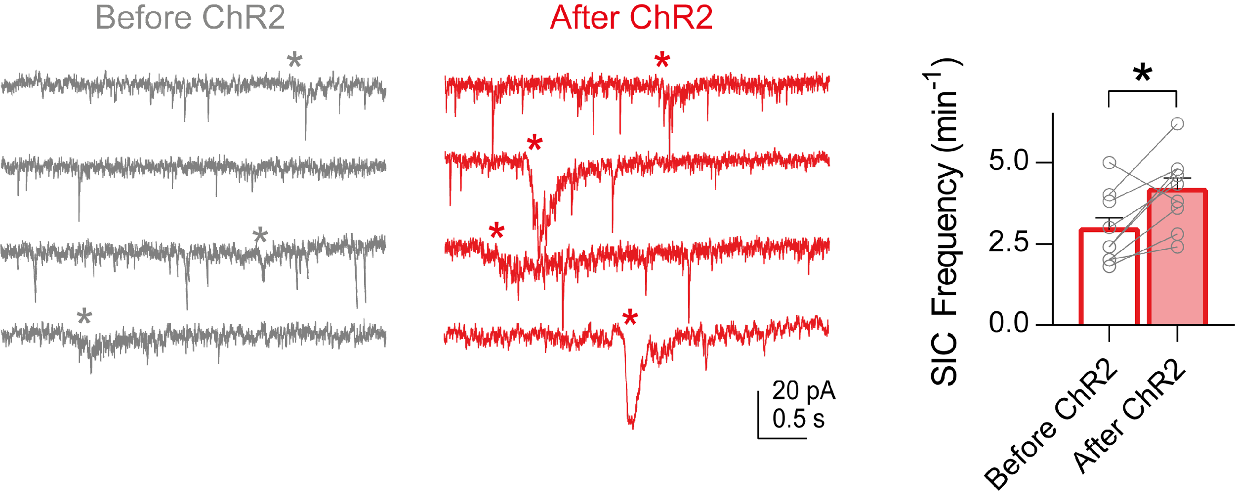

Left, representative traces of NAc neuronal patch-clamp recordings before and after optostimulation of ChR2 in a subset of mice labeled during the operant conditioning behavioral approach. * indicates the presence of slow inward currents (SICs) induced by direct glutamate release from astrocytes. Right, quantification of SIC frequency (min⁻¹) before (2.93 ± 0.37 min⁻¹) and after (4.15 ± 0.38 min⁻¹) astrocyte-ChR2 optostimulation (p = 0.01; n = 9 cells, 2 mice). Two-tailed paired t-test, *: p < 0.05; all error bars express SEM.

Fig. S7. AAV-transfection levels and three-dimensional dispersion map of GFAP-ChR2.
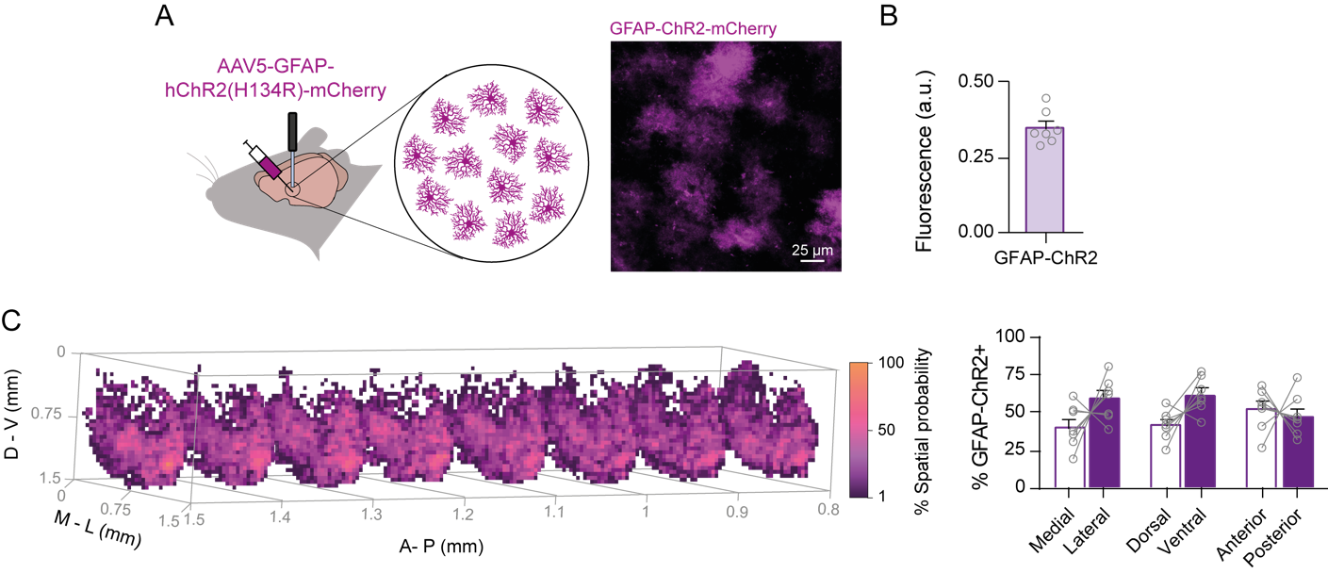
(A) Scheme of the experimental approach (left) showing AAV5-GFAP-hChR2(H134R)-mCherry astrocytic transfection and fiber photometry cannula implantation in the NAc and representative confocal image (right) of NAc astrocytes expressing GFAP-ChR2-mCherry. (B) Fluorescence (a.u.) quantified at the virus injection site (0.35 ± 0.02 a.u.; 7 mice). (C) Three-dimensional heat map gradient (left) showing the GFAP-ChR2-mCherry homogeneous dispersion in the NAc expressed as the mCherry-positive % spatial probability and quantification (right) of the average % mCherry across the medial-lateral (M-L; medial, 40.97 ± 5.42 %; lateral, 59.03 ± 5.42 %; p = 0.17), dorsal-ventral (D-V; dorsal, 41.61 ± 3.79 %; ventral, 62.01 ± 4.46 %; p = 0.16) and anterior-posterior (A-P; anterior, 55.63 ± 6.67 %; posterior, 47.99 ± 5.33 %; p = 0.46) axes. Two-way ANOVA, Holm-Sidak test for multiple comparisons; all error bars express SEM.

