Supplementary information

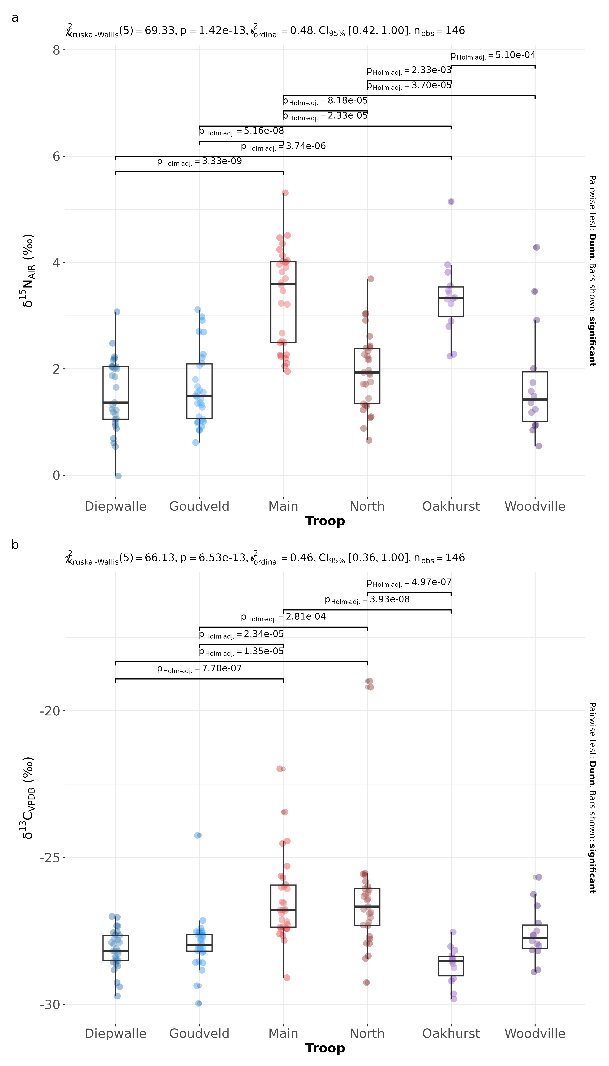Fig. 5: Kruskal-Wallis tests for (a) nitrogen and (b) carbon including Dunn post-hoc tests comparing the six total subsites within the Campus (Main and North), Hoekwil (Oakhurst and Woodville) and Knysna (Goudveld and Diepwalle).

