Supplementary Information for:
Sex effects on DNA methylation affect discovery in epigenome wide association study of schizophrenia

Markos Tesfaye, MD, PhD‡ ^{* 1, 2}, Leticia M. Spindola, PhD‡ ^{2, 3}, Anne-Kristin Stavrum, PhD^{2, 3}, Alexey Shadrin, PhD,^{1, 4} Ingrid Melle MD, PhD³, Ole A. Andreassen, MD, PhD^{1,4} and Stephanie Le Hellard, PhD* ^{2, 3}

Page 2 Figure S1: Manhattan plot of DNA methylation loci association with schizophrenia in a meta-analysis of male-only samples.
Page 3 Figure S2: Manhattan plot of DNA methylation loci association with schizophrenia in a meta-analysis of female-only samples.
Page 4 Figure S3: Manhattan plot of DNA methylation loci association with schizophrenia in sex-stratified meta-analysis.
Page 5 Figure S4: Manhattan plot of DNA methylation loci association with schizophrenia in sex-adjusted meta-analysis.
Page 6 Figure S5: Venn diagram showing the number of overlapping top 200 differentially methylated loci in female-only, male-only, sex-stratified, and sex-adjusted meta-analyses.
Page 7 Figure S6: QQ plots of sex-stratified and sex-adjusted meta-analyses of EWAS of schizophrenia. A – ABR, UCL, IoPPN and TOP cohorts. B – ABR, UCL and IoPPN cohorts.
Page 8 Table S16: Polymethylation risk score prediction model comparison metrics and statistics. Models were compared within target datasets.

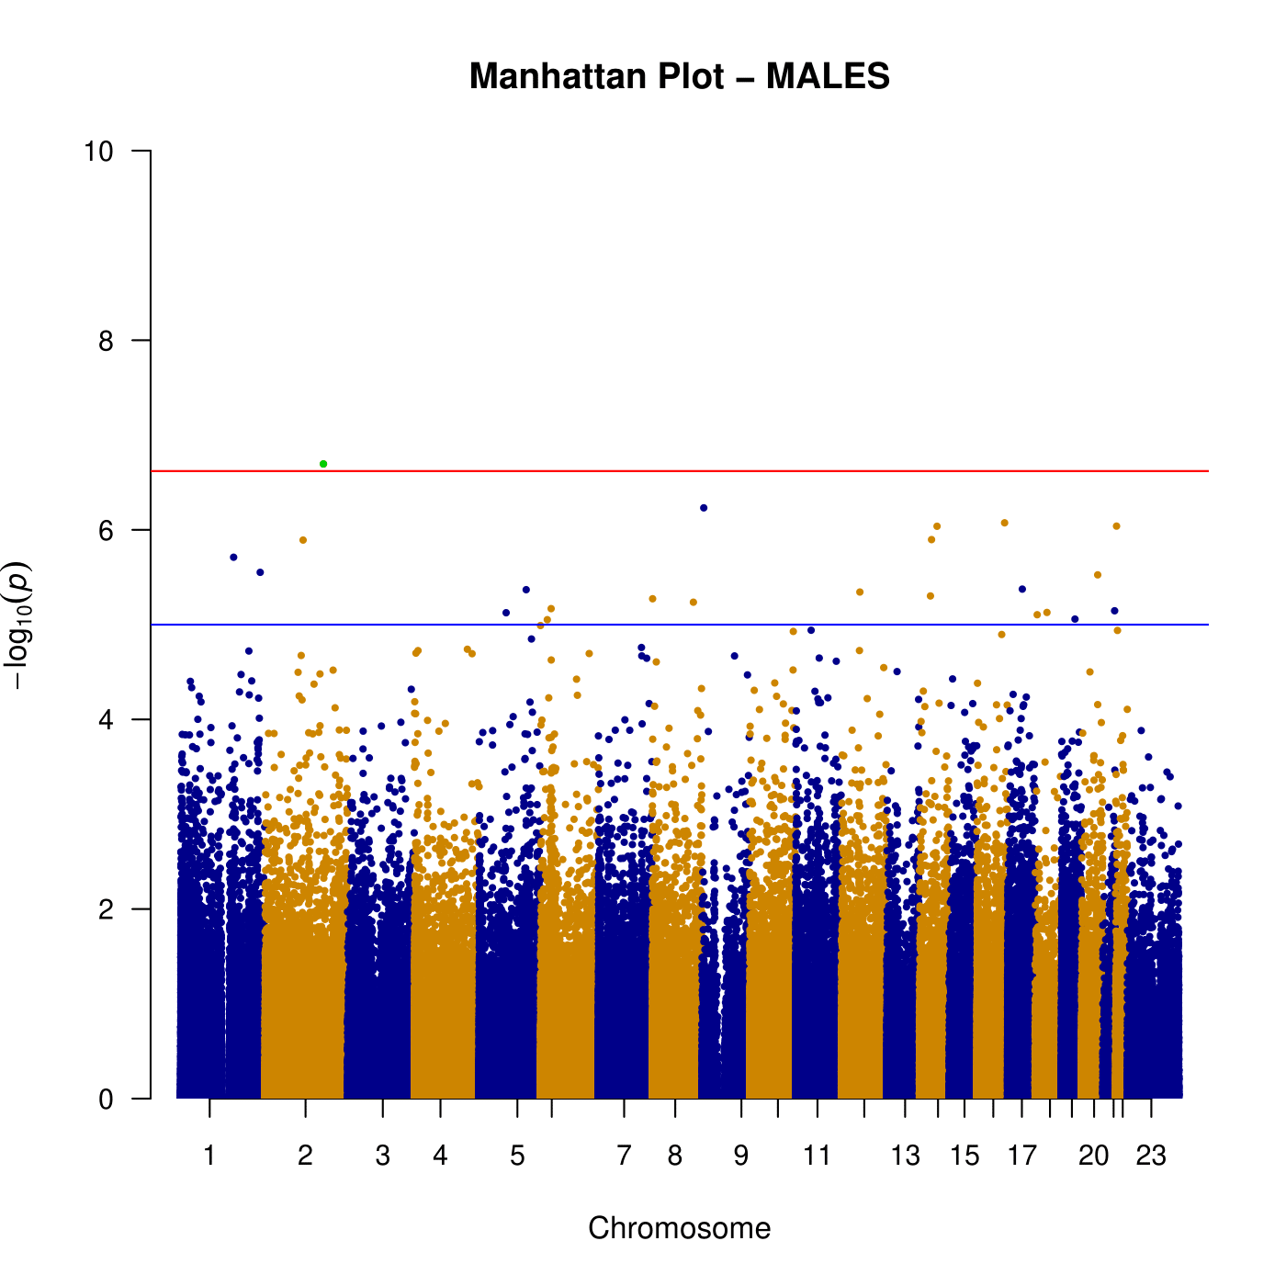
Figure S1: Manhattan plot of DNA methylation loci association with schizophrenia in a meta-analysis of male-only samples.

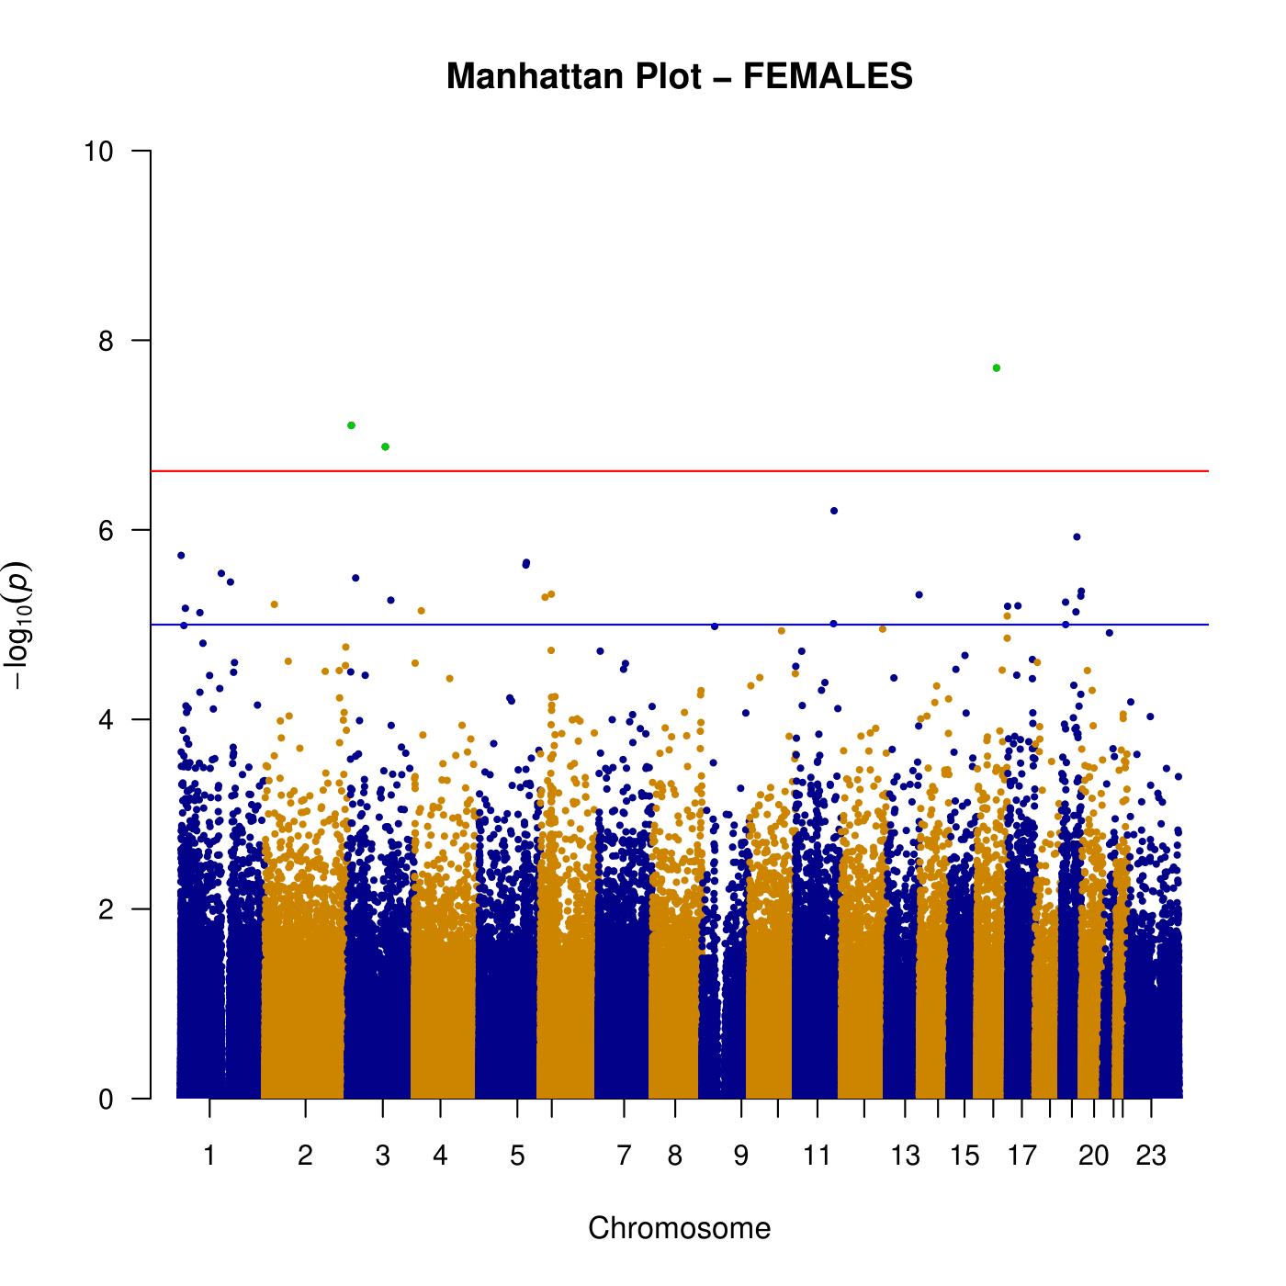
Figure S2: Manhattan plot of DNA methylation loci association with schizophrenia in a meta-analysis of female-only samples.

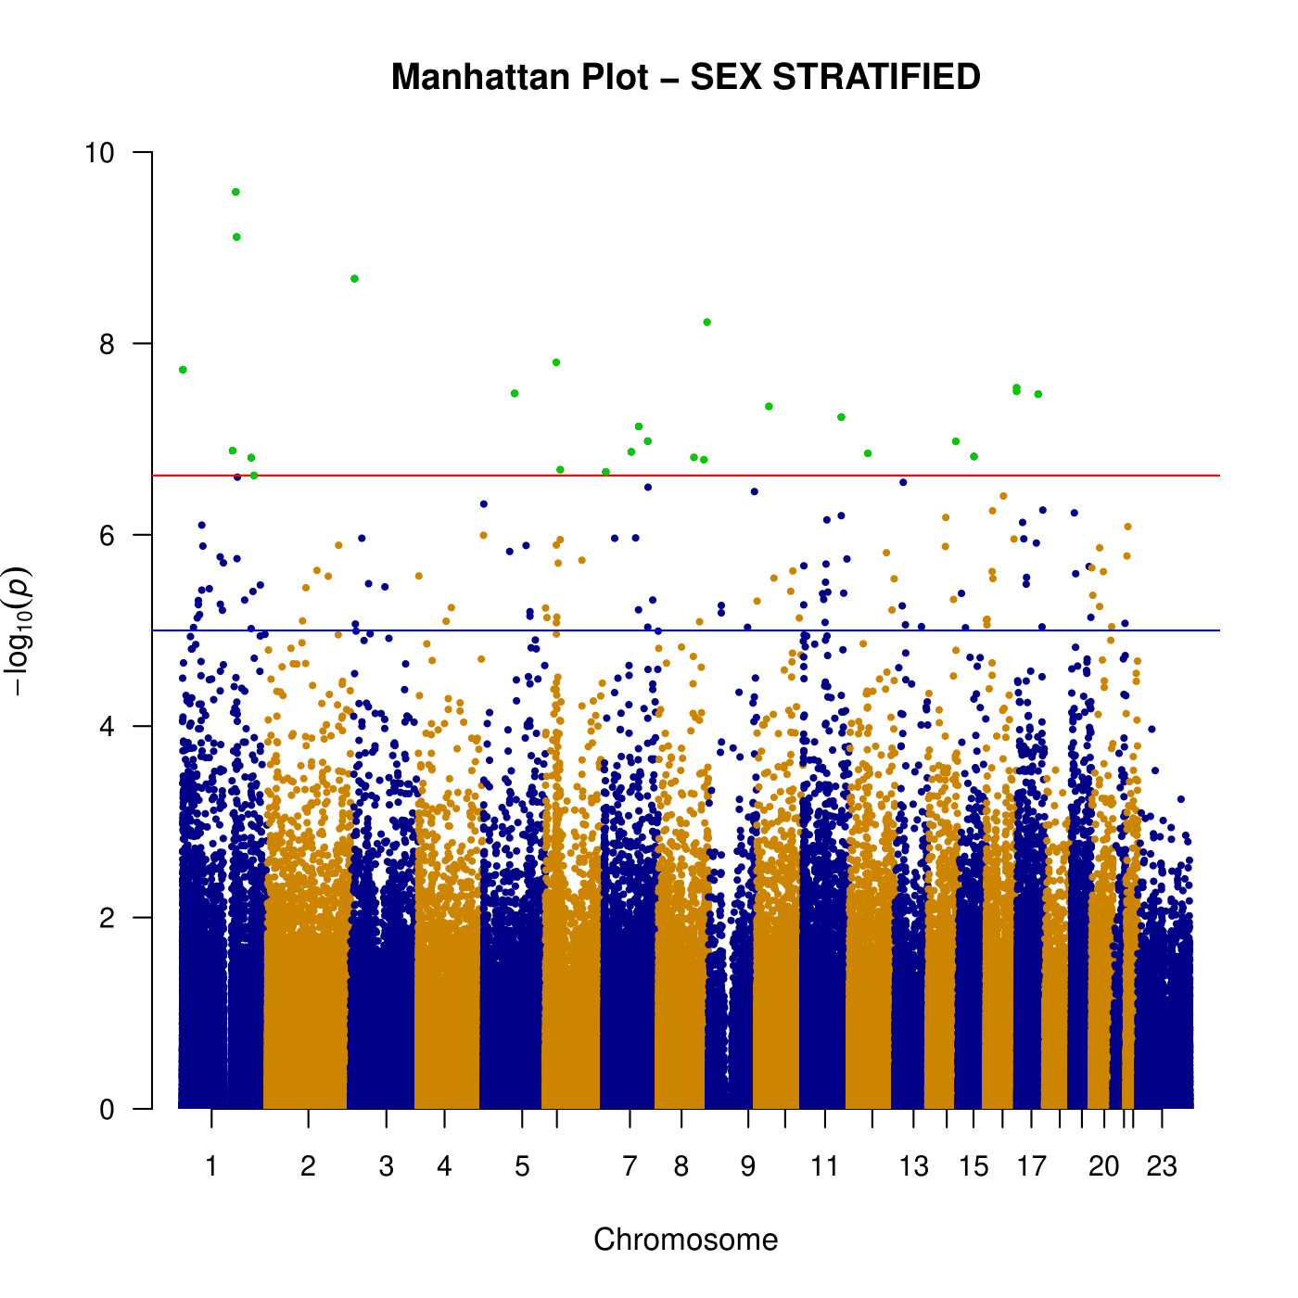
Figure S3: Manhattan plot of DNA methylation loci association with schizophrenia in sex-stratified meta-analysis.

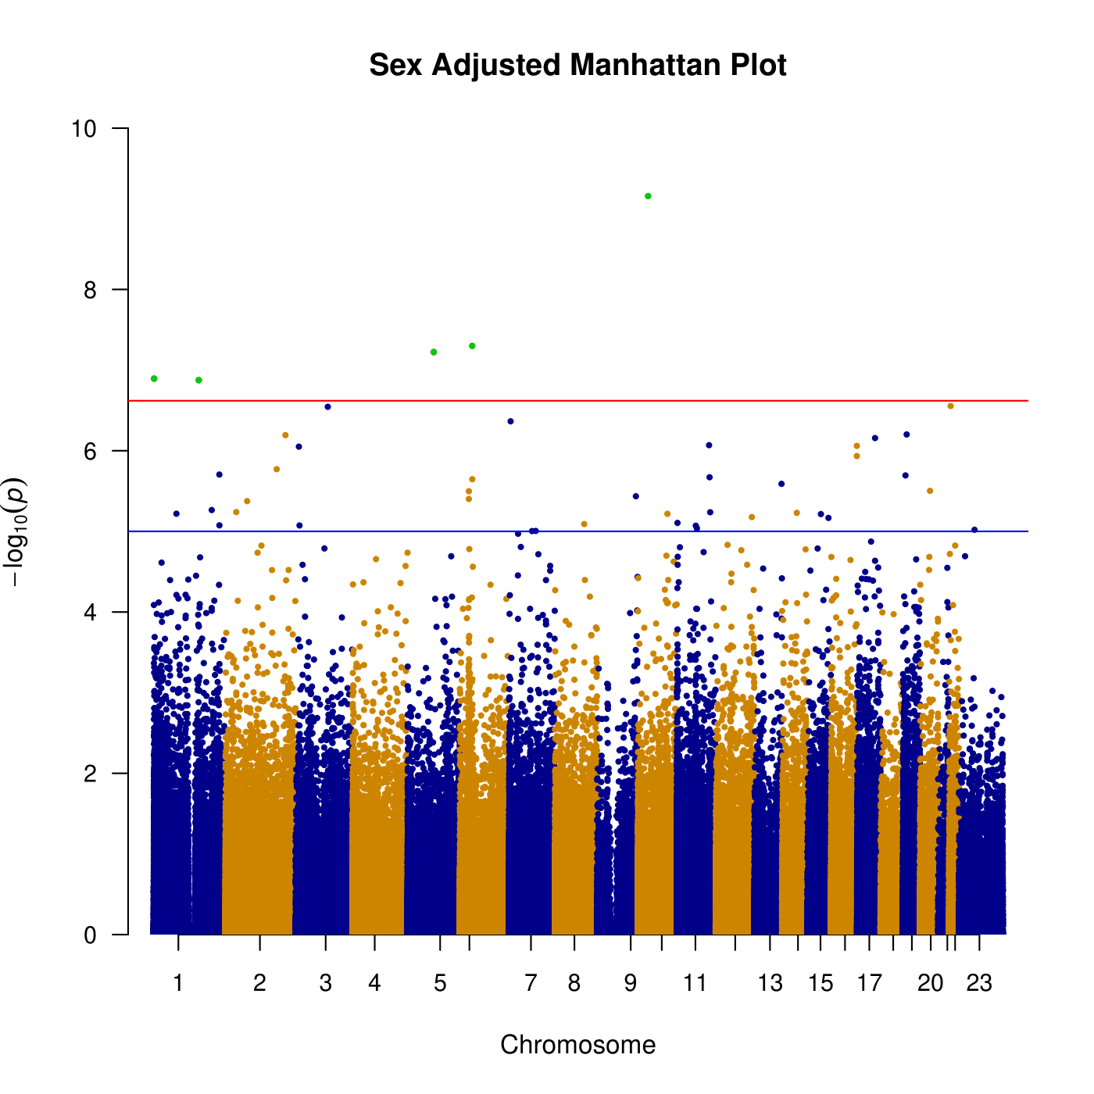
Figure S4: Manhattan plot of DNA methylation loci association with schizophrenia in sex-adjusted meta-analysis.
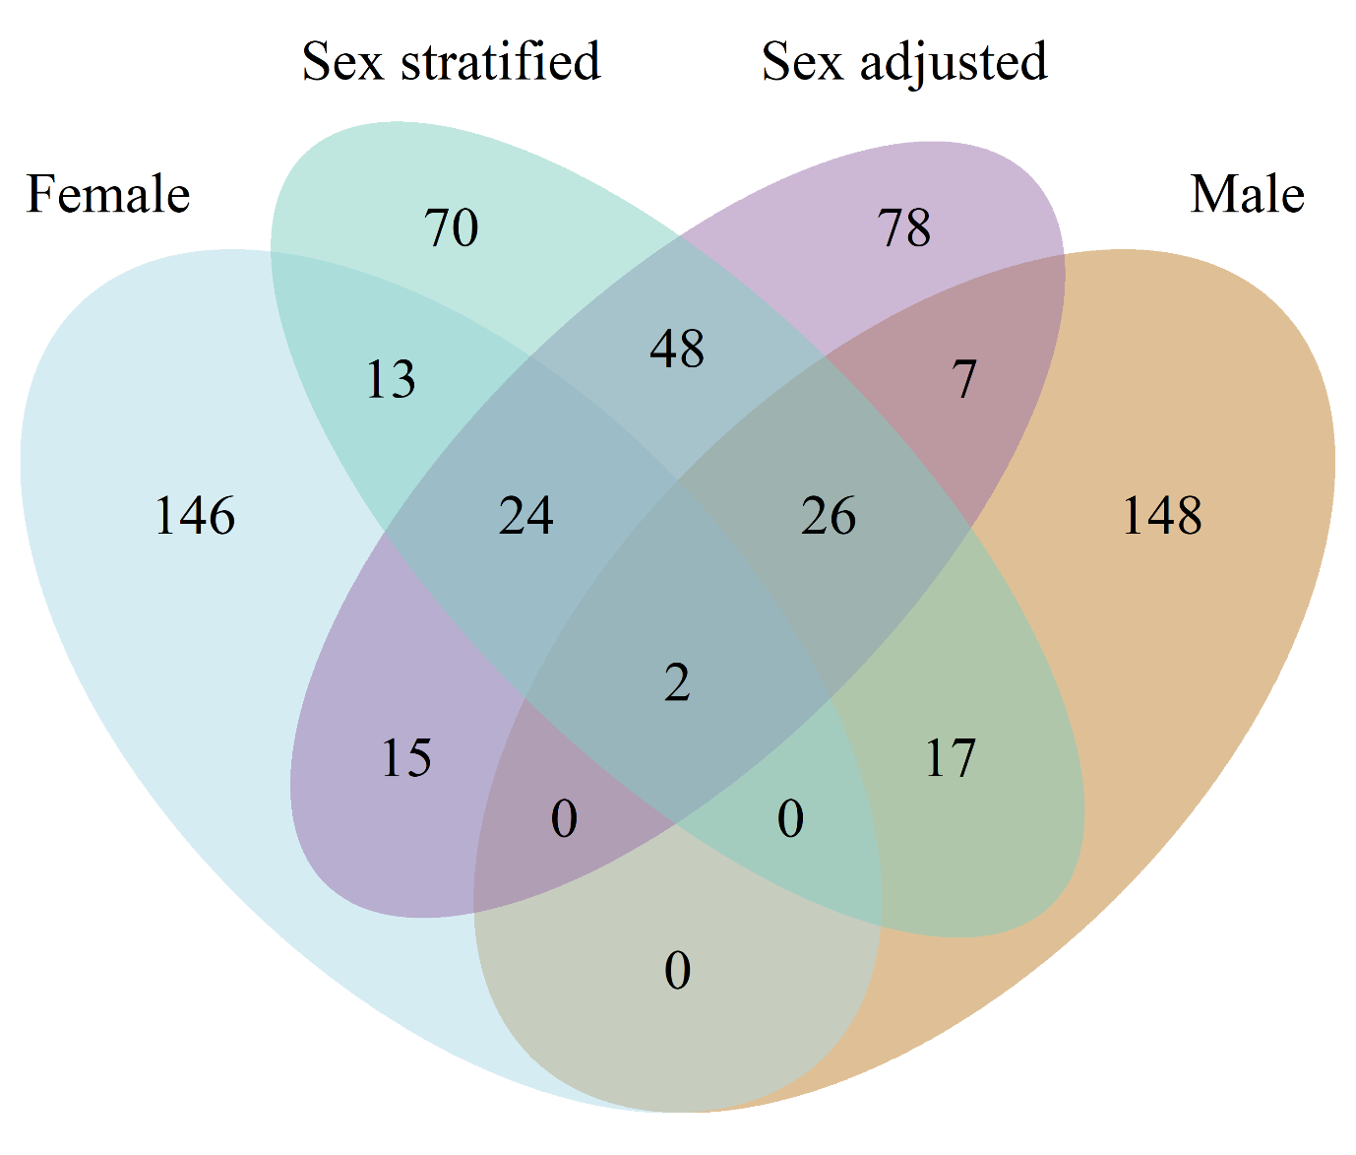
Figure S5: Venn diagram showing the number of overlapping top 200 differentially methylated loci in female-only, male-only, sex-stratified, and sex-adjusted meta-analyses.

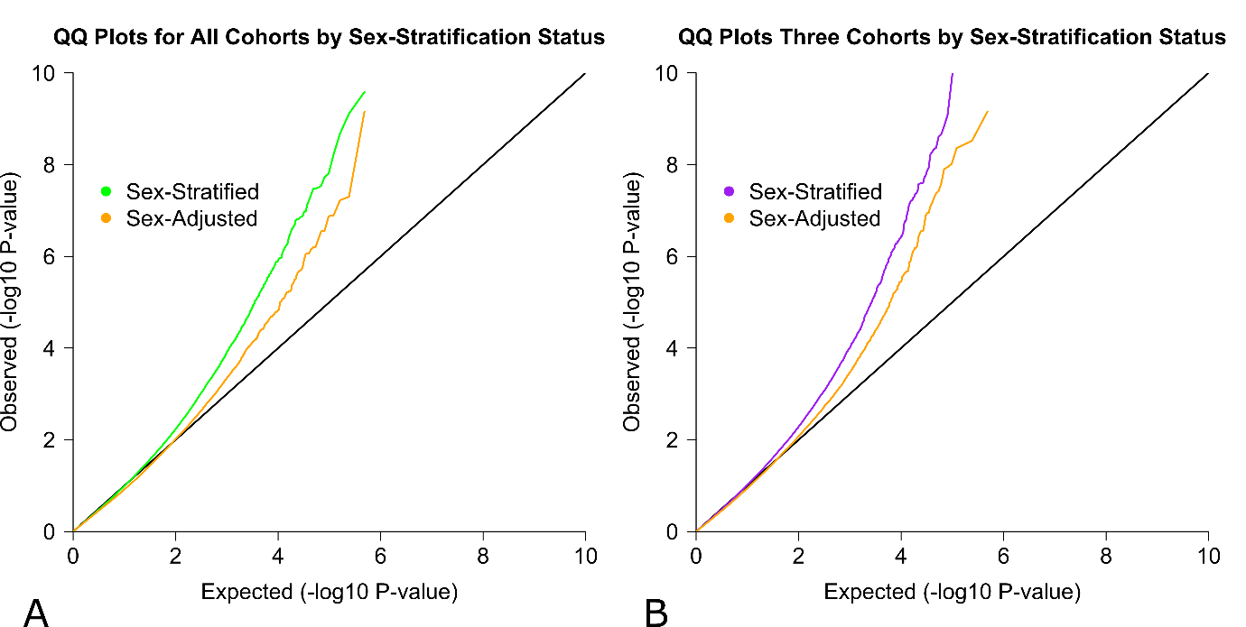
Figure S6: QQ plots of sex-stratified and sex-adjusted meta-analyses of EWAS of schizophrenia. A – ABR, UCL, IoPPN and TOP cohorts. B – ABR, UCL and IoPPN cohorts.

Table S16: Polymethylation risk score prediction model comparison metrics and statistics. Models were compared within target datasets.
Target dataset | Training dataset | AIC | BIC
TOP total sample | Sex-stratified | 1610.35 | 1620.57
TOP total sample | Sex-adjusted | 1616.09 | 1626.32
TOP total sample | Sex-specific female | 1616.33 | 1626.55
TOP total sample | Sex-specific male | 1618.92 | 1629.14
TOP male-only | Sex-stratified | 904.53 | 913.58
TOP male-only | Sex-adjusted | 906.56 | 915.61
TOP male-only | Sex-specific female | 905.19 | 914.24
TOP male-only | Sex-specific male | 906.54 | 915.59
TOP female-only | Sex-stratified | 716.29 | 724.89
TOP female-only | Sex-adjusted | 715.33 | 723.93
TOP female-only | Sex-specific female | 715.67 | 724.27
TOP female-only | Sex-specific male | 721.88 | 730.48
 | Model comparison | z-statistics | p-value
TOP total sample | Sex-stratified vs. Sex-adjusted | 1.801 | 0.036
TOP total sample | Sex-stratified vs. Sex-specific female | 0.954 | 0.170
TOP total sample | Sex-stratified vs. Sex-specific male | 1.495 | 0.067
TOP total sample | Sex-adjusted vs. Sex-specific female | 0.039 | 0.484
TOP total sample | Sex-adjusted vs. Sex-specific male | 0.577 | 0.282
TOP total sample | Sex-specific female vs. Sex-specific male | 0.336 | 0.368
TOP male-only | Sex-stratified vs. Sex-adjusted | 1.123 | 0.131
TOP male-only | Sex-stratified vs. Sex-specific female | 0.210 | 0.417
TOP male-only | Sex-stratified vs. Sex-specific male | 0.662 | 0.254
TOP male-only | Sex-adjusted vs. Sex-specific female | -0.428 | 0.334
TOP male-only | Sex-adjusted vs. Sex-specific male | -0.009 | 0.496
TOP male-only | Sex-specific female vs. Sex-specific male | 0.322 | 0.374
TOP female-only | Sex-stratified vs. Sex-adjusted | -0.425 | 0.335
TOP female-only | Sex-stratified vs. Sex-specific female | -0.138 | 0.445
TOP female-only | Sex-stratified vs. Sex-specific male | 1.440 | 0.075
TOP female-only | Sex-adjusted vs. Sex-specific female | 0.067 | 0.473
TOP female-only | Sex-adjusted vs. Sex-specific male | 1.551 | 0.060
TOP female-only | Sex-specific female vs. Sex-specific male | 1.118 | 0.132
AIC: Akaike Information Criterion; BIC: Bayesian Information Criterion; z-statistics and p-values derived from Vuong non-nested hypothesis test. The lowest AIC and BIC values are highlighted in bold.

