Additional Documents supporting the manuscript:
Chapter 1: Selection of solid food waste as medium of fermentation for synthesis of enzyme Tannase:
Table 1.- Optical Density vs. Concentration (mg/L) for standard Gallic acid curve.
SAMPLE | OPTICAL DENSITY | CONCENTRATION (mg/l)
1 | 0.018 | 0.1
2 | 0.048 | 0.25
3 | 0.096 | 0.5
4 | 0.144 | 0.75
5 | 0.192 | 1.00

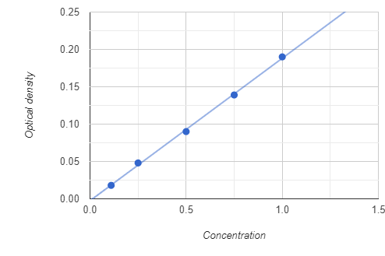
Figure 1. optical density vs concentration (mg/l) of Standard Gallic acid
The figure obtained from the table 1 is described here, from which we can determine the best enzyme activity among various food wastes.
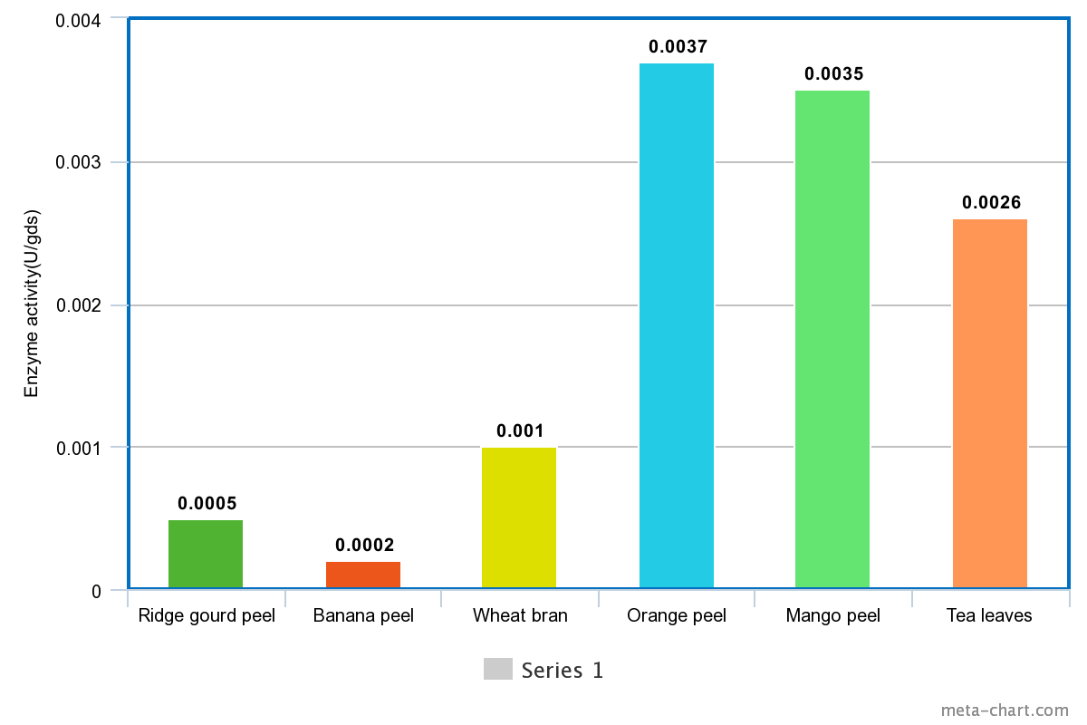
Figure 2. Productivity of Tannase(U/gds) by SSF of food wastes.
3. Chapter 2: Optimization of fermentation condition by OVAT methodology.
All the figures which are obtained from OVAT methodology have communicated her, supporting the tables that are obtained from the experiment.
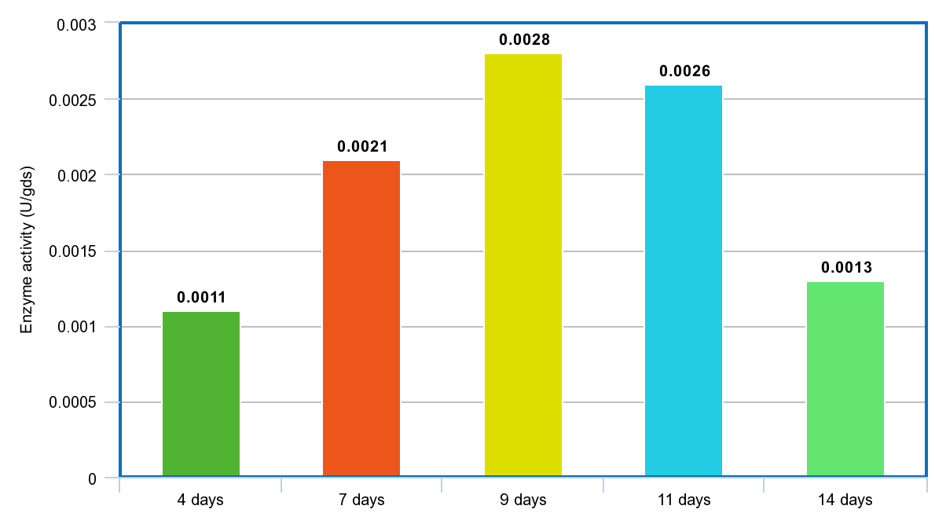 Figure 3 Tannase activity over a range of time period of SSF. (Time Factor)
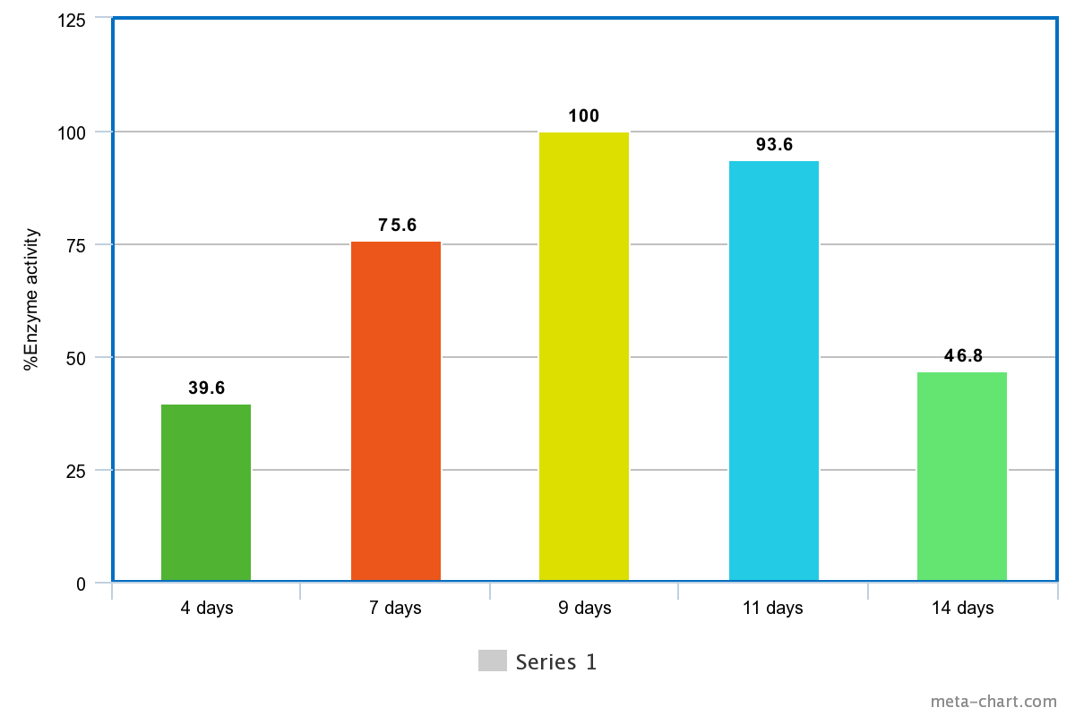
Fig 4. Tannase enzyme production (%) over a range of time period of SSF. (Time Factor).
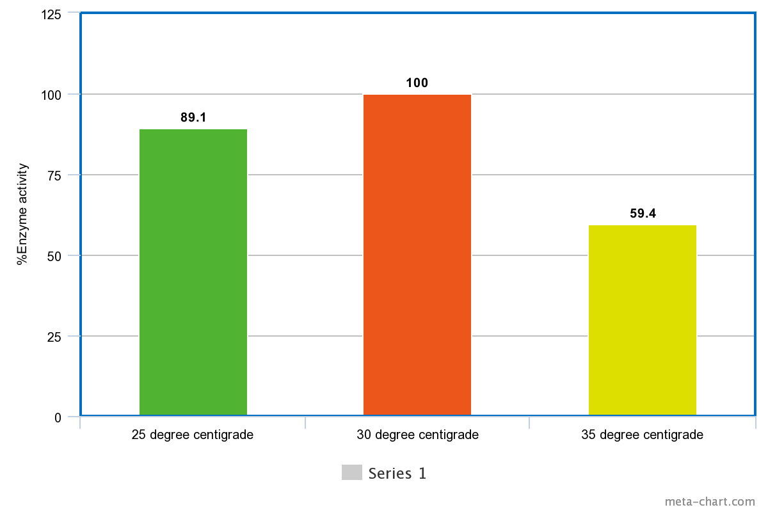
Fig 5. Activity of Tannase(%) at different temperatures of SSF. (Temperature factor)
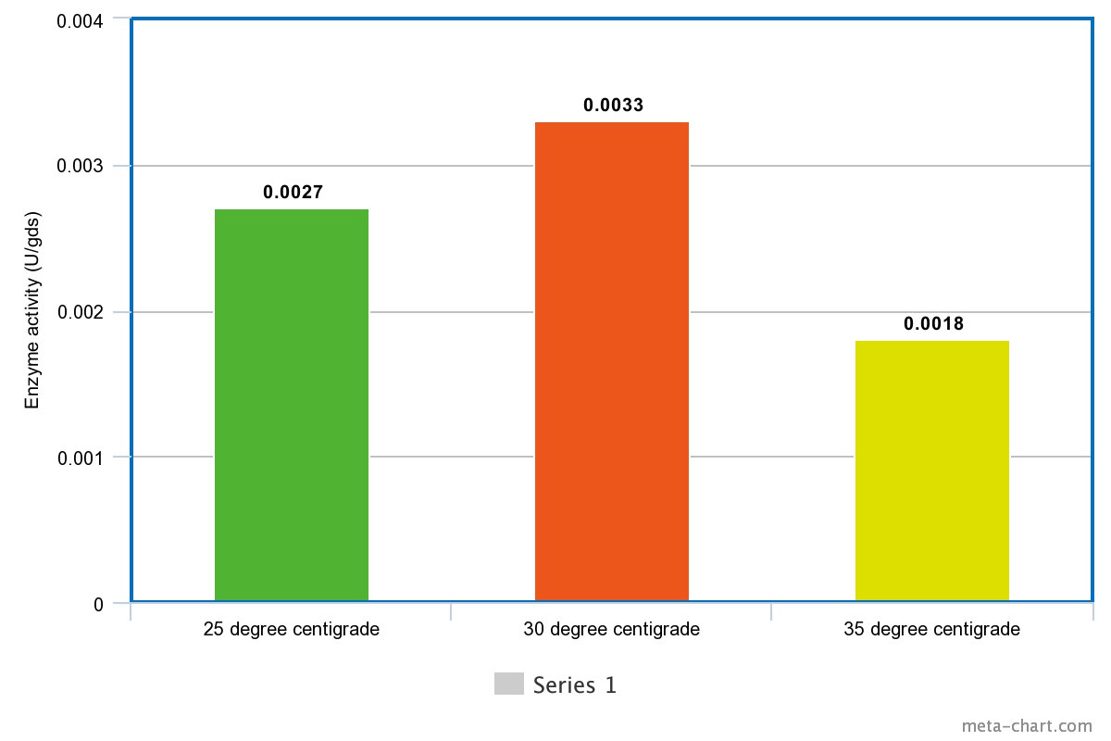
Fig 6. Adequacy of incubation temperature for exhibition of tannase (U/gds) by SSF (Temperature factor)
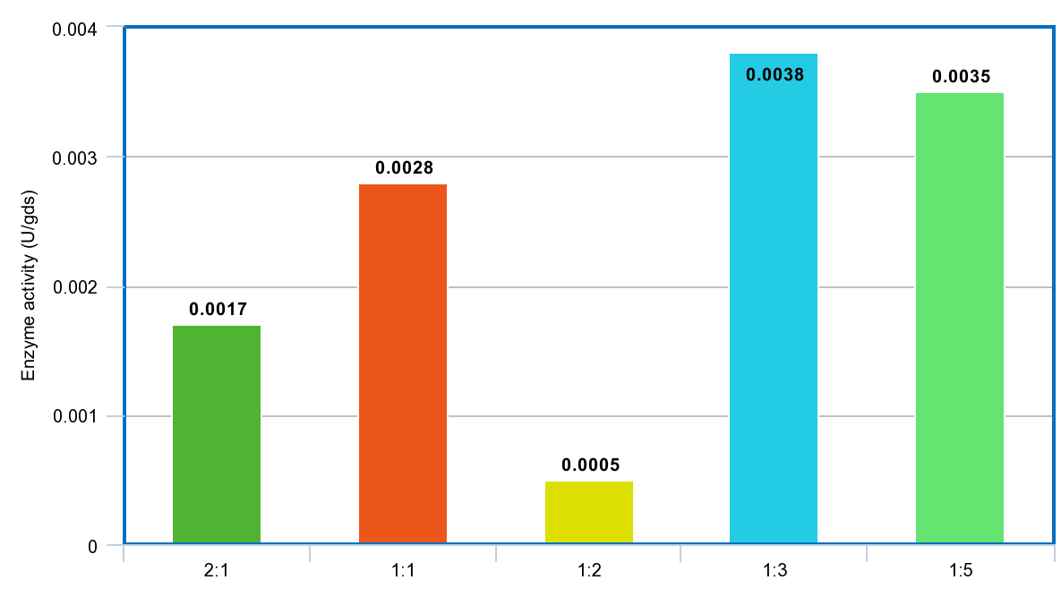
Fig 7. Efficacy of hydration of waste on preparation of Tannase (u/gds) by SSF. (Hydration ratio)
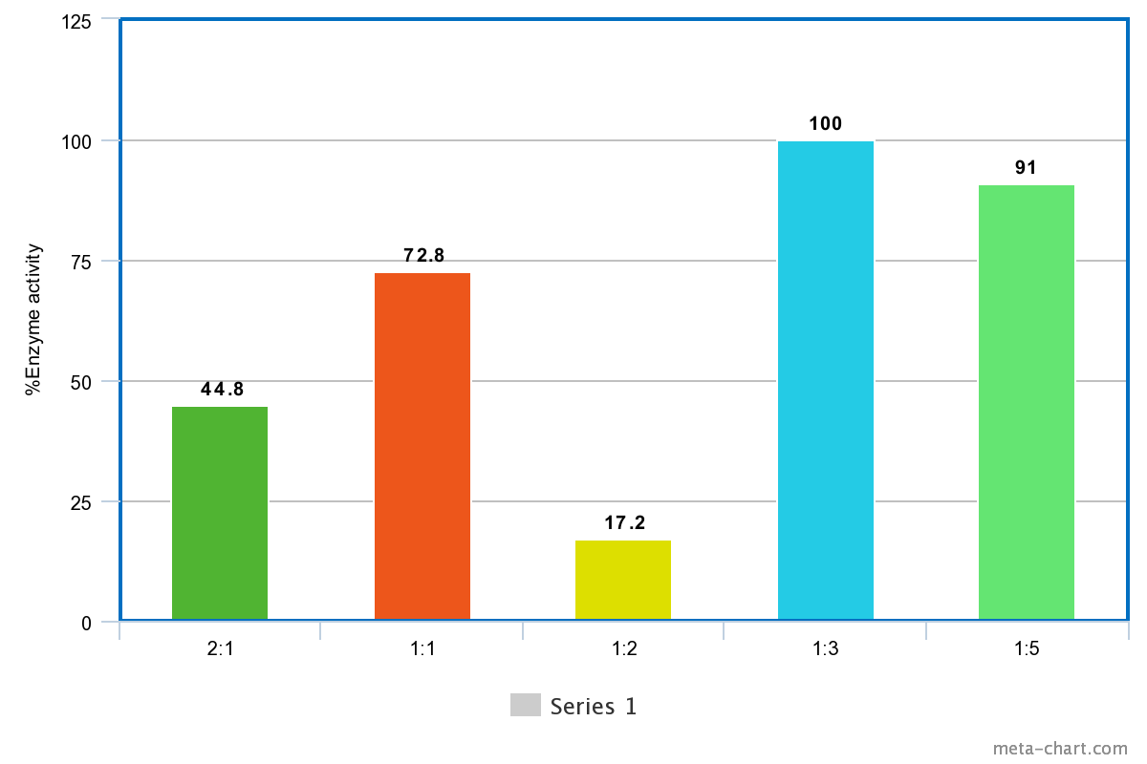
Fig 8. Effectiveness of hydration of substrate on Tannase formation (%) by SSF (Hydration ratio)
Chapter 3: Statistical optimization of tannase enzyme by Response Surface Methodology:
All the other model and graphs that had been obtained from response surface methodology which are not communicated in the manuscript are d
Results and discussion:
Table 2. Model summary using three factorial model:
i. For Considering factors:
Factor | Name | Units | Type | SubType | Minimum | Maximum | Coded Low | Coded High | Mean | Std. Dev.
A | Time | Days | Numeric | Continuous | 8.00 | 10.00 | -1 ↔ 8.00 | +1 ↔ 10.00 | 9.00 | 0.7071
B | Temaperature | Degree centigrade | Numeric | Continuous | 26.00 | 34.00 | -1 ↔ 26.00 | +1 ↔ 34.00 | 30.00 | 2.83
C | Hydration ratio | % | Numeric | Continuous | 40.00 | 60.00 | -1 ↔ 40.00 | +1 ↔ 60.00 | 50.00 | 7.07
ii. For obtaining Responses:
Response | Name | Units | Observations | Minimum | Maximum | Mean | Std. Dev. | Ratio
R1 | Enzyme activity | U/gds | 17.00 | 2E-05 | 0.0053 | 0.0025 | 0.0017 | 265.00

Table 3. Model analysis using Lack of Fit test:
Response 1: Enzyme activity
Source | Sequential p-value | Lack of Fit p-value | Adjusted R² | Predicted R²
Linear | 0.9607 |  | -0.2040 | -0.9893
2FI | 0.9311 |  | -0.5003 | -3.5747
Quadratic | 0.0048 |  | 0.6259 | -1.6190 | Suggested
Cubic |  |  | 1.0000 |  | Aliased

Table 4. Model analysis using ANOVA test:
Response 1: Enzyme activity
Source | Sum of Squares | df | Mean Square | F-value | p-value
Model | 0.0000 | 9 | 4.508E-06 | 3.97 | 0.0412 | significant
A-Time | 2.205E-08 | 1 | 2.205E-08 | 0.0194 | 0.8930
B-Temaperature | 7.200E-07 | 1 | 7.200E-07 | 0.6347 | 0.4518
C-Hydration ratio | 3.120E-07 | 1 | 3.120E-07 | 0.2751 | 0.6161
AB | 1.562E-06 | 1 | 1.562E-06 | 1.38 | 0.2789
AC | 1.024E-07 | 1 | 1.024E-07 | 0.0903 | 0.7726
BC | 3.025E-07 | 1 | 3.025E-07 | 0.2667 | 0.6215
A² | 1.074E-06 | 1 | 1.074E-06 | 0.9465 | 0.3630
B² | 9.223E-06 | 1 | 9.223E-06 | 8.13 | 0.0246
C² | 0.0000 | 1 | 0.0000 | 25.19 | 0.0015
Residual | 7.941E-06 | 7 | 1.134E-06
Lack of Fit | 7.941E-06 | 3 | 2.647E-06
Pure Error | 0.0000 | 4 | 0.0000
Cor Total | 0.0000 | 16
Factor coding is Coded.
Sum of squares is Type III - Partial
The Model F-value of 3.97 implies the model is significant. There is only a 4.12% chance that an F-value this large could occur due to noise.
P-values less than 0.0500 indicate model terms are significant. In this case B², C² are significant model terms. Values greater than 0.1000 indicate the model terms are not significant. If there are many insignificant model terms (not counting those required to support hierarchy), model reduction may improve your model.

- Obatined Diagonstics graphs supporting the model:
We had used Linear regression model to analyze the responses using three factorial model of response surface methodology. The diagonised datas and graphs were obtained using the Design expert tool, which were attached below:
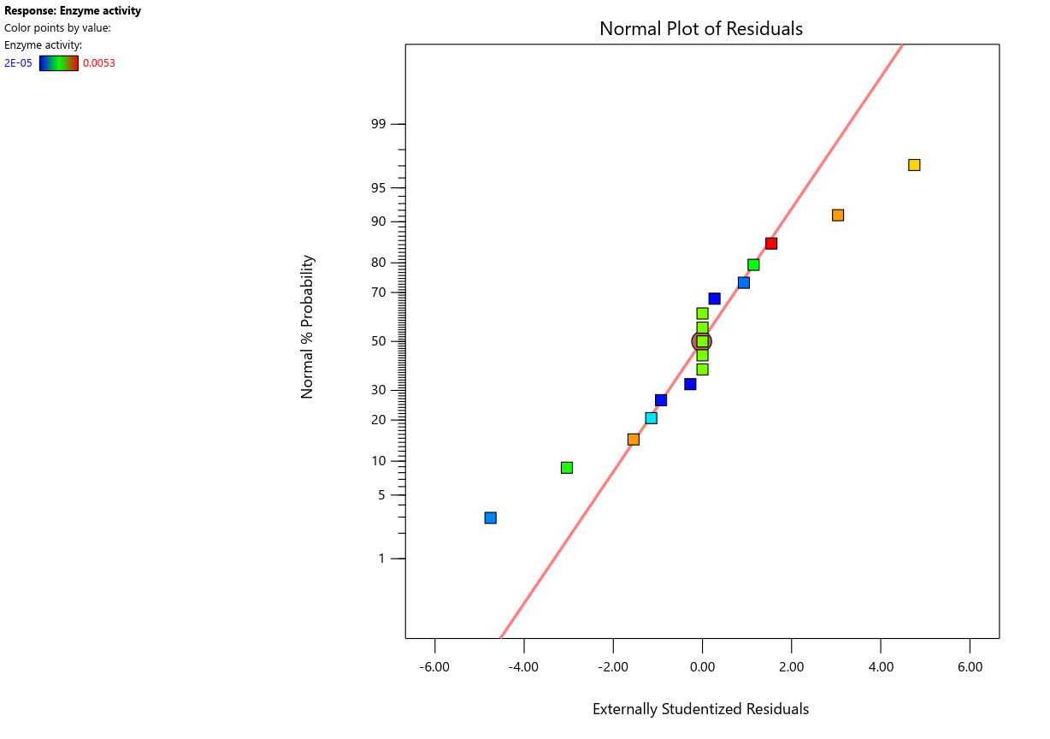
Figure 9. Normal plot of residuals
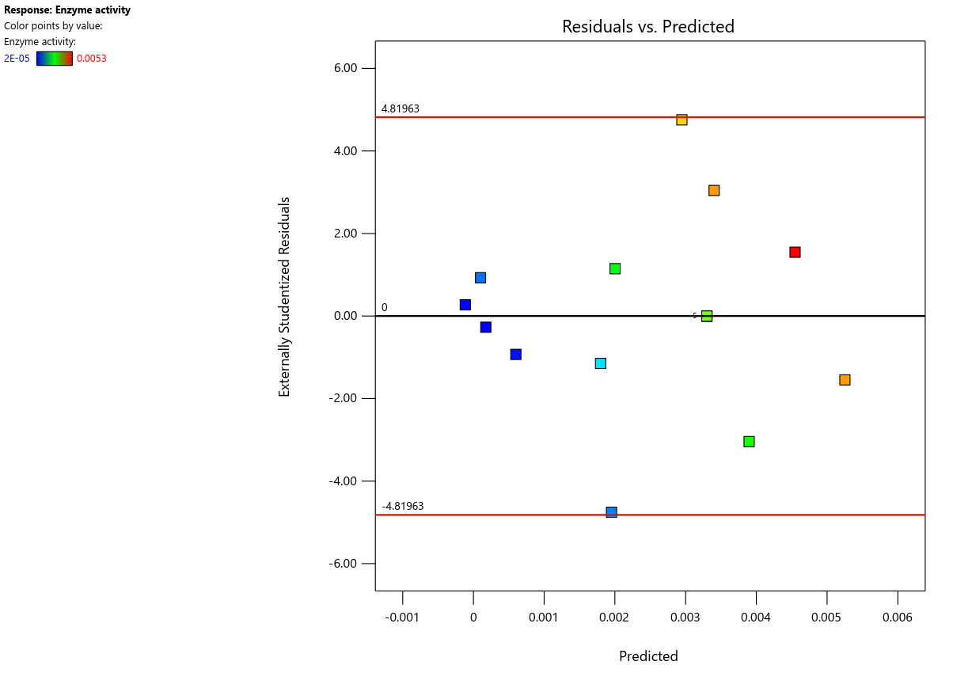
Fig 10. Residuals vs. Predicted
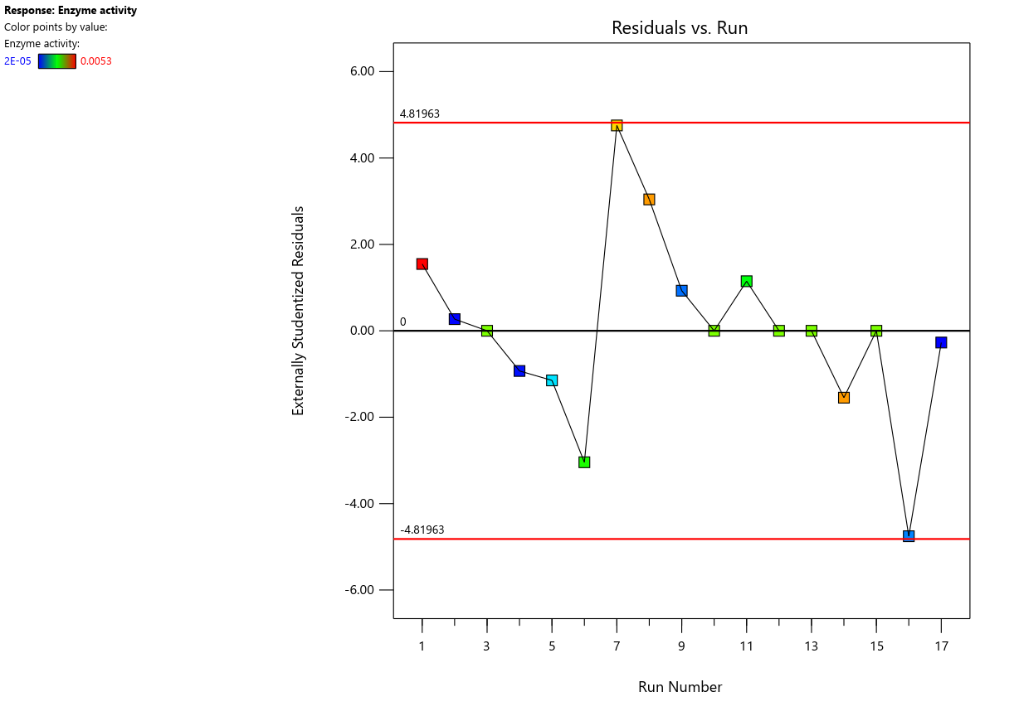
Fig 11. Residuals vs. Run
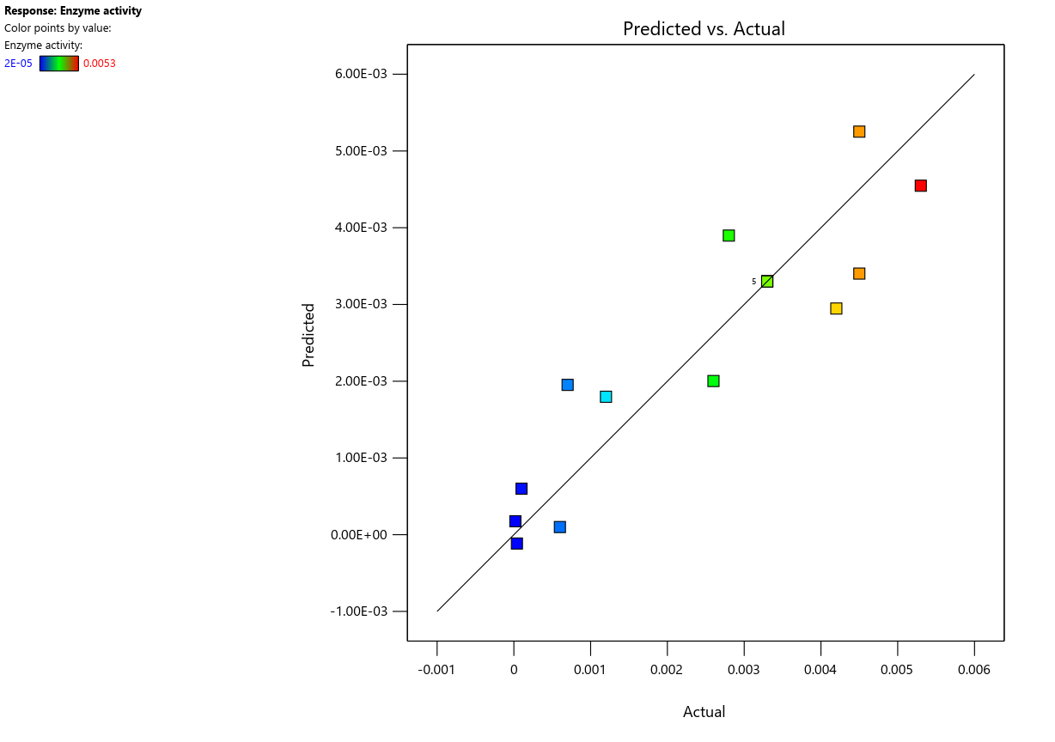
Figure 12. Predicted vs. Actual
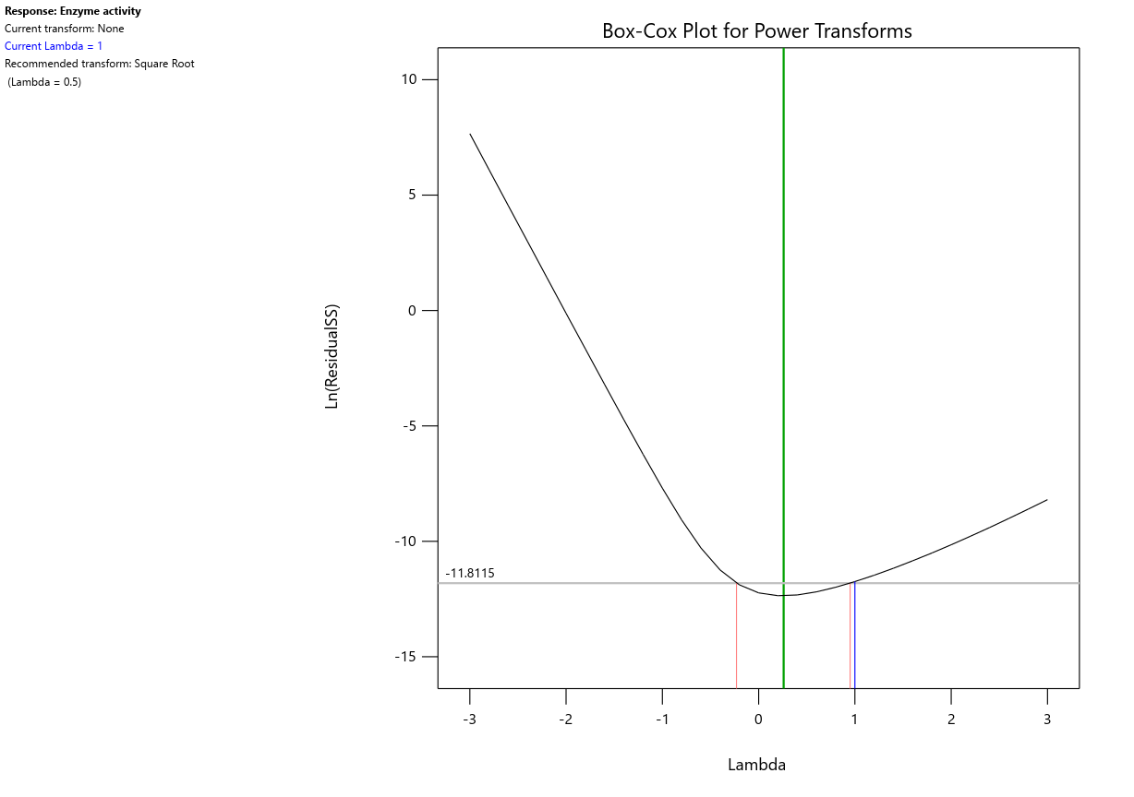
Figure 13. Box-Cox plot for power transforms
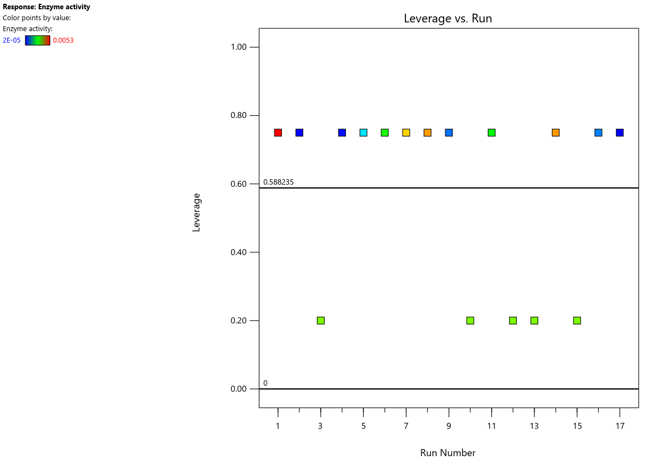
Figure 14. Leverage vs. Run
- Model graphs obtained from the linear regression analysis:
Only Perturbation test is communicated in the manuscript. Along with perturbation test there are other two models that can be obtained from linear regression analysis while performing Response surface methodology. Those two models are communicated here.
- Profiller model:
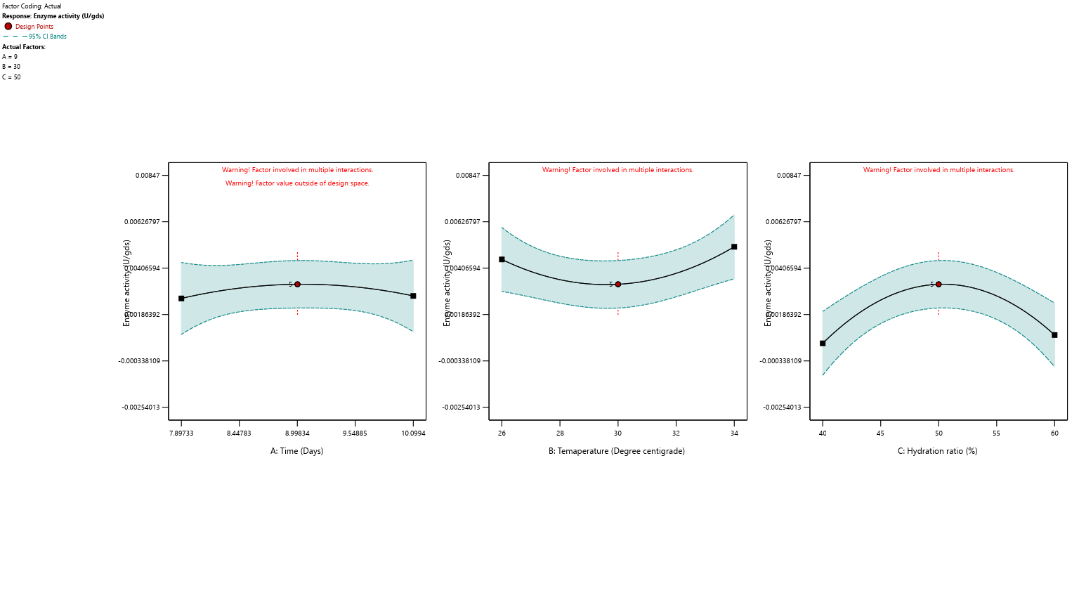Figure 15. Profiller model graphs for three factors: A. Time(days), B. Temperature (degree centigrade), C. hydratyion ratio (%)
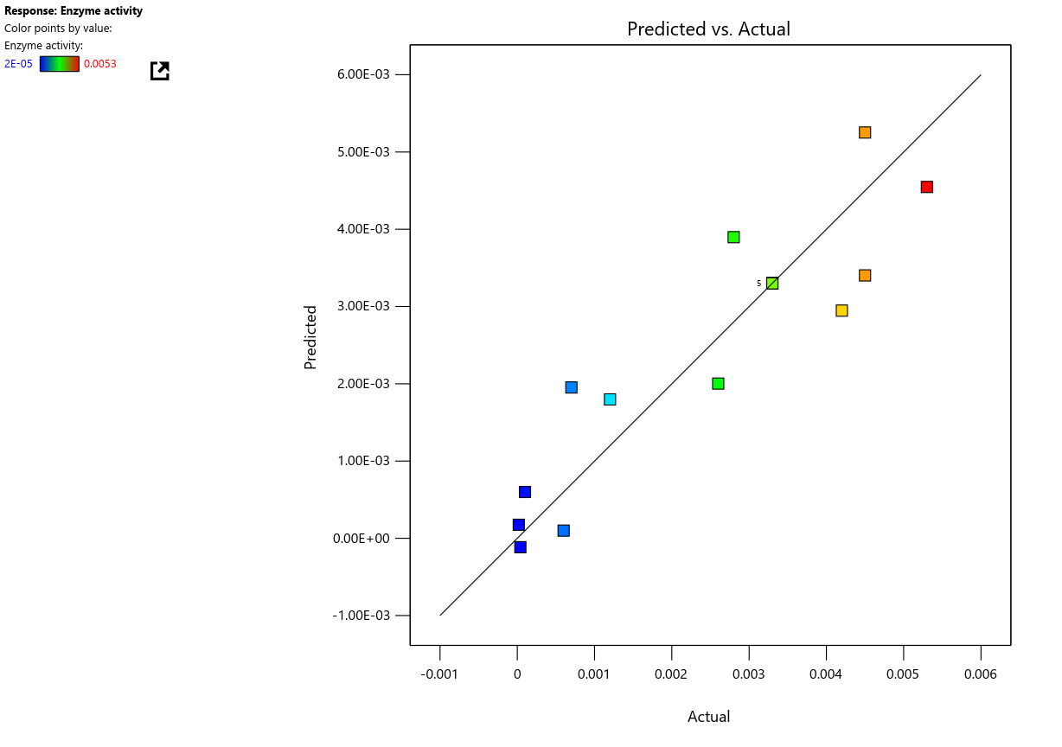
- Predicted vs. actual scatterplot in RSM model: Scatter plots of Actual vs Predicted are one of the richest form of data visualization. You can tell pretty much everything from it. Ideally, all your points should be close to a regressed diagonal line. So, if the Actual is 5, your predicted should be reasonably close to 5 to. If the Actual is 30, your predicted should also be reasonably close to 30. So, just draw such a diagonal line within your graph and check out where the points lie. If your model had a high R Square, all the points would be close to this diagonal line. The lower the R Square, the weaker the Goodness of fit of your model, the foggier or dispersed your points are (away from this diagonal line). From this scatter plot, you can tell other issues related to your model. The residuals are heteroskedastic. This means the variance of the error is not constant across various levels of your dependent variable. As a result, the standard errors of your regression coefficients are unreliable and may be understated. In turn, this means that the statistical significance of your independent variables may be overstated. In other words, they may not be statistically significant. Because of the heteroskedastic issue, you can’t tell.
Fig 16. Predicted and actual response values comparison of Tannase production.
- Interaction graphs supporting the model:
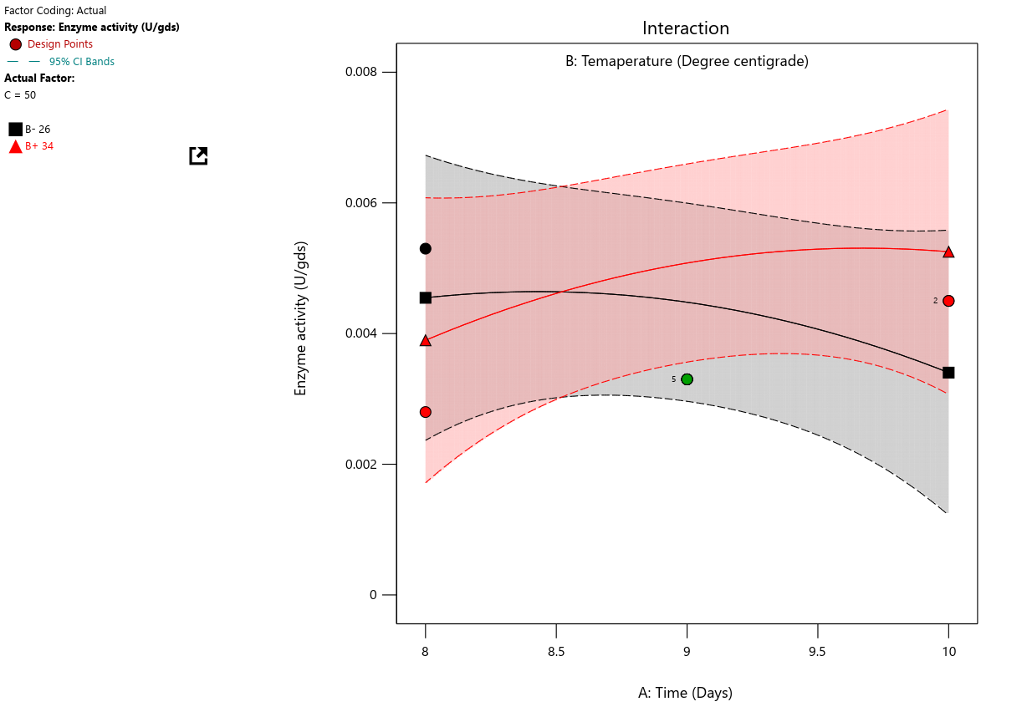
Fig 17. Plot of Interaction between the parameters: A. time, B. temperature, C: Hydration ratio.

