Supplementary file

Johanna Honka, Laura Kvist, Ingar J. Øien, Tomas Aarvak, Stefan Siivonen and Jouni Aspi

Sampling of environmental DNA for breeding distribution mapping in an endangered goose species, the lesser white-fronted goose

Examples of environmental DNA samples visualised under an UV-light on an agarose gel (Supplementary Fig. 1). In sample EL3/3 nothing amplified and thus this was determined as a failed sample. In sample EL7/2 only large (~1000 bp or larger) nonspecific fragments were amplified, so this sample was determined as a failed sample as well. In sample EL10/2 both nonspecific fragments and a fragment of the correct size (155 bp including primers) were amplified. The correctly sized fragment was cut from the gel and gel extracted. This sample was Sanger-sequenced but sequencing was successful in only one direction. In sample EL17/1 only nonspecific fragments were amplified leading to this sample being determined as a failed sample. In sample ES1 a single fragment of the correct size amplified. This sample was Sanger-sequenced, and after sequence comparison, it was determined to belong to a lesser white-fronted goose (Anser erythropus). Sample ES1 was a sample collected from a spring staging site of lesser white-fronted geese.

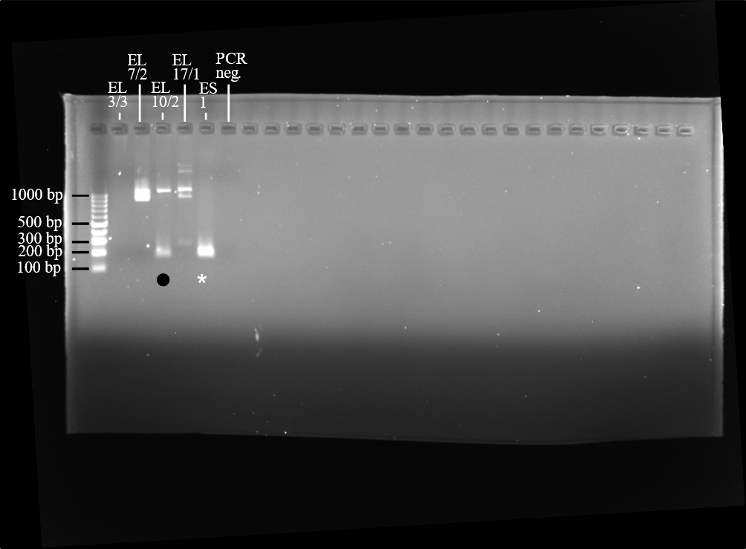
Supplementary Figure 1. Examples of environmental DNA samples collected from potential lesser white-fronted goose (Anser erythropus) breeding sites from Northern Finnish Lapland and a spring staging site. These samples were amplified by AdCR2-F and -R primers, which target Anser-geese. PCR products were visualized with 2% agarose gel run, for 50 min on 115 volts. A black dot indicates a sample in which the band of the correct size (155 bp including primers) was excised from the gel and purified. A white asterisk indicates a sample which was directly sequenced from the PCR product. The negative control (PCR neg). is a contains water instead of DNA. A molecular ladder (GeneRuler 100 bp DNA Ladder, Thermo Fisher Scientific) was added to the first well of the gel.

Supplementary text 2

New haplotype of taiga bean goose (Anser fabalis fabalis)
>EL102.2
CCCACAACACCCCACATAACCCTAGTTCCAGCACACAACAAGACCCCATCTTAAT
GAATGCTTACAGGACATACCTTAATAACAACTCTCTACCACATATCT

New haplotype 1 of taiga bean goose (Anser fabalis fabalis)
>EL89.2
CCCACAATACCCCACATAACCCTAGTTCCAGCACACAACAAGACCCCATCTTAAT
GAATGCTTACAGGACATACCTTAATAACAACTCTCTACCACATATCT

