Leaf-Inspired Asymmetrically Hierarchical Architecture Engineered Full-Paper Integrated Tactile Array for Ultra-Stable Sensory Augmentation
Sanwei Hao#, Wenqi Wang#, Chao Ma#, Xin Li, Xidie Liu, Yicong Wang, Zhimin Xue, Feng Xu, and Jun Yang*

Beijing Key Laboratory of Lignocellulosic Chemistry, College of Materials Science
and Technology, Beijing Forestry University, Beijing 100083, China.

*E-mail: yangjun11@bjfu.edu.cn Tel: 86-10-62337223.

#These authors contributed equally to this work.

Table of Contents
Supplementary Figs. 1-43
Supplementary Fig. 1 | (a) FTIR spectra and (b) XRD profiles of TOCNF, MXene, and TOCNF/MXene.
Supplementary Fig. 2 | The large-area cellulose film of 50 × 30 cm fabricated as encapsulation layer.
Supplementary Fig. 3 | (a) Digital image of screen-printed electrode pattern and (b) the layout design of interdigital electrode for LAHA pressure sensor aiming at piezoresistance performance assessment.
Supplementary Fig. 4 | Detailed drawings of size and layout for tactile array circuits.
Supplementary Fig. 5 | Schematic illustration of the screen-printing process for tactile array circuits (6×6 pixels).
Supplementary Fig. 6 | The universality of Ag based pattern on different substrates (PET, PE, cellulose film, A4 paper, and PU, respectively).
Supplementary Fig. 7 | The EDS mapping of element distribution (Ag, C, and O) indicating successful pattern of Ag electrode on encapsulation layer.
Supplementary Fig. 8 | The stable interfacial coupling tests of patterned Ag circuit without interfacial deterioration measured by cyclic stripping by commercial 3M tape.
Supplementary Fig. 9 | (a) Digital images of resistance variations measurement of Ag based circuit after cyclic stripping (1, 3, 5, 7, and 10 cycle), and (b) the corresponding resistance variations over 5 days.
Supplementary Fig. 10 | Finite element simulation of sensing unit based on HEA design, demonstrating the homogeneous vertical stress diffusion.
Supplementary Fig. 11 | Simplified model diagram of sensing units based on LAHA and HEA design and the corresponding volume mesh (LAHA: 4871610, HEA:2414010). The abundant volume networks contributing to the accurate stress transfer simulation.
Supplementary Fig. 12 | AFM image of prepared TOCNF.
Supplementary Fig. 13 | Schematic illustration of etching Ti₃AlC₂ (MAX) by HCl and LiF to obtain Ti₃C₂T_{x} (MXene) nanosheets.
Supplementary Fig. 14 | (a) AFM image and (b) TEM image confirmed the thickness and successful preparation of delaminated MXene nanosheets, the inset of characteristic diffraction peak.
Supplementary Fig. 15 | FTIR spectra and XRD profile of TOCNF (-COO⁻), LCNF (-SO₃H), ZCNF (-COO⁻ and -N⁺(CH₃)₂Cl⁻), CACNF (-N⁺(CH₃)₂Cl⁻), and CNF (-OH), respectively.
Supplementary Fig. 16 | The tensile stress-strain curves of (a) sensing layer based on different modified cellulose nanofibrils with the same content (0.2 wt%) including TOCNF (-COO⁻), LCNF (-SO₃H), ZCNF (-COO⁻ and -N⁺(CH₃)₂Cl⁻), CACNF (-N⁺(CH₃)₂Cl⁻), and CNF (-OH), and (b) sensing layer with different contents of TOCNF (0.05, 0.1, 0.15, 0.2, and 0.25 wt%, respectively).
Supplementary Fig. 17 | The TGA and DTG curves of CNF with different functional groups including CNF(-N⁺(CH₃)₂Cl⁻), CNF(-OH), ZCNF (-COO⁻ and -N⁺(CH₃)₂Cl⁻), SCNF (-SO₃H), and TOCNF(-COO⁻), respectively.
Supplementary Fig. 18 | (a) Photograph of CNF, SCNF, TOCNF, CACNF, and ZCNF suspension, respectively. (b) C 1s and O 1s XPS spectra of TOCNF, CNF, SCNF, ZCNF, and CACNF, respectively. (c) XPS survey spectrum of the MXene, LCNF/MXene, CACNF/MXene, SCNF/MXene, ZCNF/MXene, and TOCNF/MXene, respectively.
Supplementary Fig. 19 | The collection features of optimizing LAHA sensing layer associated with increasing of MXene nanosheets content (4-12 mg/mL) including (a) electric conductivity (σ), (b) interfacial impedance, (c) contact angle, (d) puncture force, and (e) the weight and thickness. Data in (a, c, e) are presented as mean values ± SD, n = 3 independent samples.
Supplementary Fig. 20 | The cross-section SEM images of LAHA sensing layer deposited with different contents of MXene.
Supplementary Fig. 21 |The brightness change of a group of small light bulbs with "B, J, F and U" pattern is significantly related to the sensing layer with different MXene contents (4-12 mg/mL).
Supplementary Fig. 22 | The cross-section SEM images showing the compact laminated LAHA sensing layer with obvious hierarchical configuration.
Supplementary Fig. 23 | (a) Photos of bending tests by horizontal tensile machine. (b) The comparison of resistivity pulses between LAHA sensor and referred HEA sensor even after 50000 folding fatigue cycles (radius ~ 2 cm, angle ~ 180°), the inset images showing the compact interface without delamination and destruction.
Supplementary Fig. 24 | The comparison of current fluctuation between LAHA and HEA sensing layer in continuous bending cycles.
Supplementary Fig. 25 | Photographs of puncture resistance test and the corresponding needle size parameters.
Supplementary Fig. 26 | Finite element simulation results of HEA based sensing unit from (a) overall vision, (b) out-plane view, and (c) in-plane view, respectively, indicating the homogeneous vertical stress diffusion under different external loadings.
Supplementary Fig. 27 | Finite element simulation results of LAHA based sensing unit from (a) overall vision, (b) the out-plane view, and (c) in-plane view, respectively, verifying the layer-by-layer energy dissipation manner and the efficient in-plane stress distribution under different vertical loadings.
Supplementary Fig. 28 | Uniaxial tensile test of LAHA and HEA sensing layer.
Supplementary Fig. 29 | The photographs of flexible pressure sensor based on LAHA sensing layer.
Supplementary Fig. 30 | Piezoresistance performance assessment. (a) Linear relation of the I-V curves under different applied pressures (1, 2, 3, 5, 8, and 10 kPa). (b) Frequency response performance of as-built LAHA pressure sensor (0.1, 0.2, 0.4, 0.6, 1, and 1.5 Hz, respectively). (c) The stable piezoresistive response in the range of 0.5, 1, 2, 3, 5, 8, and 10 kPa, respectively.
Supplementary Fig. 31 | Piezoresistance performance retention even after heavy mechanical puncture for 200 cycles (pin diameter = 900 um).The inserts showing the robust sensing interface after the continuous puncture by needle tip.
Supplementary Fig. 32 | The circuit logic diagram of wireless coordinated collection system.
Supplementary Fig. 33 | (a) Optical image for haptic feedback via assembled FPTA. (b) The smart integrated reading circuits. (c)The high-resolution pressure distribution and intensity grade mapping on tablet computer.
Supplementary Fig. 34 | The output current signals of 36 pixels on FPTA showing the desirable uniformity of tactile signal feedback.
Supplementary Fig. 35 | Long-term operation of the FPTA over 28 days, indicating the excellent stability for practical application.
Supplementary Fig. 36 | Demonstration of horizontal tension machine and the continuous bending process of FPTA, verifying the robust integrity of FPTA.
Supplementary Fig. 37 | Serial number of pixels in FPTA.
Supplementary Fig. 38 | The haptic signal intensity and distribution recorded by 36 pixels FPTA for different behaviors (lie down, fall down, lolling, touching, patting, and rubbing, respectively).
Supplementary Fig. 39 | Photographs showing the excellent skin-friendly capability of assembled LAHA pressure sensor after attachment for 24 h (the volunteer is one of the authors and signed the informed consent).
Supplementary Fig. 40 | Cell viability. (a) Confocal laser scanning microscopy (CLSM) micrographs of fibroblasts L929 on different interface of FPTA including sensing layer, layer with circuits, and encapsulation layer, and (b) the corresponding cell viability over 1, 2, and 3 days, respectively. Error bars are defined as SD (n = 3 independent samples).
Supplementary Fig. 41 | Optical images of (a) the complete degradation process of MXene solution (0.2 mg/mL) over 10 weeks and (b) the MXene degradation and nanofibril disintegration of prepared sensing layer in 2 wt % H₂O₂ solution at room temperature over 2 weeks.
Supplementary Fig. 42 | Optical images of the degradation process for comment petroleum derived substrates (PU, PE, and PDMS) and the assembled FPTA (encapsulation layer, sensing layer, and layer with circuits) over 12 weeks.
Supplementary Fig. 43 | Research flow of the FPTA monitoring system for stable haptic feedback.
Supplementary Notes 1-6
Supplementary Note 1. Interfacial robustness of circuit.
Supplementary Note 2. Intermolecular hydrogen bonding.
Supplementary Note 3. Finite element simulation.
Supplementary Note 4. Reliable piezoresistive properties.
Supplementary Note 5. Verification of biocompatibility and nontoxicity.
Supplementary Note 6. Biodegradability assessment.
Supplementary Tables 1-5
Supplementary Table 1 | Mechanical parameters including tensile stress, tensile strain, elastic modulus, and toughness of cellulose nanofibrils (with various function groups) based sensing layer including TOCNF, CNF, SCNF, ZCNF, and CACNF, respectively.
Supplementary Table 2 | Mechanical performances of LAHA sensing layer with different TOCNF contents (0.05, 0.1, 0.15, 0.2, and 0.25 wt%, respectively).
Supplementary Table 3 | Comparison of the unprecedented durability of LAHA based pressure sensor in our work with state-of-the-art counterparts with different architecture designs and material integration including aerogel, film, hydrogel, textile, elastomer, and paper, respectively.
Supplementary Table 4 | Comparison chart of the competitive piezoresistive performances of LAHA pressure sensor in this work with previously reported tactile sensors.
Supplementary Table 5 | Comparison of the collection features of the assembled tactile array in this work with reported tactile electronics in recent references.
Supplementary References

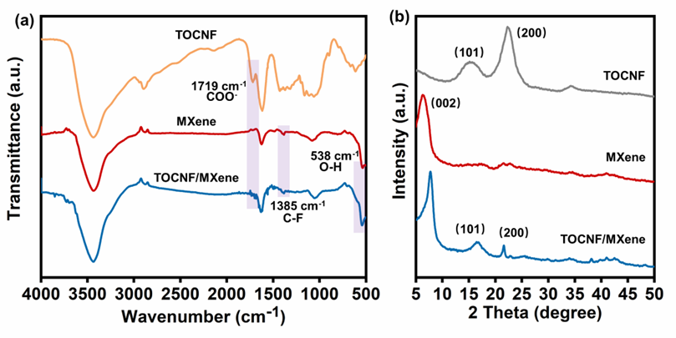
Supplementary Fig. 1 | (a) FTIR spectra and (b) XRD profiles of TOCNF, MXene, and TOCNF/MXene.
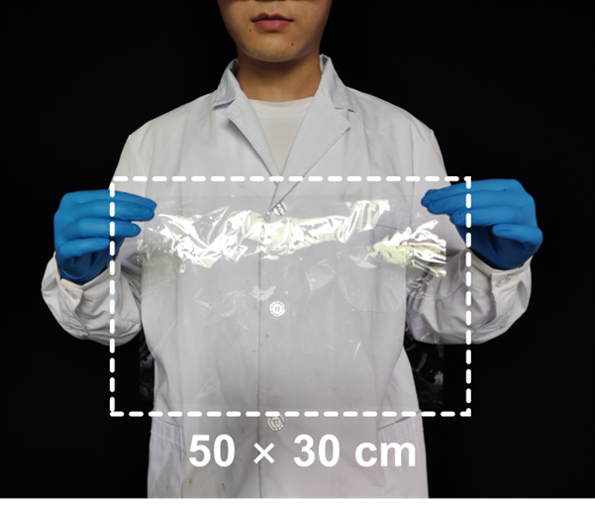
Supplementary Fig. 2 | The large-area cellulose film of 50 × 30 cm fabricated as encapsulation layer.

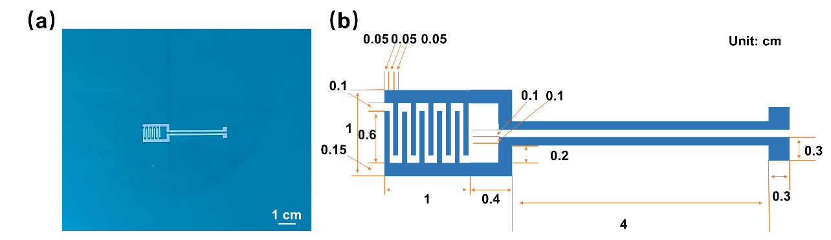
Supplementary Fig. 3 | (a) Digital image of screen-printed electrode pattern and (b) the layout design of interdigital electrode for LAHA pressure sensor aiming at piezoresistance performance assessment.
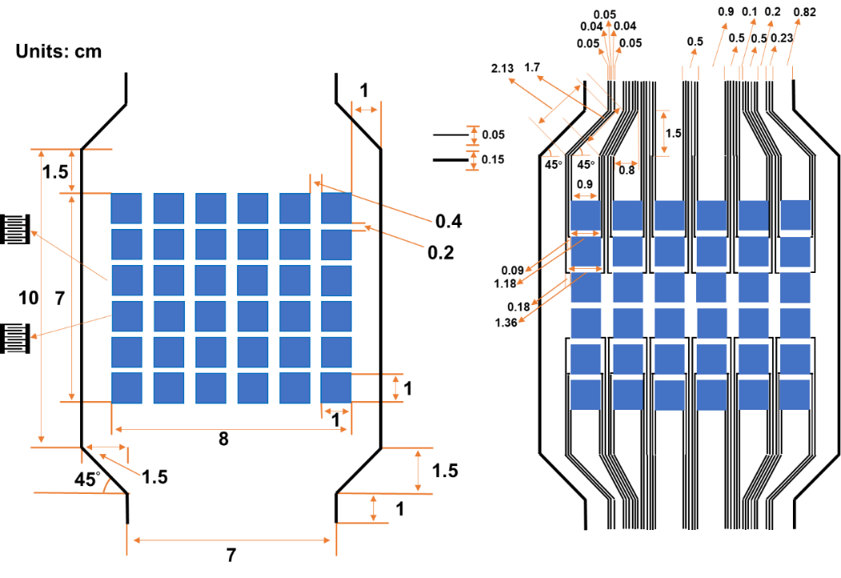
Supplementary Fig. 4 | Detailed drawings of size and layout for tactile array circuits.
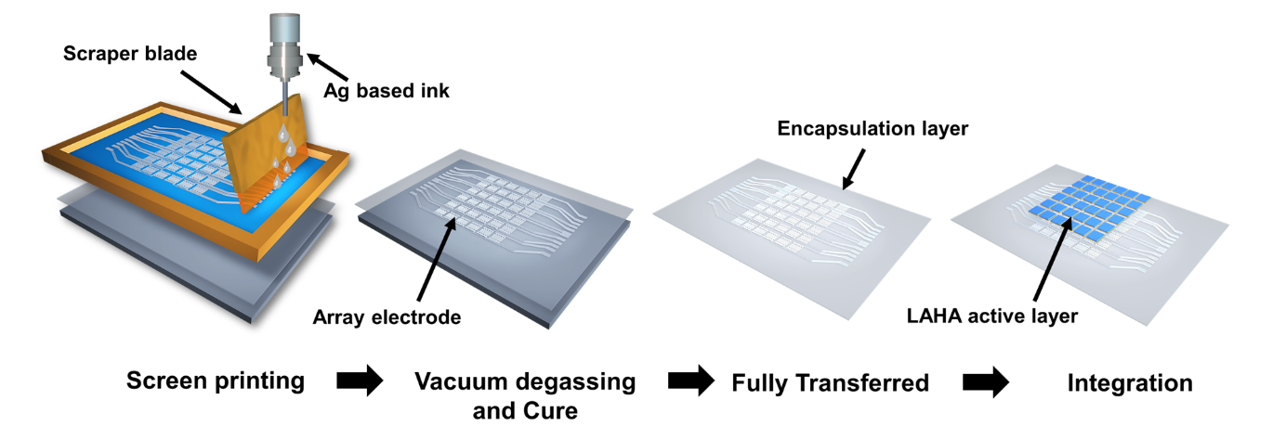
Supplementary Fig. 5 | Schematic illustration of the screen-printing process for tactile array circuits (6×6 pixels).
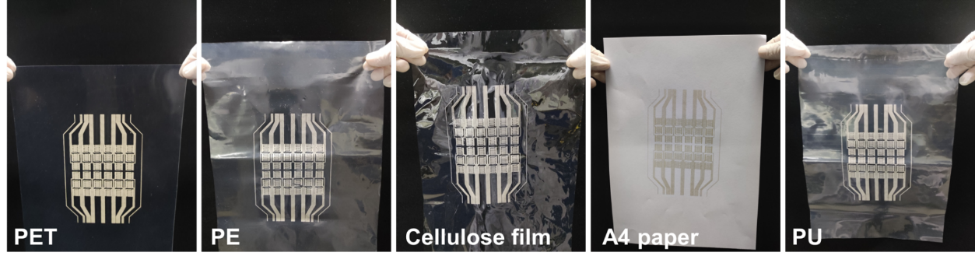
Supplementary Fig. 6 | The universality of Ag based pattern on different substrates (PET, PE, cellulose film, A4 paper, and PU, respectively).

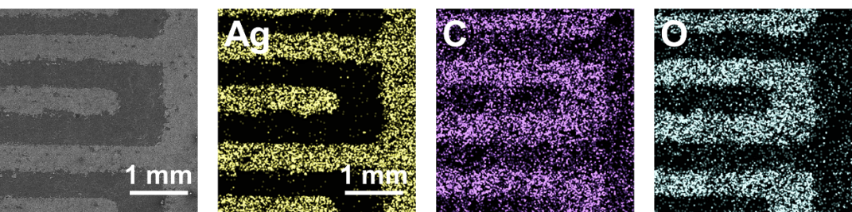
Supplementary Fig. 7 | The EDS mapping of element distribution (Ag, C, and O) indicating successful pattern of Ag electrode on encapsulation layer.

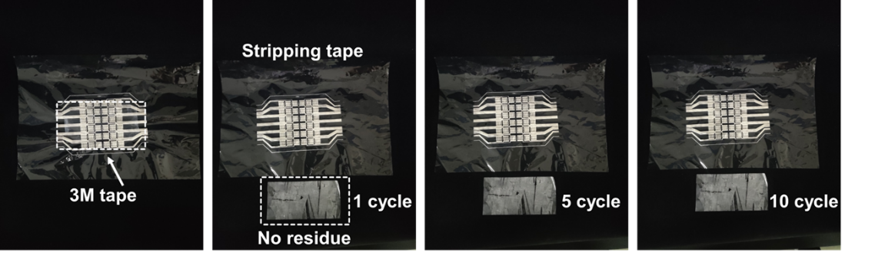
Supplementary Fig. 8 | The stable interfacial coupling tests of patterned Ag circuit without interfacial deterioration measured by cyclic stripping by commercial 3M tape.

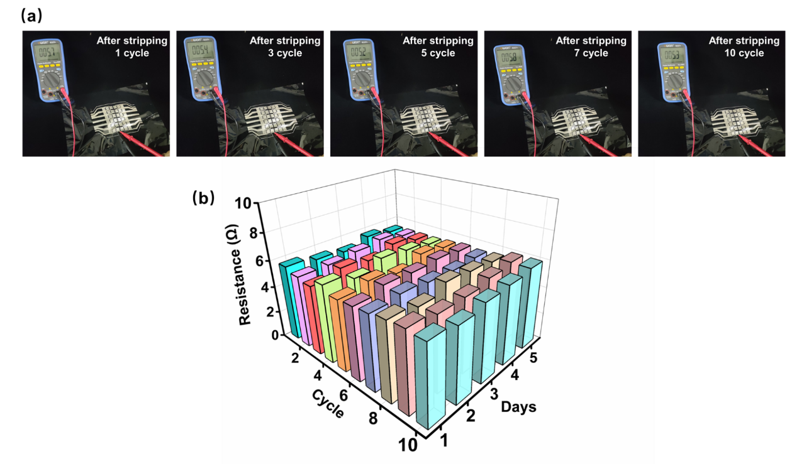
Supplementary Fig. 9 | (a) Digital images of resistance variations measurement of Ag based circuit after cyclic stripping (1, 3, 5, 7, and 10 cycle), and (b) the corresponding resistance variations over 5 days.

Supplementary Note 1. Interfacial robustness of circuit.
A crucial point for stable haptic feedback of FPTA is the development of circuit with excellent robustness and conductivity to obtain large and reproducible carrier mobility, which dramatically need to be addressed¹⁻³. It bears emphasis that, aiming at achieving reliable ohmic interconnections and avoiding the introduction of external interface, a screen-printed Ag electrode array pattern (6×6 pixels) defined by a mask-template (150 mm × 100 mm) is directly sprayed on the encapsulation layer (cellulose film), providing a straightforward and reliable route for systematic integration (detailed fabrication illustrated in Supplementary Fig. 5). By virtue of independent electrode of each sensing unit and the symmetrical arrangement of overall circuit, the designed FPTA is capable of preventing multi-channel signal distortion during dynamic deformation. Notably, we have confirmed that the screen-printed Ag based circuit (6×6 pixels) defined by a mask-template on cellulose film possesses stable patterning effect on various substrates including polyethylene terephthalate (PET), polyethylene (PE), cellulose film, A4 paper, and polyurethane (LDPE) (Supplementary Fig. 6). It can be observed that the interdigital electrode trace (width = 1 mm) is accurately patterned on encapsulation layer as visualized in SEM images and EDS mapping (Supplementary Fig. 7). As a further proof, the pattern on cellulose film could both withstand interfacial stripping without residue by 3M tape over 10 cycles (Supplementary Fig. 8) and maintain long-term and stable electrochemical functionality with almost constant resistance of 5.48 Ω over 5 days (Supplementary Fig. 9). Moreover, the spacer that is prepared by laser engraving technique possesses the same elastic modulus as the encapsulation layer and can function as a supporting frame, allowing for the fast recovery of sensing units after the removal of external pressure and alleviating the adverse influence of viscoelastic hysteresis.

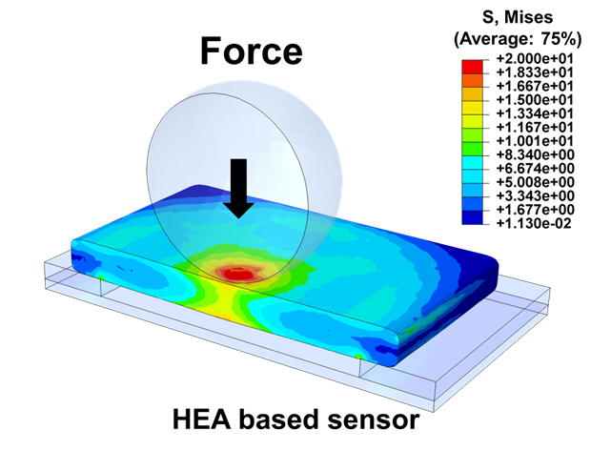
Supplementary Fig. 10 | Finite element simulation of sensing unit based on HEA design, demonstrating the homogeneous vertical stress diffusion.
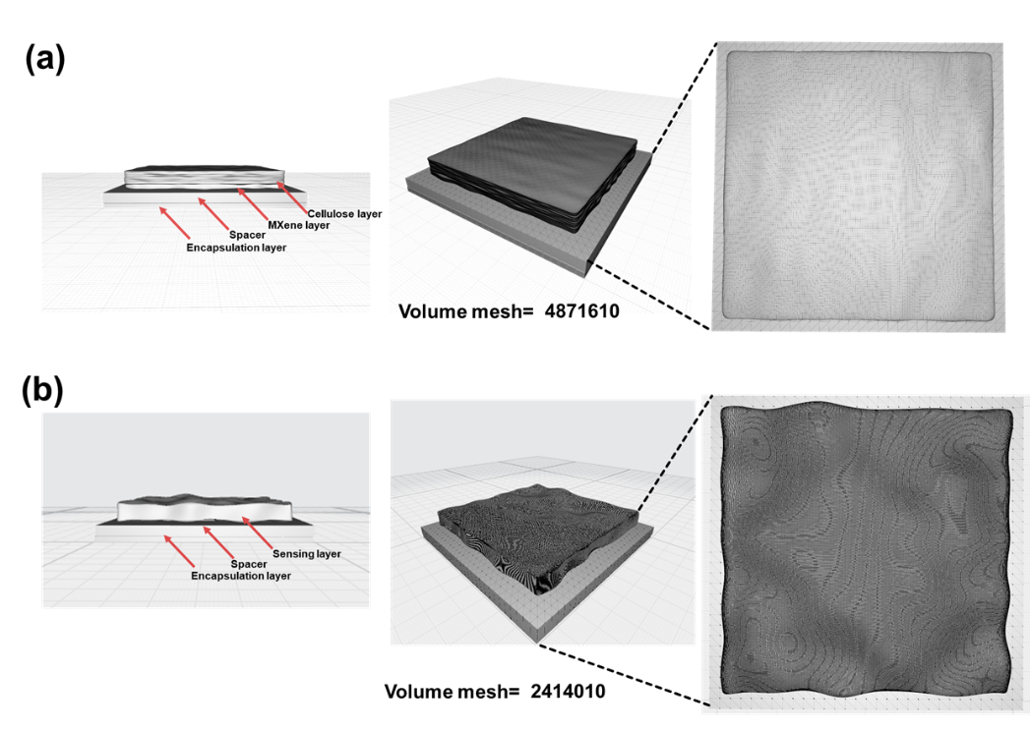
Supplementary Fig. 11 | Simplified model diagram of sensing units based on LAHA and HEA design and the corresponding volume mesh (LAHA: 4871610, HEA:2414010). The abundant volume networks contributing to the accurate stress transfer simulation.

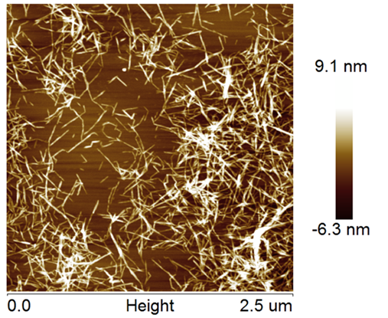
Supplementary Fig. 12 | AFM image of prepared TOCNF.
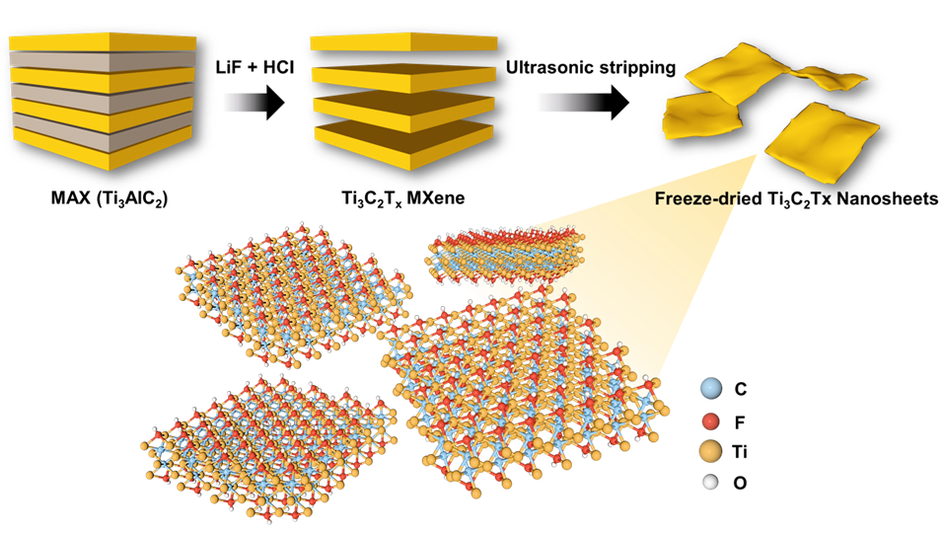
Supplementary Fig. 13 | Schematic illustration of etching Ti₃AlC₂ (MAX) by HCl and LiF to obtain Ti₃C₂T_{x} (MXene) nanosheets.
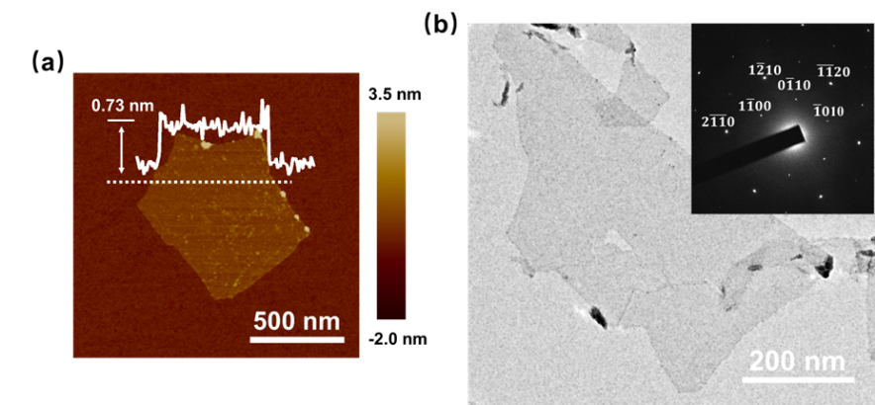
Supplementary Fig. 14 | (a) AFM image and (b) TEM image confirmed the thickness and successful preparation of delaminated MXene nanosheets, the inset of characteristic diffraction peak.

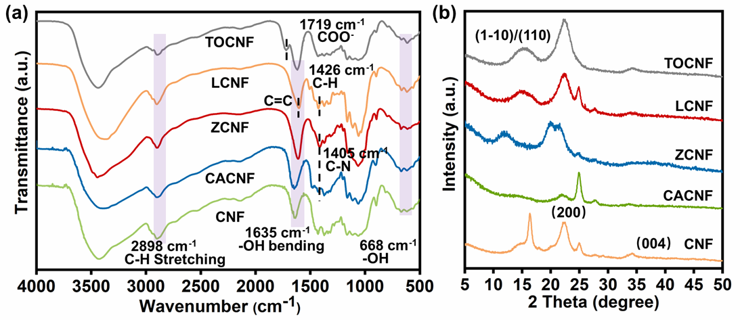
Supplementary Fig. 15 | FTIR spectra and XRD profile of TOCNF (-COO⁻), LCNF (-SO₃H), ZCNF (-COO⁻ and -N⁺(CH₃)₂Cl⁻), CACNF (-N⁺(CH₃)₂Cl⁻), and CNF (-OH), respectively.

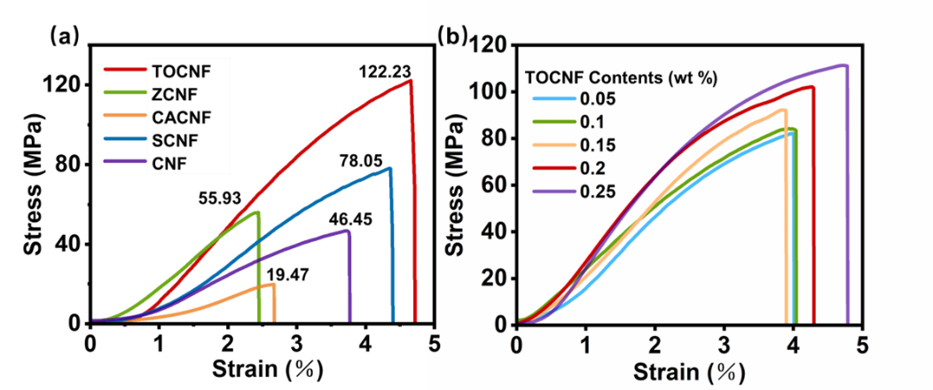
Supplementary Fig. 16 | The tensile stress-strain curves of (a) sensing layer based on different modified cellulose nanofibrils with the same content (0.2 wt%) including TOCNF (-COO⁻), LCNF (-SO₃H), ZCNF (-COO⁻ and -N⁺(CH₃)₂Cl⁻), CACNF (-N⁺(CH₃)₂Cl⁻), and CNF (-OH), and (b) sensing layer with different contents of TOCNF (0.05, 0.1, 0.15, 0.2, and 0.25 wt%, respectively).

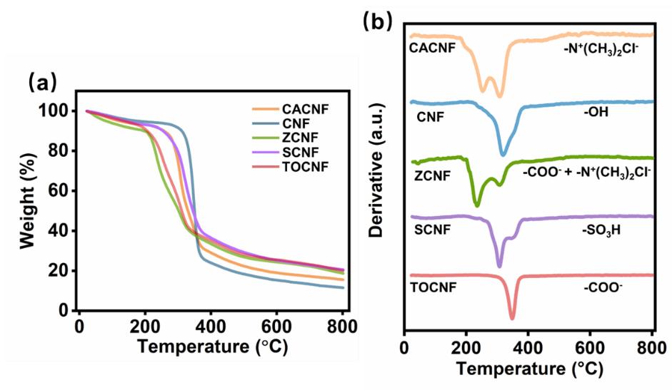
Supplementary Fig. 17 | The TGA and DTG curves of CNF with different functional groups including CNF(-N⁺(CH₃)₂Cl⁻), CNF(-OH), ZCNF (-COO⁻ and -N⁺(CH₃)₂Cl⁻), SCNF (-SO₃H), and TOCNF(-COO⁻), respectively.
Supplementary Note 2. Intermolecular hydrogen bonding.
As evident in Supplementary Fig. 15, the FTIR and XRD profiles reveal distinct characteristic peaks, e.g, 1719 cm⁻¹(COO⁻), 1426 cm⁻¹(C-H), 1405 cm⁻¹(C-N), and 668 cm⁻¹(-OH), and consistent crystallinity of various CNFs including (1-10), (110), (200) and (004), providing evidence for the successful modification of specific groups. Notably, it is found that the TOCNF sensing layer performs better in terms of tensile stress (122.2 MPa), Young’s modulus (29.75 MPa), and toughness (2.79 MJ/m³) than a series of other sensing layers (Supplementary Fig. 16). The associated ghost change of mechanical properties among different sensing layers could be rationalized from the synergistic effect of inherent rigidity of CNF and the abundant intermolecular hydrogen bonding as “dynamic bridge” for energy dissipation.

It has been reported that the formation of intermolecular hydrogen bond is closely related to the electrostatic interactions between hydrogen atoms and non-metallic atoms that possess strong electronegativity and small atomic radius^{4,5}, while the chlorine atoms with large atomic radius in ZCNF and CACNF may cause negative effect to hydrogen bonding. Conversely, the carboxyl groups on TOCNF possess two active sites (=O and O⁻), thus yielding the competitive mechanical robustness and structural integrity. Indeed, according to TGA and DTG profiles, it is also confirmed that the TOCNF sensing layer shows the higher thermal stability than that of other sensing layers, possibly ascribing to the largest energy demand for breaking hydrogen bonds (Supplementary Fig. 17).

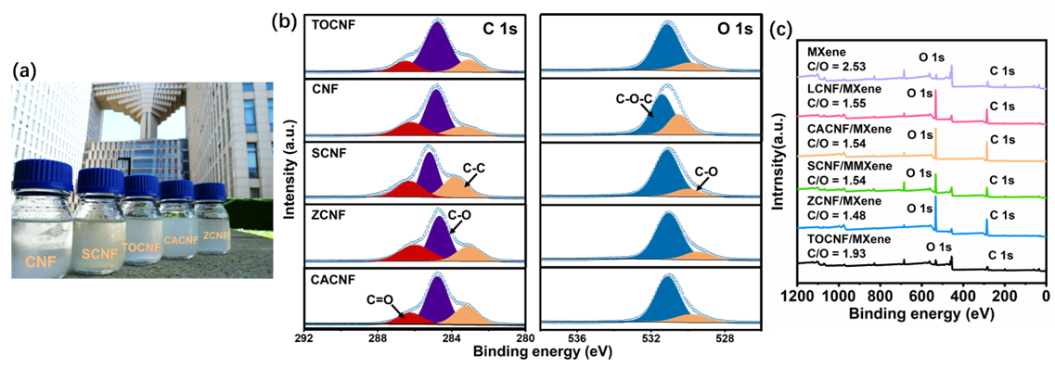
Supplementary Fig. 18 | (a) Photograph of CNF, SCNF, TOCNF, CACNF, and ZCNF suspension, respectively. (b) C 1s and O 1s XPS spectra of TOCNF, CNF, SCNF, ZCNF, and CACNF, respectively. (c) XPS survey spectrum of the MXene, LCNF/MXene, CACNF/MXene, SCNF/MXene, ZCNF/MXene, and TOCNF/MXene, respectively.

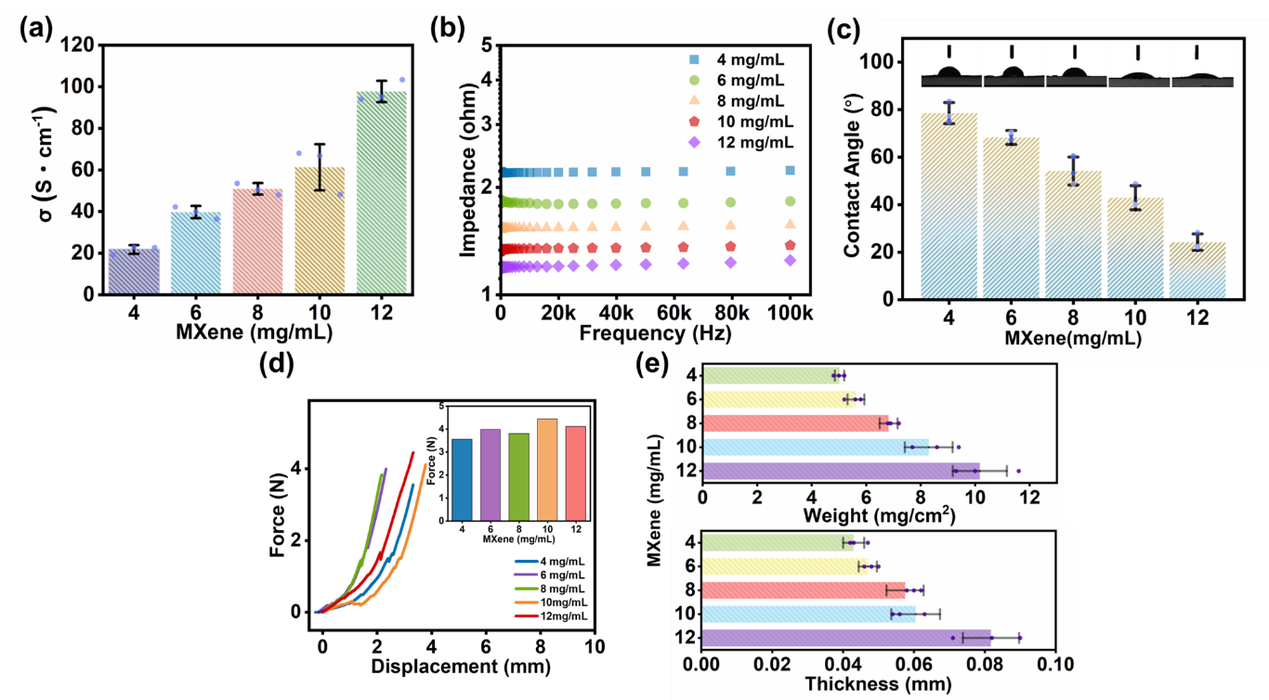
Supplementary Fig. 19 | The collection features of optimizing LAHA sensing layer associated with increasing of MXene nanosheets content (4-12 mg/mL) including (a) electric conductivity (σ), (b) interfacial impedance, (c) contact angle, (d) puncture force, and (e) the weight and thickness. Data in (a, c, e) are presented as mean values ± SD, n = 3 independent samples.

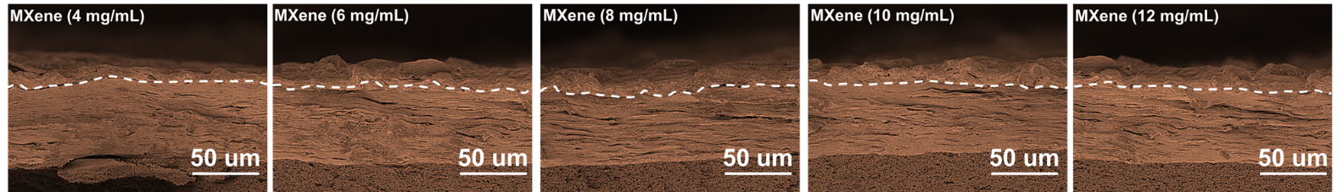
Supplementary Fig. 20 | The cross-section SEM images of LAHA sensing layer deposited with different contents of MXene.

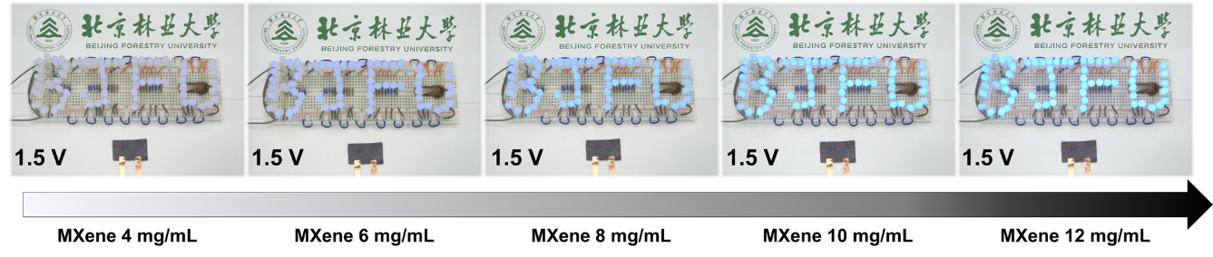
Supplementary Fig. 21 |The brightness change of a group of small light bulbs with "B, J, F and U" pattern is significantly related to the sensing layer with different MXene contents (4-12 mg/mL).

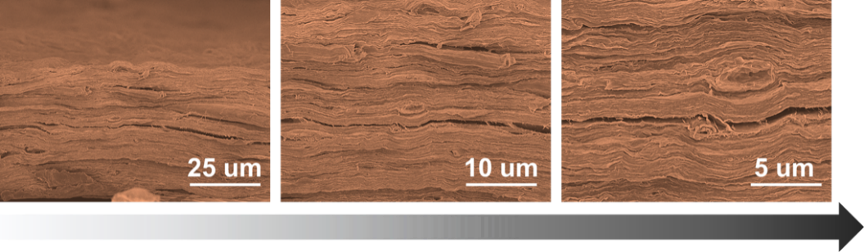
Supplementary Fig. 22 | The cross-section SEM images showing the compact laminated LAHA sensing layer with obvious hierarchical configuration.

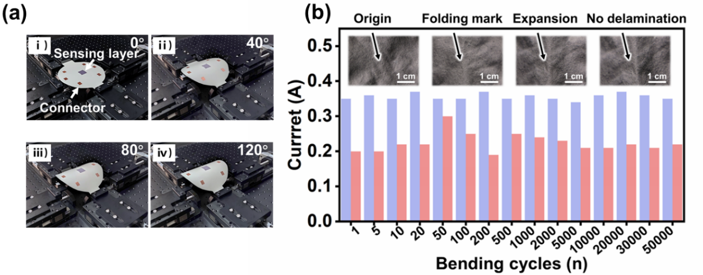
Supplementary Fig. 23 | (a) Photos of bending tests by horizontal tensile machine. (b) The comparison of resistivity pulses between LAHA sensor and referred HEA sensor even after 50000 folding fatigue cycles (radius ~ 2 cm, angle ~ 180°), the inset images showing the compact interface without delamination and destruction.

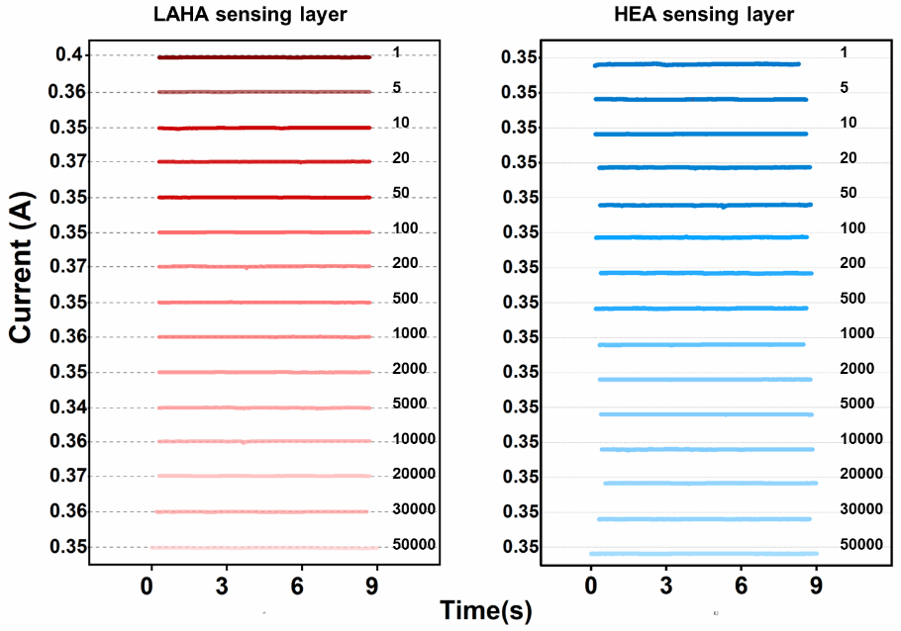
Supplementary Fig. 24 | The comparison of current fluctuation between LAHA and HEA sensing layer in continuous bending cycles.

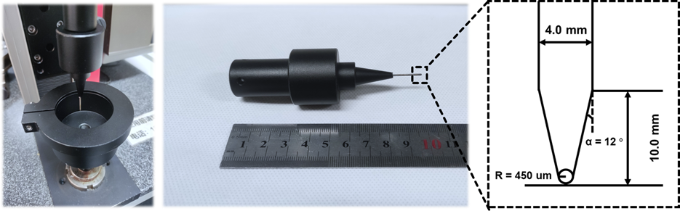
Supplementary Fig. 25 | Photographs of puncture resistance test and the corresponding needle size parameters.

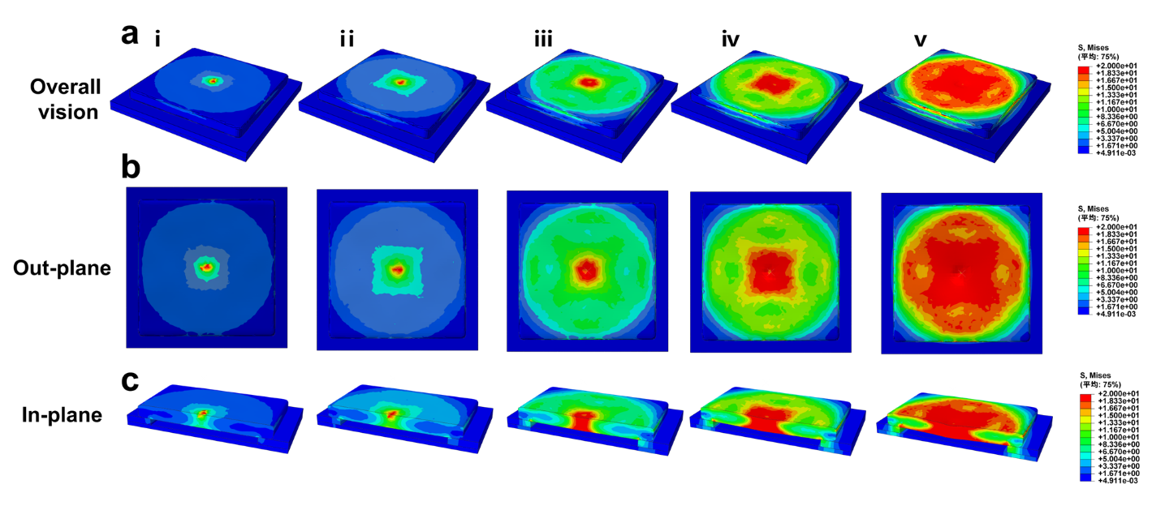
Supplementary Fig. 26 | Finite element simulation results of HEA based sensing unit from (a) overall vision, (b) out-plane view, and (c) in-plane view, respectively, indicating the homogeneous vertical stress diffusion under different external loadings.
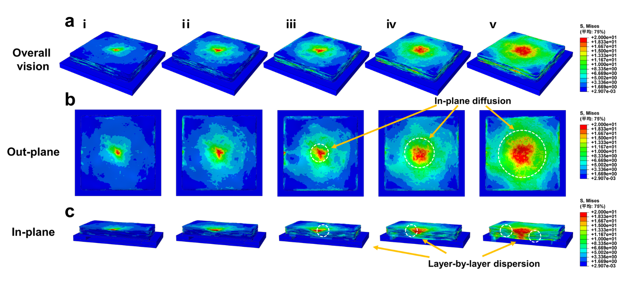
Supplementary Fig. 27 | Finite element simulation results of LAHA based sensing unit from (a) overall vision, (b) the out-plane view, and (c) in-plane view, respectively, verifying the layer-by-layer energy dissipation manner and the efficient in-plane stress distribution under different vertical loadings.
Supplementary Note 3. Finite element simulation.
In the finite element simulation, the leaf-inspired asymmetrically hierarchical architecture is modelled as a linear elastic material with Lagrangian formulation with predetermined parameters including density (ρ) = 1.25 g/cm³, Young's modulus (E) = 26.17 MPa, Poisson ratio (υ) = 0.31. The boundary conditions are set at the bottom of the architecture model, and a gradually increased smooth downward velocity of the model with the final displacement on Z direction of 100 μm within 0.1 s and an average velocity of 0.5 mm s⁻¹ is applied.

In order to dynamically manifest the stress distribution in LAHA based sensing unit during vertical loading, we developed a 3D finite element model using CINEMA 4D R20 software to achieve the finite element simulation. With regard to the interface of adjacent layer, we designed the layer volume network combined with random volume growth strategy to mimic the random cross-linking between adjacent layers, thus the adjacent layer possessed random and discrete interface gap as default option in simulation⁶⁻⁸.

While this highly idealized model differs from the practical implementation, the exploration of the local stress evolution with loading force can vividly evidence the rationality of LAHA design to tackle the issue of interfacial inferior effected signal fluctuation.

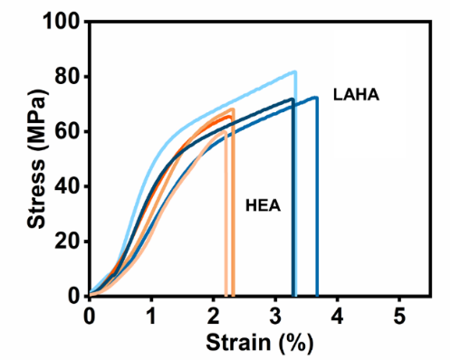
Supplementary Fig. 28 | Uniaxial tensile test of LAHA and HEA sensing layer.

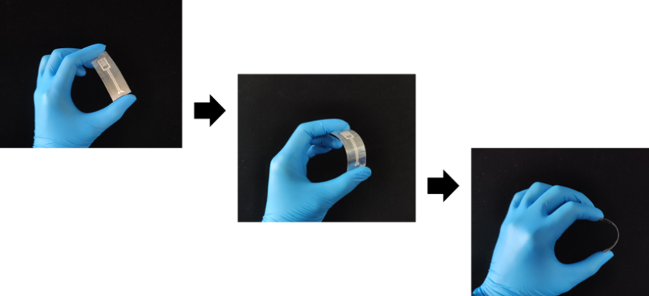
Supplementary Fig. 29 | The photographs of flexible pressure sensor based on LAHA sensing layer.

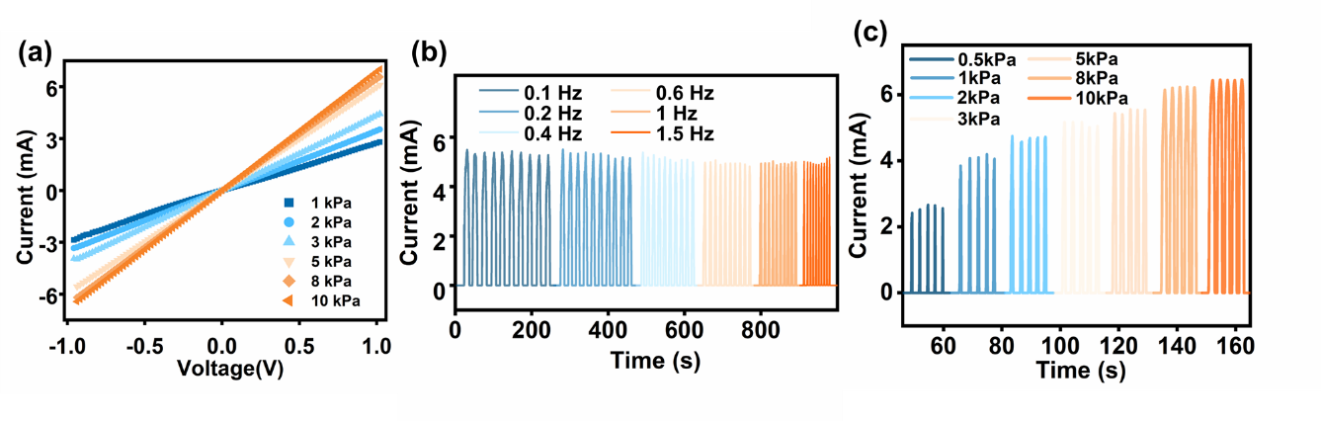
Supplementary Fig. 30 | Piezoresistance performance assessment. (a) Linear relation of the I-V curves under different applied pressures (1, 2, 3, 5, 8, and 10 kPa). (b) Frequency response performance of as-built LAHA pressure sensor (0.1, 0.2, 0.4, 0.6, 1, and 1.5 Hz, respectively). (c) The stable piezoresistive response in the range of 0.5, 1, 2, 3, 5, 8, and 10 kPa, respectively.
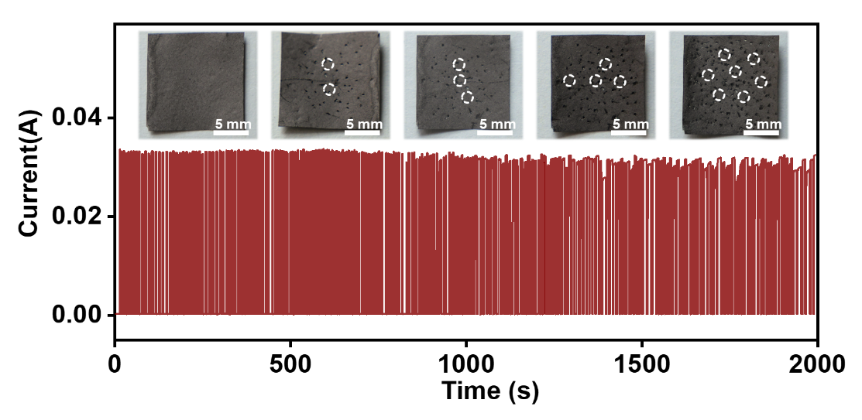
Supplementary Fig. 31 | Piezoresistance performance retention even after heavy mechanical puncture for 200 cycles (pin diameter = 900 um). The inserts showing the robust sensing interface after the continuous puncture by needle tip.

Supplementary Note 4. Reliable piezoresistive properties.
The sensitivity (S) is defined by the formula S = ∂(ΔI/I₀)/∂P, where ΔI and I₀ are the specific current and initial current under an applied pressure (P), respectively. Concerning the current-voltage (I-V) curves of the LAHA pressure sensor in the pressure range from 1 to 10 kPa (Supplementary Fig. 30a), there is a typical linear relation and the resistance reduces with increasing applied pressure, inferring the desirable ohmic contact between the LAHA sensing layer and electrode^{9,10}. Furthermore, as-built sensor delivers frequency-independent current change within the pressure frequency range 0.1−1.5 Hz, which correlates only with the applied pressure as indicated by almost the same amplitude (Supplementary Fig. 30b). Besides, the accuracy and repeatability of pressure response are examined by alternately loading and unloading pressure (0.5-10 kPa) onto the LAHA sensor for five cycles (Supplementary Fig. 30c). The output current curve under different pressure regimes (0.5-10 kPa) unveils that the current gradually increases with applied pressure and remains invariable under the five continuous cycles of loading and unloading pressure. Thus, the above results collectively imply reliable pressure-responsive capability of LAHA pressure sensor.

Additionally, Supplementary Fig. 31 demonstrates that the current variations (I-T curves) versus pressure (20 kPa) associated with puncture (diameter, 900 um) over 200 successive cycles to mimic the inevitably encountered mechanical shock or destruction in daily. It can be seen that the inset optical images demonstrate obvious interface deterioration, while the current profiles of LAHA sensing layer under continuous puncture are almost intact with tiny electrochemical signal attenuation over 200 cycles (current value retention, ~ 94.3 %), affording quantitative evidence to verify its high noise immunity even in complex and impact conditions.

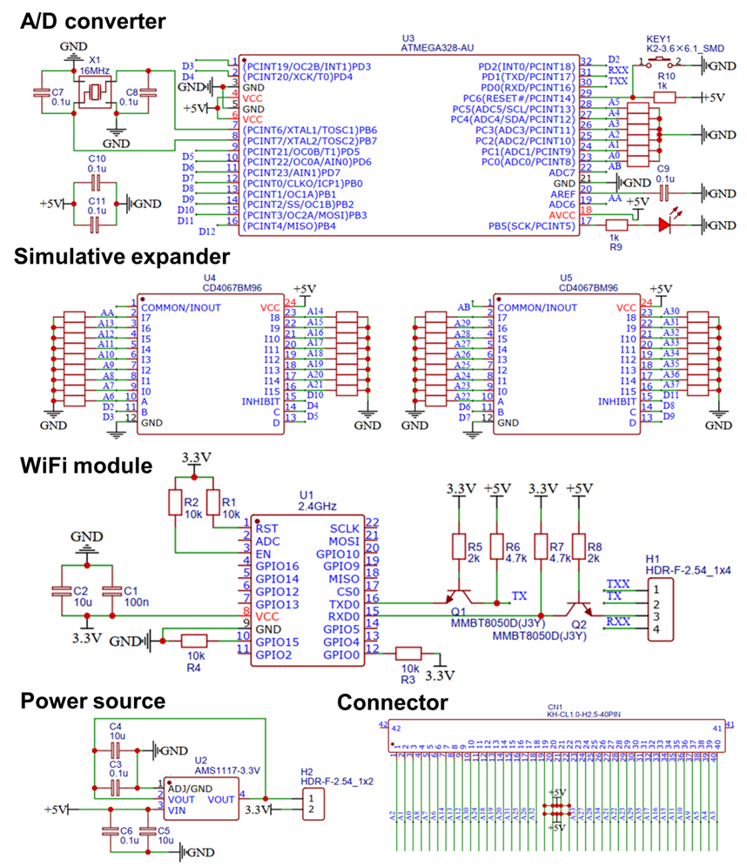
Supplementary Fig. 32 | The circuit logic diagram of wireless coordinated collection system.

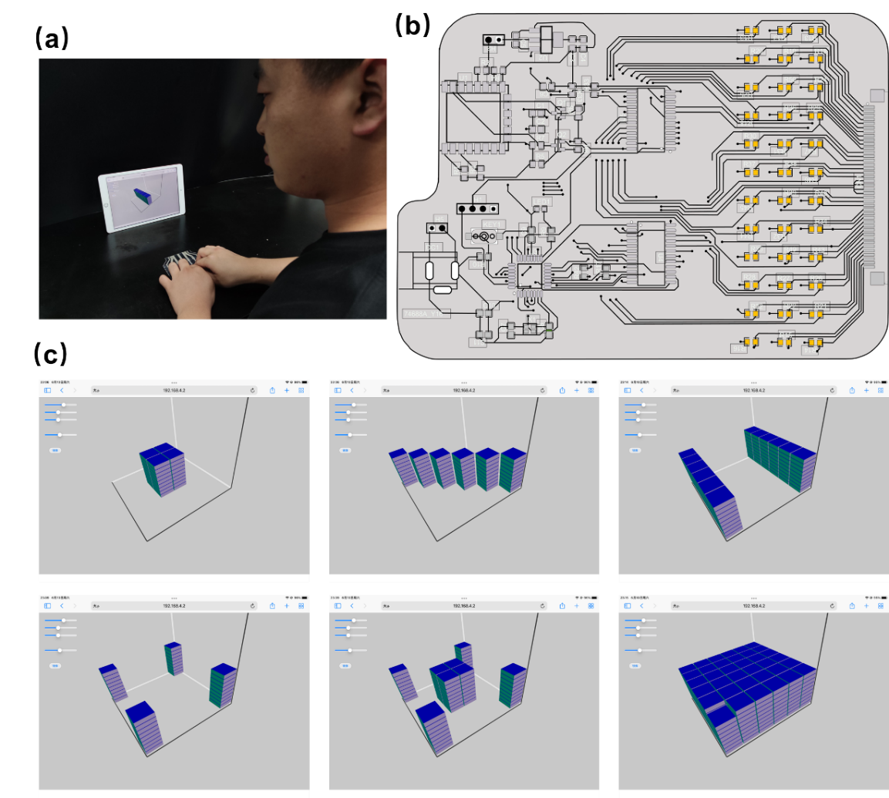
Supplementary Fig. 33 | (a) Optical image for haptic feedback via assembled FPTA. (b) The smart integrated reading circuits. (c)The high-resolution pressure distribution and intensity grade mapping on tablet computer.
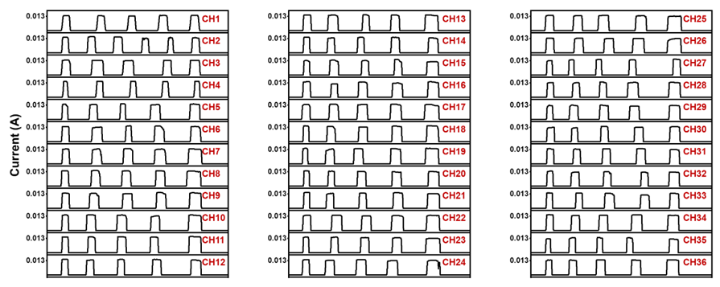
Supplementary Fig. 34 | The output current signals of 36 pixels on FPTA showing the desirable uniformity of tactile signal feedback.

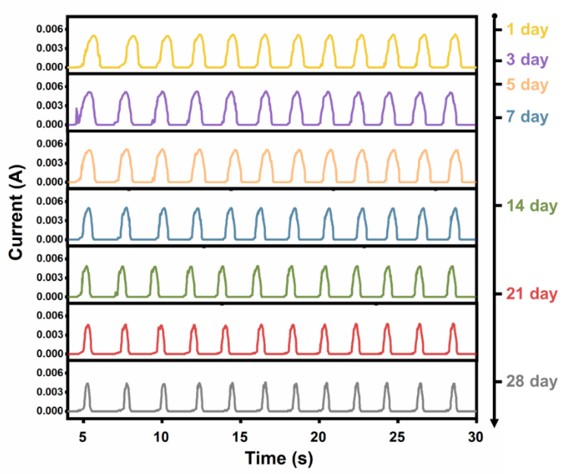
Supplementary Fig. 35 | Long-term operation of the FPTA over 28 days, indicating the excellent stability for practical application.
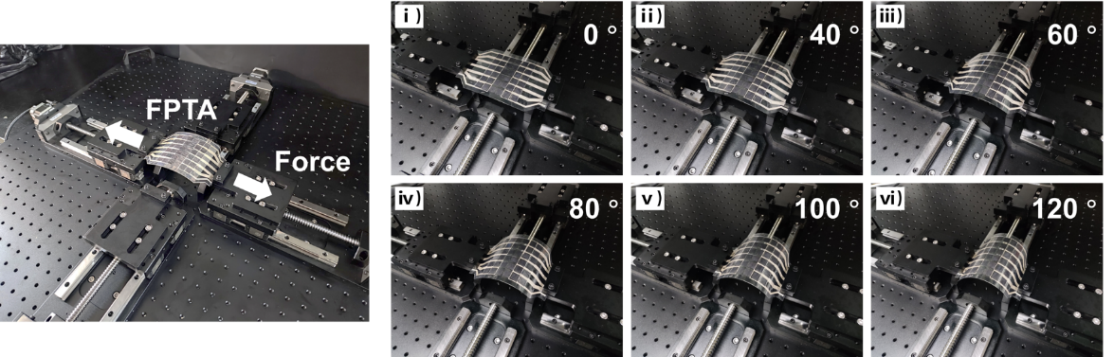
Supplementary Fig. 36 | Demonstration of horizontal tension machine and the continuous bending process of FPTA, verifying the robust integrity of FPTA.

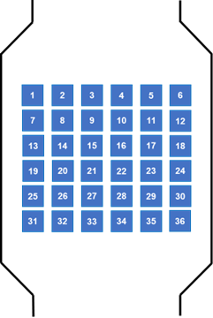
Supplementary Fig. 37 | Serial number of pixels in FPTA.

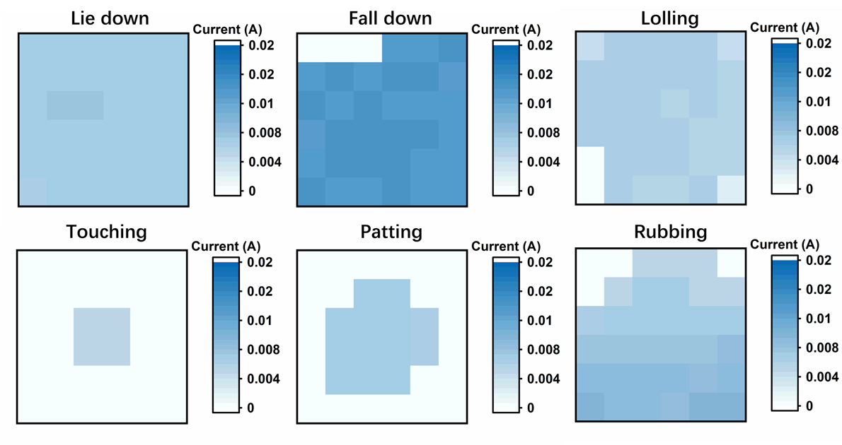
Supplementary Fig. 38 | The haptic signal intensity and distribution recorded by 36 pixels FPTA for different behaviors (lie down, fall down, lolling, touching, patting, and rubbing, respectively).

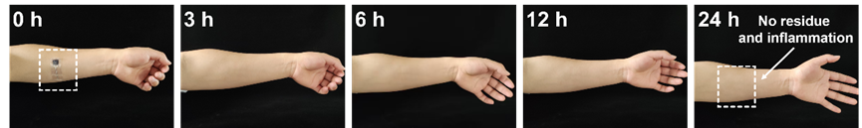

Supplementary Fig. 39 | Photographs showing the excellent skin-friendly capability of assembled LAHA pressure sensor after attachment for 24 h (the volunteer is one of the authors and signed the informed consent).

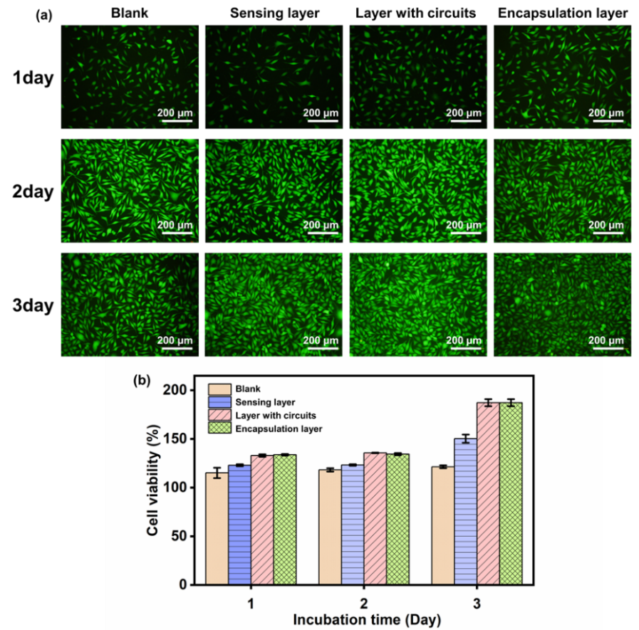
Supplementary Fig. 40 | Cell viability. (a) Confocal laser scanning microscopy (CLSM) micrographs of fibroblasts L929 on different interface of FPTA including sensing layer, layer with circuits, and encapsulation layer, and (b) the corresponding cell viability over 1, 2, and 3 days, respectively. Error bars are defined as SD (n = 3 independent samples).

Supplementary Note 5. Verification of biocompatibility and nontoxicity.
Biocompatibility is crucial to avoid skin itching and redness during on-skin sensing application. To assess the effect of FPTA on cell proliferation, a leaching pattern test was conducted to evaluate the cytotoxicity (Figure S40, Supporting Information). The mouse osteoblasts (L929) were cultured on different components of assembled FPTA (sensing layer, layer with circuits, and encapsulation layer), with tissue culture plate (TCP) as a control. Before cell culture or the implantation experiment, the prepared FPTA was purified by repeated purification in a phosphate-buffered saline solution and 75% alcohol to remove excessive residues. The LIVE/DEAD viability assay was used to show the morphology of the cells via confocal laser scanning microscopy images. All the groups exhibited continuous L929 cell proliferation in the following 2 days’ incubation and the great majority of the L929 cells were stained in green (live cells) with a spindle-like morphology, and only a small number of cells were stained in red (dead cells). The cell viability of the examined samples was even higher than that of the TCP group after 3 days’ incubation, indicating the excellent cytocompatibility of the assembled FPTA for supporting cell adhesion and spreading.
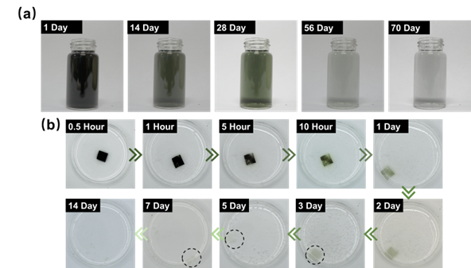
Supplementary Fig. 41 | Optical images of (a) the complete degradation process of MXene solution (0.2 mg/mL) over 10 weeks and (b) the MXene degradation and nanofibril disintegration of prepared sensing layer in 2 wt % H₂O₂ solution at room temperature over 2 weeks.

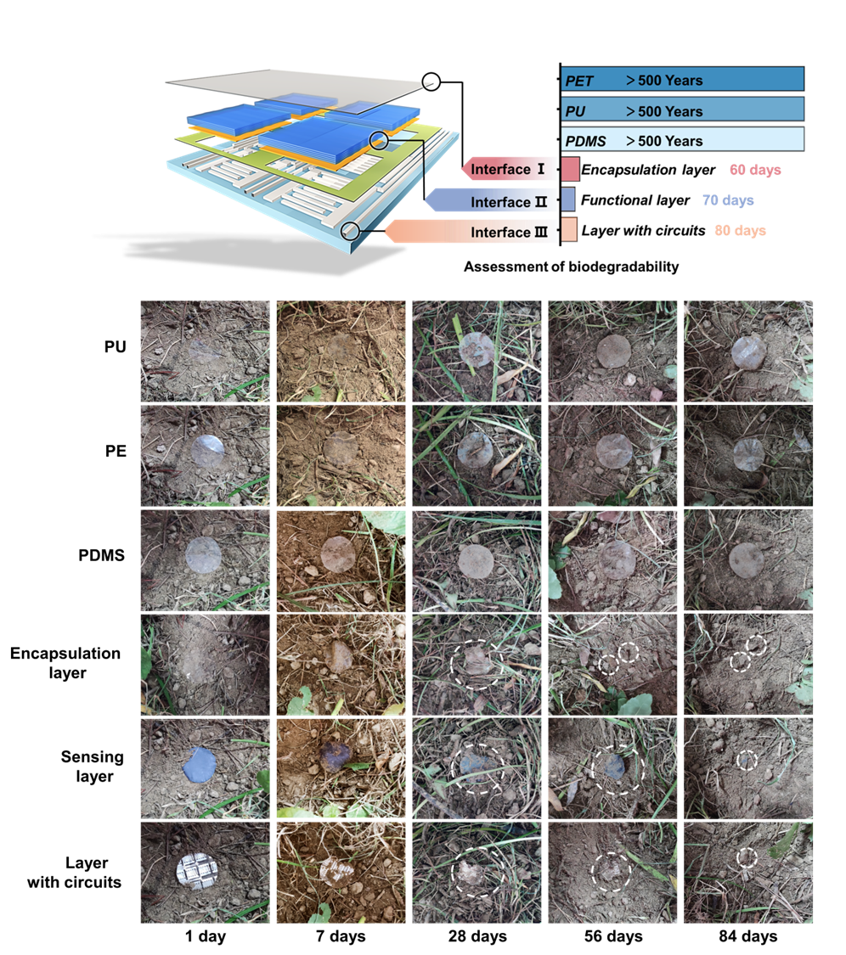
Supplementary Fig. 42 | Optical images of the degradation process for comment petroleum derived substrates (PU, PE, and PDMS) and the assembled FPTA (encapsulation layer, sensing layer, and layer with circuits) over 12 weeks.

Supplementary Note 6. Biodegradability assessment.
The prevalent use of transient electronics has resulted in a large amount of pollution caused by electronic waste. Therefore, the device proposed in this study was intentionally designed to degrade easily. TOCNF, as one kind of modified nanocelluloses, is a promising nanoparticle coming from natural cellulose like tree, cotton, straw, and grass, possessing appealing eco-friendly and user-friendly features¹¹. Additionally, MXene nanosheet is a kind of two-dimensional transition metal carbide or carbon nitride layered materials, which are mainly connected by van der Waals forces and possess excellent conductivity. Although previous reports^{7,12} have confirmed that the MXene nanosheet can maintain electrochemical performances for up to a month, there is no denying the oxidative decomposition of MXene nanosheet in the environment (Supplementary Fig. 41a), but this property also brings a new opportunity for sustainable electronics. We thereby speculate that the assembled FPTA composed of TOCNF and MXene can be completely degraded into small molecules in the soil within a certain time in sharp contrast to the widely used commercial nondegradable substrates like PDMS, PET, and PU.

Herein, we chose H₂O₂ (0.1 wt%), a common industrial oxidant, regarded as medical disinfectant, industrial fungicide, and cotton fabric bleach in daily life, to study the completely degradable property of full paper integrated tactile array. As shown in Supplementary Fig. 41b, the sensing layer (1×1 cm) achieve the degradation of MXene and nanofibril disintegration from the both side layers to the middle one with the time passing and almost completely degraded in 14 days in 0.1 wt% H₂O₂ at room temperature. Specifically, the sensing layer faded from black to greyish-green and eventually to white after 1 day because of the oxidation of MXene under the influence of H₂O₂. Simultaneously, the sensing layer became partly transparent, which implied the dispersion of cellulose nanofibrils. After 3 days, collapse of the structure was observed. Subsequently, the square sample became more transparent, gel-like, and gradually dispersed into smaller pieces until it almost completely disappeared after 14 days.

Additionally, direct outdoor soil burial (10 cm underground, 39°53 '-40 °09' N, 116°03 '-116 °23' E, campus of Beijing Forestry University) is carried out to evaluate the biodegradability of FPTA including encapsulation layer, sensing layer, and layer with circuits within 3 months. For comparison, the common petroleum derived flexible substrates, such as polyurethane (PU), polyethylene (PE), and polydimethylsiloxane (PDMS) with same size (4 cm × 4cm × 0.1mm) were used as controls to study their degradability (Supplementary Fig. 42). Ultimately, the all components of FPTA are degraded nearly 100% after 56-84 days, probably attributed to the possible rain-soaked treatment in nature and the existence of microorganisms that can directly attack and digest the cellulose chain, thus greatly avoiding the burdens of plastic wastes on the environment. On the contrary, the above commercial substrates maintain their original shape without any weight loss during the same burial time.

Considering the soil environment of different locations and the inherent hygroscopicity of cellulose, we did not quantitatively assess the degradation by measuring the dry weight of samples in each period, but the visible disappearance over a long period and the obvious comparison with the plastics substrates already indicated the desirable degradability of the assembled FPTA^{13,14}. In general, we have demonstrated the effective biodegradation of all components except Ag-based circuits, which is a tiny fraction of the total devices. Therefore, we believe that the full paper integrated tactile array can be effectively degraded within a certain time that dramatically meet the concept of green sustainable development, which is rarely reported in the field of flexible electronics (Compared with current reports in Supplementary Table 5).

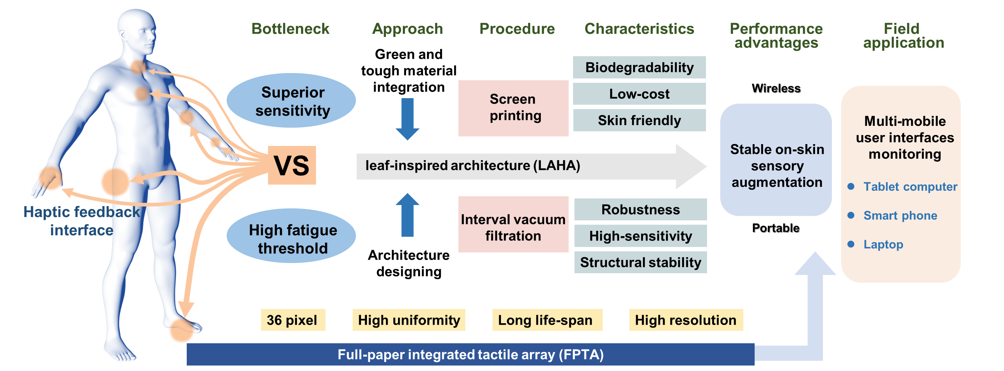
Supplementary Fig. 43 | Research flow of the FPTA monitoring system for stable haptic feedback.
Supplementary Table 1 | Mechanical parameters including tensile stress, tensile strain, elastic modulus, and toughness of cellulose nanofibrils (with various function groups) based sensing layer including TOCNF, CNF, SCNF, ZCNF, and CACNF, respectively.

Samples | Tensile stress  (MPa) | Tensile strain  (%) | Elastic modulus  (MPa) | Toughness  (MJ/m³)
TOCNF | 122.23 | 4.66 | 29.75 | 2.79
CNF | 46.45 | 3.7 | 13.92 | 0.83
SCNF | 78.05 | 4.35 | 20.22 | 1.57
ZCNF | 55.93 | 2.44 | 24.89 | 0.62
CACNF | 19.47 | 2.68 | 7.47 | 0.19

Supplementary Table 2 | Mechanical performances of LAHA sensing layer with different TOCNF contents (0.05, 0.1, 0.15, 0.2, and 0.25 wt%, respectively).

Cnontents  (wt %) | Tensile stress  (MPa) | Tensile strain  (%) | Elastic modulus  (MPa) | Toughness  (MJ/m³)
0.05 | 82.14 | 3.99 | 23.11 | 1.73
0.1 | 84.17 | 3.94 | 22.3 | 1.94
0.15 | 92.19 | 3.84 | 26.35 | 1.89
0.2 | 102.1 | 4.26 | 26.17 | 2.58
0.25 | 111.36 | 4.72 | 26.36 | 3.15

Supplementary Table 3 | Comparison of the unprecedented durability of LAHA based pressure sensor in our work with state-of-the-art counterparts with different architecture designs and material integration including aerogel, film, hydrogel, textile, elastomer, and paper, respectively.
Supplementary Table 4 | Comparison chart of the competitive piezoresistive performances of LAHA pressure sensor in this work with previously reported tactile sensors.
Supplementary Table 5 | Comparison of the collection features of the assembled tactile array in this work with reported tactile electronics in recent references.
Supplementary References
- Du, W. et al. Conformable ultrasound breast patch for deep tissue scanning and imaging. Sci. Adv. 9, 5325 (2023).
- Li, J. et al. Thin, soft, wearable system for continuous wireless monitoring of artery blood pressure. Nat. Commun. 14, 5009 (2023).
- Zu, L. et al. Multiangle, self-powered sensor array for monitoring head impacts. Sci. Adv. 9, 5152 (2023).
- Li, Xi. et al. The choice of ionic liquid ions to mitigate corrosion impacts: the influence of superbase cations and electron-donating carboxylate anions. Green Chem. 24, 2114-2128 (2022).
- Zhao, D. et al. Cellulose-based flexible functional materials for emerging intelligent electronics. Adv. Mater. 33, 2000619 (2021).
- Wang, T. et al. Mechanically durable memristor arrays based on a discrete structure design. Adv. Mater. 34, 2106212 (2022).
- Guo, Z. et al. Kirigami-based stretchable, deformable, ultralight thin-film thermoelectric generator for body NET application. Adv. Energy Mater. 12, 2102993 (2022).
- Xu, J. et al. Electrooculography and tactile perception collaborative interface for 3D human–machine interaction. ACS Nano 16, 6687−6699 (2022).
- Zheng, X. et al. Highly breathable and sensitive pressure sensors with multi-layered porous structure. Adv. Funct. Mater. 33, 2214880 (2023).
- Cantarella, G. et al. Laser-induced, green and biocompatible paper-based devices for circular electronics. Adv. Funct. Mater. 33, 2210422 (2023).
- Zou, J. et al. Highly efficient and environmentally friendly fabrication of robust, programmable, and biocompatible anisotropic, all-Cellulose, wrinkle-patterned hydrogels for cell alignment. Adv. Mater. 31, 1904762 (2019).
- Li, X. et al. MXene chemistry, electrochemistry and energy storage applications. Nat. Rev. Chem. 6, 389-404 (2022).
- Chai, S., Zan, G., Dong, K., Wu, T. & Wu, Q. Approaching superfoldable thickness-limit carbon nanofiber membranes transformed from water-soluble PVA. Nano Lett. 20, 8831–8838 (2021).
- Chiong, J., Tran, H., Lin, Y., Zheng, Y. & Bao, Z. Integrating emerging polymer chemistries for the advancement of recyclable, biodegradable, and biocompatible electronics. Adv. Sci. 8, 2101233 (2021).

