Appendix A1. Data availability, model calibration, and validation
A1.1 Data availability
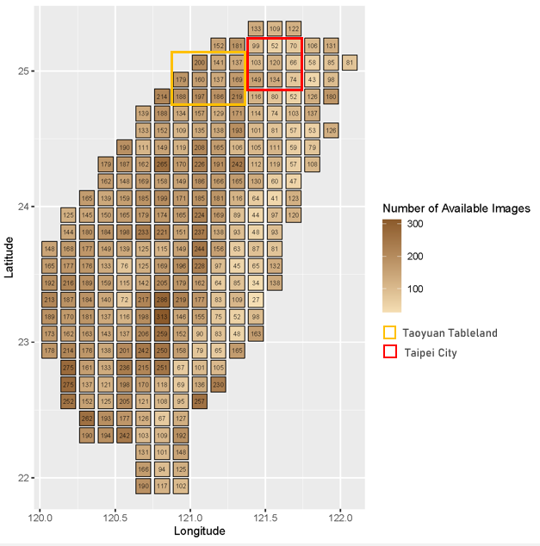
Fig. A1. Available SPOT Images from 2013-2022

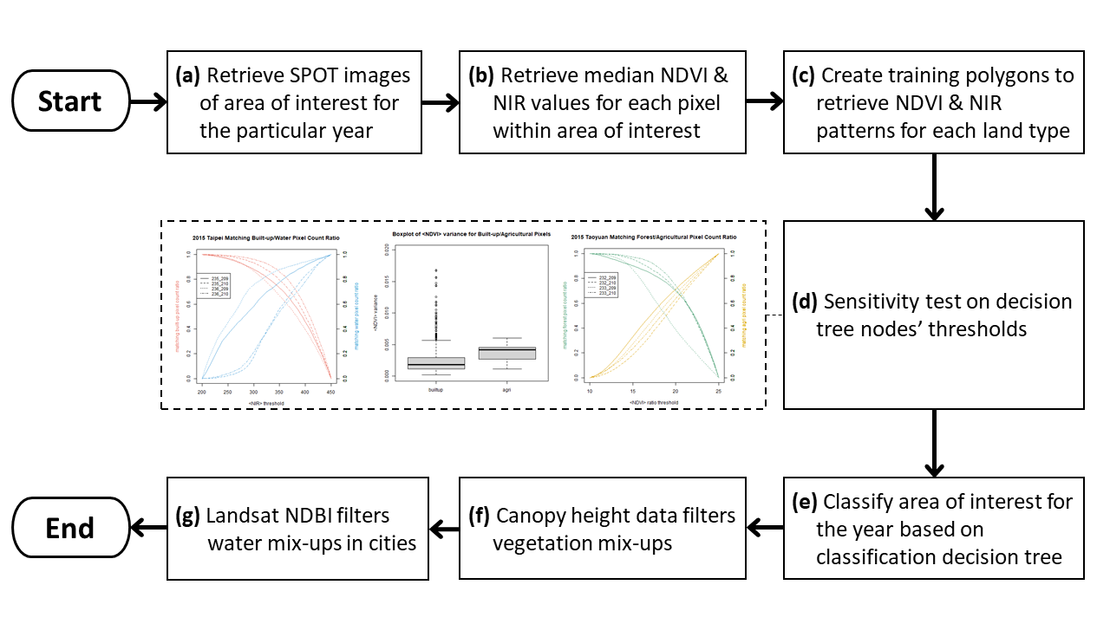
Fig. A2. PCM Flowchart: (a) Available SPOT images from 2013-2022; (b) Data pre-processing method illustration; (c) Monthly median NDVI statistics of training polygons; (d) Selectivity test on decision tree's node; (e) PCM decision tree; (f) Post-classification for mixed vegetation; (g) Post-classification for built-up water mixture.

A1.2 Model calibration
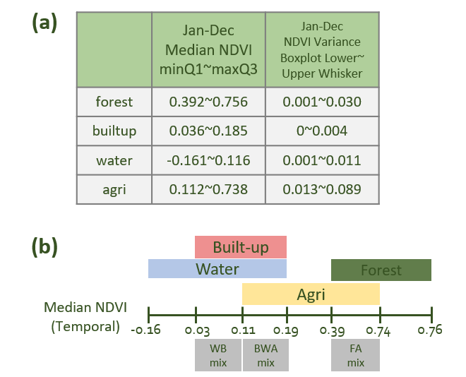
Fig. A3. Monthly Median NDVI Statistics of Training Polygons; (a) The monthly median of NDVI calculated from training polygons, and the temporal dynamics of monthly median NDVI and NDVI variance from January to December. (b) Visualization of the dynamics of monthly median NDVI (over the selected training polygons) of five major land-use/land-cover types, built-up, water, agricultural land, and forest over the training area.

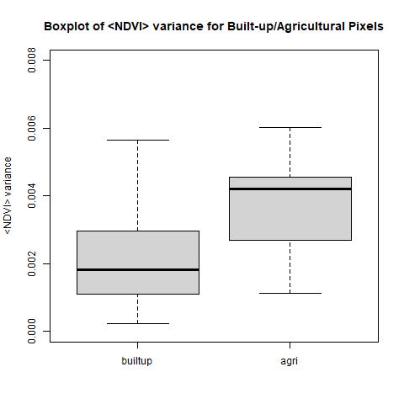
Fig. A4. PCM Decision Tree Threshold – <NDVI> variance
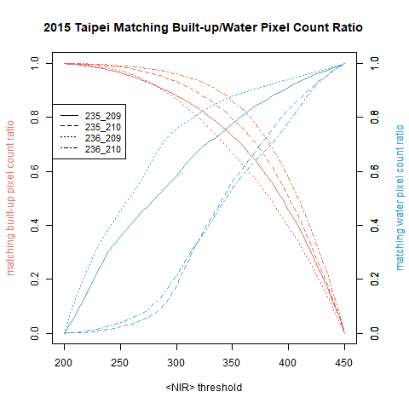
Fig. A5. PCM Decision Tree Threshold – <NIR>
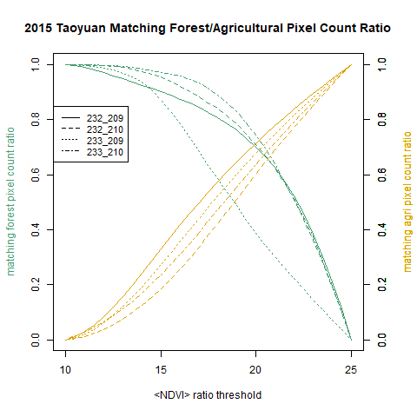
Fig. A6. PCM Decision Tree Threshold – <NDVI> _{max/variance} ratio

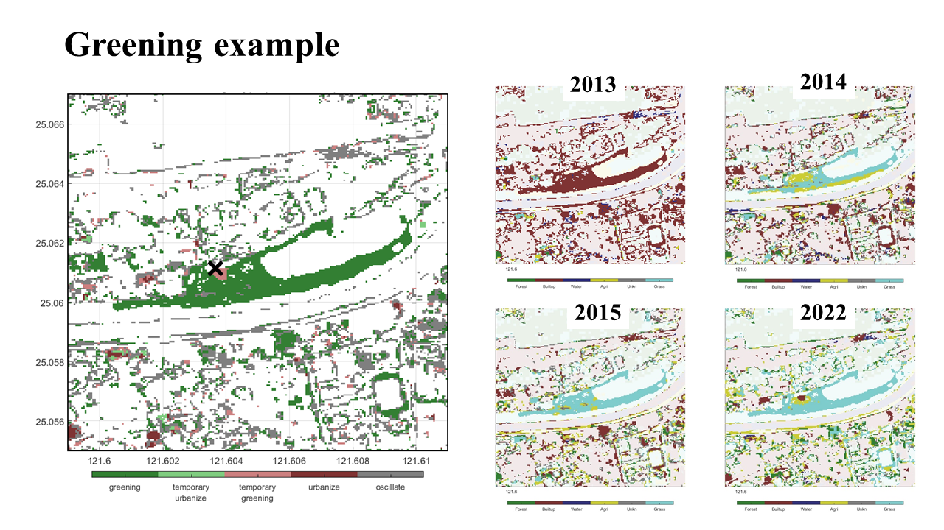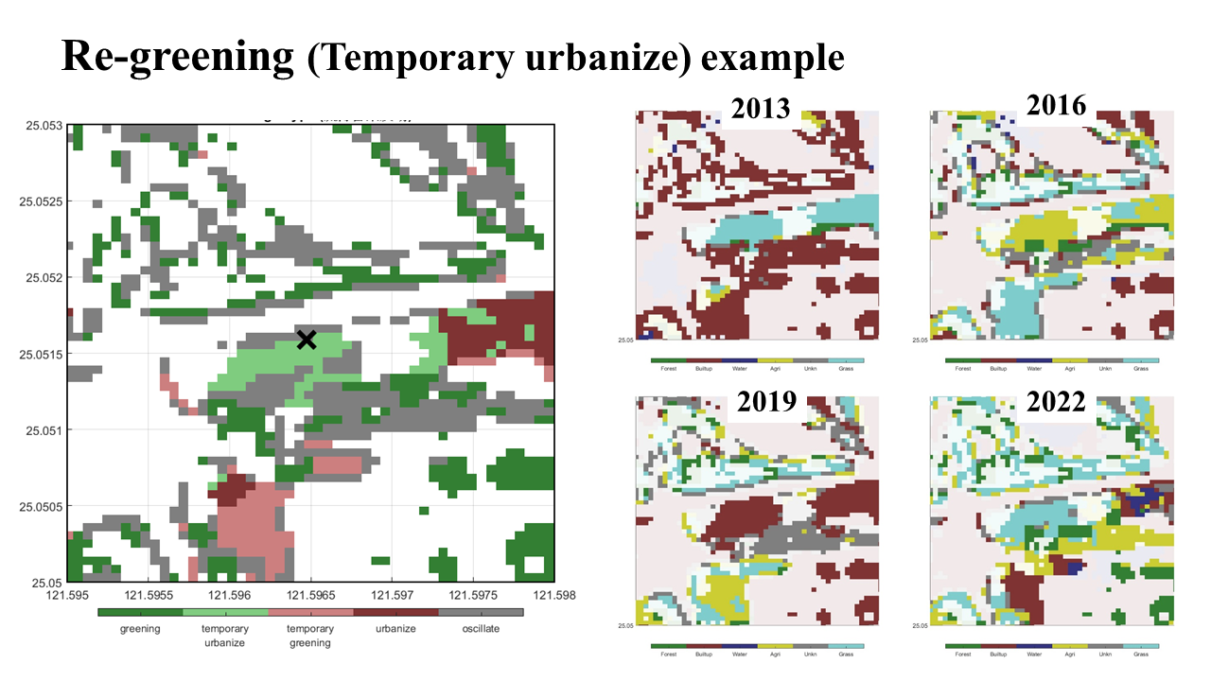
Fig. A7. The demonstration of event-based LULCC analysis for greening events and re-greening events in Taipei City.

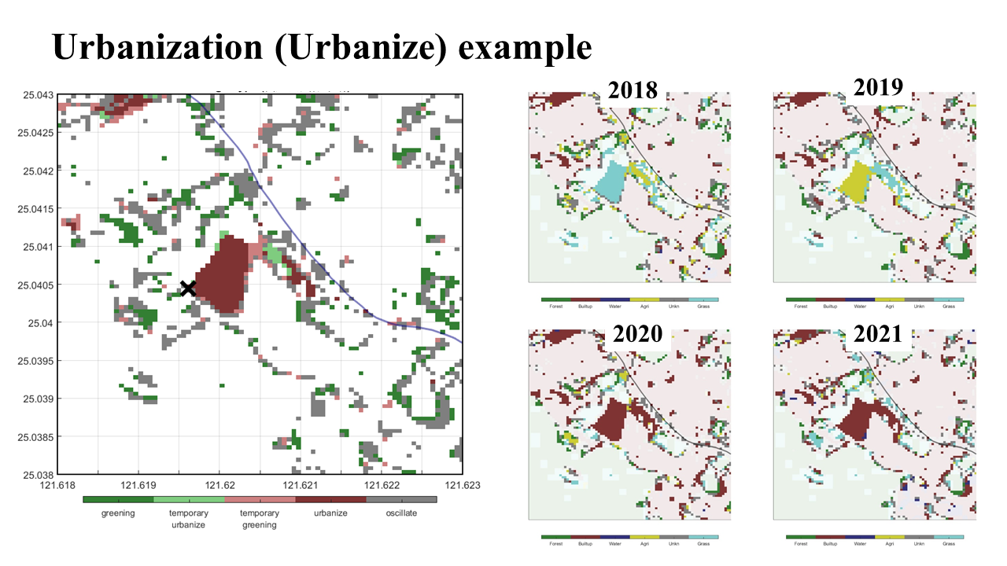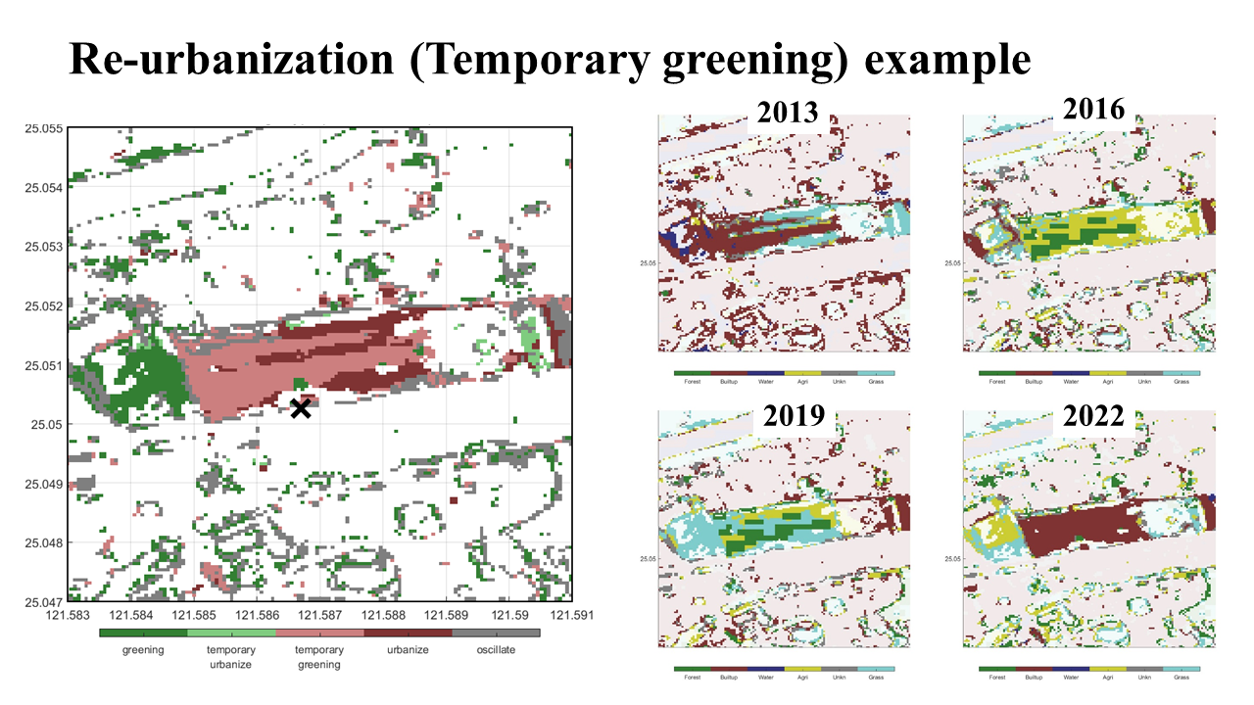
Fig. A8. The demonstration of event-based LULCC analysis for urbanization events and re-urbanization events in Taipei City.
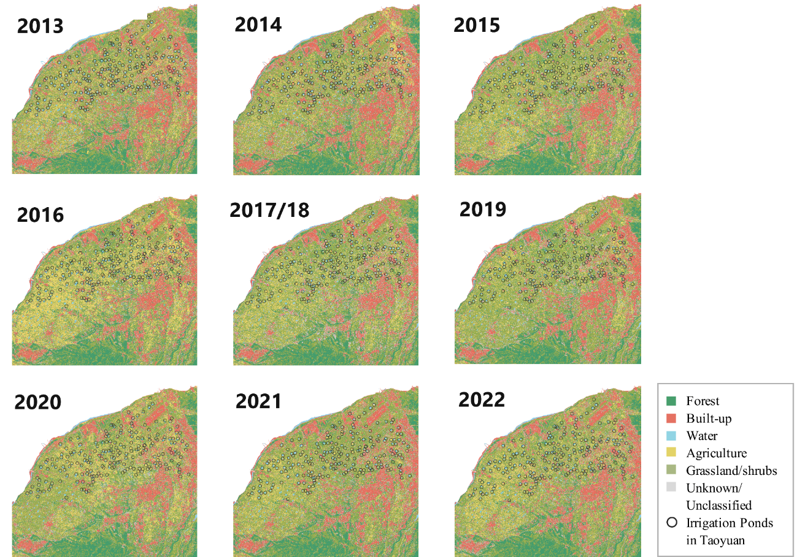
Fig. A9. 2013-2022 PCM classification results of Taoyuan, Taiwan.
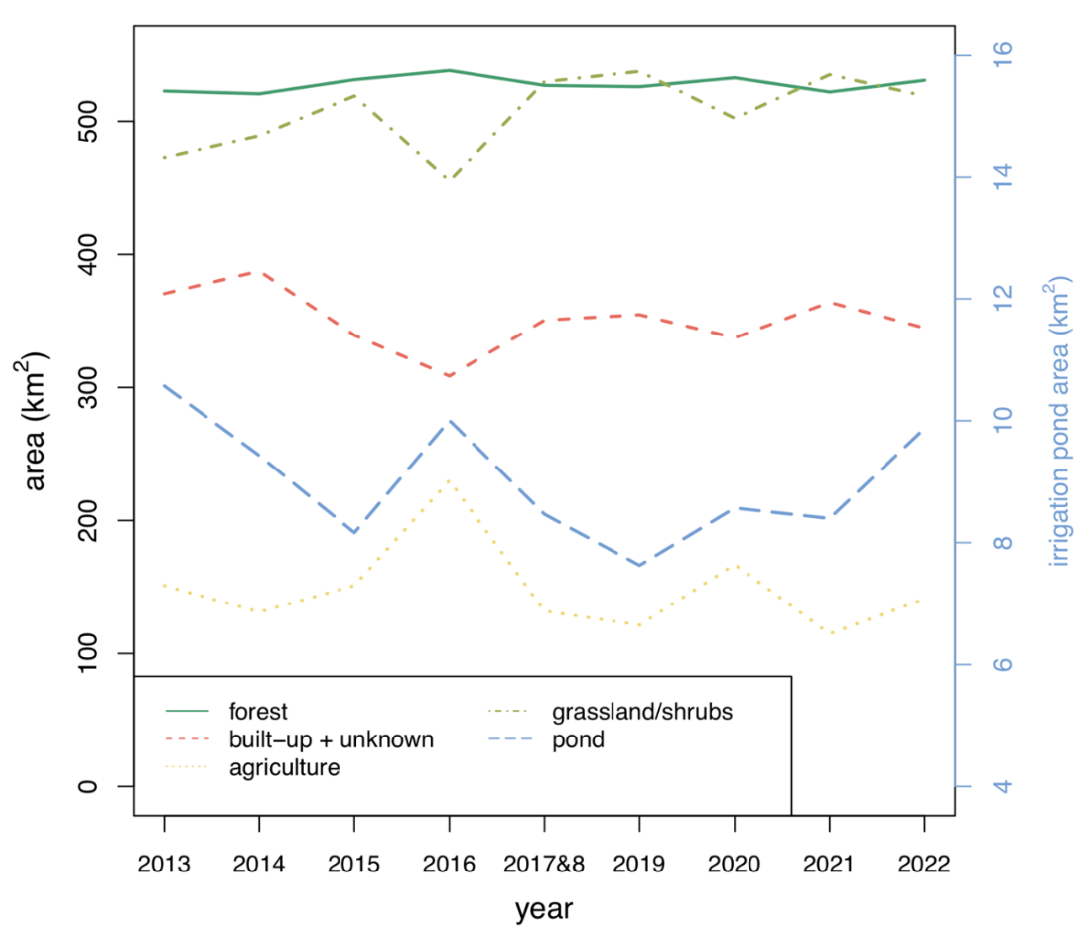
Fig. A10. 2013-2022 PCM-detected land type change in Taoyuan, Taiwan.

Table A1. The definitions of five distinct LULCC patterns, including urbanization, re-urbanization, urban green, urban re-greening, and oscillation, as well as the rules for determining these LULCC events, were applied to analyse the LULCC status of each pixel over the entire study period. These patterns and rules are summarized below.
LULCC patterns | Rules for Determining Pixel-Level LULCC Patterns
Greening | Urban Green
Re-greening | Green Urban (at least 2 years) Green
Urbanization | Green Urban
Re-urbanization | UrbanGreen (at least 2 years) Urban
Oscillation | Conversion back and forth more than 3 times

A.1.3 Model Validation
The 2021 inventory land-use dataset which covers both the northern and southern part of Taiwan was selected for validating the results from PCM algorithm. The control points are randomly selected as the validation points, in total 5000 points were selected, which were used to validate the model performance. All pixels identified as unknown land type derived from the PCM were excluded for the validation. The Kappa value among five land-use types as control points were calculated to verify the accuracy of PCM algorithm. Table A2 Confusion matrix, where the land types with subscription of PCM denotes that the pixels were identified by PCM algorithm. The classification accuracy was evaluated by Cohen’s Kappa coefficient, which shows a value of 0.85 (see Table A2).
Table A2 Confusion matrix, where the land types with subscription of PCM denotes that the pixels were identified by PCM algorithm.
 | Forest_{_PCM} | Built-up_{_PCM} |  | Water_{_PCM} | Agricultural_{_PCM} | Grassland_{_PCM} | Total
Forest | 762 |  | 82 | 58 | 89 | 9 | 1000
Built-up | 0 |  | 952 | 17 | 19 | 12 | 1000
Water | 0 |  | 4 | 996 | 0 | 0 | 1000
Agricultural | 3 |  | 40 | 67 | 890 | 0 | 1000
Grassland | 29 |  | 101 | 45 | 11 | 814 | 1000
Total | 794 |  | 1179 | 1183 | 1009 | 835 | 5000

A2. A table of each irrigation pond’s geolocation and area from 2013 to 2022
A total of 223 irrigation ponds were analysed. For detailed 2013-2022 detected area of each registered irrigation pond, see link:
https://docs.google.com/spreadsheets/d/1U-EGpBzuPBKLuESopwtYnI-6LnEz4Qpv5udKgijtjFY/edit?usp=sharing

