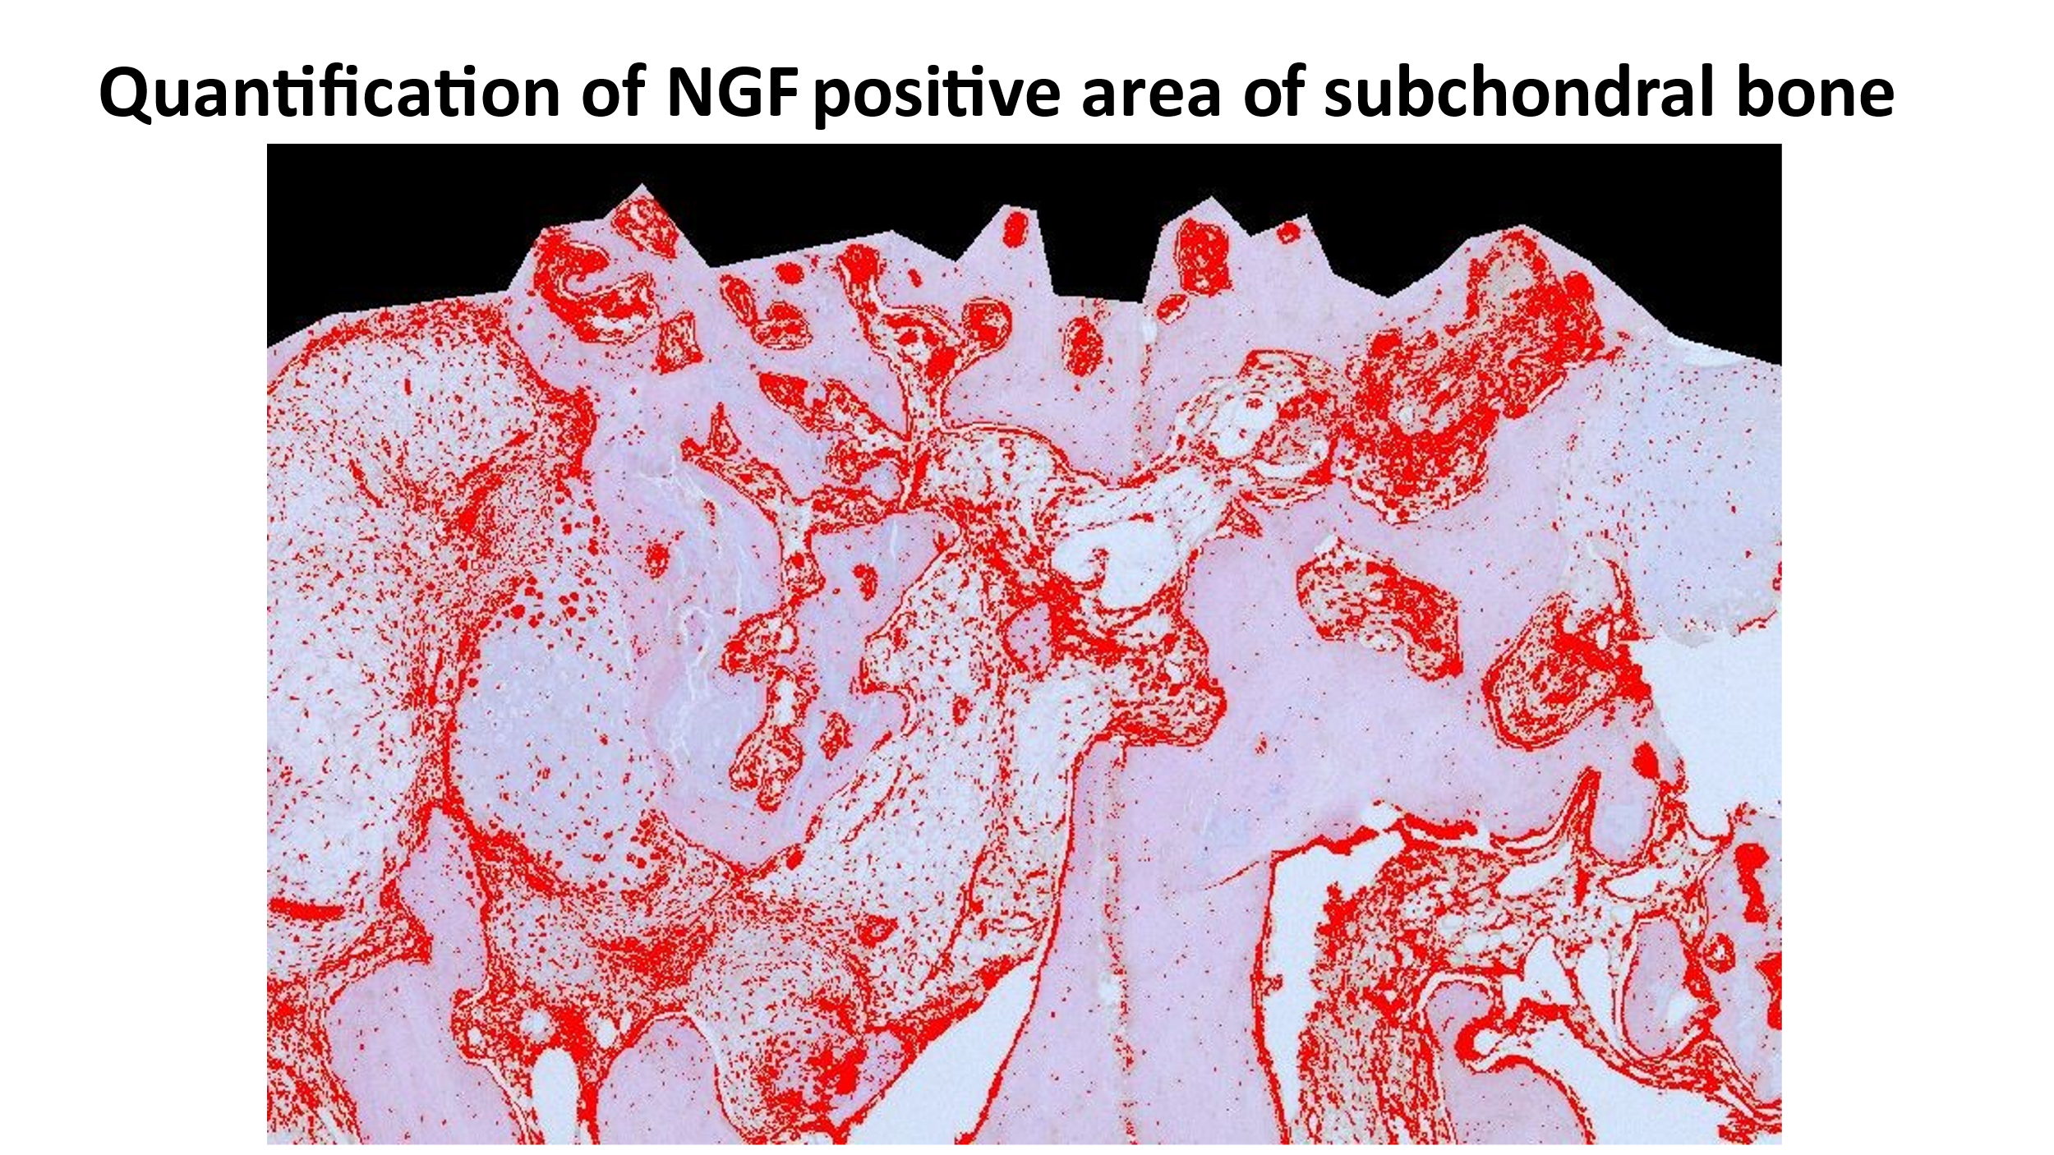
Quantification of NGF expression
NGF positive staining was differentiated from background by thresholding the image according to hue in order to create a mask. The area of positive staining (red area) was automatically measured. The fractional area was determined as the percentage of positive area for NGF immunoreactivity (red area) within the area of ROIs (area of subchondral bone).

