Supporting Information

Functionalized MXene Ink Enables Environmentally Stable Printed Electronics
Tae Yun Ko^{1,2,¶}, Heqing Ye^{3,4,¶}, G. Murali^{5,6,¶}, Seul-Yi Lee^{7,¶}, Young Ho Park^{5,6}, Jihoon Lee^{5,6}, Juyun Lee^{1,2,8}, Dong-Jin Yun⁹, Yury Gogotsi¹⁰, Seon Joon Kim^{1,2,11,*}, Se Hyun Kim^{1,2,*}, Yong Jin Jeong^{6,13,*}, Soo-Jin Park^{7,*}, Insik In^{5,6,*}

¹Materials Architecturing Research Center, Korea Institute of Science and Technology, 5, Hwarang-ro 14-gil, Seongbuk-gu, Seoul 02792, South Korea.
²Convergence Research Center for Solutions to Electromagnetic Interference in Future-mobility, Korea Institute of Science and Technology, 5, Hwarang-ro 14-gil, Seongbuk-gu, Seoul 02792, South Korea.
³School of Electrical Engineering and Automation, Changshu Institute of Technology, Changshu 215500, P.R. China
⁴Department of Chemical Engineering, Yeungnam University, Gyeongsan, 38541, Korea
⁵Department of Polymer Science and Engineering, Chemical Industry Institute, Korea National University of Transportation, Chungju 27469, South Korea.
⁶Department of IT-Energy Convergence (BK21 FOUR), Korea National University of Transportation, Chungju 27469, South Korea.
⁷Department of Chemistry, Inha University, Inharo 100, Incheon 22212, South Korea
⁸Department of Materials Science and Engineering, Korea University, 145, Anam-ro, Seongbuk-gu, Seoul 02841, South Korea.
⁹Analytical Science Laboratory of Samsung Advanced Institute of Technology (SAIT), Suwon 16678, South Korea.
¹⁰Department of Materials Science and Engineering and A. J. Drexel Nanomaterials Institute, Drexel University, Philadelphia, Pennsylvania 19104, United States.
¹¹Division of Nanoscience and Technology, KIST School, University of Science and Technology, 5, Hwarang-ro 14-gil, Seongbuk-gu, Seoul 02792, South Korea.
¹²Division of Chemical Engineering, Konkuk University, Seoul 05029, South Korea.
¹³Department of Materials Science and Engineering, Korea National University of Transportation, Chungju 27469, South Korea.
¶Tae Yun Ko, Heqing Ye, G. Murali, and Seul-Yi Lee are the first authors of this manuscript.
*Correspondence: in1@ut.ac.kr (Insik In), sjpark@inha.ac.kr (Soo-Jin Park), yjjeong@ut.ac.kr (Yong Jin Jeong), shkim97@konkuk.ac.kr (Se Hyun Kim), Seonjkim@kist.re.kr (Seon Joon Kim)

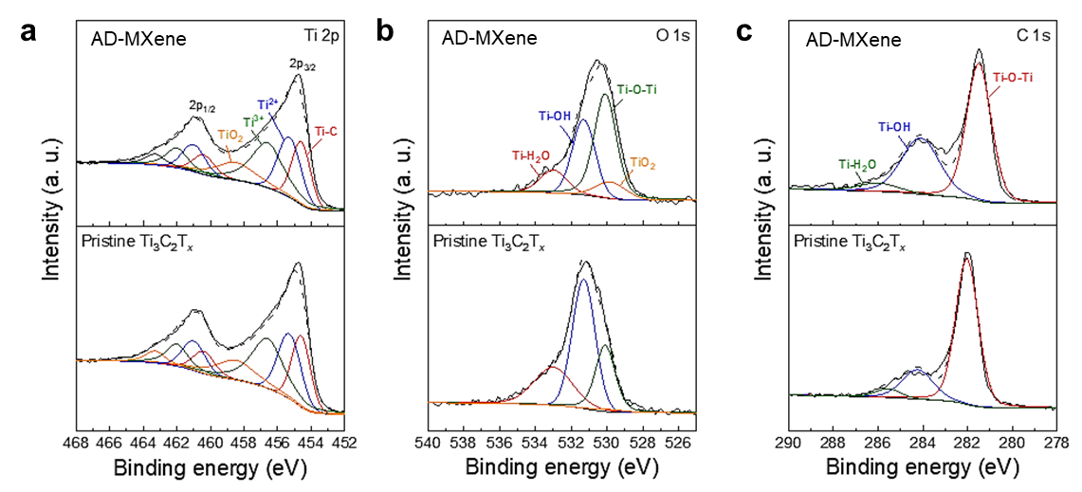
Supplementary Fig. 1: XPS spectra of pristine MXene and AD-MXene. a-c, Ti 2p (a), O 1s (b), and C 1s (c).

Supplementary Fig. 2: XRD patterns of pristine MXene and AD-MXene.

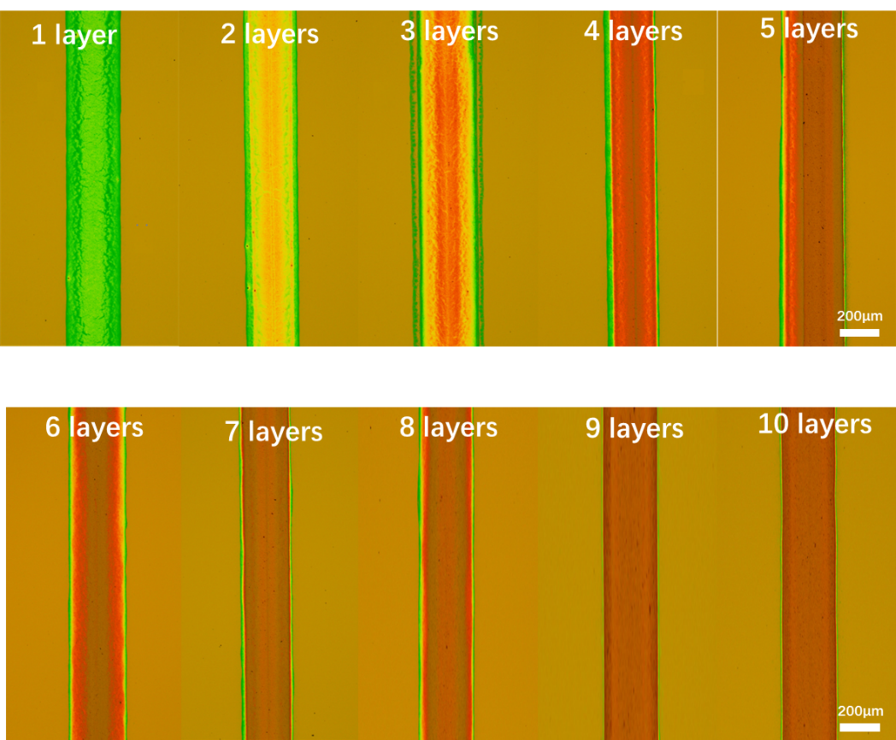

Supplementary Fig. 3. Optical micrographs of AD-MXene lines fabricated with different number of EHD printing cycles.
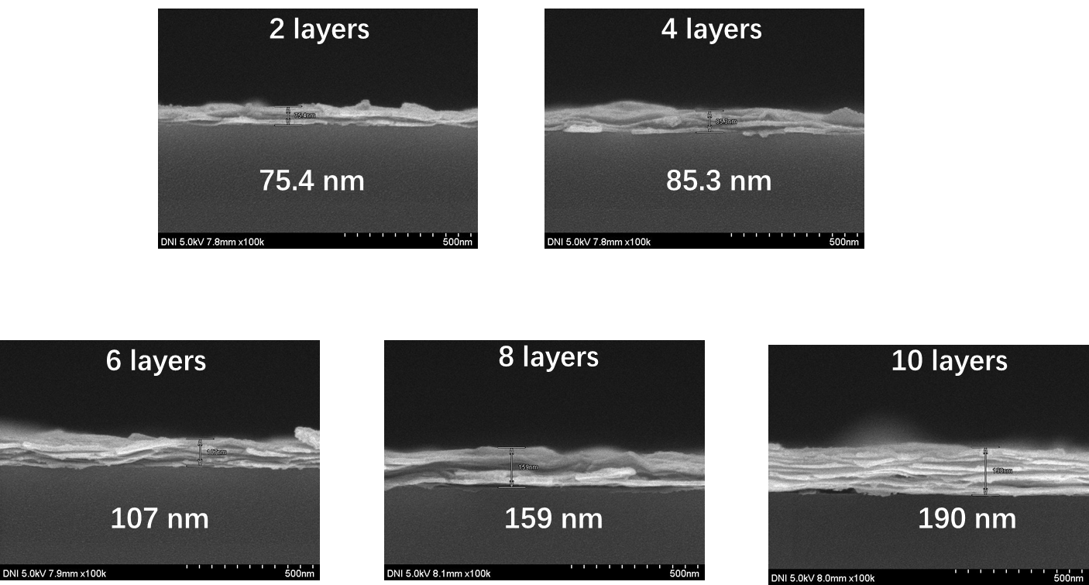
Supplementary Fig. 4. Cross-sectional FE-SEM images of AD-MXene lines fabricated with different number of printing cycles.
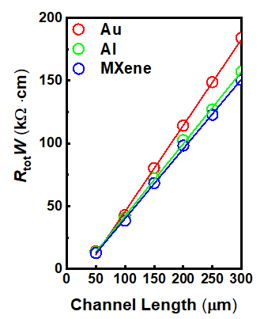
Supplementary Fig. 5. Width-normalized total resistance as a function of channel length for TFTs with Au, Al, and AD-MXene electrodes.
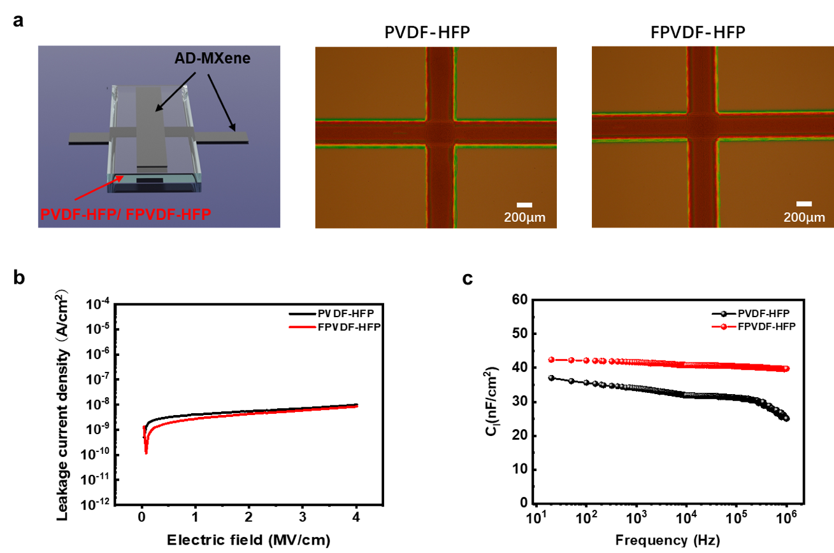
Supplementary Fig. 6. a, Schematic representation (left) and top-view optical images (middle and right) of MIM capacitors with EHD-printed AD-MXene and PVDF-HFP or FPVDF-HFP layers. b,c, Leakage current density as a function of applied electric field strength (b) and areal capacitance (Ci) as a function of frequency (c) plots of MIM capacitors with PVDF-HFP and FPVDF-HFP dielectrics.
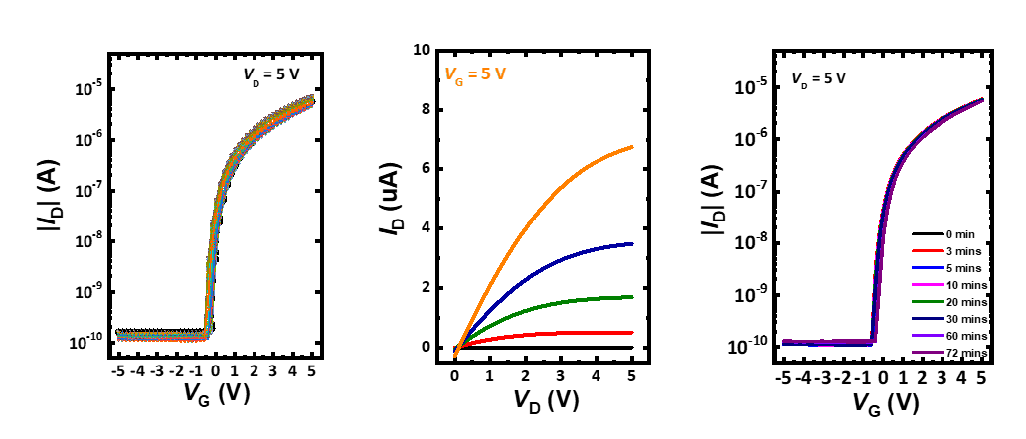
Supplementary Fig. 7. Transfer curves of 64 TFT devices; output characteristics and gate bias stress stabilities of an individual TFT in the array.

Supplementary Fig. 8. Transfer curves after applying programming level (20 V) for 1 s; and erasing level (-20 V) for various time durations (0.3, 0.5, 1.0, and 2.0 s).

