Supplementary Information

Extreme Li-Mg Selectivity via Precise Ion Size Differentiation of Polyamide Membrane
by Quan Peng, et al.

Table of contents

Supplemental methods

Supplemental Figures S1-S9

Supplemental Tables S1-S11

Contents
1. Supplementary Methods 1
1.1 Chemicals and Materials 1
1.2 Fabrication of PA NF membranes 1
1.2.1 Fabrication of PA NF membranes via OSARIP 1
1.2.2 Fabrication of PA NF membranes via traditional IP 2
1.3 Characterization 2
1.3.1 Scanning electron microscopy (SEM) 2
1.3.2 X-ray photoelectron spectroscopy (XPS) 2
1.3.4 Total organic carbon (TOC) 2
1.3.5 Streaming potential measurement 3
1.3.6 Interfacial tension measurement 3
1.4 Membrane performance test 3
1.4.1 Determination of salt rejection and Li⁺/Mg²⁺ selectivity 3
1.4.2 Determination of MWCO and pore size distribution of PA NF membranes 4
1.5 SDEM model 5
2. Supplementary figures 6
2.1 Variation of water/hexane interfacial tension and PIP concentration near the interface 6
2.2 Surface chemical composition and zeta potential of the PA NF membranes prepared from traditional IP and OSARIP 8
2.3 Desalination performance of the PA NF membranes prepared from OSARIP 9
2.4 MgCl₂ rejection of NF membranes reported in literatures 11
2.5 Size, hydration energy, and corresponding rejection of various cations 12
2.6 MWCO, pore size distribution, and desalination performance of DK membrane 14
2.7 Performance of the PA NF membrane prepared from OSARIP for separating Li⁺ and Mg²⁺ from binary salt mixture solution 15
2.8 Summary of Li/Mg selectivity of various membranes 16
2.9 PA NF membranes prepared from different conditions 18
2.10 PA NF membranes prepared from OSARIP by using PEI and TMC as the monomers 19
3. Supplementary references 21

1. Supplementary Methods

1.1 Chemicals and Materials
Trimesoyl choride (TMC, 98%) was purchased from Sigma-Aldrich and piperazine (PIP, 99%) was purchased from Aladdin. Didecyl phosphate (95%) was purchased from TCI and monododecyl phosphate (90%) was purchased from Alfa. Commercial polyethersulfone (PES) ultrafiltration membrane with MWCO of 50000 Da was purchased from Risingsun Membrane Technology Co., Ltd. (Beijing, China). Na₂SO₄ (≥99%), MgSO₄ (≥99%), MgCl₂∙6H₂O (≥99%), CaCl₂∙2H₂O (≥99%), NaCl (≥99.5%), LiCl (99%), ZnCl₂ (99%), CuCl₂ (99%), NiCl₂ (99%), CoCl₂ (99%), BaCl₂ (99%), CuCl₂ (99%), KCl (99%), RbCl (99%), CsCl (99%), glycerol (99%), xylose (99%), sucrose (99%), glucose (99%), n-hexane (97%) and raffinose (98%) were all brought from Innochem (Beijing, China).

1.2 Fabrication of PA NF membranes

1.2.1 Fabrication of PA NF membranes via OSARIP
Initially, aqueous solution containing 5 g/L PIP and hexane solutions containing 2 g/L TMC and a certain amount of dodecyl phosphate (DDP) were prepared, respectively. The two kinds of solutions were subsequently heated to 35°C and kept at this temperature for further use. To fabricate the PA NF membranes via traditional IP, the top surface of the PES ultrafiltration membrane was first contacted with PIP aqueous solution for 60 s. Any visible aqueous drops on the membrane surface were then gently wiped away using a clean sheet. The TMC hexane solution containing DDP was then poured onto the surface of the PES and held horizontally for 30 s. The membrane was subsequently washed with pure hexane solution for 30 s to remove any unreacted TMC. The resulting membranes were cured in an oven at 60 °C for 30 minutes, and the membranes were finally washed with pure water and stored in water at 4 ºC for further use.

1.2.2 Fabrication of PA NF membranes via traditional IP
The process of creating PA membranes via traditional IP is similar to the fabrication of membranes via OSARIP but without the addition of DDP in hexane containing TMC.

1.3 Characterization

1.3.1 Scanning electron microscopy (SEM)
SEM images were characterized by a Su8200 (Hitachi, Japan) field emission scanning electron microscopes (FE-SEM). Before characterization, the membrane samples were dried in an oven at 60 ºC for 30 minutes. Subsequently, they were sprayed with platinum at 20 mA for 1 minute.

1.3.2 X-ray photoelectron spectroscopy (XPS)
The surface chemical compositions of PA NF membranes were analyzed using a X-Ray photoelectron spectroscopy (Thermo Fisher Scientific ESCALAB Xi+). For XPS measurement, high-resolution scans were conducted for carbon, nitrogen, and oxygen regions. The resulting XPS spectra were analyzed using a XPSPEAK41 software. The crosslinking degree of PA selective layers were determined based on the atomic content ratio of O and N elements detected by XPS.^{1,2} 1.3.3 Transmission electron microscopy (TEM)
Cross-sectional TEM images of PA NF membranes were obtained on a Tecnai G2 F20 S-TWIN field emission TEM. To prepare TEM samples, the PA NF membranes were first cut into 2 mm wide strips using a microtome (Leica EM UC7). Then the samples were embedded in epoxy resins and dried at 60°C for 24 hours before placed on carbon support grids.

1.3.4 Total organic carbon (TOC)
The concentration of neutral molecules in the feed solution and permeate were measured using the OI Analytical Aurora Model 1030 through total organic carbon (TOC) analysis.

1.3.5 Streaming potential measurement
The surface zeta potentials of PA NF membranes were measured on an electro-kinetic analyzer (SurPASS3, Anton Paar) with a pH scanning range of 2 to 10.5.

1.3.6 Interfacial tension measurement
An interfacial tensiometer (BZY200, Shanghai Fangbo) was used to measure the interfacial tension between PIP aqueous solution and TMC hexane solution containing DDP in different concentrations.

1.4 Membrane performance test

1.4.1 Determination of salt rejection and Li⁺/Mg²⁺ selectivity
In this study, we utilized a cross-flow filtration system containing three circular cells to evaluate the separation performance of PA NF membranes. Before testing, the membrane was compacted using pure water at 6 bar for 1 h. Next, various salt solutions with a concentration of 1000 ppm were used as feed to pass through the membrane at 4 bar with a cross-flow rate of 50 L/h. The temperature of feed solution was maintained at 25 ºC. To calculate the permeance of the PA NF membranes, we employed equation S1.$\begin{aligned}Permeance=\frac{∆V}{A∙∆t∆P}\#\left(S1\right)\end{aligned}$
where $∆V$ (L) is the permeate volume collected within the period of ∆t (h). $A$(m²) is the effective area of the membrane, which is 7.1×10⁻⁴ m². ∆P (bar) is the applied pressure.
The salt rejection, R (%), of the membranes is calculated according to equation S2:
$$\begin{aligned}R=\left(1-\frac{C_{p}}{C_{f}}\right)×100\%\#\left(S2\right)\end{aligned}$$
where C_{p} and C_{f} is used to denote permeate and feed solution concentrations, respectively, which is determined by the conductivity measured by a conductivity meter (FE30K, Mettler Toledo).
For evaluating the performance of PA NF membrane for separating Li⁺ from brine, binary salt mixtures of MgCl₂ and LiCl with various concentrations and various Mg²⁺/Li⁺ mass ratios were used as the feed solutions. Within the experiment, the applied pressure is 4 bar, and the cross-flow rate is 50 L h⁻¹. The concentrations of Mg²⁺ and Li⁺ in the permeate and feed solutions were determined by inductively coupled plasma spectroscopy (ICP, Agilent 5100, Bruke). The rejections of R_{Mg2+} and R_{Li+} were determined by equation S2. The Li⁺/Mg²⁺ selectivity, S_{Li/Mg}, was calculated according to equation S3:
$$\begin{aligned}S_{Li/ Mg}=\frac{J_{Li}/C_{f, Li}}{J_{Mg}/C_{f,Mg}}=\frac{(J_{w}∙C_{P, Li})/C_{f, Li}}{(J_{w}∙C_{P, Mg})/C_{f,Mg}}=\frac{C_{P, Li}/C_{f, Li}}{C_{P, Mg}/C_{f,Mg}}\#\left(S3\right)\end{aligned}$$
where J_{Li} and J_{Mg} are the flux of Li⁺ and Mg²⁺, respectively; C_{f,Li} and C_{f,Mg} are the concentrations of Li⁺ and Mg²⁺ in feed, respectively; C_{p,Li} and C_{p,Mg} are the concentrations of Li⁺ and Mg²⁺ in permeate, respectively; J_{w} is the water flux using the binary salt mixture as feed solution.

1.4.2 Determination of MWCO and pore size distribution of PA NF membranes
The MWCO of the PA NF membranes was determined by a standard method of measuring the rejection of neutral molecules, such as glycerol (92 Da), xylose (120 Da), glucose (180 Da), sucrose (342 Da), and raffinose (504 Da), by the membranes. The aqueous solution of these neutral molecules with a concentration of 200 ppm was used as feed to pass through the membrane at 4 bar. The rejection of neutral molecules was calculated according to equation S2. The concentration of the feed (Cf) and permeate (Cp) of these neutral molecules were qualified by TOC. The MWCO of the membranes was equal to the molecular weight of the neutral molecule with a rejection of 90%.
With the premise of no steric and hydrodynamic interactions between these neutral solutes and the pores of the membranes, the corresponding pore size distribution can be expressed by the probability density function (PDF) (equation S4).
$$\begin{aligned}\frac{dR\left(d_{p}\right)}{dd_{p}}=\frac{1}{r_{p}lnσ_{p}\sqrt{2π}}exp\left[-\frac{{\left(lnd_{p}-lnμ_{p}\right)}^{2}}{2{\left(lnσ_{p}\right)}^{2}}\right]\#(S4)\end{aligned}$$
where d_{p} is the Stokes diameter of the neutral molecules, μ_{p} is the mean pore size and σ_{p} is the geometric standard deviation of the PDF curve. The μ_{p} is equals to the d_{p} of the neutral solute with a rejection of 50%. σ_{p} represents the distribution of the membrane pore size, which is the ratio of d_{p} of the neutral molecule with a rejection of 84.13% to that of 50%. The d_{p} of the neutral solutes is calculated according to equation S5.
$$\begin{aligned}lg\frac{d_{p}}{2}=-1.4962+0.4654lgM\#\left(S5\right)\end{aligned}$$
The pore size range of PA NF membranes is determined from the PDF curve using the data extraction tool (Getdata), where all pores with probability density greater than 0.01 in the curve are included to determine the distribution range of pore size from minimum to maximum.

1.5 SDEM model
The mass transport of mixed electrolyte solutions across the PA NF membrane can be described by the solution-diffusion-electromigration (SDEM) model.³⁻⁵ The ion flux for species $i$, $J_{i}$, in the SDEM model is described using the modified Nernst-Planck equation S6:
$$J_{i}=-P_{i}\left(\frac{dc_{i}}{dx}+z_{i}c_{i}\frac{dφ}{dx}\right)$$ | (S6)
where $P_{i}$ is the ion permeability, $c_{i}$ is the ion concentration in a virtual solution that is in thermodynamic equilibrium with the membrane phase, $x$ is the transmembrane coordinate normalized by the membrane thickness, $z_{i}$ is the valence of species $i$, and $φ$ is the dimensionless electrical potential in the virtual solution. The ion flux and ion rejections can be determined by solving Eq. (S6) with charge neutrality (Eq. S7) and steady-state conditions (Eq. S8):
$$\sum_{i}{z_{i}c_{i}}=0$$ | (S7)
$$J_{i}=J_{w}c_{p,i}$$ | (S8)
where$J_{w}$ is the permeate flux, and $c_{p,i}$ is permeate concentration of ion $i$. $J_{w}$ can be measured experimentally or estimated by equation S9:
$$J_{w}=P_{w}\left(ΔP-Δπ\right)$$ | (S9)
where $P_{w}$ is the water permeability, $ΔP$ and $Δπ$ are hydrostatic pressure difference and osmotic pressure difference across the membrane, respectively.
Thus, the selective ion transport between Li⁺ and Mg²⁺ across the NF membrane is characterized by the difference of ion permeability in the SDEM model. Ion permeability, $P_{i}$, can be fitted from experimental rejection results, given the used feed composition and measured permeate flux. The fitting applies least squares method, i.e., minimizing the sum of the squares of the residuals between experimentally measured ion rejections and rejections predicted by the SDEM model. More details about the SDEM model and its application to describe the selective separation of Li⁺ and Mg²⁺ can be found elsewhere.⁵

2. Supplementary figures

2.1 Variation of water/hexane interfacial tension and PIP concentration near the interface with the change of DDP concentration in hexane
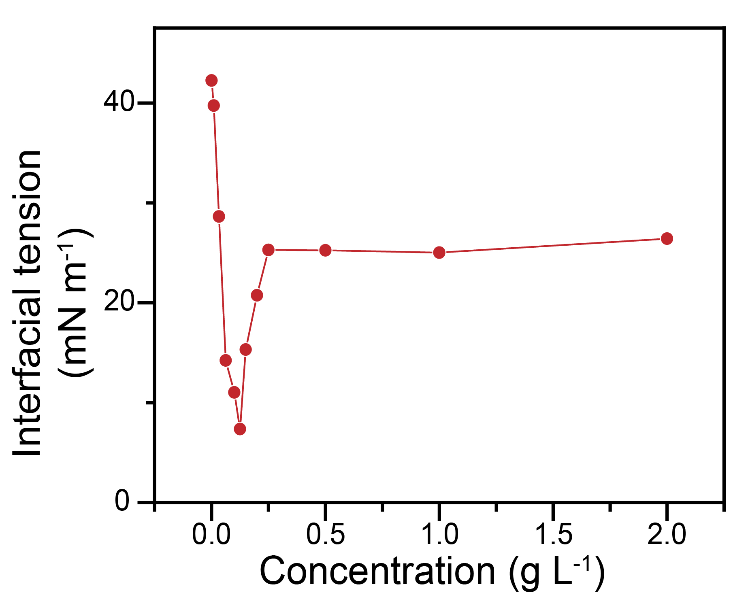
Figure S1. Variation of the interfacial tension of water and hexane as a function of DDP concentration in hexane.
Note: The critical concentration of DDP in hexane can be determined through the utilization of an interfacial tensiometer to monitor the variation of oil/water interfacial tension with respect to DDP concentration in hexane. As demonstrated in Figure S1, the interfacial tension rapidly decreases and reaches a minimum at a concentration of 0.1 g L⁻¹. Increasing the concentration of DDP in hexane further results in an increase in interfacial tension, reaching a value of 27 mN m⁻¹ at around 0.25 g L⁻¹, after which no further change is observed. The change of water/hexane interfacial tension may attribute to the transition in the molecular arrangement structure of the DDP assembly.

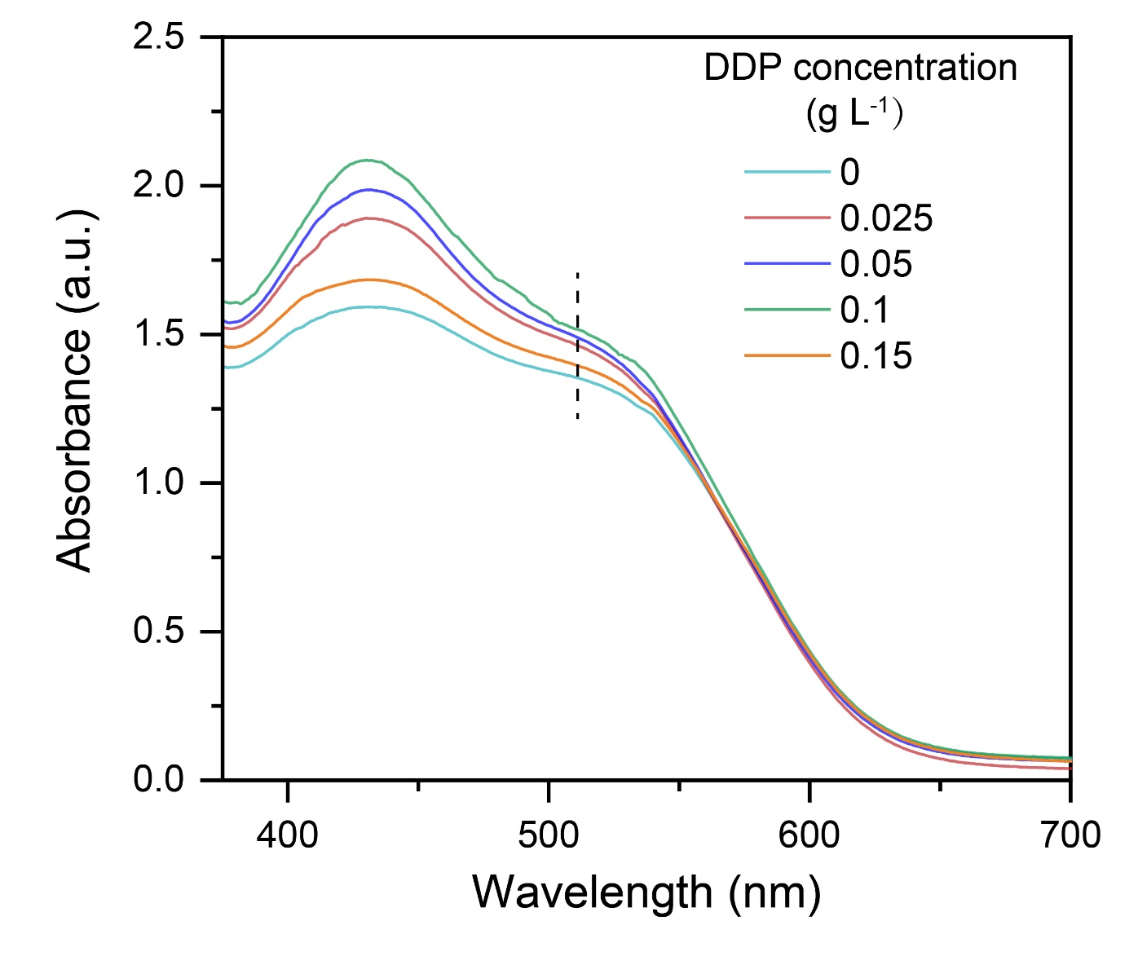
Figure S2. UV-vis absorption spectra of PIP aqueous solution near the water/hexane interface with different concentration of DDP in hexane.
Note: In order to confirm the effect of the DDP assembly on accumulating the PIP molecules at the interface and facilitating the PIP diffusion to across the interface, we conducted a UV-vis absorption measurement to examine the PIP concentration near the interface following the method developed by Zhu et al.⁶ In the UV-vis absorption spectra, the absorbance peak of PIP is at 512 nm. Upon increasing the concentration of DDP in the hexane solution, the UV-vis absorbance correspondingly increases and reaches its maximum level at a concentration of 0.1 g L⁻¹, which is consistent with the variation of interfacial tension to the change of DDP concentration shown in Fig. S1.

2.2 Surface chemical composition and zeta potential of the PA NF membranes prepared from traditional IP and OSARIP
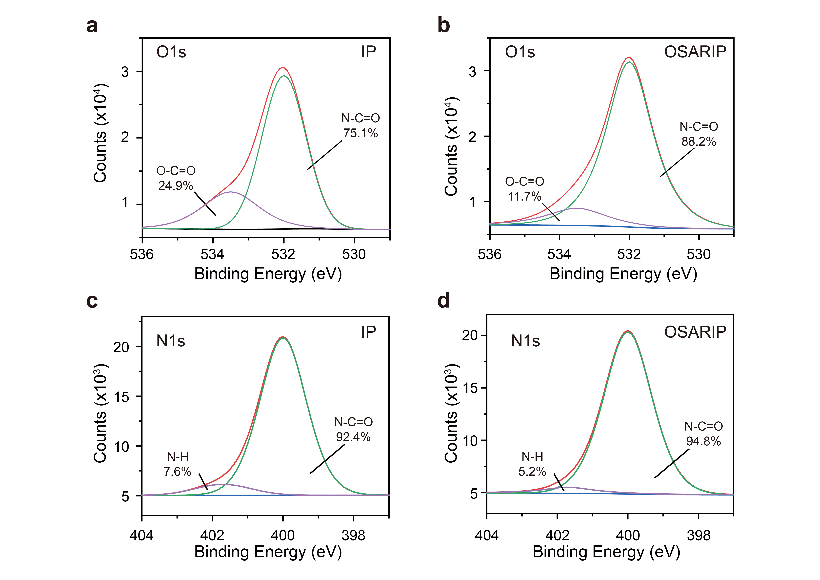
Figure S3. O1s and N1s XPS spectra of the PA membranes prepared from traditional IP and OSARIP. (a, b) O 1s spectra and (c, d) N 1s spectra.

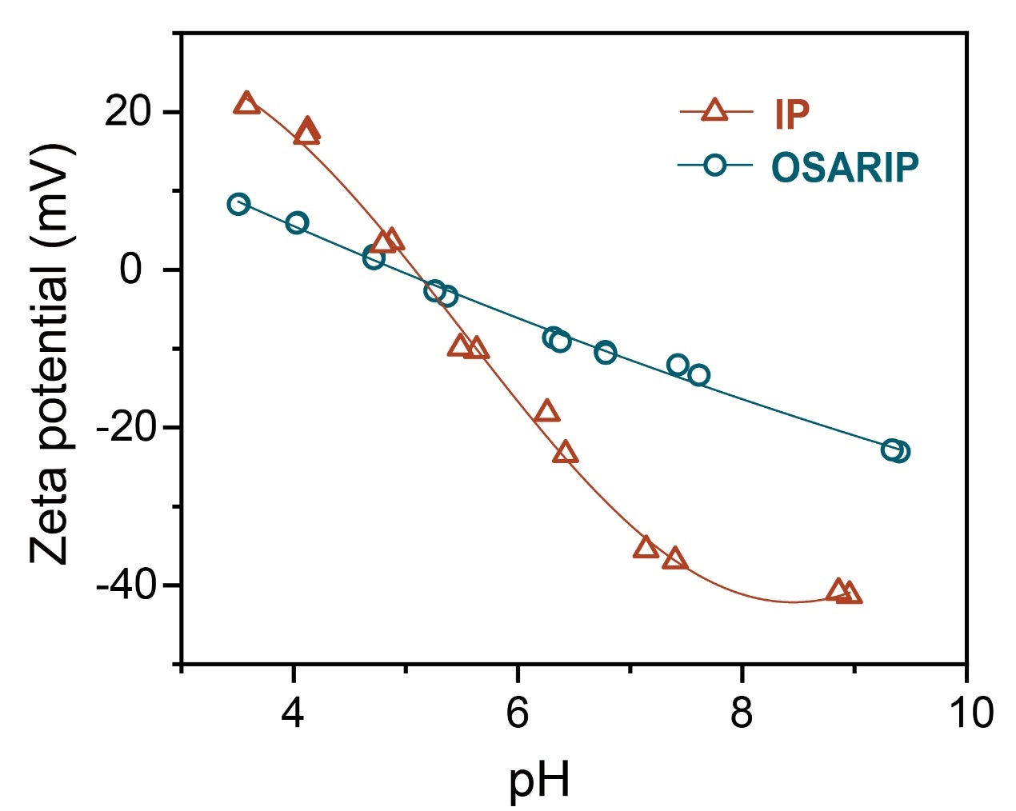
Figure S4. Surface zeta potential of PA NF membranes prepared from traditional IP and OSARIP.
Note: In order to detect the surface chemical composition of the PA NF membranes prepared from traditional IP and OSARIP, we fitted the O 1s and N1s peaks of XPS survey spectra according to the binding energy of various chemical functional groups (Figure S3). It shows that the content of carboxyl group (O-C=O) and amine group (N-H) in the PA NF membrane prepared from OSARIP is less than that of the PA NF membrane prepared from traditional IP. This indicates that the reaction degree between PIP and TMC in the PA NF membrane prepared from OSARIP is greater than in the PA NF membrane prepared from traditional IP. This result is consistent with the crosslinking degree, as shown in Fig. 1c in the main text. Because the surface charge of the PA NF membrane is primarily determined by the amount of amine and carboxyl groups on its surface, the decrease in the content of these groups enables the surface of the membrane less charged, as evidenced by the change of surface zeta potential of the membranes with respect to the pH (Figure S4).

2.3 Desalination performance of the PA NF membranes prepared from OSARIP
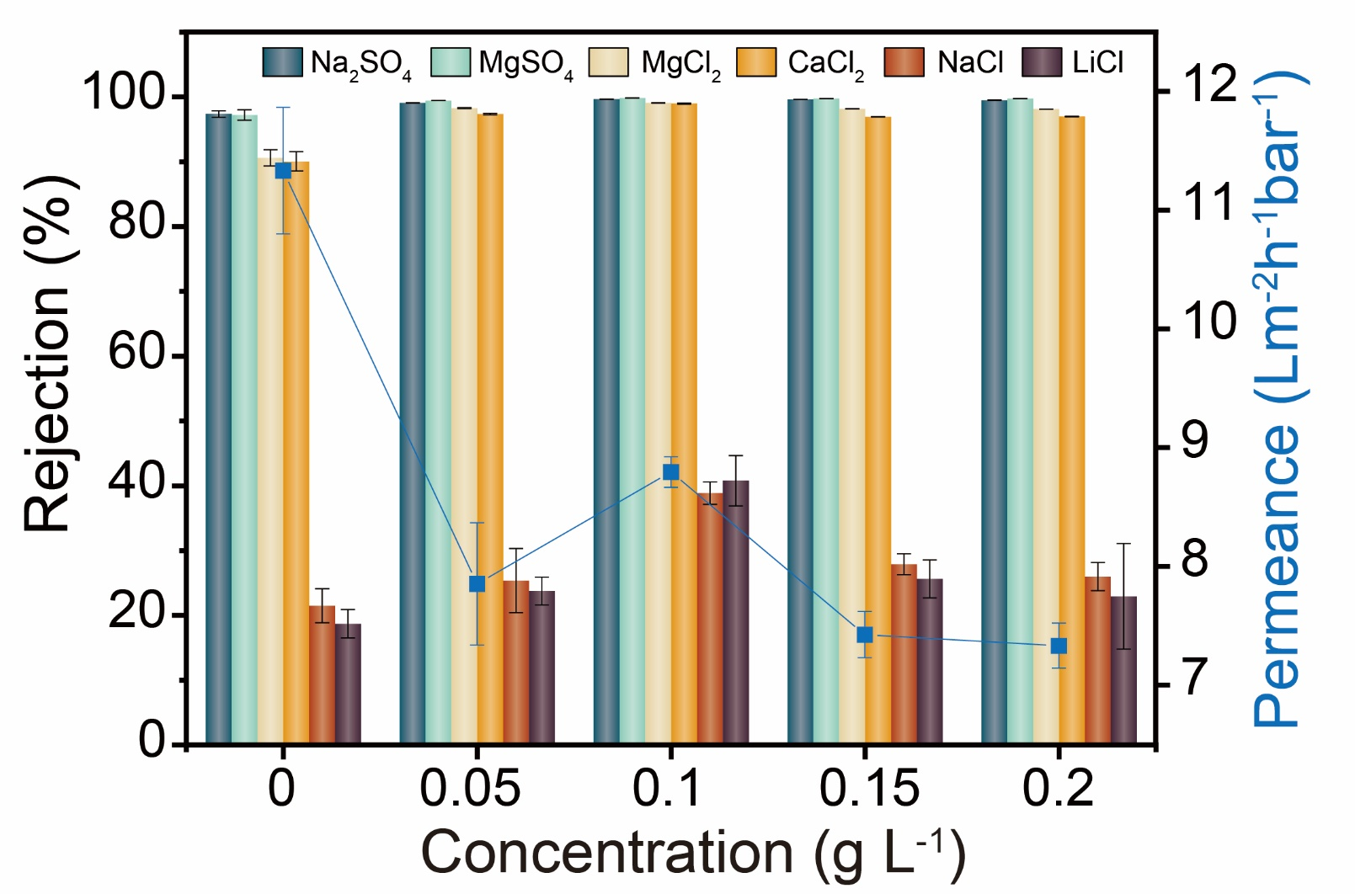
Figure S5. Desalination performance of the PA NF membranes prepared from OSARIP with different concentration of DDP in hexane.

Table S1. Data list of salt rejection and water permeance of the PA NF membranes prepared from OSARIP with different concentration of DDP in hexane.
C_{DDP}  (g L⁻¹) | R_{salt} (%) |  |  |  |  |  | Pw  (Lm⁻²h⁻¹bar⁻¹)
C_{DDP}  (g L⁻¹) | Na₂SO₄ | MgSO₄ | MgCl₂ | CaCl₂ | NaCl | LiCl | Pw  (Lm⁻²h⁻¹bar⁻¹)
0 | 97.37±0.48 | 97.23±0.79 | 91.21±1.26 | 90.87±1.48 | 23.34±2.62 | 20.26±2.19 | 11.33±0.53
0.05 | 99.08±0.02 | 99.44±0.01 | 98.28±0.05 | 97.37±0.13 | 25.32±4.9 | 23.74±2.14 | 7.85±0.51
0.10 | 99.66±0.01 | 99.84±0.01 | 99.08±0.04 | 99.00±0.09 | 38.86±1.73 | 40.78±3.88 | 8.79±0.13
0.15 | 99.63±0.01 | 99.75±0.01 | 98.18±0.02 | 96.95±0.04 | 27.89±1.62 | 25.63±2.92 | 7.425±0.19
0.20 | 99.48±0.03 | 99.75±0.01 | 98.14±0.02 | 97.00±0.05 | 25.99±2.17 | 22.40±8.13 | 7.33±0.05
C_{DDP}: DDP concentration in hexane; R_{salt}: salt rejection; P_{w}: water permeance.
Note: The salt rejection and water permeance of PA NF membranes prepared from OSARIP with different concentrations of DDP in hexane are presented in Fig. S5 and Table S1. Increasing the concentration of DDP in hexane can effectively enhance the rejection of divalent salts, such as Na₂SO₄, MgSO₄, MgCl₂, and CaCl₂. At the concentration of 0.1 g L⁻¹, the resulting membrane exhibits the highest rejection to the salts of Na₂SO₄, MgSO₄, MgCl₂, and CaCl₂, all of which are higher than 99%. Meanwhile, the rejections of monovalent salts, including NaCl and LiCl, are around 20-40%. Further increasing the concentration of DDP leads to a slight decrease in salt rejection. The salt rejection as a function of DDP concentration indicates that 0.1 g L⁻¹ DDP is the optimal condition for preparing PA NF membrane with the best desalination performance. In the following text, all PA NF membranes were prepared at 0.1 g L⁻¹ DDP unless stated otherwise.

2.4 MgCl₂ rejection of NF membranes reported in literatures
Table S2. List of the MgCl₂ rejection and the corresponding MWCO of the NF membranes reported in the literatures.
Membrane | MWCO (Da) | MgCl₂ rejection (%) | Ref.
OSARIP | 134 | 99.13 | This work
IP | 258 | 90.61 | This work
PIP-TMC | 335 | 46.0 | 9
SDS | 245 | 94.5 | 9
STS | 212 | 98.2 | 9
SHS | 134 | 98.1 | 9
SDS | 208 | 95.0 | 10
SDBS | 224 | 82.0 | 10
SB3-14 | 220 | 89.6 | 10
CTAB | 302 | 66.0 | 10
PIP-TMC | 274 | 45.5 | 10
TsNA# | 255 | 50.0 | 10
BTC–PIP | 240 | 99.1 | 11
TFC-2-1PIP | 285 | 73.0 | 12
TFC-0-1PIP | 326 | 90.0 | 12
PES-CNT-PA | 353 | 93.2 | 13
PA20 | 360 | 72.2 | 14
CSP0 | 320 | 78.2 | 15
CSP6 | 250 | 71.0 | 15
PIP/TMC | 200 | 88.5 | 15
PIP/TMC/SWCNT | 397 | 64.9 | 16
TFN-50 | 308 | 45.0 | 17
H-TFC NF | 170 | 94.0 | 18
PDA/PEI | 190 | 95.8 | 19
TMC/TAEA | 388 | 81.0 | 20
TMC/PIP | 350 | 83.0 | 20
PIP/β-CD/TMC | 530 | 20.0 | 21
TMC@-15 | 430 | 42.6 | 22
TMC@5 | 400 | 50.8 | 22
TMC@20 | 385 | 61.0 | 22
TMC@35 | 375 | 70.5 | 22
TMC@50 | 360 | 86.0 | 22
PA@A-0 | 353 | 38.0 | 23
PA@20-3 | 316 | 46.0 | 23
PA@50-3 | 300 | 63.0 | 23
PA@80-3 | 273 | 67.0 | 23
2D BFS/TMC/PIP | 345 | 35.0 | 24
PA@W-14 | 306 | 33.0 | 25
PA@W-0 | 300 | 78.0 | 25
PA@W-7 | 245 | 90.0 | 25
PEI-g-PA | 300 | 35.5 | 26
THPC-5 | 348 | 34.0 | 27
PA/M-50 | 384 | 11.4 | 28
MBA50 | 320 | 32.0 | 29
BDSA/PIP | 400 | 45.5 | 30
HL | 300 | 82.9 | 31
PIP/TMC/TMA | 546 | 32.0 | 32
NF40 | 180 | 99.0 | 33
UTC20 | 180 | 92.0 | 33
UTC60 | 180 | 83.6 | 34
NF90 | 180 | 92.0 | 35
NF270 | 300 | 55.0 | 35
Desal 5 DK | 300 | 75 | 36
Note: All the membranes are negatively charged.

2.5 Size, hydration energy, and corresponding rejection of various cations
Table S3. The size and hydration energy of the cations and their corresponding rejections by the PA NF membrane prepared from OSARIP.^{7,8}
 | Ionic  Radius (Å) | Stokes Radius (Å) | Hydration Radius (Å) | Hydration Energy  (kcal mol⁻¹) | Salt | R (%)
Zn²⁺ | 0.74 | 3.49 | 4.3 | 467.3 | ZnCl₂ | 99.21%
Co²⁺ | 0.72 | 3.35 | 4.23 | 457.7 | CoCl₂ | 99.04%
Mg²⁺ | 0.65 | 3.47 | 4.23 | 437.4 | MgCl₂ | 99.13%
Cu²⁺ | 0.72 | 3.25 | 4.19 | 480.4 | CuCl₂ | 99.15%
Ca²⁺ | 0.99 | 3.1 | 4.12 | 359.7 | CaCl₂ | 99.03%
Ni²⁺ | 0.7 | 2.92 | 4.04 | 473.2 | NiCl₂ | 99.01%
Ba²⁺ | 1.35 | 2.9 | 4.04 | 298.8 | BaCl₂ | 98.36%
Li⁺ | 0.6 | 2.38 | 3.82 | 113.5 | LiCl | 40.78%
Na⁺ | 0.95 | 1.84 | 3.58 | 87.2 | NaCl | 38.86%
K⁺ | 1.33 | 1.25 | 3.31 | 70.5 | KCl | 36.46%
Rb⁺ | 1.48 | 1.18 | 3.29 | 65.7 | RbCl | 41.27%
Cs⁺ | 1.69 | 1.19 | 3.29 | 59.8 | CsCl | 42.33%

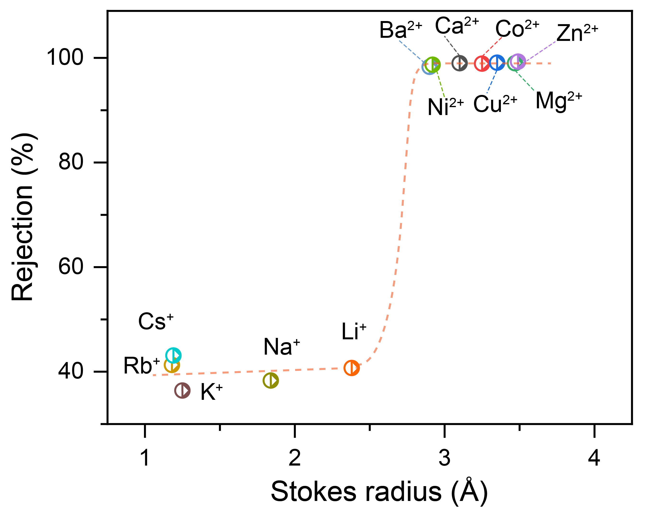
Figure S6. The rejection of cations by PA NF membranes prepared from OSARIP as a function of Stokes radius.
Note: The selectivity of the PA NF membrane prepared from OSARIP for separating monovalent and divalent cations was evaluated by passing the chloride salt of the cations aqueous solution with a concentration of 1000 ppm through the membrane. The rejection rates of these cations are presented in Figure S6 and Table S3. The membrane displayed high rejection rates of up to 99% to all divalent cations, while showed a relatively low rejection rates to all monovalent cations. This suggests the outstanding ability of the PA NF membrane for separating divalent and monovalent cations. The surface of the PA NF membrane prepared from OSARIP was found to be negative from the result of surface streaming potential measurement as shown in Fig. S4. Hence, the rejection of the membrane to all cations is primarily induced by the size-sieving effect, rather than Donnan exclusion. Upon correlating the rejection to the Stokes radius of the cations, a sharp transition region between the size range of 0.6 Å was observed, indicating the ultra-precise size separation capability of the PA NF membrane.

2.6 MWCO, pore size distribution, and desalination performance of DK membrane
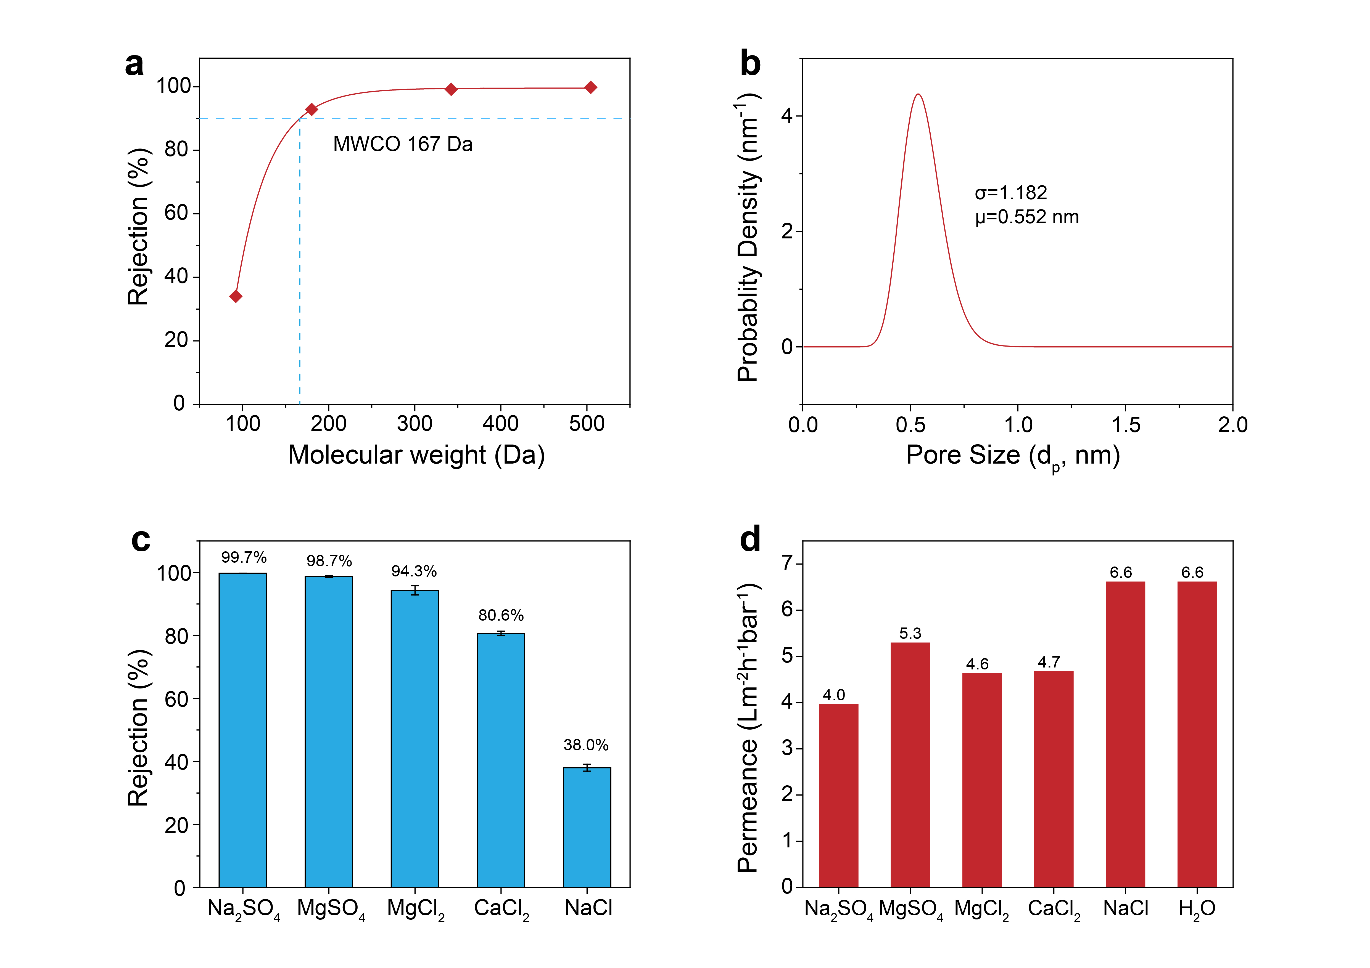
Figure S7. (a) Rejection of neutral molecules, including glycerol, glucose, sucrose, and raffinose, by the commercial DK membrane. (b) Pore size distribution of the DK membrane derived from the rejection curve of neutral molecules. (c) Salt rejection and (d) corresponding permeance of the DK membrane using single salt aqueous solution as feed.
Note: Utilizing neutral molecules with different molecular weights as probes, we analyzed the pore size of the commercial DK membrane. The membrane displayed a MWCO of 166 Da, which is smaller than most of NF membranes. The rejection curve of neutral molecules indicated a pore size distribution parameter of 1.182, which suggests a relatively narrow pore size distribution of the membrane. The membrane showed a high rejection to divalent salts with 99.7% of Na₂SO₄, 98.7% of MgSO₄, and 94.3% of MgCl₂. The corresponding permeance of these salts and pure water are shown in Fig. S7d.

2.7 Performance of the PA NF membrane prepared from OSARIP for separating Li⁺ and Mg²⁺ from binary salt mixture solution
Table S4. The rejection of Li⁺ and Mg²⁺ and Li⁺/Mg²⁺ selectivity as a function of Mg²⁺/Li⁺ mass ratios of feed solution. The salt concentration of the binary salt mixture is 2000 ppm.
Mg²⁺/Li⁺ mass ratios | feed (ppm) |  | permeate (ppm) |  | Li⁺ Rejection (%) | Mg²⁺ Rejection (%) | S_{Mg/Li}
Mg²⁺/Li⁺ mass ratios | Li⁺ | Mg²⁺ | Li⁺ | Mg²⁺ | Li⁺ Rejection (%) | Mg²⁺ Rejection (%) | S_{Mg/Li}
10:1 | 44.4±2.1 | 542.6±24.3 | 52.06±2.72 | 1.16±0.27 | -17.25 | 99.79 | 548
20:1 | 21.8±1.7 | 497.0±26.8 | 32.34±3.37 | 0.89±0.35 | -48.34 | 99.82 | 828
40:1 | 12.8±1.4 | 542.7±21.3 | 20.51±2.91 | 0.51±0.27 | -60.23 | 99.91 | 1705
60:1 | 8.4±0.9 | 535.6±28.1 | 12.36±2.39 | 0.19±0.07 | -47.14 | 99.96 | 4147

Table S5. The rejection of Li⁺ and Mg²⁺ and the Li⁺/Mg²⁺ selectivity as a function of the concentration of feed solution. The Mg²⁺/Li⁺ mass ratio of the feed solution is 20:1.
Concentration（ppm） | Feed (ppm) |  | Filtrate (ppm) |  | Li⁺ Rejection (%) | Mg²⁺ Rejection (%) | S_{Mg/Li}
Concentration（ppm） | Li⁺ | Mg²⁺ | Li⁺ | Mg²⁺ | Li⁺ Rejection (%) | Mg²⁺ Rejection (%) | S_{Mg/Li}
2000 | 21.8±1.7 | 497.0±26.8 | 32.34±3.3 | 0.9±0.3 | -48.35 | 99.82 | 824
3000 | 29.5±2.1 | 720.7±34.1 | 45.1±4.3 | 5.3±1.2 | -52.71 | 99.25 | 203
4000 | 42.4±4.7 | 1059.0±36.8 | 73.4±5.5 | 8.9±2.3 | -73.21 | 99.16 | 206
5000 | 56.7±5.3 | 1393.5±35.6 | 110.2±6.3 | 14.6±3.1 | -94.35 | 98.95 | 185

2.8 Summary of Li/Mg selectivity of various membranes
Table S6. Summary of Li⁺/Mg²⁺ selectivity of the membranes prepared from OSARIP and previously reported membranes.
Membrane | Mg²⁺/Li⁺ mass ratio | Applied pressure | Feed concentration  (ppm) | S_{Mg/Li} | Ref.
OSARIP | 10:1 | 0.4 MPa | 2000 | 548 | This work
OSARIP | 20:1 | 0.4 MPa | 2000 | 828 | This work
OSARIP | 40:1 | 0.4 MPa | 2000 | 1705 | This work
OSARIP | 60:1 | 0.4 MPa | 2000 | 4147 | This work
OSARIP | 20:1 | 0.4 MPa | 5000 | 185 | This work
PIP-MWCNTs/PEI/PES | 21.4:1 | 0.4 MPa | 2000 | 7 | 37
DAPP/TMC | 20:1 | 0.3 MPa | 2000 | ~3 | 38
TMC-BPEI-EDTA | 24:1 | 1.0 MPa | 2500 | 9 | 39
PES/ PIP-PHF/ TMC | 21.4：1 | 0.6 MPa | 2000 | 13 | 40
PEI/ TMC | 20:1 | 0.8 MPa | 2000 | 20 | 41
CQDs-NH₂/TMC | 30:1 | 0.2 MPa | 2000 | 14 | 42
QEDTP/PEI/TMC | 120:1 | 0.6 MPa | 2000 | 16 | 43
CNC-COOH/PEI/TMC | 30:1 | 0.8 MPa | 2000 | 12 | 44
（MWCNTs-COOK）-PEI/TMC | 20:1 | 0.3 MPa | 2000 | 58 | 45
PA-g-AS-Fe | 20:1 | 0.6 MPa | 2000 | 81 | 46
（PES-GO）/PEI/TMC | 20:1 | 0.3 MPa | 2000 | 16 | 47
UIO-66-NH₂/PIP/TMC | 30.6:1 | 1 MPa | 2000 | 79 | 48
NF-IL-2.0% | 20:1 | 0.6 MPa | 2100 | 8 | 49
PEI-LDH/GA | 10:1 | 0.5 MPa | 1000 | 19 | 50
PDA-PEI-NF270 | 30:1 | - | 12000 | 7 | 51
PDA-PEI-DL | 30:1 | - | 12000 | 5 | 51
PDA-PEI-DK | 30:1 | - | 12000 | 59 | 51
PEI/GQDs-NH2/TMC | 20:1 | 0.3 MPa | 2000 | 28 | 52
MBCN-0.02 | 73:1 | 0.4 MPa | 2000 | 24 | 53
PIP-TMC-PEI | 21.4:1 | 0.4 MPa | 2000 | 33 | 26
SPE-PEI600 | 150:1 | 0.6 MPa | 2000 | 12 | 54
PSS/PAH (pH 2.7) | 60:1 | 0.4 MPa | 2000 | 430 | 55
PSS/PAH 2 | 20:1 | 0.4 MPa | 2000 | 176 | 55
PSS/PAH | 60:1 | 0.4 MPa | 2000 | 75 | 56
SIP-PEI-TMC | 20:1 | 1.5 MPa | 2000 | 15 | 57
QBPD/PEI | 50:1 | 0.6 MPa | 2000 | 5 | 58

Table S7. Summary of Li⁺/Mg²⁺ selectivity of MOFs membranes, COFs membrane, and POPs membranes reported in literatures.
Membrane | S_{Mg/Li} | Ref.
HKUST-1-PSS | 1815 | 59
UiO-66-(COOH)₂ | 1590 | 60
UiO-66-COOH | 200 | 61
UiO-66-NH₂ | 60 | 62
COF (TpBDMe₂) | 217 | 63
COF-EB₁BD₁₋PAN | 443 | 64
COF-4EO-PAN | 64 | 65
PIM-TB-FeCl₃ | 176 | 66
PIM-BzMA-TB | 33 | 67
POCs-CC3 | 284 | 68
MXene-(Ti₃C₂Tx)-PSS | 28 | 69
Note: We must emphasize here that the examining of ion separation performance of all these membranes is based on a slow diffusion process that relies on concentration gradients without applied pressure, rather than a pressure-driven process like nanofiltration membranes. Although these two processes are not comparable in terms of processing capacity and scale application (obviously pressure-driven nanofiltration membranes have more advantages), we only compare their separation selectivity without considering other aspects.

2.9 PA NF membranes prepared from different conditions
Table S8. Different PA NF membranes prepared from OSARIP (M1-M8) and their corresponding preparation conditions. The reaction temperature is 35 ºC.
PA NF membrane | Conditions
M1 | TMC: 2 g L⁻¹, PIP: 5 g L⁻¹, DDP: 0.1 g L⁻¹
M2 | TMC: 2 g L⁻¹, PIP 5: g L⁻¹, DDP: 0.125 g L⁻¹
M3 | TMC: 2 g L⁻¹, PIP: 5 g L⁻¹, DDP: 0.05 g L⁻¹
M4 | TMC: 2 g L⁻¹, PIP: 5 g L⁻¹, DDP: 0.15 g L⁻¹
M5 | TMC: 2 g L⁻¹, PIP: 2.5 g L⁻¹, DDP: 0.1 g L⁻¹
M6 | TMC: 2 g L⁻¹, PIP: 5 g L⁻¹, DDP: 0.01 g L⁻¹
M7 | TMC: 2 g L⁻¹, PIP: 5 g L⁻¹, DDP: 0 g L⁻¹
M8 | TMC: 2 g L⁻¹, PIP: 2.5 g L⁻¹, DDP: 0 g L⁻¹

Table S9. Salt rejection and water permeance of PA NF membranes (M1-M8). The concentration of feed solution is 1000 ppm. The applied pressure is 4 bar.
PA NF membrane | Rejection (%) |  |  |  |  |  | Water permeance  (Lm⁻²h⁻¹bar⁻¹)
PA NF membrane | Na₂SO₄ | MgSO₄ | MgCl₂ | CaCl₂ | NaCl | LiCl | Water permeance  (Lm⁻²h⁻¹bar⁻¹)
M1 | 99.73 | 99.91 | 99.29 | 99.33 | 40.32 | 43.00 | 8.5
M2 | 99.65 | 99.83 | 98.96 | 98.26 | 35.15 | 30.36 | 7.1
M3 | 99.23 | 99.56 | 98.46 | 97.20 | 27.87 | 25.31 | 7.1
M4 | 99.70 | 99.81 | 98.32 | 97.10 | 29.32 | 27.54 | 7.8
M5 | 98.47 | 98.83 | 95.47 | 94.19 | 23.86 | 24.71 | 9.2
M6 | 98.90 | 98.88 | 93.67 | 95.94 | 24.58 | 23.67 | 11.3
M7 | 98.13 | 97.79 | 91.21 | 88.42 | 19.41 | 20.37 | 14.1
M8 | 99.30 | 98.59 | 57.77 | 65.17 | 12.53 | 15.67 | 16.3

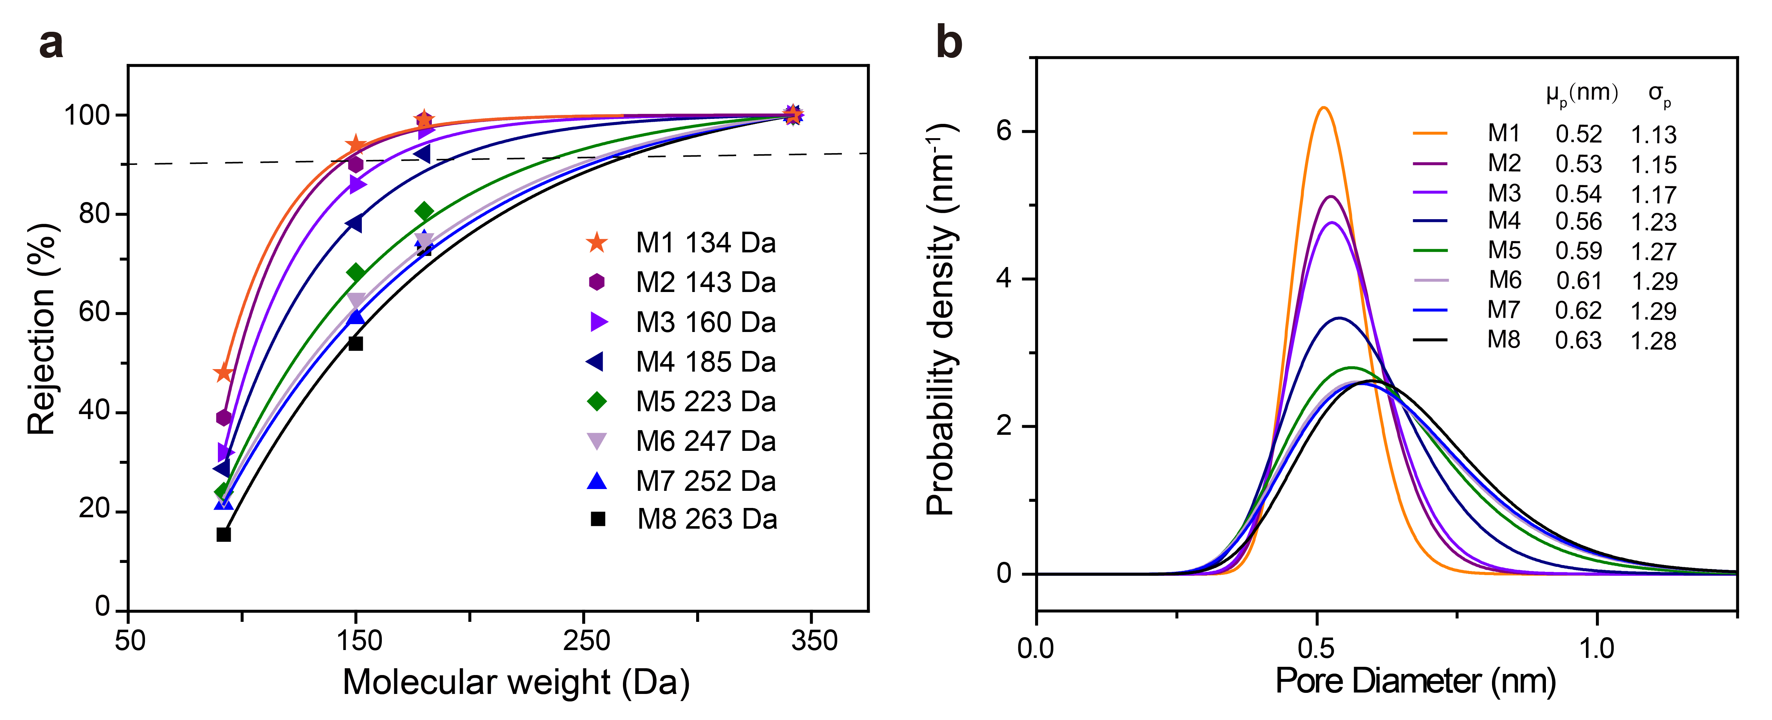
Figure S8. (a) Rejection of neutral solutes with different molecular weights by the PA NF membranes (M1-M8), and (b) corresponding pore size distribution derived from the rejection curve of neutral solutes.

2.10 PA NF membranes prepared from OSARIP by using PEI and TMC as the monomers
Table S10. The conditions for preparing PA NF membranes via OSARIP using PEI and TMC as the reaction monomers. The molecular weight of PEI is 600,
 | Preparation conditions
M1-PEI | TMC: 2 g L⁻¹, PEI: 10 gL⁻¹, DDP: 0.1 g L⁻¹
M2-PEI | TMC: 2 g L⁻¹, PEI: 10 g L⁻¹, DDP: 0.15 g L⁻¹
M3-PEI | TMC: 2 g L⁻¹, PEI: 10 g L⁻¹, DDP: 0.2 g L⁻¹
M4-PEI | TMC: 2 g L⁻¹, PEI: 10 g L⁻¹, DDP: 0.05 g L⁻¹
M5-PEI | TMC: 2 g L⁻¹, PEI: 10 g L⁻¹, DDP: 0 g L⁻¹

Table S11. The rejection of Li⁺ and Mg²⁺ and Li⁺/Mg²⁺ selectivity of the PA NF membranes prepared from OSARIP by using PEI and TMC as monomers for treating binary salt mixture solutions as feed. The salt concentration of feed solution is 2000 ppm. The Mg²⁺/Li⁺ mass ratio of feed solution is 20:1.
 | Li⁺ rejection | Mg²⁺ rejection | S_{Mg/Li}
M1-PEI | 52.23% | 98.11% | 25
M2-PEI | 29.53% | 93.96% | 12
M3-PEI | 25.15% | 91.65% | 9
M4-PEI | 19.22% | 88.53% | 7
M5-PEI | 8.21% | 67.61% | 3

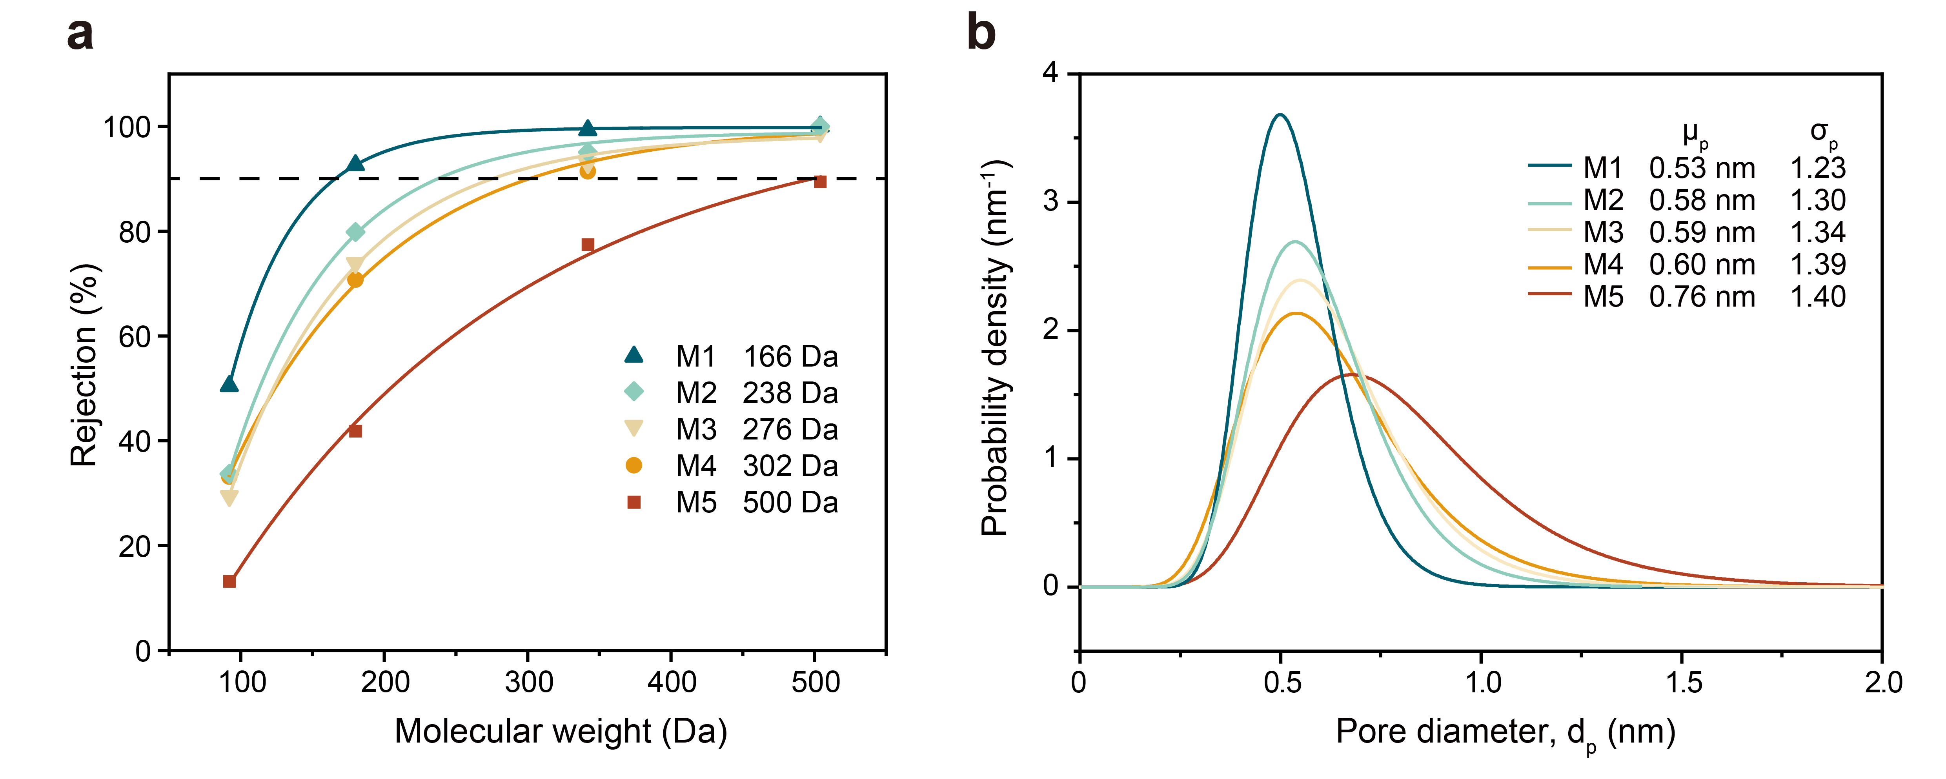
Figure S9. The rejection of neutral solutes with different molecular weights and the pore size distribution derived from the rejection curve of neutral solutes by the PA NF membrane prepared from OSARIP by using PEI and TMC as monomers.
Note: As presented in Tables S10, S11, and Fig. S9, the OSARIP process can also enhance the pore size uniformity of the PA NF membrane prepared from PEI and TMC. It is well known that PA NF membranes prepared from the IP reaction of PEI and TMC is strongly positive. When using these positive PA NF membranes for separating Li⁺ and Mg²⁺ from the binary salt mixture solution, a higher Mg²⁺ rejection is presented by the membrane with narrower pore size distribution, which is similar to the PA NF membranes prepared using PIP and TMC as monomers. But, a higher Li⁺ rejection is also presented by the positive PA NF membranes and no negative rejection is obtained. Meanwhile, the Li⁺ rejection increases with narrowing the pore size distribution. The change of Li⁺ rejection by the PA NF membrane of PEI and TMC is contrast to that of the PA NF membranes of PIP and TMC. We postulate that this difference relies mainly on the naturally positive property of PEI-TMC-based NF membrane, which dramatically reduces the permeation of Li⁺ via Donnan exclusion by hindering the Li⁺ partition and electrostatic interaction for slowing down the transport of Cl⁻. This is not beneficial for obtaining a high recovery of Li⁺ when using these positively charged PA NF membranes for extracting Li⁺ from brine. These findings also prove the superiority of negatively charged PA NF membranes with highly uniform pore size distribution for extracting Li⁺ from brine.

3. Supplementary references
1. Tang, C. Y., Kwon, Y.-N. & Leckie, J. O. Effect of membrane chemistry and coating layer on physiochemical properties of thin film composite polyamide RO and NF membranes: I. FTIR and XPS characterization of polyamide and coating layer chemistry. Desalination 242, 149–167 (2009).
2. Karan, S., Jiang, Z. & Livingston, A. G. Sub–10 nm polyamide nanofilms with ultrafast solvent transport for molecular separation. Science 348, 1347–1351 (2015).
3. Yaroshchuk, A. & Bruening, M. L. An analytical solution of the solution-diffusion-electromigration equations reproduces trends in ion rejections during nanofiltration of mixed electrolytes. J. Membr. Sci. 523, 361–372 (2017).
4. Yaroshchuk, A., Bruening, M. L. & Licón Bernal, E. E. Solution-Diffusion–Electro-Migration model and its uses for analysis of nanofiltration, pressure-retarded osmosis and forward osmosis in multi-ionic solutions. J. Membr. Sci. 447, 463–476 (2013).
5. Wang, R., He, R., He, T., Elimelech, M. & Lin, S. Performance metrics for nanofiltration-based selective separation for resource extraction and recovery. Nat. Water 1, 291–300 (2023).
6. Zhu, C.-Y. et al. Polyamide nanofilms with linearly-tunable thickness for high performance nanofiltration. J. Membr. Sci. 627, 119142 (2021).
7. Nightingale, E. R. Jr. Phenomenological Theory of Ion Solvation. Effective Radii of Hydrated Ions. J. Phys. Chem. 63, 1381–1387 (1959).
8. Marcus, Y. Thermodynamics of solvation of ions. Part 6.—The standard partial molar volumes of aqueous ions at 298.15 K. J. Chem. Soc., Faraday Trans. 89, 713–718 (1993).
9. Zhang, R. et al. Polyamide Nanofiltration Membranes from Surfactant-Assembly Regulated Interfacial Polymerization: The Effect of Alkyl Chain. Macromol. Chem. Phys. 222, 2100222 (2021).
10. Liang, Y. et al. Polyamide nanofiltration membrane with highly uniform sub-nanometre pores for sub-1 Å precision separation. Nat. Commun. 11, 2015 (2020).
11. Yuan, B. et al. Ultrathin Polyamide Membrane with Decreased Porosity Designed for Outstanding Water-Softening Performance and Superior Antifouling Properties. ACS Appl. Mater. Interfaces 10, 43057–43067 (2018).
12. Tian, B. et al. Nanofiltration membrane combining environmental-friendly polycarboxylic interlayer prepared from catechol for enhanced desalination performance. Desalination 512, 115118 (2021).
13. Gong, G., Wang, P., Zhou, Z. & Hu, Y. New Insights into the Role of an Interlayer for the Fabrication of Highly Selective and Permeable Thin-Film Composite Nanofiltration Membrane. ACS Appl. Mater. Interfaces 11, 7349–7356 (2019).
14. Shen, K., Li, P., Zhang, T. & Wang, X. Salt-tuned fabrication of novel polyamide composite nanofiltration membranes with three-dimensional turing structures for effective desalination. J. Membr. Sci. 607, 118153 (2020).
15. Hao, Y. et al. An ultrahighly permeable-selective nanofiltration membrane mediated by an in situ formed interlayer. J. Mater. Chem. A 8, 5275–5283 (2020).
16. Gao, S. et al. Ultrathin Polyamide Nanofiltration Membrane Fabricated on Brush-Painted Single-Walled Carbon Nanotube Network Support for Ion Sieving. ACS Nano 13, 5278–5290 (2019).
17. Huang, S. et al. Polyamide Nanofiltration Membranes Incorporated with Cellulose Nanocrystals for Enhanced Water Flux and Chlorine Resistance. ACS Sustainable Chem. Eng. 7, 12315–12322 (2019).
18. Wang, Q. et al. Designing High-Performance Nanofiltration Membranes for High-Salinity Separation of Sulfate and Chloride in the Chlor-Alkali Process. Ind. Eng. Chem. Res. 58, 12280–12290 (2019).
19. Du, Y., Qiu, W.-Z., Lv, Y., Wu, J. & Xu, Z.-K. Nanofiltration Membranes with Narrow Pore Size Distribution via Contra-Diffusion-Induced Mussel-Inspired Chemistry. ACS Appl. Mater. Interfaces 8, 29696–29704 (2016).
20. Yuan, B. et al. Semi-aromatic polyamide nanofiltration membranes with tuned surface charge and pore size distribution designed for the efficient removal of Ca2+ and Mg2+. Sep. Purif. Technol. 220, 162–175 (2019).
21. Liu, Y. et al. A Facile and Scalable Fabrication Procedure for Thin-Film Composite Membranes: Integration of Phase Inversion and Interfacial Polymerization. Environ. Sci. Technol. 54, 1946–1954 (2020).
22. Cheng, X. et al. Toward Enhancing Desalination and Heavy Metal Removal of TFC Nanofiltration Membranes: A Cost-Effective Interface Temperature-Regulated Interfacial Polymerization. ACS Appl. Mater. Interfaces 13, 57998–58010 (2021).
23. Zhan, Z.-M., Xu, Z.-L., Zhu, K.-K. & Tang, Y.-J. How to understand the effects of heat curing conditions on the morphology and performance of polypiperazine-amide NF membrane. J. Membr. Sci. 597, 117640 (2020).
24. Lu, Y. et al. Two-dimensional fractal nanocrystals templating for substantial performance enhancement of polyamide nanofiltration membrane. Proceedings of the National Academy of Sciences 118, e2019891118 (2021).
25. Zhan, Z.-M. et al. Superior nanofiltration membranes with gradient cross-linked selective layer fabricated via controlled hydrolysis. J. Membr. Sci. 604, 118067 (2020).
26. Yang, Z. et al. Dual-skin layer nanofiltration membranes for highly selective Li+/Mg2+ separation. J. Membr. Sci. 620, 118862 (2021).
27. Peng, H. et al. Phosphonium Modification Leads to Ultrapermeable Antibacterial Polyamide Composite Membranes with Unreduced Thickness. Adv. Mater. 32, 2001383 (2020).
28. Huang, B.-Q., Tang, Y.-J., Zeng, Z.-X. & Xu, Z.-L. Microwave heating assistant preparation of high permselectivity polypiperazine-amide nanofiltration membrane during the interfacial polymerization process with low monomer concentration. J. Membr. Sci. 596, 117718 (2020).
29. Liu, Y., Wang, X., Yang, H., Xie, Y. F. & Huang, X. Preparation of nanofiltration membranes for high rejection of organic micropollutants and low rejection of divalent cations. J. Membr. Sci. 572, 152–160 (2019).
30. Huang, B.-Q., Xu, Z.-L., Ding, H., Miao, M.-C. & Tang, Y.-J. Antifouling sulfonated polyamide nanofiltration hollow fiber membrane prepared with mixed diamine monomers of BDSA and PIP. RSC Adv. 7, 56629–56637 (2017).
31. Dolar, D., Vuković, A., Ašperger, D. & Košutić, K. Effect of water matrices on removal of veterinary pharmaceuticals by nanofiltration and reverse osmosis membranes. J. Environ. Sci. 23, 1299–1307 (2011).
32. Qin, Y. et al. Performance enhancement of nanofiltration membranes via surface modification with a novel acylation reagent. J. Appl. Polym. Sci. 138, 50315 (2021).
33. Schaep, J., Van der Bruggen, B., Vandecasteele, C. & Wilms, D. Influence of ion size and charge in nanofiltration. Sep. Purif. Technol. 14, 155–162 (1998).
34. Van der Bruggen, B., Koninckx, A. & Vandecasteele, C. Separation of monovalent and divalent ions from aqueous solution by electrodialysis and nanofiltration. Water Res.38, 1347–1353 (2004).
35. Yang, Z. et al. Tannic Acid/Fe3+ Nanoscaffold for Interfacial Polymerization: Toward Enhanced Nanofiltration Performance. Environ. Sci. Technol. 52, 9341–9349 (2018).
36. Ren, T. et al. Influence of inorganic salt on retention of ibuprofen by nanofiltration. Sep. Purif. Technol. 189, 382–388 (2017).
37. Zhang, H.-Z., Xu, Z.-L., Ding, H. & Tang, Y.-J. Positively charged capillary nanofiltration membrane with high rejection for Mg2+ and Ca2+ and good separation for Mg²⁺ and Li⁺. Desalination 420, 158–166 (2017).
38. Li, X. et al. Preparation and characterization of positively charged polyamide composite nanofiltration hollow fiber membrane for lithium and magnesium separation. Desalination 369, 26–36 (2015).
39. Li, W. et al. A positively charged composite nanofiltration membrane modified by EDTA for LiCl/MgCl2 separation. Sep. Purif. Technol. 186, 233–242 (2017).
40. Shen, Q., Xu, S.-J., Xu, Z.-L., Zhang, H.-Z. & Dong, Z.-Q. Novel thin-film nanocomposite membrane with water-soluble polyhydroxylated fullerene for the separation of Mg²⁺/Li⁺ aqueous solution. J. Appl. Polym. Sci. 136, 48029 (2019).
41. Xu, P. et al. Positive charged PEI-TMC composite nanofiltration membrane for separation of Li⁺ and Mg²⁺ from brine with high Mg²⁺/Li⁺ ratio. Desalination 449, 57–68 (2019).
42. Guo, C. et al. Amino-rich carbon quantum dots ultrathin nanofiltration membranes by double “one-step” methods: Breaking through trade-off among separation, permeation and stability. Chem. Eng. J. 404, 127144 (2021).
43. Xu, Y. et al. High performance Mg²⁺/Li⁺ separation membranes modified by a bis-quaternary ammonium salt. Desalination 526, 115519 (2022).
44. Guo, C. et al. Ultra-thin double Janus nanofiltration membrane for separation of Li⁺ and Mg²⁺: “Drag” effect from carboxyl-containing negative interlayer. Sep. Purif. Technol. 230, 115567 (2020).
45. Xu, P., Hong, J., Xu, Z., Xia, H. & Ni, Q.-Q. MWCNTs-COOK-assisted high positively charged composite membrane: Accelerating Li⁺ enrichment and Mg²⁺ removal. Compos. Part B: Eng. 212, 108686 (2021).
46. Liu, Y. et al. A nanofiltration membrane with positively and negatively charged groups by grafted p-aminosalicylic acid-Fe(III) chelation for Li⁺/Mg²⁺ efficient separation. Sep. Purif. Technol. 308, 122968 (2023).
47. Xu, P. et al. “Bridge” graphene oxide modified positive charged nanofiltration thin membrane with high efficiency for Mg²⁺/Li⁺ separation. Desalination 488, 114522 (2020).
48. Yuan, B. et al. Polyamide nanofiltration membrane fine-tuned via mixed matrix ultrafiltration support to maximize the sieving selectivity of Li⁺/Mg²⁺ and Cl–/SO₄^{2–}. Desalination 538, 115929 (2022).
49. Wu, H. et al. A novel nanofiltration membrane with [MimAP][Tf₂N] ionic liquid for utilization of lithium from brines with high Mg²⁺/Li⁺ ratio. J. Membr. Sci. 603, 117997 (2020).
50. Ni, H., Wang, N., Yang, Y., Shen, M. & An, Q.-F. Positively-charged nanofiltration membrane constructed by polyethyleneimine/layered double hydroxide for Mg²⁺/Li⁺ separation. Desalination 548, 116256 (2023).
51. Ashraf, M. A. et al. Enhancement in Li⁺/Mg²⁺ separation from salt lake brine with PDA–PEI composite nanofiltration membrane. J. Appl. Polym. Sci. 137, 49549 (2020).
52. Xu, P., Hong, J., Xu, Z., Xia, H. & Ni, Q.-Q. Novel aminated graphene quantum dots (GQDs-NH2)-engineered nanofiltration membrane with high Mg²⁺/Li⁺ separation efficiency. Sep. Purif. Technol. 258, 118042 (2021).
53. Bi, Q., Zhang, C., Liu, J., Liu, X. & Xu, S. Positively charged zwitterion-carbon nitride functionalized nanofiltration membranes with excellent separation performance of Mg²⁺/Li⁺ and good antifouling properties. Sep. Purif. Technol. 257, 117959 (2021).
54. Lu, D. et al. Constructing a selective blocked-nanolayer on nanofiltration membrane via surface-charge inversion for promoting Li⁺ permselectivity over Mg2+. J. Membr. Sci. 635, 119504 (2021).
55. He, R. et al. Polyelectrolyte-based nanofiltration membranes with exceptional performance in Mg2+/Li+ separation in a wide range of solution conditions. J. Membr. Sci. 663, 121027 (2022).
56. He, R. et al. Unprecedented Mg²⁺/Li⁺ separation using layer-by-layer based nanofiltration hollow fiber membranes. Desalination 525, 115492 (2022).
57. Li, Y. et al. Polyamide nanofiltration membranes with rigid–flexible microstructures for high-efficiency Mg²⁺/Li⁺ separation. Sep. Purif. Technol. 306, 122552 (2023).
58. Feng, Y., Peng, H. & Zhao, Q. Fabrication of high performance Mg²⁺/Li⁺ nanofiltration membranes by surface grafting of quaternized bipyridine. Sep. Purif. Technol. 280, 119848 (2022).
59. Guo, Y., Ying, Y., Mao, Y., Peng, X. & Chen, B. Polystyrene Sulfonate Threaded through a Metal–Organic Framework Membrane for Fast and Selective Lithium-Ion Separation. Angew. Chem. Int. Ed. 55, 15120–15124 (2016).
60. Lu, J. et al. Efficient metal ion sieving in rectifying subnanochannels enabled by metal–organic frameworks. Nat. Mater. 19, 767–774 (2020).
61. Lu, J. et al. Ultraselective Monovalent Metal Ion Conduction in a Three-Dimensional Sub-1 nm Nanofluidic Device Constructed by Metal–Organic Frameworks. ACS Nano 15, 1240–1249 (2021).
62. Xu, T. et al. Highly Cation Permselective Metal–Organic Framework Membranes with Leaf-Like Morphology. ChemSusChem 12, 2593–2597 (2019).
63. Sheng, F. et al. Efficient Ion Sieving in Covalent Organic Framework Membranes with Sub-2-Nanometer Channels. Adv. Mater. 33, 2104404 (2021).
64. Hou, L. et al. Understanding the Ion Transport Behavior across Nanofluidic Membranes in Response to the Charge Variations. Adv. Funct. Mater. 31, 2009970 (2021).
65. Yang, J., Li, L. & Tang, Z. An efficient lithium extraction pathway in covalent organic framework membranes. Matter 4, 2666–2668 (2021).
66. Zhang, C., Mu, Y., Zhao, S., Zhang, W. & Wang, Y. Lithium extraction from synthetic brine with high Mg²⁺/Li⁺ ratio using the polymer inclusion membrane. Desalination 496, 114710 (2020).
67. Tan, R. et al. Hydrophilic microporous membranes for selective ion separation and flow-battery energy storage. Nat. Mater. 19, 195–202 (2020).
68. Xu, T. et al. Highly Ion-Permselective Porous Organic Cage Membranes with Hierarchical Channels. J. Am. Chem. Soc. 144, 10220–10229 (2022).
69. Lu, Z., Wu, Y., Ding, L., Wei, Y. & Wang, H. A Lamellar MXene (Ti₃C₂T_{x})/PSS Composite Membrane for Fast and Selective Lithium-Ion Separation. Angew. Chem. Int. Ed. 60, 22265–22269 (2021).

