Additional figure 1 : Quality of audit and feedback reports

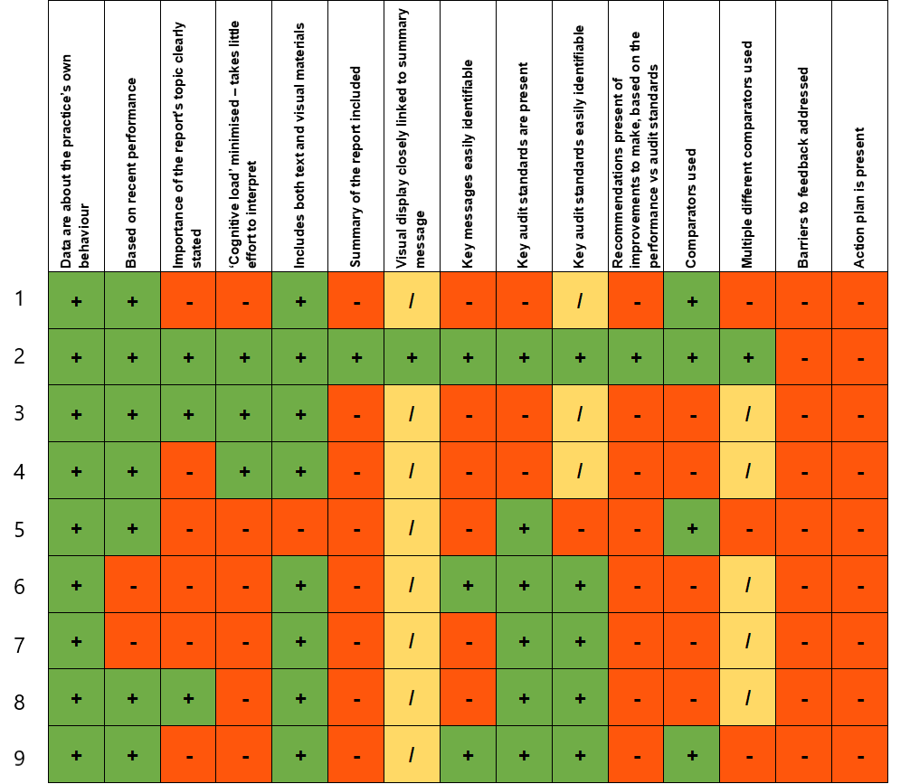
Green + = Yes, Red - = No, Yellow / = N/A

