Removal efficiency of six typical organic pesticides from water by different oxidation technologies
Yuliang Zhuª, Yucan Liu^{a*}, Ke Yu^{b}, Jinlin Guoª, Xianguo Jiª, Xinyi Xuª, Yan Zhangª, Yuxia Wang^{c}, Jinming Duan^{d}, Hongwei Sun^{e}
ª School of Civil Engineering, Yantai University, Yantai 264005, China
^{b} Xinjiang Uygur Autonomous Region Tobacco Company, Uygur 830000, China
^{c} School of Environmental and Municipal Engineering, North China University of Water Resources and Electric Power, Zhengzhou 450046, China
^{d} Centre for Water Management and Reuse, UniSA STEM, University of South Australia, Mawson Lakes Campus, SA 5095, Australia
^{e} School of Environmental and Materials Engineering, Yantai University, Yantai 264005, China

* Corresponding author
E–mail: liuyucan@ytu.edu.cn (Yucan Liu)

TABLE OF CONTENTS
Fig. S1 The effect of solution pH on the removal of the six pesticides by potassium permanganate oxidation process. 4
Fig. S2 The effect of solution pH on the removal of the six pesticides by sodium hypochlorite oxidation process. 5
Fig. S3 The effect of different concentration on the removal of the six pesticides by potassium persulphate oxidation process. 6
Fig. S4 The effect of solution pH on the removal of the six pesticides by potassium persulphate oxidation process. 7
Fig. S5 The effect of H₂O₂/Fe²⁺ ratio on the removal of the six pesticides by Fenton process. 8
Fig. S6 The effect of H₂O₂ concentration on the removal of the six pesticides by Fenton process. 9
Fig. S7 The effect of solution pH on the removal of the six pesticides by Fenton process. 10
Fig. S8 The effect of potassium persulphate concentration on the removal of the six pesticides by UV/PS process. 11
Fig. S9 The effect of solution pH on the removal of the six pesticides by UV/PS process. 12
Table S1 The reaction rate constant of the six pesticides removal by potassium permanganate oxidation at different pH conditions. 13
Table S2 The reaction rate constant of the six pesticides removal by sodium hypochlorite oxiadtion at different pH conditions. 14
Table S3 The reaction rate constant of the six pesticides removal at different concentration of potassium persulphate. 15
Table S4 The reaction rate constant of the six pesticides removal by potassium persulphate at different pH conditions. 16
Table S5 The reaction rate constant of the six pesticides removal by Fenton process at different H₂O₂/Fe²⁺ ratio. 17
Table S6 The reaction rate constant of the six pesticides removal by Fenton process at different H₂O₂ concentration. 18
Table S7 The reaction rate constant of the six pesticides removal by Fenton process at different pH conditions. 19
Table S8 The reaction rate constant of the six pesticides removal by UV/PS process at different potassium persulphate concentration. 20
Table S9 The reaction rate constant of the six pesticides removal by UV/PS process at different pH conditions. 21

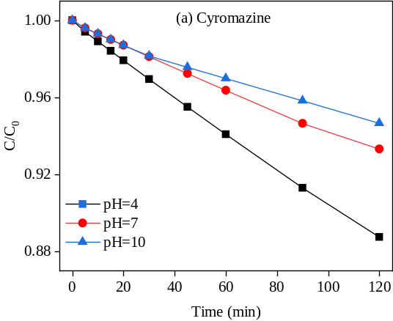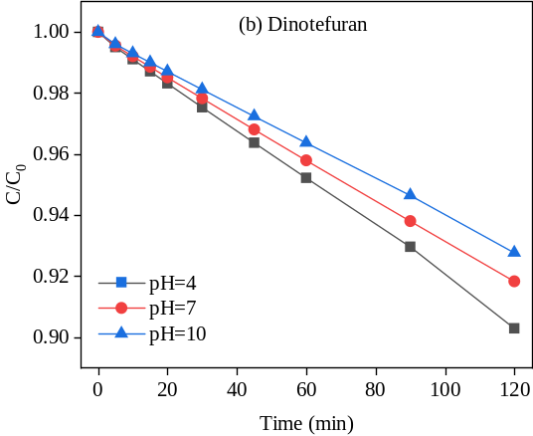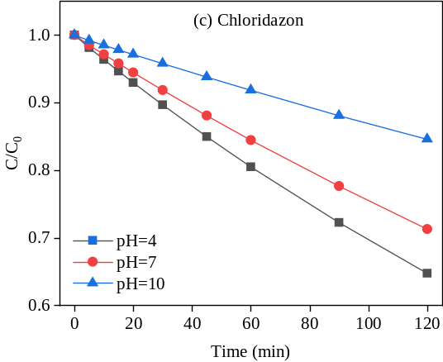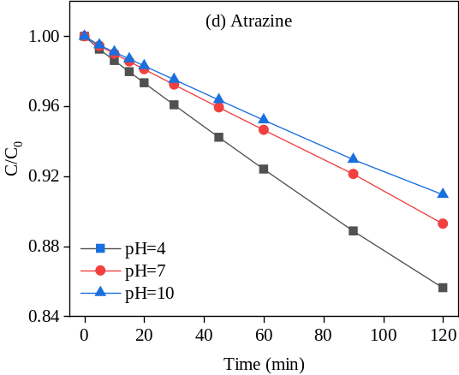
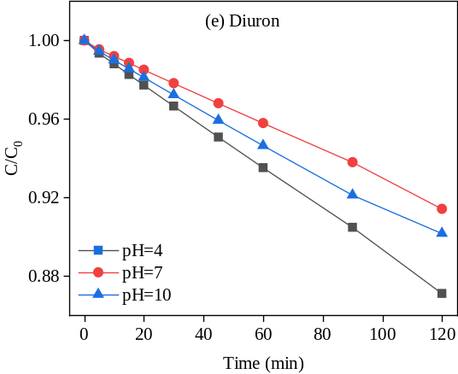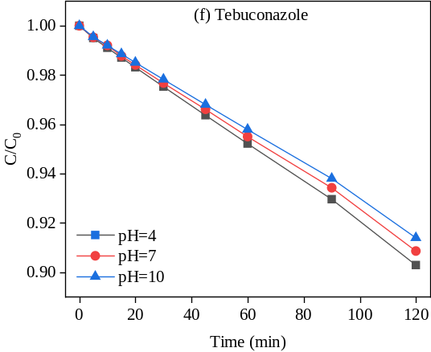

Fig. S1 The effect of solution pH on the removal of the six pesticides by potassium permanganate oxidation process.

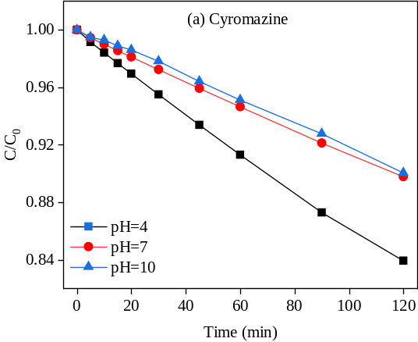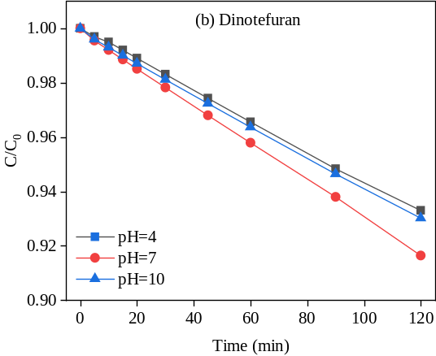
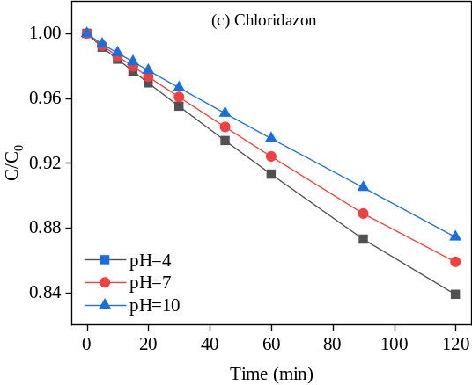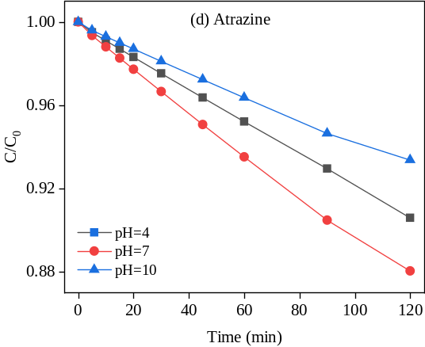
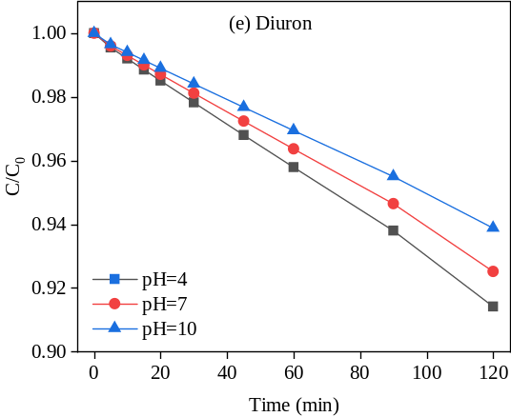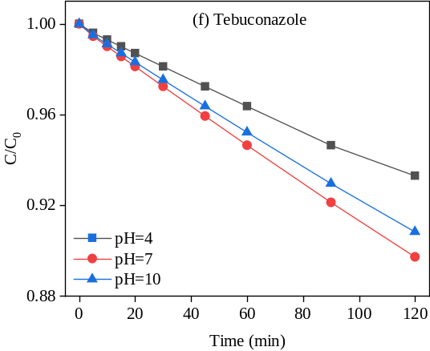

Fig. S2 The effect of solution pH on the removal of the six pesticides by sodium hypochlorite oxidation process.

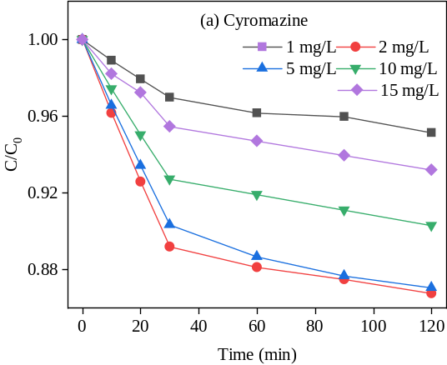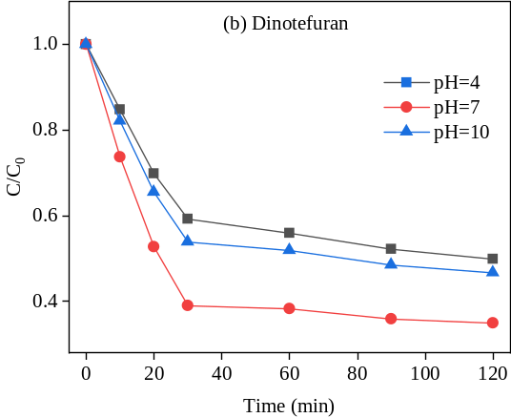
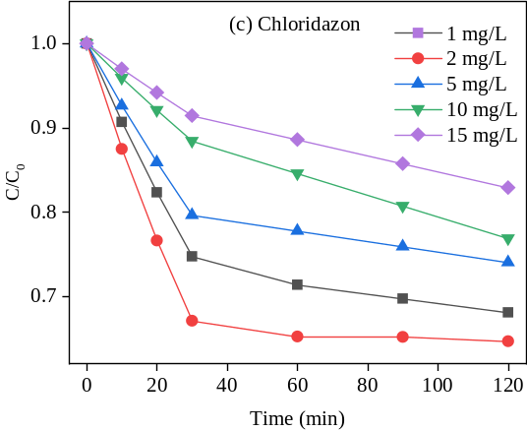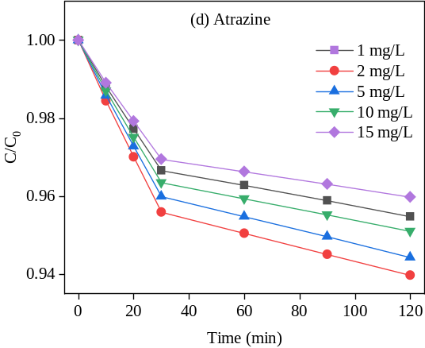
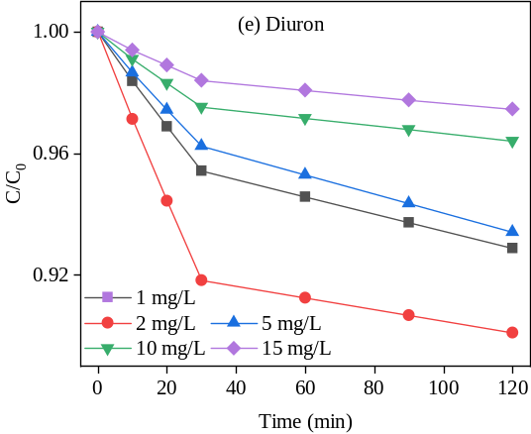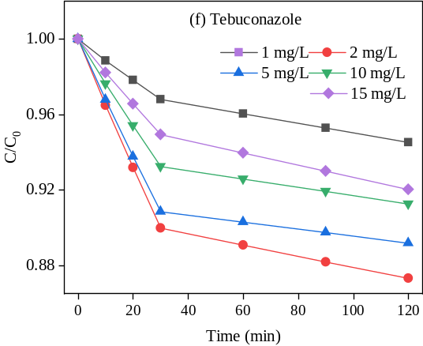

Fig. S3 The effect of different concentration on the removal of the six pesticides by potassium persulphate oxidation process.

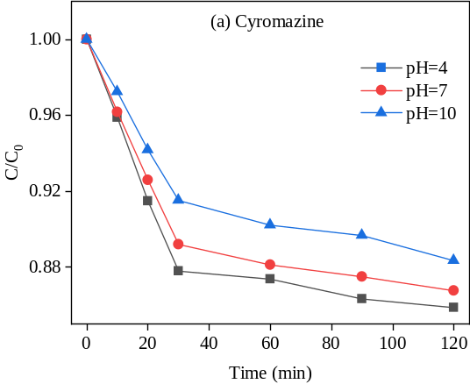
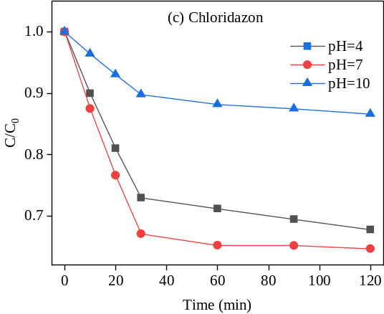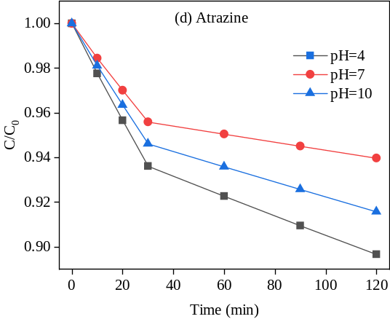
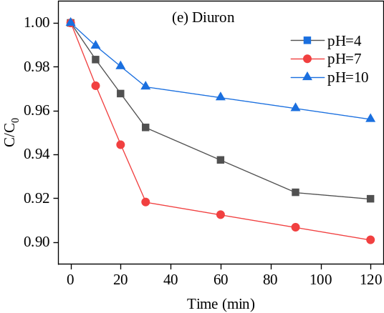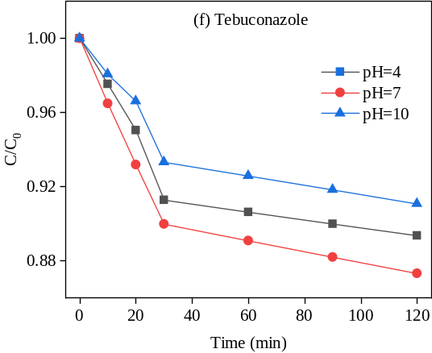

Fig. S4 The effect of solution pH on the removal of the six pesticides by potassium persulphate oxidation process.

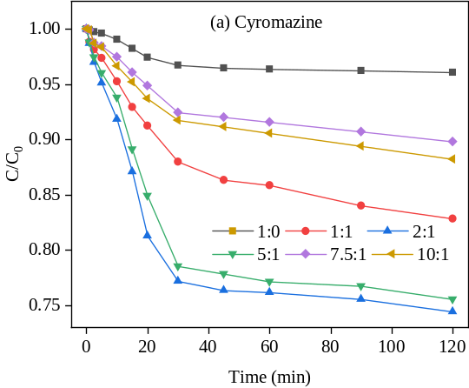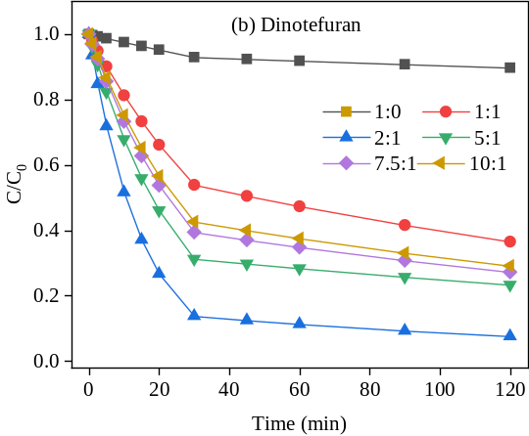
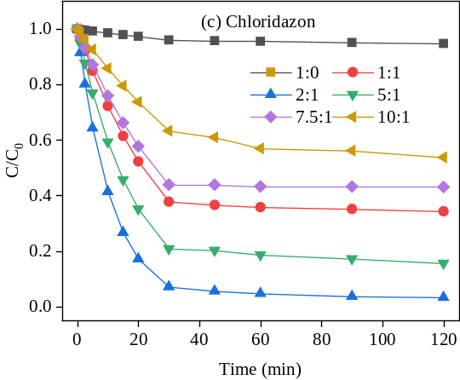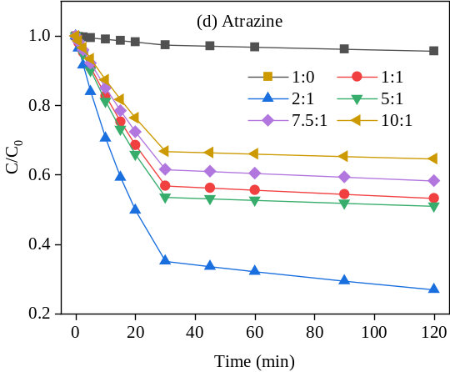
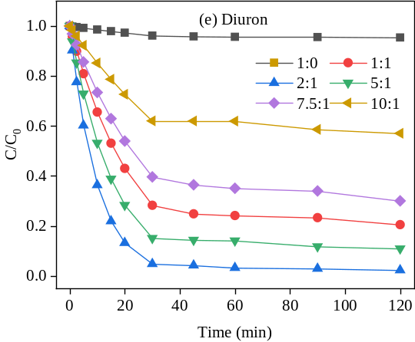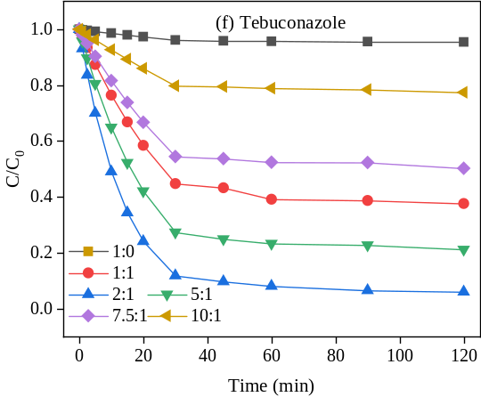

Fig. S5 The effect of H₂O₂/Fe²⁺ ratio on the removal of the six pesticides by Fenton process.

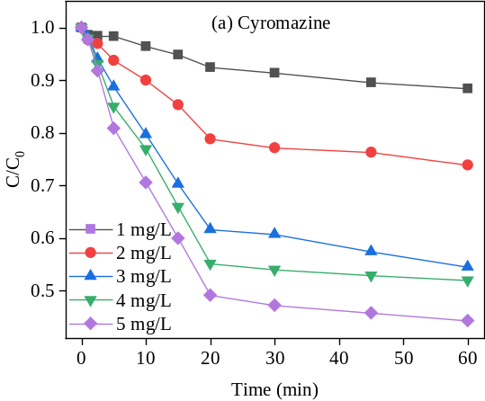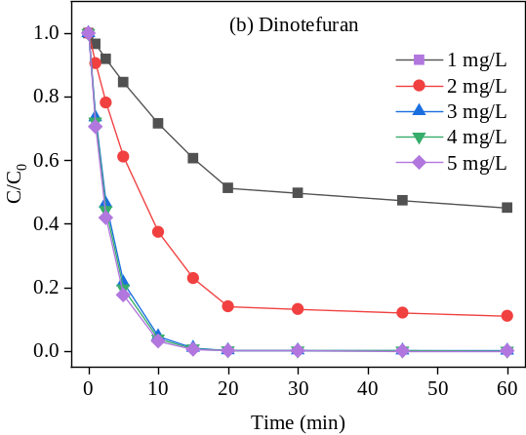
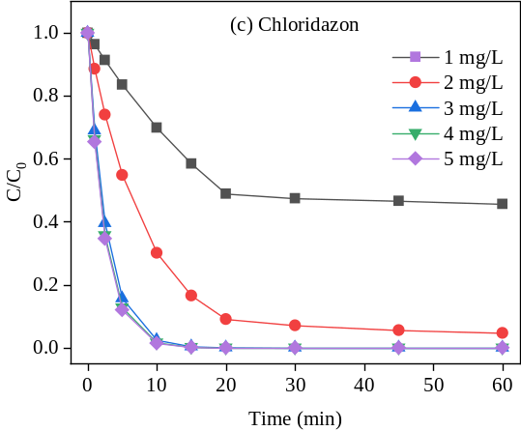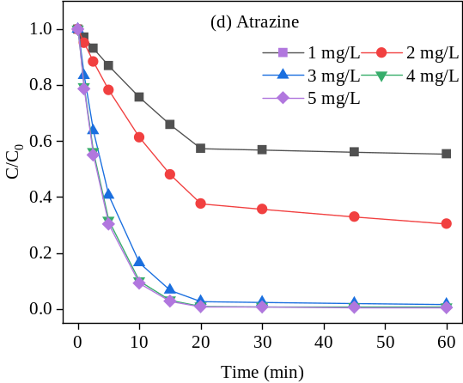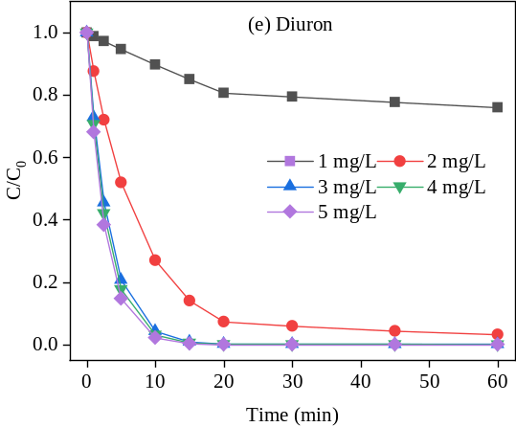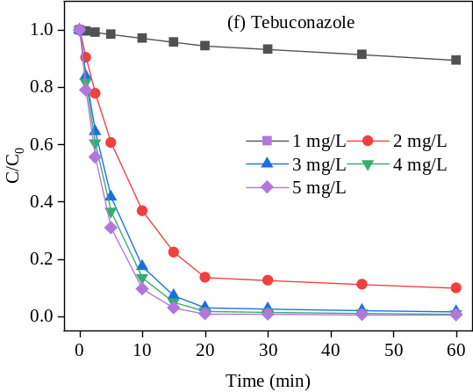

Fig. S6 The effect of H₂O₂ concentration on the removal of the six pesticides by Fenton process.

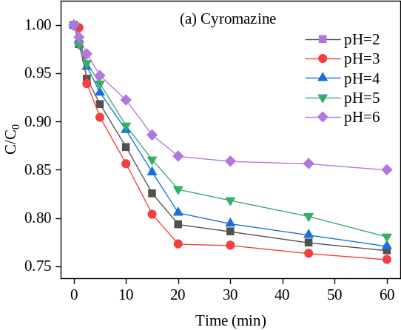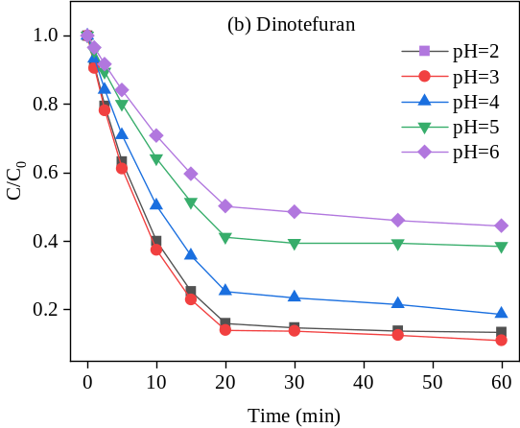
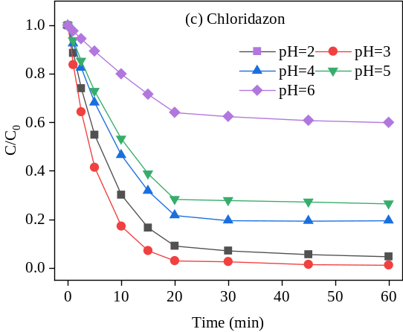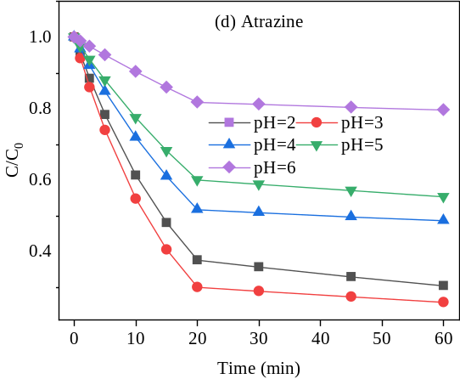
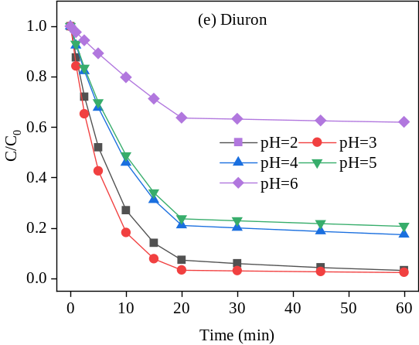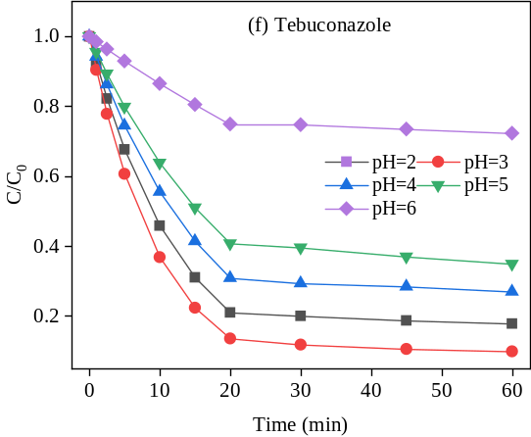

Fig. S7 The effect of solution pH on the removal of the six pesticides by Fenton process.

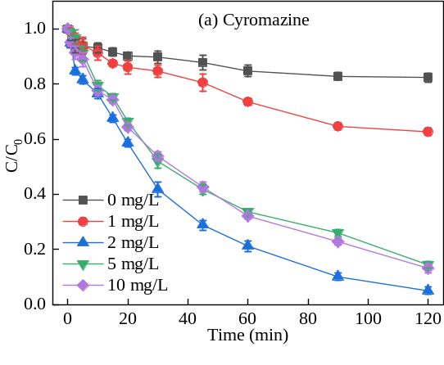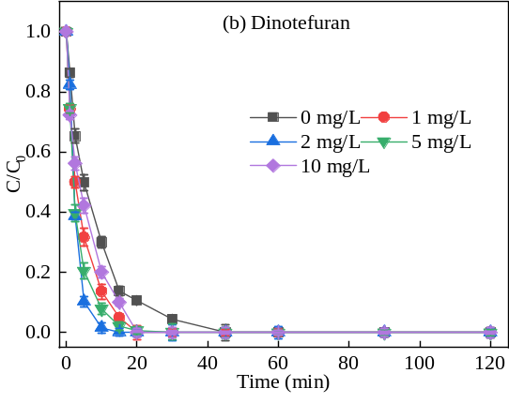
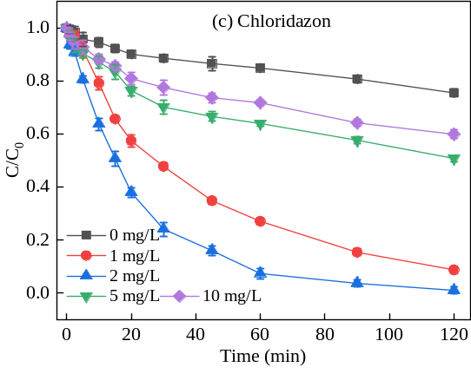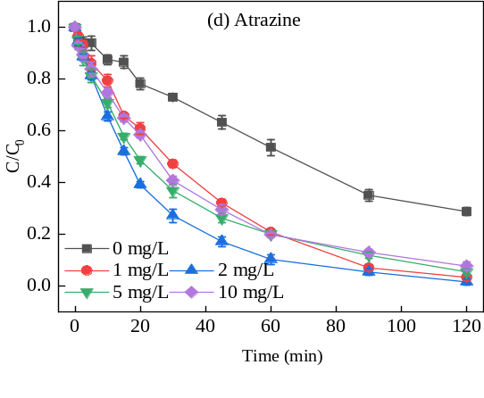
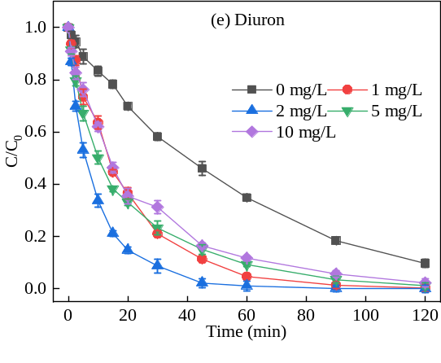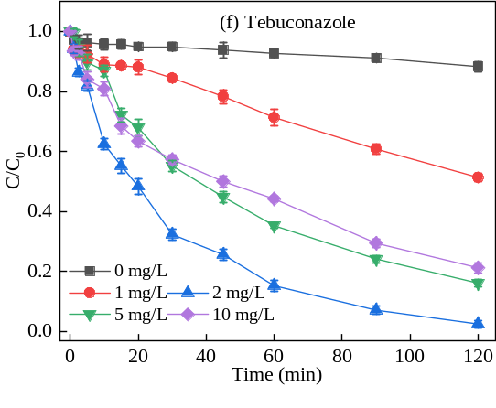

Fig. S8 The effect of potassium persulphate concentration on the removal of the six pesticides by UV/PS process.

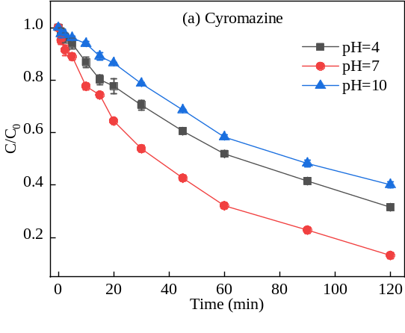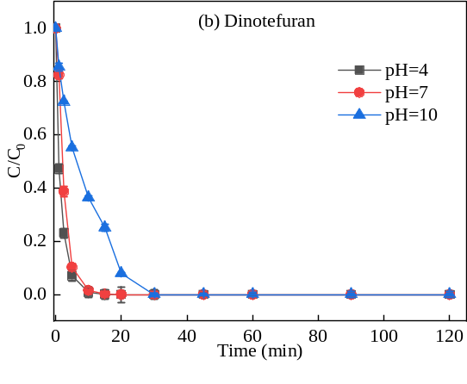
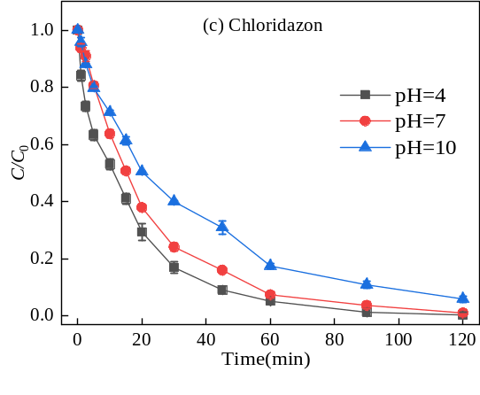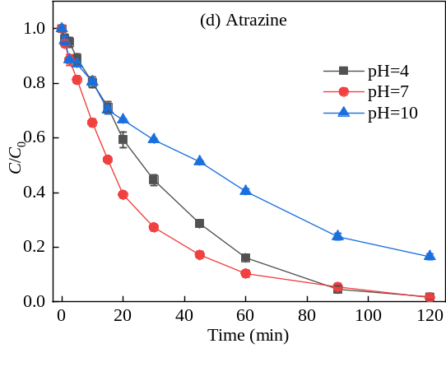
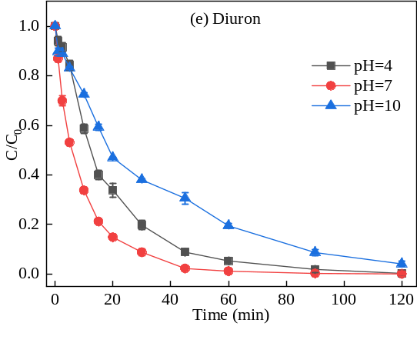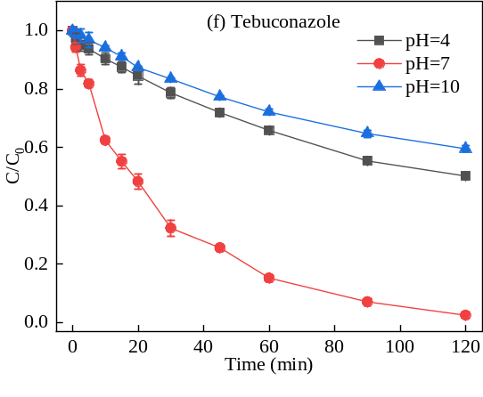

Fig. S9 The effect of solution pH on the removal of the six pesticides by UV/PS process.

Table S1 The reaction rate constant of the six pesticides removal by potassium permanganate oxidation at different pH conditions.
Pesticides | pH
Pesticides | 4 | 7 | 10
Cyromazine | 0.000993333 | 0.000580658 | 0.000445167
Dinotefuran | 0.00083221 | 0.000704207 | 0.000614715
Chloridazon | 0.00361 | 0.00281 | 0.00139
Atrazine | 0.00129 | 0.000927154 | 0.000790234
Diuron | 0.00113 | 0.000729313 | 0.000871206
Tebuconazole | 0.00083221 | 0.00077976 | 0.00073113

Table S2 The reaction rate constant of the six pesticides removal by sodium hypochlorite oxiadtion at different pH conditions.
Pesticides | pH
Pesticides | 4 | 7 | 10
Cyromazine | 0.00147 | 0.000895953 | 0.000869148
Dinotefuran | 0.000585123 | 0.000715567 | 0.000598981
Chloridazon | 0.00147 | 0.00128 | 0.00111
Atrazine | 0.000813011 | 0.00107 | 0.000577511
Diuron | 0.000729824 | 0.000629881 | 0.000514829
Tebuconazole | 0.000581771 | 0.000899549 | 0.0007983

Table S3 The reaction rate constant of the six pesticides removal at different concentration of potassium persulphate.
Pesticides | potassium persulphate concentration (mg/L)
Pesticides | 1 | 2 | 5 | 10 | 15
Cyromazine | 0.00102  0.00019883 | 0.00381  0.000300816 | 0.00338  0.000407651 | 0.00252  0.000294441 | 0.00149  0.000266933
Dinotefuran | 0.01966  0.0028 | 0.0316  0.00132 | 0.02462  0.00236 | 0.0182  0.0019 | 0.01078  0.00131
Chloridazon | 0.00971  0.00101 | 0.01331  0.0003713 | 0.00759  0.0008123 | 0.0041  0.00156 | 0.00298  0.00109
Atrazine | 0.00113  0.000136667 | 0.0015  0.0001899 | 0.00136  0.0001824 | 0.00124  0.000144633 | 0.00103  0.0001117
Diuron | 0.00156  0.0003006 | 0.00284  0.0002106 | 0.00127  0.0003318 | 0.00083  0.000128367 | 0.000533  0.0001073
Tebuconazole | 0.00108  0.0000284633 | 0.00352  0.000334067 | 0.0032  0.000205833 | 0.00233  0.00023867 | 0.00173  0.000345933

Table S4 The reaction rate constant of the six pesticides removal by potassium persulphate at different pH conditions.
Pesticides | pH
Pesticides | 4 | 7 | 10
Cyromazine | 0.00438  0.000261267 | 0.00381  0.000300816 | 0.00298  0.000372974
Dinotefuran | 0.01765  0.00195 | 0.03116  0.00132 | 0.02081  0.00166
Chloridazon | 0.01051  0.0008213 | 0.01331  0.0003713 | 0.00359  0.000387467
Atrazine | 0.0022  0.000479 | 0.0015  0.0001899 | 0.00184  0.000363333
Diuron | 0.00163  0.0004008 | 0.00294  0.0002106 | 0.00099  0.0001708
Tebuconazole | 0.003  0.000236367 | 0.00352  0.000333733 | 0.00222  0.000271

Table S5 The reaction rate constant of the six pesticides removal by Fenton process at different H₂O₂/Fe²⁺ ratio.
Pesticides | H₂O₂/Fe²⁺ ratio
Pesticides | 1:0 | 1:1 | 2:1 | 5:1 | 7.5:1 | 10:1
Cyromazine | 0.00118  0.00068408 | 0.00419  0.0006456 | 0.00891  0.0003705 | 0.00796  0.0004 | 0.00257  0.0003218 | 0.00295  0.000434
Dinotefuran | 0.00242  0.000392 | 0.02059  0.00432 | 0.06602  0.00661 | 0.03874  0.00325 | 0.03101  0.00412 | 0.02841  0.00423
Chloridazon | 0.00132  0.00014644 | 0.03241  0.0009936 | 0.0881  0.00832 | 0.05223  0.00327 | 0.02741  0.0002225 | 0.01522  0.00173
Atrazine | 0.0008362  0.0002021 | 0.01879  0.0007258 | 0.03483  0.00295 | 0.02078  0.0005448 | 0.01614  0.0006041 | 0.01343  0.0003624
Diuron | 0.00129  0.0007566 | 0.04211  0.00303 | 0.10113  0.00796 | 0.06298  0.00383 | 0.03083  0.00274 | 0.0159  0.00104
Tebuconazole | 0.00129  0.0007569 | 0.02678  0.00189 | 0.07112  0.00745 | 0.04319  0.00253 | 0.02023  0.0008186 | 0.00752  0.000328

Table S6 The reaction rate constant of the six pesticides removal by Fenton process at different H₂O₂ concentration.
Pesticides | H₂O₂ concentration (mg/L)
Pesticides | 1 | 2 | 3 | 4 | 5
Cyromazine | 0.0035  0.00114 | 0.01109  0.00152 | 0.02398  0.00318 | 0.02897  0.00145 | 0.03503  0.00249
Dinotefuran | 0.03334  0.00323 | 0.09813  0.00602 | 0.30684  0.01733 | 0.32534  0.02614 | 0.34721  0.0303
Chloridazon | 0.03572  0.00163 | 0.11983  0.0162 | 0.37026  0.02754 | 0.41155  0.0301 | 0.42329  0.0292
Atrazine | 0.02771  0.0008716 | 0.04875  0.00528 | 0.17982  0.01169 | 0.22975  0.00966 | 0.23843  0.01369
Diuron | 0.01071  0.00149 | 0.13069  0.02051 | 0.31461  0.0166 | 0.34589  0.01325 | 0.38259  0.01134
Tebuconazole | 0.00281  0.00136 | 0.09973  0.00793 | 0.17491  0.0151 | 0.20067  0.02047 | 0.23456  0.01349

Table S7 The reaction rate constant of the six pesticides removal by Fenton process at different pH conditions.
Pesticides | pH
Pesticides | 2 | 3 | 4 | 5 | 6
Cyromazine | 0.01129  0.0008803 | 0.01305  0.0005556 | 0.01045  0.00108 | 0.00908  0.00152 | 0.00718  0.0003865
Dinotefuran | 0.09152  0.00431 | 0.09813  0.00616 | 0.06855  0.00745 | 0.04431  0.00143 | 0.0344  0.00308
Chloridazon | 0.11983  0.0162 | 0.17583  0.02489 | 0.07641  0.0022 | 0.06303  0.00164 | 0.0222  0.00165
Atrazine | 0.04875  0.00528 | 0.06  0.00375 | 0.03285  0.00153 | 0.02543  0.00204 | 0.01001  0.000665
Diuron | 0.13069  0.02051 | 0.17023  0.00794 | 0.07775  0.00479 | 0.07186  0.00338 | 0.0225  0.0006725
Tebuconazole | 0.07794  0.00412 | 0.09974  0.00772 | 0.05871  0.00319 | 0.04484  0.00397 | 0.01441  0.0009293

Table S8 The reaction rate constant of the six pesticides removal by UV/PS process at different potassium persulphate concentration.
Pesticides | potassium persulphate concentration (mg/L)
Pesticides | 0 | 1 | 2 | 5 | 10
Cyromazine | 0.0013 | 0.0039 | 0.0248 | 0.0165 | 0.0158
Dinotefuran | 0.1268 | 0.1929 | 0.4236 | 0.2478 | 0.1467
Chloridazon | 0.0022 | 0.0204 | 0.0377 | 0.0054 | 0.0041
Atrazine | 0.0109 | 0.0284 | 0.0336 | 0.0235 | 0.0218
Diuron | 0.0233 | 0.0482 | 0.0679 | 0.0354 | 0.0309
Tebuconazole | 0.0008 | 0.0051 | 0.0295 | 0.0154 | 0.0124

Table S9 The reaction rate constant of the six pesticides removal by UV/PS process at different pH conditions.
Pesticides | pH
Pesticides | 4 | 7 | 10
Cyromazine | 0.0096 | 0.0165 | 0.0079
Dinotefuran | 0.4236 | 0.5067 | 0.0906
Chloridazon | 0.0465 | 0.0377 | 0.0237
Atrazine | 0.0336 | 0.0338 | 0.0146
Diuron | 0.0483 | 0.0679 | 0.0261
Tebuconazole | 0.0058 | 0.0295 | 0.0045

