The phenotypic characterization of Rivet wheat accessions (Triticum turgidum L. ssp. turgidum) for grain quality and other agronomic properties
Genetic Resources and Crop Evolution
Tatyana A. Pshenichnikova, Ludmila V. Shchukina, Andreas Börner
E-mail address: wheatpsh@bionet.nsc.ru
T.A. Pshenichnikova? Institute of Cytology and Genetics SB RAS, 630090, Novosibirsk, Russia

Table S1. Technological parameters of the Rivet accessions of T. turgidum from IPK collection grown in the field (Gatersleben, 2019-2020?)
Accession number in IPK | Accession name | Technological parameters
Accession number in IPK | Accession name | Vitreousness, % | Flour particle size, µm | M1000t*, g | Gluten content, %
TRI 28386 | England Rivet Wheat | 78.5 | 23.6 | 54.5 | 43.0
TRI 1256 | Rivets Grannen | 74.3 | 25.2 | 44.2 | 32.0
TRI 24752 | “RIVETTS GRANNEN” | 56.0 | 22.4 | 32.6 | 36.3

Table S2. Plant yield components among the Rivet accessions of T. turgidum from IPK collection grown in the field (Gatersleben, 2019-2020?)
Accession number in IPK | Accession name |  | Yield components
Accession number in IPK | Accession name | SL, cm | SN | SpL, cm | SpN | GN | GW, g | GNt | GWt, g | TGW, g
TRI 28386 | England Rivet Wheat | 91.9 | 6 | 9.2 | 24 | 25 | 1.87 | 187 | 10.8 | 57.6
TRI 1256 | Rivets Grannen | 76.7 | 7 | 7.3 | 24 | 39 | 1.67 | 276 | 12.7 | 46.0
TRI 24752 | “RIVETTS GRANNEN” | 68.7 | 5 | 7.3 | 26 | 33 | 1.37 | 131 | 5.4 | 41.2
SL – stem length; SN – stem number; SpL – spike length; SpN – spikelet number; SN – grain number from the spike; GW - grain weight from the spike; GNt – grain number from plant; GWt – grain weight from plant; M1000 – calculated thousand grains weight

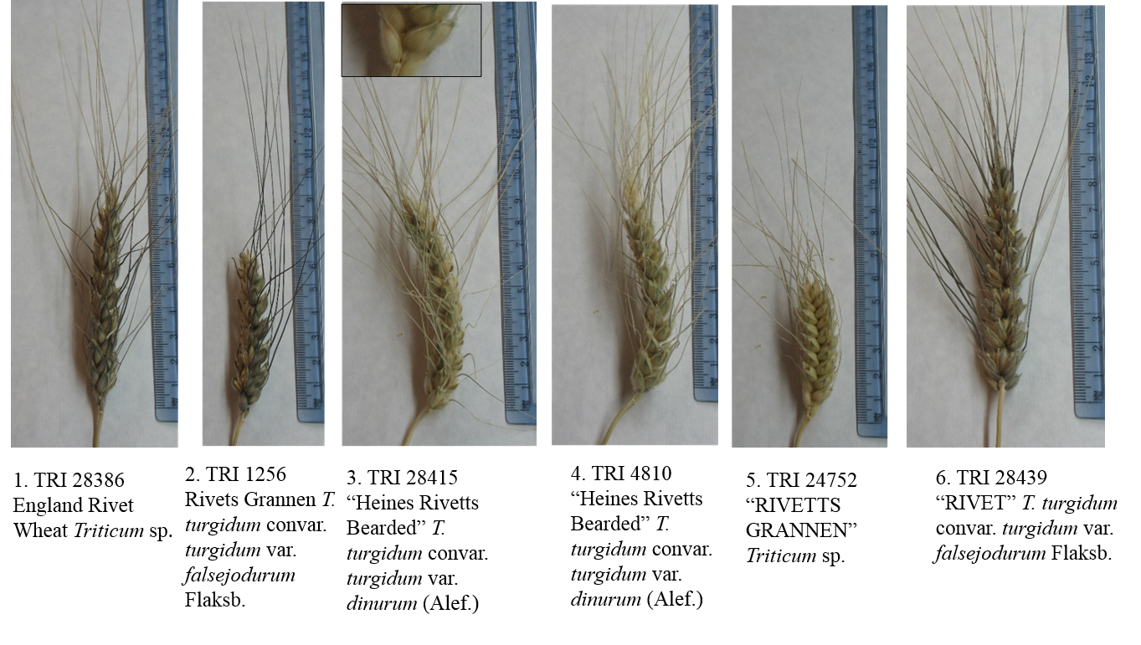
Fig. S1 Spikes of the studied Rivet accessions. Inset demonstrates glume pubescence

