Theoretical and Applied Genetics

Pinpointing genomic regions associated with root system architecture in rice through an integrative meta-analysis approach

Parisa Daryani^{1,2}, Hadi Darzi Ramandi³, Sara Dezhsetan¹*, Raheleh Mirdar Mansuri², Ghasem Hosseini Salekdeh², Zahra-Sadat Shobbar²*
1- Department of Agronomy & Plant Breeding, University of Mohaghegh Ardabili, Ardabil, Iran
2- Department of Systems Biology, Agricultural Biotechnology Research Institute of Iran (ABRII), Agricultural Research Education and Extension Organization (AREEO), PO Box 31535-1897, Karaj, Iran
3- Department of Molecular Physiology, Agricultural Biotechnology Research Institute of Iran, Agricultural Research Education and Extension Organization (AREEO), Karaj, Iran
*Corresponding authors:
Zahra-Sadat Shobbar: Email: shobbar@abrii.ac.ir; Phone: +989123441775
Sara Dezhsetan: Email: sdezhsetan@uma.ac.ir; Phone: +989143064277

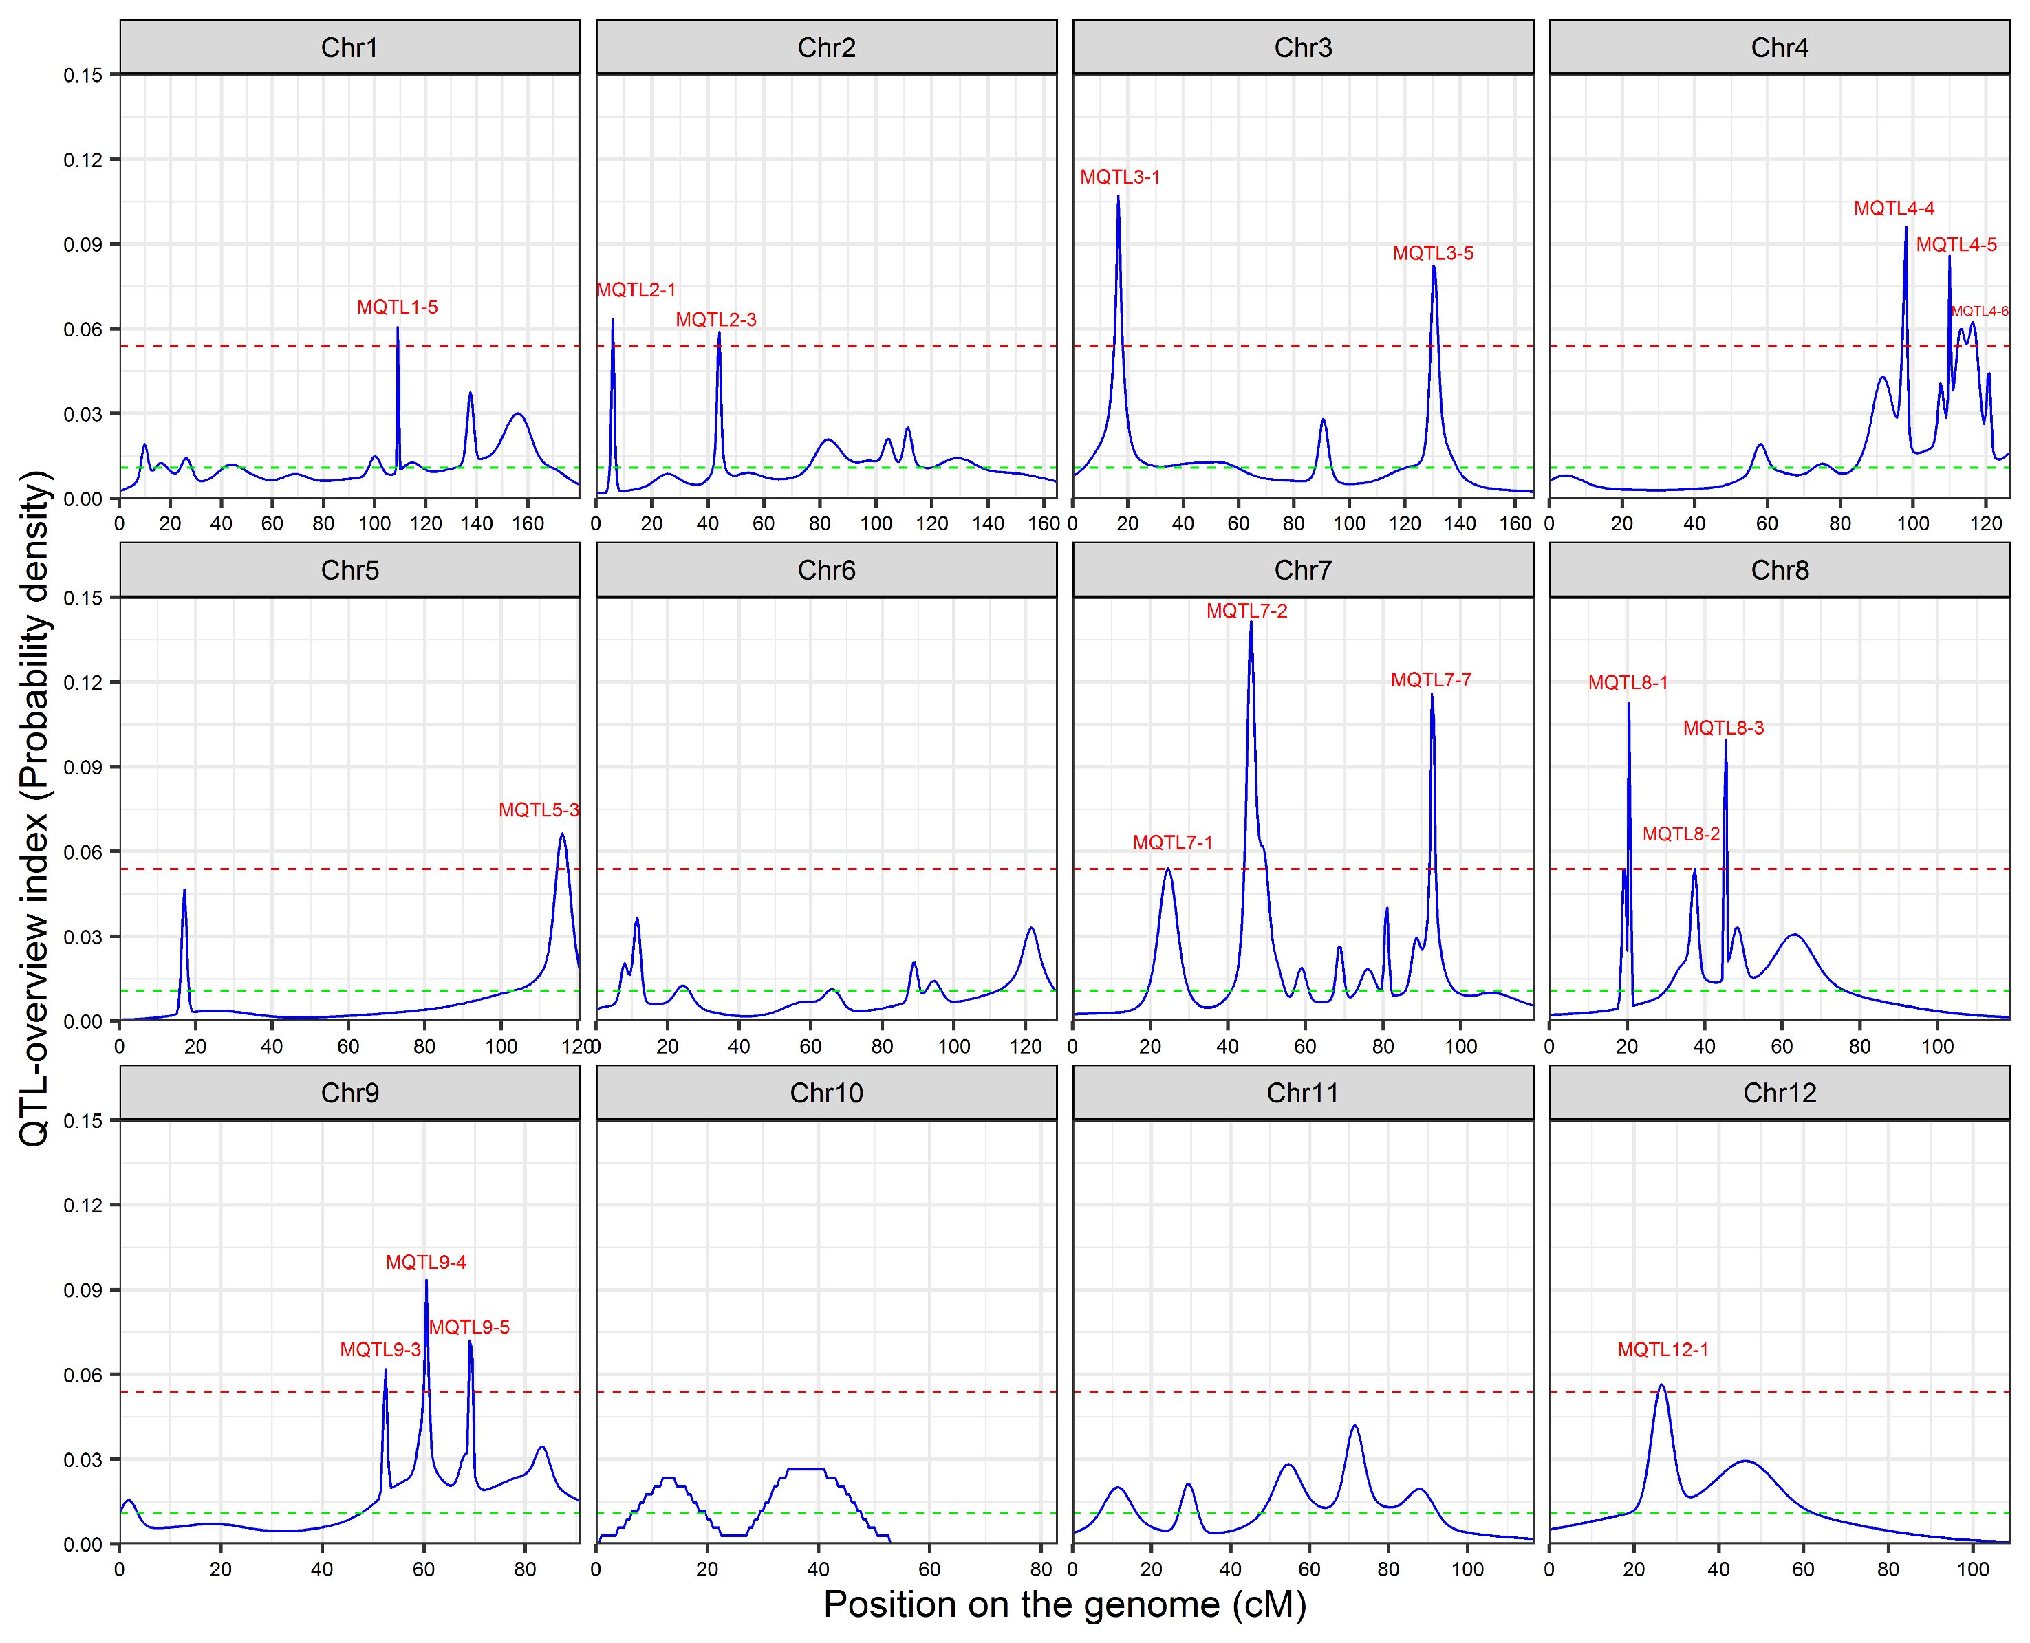
Supplementary Figure S1. QTL-overview index for root architecture traits on the rice consensus genetic map. The QTL dataset was collected from 34 independent studies including 425 QTLs and 26 experiments. The two dashed lines with value of 0.01077 and 0.05386 indicate the average index and high-value threshold, respectively. Upper labels indicate the position of nineteen "real QTLs" regions

RNA-seq
Microarray
M-QTL
5990
803
10547
10639
611
510
217
RNA-seq
Microarray
M-QTL
5265
3276
8946
8855
2395
2111
942
a)
b)
Supplementary Figure S2. Venn diagram of differential expressed genes (DEGs) derived from RNA-seq, microarray data compared with (a) 36 MQTLs regions with CI of less than 1Mb (b) all MQTLs regions (Venn diagram was drawn using a tool in this website: http://bioinformatics.psb.ugent.be/webtools/Venn/). Detailed information is presented in the supplementary table S8.

a) | b)
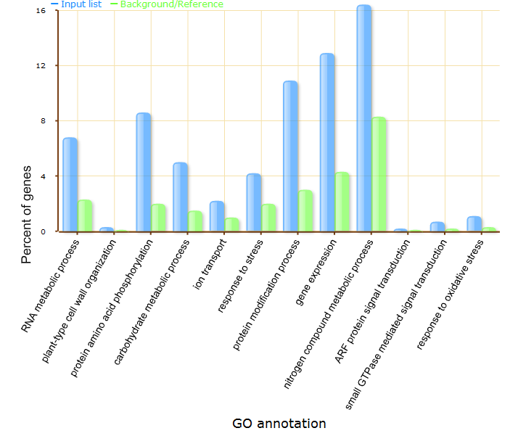 | 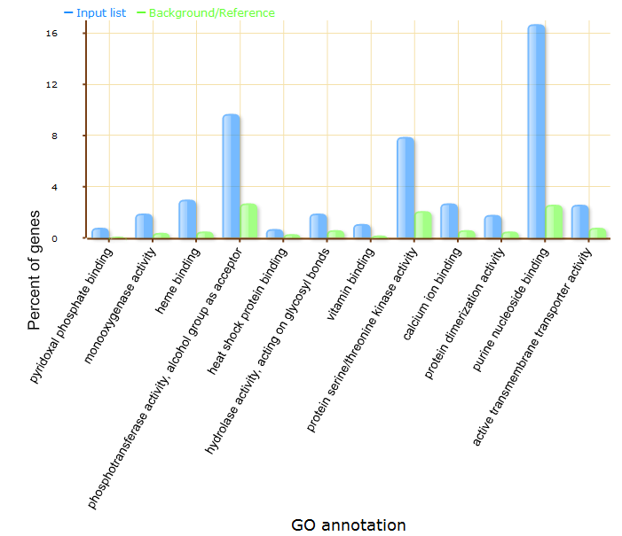
c) | d)
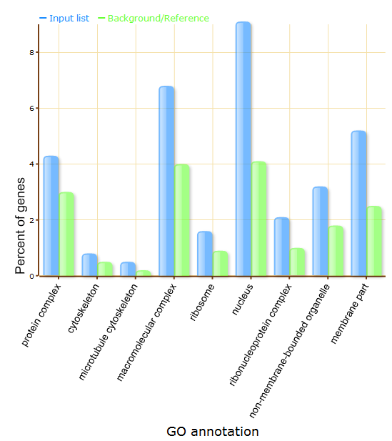 | 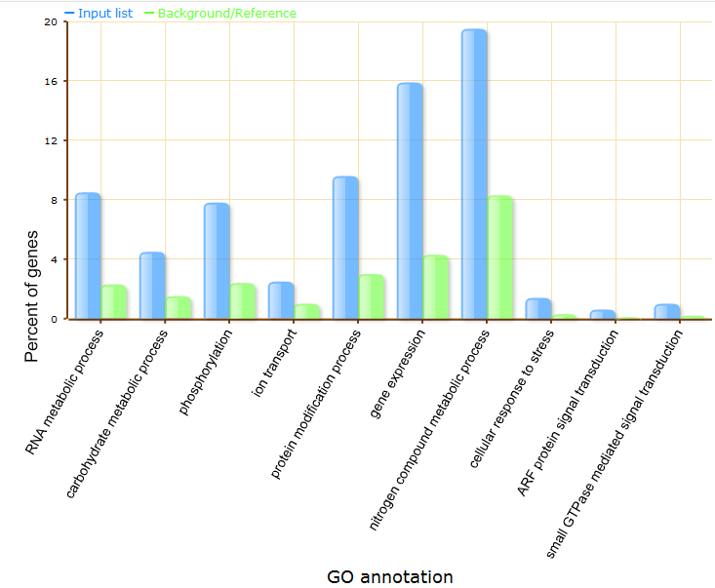
e) | f)
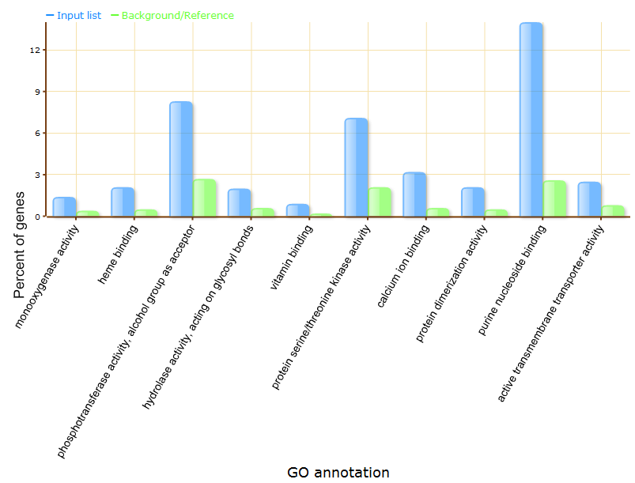 | 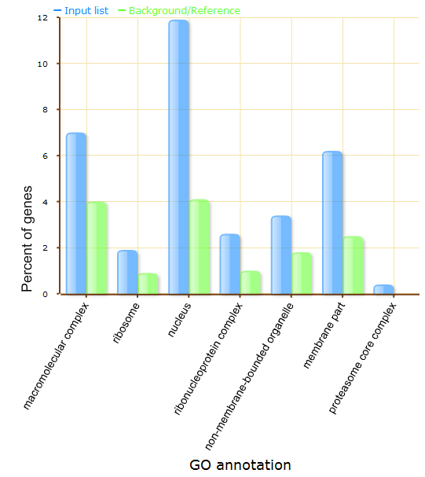
Supplementary Figure S3. Gene ontology (GO) analysis of the genes located in RSA related MQTL regions: The bar chart of GO term enrichment analysis of the genes located in the 64 MQTLs (a-c) and 36 MQTLs (with an interval of less than 1Mb) (d-f), which were grouped into the three major GO categories included biological process (a, d), molecular function (b, e), and cellular component (c, f). Cumulative chart showing GO classification for the differentially expressed candidate genes (DECGs) and constitutively expressed candidate genes (CECGs) (g). Venn diagram revealing common enriched terms among the genes located in the 64 MQTLs, DECGs and CECGs (h)

g)
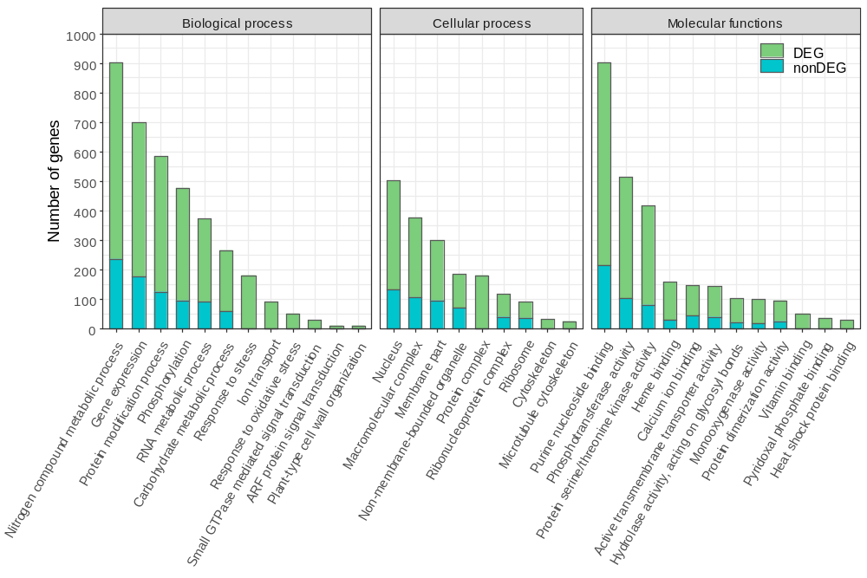
GO non-DEG (64 MQTL)
GO DEG (64 MQTL)

GO (64 MQTL)

29
25
35
3
220
208
28
h)
Supplementary Figure S3 continued

a)
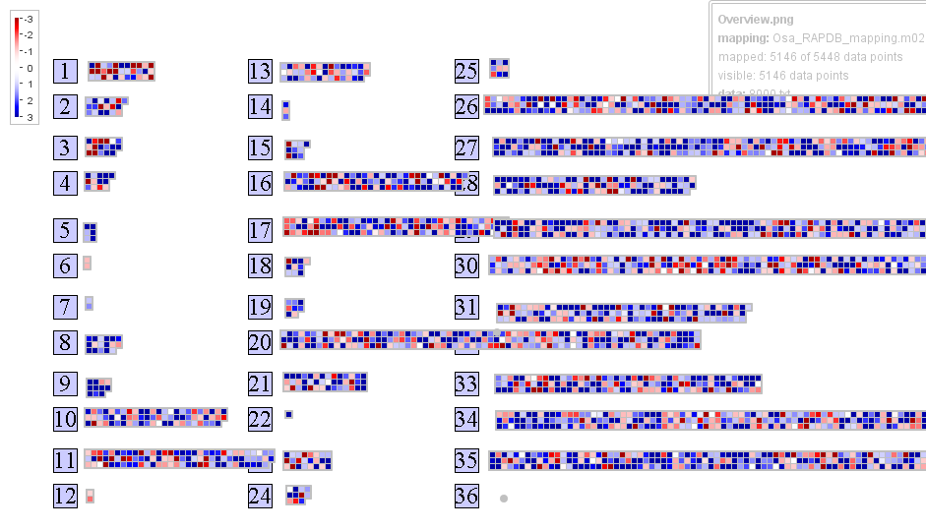

b)
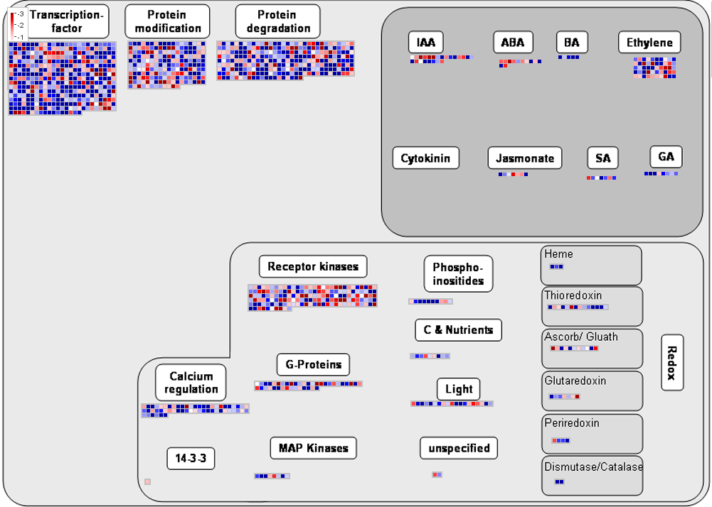

Supplementary Figure S4. MapMan analysis of the drought-responsive candidate genes located in the 64 (a-c) and 36 (d-f) RSA related MQTLs. Overview (a, d), Regulation (b, e), Transcription (c, f), blue: up-regulated genes and red: down-regulated genes. Detailed information is presented in the supplementary table S10.

The drought-induced TFs located in RSA MQTLs included 58 myeloblastosis (MYB), 22 Apetala2/Ethylene Responsive Element Binding Proteins (AP2/EREBPs), 17 Basic Helix-Loop-Helix (bHLH) genes, 14 homeobox genes (HB), 12 Chromatin remodeling factors, 11 SET-domains, 15 WRKY domains, 5 C2C2(Zn) DOF zinc finger family, 3 C3H zinc fingers, 6 MADS box genes, 4 NAC box genes, 10 G2-like transcription factor family (GARP), 3 Auxin Response Factor family (ARF), and 23 basic leucine zipper (bZIP) (Supplementary Fig. S4c). According to Supplementary Fig. S2b, 56 genes for calcium regulation were identified for signaling pathways along with 160 for receptor kinase, 40 for G-proteins, 8 for MAP kinase, 10 for phosphoinositide, one for 14-3-3 proteins, 19 for light signaling and 2 unspecified signaling genes.
c)
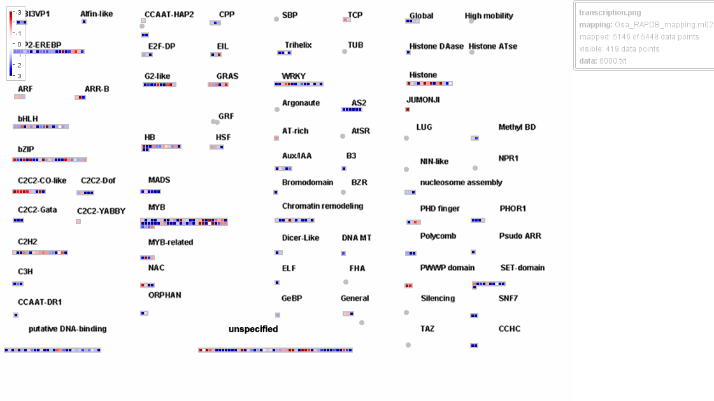

d)
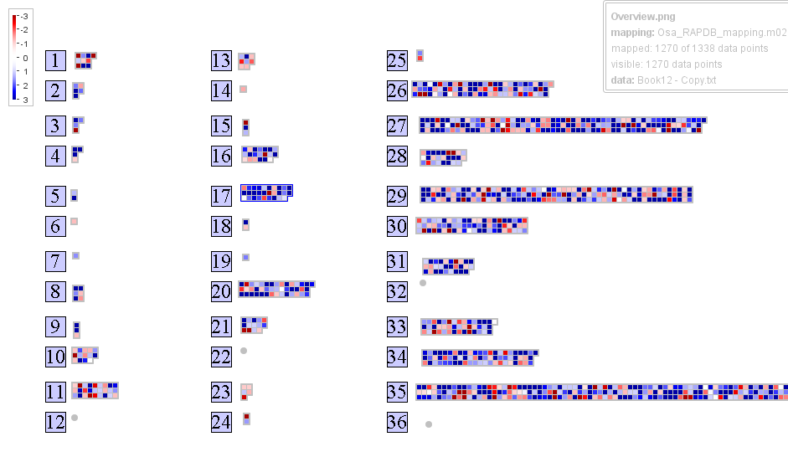

Supplementary Figure S4 continued

e)
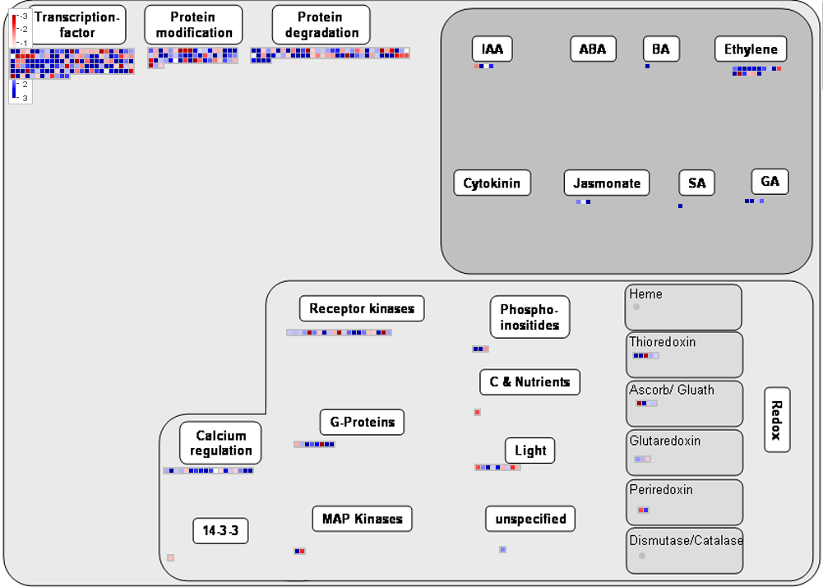

f)
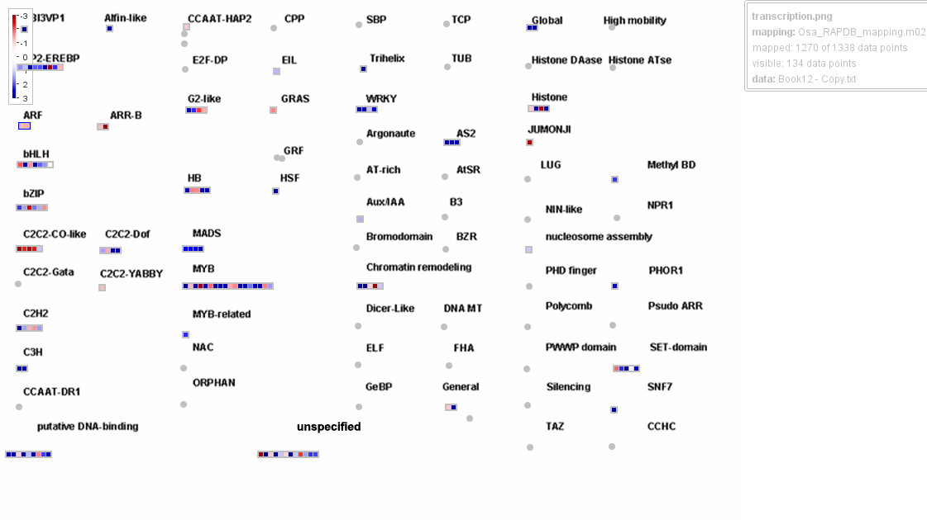
Supplementary Figure S4 continued

32
100
2
2295
8853
3
5262
8940
2051
3244
917
6
60
7
25
GWAS
RNA-seq
Microarray
M-QTL

Supplementary Figure S5. Venn diagram of the genes located in the identified MQTLs associated with RSA (M-QTL), genes located in SNP peak positions reported in the GWAS studies for root morphological traits, and the differentially expressed genes (DEGs) derived from RNA-seq and microarray data. Based on this comparison, 100 drought responsive genes in rice root were found in both the MQTL regions and SNP positions associated with RSA. (Venn diagram was drawn using a tool in this website: http://bioinformatics.psb.ugent.be/webtools/Venn/)

