Supplementary Information for

Scalable production of uniform and mature organoids in a 3D geometrically-engineered permeable membrane

Dohui Kim^{‡,1}, Hyeonji Lim^{‡,2}, Jaeseung Youn¹, Tae-Eun Park^{2,*}, Dong Sung Kim^{1,3,4,5*}

¹ Department of Mechanical Engineering, Pohang University of Science and Technology (POSTECH), Pohang, 37673, South Korea
² Department of Biomedical Engineering, College of Information and Biotechnology, Ulsan National Institute of Science and Technology (UNIST), Ulsan, 44919, South Korea
³ Department of Chemical Engineering, Pohang University of Science and Technology (POSTECH), Pohang, 37673, South Korea
⁴ School of Interdisciplinary Bioscience and Bioengineering, Pohang University of Science and Technology (POSTECH), Pohang, 37673, South Korea
⁵ Institute for Convergence Research and Education in Advanced Technology, Yonsei University, Seoul, 03722, South Korea

‡ These authors contributed to this work equally.
∗ Authors to whom any correspondence should be addressed.
E-mail: smkds@postech.ac.kr (D.S. Kim) and tepark@unist.ac.kr (T.E. Park)
Table of Contents

Supplementary Notes 4
Supplementary Note 1. Optimization of kidney organoid differentiation protocol on hydrogel layer 4
Supplementary Note 2. Optimization of kidney organoid differentiation protocol in 3D culture platform 5
Supplementary Note 3. Exploration of potential of UniMat to regulate initial aggregate size 6

Supplementary Tables 8
Supplementary Table 1. COV for sizes of kidney organoids in hydrogel layer and UniMat 8
Supplementary Table 2. COV for structures of kidney organoids in hydrogel layer and UniMat 9
Supplementary Table 3. COV for gene expressions of kidney organoids in hydrogel layer and UniMat 10
Supplementary Table 4. COV for organoid formation efficiency of kidney organoids in hydrogel layer and UniMat 11
Supplementary Table 5. Count of cells in AggreWell and UniMat 12
Supplementary Table 6. GO Term enriched in UniMat podocyte (POD) cluster 13
Supplementary Table 7. GO Term enriched in UniMat proximal tubule (PT) and loop of Henle/distal tubule (LOH/DT) clusters 14
Supplementary Table 8. GO Term enriched in UniMat endothelial cell (EC) cluster 15
Supplementary Table 9. COV for structures of kidney organoids in AggreWell and UniMat 16
Supplementary Table 10. COV for gene expressions of kidney organoids in AggreWell and UniMat 17
Supplementary Table 11. Antibodies for immunostaining 18
Supplementary Table 12. Primers for qRT-PCR 19
Supplementary Table 13. Simulation parameters used to predict glucose diffusion profiles 20

Supplementary Figures 21
Supplementary Figure 1. Geometric characteristics of UniMat 21
Supplementary Figure 2. Optimization of kidney organoid differentiation protocol on hydrogel layer 22
Supplementary Figure 3. Optimization of kidney organoid differentiation protocol in 3D culture platform 24
Supplementary Figure 4. Exploration of potential of UniMat to regulate initial aggregate size 25
Supplementary Figure 5. Mature hiPSCs-derived kidney organoids in UniMat 26
Supplementary Figure 6. Enhanced vascularization of hiPSCs-derived kidney organoids in UniMat 27
Supplementary Figure 7. UMAP plot of distribution of kidney organoid cells in AggreWell and UniMat 28
Supplementary Figure 8. UMAP plots of gene expression of kidney organoid cells in AggreWell and UniMat 29
Supplementary Figure 9. Comparison of proportion of early proximal tubules (EPT) between AggreWell and UniMat 30
Supplementary Figure 10. Confocal images of polycystic kidney disease (PKD) organoids 31

Supplementary Video Captions 32
Supplementary Video 1. Confocal z-stack movie of kidney organoids cultured in AggreWell stained with PODXL (cyan) and PECAM1 (red) 32
Supplementary Video 2. Confocal z-stack movie of kidney organoids cultured in UniMat stained with PODXL (cyan) and PECAM1 (red) 32

References 33

Supplementary Notes

Supplementary Note 1: Optimization of kidney organoid differentiation protocol on hydrogel layer
The Morizane protocol¹ stands as a well-established method for the differentiation of kidney organoids from both human embryonic stem cells (hESCs) and human induced pluripotent stem cells (hiPSCs). In this study, we directed our focus towards the optimization of the Morizane protocol, specifically tailored to hiPSCs. Leveraging the original Morizane protocol (Supplementary Fig. 2a), we meticulously optimized the concentration of growth factors and small molecules to differentiate hiPSCs into kidney organoids. Initially, we fine-tuned the concentrations of both CHIR99021 (CHIR) and Noggin to facilitate the induction of late primitive streak, using WTC11 hiPSCs (Supplementary Fig. 2b). Notably, when assessing the mRNA expression levels of TBX6 in day 4 cells, we observed statistically significant increases in mRNA expression when exposed to CHIR concentrations of 8 and 10 µM, in comparison to concentrations of 3 and 6 µM (Supplementary Fig. 2c). Furthermore, the treatment with 10 ng/ml of Noggin resulted in elevated mRNA expression of TBX6, compared to the 5 ng/ml Noggin treatment (Supplementary Fig. 2c). Subsequently, while maintaining the original Morizane protocol unchanged, we successfully induced the formation of kidney organoids on a Geltrex hydrogel layer by day 21 (Supplementary Fig. 2d). To validate the robustness and versatility of our optimized protocol, we conducted independent replication experiments employing a different hiPSCs line, IMR90-4 (Supplementary Fig. 2e). Impressively, our optimized protocol consistently demonstrated its proficiency in inducing kidney organoids on the hydrogel layer (Supplementary Fig. 2e), thereby reaffirming its reliability and adaptability for hiPSCs-derived kidney organoid differentiations.
Supplementary Note 2: Optimization of kidney organoid differentiation protocol in 3D culture platform
Having established a robust hiPSCs-derived kidney organoid differentiation protocol on a hydrogel layer, we endeavored to adapt this protocol to a 3D culture platform. Specifically, we explored two different 3D culture platforms: the 96-well, round-bottom, ultra-low-attachment plate (96-well plate) and the AggreWell™ Microwell Plate (AggreWell). Inspired by the original procedural steps of the Morizane protocol from day 9 to day 21 (Supplementary Fig. 3a), our optimization focused on the period from day 11 to day 14, employing WTC11 hiPSCs. Notably, our findings diverged from the original Morizane protocol. We discovered that the administrating FGF9 at a concentration of 30 ng/ml, supplemented with 1.5% fetal bovine serum (FBS), enhanced the induction of renal vesicle formation (Supplementary Fig. 3b). Furthermore, we confirmed the indispensable role of FBS in sustaining organoid differentiation after FGF9 removal from day 14 onwards. Subsequently, we successfully induced the formation of kidney organoids using our optimized protocol (Supplementary Fig. 3c) in both the 96-well plate and the AggreWell by day 21 (Supplementary Fig. 3d). To validate the robustness and versatility of our optimized protocol, we conducted independent replication experiments utilizing the different hiPSC line, IMR90-4 (Supplementary Fig. 3e). Impressively, our optimized protocol consistently demonstrated its proficiency in inducing kidney organoids within the 3D culture platforms (Supplementary Fig. 3e), thus reaffirming its reliability and adaptability for hiPSC-derived kidney organoid differentiations within 3D culture platforms.

Supplementary Note 3: Exploration of potential of UniMat to regulate initial aggregate size
In our investigation to estimate the initial aggregate size within a single microwell of the UniMat, we started with the assumption that the total volume of seeded cells was equivalent to the aggregate size. In this study, cells were seeded at a density of approximately 960,000 cells per UniMat, enabling to calculate the average number of cells within individual microwells of the UniMat (Supplementary Fig. 4c). To facilitate our estimation, we employed a simplified geometry of the microwell within UniMat (Supplementary Fig. 4d). In addition, we measured the diameter of an individual suspended cell, which was approximately 10 μm. Based on our data, we inferred that the diameter of the initial aggregate aligns with the diameter of the uppermost cell layer when cells are vertically stacked within a microwell (Supplementary Fig. 4e). Upon analysis, we observed that the estimated sizes closely matched but were slightly below the measured sizes (Supplementary Fig. 4f). This discrepancy could be due to factors inherent in our estimation method. The primary assumption behind our method was perfect cell packing within the microwells, with the initial aggregate size equating to the total cell volume. In practice, the packing of the aggregate within a microwell might not be uniformly dense, leading to differences between the estimated and actual sizes. Additionally, cells often tend to form clumps or clusters, particularly when cultured at high cell densities. Such cellular aggregates might not have been fully accounted for in our estimation, consequently contributing to disparity between the estimated and measured aggregate sizes. Nonetheless, it is noteworthy that the measured sizes closely approximated the estimated sizes (Supplementary Fig. 4f), as determined from the geometrical data of the microwells and the average number of cell sedimentations per microwell in each UniMat. This suggests that, despite the complexities in estimating initial aggregate size, our method provided reasonably accurate estimations within the context of this study.
Supplementary Tables

Supplementary Table 1. COV for sizes of kidney organoids in hydrogel layer and UniMat. Calculation of COV for diameters of kidney organoids formed in hydrogel layer, UniMat400, UniMat600, and UniMat800.
 | Diameters of kidney organoids (µm)
 | Mean | SD | COV
Hydrogel layer | 276.80 | 58.68 | 21.20
UniMat400 | 178.17 | 15.67 | 8.79
UniMat600 | 258.14 | 15.11 | 5.85
UniMat800 | 281.08 | 8.04 | 2.86

Supplementary Table 2. Cov for structures of kidney organoids in hydrogel layer and UniMat. COV for PODXL⁺ podocytes, LTL⁺ proximal tubules, and CDH1⁺ distal tubules volume in individual kidney organoids formed in hydrogel layer, UniMat400, UniMat600, and UniMat800.
 | PODXL⁺ podocytes volume in individual kidney organoids (10⁵ µm³)
 | Mean | SD | COV
Hydrogel layer | 6.96 | 2.92 | 41.92
UniMat400 | 3.90 | 0.75 | 19.22
UniMat600 | 8.16 | 0.85 | 10.41
UniMat800 | 9.51 | 0.45 | 4.68
 | LTL⁺ podocytes volume in individual kidney organoids (10⁵ µm³)
 | Mean | SD | COV
Hydrogel layer | 10.41 | 4.67 | 44.84
UniMat400 | 4.46 | 0.86 | 19.24
UniMat600 | 7.89 | 0.85 | 10.83
UniMat800 | 14.99 | 0.75 | 4.98
 | CDH1⁺ podocytes volume in individual kidney organoids (10⁵ µm³)
 | Mean | SD | COV
Hydrogel layer | 9.62 | 4.11 | 42.71
UniMat400 | 4.59 | 0.64 | 13.98
UniMat600 | 8.08 | 0.95 | 11.73
UniMat800 | 10.59 | 0.90 | 8.47

Supplementary Table 3. COV for gene expressions of kidney organoids in hydrogel layer and UniMat. COV of variation for PODXL, SLC34A1, and CDH1 gene expressions of kidney organoids cultured in hydrogel layer and UniMat.
 | mRNA expression ratio of PODXL
 | Mean | SD | COV
Hydrogel layer | 1.00 | 0.60 | 59.59
UniMat | 1.12 | 0.25 | 22.31
 | mRNA expression ratio of SLC34A1
 | Mean | SD | COV
Hydrogel layer | 1.00 | 0.75 | 74.92
UniMat | 1.32 | 0.17 | 13.08
 | mRNA expression ratio of CDH1
 | Mean | SD | COV
Hydrogel layer | 1.00 | 0.47 | 47.37
UniMat | 1.41 | 0.13 | 9.12

Supplementary Table 4. COV for organoid formation efficiency of kidney organoids in hydrogel layer and UniMat. COV of variation for organoid formation efficiency of kidney organoids in hydrogel layer and UniMat.
 | Number of organoids per mm²
 | Mean | SD | COV
Hydrogel layer
Batch 1 | 1.43 | 0.25 | 17.21
Batch 2 | 0.89 | 0.31 | 35.00
Batch 3 | 1.86 | 0.38 | 20.44
UniMat
Batch 1 | 3.24 | 0.15 | 4.53
Batch 2 | 3.18 | 0.10 | 3.27
Batch 3 | 3.10 | 0.14 | 4.37

Supplementary Table 5. Count of cells in AggreWell and UniMat.
Cluster | Cell type | AggreWell | UniMat
POD | Podocyte | 2,254 | 311
EPT | Proximal tubule | 1,903 | 443
PT | Proximal tubule | 1,162 | 1,930
LOH/DT | Distal tubule | 989 | 1,212
EC | Endothelial cell | 106 | 45
JG | Juxtaglomeruluar cell | 250 | 23
Mesen.1 | Mesenchyme | 1,941 | 2,863
Mesen.2 | Mesenchyme | 1,887 | 2,215
Mesen.3 | Mesenchyme | 2,218 | 903
Mesen.4 | Mesenchyme | 248 | 355
Mesen.5 | Mesenchyme | 98 | 21
NPC | Nephron progenitor cell | 931 | 523
Tub.pre | Tubular precursor | 125 | 421
Prolif.Mesen.1 | Proliferating mesenchyme | 1,962 | 654
Prolif.Mesen.2 | Proliferating mesenchyme | 715 | 804
Muscle | Muscle | 623 | 375

Supplementary Table 6. GO Term enriched in UniMat podocyte (POD) cluster.
GO Terms |  | Fold enrichment | p-value
GO:0019064 | fusion of virus membrane with host plasma membrane | 17.60641 | 0.010244
GO:1905274 | regulation of modification of postsynaptic actin cytoskeleton | 17.60641 | 0.010244
GO:0099638 | endosome to plasma membrane protein transport | 17.60641 | 0.010244
GO:0032835 | glomerulus development | 14.67201 | 1.99E-04
GO:0061795 | Golgi lumen acidification | 14.08513 | 2.90E-05
GO:0072284 | metanephric S-shaped body morphogenesis | 14.08513 | 0.016594
GO:1905636 | positive regulation of RNA polymerase II regulatory region sequence-specific DNA binding | 14.08513 | 0.016594
GO:0031340 | positive regulation of vesicle fusion | 14.08513 | 0.016594
GO:0032510 | endosome to lysosome transport via multivesicular body sorting pathway | 14.08513 | 0.016594
GO:0032836 | glomerular basement membrane development | 11.73761 | 5.56E-04

Supplementary Table 7. GO Term enriched in UniMat proximal tubule (PT) and loop of Henle/distal tubule (LOH/DT) clusters.
GO Terms |  | Fold enrichment | p-value
GO:1900212 | negative regulation of mesenchymal cell apoptotic process involved in metanephros development | 32.46488 | 0.002774
GO:2000611 | positive regulation of thyroid hormone generation | 24.34866 | 0.005436
GO:0072221 | metanephric distal convoluted tubule development | 24.34866 | 0.005436
GO:1901890 | positive regulation of cell junction assembly | 24.34866 | 0.005436
GO:0072050 | S-shaped body morphogenesis | 24.34866 | 0.005436
GO:0072289 | metanephric nephron tubule formation | 24.34866 | 0.005436
GO:0048793 | pronephros development | 21.64326 | 5.40E-04
GO:0072197 | ureter morphogenesis | 21.64326 | 5.40E-04
GO:0006122 | mitochondrial electron transport, ubiquinol to cytochrome c | 18.55136 | 7.14E-08
GO:0045333 | cellular respiration | 16.23244 | 1.11E-19

Supplementary Table 8. GO Term enriched in UniMat endothelial cell (EC) cluster.
GO Terms |  | Fold enrichment | p-value
GO:0003209 | cardiac atrium morphogenesis | 22.57442 | 4.18E-04
GO:0061333 | renal tubule morphogenesis | 21.16352 | 0.007154
GO:0003273 | cell migration involved in endocardial cushion formation | 21.16352 | 0.007154
GO:1905686 | positive regulation of plasma membrane repair | 21.16352 | 0.007154
GO:1990410 | adrenomedullin receptor signaling pathway | 21.16352 | 0.007154
GO:0070668 | positive regulation of mast cell proliferation | 21.16352 | 0.007154
GO:0061299 | retina vasculature morphogenesis in camera-type eye | 18.81202 | 8.14E-04
GO:0060956 | endocardial cell differentiation | 16.93081 | 0.011645
GO:0002248 | connective tissue replacement involved in inflammatory response wound healing | 16.93081 | 0.011645
GO:0030035 | microspike assembly | 16.93081 | 0.011645

Supplementary Table 9. COV for structures of kidney organoids in AggreWell and UniMat. COV of variation for PODXL⁺ podocytes, LTL⁺ proximal tubules, and CDH1⁺ distal tubules volume in individual kidney organoids formed in AggreWell and UniMat.
 | PODXL⁺ podocytes volume in individual kidney organoids (10⁵ µm³)
 | Mean | SD | COV
AggreWell | 8.44 | 1.17 | 13.82
UniMat | 9.51 | 0.45 | 4.68
 | LTL⁺ podocytes volume in individual kidney organoids (10⁵ µm³)
 | Mean | SD | COV
AggreWell | 9.53 | 1.34 | 14.05
UniMat | 14.99 | 0.75 | 4.98
 | CDH1⁺ podocytes volume in individual kidney organoids (10⁵ µm³)
 | Mean | SD | COV
AggreWell | 8.13 | 1.29 | 15.83
UniMat | 10.59 | 0.90 | 8.47

Supplementary Table 10. COV for gene expressions of kidney organoids in AggreWell and UniMat. COV of PODXL, SLC34A1, and CDH1 gene expressions of kidney organoids cultured in AggreWell and UniMat.
 | mRNA expression ratio of PODXL
 | Mean | SD | COV
AggreWell | 1.00 | 0.63 | 62.99
UniMat | 5.10 | 0.10 | 2.03
 | mRNA expression ratio of SLC34A1
 | Mean | SD | COV
AggreWell | 1.00 | 0.42 | 42.00
UniMat | 4.09 | 0.18 | 4.33
 | mRNA expression ratio of CDH1
 | Mean | SD | COV
AggreWell | 1.00 | 0.51 | 51.23
UniMat | 5.62 | 0.35 | 6.29

Supplementary Table 11. Antibodies for immunostaining.
Antibody | Source | Catalog # | Host species & reactivity | Concentration
PODXL | R&D Systems | AF1658 | Goat anti-human | 1:300
LTL | Vector Labs | B-1325-2 | N/A | 1:200
CDH1 | Abcam | ab40772 | Rabbit anti-human | 1:300
PECAM1 | Abcam | ab9498 | Mouse anti-human | 1:300
ZO-1 | ThermoFisher | 40-2200 | Rabbit anti-human | 1:300

Supplementary Table 12. Primers for qRT-PCR.
Gene | Forward | Reverse
ABCB1 | GGGAGCTTAACACCCGACTTA | GCCAAAATCACAAGGGTTAGCTT
AQP1 | TAACCCTGCTCGGTCCTTTG | AGTCGTAGATGAGTACAGCCAG
CDH1 | ATTTTTCCCTCGACACCCGAT | TCCCAGGCGTAGACCAAGA
GAPDH | TGTGGGCATCAATGGATTTGG | ACACCATGTATTCCGGGTCAAT
NPSH1 | GGCTCCCAGCAGAAACTCTT | CACAGACCAGCAACTGCCTA
PECAM1 | AACAGTGTTGACATGAAGAGCC | TGTAAAACAGCACGTCATCCTT
PODXL | GATAAGTGCGGCATACGGCT | GCTCGTACACATCCTTGGCA
SLC34A1 | TCACGAAGCTCATCATCCAG | TTCCTCAGGGACTCATCACC
TBX6 | CATCCACGAGAATTGTACCCG | AGCAATCCAGTTTAGGGGTGT
UMOD | ATGTGGGGCCAATGACATGAA | CAGTCCCGGTTGTCTCTGT

Supplementary Table 13. Simulation parameters used to predict glucose diffusion profiles.
Parameter | Value | Ref.
Density of culture medium (kg/m³) | 1030 | ²
Dynamic viscosity of culture medium (Pa⋅s) | 0.0025 | ²
Glucose diffusion coefficient in culture medium (µm²/s) | 580 | ³
Initial glucose concentration in culture medium (mM) | 21 | Experimentally measured
Porosity of UniMat_ZP | 0 | Experimentally measured
Porosity of UniMat_LP | 0.1 | Experimentally measured
Porosity of UniMat | 0.4 | Experimentally measured
Glucose consumption rate (mol/cell⋅s) | 3.9 × 10⁻¹⁷ | ⁴

Supplementary Figures

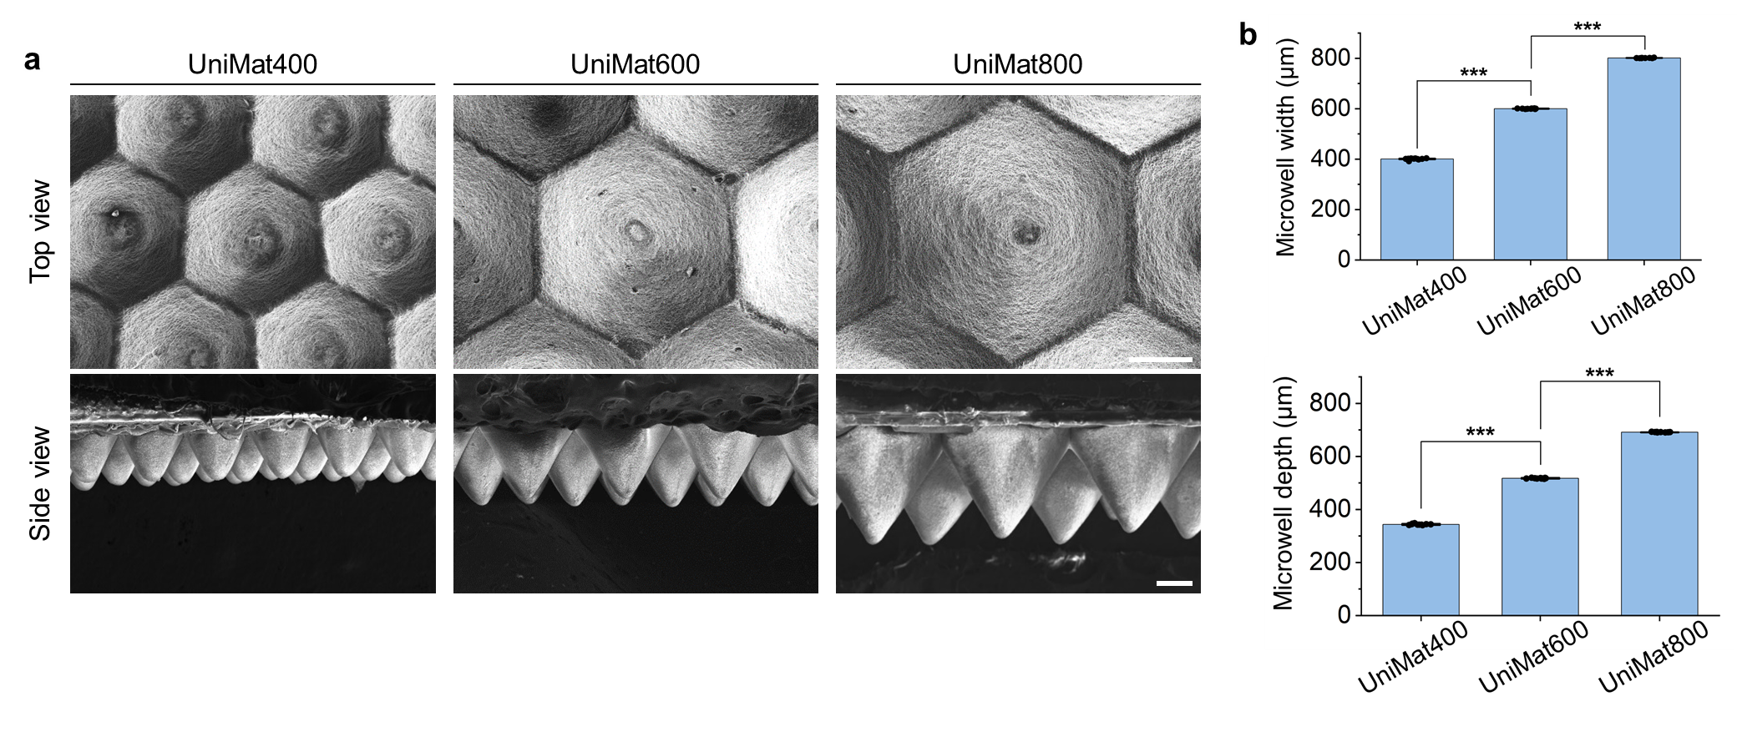Supplementary Figure 1. Geometric characteristics of UniMat. (a) SEM images of UniMat400, UniMat600, and UniMat800. Scale bars = 200 µm. (b) Width and depth of microwell within UniMat400, UniMat600, and UniMat800. (n = 10; ***P < 0.0001).

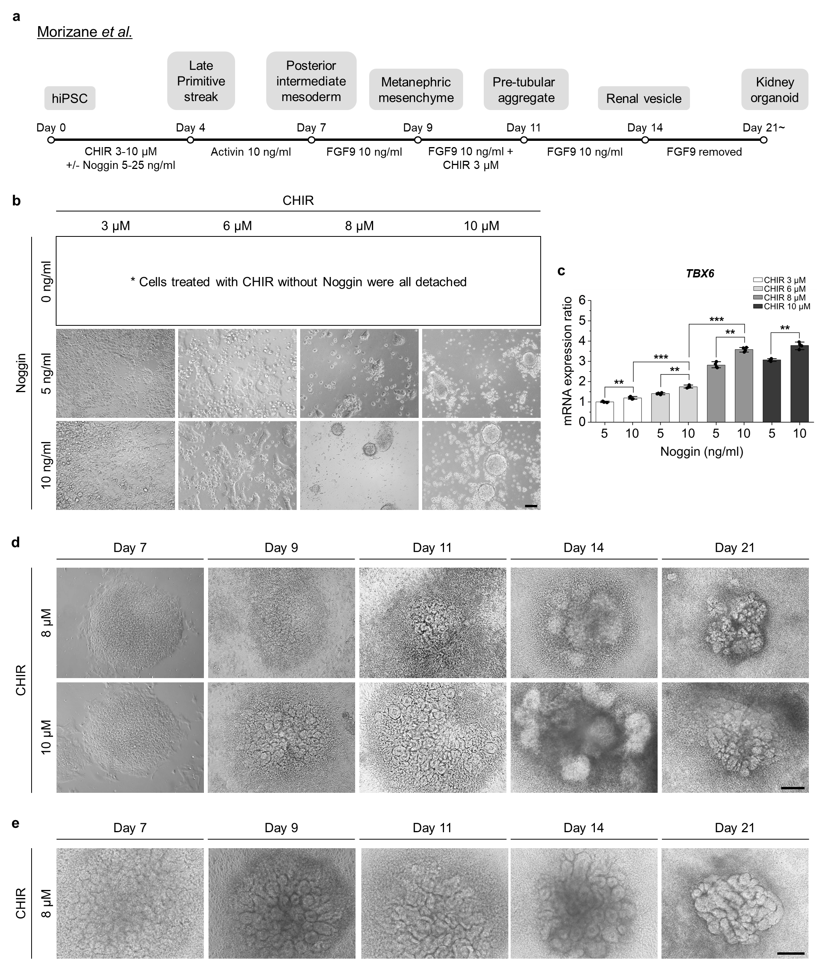
Supplementary Figure 2. Optimization of kidney organoid differentiation protocol on hydrogel layer. (a) Schematic of Morizane protocol¹ for generation of kidney organoids on Geltrex hydrogel layer. (b) Optimization of CHIR 99021 (CHIR) and Noggin concentrations for differentiation of late primitive streak at day 4 on hydrogel layer using WTC11 hiPSCs. Scale bar = 200 µm (c) qRT-PCR of TBX6 expression of differentiated WTC11 hiPSCs at day 4 on hydrogel layer with varied CHIR concentrations (3, 6, 8, and 10 µM) and Noggin concentrations (0, 5, and 10 ng/ml) (n = 4; **P < 0.001, ***P < 0.0001). (d) Bright field images showing progression of kidney organoid differentiation under optimal CHIR concentration of 8 or 10 µM and Noggin concentration of 10 ng/ml (from day 0 to day 4) on hydrogel layer using WTC11 hiPSCs. Scale bar = 100 µm. (e) Bright field images showing progression of kidney organoid differentiation under optimal CHIR concentration of 8 µM and Noggin concentration of 10 ng/ml (from day 0 to day 4) on hydrogel layer using IMR90-4 hiPSCs.

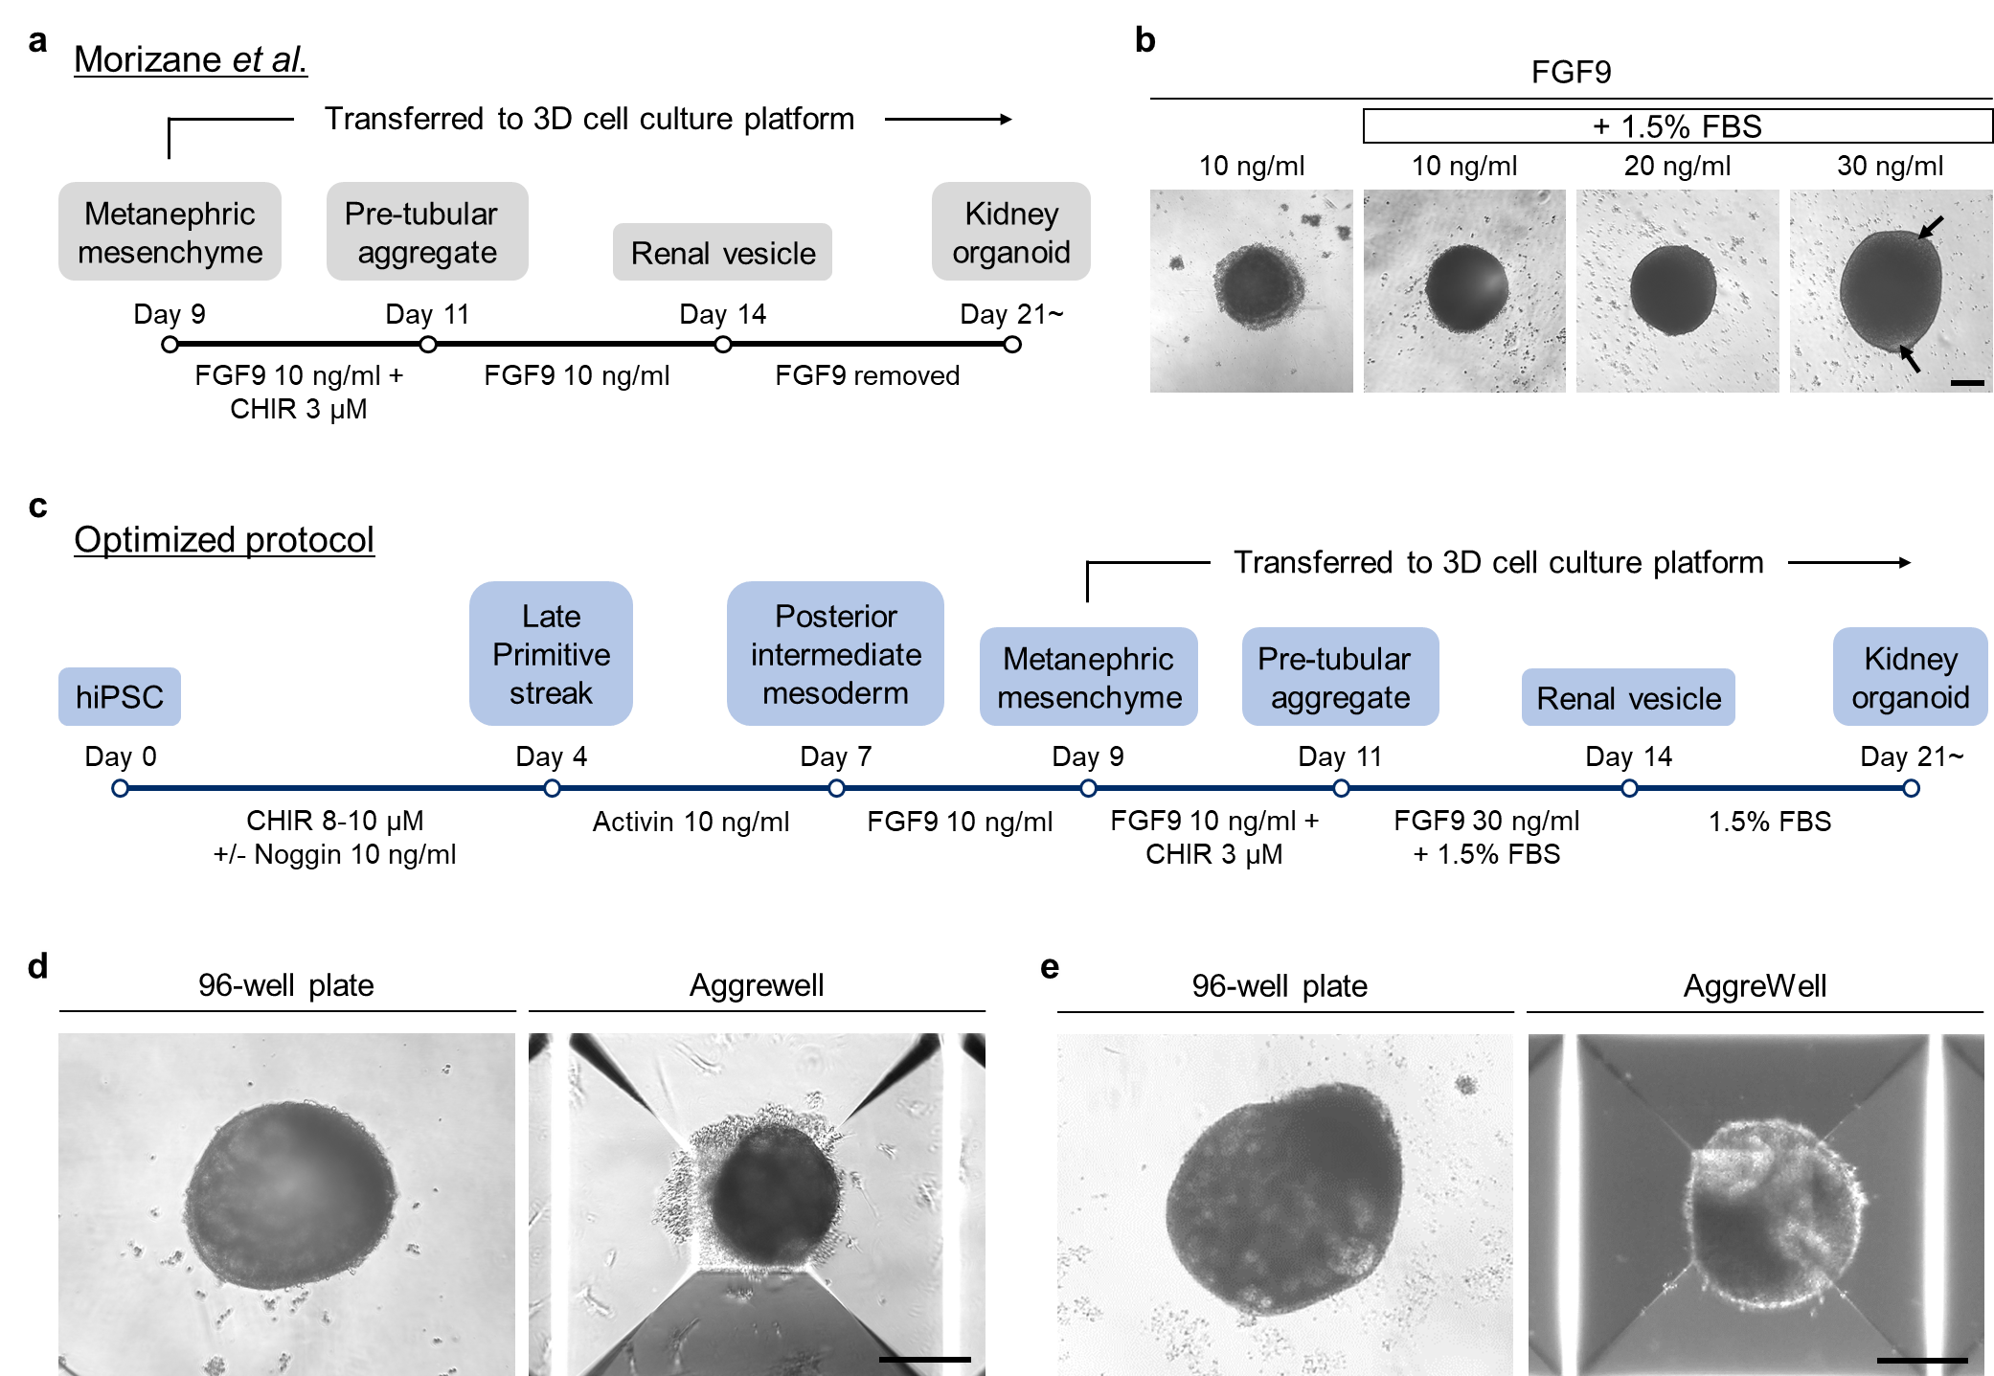
Supplementary Figure 3. Optimization of kidney organoid differentiation protocol in 3D culture platform. (a) Schematic of Morizane protocol's procedural steps¹ from day 9 to day 21 for generation of kidney organoids in 3D culture platform. (b) Optimization of FGF9 concentration and FBS treatment for differentiation of renal vesicle (black arrows) at day 14 on 96-well, round-bottom, ultra-low-attachment plates (96-well plate) using WTC11 hiPSCs. Scale bar = 200 µm. (c) Schematic of optimized protocol employed in this study for generation of kidney organoids in 3D culture platform. (d) Bright field images showing kidney organoid differentiated at day 21 under optimal FGF9 concentration of 30 ng/ml (from day 9 to day 14) and 1.5% fetal bovine serum (FBS) treatment (from day 9) in 96-well plate and AggreWell™800 Microwell Plates (Aggrewell) using WTC11 hiPSCs. Scale bar = 200 µm. (e) Bright field images showing kidney organoid differentiated at day 21 under optimal FGF9 concentration of 30 ng/ml (from day 9 to day 14) and 1.5% FBS treatment (from day 9) in 96-well plate and AggreWell using IMR90-4 hiPSCs. Scale bar = 200 µm.

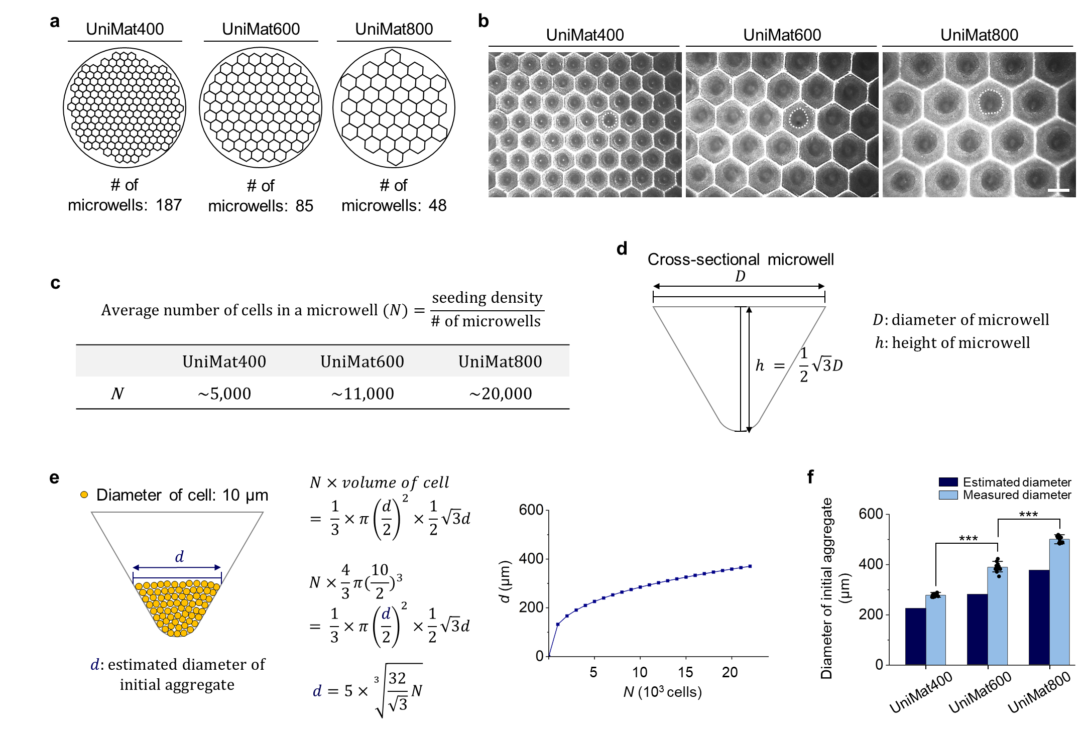 Supplementary Figure 4. Exploration of potential of UniMat to regulate initial aggregate size. (a) Top view schematics of UniMat400, UniMat600, and UniMat800 with array of microwells within each configuration. (b) Bright field images of initial aggregates in UniMat400, UniMat600, and UniMat800. Scale bar = 400 µm. White dotted lines in each image highlight perimeters of aggregates. (c) Average number of seeded cells in single microwell of UniMat400, UniMat600, and UniMat800. (d) Schematic of simplified cross-sectional geometry of single microwell within UniMat. (e) Estimation of initial aggregate diameter in single microwell as function of average number of seeded cells. (f) Estimated and measured diameters of initial aggregate in individual microwells of UniMat400, UniMat600, and UniMat800. (n = 15; ***P < 0.0001).
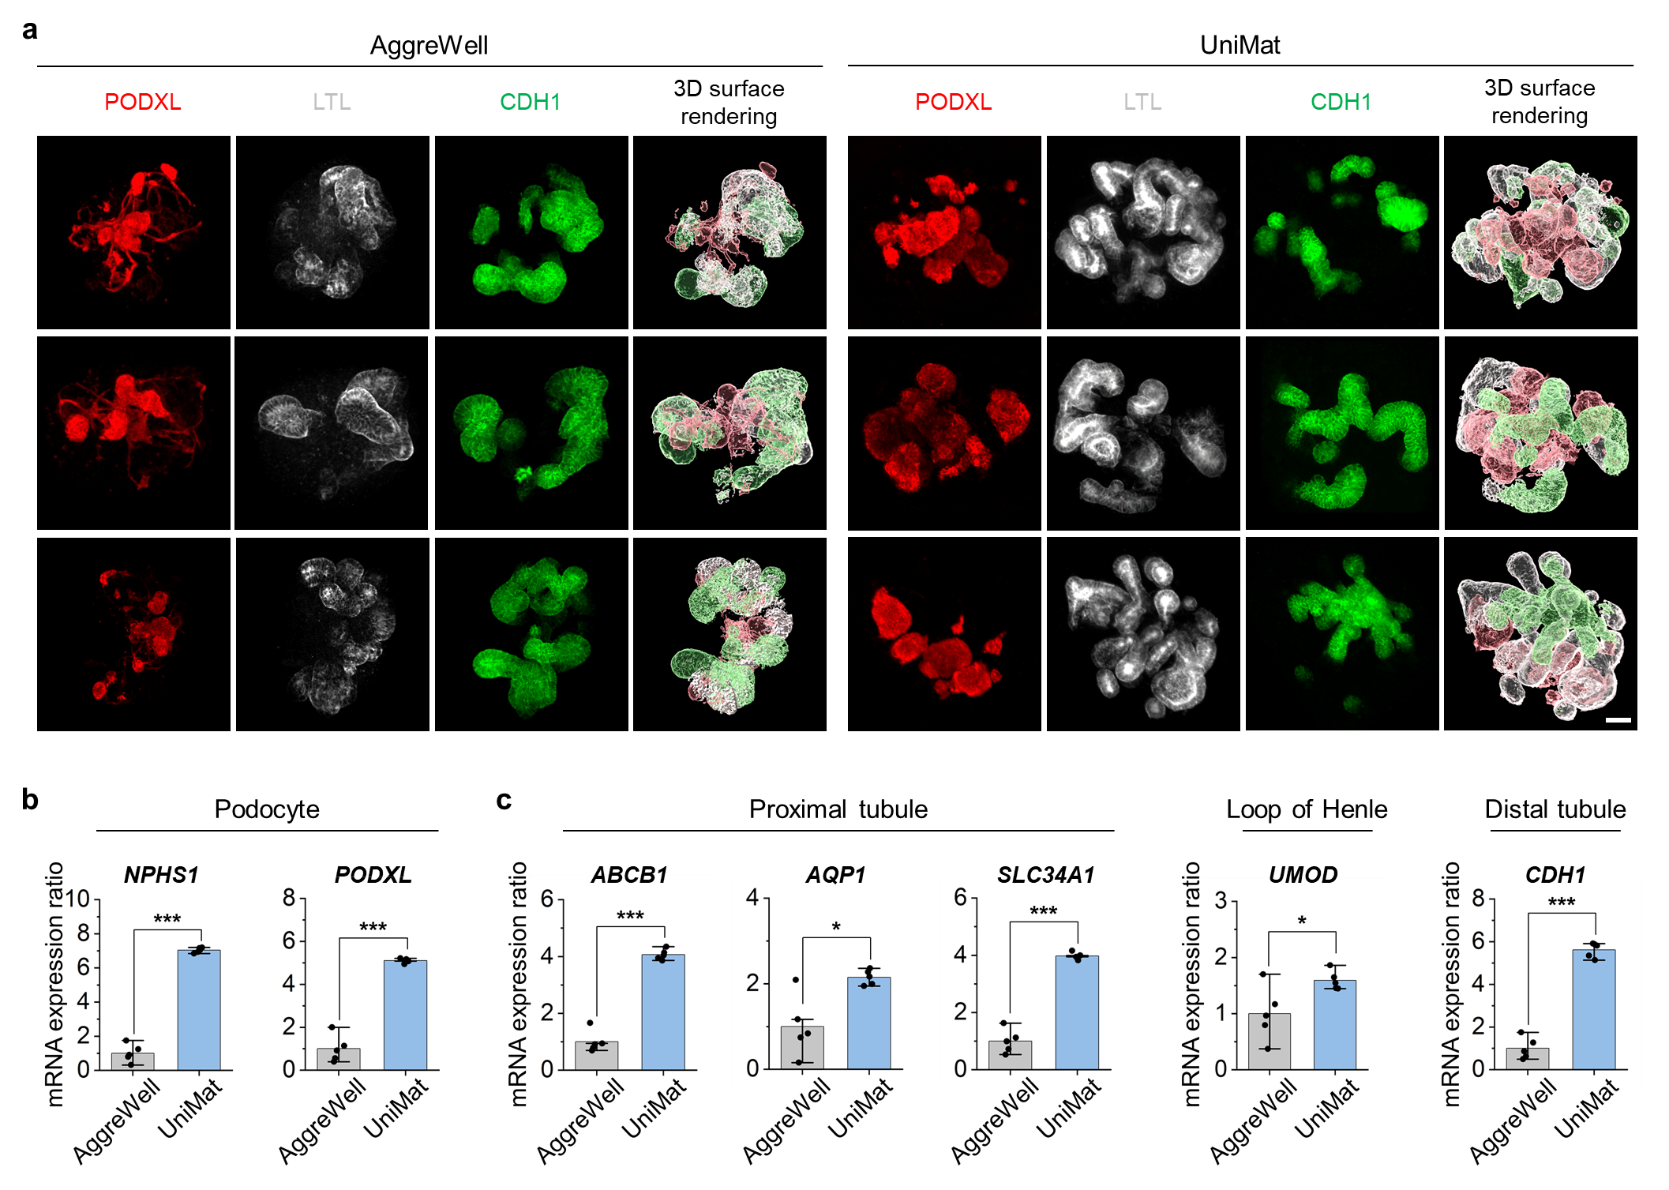Supplementary Figure 5. Mature hiPSCs-derived kidney organoids in UniMat. (a) Confocal z-stack images for markers of podocytes (PODXL), proximal tubules (LTL), and distal tubules (CDH1), and corresponding Imaris 3D surface rendering images of kidney organoids cultured in AggreWell and UniMat. Scale bar = 50 µm. (b) qRT-PCR of NPHS1 and PODXL expressions of kidney organoids cultured in AggreWell and UniMat (n = 5; ***P < 0.0001). (c) qRT-PCR of ABCB1, AQP1, SLC34A1, UMOD, and CDH1 expressions of kidney organoids cultured in AggreWell and UniMat (n = 5; **P < 0.001 ***P < 0.0001).

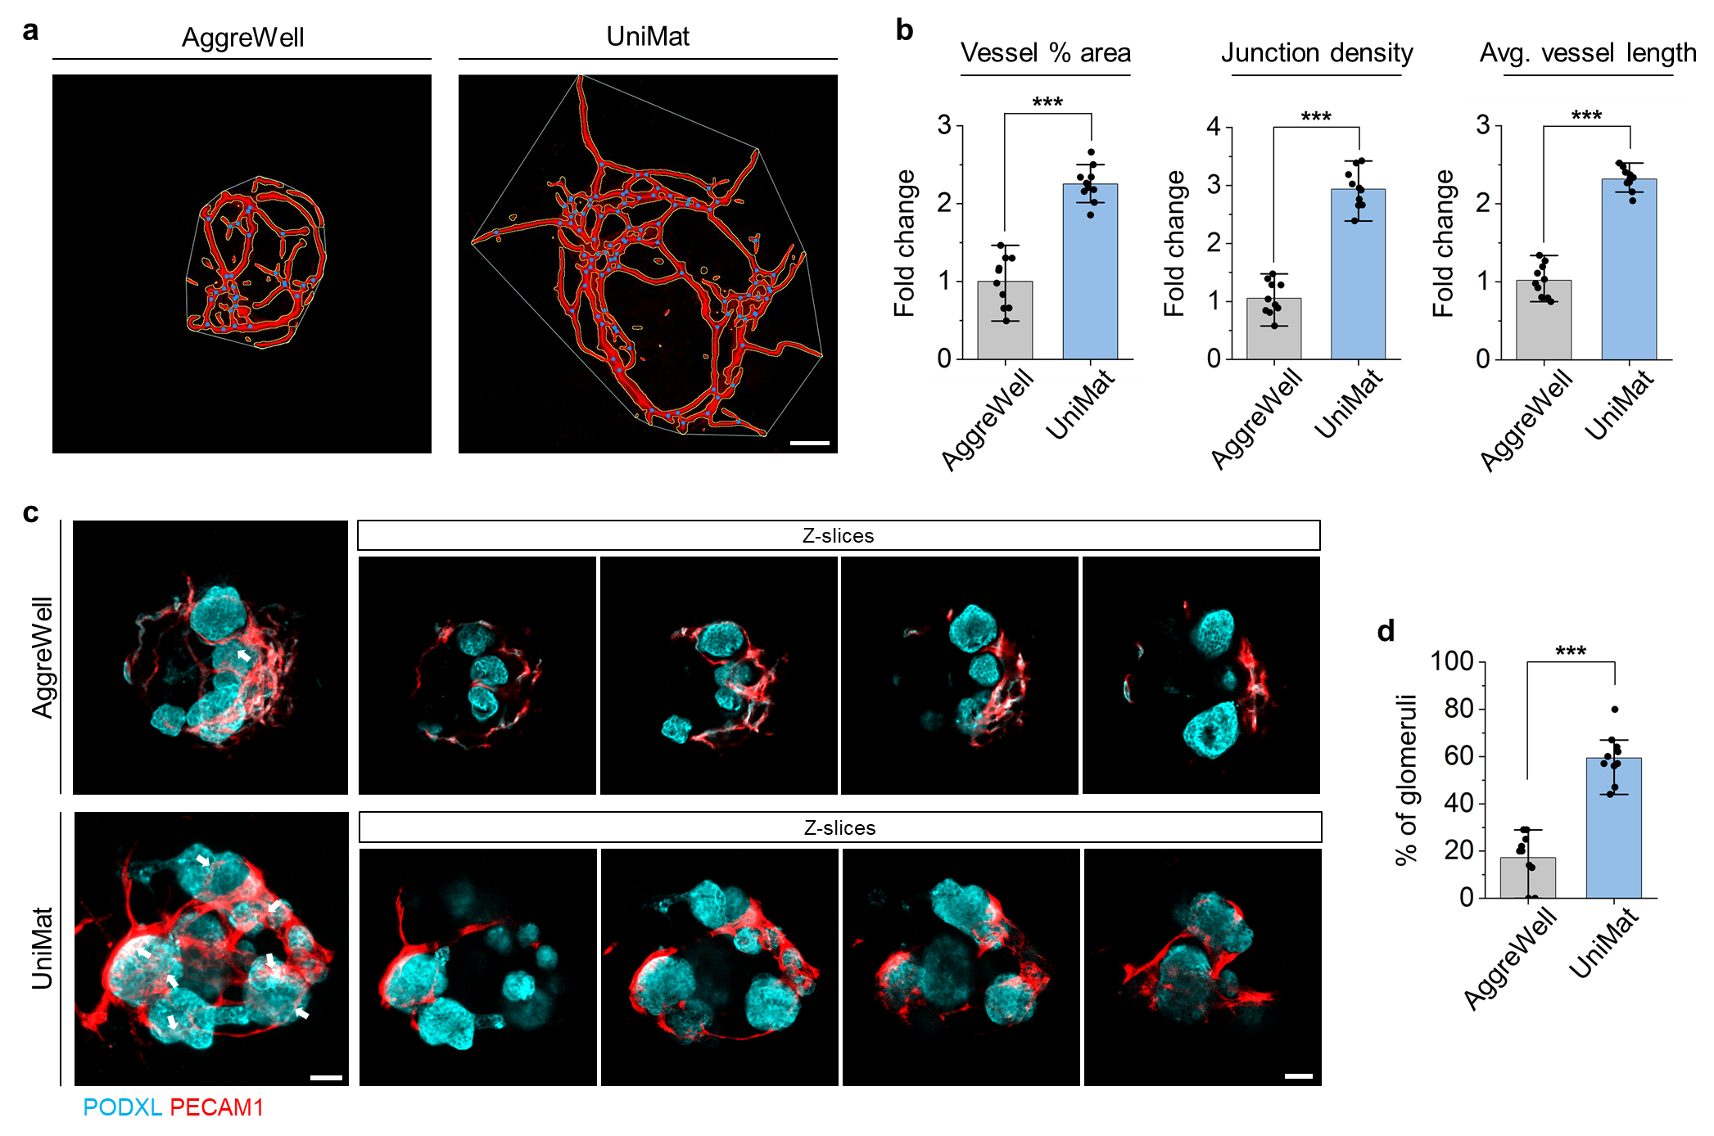 Supplementary Figure 6. Enhanced vascularization of hiPSCs-derived kidney organoids in UniMat. (a) Result images from AngioTool analysis of kidney organoids cultured in AggreWell and UniMat. Scale bar = 50 µm. (b) AngioTool outputs of abundance and character of vasculature of kidney organoids cultured in AggreWell and UniMat (reported as fold change relative to AggreWell-cultured organoids). (n = 10; ***P < 0.0001). (c) Sequential individual confocal z-slice images of kidney organoids cultured in AggreWell and UniMat, stained with PODXL (cyan) and PECAM1 (red). Scale bar = 20 µm. White arrows indicate invasion of PECAM1⁺ endothelial cells into PODXL⁺ podocytes clusters. (d) Quantification of percentage of PECAM1⁺ endothelial cells invasion into glomerular-like structure in kidney organoids cultured in AggreWell and UniMat (n = 10; ***P < 0.0001).
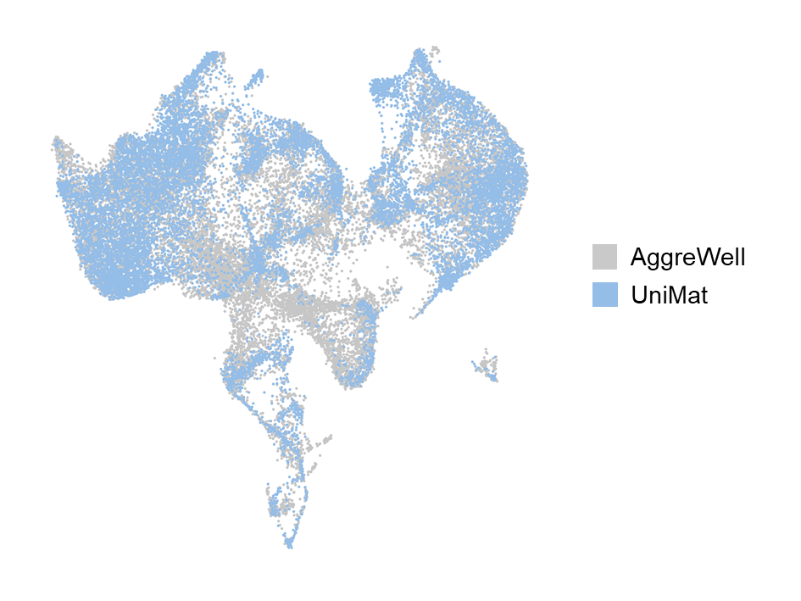
Supplementary Figure 7. UMAP plot of distribution of kidney organoid cells in AggreWell and UniMat.

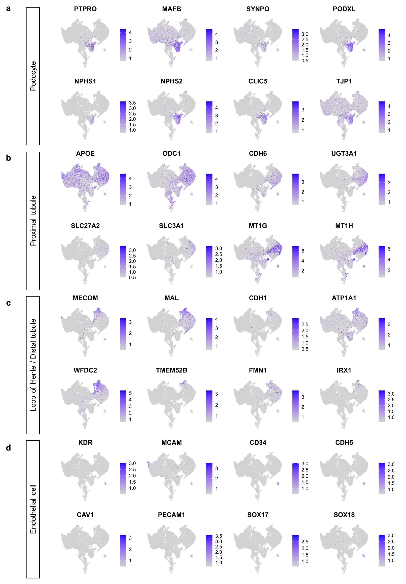
Supplementary Figure 8. UMAP plots of gene expression of kidney organoid cells in AggreWell and UniMat. (a) Podocyte-specific genes. (b) Proximal tubule-specific genes. (c) Loop of Henle/distal tubule-specific genes. (d) Endothelial cell-specific genes.
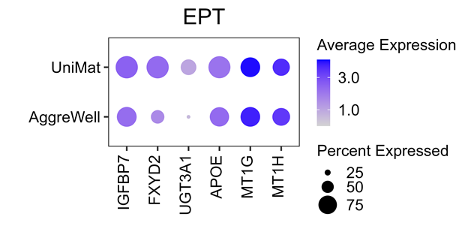
Supplementary Figure 9. Comparison of proportion of early proximal tubules (EPT) between AggreWell and UniMat. Dot plot comparing expression of proximal tubule signatures genes in EPT cluster between AggreWell and UniMat.

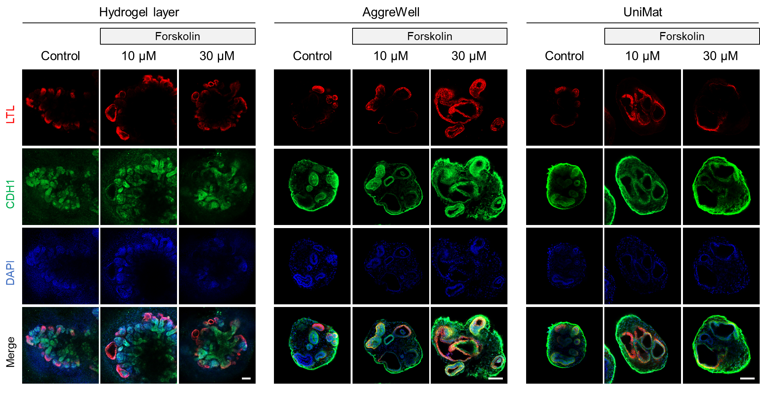
Supplementary Figure 10. Confocal images of polycystic kidney disease (PKD) organoids. Confocal images of forskolin-treated PKD organoids induced from kidney organoids differentiated in hydrogel layer, AggreWell, and UniMat. Scale bars = 100 µm.

Supplementary Video Captions

Supplementary Video 1. Confocal z-stack movie of kidney organoids cultured in AggreWell stained with PODXL (cyan) and PECAM1 (red)

Supplementary Video 2. Confocal z-stack movie of kidney organoids cultured in UniMat stained with PODXL (cyan) and PECAM1 (red)

References
1. Morizane, R. & Bonventre, J.V. Generation of nephron progenitor cells and kidney organoids from human pluripotent stem cells. Nat Protoc 12 (2017).
2. Singh, H., Teoh, S.H., Low, H.T. & Hutmacher, D.W. Flow modelling within a scaffold under the influence of uni-axial and bi-axial bioreactor rotation. J Biotechnol 119, 181-196 (2005).
3. Provin, C., Takano, K., Sakai, Y., Fujii, T. & Shirakashi, R. A method for the design of 3D scaffolds for high-density cell attachment and determination of optimum perfusion culture conditions. J Biomech 41, 1436-1449 (2008).
4. Rousset, N., Monet, F. & Gervais, T. Simulation-assisted design of microfluidic sample traps for optimal trapping and culture of non-adherent single cells, tissues, and spheroids. Sci Rep-Uk 7 (2017).

