Supporting Information
Ultra-stretchable, Crack propagation resistance and Impact-Resistant Ionogels

Haiyu Huang,† Yishun Wuliu,† Weiliang Dong, Jiji Tan, Yongbin Xu, Caizhen Zhu, Jian Xu, Lei Tian*

Institute of Low-Dimensional Materials Genome InitiativeDepartment, College of Chemistry and Environmental Engineering, Shenzhen University, Shenzhen, 518060, China

*Corresponding Author
- mail: leitian@szu.edu.cn.

EXPERIMENTAL SECTION
Characterizations. Characterization of the morphology of the ionogels by transmission electron microscopy (TEM, JEOL JEM-2100) and atomic force microscopy (AFM). Scanning electron microscopy (S-3400N, Hitachi) was used for scanning observation of lyophilized samples. Thermogravimetric analysis (TGA) measurements were performed on a METTLER TOLEDO TGA2 instrument from room temperature to 800°C under flowing nitrogen at a scanning rate of 10 K/min, and differential scanning calorimetry (DSC) using METTLER TOLEDO DSC3 from -50°C to 210°C under flowing nitrogen at a heating rate of 10 K/min to characterize the thermal stability of the materials. Fourier transform infrared (FT-IR) spectra were recorded on a Bruker INVENIO S spectrometer with an in-situ cell (programmable heating and cooling unit) for in-situ FT-IR with sample heating from 30°C to 190°C. Scattering data were obtained by the wide-angle/small-angle X-ray scattering (WAXS/SAXS) instrument Xeuss 3.0.WAXS test was carried out under the condition that the sample-detector (SD) distance was 55 mm and exposure time was 60 s. SAXS test was carried out under the condition that the sample-detector (SD) distance was 900 mm and exposure time was 150 s. XRD analysis was performed using a MiniFlex 600 X-ray polycrystalline powder diffractometer with a test angle of 5-90°.
Mechanical Properties. Mechanical testing with CMT-1203 universal testing machine. Tensile test was performed on the sample at a rate of 5 mm/min under ambient conditions (25℃, RH40%). Cyclic tensile tests were performed at 100% strain with multiple cycles and stopping for different time intervals. Tear resistance test using pant type (single seam) tearing method. The puncture resistance tests were performed using different size (0.5mm, 2mm, 4mm, 8mm) probes. The corresponding fracture energy valus^{[1, 2]1, 2} are obtained by multiplying the integrated area (ℇ_{c}) of the notched sample from the initial loading strain to the critical strain for the stress-strain curve of the unnotched sample by the original scale distance (H) between the two fixtures,thus obtaining the fracture energy value (Γ) of the specimen. The fracture energy value is calculated according to equation (1):
$Γ=H\int_{0}^{ε_{c}}{σdε}$ (1)
For notched samples, cracks were implemented from the edge to the center (20% and 50% of the notched sample width) and tested on a flexible electronic tester (FT2000 type) using the one-sided notching method, and samples with cracks of 2 mm were subjected to an add/drop cycle test at a fixed strain.
Impact resistance test. The samples were tested for impact resistance using a homemade device that used square acrylic plates (28*28 cm, 13*13 cm) and clamps to fix the samples, and the velocities before and after the carriage impacted the ionogel and the iron ball impacted the ionogel were obtained by a cell phone camera (resolution 4000*60). For the carts (816.4 g) impacting the ionogel different velocities were used for the impacts, respectively. For the iron ball impact ionogel, different masses of iron balls (350 g, 500 g) and different heights (90 cm, 100 cm, 150 cm, 170 cm) were used for impact. The kinetic energy loss of the cart and the iron ball upon impact with the gel was used to determine the impact energy absorption of the ionogel. Energy absorption equation^{[3, 4]3, 4} calculated from equation (2):
$Q=m(V_{1}^{2}−V_{2}^{2})/2t$ (2)
where m is the mass of the cart and the iron ball, t is the thickness of the ionogel, and V₁ and V₂ are the velocities of the carts and the iron ball before and after they hit the ionic gel, respectively.
Ion conductivity and strain sensing. The EIS of all ionic gels was measured by the 1470E Cell Test Electrochemical Workstation (Solartron analytical, America) at room temperature. Ion conductivity of ionic gels based on AC impedance spectra from 0.1 Hz to 100 kHz. The ionic conductivity^{[5]5} was calculated according to equation (3):
$σ=L/RA$ (3)
where L is the thickness of the ionogel, R is the impedance value of the corresponding ionogel, and A is the contact area of the ionogel.
The strain sensor is assembled from a source meter (DMM65006 1/2DIGIT MULTIMETER) and a flexible electronic tester (FT2000 type). The alligator clips accompanying the source meter are clamped to the ends of the ionogel and the elongation is adjusted using the flexible electronic tester. The relative resistance change^{[6]6} is calculated according to equation (4):
$\frac{△R}{R_{0}}=\frac{R−R_{0}}{R_{0}}∗100\%$ (4)
where R is the dynamic resistance at different strains and R0 is the resistance in the initial state. The measurement factor (GF) is defined as GF=(ΔR/R₀)/ε, where ε is the applied strain.
Adhesion and self-healing properties. The test sample is cut into a small rectangular ionogel block, glued to the surface of the substrate and lifted up. Model substrates are wood, rubber, glass, ceramic and other substrates. The dumbbell-shaped sample was sheared off in the middle and the ionogels were physically contacted by gently placing the two ionogels together and observing their self-healing properties from a macroscopic point of view. The image of the healing section is on the HD monitor (B116-CB).
DFT calculation. All the calculations were performed with Gaussian 16 package. Density functional theory (DFT) calculations at the B3LYP/6-311+G(d,p) level were used to investigate the interactions in the ionogel systems, where B3LYP is Becke’s there-parameter functional combined with the Lee-Yang-Parr correlation functional and 6-311+G(d,p) is basis set.^{[7, 8]7, 8} To improve the description of the non-bond interactions, Grimme's D3BJ dispersion correction was also combined with the B3LYP functional.^{[9]9} The binding energy ($∆E_{b}$) of multimers was evaluated by equation (5)
$∆E_{b}=E_{m}−E_{1}−E_{2}−⋯−E_{n}$ (5)
where denotes the calculated energy of multimers. n represents the number of monomers forming a multimer,$E_{1}$, $E_{2}$ and $E_{n}$, are the energies of monomers 1, 2, and n, respectively.
Finite element simulation. The nonlinear finite element software Abaqus is used, based on a module that dynamically displays the impact analysis. The impact energy formula is a method for calculating the impact energy, which can effectively help us to evaluate the magnitude of the impact energy and thus better analyze physical phenomena. The impact energy formula is usually expressed as: E=1/2 mv², where E is the impact energy, m is the mass of the object, v is the object's velocity.

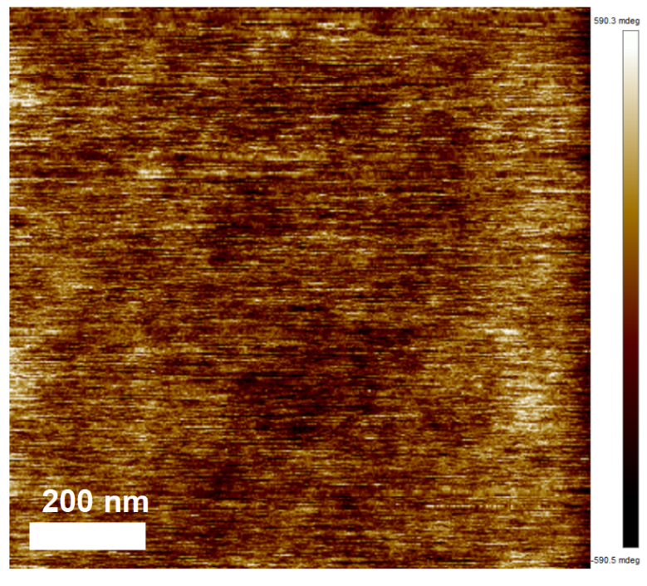
Figure S1 AFM phase diagram of P(AMPS-AM)-Collagen ionogels. Scale bar: 1um.

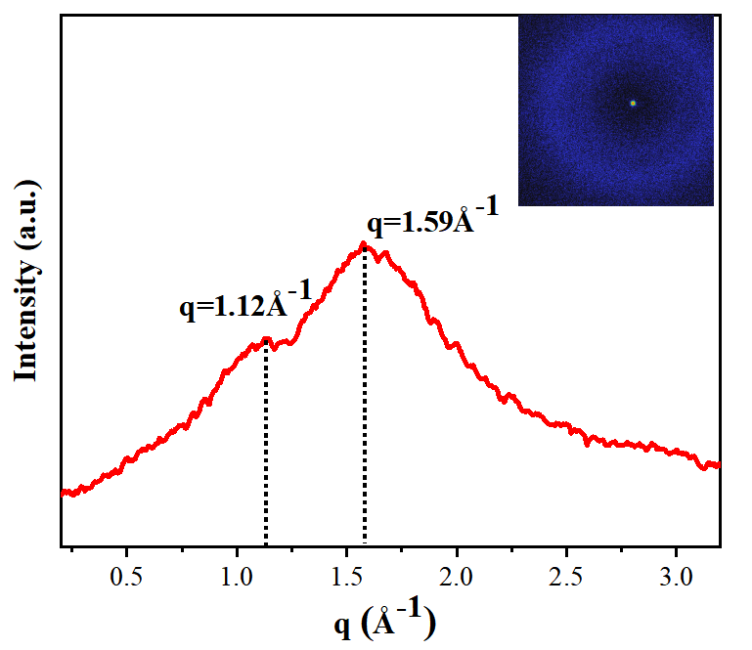
Figure S2 the wide-angle X-ray scattering (WAXS) of P(AMPS-AM)-Collagen ionogels.

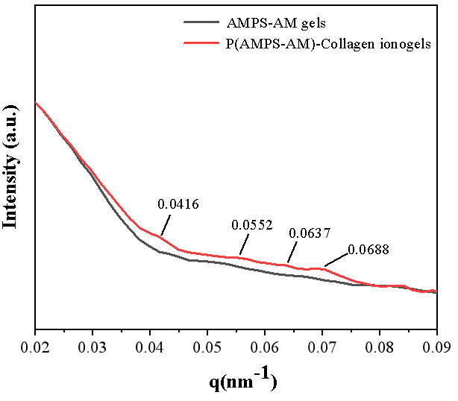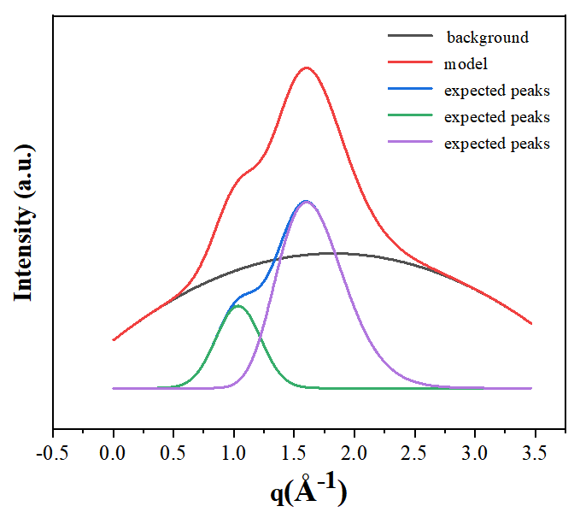
Figure S3 The small-angle X-ray scattering (SAXS) measurements of P(AMPS-AM)-Collagen and P(AMPS-AM) ionogels and WAXS peak splitting processing of P(AMPS-AM)-Collagen ionogel

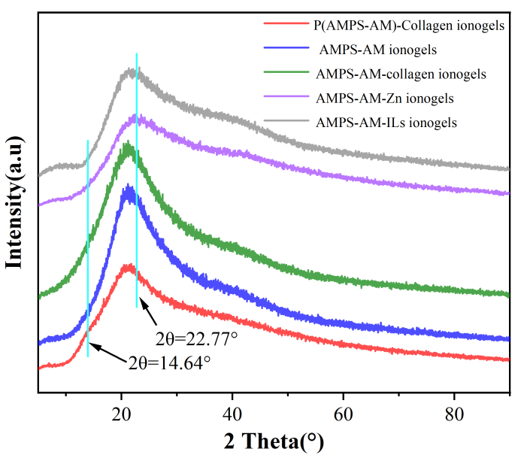
Figure S4 XRD curves of the ionogels with different formulations.

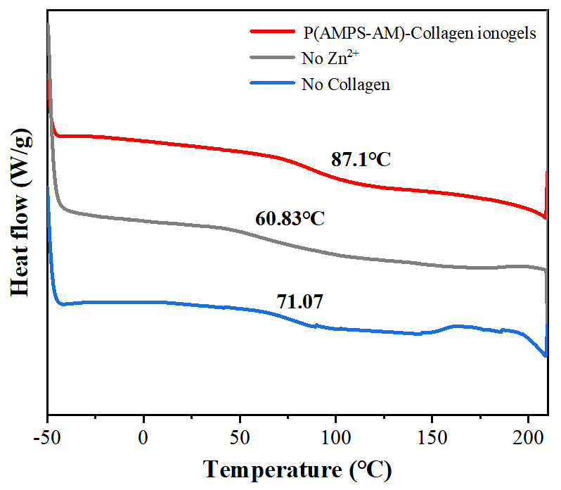
Figure S5 DSC curves of the ionogels without one of the ingredients with the scanning rate of 10°C min⁻¹.

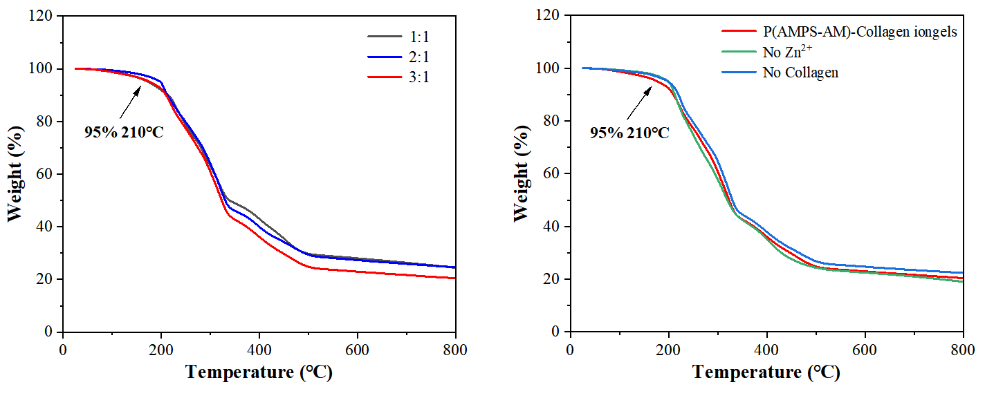
Figure S6 TGA curves of the ionogels without one or both components showing a decomposition temperature of 210℃.

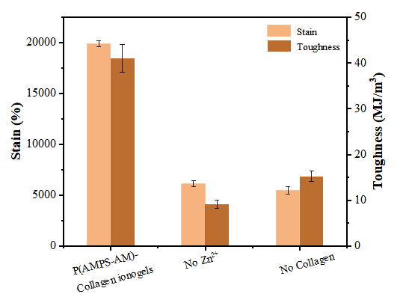
Figure S7 Comparison of elongation at break and toughness of the ionogels without Zn²⁺ and collagen, respectively.

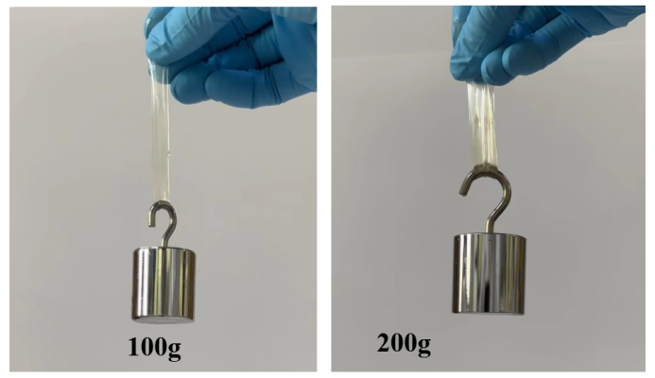
Figure S8 The photograph of P(AMPS-AM)-Collagen ionogels loading different masses of weights (100g/200g).

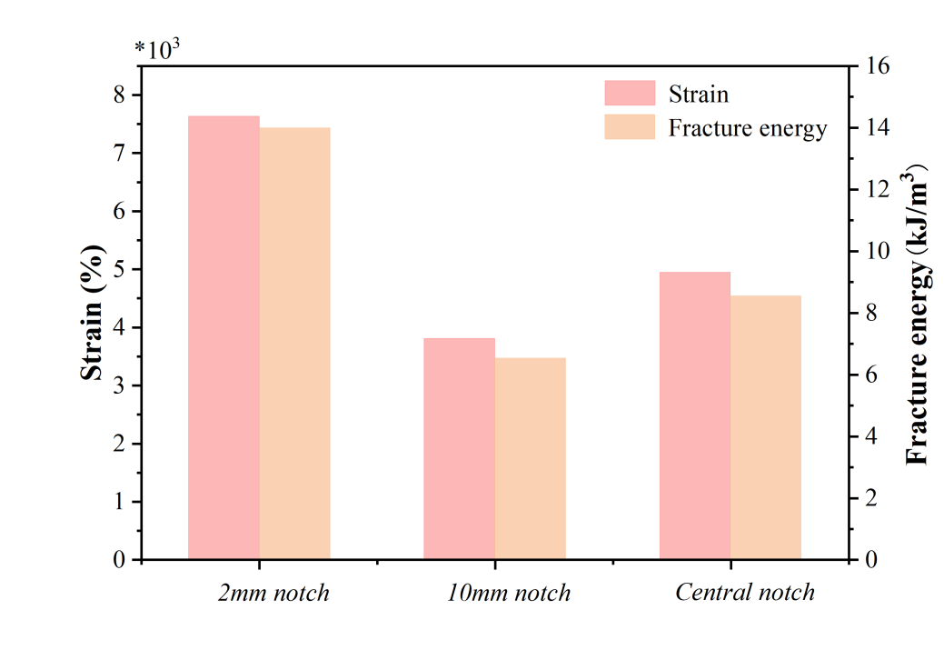
Figure S9 Strain and fracture energy of P(AMPS-AM)-collagen ionogels with different notches.

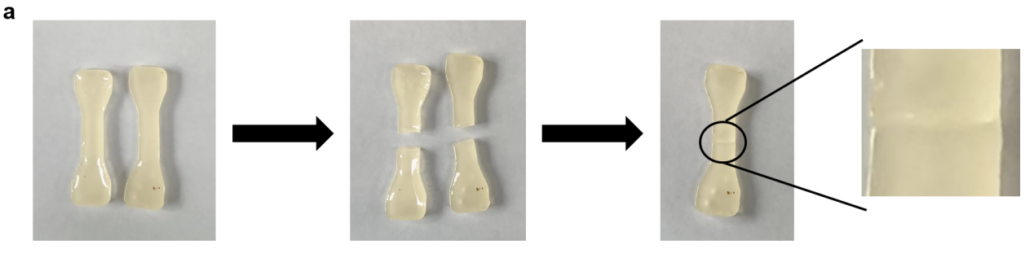
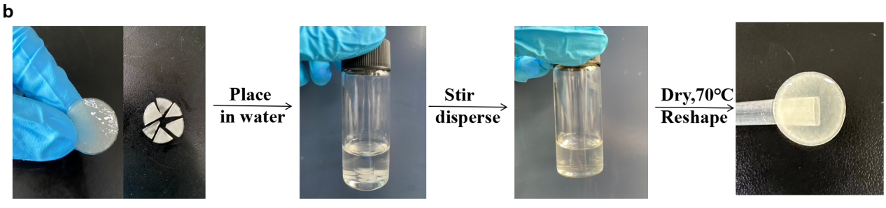
Figure S10 The photographs of P(AMPS-AM)-Collagen ionogels self-healing and recyclable process.

Figure S11 Impact energy of different masses of iron balls dropped from different heights

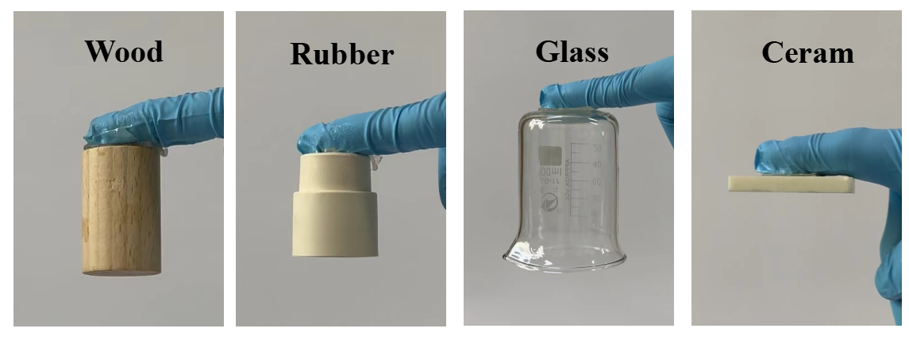
Figure S12 The adhesion property of P(AMPS-AM)-collagen ionogels adhering to different substrates (wood, rubber, glass, ceramics).

Table S1 Mean-square radius of rotation (R_{g}) of the microphase separation structure of P(AMPS-AM)-Collagen ionogels.
Peak number | Qmax (nm⁻¹) | d (nm) | Rg (nm)
1 | 0.0416 | 0.261 | 38.06
2 | 0.0552 | 0.347 | 38.06
3 | 0.0637 | 0.400 | 38.06
4 | 0.0688 | 0.432 | 38.06
d = 2π/q_{max}

Table S2 Comparison of response and recovery times with previously reported strain sensors.
 | Response time  (ms) | Recovery time  (ms)
PAA-CNF-IL-H₂O ionogel | 287 | 300^{[10]10}
AAm/LMA hydrogel | 197 | 269^{[11]11}
PNA/PVP/TA/Fe³⁺ hydrogel | 265 | 270^{[12]12}
This work | 180 | 163

Comparison of response and recovery times with previously reported strain sensors.

REFERENCES
1. Xu, L. et al. A Transparent, Highly Stretchable, Solvent‐Resistant, Recyclable Multifunctional Ionogel with Underwater Self‐Healing and Adhesion for Reliable Strain Sensors. Adv. Mater. 33, 2105306 (2021).
2. Wu, J. et al. Strong and Ultra‐Tough Supramolecular Hydrogel Enabled by Strain‐Induced Microphase Separation. Adv. Funct. Mater. 33, 2210395 (2023).
3. Ye, Y. et al. Ultrastretchable Ionogel with Extreme Environmental Resilience through Controlled Hydration Interactions. Adv. Funct. Mater. 33, 2209787 (2023).
4. Tan, S.; Wang, C.; Yang, B.; Luo, J.; Wu, Y. Unbreakable Hydrogels with Self‐Recoverable 10 200% Stretchability. Adv. Mater. 34, 2206904 (2022).
5. Shi, P.; Wang, Y.; Wan, K.; Zhang, C.; Liu, T. A Waterproof Ion‐Conducting Fluorinated Elastomer with 6000% Stretchability, Superior Ionic Conductivity, and Harsh Environment Tolerance. Adv. Funct. Mater. 32, 2112293 (2022).
6. Yuan, T.; Cui, X.; Liu, X.; Qu, X.; Sun, J. Highly Tough, Stretchable, Self-Healing, and Recyclable Hydrogels Reinforced by in Situ-Formed Polyelectrolyte Complex Nanoparticles. Macromolecules. 52(8), 3141-3149 (2019).
7. Li, W. et al. Recyclable, Healable, and Tough Ionogels Insensitive to Crack Propagation. Adv. Mater. 34, 2203049 (2022).
8. Wang, M. et al. Tough and Stretchable Ionogels by in Situ Phase Separation. Nat. Mater. 21(3), 359-365 (2022).
9. Yao, B. et al. Hydrogel Ionotronics with Ultra‐Low Impedance and High Signal Fidelity Across Broad Frequency and Temperature Ranges. Adv. Funct. Mater. 32, 2109506 (2022).
10. Ye, Y.; Zhang, Y.; Chen, Y.; Han, X.; Jiang, F. Cellulose Nanofibrils Enhanced, Strong, Stretchable, Freezing‐Tolerant Ionic Conductive Organohydrogel for Multi‐Functional Sensors. Adv. Funct. Mater. 30, 2003430 (2020).
11. Zhang, M. et al. Toughening Double‐Network Hydrogels by Polyelectrolytes. Adv. Mater. 10, 2207233 (2023).
12. Ye, Y. et al. Ultrastretchable Ionogel with Extreme Environmental Resilience through Controlled Hydration Interactions. Adv. Funct. Mater. 33, 2209787 (2023).

