Supplemental Table 1: The details of features selected in the final prediction model
Feature source | Feature name | Abbreviations | Feature type | CDC National Clinical v2.0
Outpatient record | Drug-induced hepatitis | ODIH | Binary | K71.601
 | Unspecified liver disease | OULD | Binary | K76.900
 | Hyperlipidemia | OH | Binary | E78.500
 | Abnormal results of liver function tests | OARL | Binary | R94.500
 | Drug-induced liver injury | ODILI | Binary | K71.901
 | stomachache | OS | Binary | R10.400
 | Drug-induced dermatitis | ODID | Binary | L27.005
 | Thyroid nodules | OTN | Binary | E04.101
 | Chronic hepatitis | OCHS/OCHO* | Binary | K73.900
 | Pathological negative tuberculosis | OPNTB | Binary | A16.020
Inpatient record | Drug-induced liver injury | IDILI | Binary | K71.901
 | 0.9% Sodium chloride injection | IPSCI | Binary | /
Baseline record | Sex | Gender | Binary | /
 | Race | Race | Binary | /
 | Profession | Profession | Categorical | /
 | Type of diagnosis | Diagnosis | Binary | /
 | Type of tuberculosis | tuberculosis | Binary | /
 | Education | Education | Ordinal | /
 | Age | Age | Categorical | /
 | Diabetes | Diabetes | Binary | /
 | Liver-related disease | Liver | Binary | /
 | Hypertension | Hypertension | Binary | /
 | viral hepatitis type B | HBV | Binary | /
 | Alcohol consumption | Drunk | Binary | /
Laboratory record | ULN of ALT | ALT_ratio | Numerical | /
 | ULN of ALP | ALP_ratio | Numerical | /
 | ULN of Tbil | Tbil_ratio | Numerical | /
 | Abnormal results of ALT tests | ALT | Binary | /
 | Abnormal results of ALP tests | ALP | Binary | /
 | Abnormal results of Tbil tests | Tbil | Binary | /
Medication record | Traditional Chinese medicine | TCM | Binary | /
 | The count of hepatoprotective agents | Hepato | Numerical | /
 | Pyrazinamide | Pyrazinamide | Binary | /
 | Rifampicin | Rifampicin | Binary | /
 | Isoniazid | Isoniazid | Binary | /
* represents two features due to the high dimensional propensity score matching method.
ALP=alkaline phosphatase, ALT=alanine aminotransferase, Tbil=total serum bilirubin, ULN=upper limit of normal

Supplemental Table 2: Key parameters of the eXtreme Gradient Boosting (XGBoost) model
Parameter name | Value
nrounds | 20
eta | 0.1
Max.depth | 6
gamma | 0
Colsample_bytree | 0.8
Min_child_weight | 1
subsample | 0.8

Supplemental Table 3: Comparison of performance ability of the three models in the validation set
Performance ability | Indicators | Logistic | XGBoost | Random forest
Discrimination | Optimal cutoff (Youden) | 0.238 | 0.217 | 0.230
 | True negative | 1642 | 1517 | 1579
 | False positive | 134 | 259 | 197
 | False negative | 121 | 89 | 112
 | True positive | 224 | 256 | 233
 | Specificity | 0.925 | 0.854 | 0.889
 | Sensitivity | 0.649 | 0.742 | 0.675
 | Precision | 0.626 | 0.497 | 0.542
 | Recall | 0.649 | 0.742 | 0.675
 | F1 score | 0.637 | 0.595 | 0.601
 | Accuracy | 0.880(0.865, 0.893) | 0.836(0.820, 0.852) | 0.854(0.839, 0.869)
 | AUROC | 0.844(0.818, 0.870) | 0.862(0.836, 0.886) | 0.863(0.839, 0.884)
 | AUPR | 0.666 | 0.686 | 0.687
Calibration | Brier score | 0.086 | 0.087 | 0.083
AUROC=area under receiver operative curve, AUPR=area under the precision-recall curve

Supplemental Figure 1: Study cohort construction
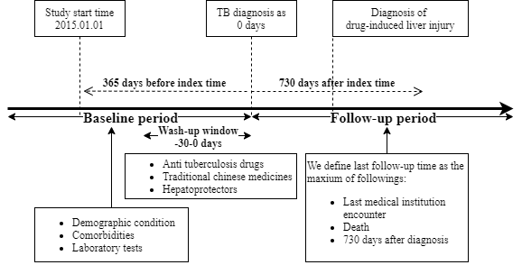
TB: tuberculosis

Supplemental Figure 2: Study flowchart
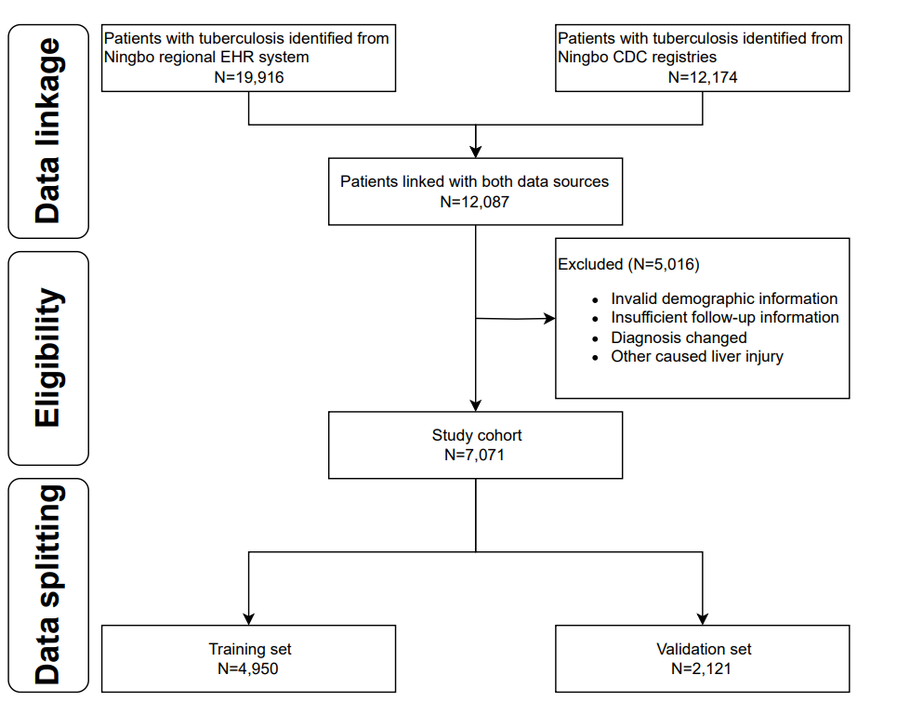
EHR= Electronic healthcare record, CDC= Center for Disease Control

Supplemental Figure 3: Study design and workflow
LASSO=least absolute shrinkage and selection operator, AUC=area under curve.

Supplemental Figure 4: Top five important features selected by XGBoost, random forest and logistic.
All abbreviations can be seen in Supplemental Table 1.

Supplemental Figure 5: SHAP value summary plot of XGBoost prediction model
SHAP=The SHapley Additive exPlanations, XGBoost=eXtreme Gradient Boosting.
All abbreviations can be seen in Supplemental Table 1.

Supplemental Figure 6: The partial dependence plot of history of disease and serological markers between logistic and random forest model.
All abbreviations can be seen in Supplemental Table 1, ALT/ALP/Tbil refers to the maximum ratio of the upper limit of normal.

