Néel tensor torque at the ferromagnet/antiferromagnet interface
Chao-Yao Yang^{1,3}, Sheng-Huai Chen¹, Chih-Hsiang Tseng¹, Chang-Yang Kuo^{4.5}, Hsiu-Hau Lin²*, Chih-Huang Lai^{1,6}*
¹Department of Materials Science and Engineering, National Tsing Hua University, Hsinchu 300044, Taiwan.
²Department of Physics, National Tsing Hua University, Hsinchu 300044, Taiwan.
³Department of Materials Science and Engineering, National Yang Ming Chiao Tung University, Hsinchu 300093, Taiwan.
⁴Department of Electrophysics, National Yang Ming Chiao Tung University, Hsinchu 300093, Taiwan.
⁵National Synchrotron Radiation Research Center, 101 Hsin-Ann Road, Hsinchu, 300092, Taiwan
⁶College of Semiconductor Research, National Tsing Hua University, Hsinchu 300044, Taiwan.

* To whom correspondence should be addressed. hsiuhau.lin@phys.nthu.edu.tw;
chlai@mx.nthu.edu.tw

Methods
Film stack of Si/Ta(2)/Pt(5)/Co(1)/IrMn(8)/Ti(5) (unit: nm) was fabricated by magnetron sputtering at room temperature with base pressure better than 2x10⁻⁷ torr. Magnetic properties of sheet films were characterized by using a vibrating sample magnetometer (VSM). The sheet film structure was then patterned into the Hall-cross devices by ion beam etching with 10 μm in width and 40 μm in length, and the Ta(10)/Pt(100) electrode was deposited using an lift-off technique. Device characteristics were characterized by anomalous Hall effect (AHE) using a 4-point probe station. The AHE was acquired by applying 1 mA dc current during the collection of the voltage along the transverse channel of the Hall-cross. The SOT switching was measured via the AHE signal after giving various current amplitudes with the pulse duration of 0.3 ms. The resistance variation was performed by applying 1 mA dc current along x- and y-direction of the device before and after SOT experiments, whose signals were collected separately to avoid the electrical interference between the x- and y- channel of the Hall-cross device during the measurement.

Supplementary Information 1 – Exclusion of the in-plane exchange bias
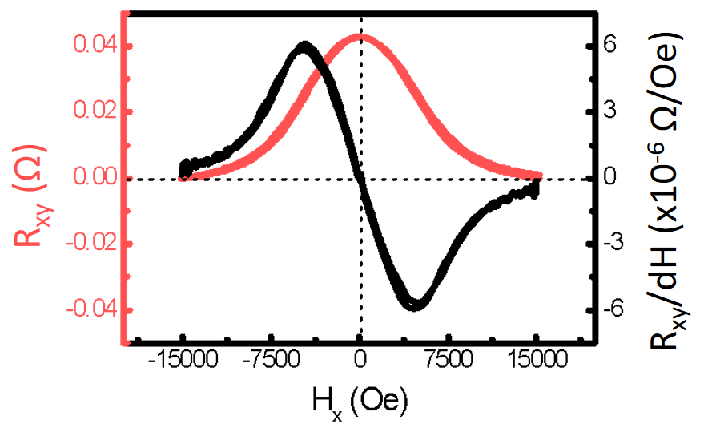
Figure S1｜Absence of in-plane exchange bias. Anomalous Hall effect ($R_{xy}$) versus $H_{x}$ curve (red) and the first-order derivative curve (black) taken after performing the SOT switching. The centro-symmetric feature on the $R_{xy}$-$H_{x}$ curve suggests the absence of exchange bias developed along the longitudinal direction (x-direction) of the device. The derivative $dR_{xy}/dH_{x}$ curve (black) is also shown across the origin to ensure the claim.

Supplementary Information 2. – Intrinsic polarity and “switching ratio”

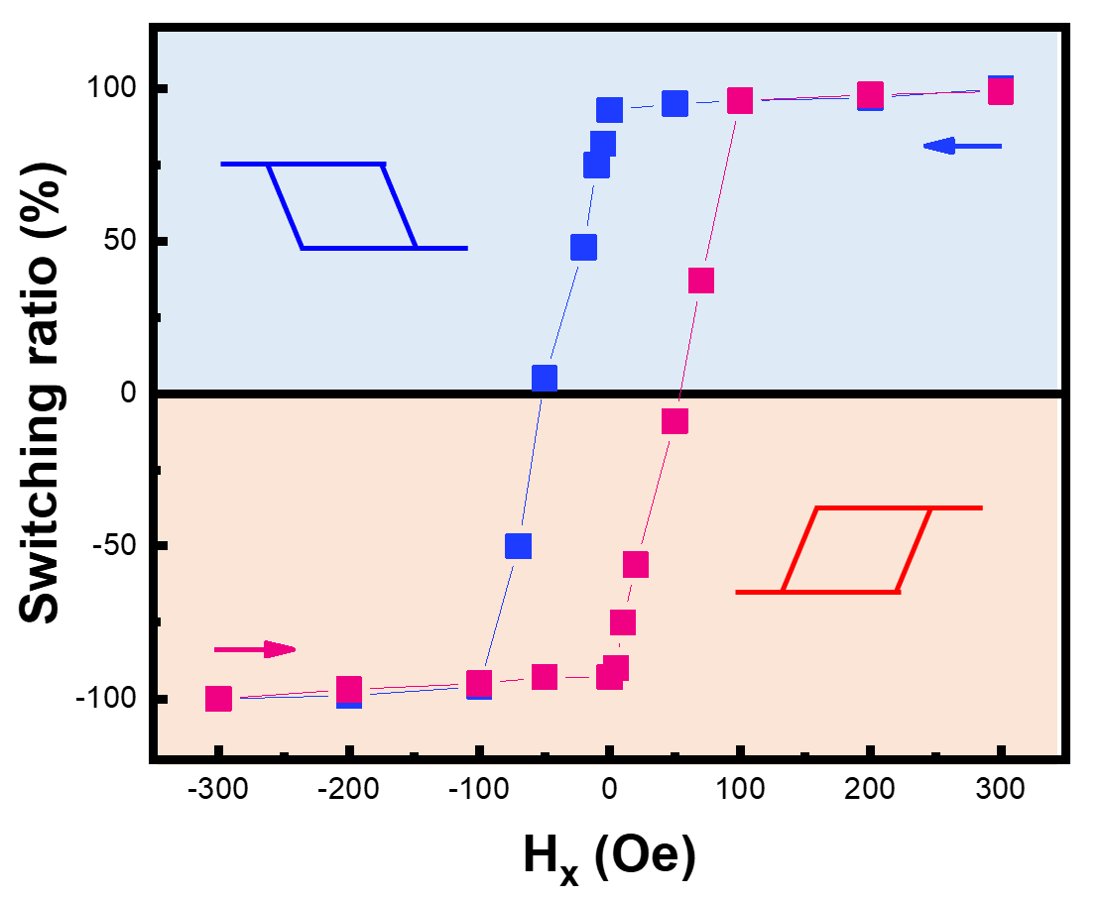
Figure S2 ｜SOT switching ratio versus $H_{x}$. Blue and red curves are obtained from two as-fabricated Pt/Co/IrMn devices and performed from the $H_{x}$-assisted switching as arrowed. The “switching ratio” is defined by the change of $R_{xy}$ on the SOT switching curve relative to that taken with $H_{x}=300$ Oe. The blue (red) curve is taken by performing SOT with $H_{x}=300$ Oe (-300 Oe) first, and then subsequently performing SOT with various $H_{x}.$Note that the polarity of blue and red curves stands for the SOT switching of $P=-1$ and $P=+1$, respectively. Two important characteristics should be noticed: the magnitudes of the switching ratio at $H_{x}=0$Oe for both cases are still larger than 90 %, suggesting the robust field-free switching as shown in Figure 1(e) and Figure 1(f) in the main text. Furthermore, once the SOT switching was performed from positive $H_{x}$, the switching ratio versus $H_{x}$ correlation is determined as a fingerprint as shown by the blue plots. The polarity of the field-free switching is always $P=-1$. After being set by $H_{x}=300$ Oe (blue curve), even if we applied a small negative$H_{x}$ ($H_{x}≥-50 Oe)$, the polarity remains the same, indicating the Néel tensor torque prevails over the field torque under these conditions.

Supplementary Information 3 – Sign rules from the Landau-Lifshitz-Gilbert equation

The polarity of the SOT switching is dictated by several important sign rules and can be derived from the Landau-Lifshitz-Gilbert (LLG) equation for the FM magnetization,
$$\frac{∂\hat{m}}{∂t}=α \hat{m}×\frac{∂\hat{m}}{∂t}-γ \hat{m}×{\vec{H}}_{\text{eff}}- γσ C_{J} \hat{m}×\left(\hat{m}×\hat{y}\right) (S1)$$
where $\hat{m}=\left(m_{x},m_{y},m_{z}\right)$ is the unit vector of the magnetization, $α$ is the damping constant and $γ$ represents the gyromagnetic ratio. Here $σ=+1, -1$ denotes that the spin current is injected from top or bottom layer relative to the FM layer respectively. Two types of torques are present: the usual torque from the effective magnetic field ${\vec{H}}_{\text{eff}}$ and the Slonczewski torque with strength denoted by the parameter $C_{J}=\frac{ℏ}{2e}\frac{θ_{\text{SH}}}{M_{s}t_{F}} J$, where $J$ is the current density,$θ_{\text{SH}}$ is spin Hall angle, $t_{F}$ is the thickness of the FM layer and $M_{s}$ is the saturation magnetization.

The magnetization vector $\hat{m}$ quickly damps into the steady state ($∂\hat{m}/∂t=0$) with direction determined by the torque balance between the longitudinal field and the spin-orbit interaction. The dynamics of the magnetization can be classified by a current density threshold,
$$J_{c}=\frac{e}{ℏ}\frac{M_{s}t_{F}}{θ_{\text{SH}}}\left(H_{K}-\sqrt{2}{ H}_{x}\right)$$
When the current density is below the threshold $J<J_{c}$, the magnetization remains in the initial direction. Above the current density threshold $J>J_{c},$ the torque balance gives rise to the stationary state ${\hat{m}}^{*}=\left(m_{x}^{*},m_{y}^{*},m_{z}^{*}\right)$,
$$m_{x}^{*}= 0 (S2)$$
$$m_{y}^{*}=\frac{1}{σC_{J}}\sqrt{σ^{2}C_{J}^{2}-H_{x}^{2}} (S3)$$
$$m_{z}^{*}=\frac{H_{x}}{σC_{J}} (S4)$$
The stationary magnetization ${\vec{M}}^{*}=M{\hat{m}}^{*}=M(0,m_{y}^{*},m_{z}^{*})$. For realistic parameters, $M_{z}^{*}≪M_{y}^{*}$, i.e., ${\vec{M}}^{*}$ is very close to the $y$-axis with a small tilting angle $θ_{t}$ away from the $x-y$ plane,
$$θ_{t}= \frac{π}{2}-θ=\sin^{-1}\left(\frac{H_{x}}{{σ C}_{J}}\right)$$
From the steady-state solution ${\vec{M}}^{*}=(0,M_{y}^{*},M_{z}^{*})$, we are now ready to derive the sign rules for the stationary magnetization during the pulse-ON period,

$$\text{sign}\left(M_{y}^{*}\right)=σ \text{sign}\left(C_{J}\right)=σ \text{sign}\left(θ_{\text{SH}} J\right) (S5)$$
$$\text{sign}\left(M_{z}^{*}\right)=σ \text{sign}\left(H_{x}C_{J}\right)=σ \text{sign}\left(H_{x}θ_{\text{SH}} J\right) (S6)$$

Supplementary Information 4 – Polarity of SOT switching

The polarity is closely related to the symmetry breaking in the SOT switching. Below the current threshold ($J<J_{c}$), the magnetization $\vec{M}$ in the FM layer remains in the vicinity of the $z$-axis, while it gets pushed toward the $y$-axis when the current exceeds the threshold ($J>J_{c}$). In the presence of longitudinal magnetic field, the Landau-Lifshitz-Gilbert (LLG) equation gives rise to a temporary stationary solution (during the pulse-on period) for the magnetization ${\vec{M}}^{*}=(0,M_{y}^{*},M_{z}^{*})$ where $M_{z}^{*}≪M_{y}^{*}$, satisfying the following sign rules,
$$\text{sign}\left(M_{y}^{*}\right)=σ \text{sign}\left(θ_{\text{SH}} J\right) (S5)$$
$$\text{sign}\left(M_{z}^{*}\right)=σ \text{sign}\left(H_{x}θ_{\text{SH}} J\right) (S6)$$
Here $σ=+1, -1$ denotes that the spin current is injected from top or bottom layer relative to the FM layer respectively. As elaborated below, these sign rules pave the first step to understand why symmetry breaking is necessary for the SOT switching.

Define the polarity of the SOT switching as $P≡\text{sign}\left(M_{z} J\right)$. When the pulse is off, the magnetization relaxes from $M_{z}^{*}$ to the final value $M_{z}$ (both share the same sign) so that $P≡\text{sign}\left(M_{z} J\right)=\text{sign}\left(M_{z}^{*} J\right)$. Making use of the relation in (S5), the polarity can be rewritten in a more suggestive form,
$$P=σ \text{sign}\left(θ_{\text{SH}}\right)∙\text{sign}\left(M_{y}^{*}M_{z}^{*}\right) (S7)$$
In above, we insert the trivial identity $\text{sign}\left(M_{y}^{*}M_{y}^{*}\right)=1$ to facilitate the derivation. The first factor is related to the spin current injection, depending on the setup geometry $σ$ and the materials property $θ_{\text{SH}}$. The second factor is the sign of the product $M_{y}^{*}M_{z}^{*}$, describing how parity symmetry is broken during the pulse-ON period.

Combining the sign rules $M_{y}^{*}$ and $M_{z}^{*}$ in Eq.(S5) and Eq. (S6) derived from the LLG equation, it leads to the important relation concerning symmetry breaking,
$$\text{sign}\left(M_{y}^{*}M_{z}^{*}\right)=\text{sign}\left(H_{x}\right) (S8)$$
It is rather remarkable that the sign of the product $M_{y}^{*}M_{z}^{*}$ solely depends on the external magnetic field $H_{x}$. Therefore, in the presence of the external magnetic field $H_{x}$, the polarity of the SOT switching is
$$P=σ \text{sign}\left(H_{x}θ_{\text{SH}}\right) (S9)$$
Note that the above formula reveals the necessity of symmetry breaking for the SOT switching – the polarity $P$ is ill-defined for $H_{x}=0$.

Applying the sign rule to the experimental setup described in Figure 1, the spin current is injected from the bottom layer so that $σ=-1$. The sign of spin Hall angle $θ_{\text{SH}}$ (Pt layer) is positive and the longitudinal field $H_{x}$ is pointing to the positive $x$-direction. So, the polarity is $P=σ \text{sign}\left(H_{x}θ_{\text{SH}}\right)=-1$, consistent with the experimental finding from the $M-I$ curve. In fact, the above sign rule is verified in all our experimental results for the SOT switching.

It is important to emphasize that, after the dynamical setting, the device exhibits field-free SOT switching with an intrinsic polarity. Once the polarity is set, it remains robust and will not be erased by applying the opposite field. And, the field-free SOT switching found in our experiment is a strong hint for some unknown symmetry-breaking interaction, later identified as the Néel tensor torque.

Supplementary Information 5 – AFM viewed as probability distribution of spin orientations

As explained in the main text, an AFM domain can be viewed as the statistical ensemble of three correlated random variables $s^{x}$, $s^{y}$, $s^{z}$ with specific probability distribution depending on the microscopic spin-dependent interactions. Viewing the AFM domain as the ensemble, the statistical average can be expressed in terms of summation over all spins,
$$〈O〉=\frac{1}{n_{d}}\sum_{i=1}^{n_{d}}{O_{i}} (S10)$$
Here $O$ denotes an observable depending on the random variables $s^{α}$ and $O_{i}$ is specific realization from the statistical ensemble. For simplicity, let us assume the residual spin ${\vec{S}}_{R}=0$, so that the correlation matrix $Q$, capturing the correlations between three spatial components of the spin, is simplified,
$$Q^{αβ}≡〈s^{α}s^{β}〉=\frac{1}{n_{d}}\sum_{i=1}^{n_{d}}{s_{i}^{α}s_{i}^{β}}=\frac{1}{n_{d}}N^{αβ} (S11)$$
It is rather interesting to observe that the correlation matrix $Q$ from statistical perspective is just the Néel tensor $\overset{⃡}{N}$ defined before (up to a normalization factor $n_{d}$). By rotation from the lab frame to the principal frame, the correlation matrix (and also the Néel tensor) is diagonalized,
$$Q^{'}=\left(\begin{matrix}Δ_{x'} & 0 & 0 \\ 0 & Δ_{y'} & 0 \\ 0 & 0 & Δ_{z'}\end{matrix}\right) (S12)$$
In the principal frame, the spin components $s^{x'}$, $s^{y'}$, $s^{z'}$ are no longer correlated because the off-diagonal elements of $Q^{'}$ are identically zero. The spin arrangement viewed in the principal frame is thus characterized by the variances $Δ_{x'}$, $Δ_{y'}$, $Δ_{z'}$ along three principal axes. Note that “uncorrelated” is not the same as “independent” in data science and our analysis here resembles the Principal Components Analysis (PCA) within the linear factor model in machine learning and shall not be mistaken as Independent Components Analysis (ICA).

The statistical perspective provides an alternative way to look at spin arrangements in an AFM domain. Multiplying the normalization factor $n_{d}$, the eigenvalues of the Néel tensor are $n_{d}Δ_{x'}$, $n_{d}Δ_{y'}$, $n_{d}Δ_{z'}$ respectively. In the principal frame, the spin components are uncorrelated and the spin variance $Δ_{α'}$ renders an intuitive picture for the spin arrangement. As shown in Figure 2(a), in a collinear AFM along the $z'$-axis, spin variance $Δ_{z'}=s^{2}$ (long axis) while those in the transverse directions are zero, $Δ_{x'}=Δ_{y'}=0$ (short axes). In a non-collinear AFM shown in Figure 2(c), the spin variances $Δ_{z'}>Δ_{y'}>Δ_{x'}$, so that the spin arrangement contains largest weight along the $z'$-axis (long axis) and the smallest weight along the $x'$-axis (short axis).

Supplementary Information 6 – Néel tensor torque

The Néel tensor torque provides another way to understand the field-free SOT switching with intrinsic polarity. In the following, we would like to show that the intrinsic polarity satisfies the sign rule,
$$P=σ \text{sign}\left(θ_{\text{SH}}\right)∙\text{sign}\left(n_{y}^{*}n_{z}^{*}\right) (S13)$$
where ${\vec{n}}^{*}=(0,n_{y}^{*},n_{z}^{*})$ correspond to the short axis of the Néel tensor aligned in the $y$-$z$ plane. For example, if the short axis of the Néel tensor is aligned in the 1st and 3rd quadrants of the $y$-$z$ plane, as shown in Figure 3(d), the intrinsic polarity is
$$P=σ \text{sign}\left(θ_{\text{SH}}\right)∙\text{sign}\left(n_{y}^{*}n_{z}^{*}\right)=\left(-1\right)∙1= -1$$

The combined effects from the Slonczewski and Néel tensor torques give rise to the above sign rule. When the Slonczewski torque drives the magnetization to the positive $y$ direction, the Néel tensor torque pushes it upward and the stationary magnetization ${\vec{M}}^{*}=(0,M_{y}^{*},M_{z}^{*})$ lies in the 1st quadrant of the $y$-$z$ plane, as shown in Figure 3(d). When the Slonczewski torque drives the magnetization to the negative $y$ direction, the Néel tensor torque pushes it downward with stationary magnetization ${\vec{M}}^{*}$ in the 3rd quadrant. In consequence, the Néel tensor torque leads to the sign rule,
$$\text{sign}\left(M_{y}^{*}M_{z}^{*}\right)=\text{sign}\left(n_{y}^{*}n_{z}^{*}\right)=1$$
Making use of the sign rule derived in the previous paragraphs, the intrinsic polarity of the SOT switching is
$$P=σ \text{sign}\left(θ_{\text{SH}}\right)∙\text{sign}\left(M_{y}^{*}M_{z}^{*}\right)=σ \text{sign}\left(θ_{\text{SH}}\right)∙\text{sign}\left(n_{y}^{*}n_{z}^{*}\right)= -1$$
The sign rule reflects the short axis of the Néel tensor ${\vec{n}}^{*}=(0,n_{y}^{*},n_{z}^{*})$ is set by the stationary magnetization ${\vec{M}}^{*}=(0,M_{y}^{*},M_{z}^{*})$ during the field-SOT setting or the field setting.

Supplementary Information 7 – Angular scan of ∆MLD

To integrate an angular scan into the XMLD analysis, experimentally it is very challenging; therefore, we initiate with a theoretical exploration leveraging the configuration interaction (CI) cluster calculation. For simplicity, tetrahedral symmetry within the cluster is assumed and the CI calculation, encompassing thermal population with Boltzmann distribution, accurately emulates XAS at room temperature. Within this theoretical framework, each distinct spin configuration guided by the CI calculation yields predictive XMLD spectra across varying X-ray incident angles. This process facilitates the introduction of ∆MLD, derived from the differential of spectral peaks at the $L_{3}$-edge, serving as a reliable indicator of angular variations.
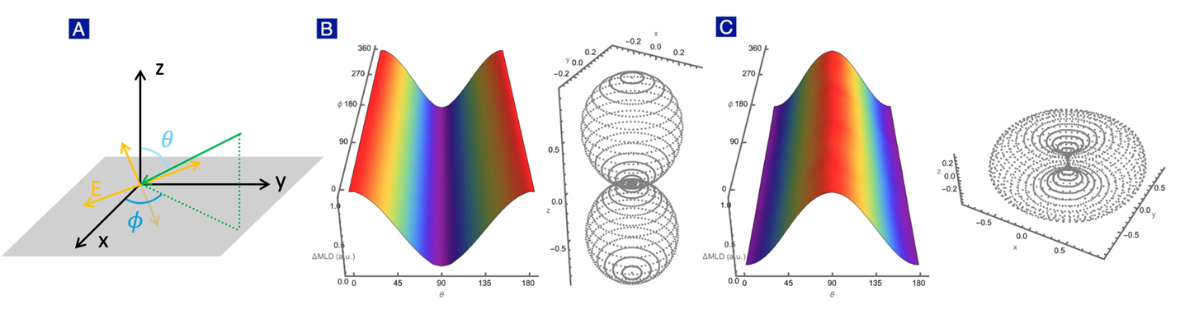
Figure S3｜Spherical representations of ∆MLD. (a) The X-ray propagation direction (green arrow) and corresponding electric field polarizations (yellow arrows), where $θ$ and $ϕ$ represent the angles between the $z$ and $x$ axes respectively. Since one of the electric field polarizations is lying in the $x-y$ plane during rotation, the other one can be determined by performing the outer product of the Poynting vector and the known polarization. (b) The angular variation of ∆MLD corresponding to the collinear spin configuration depicted in Figure 2(a). The angular dependence in terms of $(θ, ϕ)$ is illustrated on the left and its corresponding spherical plot is displayed on the right. Notably, the elongated axis of the dumbbell-shaped representation aligns with the Néel vector. (c) This panel showcases the angular variation of ∆MLD for the non-collinear spin configuration in Figure 2(b). It is evident that the conventional Néel vector is insufficient to encapsulate the donut-shaped structure emerging from the non-collinear spin arrangement.

As illustrated in Figure S3, we present the angular variations of ∆MLD across different spin configurations. It is important to note that we have normalized the ∆MLD values at each angle by subtracting the minimum value, facilitating a spherical plot of the angular scan. In the case of a collinear AFM where spins are aligned along the z-axis, a dumbbell shape emerges and its longest axis corresponds to the Néel vector, as depicted in Figure S3(a). On the other hand, the non-collinear spin configuration leads to a donut shape as shown in Figure S3(b), a formation that cannot be adequately described by the Néel vector alone. This scenario points up the critical role of the Néel tensor in offering a holistic representation of spin configurations in AFM materials.

Supplementary Information 8 – Néel tensor for tetrahedral spin arrangement

In our polycrystalline IrMn film, its $〈111〉$ direction is aligned along the $z$-axis while the transverse directions are randomly oriented. The microscopic spin-dependent interaction leads to the so-called 3Q tetrahedral spin arrangement as shown in Figure S4. In an ideal situation, all spins at the corners point to the body center of the tetrahedron,
$${\vec{s}}_{1}=s\left(0,0,-1\right)$$
$${\vec{s}}_{2}=s\left(-\frac{2\sqrt{2}}{3},0,\frac{1}{3}\right)$$
$${\vec{s}}_{3}=s\left(\frac{\sqrt{2}}{3},-\frac{\sqrt{6}}{3},\frac{1}{3}\right)$$
$${\vec{s}}_{4}=s\left(\frac{\sqrt{2}}{3},\frac{\sqrt{6}}{3},\frac{1}{3}\right)$$
The Néel tensor can be computed by summing over all spin contributions. For the ideal tetrahedral spin arrangement, the Néel tensor turns out to be zero,
$$N^{αβ}=\sum_{i=1}^{4}{s_{i}^{α}s_{i}^{β}}=0 (S14)$$
Thus, the 3Q tetrahedral spin arrangement is sensitive to all perturbations, leading to non-zero Néel tensors. However, for realistic materials below the blocking temperature, the Néel tensor associated with each domain is likely to be non-vanishing due to domain-domain interaction or/and other microscopic spin-dependent interactions, distorting the spin arrangement from the ideal 3Q tetrahedral one.
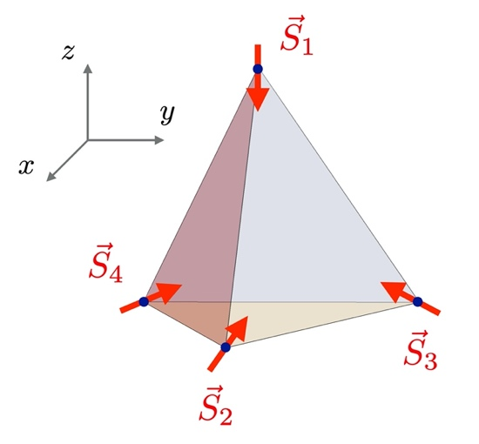
Figure S4｜Tetrahedral spin arrangement. In our polycrystalline IrMn film, its $〈111〉$ direction is aligned perpendicularly and the AFM coupling leads to the so-called 3Q tetrahedral spin arrangement. It is straightforward to compute the Néel tensor for the ideal tetrahedral spin arrangement and the answer turns out to be zero.

