Contents
Supplemental Tables 2
Table S1. Storage Characteristics in California under Varying Energy Storage Costs 2
Table S2. Existing and Available Capacities by Technology Used in the Model 2
Supplementary Figures 4
Figure S1. Regional Impacts of 50% Hydropower Reduction on Storage, Generation, and Transmission 4
Figure S2. Impacts on Storage of 10x Increase in Transmission Expansion Costs 4
Figure S3. Seasonal Cycles in the Energy Stored in the WECC under Varying Storage Cost Scenarios 5
Figure S4. Impact of Four Factors on the Use and Value of LDES Using Net Amounts 6
Figure S5. Load zones and transmission lines used by the SWITCH model. 7
SWITCH Data 8
Financial Data 8
Load Zones 8
Existing Generators 8
Candidate Generators 9
Technology assumptions on lifetime, capacity factors, efficiencies 10
Transmission 10
Overnight capital cost, variable O&M cost, fixed O&M cost 11
Connection costs 12
Fuel costs and Emissions 12
Transmission costs 12
Load 12
Carbon cap 13
Supplemental References 14

Supplemental Tables

Table S1. Storage Characteristics in California under Varying Energy Storage Costs
Energy Storage Cost | California energy storage capacity (TWh) | California median storage duration (h) | California largest storage duration (h)
102 $/kWh | 0.70 | 6.3 | 7.9
22 $/kWh  (Baseline) | 0.74 | 7.1 | 8.2
10 $/kWh | 0.80 | 7.3 | 11
5 $/kWh | 3.4 | 19 | 212
2 $/kWh | 9.7 | 134 | 474
1 $/kWh | 10 | 159 | 620
0.5 $/kWh | 16 | 163 | 787
For all scenarios, storage power capital costs are 19.58$/kW and O&M costs of 6.10$/kW-year. The baseline costs represent a scenario where the Department of Energy’s “Energy Storage Grand Challenge” is achieved (90% reduction in storage costs by 2030).

Table S2. Existing and Available Capacities by Technology Used in the Model
Energy Source | Generation Technology | Total Existing Capacity (GW) | Existing Capacity Still Online in 2050 (GW) | Maximum Available Capacity (GW)
Biogas | Biogas | 0.2 | 0.0 | No max. Constrained by fuel costs
Biogas | Biogas Internal Combustion Engine | 0.4 | 0.0 | 0.0
Biogas | Biogas Internal Combustion Engine Cogen | 0.2 | 0.0 | 0.1
Biogas | Biogas Steam Turbine | 0.1 | 0.0 | 0.0
Bio Liquid | Bio Liquid Steam Turbine Cogen | 0.5 | 0.0 | 0.3
Bio Solid | Bio Solid Steam Turbine | 0.7 | 0.0 | 0.0
Bio Solid | Bio Solid Steam Turbine Cogen | 0.6 | 0.1 | 0.4
Coal | IGCCC | 0.0 | 0.0 | Effectively 0.0 due to zero-emissions constraint
Coal | Coal Steam Turbine | 95.4 | 3.3 | Effectively 0.0 due to zero-emissions constraint
Coal | Coal Steam Turbine Cogen | 0.5 | 0.0 | Effectively 0.0 due to zero-emissions constraint
Distillate Fuel Oil | Distillate Fuel Oil Combustion Turbine | 0.5 | 0.0 | 0.0
Distillate Fuel Oil | Distillate Fuel Oil Internal Combustion Engine | 0.9 | 0.0 | 0.0
Electricity | Battery Storage | 1.1 | 0.0 | 0.0
Electricity | LDES | 0.0 | 0.0 | No max. See main paper for details.
Gas | CCGT | 67.1 | 8.9 | Effectively 0.0 due to zero-emissions constraint
Gas | CCGT Cogen | 7.7 | 0.0 | Effectively 0.0 due to zero-emissions constraint
Gas | Gas Combustion Turbine | 31.1 | 6.9 | Effectively 0.0 due to zero-emissions constraint
Gas | Gas Combustion Turbine Cogen | 4.5 | 0.0 | Effectively 0.0 due to zero-emissions constraint
Gas | Gas Internal Combustion Engine | 1.7 | 0.0 | 0.0
Gas | Gas Internal Combustion Engine Cogen | 0.5 | 0.0 | Effectively 0.0 due to zero-emissions constraint
Gas | Gas Steam Turbine | 38.1 | 0.2 | 0.0
Gas | Gas Steam Turbine Cogen | 0.4 | 0.0 | Effectively 0.0 due to zero-emissions constraint
Gas | Other Turbine | 0.0 | 0.0 | 0.0
Geothermal | Geothermal | 13.3 | 0.0 | 11.1
Residual Fuel Oil | Gas Combustion Turbine | 0.2 | 0.0 | 0.0
Solar | Central PV | 26.6 | 0.0 | 3270.2
Solar | Commercial PV | 0.0 | 0.0 | 52.7
Solar | Residential PV | 0.0 | 0.0 | 125.3
Solar | Concentrating Solar Power Trough, No Storage | 0.4 | 0.0 | 5362.5
Solar | Concentrating Solar Power Trough, 6h Storage | 0.0 | 0.0 | 3695.3
Solar | Steam Turbine | 1.6 | 0.0 | 0.0
Uranium | Nuclear | 14.3 | 9.6 | 0.0
Waste Heat | Other Turbine | 0.0 | 0.0 | 0.0
Waste Heat | Steam Turbine | 0.2 | 0.0 | 0.0
Water | Hydropower | 239.3 | 239.3 | 0.0
Water | Pumped Storage | 12.4 | 12.4 | 0.0
Wind | Onshore Wind | 42.3 | 0 | 521.4
Wind | Offshore Wind | 0.0 | 0.0 | 6.4
Total |  | 602.8 | 280.7 | N/A

Supplementary Figures
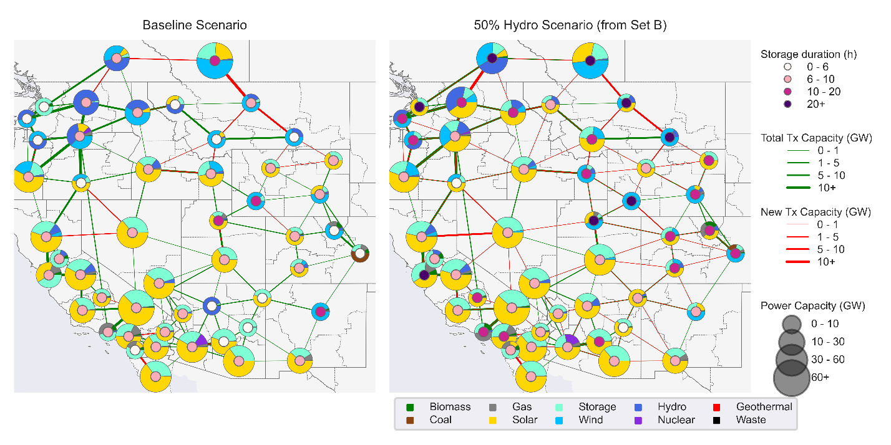

Figure S1. Regional Impacts of 50% Hydropower Reduction on Storage, Generation, and Transmission
Regions that previously rely on hydropower need more storage of longer durations.
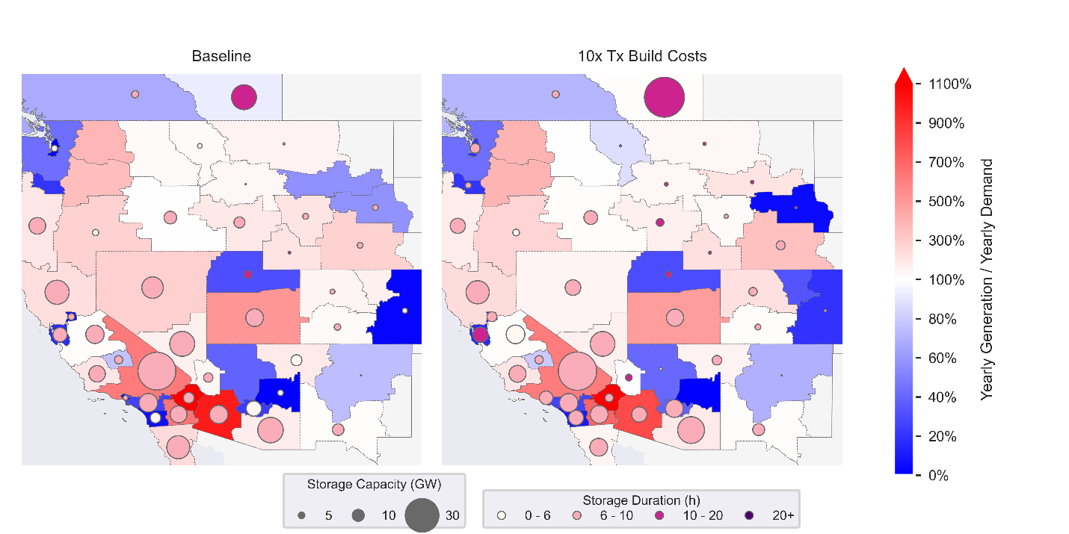

Figure S2. Impacts on Storage of 10x Increase in Transmission Expansion Costs
Storage is only impacted in a handful of transmission-dependent load zones (e.g. Alberta). Blue load zones generate less than their yearly demand (net importers), and red load zones generate more than their yearly demand (net exporters). Circle size represents storage power capacity. Circle color represents storage duration.
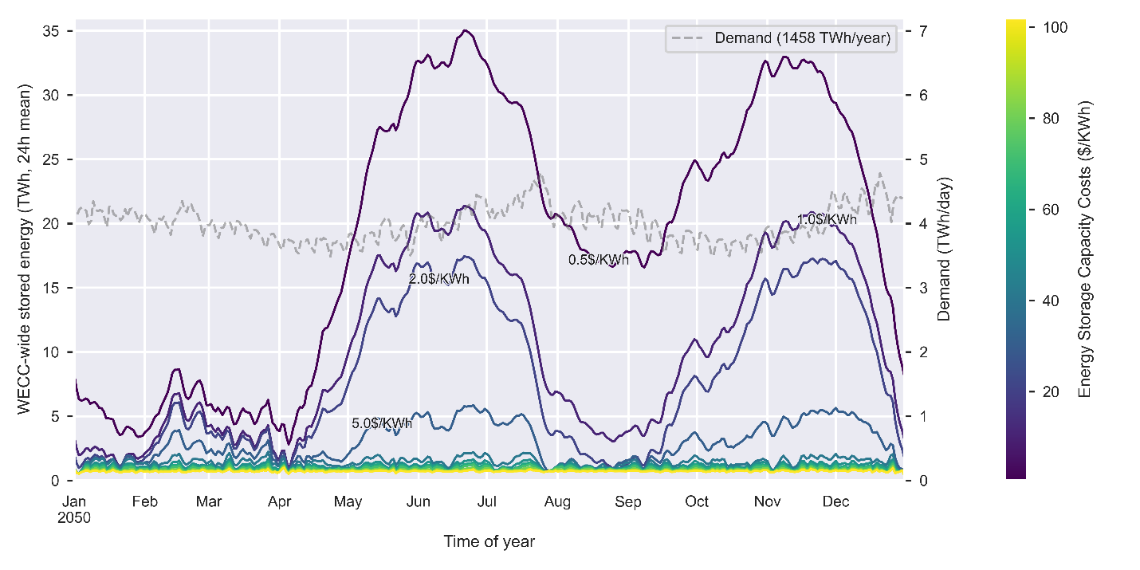

Figure S3. Seasonal Cycles in the Energy Stored in the WECC under Varying Storage Cost Scenarios
Storage resources are operated on seasonal cycles when energy storage capacity costs are at or below 5 $/kWh. Storage resources are additionally operated on yearly cycles when costs are at or below 1 $/kWh.
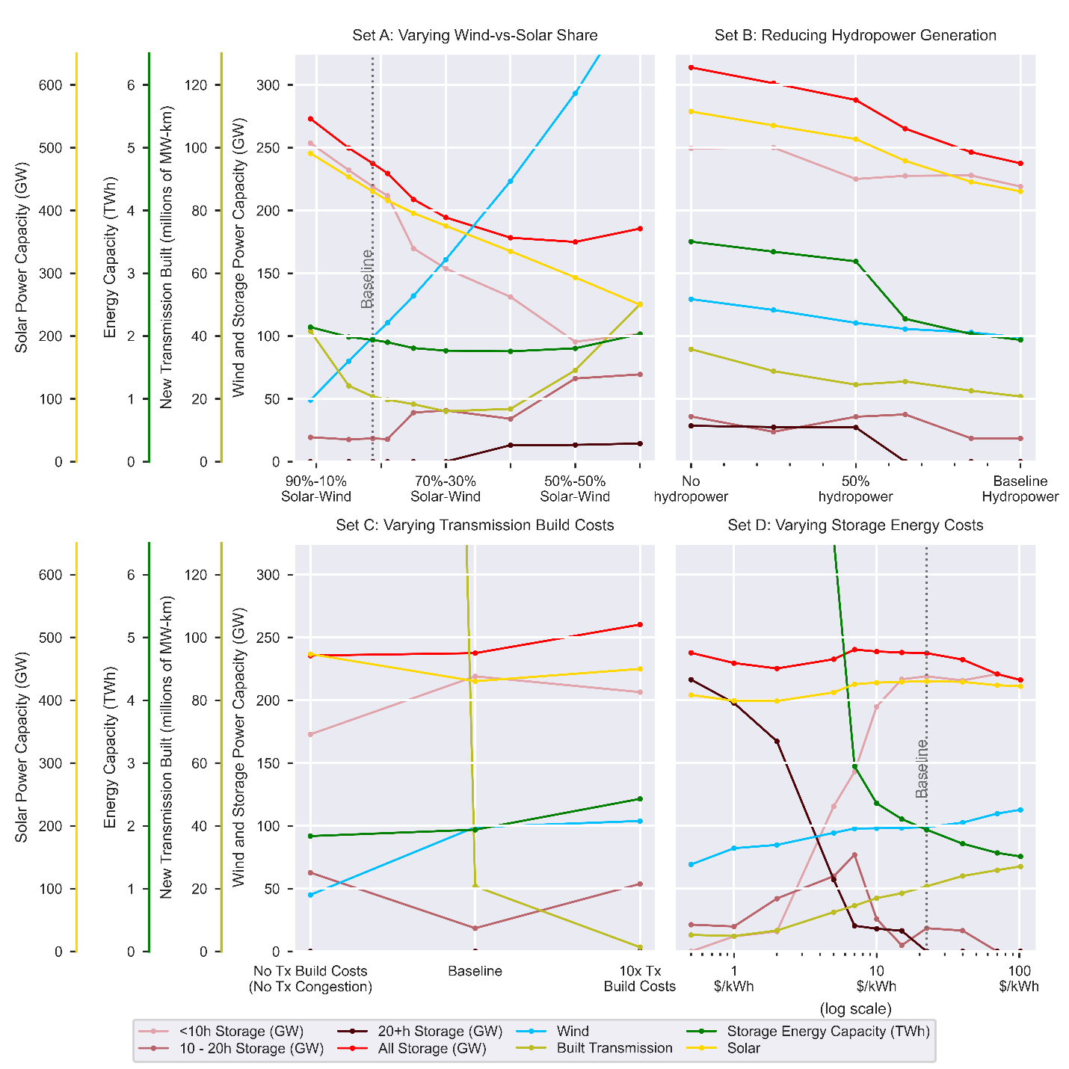

Figure S4. Impact of Four Factors on the Use and Value of LDES Using Net Amounts
Equivalent to figure 2 but values are net amounts rather than percentages changed relative to the baseline.
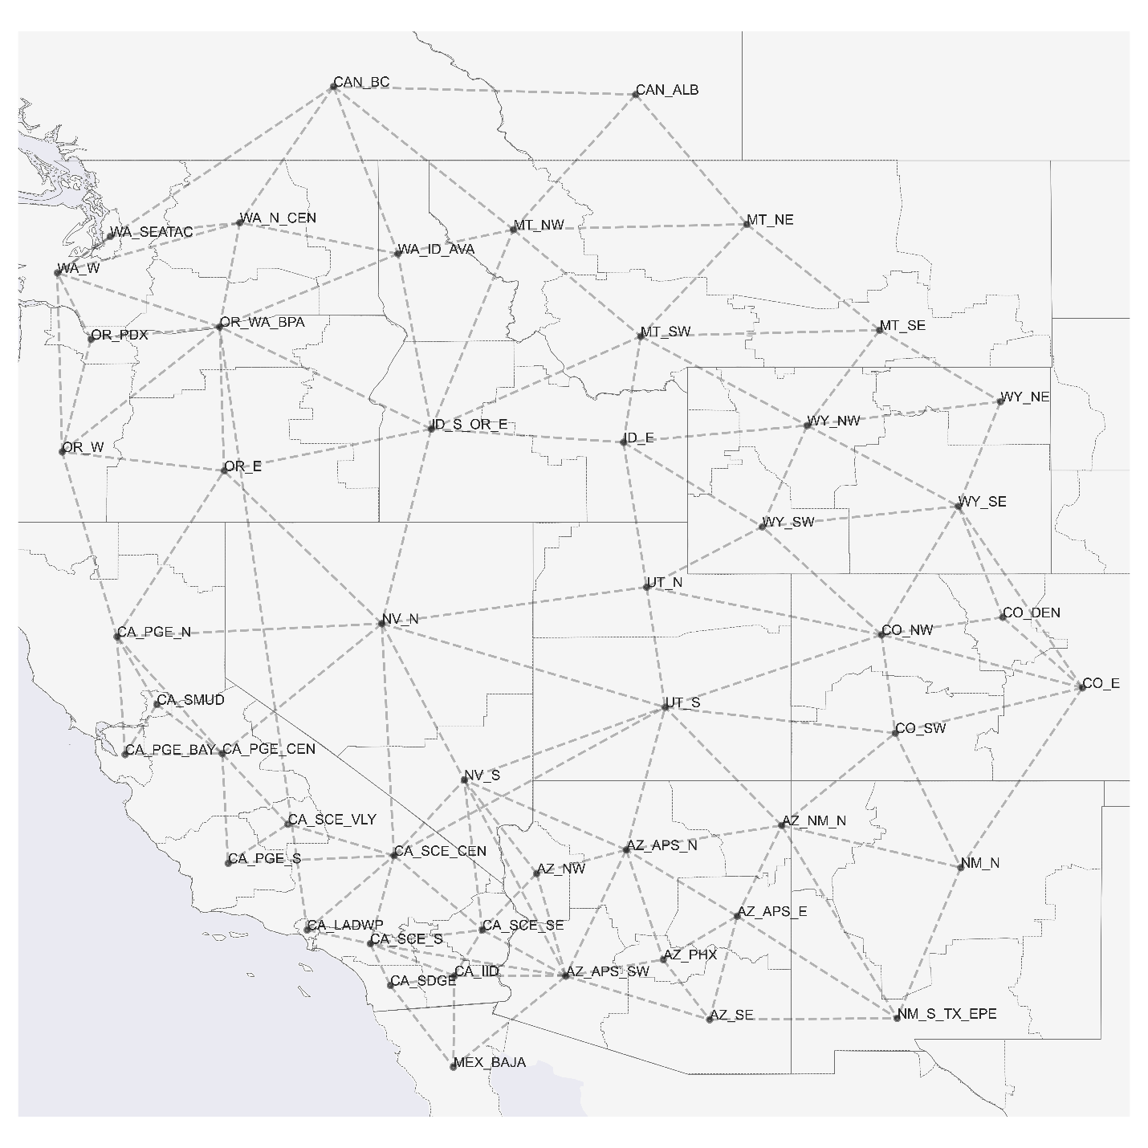

Figure S5. Load zones and transmission lines used by the SWITCH model.

SWITCH Data
This section describes the data sources used for the SWITCH model.

Financial Data
5% was used for the interest rate and discount rate in the model to reflect the general decrease in US interest rates in recent years. All costs in the model are 2018 costs.

Load Zones
The SWITCH model divides the WECC into 50 “load zone” regions shown in figure S5. Load zone boundaries were used from prior SWITCH-WECC analyses,^{1,2} which constructed the regions based on state lines, North American Electric Reliability Corporation (NERC) control areas, utility service territory boundaries, and high-population metropolitan areas. Some utility service territories were divided into multiple zones if there was a large amount of high-voltage transmission connectivity existing within the same service territory (i.e. CA PGE BAY, CA PGE CEN, CA PGE S, CA PGE N for PG&E). The boundaries were also constructed to represent zones that are unlikely to have transmission congestion within the zone (since only transmission between zones is included), and between which there has historically been transmission congestion (reflecting pathways where additional transmission may be needed).

Existing Generators
As inputs into SWITCH, we include the list of individual generators that are existing and/or are planned for the WECC region. For the US portion of WECC, we extract the list of generators and their characteristics (such as location, fuel source, generating technology, online year, and retirement year if any) from the Energy Information Administration (EIA) Form 860.³ At the time of the data collection (in late 2019/early 2020), the latest complete year of data was the 2018 EIA Form 860. We include generators from this form that are flagged with any of these statuses: operating, standby/backup, new unit under construction, cold standby, out of service but will be returned to service, construction complete but not yet in commercial operation, not under construction but site prep underway, and under construction. Generators are assigned to load zones based on their latitude and longitude.
The EIA Form 860 also includes planned retirement years for generators, if known. Generators are not allowed to operate beyond their expected lifetime, and therefore planned retirement years are used to calculate the lifetime of the plant to be included in the SWITCH runs. Monthly data was used from more recent Form 860 data to confirm that there were no additional planned retirements. For generators with no known retirement years, we assign a maximum lifetime based on the generating technology (Table S3.
For thermal generators, we join the list of generators from Form 860 with the monthly generation and fuel use from the EIA Form 923, for the available years 2004 – 2018.⁴ We use the historical monthly generation and fuel use from Form 923 to calculate the second-best (or second-lowest) heat rate (MMBtu/MWh) for each generator, avoiding any outliers from the best heat rate. The heat rate is used in the SWITCH dispatch optimization to calculate the fuel use and associated variable cost and emissions from dispatching thermal generators.
Hydropower generators are constrained to generate at their average historical monthly capacity factor². We extract the monthly generation by generator from 2004 – 2018 (the most recent complete data at the time of the analysis) from the Form 923. For each generator, we calculate the average power for each month (monthly generation/hours in month) and estimate that the proxy for minimum flows for each generator is the power generated at half the average monthly level. Monthly hydropower capacity factors by generator for the Canadian load zones (British Columbia and Alberta) are used from the prior SWITCH database, based on data from Statistics Canada Tables.²
The existing generator set for the Canadian and Mexican load zones are used from the data previously compiled for prior SWITCH-WECC analysis, originally from the WECC Transmission Expansion Planning Policy Committee database of generators, and were not updated for this study.^{2,5}

Candidate Generators
One of the key decision variables in SWITCH is the capacity investment of generation, out of a set of candidate generators with specific generating technologies and fuel sources, load zone locations, and other physical and financial generating characteristics. We use the dataset of candidate generators that was previously compiled in prior SWITCH-WECC analyses.^{1,2,5}
Candidate onshore and offshore wind generators were derived based on wind power output from a gridded 3TIER Western Wind and Solar Integration Study dataset⁸ and a gridded Canadian wind developer dataset, and a selection of prime sites based on criteria including high wind energy density, and proximity to transmission.² A portion of candidate generators were screened out in California if they were in “Category 3, high environmental risk” locations, which include areas legally excluded for development, protected areas with ecological or social value, conservation regions, and prime agricultural land.⁶
Candidate solar generators include Residential PV (rooftop PV on homes), Commercial PV (rooftop PV on commercial buildings), Central PV (utility-scale), and Concentrating Solar Power with and without storage (solar thermal trough systems with or without thermal energy storage). Distributed Residential and Commercial PV candidate generation had been derived based on a gridded population density dataset, solar insolation data from NREL’s (now deprecated) Solar Prospector tool, and assumptions on rooftop area and solar cell characteristics.² Available land and capacity for Central PV and Concentrating Solar Power candidate generators were screened based on land exclusion criteria (including national parks, wildlife areas, and steep terrain), solar insolation from the System Advisor Model from the National Renewable Energy Laboratory,⁷ and assumptions on the solar technology characteristics.²
To simulate the dispatch of wind and solar generators, we use an exogenous dataset of hourly capacity factors by generator that had been constructed in prior SWITCH analyses.^{1,2} For wind generators, hourly capacity factors for the candidate generator set were calculated from the 3TIER Western Wind and Solar Integration Study wind speed dataset⁸ using idealized turbine power curves. For solar generators, hourly capacity factors for the candidate generator set are calculated from the System Advisor, using data from 2006 (consistent with the base weather year underlying the load profiles).⁷ Central PV and onshore wind generators with capacity-weighted average capacity factors below the 75th percentile for their technology were screened out to only have the candidate set among a computationally tractable, and commercially viable, set of higher-quality resource sites.² For existing solar and wind generators, we average the hourly capacity factors for all solar and wind generators, respectively, in each load zone, and assign all the generators in that load zone the average capacity factor for the given technology.
Biogas (from landfill, wastewater treatment plants, and manure) candidate generator availability is derived from an assessment of the technical resource/feed stock availability.⁹ Bioliquid generators are allowed to be reinstalled in their current locations but no new bioliquid plants are assumed. No new biomass (bio solid) candidate generators are assumed, but cogeneration bio solid generation is allowed to be reinstalled at the end of its lifetime.² Candidate geothermal generators are based on the current locations and capacity of existing plants that may be reinstalled after retirement.² We assume there is no candidate hydropower generation.
Natural gas combined cycle generators and combustion turbines do not have imposed maximum capacity limits. Coal generators are not allowed to be installed in California but are otherwise allowed to expand without capacity limits. Cogeneration plants (with gas combined cycle or combustion turbine plants) are given the option to be reinstalled at current locations after reaching their maximum age, at current capacity limits. We assume that there is no nuclear generation available for new, candidate generation.
Table S2 summarizes the maximum capacity available for the set of candidate generators, and the capacity installed for existing generators.

Technology assumptions on lifetime, capacity factors, efficiencies
For all existing generators and candidate generators, we assume the following default technology assumptions based on the generating technology and fuel source (table S3), primarily based on the technology and cost assumptions from Black & Veatch¹⁰ and a CEC Cost of Generation Report collected in the prior SWITCH analyses^{2,5} and converted to $2018, with some technology values (natural gas combined cycle, natural gas turbine, battery, wind, solar PV, solar CSP, and geothermal) updated based on NREL’s 2020 Annual Technology Baseline.¹¹ For existing generators with known planned retirement years, a specific lifetime is calculated.
Table S3. Technology assumptions for existing and candidate generators.
Fuel Source | Generating Technology | Lifetime (Years) | Forced Outage Rate (%) | Scheduled Outage Rate (%)
Biogas | Biogas | 20 | 4% | 6%
Biogas | Biogas Internal Combustion Engine | 20 | 4% | 6%
Biogas | Biogas Internal Combustion Engine Cogen | 20 | 11% | 4%
Biogas | Biogas Steam Turbine | 20 | 13% | 9%
Bio Liquid | Bio Liquid Steam Turbine Cogen | 40 | 13% | 9%
Bio Solid | Bio Solid Steam Turbine | 20 | 4% | 6%
Bio Solid | Bio Solid Steam Turbine Cogen | 40 | 13% | 9%
Electricity | Battery Storage | 10 | 2% | 1%
Electricity | LDES | 15 | 2% | 0.55%
Geothermal | Geothermal | 20 | 0% | 0%
Solar | Central PV | 20 | 0% | 0%
Solar | Commercial PV | 20 | 0% | 0%
Solar | Concentrating Solar Power Trough 6h Storage | 20 | 6% | 0%
Solar | Concentrating Solar Power Trough No Storage | 20 | 0% | 0%
Solar | Residential PV | 20 | 0% | 0%
Solar | Steam Turbine | 20 | 4% | 6%
Uranium | Nuclear | 80 | 4% | 6%
Waste Heat | Other Turbine | 40 | 4% | 6%
Waste Heat | Steam Turbine | 40 | 4% | 6%
Water | Hydropower | 200 | 5% | 5%
Water | Pumped Storage | 200 | 5% | 5%
Wind | Offshore Wind | 30 | 5% | 1%
Wind | Onshore Wind | 20 | 0% | 0%
Note: Values for emitting generators (e.g., coal, natural gas, etc.) are not shown since these generators do not contribute to the model dispatch due to the zero-emissions constraint.

Transmission
The SWITCH optimization includes the construction of new transmission lines and the operations of existing and new transmission as decision variables. The model includes a set of 126 existing aggregated transmission lines between load areas within the WECC, based on a prior SWITCH analysis that aggregated the thermal limits of individual high-voltage lines between load areas from a Ventyx purchased dataset and Federal Energy Regulatory Commission (FERC) data.² New transmission capacity may be added to existing transmission corridors or constructed between 21 adjacent load zone pairs where there is currently no transmission. The line length assumed is 1.3 times the straight-line distance between the largest substations in each load zone, based on a prior analysis that calculated this as the average ratio between line length and straight-line distance between transmission substations in WECC.² For every 100 miles of distance, a 1% efficiency loss is assumed, based on typical losses for high-voltage transmission.¹² For both existing and newly constructed transmission lines, the maximum power transfer on each line is the thermal limit multiplied by a derating factor. The derating factor is from a prior SWITCH analysis and is meant to capture the combined effect of stability concerns, loop flows, voltage concerns, power factors less than unity, and overloading of individual transmission lines within the bundle, that are difficult to model in detail in the linear model. The factors are 0.59 for alternating current (AC) lines, and 0.91 for direct current (DC) lines, of which there are only two in our analysis.²

Overnight capital cost, variable O&M cost, fixed O&M cost
The SWITCH optimization includes several types of costs in the decision to invest and/or operate in generation. Costs for candidate generators include overnight capital cost (applied to the built capacity), fixed O&M costs per MW-year of operations, and variable O&M costs per MWh of operation. Mature technologies (biogas, bioliquid, biosolid, coal, gas cogeneration, gas steam turbine) are assumed to have their real costs stay constant over time, whereas other technologies are assumed to decrease costs over time with technology improvements and economies of scale. Capital, fixed O&M, and variable O&M costs by generator technology type originate primarily from Black & Veatch estimates for the mature technologies.^{2,10} For technologies with changing costs over time (solar PV, solar CSP, wind, geothermal, gas CCGT, gas CT), we compile cost data from NREL’s 2020 Annual Technology Baseline database using the “Moderate Scenario” which is based on the of median projections from the literature.¹¹ The average costs by energy source, and technology are in Table S4. Capital costs for existing generators are considered sunk costs and we do not include them in the total system costs; they do not affect future investment decisions. Variable O&M costs for existing generators are set to be the same as for candidate generators.
Table S4. Average capital, fixed O&M, and variable O&M costs for candidate generation ($2018).
Energy Source | Generation Technology | Overnight capital cost ($/MW) | Fixed O&M cost ($/MW-year) | Variable O&M cost ($/MWh)
Bio Gas | Bio Gas | 2,118,354 | 64,380 | 9.20
Bio Gas | Bio Gas Internal Combustion Engine Cogen | 1,588,766 | 48,285 | 16.00
Bio Liquid | Bio Liquid Steam Turbine Cogen | 3,225,737 | 80,012 | 16.80
Bio Solid | Bio Solid Steam Turbine Cogen | 3,225,737 | 80,012 | 16.80
Electricity | LDES | 19,580 | 6,096 | 0.0
Geothermal | Geothermal | 6,970,164 | 173,105 | 0.0
Solar | Central PV | 702,651 | 8,229 | 0.0
Solar | Commercial PV | 819,995 | 5,879 | 0.0
Solar | CSP Trough 6h Storage | 4,023,815 | 52,447 | 3.59
Solar | CSP Trough No Storage | 3,937,151 | 56,149 | 0.0
Solar | Residential PV | 884,353 | 6,633 | 0.0
Wind | Offshore Wind | 2,226,776 | 112,298 | 0.0
Wind | Onshore Wind | 1,042,433 | 33,692 | 0.0
Note: Costs for emitting generators (e.g., coal, natural gas, etc.) are not shown since these generators do not contribute to the model dispatch due to the zero-emissions constraint.

Connection costs
In addition to capital costs for the construction of a generator itself, for candidate generators we also add a connection cost to reflect the expense of connecting to the grid. This connection cost originally derived from EIA data and compiled in a prior SWITCH analysis² is either a “generic” cost if the generator is not located at a specific site (for gas, coal, biosolid, biogas, or battery storage), or is calculated for a specific site (for onshore wind, offshore wind, geothermal, central PV, and CSP with and without storage). The “generic” cost includes the cost of building a substation ($80,000/MW in $2018) and a small transmission line to the substation ($31,000 in $2018). Site specific connection costs include a transmission line cost of $1,200 per MW per km based on the distance from the site to the substation, and the cost of the substation. The cost for underwater cable for offshore wind is $6000 per MW per km. There is no connection cost applied for existing generation.

Fuel costs and Emissions
Fuel costs are applied to non-renewable generators (natural gas, coal, fuel oil, uranium) and originate from the EIA’s Annual Energy Outlook (AEO) compiled from a prior WECC analysis.⁵ Gas costs differ by load zone based differences in regional market prices and the wellhead price.² Table S5 shows the average costs across all the load zones, in $2018. The fuel costs for bio solid generators are based on supply curves derived based on estimates of the economically feasible volumes of biomass feedstock available by load zone and different fuel price tiers.²
Table S5. Average fuel costs across load zones, by investment period ($/MMBtu in $2018)
Fuel Source | Fuel Cost in 2050
Bio Liquid | 0.01
Coal | 2.33
Distillate Fuel Oil | 27.64
Gas | 6.34
Residual Fuel Oil | 20.44
Uranium | 1.53

Transmission costs
The cost of building new transmission lines is calculated as the product of a line length, a base $/MW/km cost, a terrain multiplier that reflects the topography differences that make a line more expensive to construct, and an economic multiplier that represents differences in labor, permitting, and other “soft” costs between WECC load zones.
We assume a base $960/MW-km cost, which is the cost for constructing a 500 kV line in the WECC from the ReEDS capacity expansion model database ($1,347/MW-mile in $2010 dollars, converted to $/MW-km and $2018 dollars).¹² For the economic multiplier, for all lines within California we use a factor of 2.25, between California and other WECC load zones we use a factor of 1.125, and within other WECC load zones we use a factor of 1 (keeping the base cost as it is) from the the ReEDS documentation.¹² Steeper terrain and urban land area increase transmission construction costs. Terrain multipliers come from a prior SWITCH GIS analysis that overlaid the transmission line paths over a gridded dataset of terrain-dependent transmission costs, that had been derived from the slope and the land cover in the WECC region.² The multipliers range from 0.7 to 3.4. Transmission lines also have a fixed O&M cost applied to reflect upkeep costs for lines, which is assumed to be 3% of capital costs from the prior SWITCH analysis.

Load
The future load assumed in this analysis was developed in a prior study and represents a case of high energy efficiency and building electrification, as well as increased adoption of Zero Emissions Vehicles (ZEVs), primarily from electric vehicles.⁵ The load forecast achieves a doubling of the rate of energy efficiency by 2030 in California, compliant with the state’s SB 350 legislative targets, aggressive building electrification starting in 2020, growing industry electrification, and approximately 125,000 GWh in electricity demand from transportation. Hourly demand profiles from 2006 (consistent with the weather-year used for calculating solar and wind capacity factors) from FERC Form 714 and a dataset procured from ITRON were used as a base from which demand projects (residential, commercial, industrial, transportation) were created and scaled by sector to meet states’ policy targets and reflect population growth.¹⁷ Where detailed state/province-level load forecasts with state efficiency, electrification, and population estimates were available (including California, Washington, Oregon, British Columbia, and Alberta) load zone forecasts were scaled to those projections; otherwise forecasts were scaled to the EIA’s Annual Energy Outlook projections in the prior SWITCH analysis.^{5,13} In the 2017 Annual Energy Outlook Electric projections used, population growth across the U.S. is on average 0.6% annually, based on the U.S. Census Bureau’s mid-case projections at the time.¹³ Electric vehicles are assumed to charge in an “unmanaged” way (without smart charging or time-of-use rates), based on charging profiles developed with an agent-based mobility model BEAM.^{14,15}

Carbon cap
A constraint on carbon emissions from generators can be imposed in SWITCH by load zone and investment period. In this analysis, we force carbon emissions to be zero in the 2050 investment period for all load zones in WECC. To measure compliance with this constraint, SWITCH tracks the emissions from each generator and aggregates to the load zone, based on emissions intensity for each fuel source¹⁶ (Table S6).
Table S6. Emissions Intensity of Fuel-based Energy Sources (tons CO₂/BTU).
Fuel | CO₂ Intensity of Fuel
Biogas | 0
Bio Liquid | 0
Bio Solid | 0
Coal | 0.09552
Distillate Fuel Oil | 0.07315
Gas | 0.05306
Residual Fuel Oil | 0.0788
Uranium | 0

Supplemental References
1. Nelson, J., Johnston, J., Mileva, A., Fripp, M., Hoffman, I., Petros-Good, A., Blanco, C., and Kammen, D.M. (2012). High-resolution modeling of the western North American power system demonstrates low-cost and low-carbon futures. Energy Policy 43, 436–447.
2. Mileva, A., Johnston, J., Nelson, J.H., and Kammen, D.M. (2016). Power system balancing for deep decarbonization of the electricity sector. Applied Energy 162, 1001–1009.
3. Form EIA-860 detailed data with previous form data (EIA-860A/860B) https://www.eia.gov/electricity/data/eia860/.
4. Form EIA-923 detailed data with previous form data (EIA-906/920) https://www.eia.gov/electricity/data/eia923/.
5. Wei, M., Raghavan, S. v., and Hidalgo-Gonzalez, P. (2019). Building a Healthier and More Robust Future: 2050 Low-Carbon Energy Scenarios for California.
6. Wu, G.C., Torn, M.S., and Williams, J.H. (2015). Incorporating land-use requirements and environmental constraints in low-carbon electricity planning for California. Environmental Science and Technology 49, 2013–2021.
7. Blair, N., Diorio, N., Freeman, J., Gilman, P., Janzou, S., Neises, T., and Wagner, M. (2018). System Advisor Model (SAM) General Description (Version 2017.9.5).
8. National Renewable Energy Laboratory Western Wind Data Set.
9. Milbrandt, A. (2005). A Geographic Perspective on the Current Biomass Resource Availability in the United States.
10. Black & Veatch (2011). Cost and Performance Data for Power Generation Technologies, Prepared for the National Renewable Energy Laboratory.
11. National Renewable Energy Laboratory (2020). 2020 Annual Technology Baseline.
12. Brown, M., Cole, W., Eurek, K., Becker, J., Bielen, D., Chernyakhovskiy, I., Cohen, S., Frazier, W., Gagnon, P., Gates, N., et al. (2020). Regional Energy Deployment System (ReEDS) Model Documentation: Version 2019.
13. Energy Information Administration (2017). Assumptions to the Annual Energy Outlook 2017.
14. Sheppard, C., Waraich, R., Campbell, A., Pozdnukhov, A., and Gopal, A.R. (2017). Modeling plug-in electric vehicle charging demand with BEAM The framework for behavior energy autonomy mobility.
15. Szinai, J.K., Sheppard, C.J.R., Abhyankar, N., and Gopal, A.R. (2020). Reduced grid operating costs and renewable energy curtailment with electric vehicle charge management. Energy Policy 136, 111051.
16. U.S. Energy Information Administration (2021). Carbon Dioxide Emissions Coefficients. https://www.eia.gov/environment/emissions/co2_vol_mass.php.

