A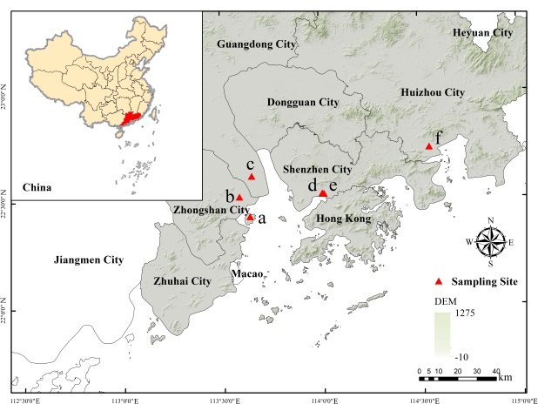 | B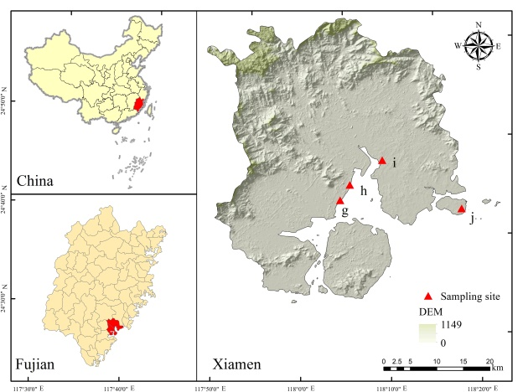
Extended data Fig. 1: Study sites
A, Guangdong province, including six sites: (a) Qiao Island Mangrove Nature Reserve. (b) Cuiheng National Wetland Park. (c) Nansha Wetland Park. (d) Shenzhen Bay Park. (e) Futian Mangrove Nature Reserve. (f) Daya Bay Mangrove Urban Wetland Park. B, Xiamen city, including four sites: (g) Jimei Bridge (JMB). (h) Caihong Bay (CHW). (i) Xiatanwei Mangrove Wetland Park. (j) Dadeng Island. C, The plots at JMB sit and CHW site.

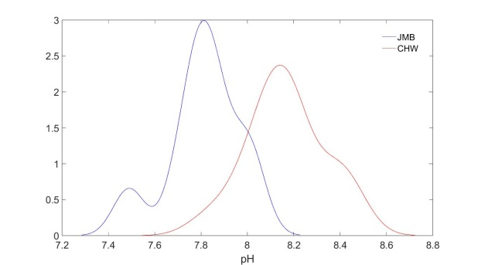 | 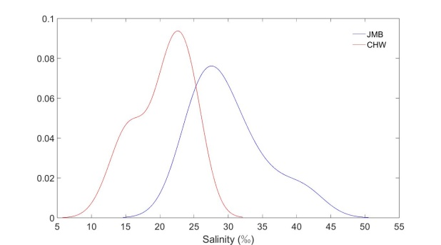
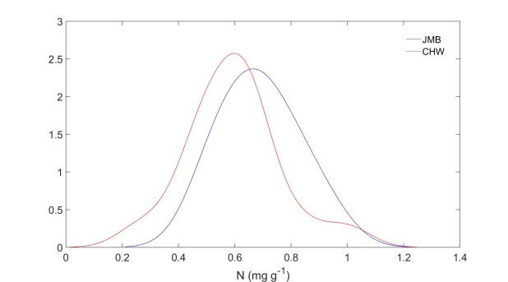 | 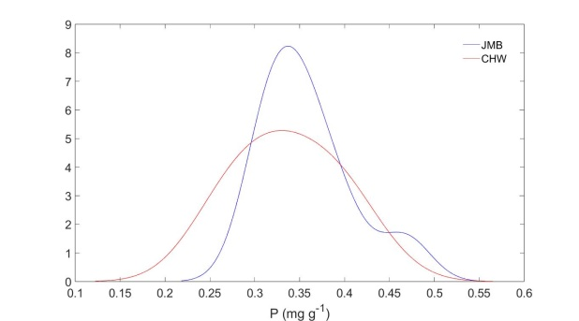
Extended data Fig. 2: Soil comparison between JMB and CHW in Xiamen city
JMB site had overall higher salinity and EC (P < 0.001, n = 27) while lower pH (P < 0.001, n = 26) than CHW site, regardless of the variation across plots within each site, but soil N (P = 0.332, n = 27) and P (P = 0.155, n = 27) did not show significant differences.

Extended data Table 1: Species and their location
Guangdong
Site | Location | Species
Daya Bay Mangrove Urban Wetland Park | 22°30′-22°50′N  114°30′-114°50′E | Aegiceras corniculatum  Sonneratia apetala  Acrostichum aureum  Excoecaria agallocha  Acanthus ilicifolius  Bruguiera gymnorhiza  Kandelia obovata
Nansha Wetland Park | 22°35′-22°37′N  113°37′-113°38′E | Aegiceras corniculatum  Kandelia obovata  Sonneratia caseolaris  Bruguiera gymnorhiza  Acrostichum aureum  Acanthus ilicifolius
Cuiheng National Wetland Park | 22°29′-22°32′N  113°34′-113°35′E | Pongamia pinnata  Pluchea indica  Heritiera littoralis  Scaevola taccada
Qiao Island Mangrove Nature Reserve | 22°23'-22°27'N  113°36'-113°39'E | Kandelia obovata  Cerbera manghas  Heritiera littoralis  Bruguiera gymnorhiza  Acanthus ilicifolius  Acrostichum aureum  Aegiceras corniculatum  Dolichandrone spathacea  Conocarpus erectus  Pluchea indica  Bruguiera parviflora  Excoecaria agallocha  Talipariti tiliaceum  Barringtonia racemosa  Bruguiera sexangula  Thespesia populnea  Lumnitzera racemosa
Shenzhen Bay Park | 22°30′-22°33′N  113°58′-114°05′E | Acanthus ilicifolius  Bruguiera gymnorhiza  Kandelia obovata  Aegiceras corniculatum  Avicennia marina  Thespesia populnea  Heritiera littoralis  Sonneratia apetala  Acrostichum aureum  Sonneratia caseolaris
Futian Mangrove Nature Reserve | 22°30′-22°32′N  114°00′-114°02′E | Acanthus ilicifolius  Bruguiera gymnorhiza  Excoecaria agallocha  Rhizophora stylosa  Aegiceras corniculatum  Bruguiera sexangula  Sonneratia apetala  Sonneratia caseolaris  Heritiera littoralis  Kandelia obovata  Cerbera manghas  Thespesia populnea  Pluchea indica  Lumnitzera racemosa  Bruguiera sexangula  Laguncularia racemosa
Xiamen
Xiatanwei Mangrove Wetland Park | 24°37′-24°39′N 118°12′-118°13′E | Bruguiera gymnorhiza  Cerbera manghas
Dadeng Island | 24°33′-24°34′N 118°19′-118°20′E | Volkameria inermis  Terminalia catappa
Caihongwan (CHW) | 24°36′-24°37′N 118°8′-118°9′E | Kandelia obovata  Laguncularia racemosa
Jimei Bridge (JMB) | 24°35′-24°37′N  118°7′-118°9′E | Kandelia obovata  Laguncularia racemosa

Extended data Table 2: Comparison of soil conditions among plots within each site
JMB
 |  |  | Sum of Squares | df | Mean Square | F | Sig.
pH | Between Groups |  | 0.101 | 2 | 0.050 | 3.096 | 0.119
pH | Within Groups |  | 0.098 | 6 | 0.016
pH | Total |  | 0.199 | 8
EC | Between Groups |  | 1.100 | 2 | 0.550 | 0.325 | 0.735
EC | Within Groups |  | 10.162 | 6 | 1.694
EC | Total |  | 11.263 | 8
Salinity | Between Groups |  | 22.253 | 2 | 11.127 | 0.325 | 0.735
Salinity | Within Groups |  | 205.535 | 6 | 34.256
Salinity | Total |  | 227.788 | 8
N | Between Groups |  | 0.004 | 2 | 0.002 | 0.076 | 0.928
N | Within Groups |  | 0.144 | 6 | 0.024
N | Total |  | 0.147 | 8
P | Between Groups |  | 0.009 | 2 | 0.005 | 2.308 | 0.181
P | Within Groups |  | 0.012 | 6 | 0.002
P | Total |  | 0.021 | 8
CHW
 |  |  | Sum of Squares | df | Mean Square | F | Sig.
pH |  | Between Groups | 0.084 | 2 | 0.042 | 1.725 | 0.212
 |  | Within Groups | 0.364 | 15 | 0.024
 |  | Total | 0.448 | 17
EC |  | Between Groups | 2.822 | 2 | 1.411 | 2.062 | 0.162
 |  | Within Groups | 10.262 | 15 | 0.684
 |  | Total | 13.084 | 17
Salinity |  | Between Groups | 57.068 | 2 | 28.534 | 2.062 | 0.162
 |  | Within Groups | 207.545 | 15 | 13.836
 |  | Total | 264.613 | 17
N |  | Between Groups | 0.154 | 2 | .077 | 3.702 | 0.049*
 |  | Within Groups | 0.311 | 15 | .021
 |  | Total | 0.465 | 17
P |  | Between Groups | 0.028 | 2 | 0.006 | 2.702 | 0.074
 |  | Within Groups | 0.025 | 15 | 0.002
 |  | Total | 0.054 | 17
*The difference in soil N was only observed between the plot 1 and 2 that growing Kandelia obovata at CHW site (LSD post-hoc analysis, P = 0.046).

Extended data Table 3: Correlation coefficients and slopes of trait coordination at species and individual level
Region | Guangdong
Trait pair | LMA-N |  | LMA-P
 | Individual | Species | Individual | Species
r (Pearson) | -0.632 | -0.643 | -0.774 | -0.594
P value | < 0.001 | 0.001 | < 0.001 | 0.002
Slope | -0.887 | -0.834 | -0.653 | -0.581
Region | Xiamen
Trait pair | LMA-N |  | LMA-P
 | Individual | Species | Individual | Species
r (Spearman’s) | -0.667 | -0.250 | -0.489 | -0.179
P value | < 0.001 | 0.589 | < 0.001 | 0.702
Slope | -1.064 | 6.062 | -0.673 | 1.719

Extended data Table 4: Comparison of leaf traits among plots within each site
JMB Kandelia obovata
 |  | Sum of Squares | df | Mean Square | F |  | Sig.
LMA | Between Groups | 2059.682 | 2 | 1029.841 | 8.197 |  | 0.019
LMA | Within Groups | 753.855 | 6 | 125.642
LMA | Total | 2813.537 | 8
Leaf N | Between Groups | 0.229 | 2 | 0.115 | 8.162 |  | 0.019
Leaf N | Within Groups | 0.084 | 6 | 0.014
Leaf N | Total | 0.313 | 8
Leaf P | Between Groups | 0.002 | 2 | 0.001 | 10.778 |  | 0.010
Leaf P | Within Groups | 0.001 | 6 | 0.000
Leaf P | Total | 0.003 | 8
JMB Laguncularia racemosa
LMA | Between Groups | 10117.841 | 2 | 5058.921 | 12.689 |  | 0.011
LMA | Within Groups | 1993.410 | 5 | 398.682
LMA | Total | 12111.251 | 7
Leaf N | Between Groups | 0.020 | 2 | 0.010 | 0.206 |  | 0.821
Leaf N | Within Groups | 0.240 | 5 | 0.048
Leaf N | Total | 0.260 | 7
Leaf P | Between Groups | 0.000 | 2 | 0.000 | 0.625 |  | 0.572
Leaf P | Within Groups | 0.001 | 5 | 0.000
Leaf P | Total | 0.001 | 7
CHW Kandelia obovata
LMA | Between Groups | 34036.989 | 2 | 17018.494 |  | 51.943 | 0.000
LMA | Within Groups | 1965.824 | 6 | 327.637
LMA | Total | 36002.813 | 8
Leaf N | Between Groups | 1.632 | 2 | 0.816 |  | 110.775 | 0.000
Leaf N | Within Groups | 0.044 | 6 | 0.007
Leaf N | Total | 1.676 | 8
Leaf P | Between Groups | 0.008 | 2 | 0.004 |  | 7.078 | 0.026
Leaf P | Within Groups | 0.003 | 6 | 0.001
Leaf P | Total | 0.011 | 8
CHW Laguncularia racemosa
LMA | Between Groups | 21192.623 | 2 | 10596.312 |  | 8.544 | 0.018
LMA | Within Groups | 7440.803 | 6 | 1240.134
LMA | Total | 28633.426 | 8
Leaf N | Between Groups | 2.581 | 2 | 1.291 |  | 23.035 | 0.002
Leaf N | Within Groups | 0.336 | 6 | 0.056
Leaf N | Total | 2.918 | 8
Leaf P | Between Groups | 0.009 | 2 | 0.005 |  | 32.846 | 0.001
Leaf P | Within Groups | 0.001 | 6 | 0.000
Leaf P | Total | 0.010 | 8

Extended data Table 5: Comparison of traits between species at JMB
 |  | Levene's Test for Equality of Variances |  | t-test for Equality of Variances
 |  | F | Sig. | t | df | Sig. (2-tailed)
A_{area} | Equal variances assumed | 0.018 | 0.895 | -3.09 | 15 | 0.008
A_{area} | Equal variances not assumed |  |  | -3.06 | 13.95 | 0.009
A_{mass} | Equal variances assumed | 3.409 | 0.085 | -4.81 | 15 | 0.000
A_{mass} | Equal variances not assumed |  |  | -4.61 | 9.30 | 0.001
g_{s} | Equal variances assumed | 2.312 | 0.149 | -0.09 | 15 | 0.923
g_{s} | Equal variances not assumed |  |  | -0.10 | 14.72 | 0.922
LMA | Equal variances assumed | 6.904 | 0.019 | -5.21 | 15 | 0.000
LMA | Equal variances not assumed |  |  | -5.00 | 9.49 | 0.001
N_{mass} | Equal variances assumed | 0.014 | 0.906 | 7.29 | 15 | 0.000
N_{mass} | Equal variances not assumed |  |  | 7.30 | 14.85 | 0.000
P_{mass} | Equal variances assumed | 5.130 | 0.039 | 6.69 | 15 | 0.000
P_{mass} | Equal variances not assumed |  |  | 6.92 | 12.79 | 0.000
N_{area} | Equal variances assumed | 1.127 | 0.305 | 1.49 | 15 | 0.156
N_{area} | Equal variances not assumed |  |  | 1.45 | 11.57 | 0.173
P_{area} | Equal variances assumed | 1.041 | 0.324 | -0.92 | 15 | 0.374
P_{area} | Equal variances not assumed |  |  | -0.90 | 13.22 | 0.383
Tree  Height | Equal variances assumed | 10.965 | 0.004 | -14.67 | 16 | 0.000
Tree  Height | Equal variances not assumed |  |  | -14.67 | 10.10 | 0.000
P: N | Equal variances assumed | 3.321 | 0.087 | -4.13 | 16 | 0.001
P: N | Equal variances not assumed |  |  | -4.13 | 11.51 | 0.002
Thickness | Equal variances assumed | 1.049 | 0.321 | -7.631 | 16 | 0.000
Thickness | Equal variances not assumed |  |  | -7.631 | 14.66 | 0.000

Extended data Table 6: Comparison of traits of Laguncularia racemosa between sites
 |  | Levene's Test for Equality of Variances |  | t-test for Equality of Variances
 |  | F | Sig. | t | df | Sig. (2-tailed)
A_{area} | Equal variances assumed | 0.000 | 0.986 | -3.40 | 17 | 0.003
A_{area} | Equal variances not assumed | 0.679 | 0.423 | -3.39 | 15.07 | 0.004
A_{mass} | Equal variances assumed | 1.000 | 0.331 | -4.16 | 15 | 0.001
A_{mass} | Equal variances not assumed | 1.239 | 0.283 | -4.08 | 12.84 | 0.001
g_{s} | Equal variances assumed | 10.059 | 0.006 | -4.09 | 17 | 0.001
g_{s} | Equal variances not assumed | 13.812 | 0.002 | -3.66 | 9.08 | 0.005
LMA | Equal variances assumed | 0.591 | 0.454 | -2.69 | 15 | 0.020
LMA | Equal variances not assumed | 10.832 | 0.005 | -2.75 | 14.25 | 0.016
N_{mass} | Equal variances assumed | 0.002 | 0.963 | 1.79 | 15 | 0.093
N_{mass} | Equal variances not assumed | 3.495 | 0.080 | 1.89 | 9.79 | 0.089
P_{mass} | Equal variances assumed | 0.000 | 0.986 | -2.63 | 15 | 0.019
P_{mass} | Equal variances not assumed | 0.679 | 0.423 | -2.77 | 9.47 | 0.021
N_{area} | Equal variances assumed | 1.000 | 0.331 | -0.62 | 15 | 0.544
N_{area} | Equal variances not assumed | 1.239 | 0.283 | -0.61 | 12.60 | 0.553
P_{area} | Equal variances assumed | 10.059 | 0.006 | -6.69 | 15 | 0.000
P_{area} | Equal variances not assumed | 13.812 | 0.002 | -6.38 | 8.89 | 0.000
Tree  Height | Equal variances assumed | 0.591 | 0.454 | -2.91 | 17 | 0.010
Tree  Height | Equal variances not assumed | 10.832 | 0.005 | -2.92 | 16.98 | 0.010
P: N | Equal variances assumed | 0.002 | 0.963 | -8.29 | 16 | 0.000
P: N | Equal variances not assumed | 3.495 | 0.080 | -8.29 | 11.43 | 0.000
Thickness | Equal variances assumed | 9.060 | .008 | -17.103 | 16 | .000
Thickness | Equal variances not assumed |  |  | -17.103 | 11.006 | .000

