Supporting Information

Hydroxyl-rich KIr₄O₈ Nanowires Promote Acidic Water Oxidation Electrocatalysis with Industrial Current Density

Zhenyu Li,¹ Xiang Li,^{1,2} Pengfei Wei,¹ Ziqi Liao,^{1,3} Mengna Wang,^{1,2} Jingcheng Yu,^{1,3} Fang Lu,¹ Tianfu Liu,¹ Guoxiong Wang*^{,1}
¹State Key Laboratory of Catalysis, Dalian National Laboratory for Clean Energy, iChEM (Collaborative Innovation Center of Chemistry for Energy Materials), Dalian Institute of Chemical Physics, Chinese Academy of Sciences, Dalian, 100039, China
²College of Environmental and Chemical Engineering, Dalian Jiaotong University, Dalian, 116028, China
³College of Energy, University of Chinese Academy of Sciences, Beijing, 100039, China
Corresponding author
- mail: wanggx@dicp.ac.cn (G. Wang)

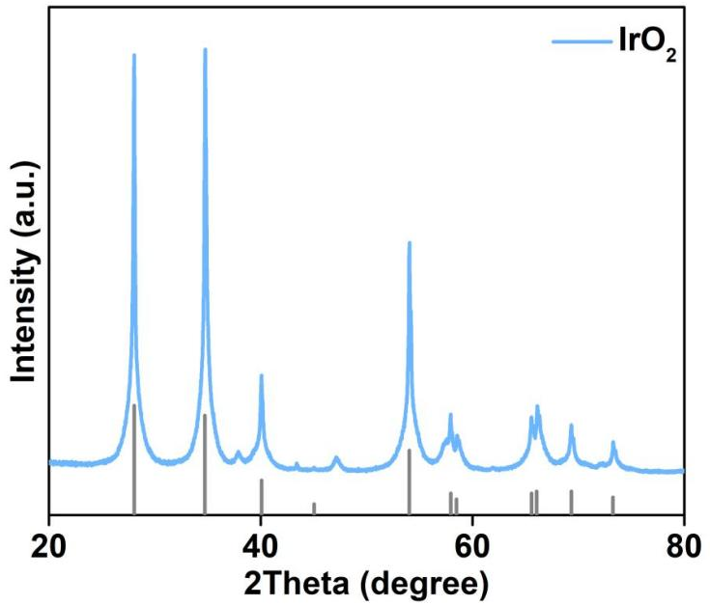

Fig. S1 XRD pattern of IrO₂ catalyst.

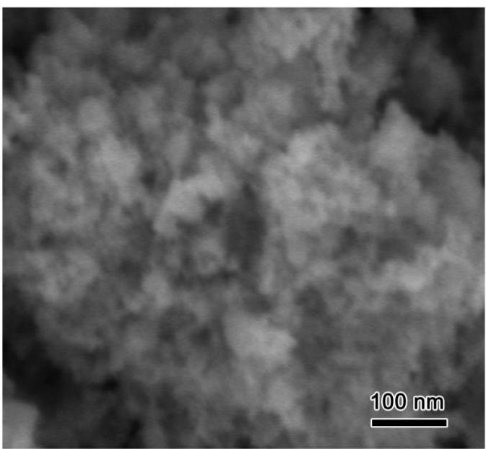

Fig. S2 SEM image of IrO₂ catalyst.

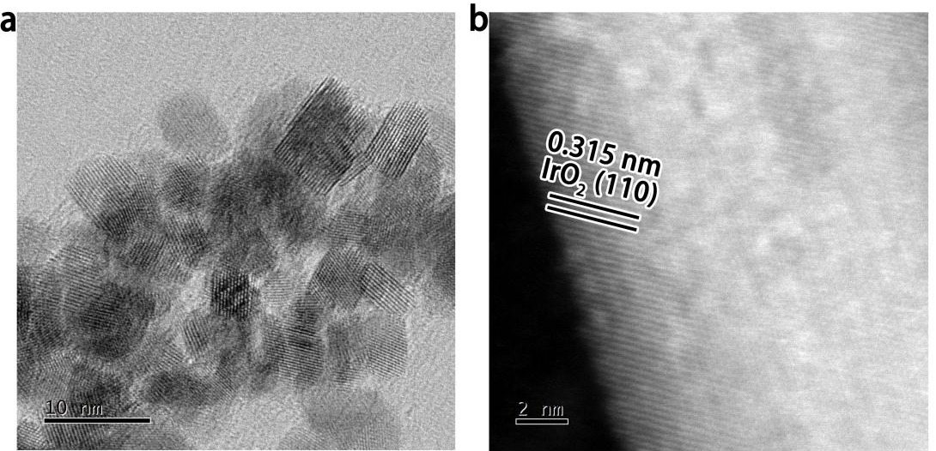

Fig. S3 (a-b) HRTEM images of IrO₂ catalyst.

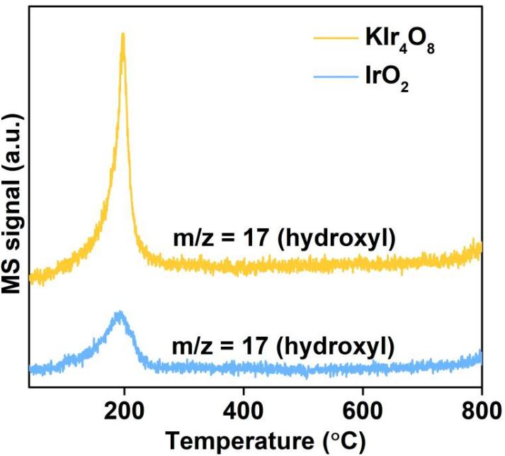

Fig. S4 TGA-MS curves of KIr₄O₈ and IrO₂ catalysts.

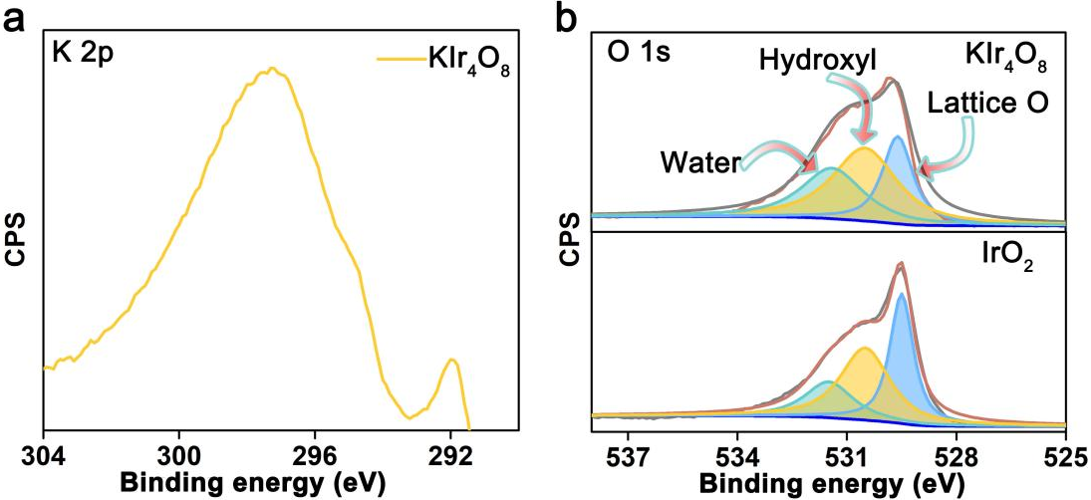

Fig. S5 (a) K 2p XPS spectrum of KIr₄O₈ catalyst. (b) O 1s XPS spectra of IrO₂ and KIr₄O₈ catalysts.

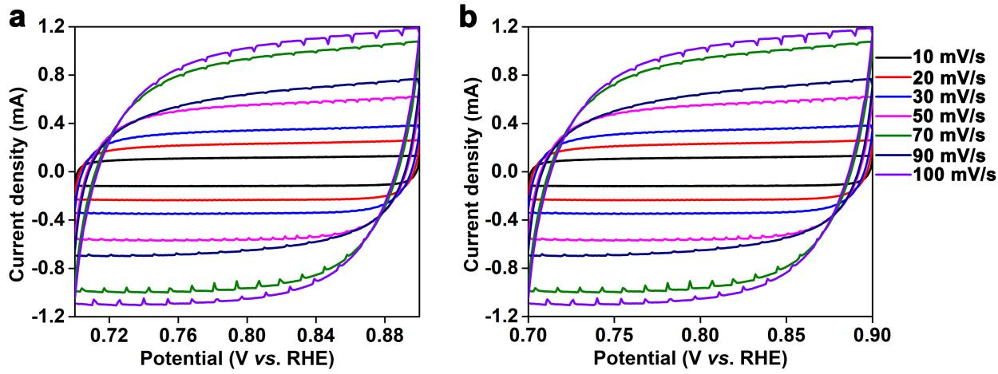

Fig. S6 (a-b) Cyclic voltammograms of KIr₄O₈ and IrO₂ catalysts in the potential region of 0.7-0.9 V vs. RHE at various scan rates.

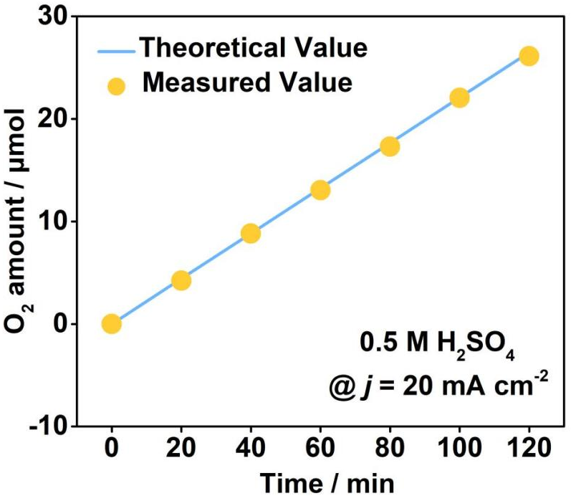

Fig. S7 Faradaic efficiency of KIr₄O₈ catalyst at 20 mA/cm² toward the OER.

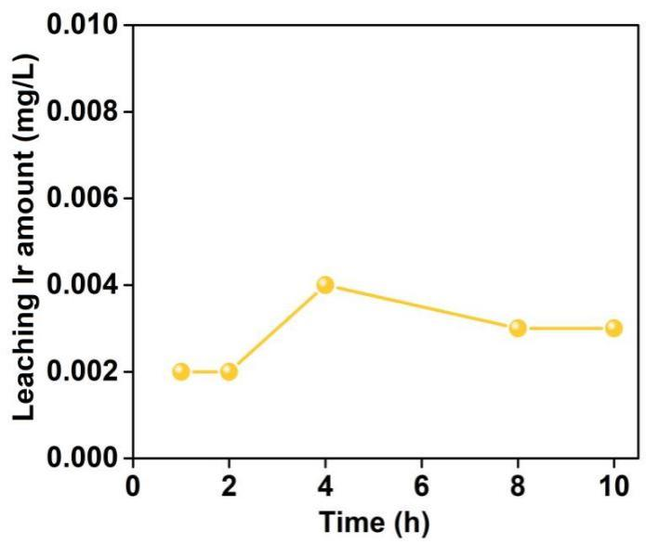

Fig. S8 Leached amount of Ir from KIr₄O₈ catalyst during OER electrocatalysis for 10 h in 0.5 M H₂SO₄.

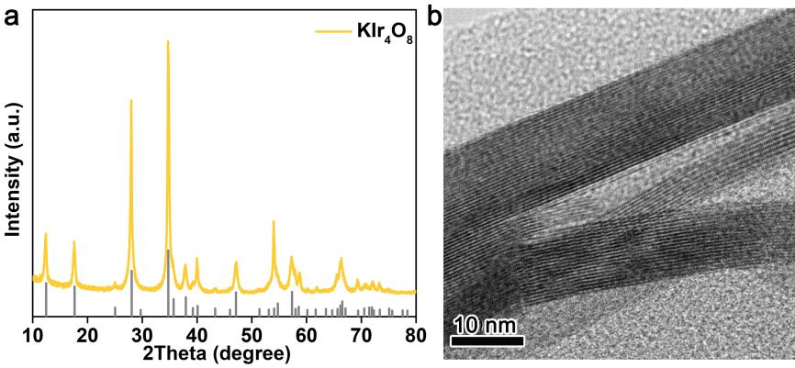

Fig. S9 (a-b) XRD pattern and HRTEM image of KIr₄O₈ after stability test toward the OER.

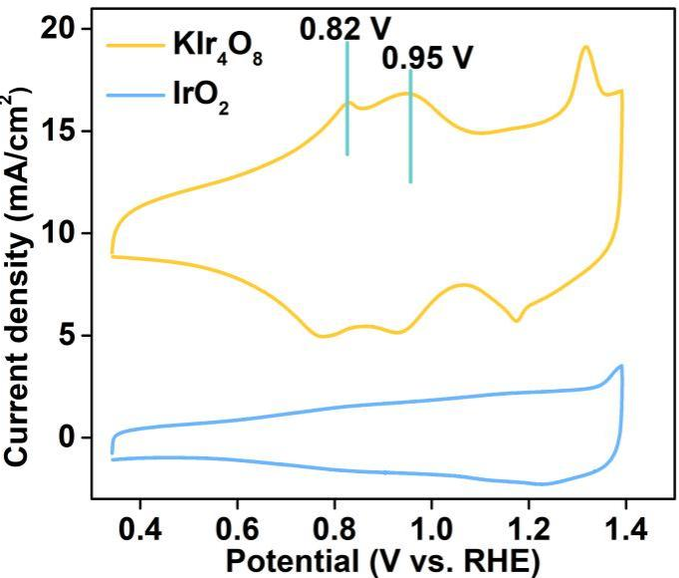

Fig. S10 Cyclic voltammograms of IrO₂ and KIr₄O₈ catalysts recorded at the scan rate of 1 mV/s in 0.5 M H₂SO₄.

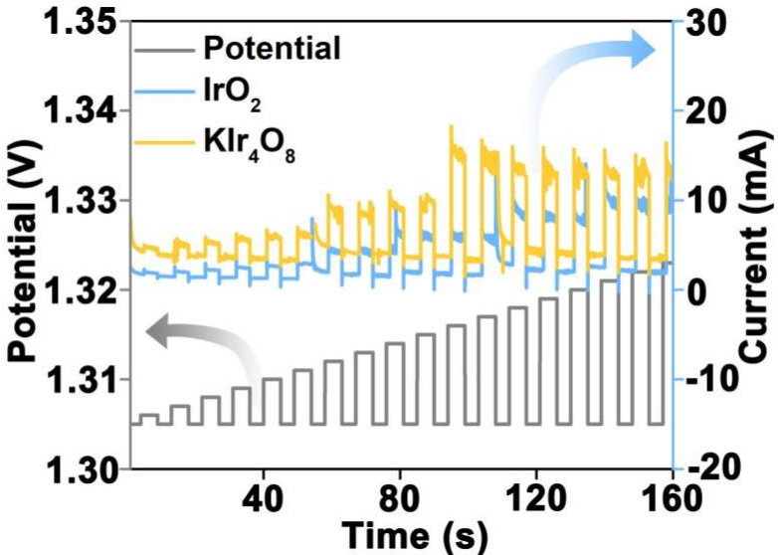

Fig. S11 Pulse voltammetry measurements and corresponding current responses for KIr₄O₈ and IrO₂ catalysts.

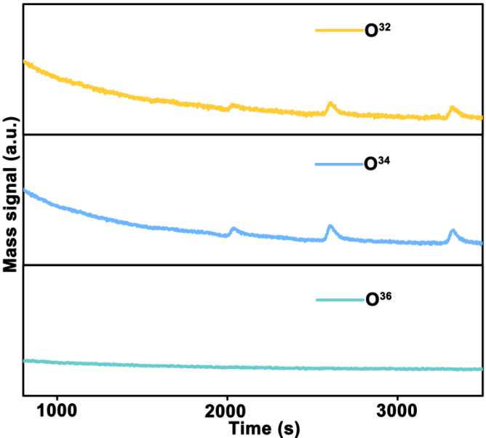

Fig. S12 DEMS signals of O₂ products for ¹⁸O-labeled IrO₂ catalyst in 0.5 M H₂SO₄ with H₂¹⁶O.

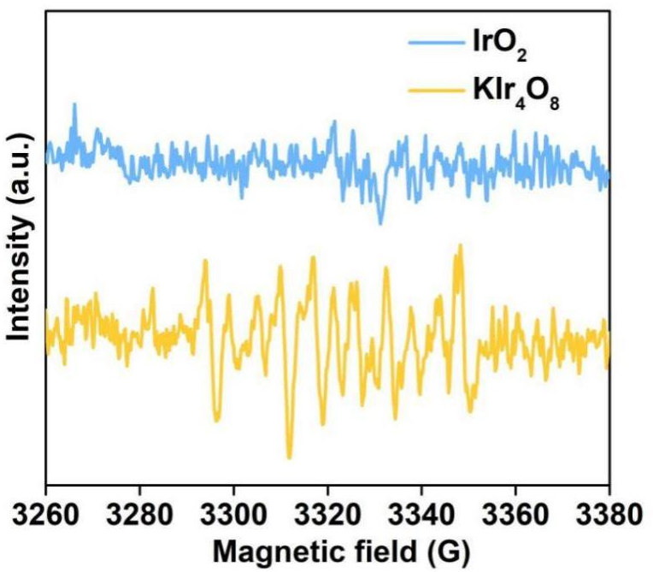

Fig. S13 Electron paramagnetic resonance spectra of IrO₂ and KIr₄O₈ catalysts in DMPO solution.

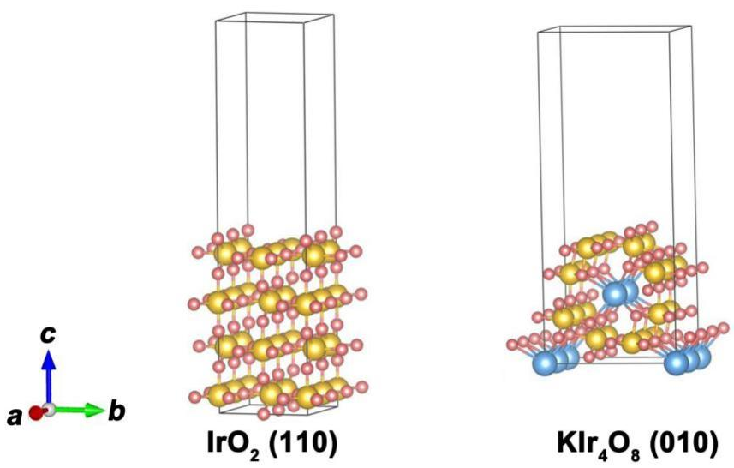

Fig. S14 Theoretical models for IrO₂ (110) and KIr₄O₈ (010).

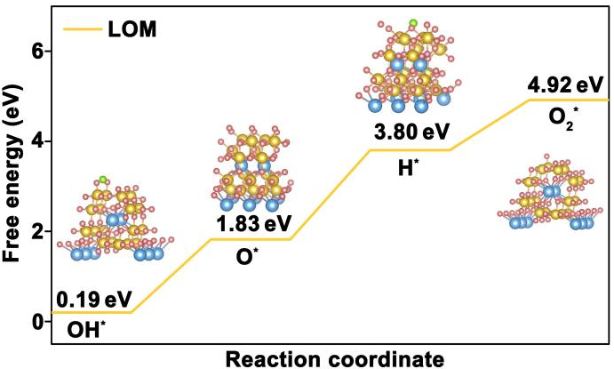

Fig. S15 Gibbs free energy diagram of lattice oxygen mechanism for KIr₄O₈.

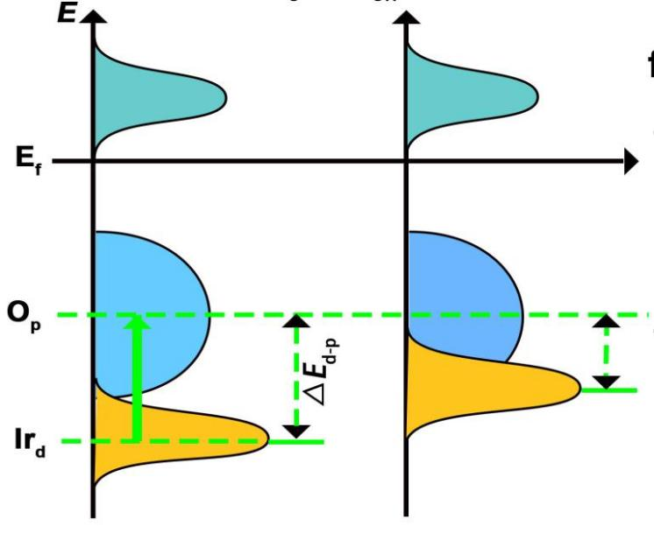

Fig. S16 Schematic explanation for the relative distance between the Ir d band center and oxygen 2p (O 2p) band center in KIr₄O₈.

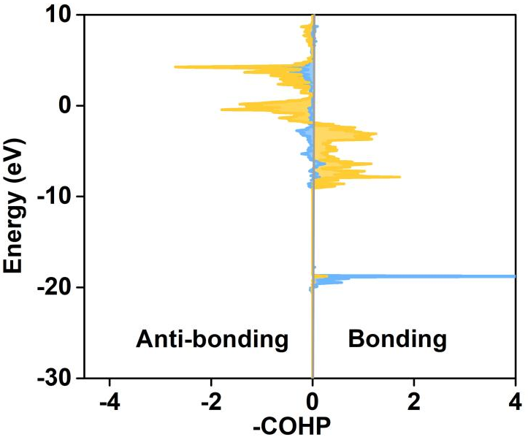

Fig. S17 Integrated crystal orbital Hamilton population (ICOHP) curves of OH bond covered on IrO₂.

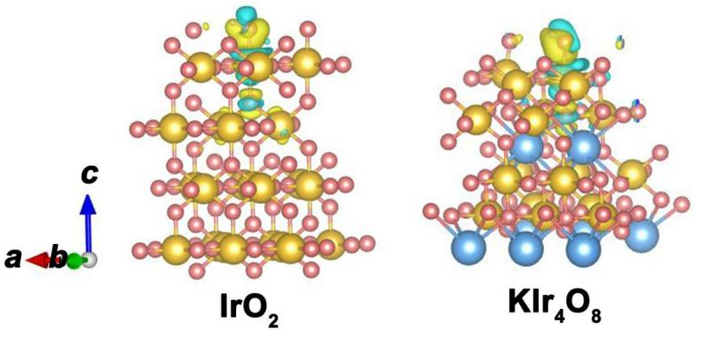

Fig. S18 Charge density difference of OH covered on IrO₂ and KIr₄O₈ models.

Table S1. Comparison of OER performance of KIr₄O₈ with some representative Ir-based catalysts in acidic media.
Catalysts | Loading amount (mg/cm²) | Overpotential at 10 mA/cm² (mV) | Scan rate (mV/s) | Stability | Electrolyte | Reference
KIr₄O₈ | 0.281 | 266 | 1 | 100 h | 0.5 M H₂SO₄ | This work
5 nm-thick Ir film/Ti substrate |  | 276 | 5 | 24 h | 0.5 M H₂SO₄ | ¹
Porous-Ir-SAs/C | 0.375 | 284 | 10 | 20 h | 0.1 M HClO₄ | ²
Ir₃Pb | 0.084 | 307 | 10 | 2000 cycles | 0.1 M HClO₄ | ³
Pd@Ir/CNT | 0.285 | 266 | 10 | 2000 cycles | 0.5 M H₂SO₄ | ⁴
IrCo alloy nanodendrites | 0.09 | 281 | 5 | 500 cycles | 0.1 M HClO₄ | ⁵
IrNi₂ after 25 potential cycles | 0.024 | 315 | 5 |  | 0.05 M H₂SO₄ | ⁶
IrCoNi multimetallic porous hollow nanocrystals | 0.01 | 309 | 5 | 1000 cycles | 0.5 M H₂SO₄ | ⁷
IrCuNi deeply concave nanocubes | 0.006 | 273 | 10 | 1800 cycles | 0.1 M HClO₄ | ⁸
P-IrCu_{x} NCs | 0.06 mg | 311 | 10 | 10 h | 0.05 M H₂SO₄ | ⁹
Ultrathin IrO₂ nanoneedles | 0.25 | 313 | 10 | 2 h | 1 M H₂SO₄ | ¹⁰
Porous IrO_{x} nanoclusters | 0.4 | 290 | 5 | 27.7 | 0.5 M H₂SO₄ | ¹¹
Li-IrO_{x} | 0.0204 | 290 | 1 | 10 h | 0.5 M H₂SO₄ | ¹²
La₃IrO₇ | 0.467 | 296 | 5 | 16.7 h | 0.1 M HClO₄ | ¹³
6H-SrIrO₃ | 0.284 | 248 | 1 | 30 h | 0.5 M H₂SO₄ | ¹⁴
H_{x}IrO₃ NSs | 0.255 | 277 |  | 12 | 0.5 M H₂SO₄ | ¹⁵

References
1. Park, N.-Y.; Kim, M.; Kim, Y.-H.; Ramesh, R.; Nandi, D. K.; Tsugawa, T.; Shigetomi, T.; Suzuki, K.; Harada, R.; Kim, M.; An, K.-S.; Shong, B.; Kim, S.-H. Atomic Layer Deposition of Iridium Using a Tricarbonyl Cyclopropenyl Precursor and Oxygen. Chem. Mater. 2022, 34 (4), 1533-1543.
2. Wang, Y.; Guo, X.; Wang, X.; Huang, J.; Yin, L.; Zhu, W.; Zhuang, Z. Construction of steady-active self-supported porous Ir-based electrocatalysts for the oxygen evolution reaction. Chem. Commun. 2023, 59 (13), 1813-1816.
3. Tian, H.; Zhu, W.; Shi, Q.; Ding, S.; Lyu, Z.; Xu, M.; Pan, X.; Engelhard, M. H.; Dan, D.; Lin, Y. Bimetallic Ir_{x}Pb nanowire networks with enhanced electrocatalytic activity for the oxygen evolution reaction. J. Mater. Chem. A 2022, 10 (20), 11196-11204.
4. Xie, Y.; Chang, C.; Luo, F.; Yang, Z. Modulation in the d Band of Ir by Core-Shell Construction for Robust Water Splitting Electrocatalysts in Acid. ACS Appl. Mater. Interfaces 2023.
5. Fu, L.; Zeng, X.; Cheng, G.; Luo, W. IrCo Nanodendrite as an Efficient Bifunctional Electrocatalyst for Overall Water Splitting under Acidic Conditions. ACS Appl. Mater. Interfaces 2018, 10 (30), 24993-24998.
6. Pi, Y.; Shao, Q.; Zhu, X.; Huang, X. Dynamic Structure Evolution of Composition Segregated Iridium-Nickel Rhombic Dodecahedra toward Efficient Oxygen Evolution Electrocatalysis. ACS Nano 2018, 12 (7), 7371-7379.
7. Feng, J.; Lv, F.; Zhang, W.; Li, P.; Wang, K.; Yang, C.; Wang, B.; Yang, Y.; Zhou, J.; Lin, F.; Wang, G.-C.; Guo, S. Iridium-Based Multimetallic Porous Hollow Nanocrystals for Efficient Overall-Water-Splitting Catalysis. Adv. Mater. 2017, 29 (47), 1703798.
8. Liu, D.; Lv, Q.; Lu, S.; Fang, J.; Zhang, Y.; Wang, X.; Xue, Y.; Zhu, W.; Zhuang, Z. IrCuNi Deeply Concave Nanocubes as Highly Active Oxygen Evolution Reaction Electrocatalyst in Acid Electrolyte. Nano. Lett. 2021, 21 (7), 2809-2816.
9. Pi, Y.; Guo, J.; Shao, Q.; Huang, X. Highly Efficient Acidic Oxygen Evolution Electrocatalysis Enabled by Porous Ir-Cu Nanocrystals with Three-Dimensional Electrocatalytic Surfaces. Chem. Mater. 2018, 30 (23), 8571-8578.
10. Lim, J. a., D.; Jeon, S. S.; Roh, C. W.; Choi, J.; Yoon, D.; Park, M.; Jung, H.; Lee, H. Ultrathin IrO₂ Nanoneedles for Electrochemical Water Oxidation. Adv. Funct. Mater. 2018, 2018, 1704796-1704802.
11. Zhuang, L.; Xu, F.; Wang, K.; Li, J.; Liang, C.; Zhou, W.; Xu, Z.; Shao, Z.; Zhu, Z. Porous Structure Engineering of Iridium Oxide Nanoclusters on Atomic Scale for Efficient pH-Universal Overall Water Splitting. Small 2021, 17 (20), e2100121.
12. Gao, J.; Xu, C. Q.; Hung, S. F.; Liu, W.; Cai, W.; Zeng, Z.; Jia, C.; Chen, H. M.; Xiao, H.; Li, J.; Huang, Y.; Liu, B. Breaking Long-Range Order in Iridium Oxide by Alkali Ion for Efficient Water Oxidation. J. Am. Chem. Soc. 2019, 141 (7), 3014-3023.
13. Qin, Q.; Jang, H.; Wang, Y.; Zhang, L.; Li, Z.; Kim, M. G.; Liu, S.; Liu, X.; Cho, J. Gettering La Effect from La₃IrO₇ as a Highly Efficient Electrocatalyst for Oxygen Evolution Reaction in Acid Media. Adv. Energy Mater. 2020, 11 (5), 2003561.
14. Yang, L.; Yu, G.; Ai, X.; Yan, W.; Duan, H.; Chen, W.; Li, X.; Wang, T.; Zhang, C.; Huang, X.; Chen, J. S.; Zou, X. Efficient oxygen evolution electrocatalysis in acid by a perovskite with face-sharing IrO₆ octahedral dimers. Nat. Commun. 2018, 9 (1), 5236.
15. Liu, Z.; Qi, J.; Zeng, H.; Zeng, Y.; Wang, J.; Gu, L.; Hong, E.; Yang, M.; Fu, Q.; Chen, J.; Yang, C. Electrochemical Preparation of Iridium Hydroxide Nanosheets with Ordered Honeycomb Structures for the Oxygen Evolution Reaction in Acid. ACS Appl. Energy Mater. 2022, 5 (6), 6869-687

