Table 1 Moisture sorption of pure polyvinyl alcohol (PVA) and cellulose microfiber (CMF)/PVA composites
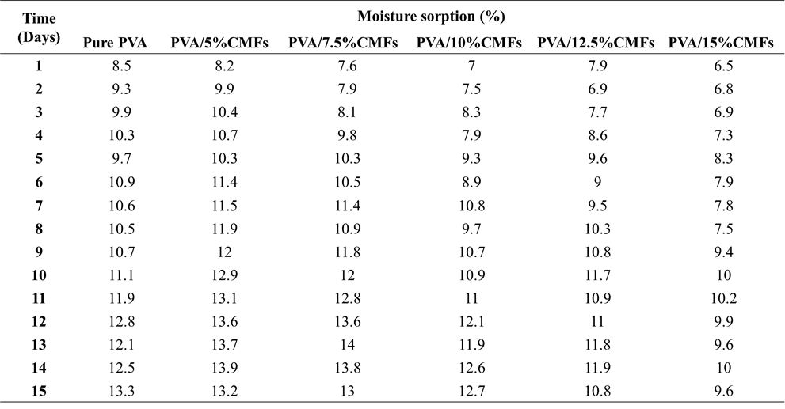

Table 2 Biodegradable behavior of pure polyvinyl alcohol (PVA) and cellulose microfiber (CMF)/PVA composites
